Name:Muhammad Sameer I.D:FA18-BECE-0014

Lab 9 – Images in MATLAB

1.1 Exercise

1.1.1 Exercise 1

Apply filter to the salt &amp; pepper image using MATLAB

Code

clear all

clc

i1=imread("rose.png");

i2=imnoise(i1,'salt & pepper',0.25);

i3=rgb2gray(i2);

subplot(2,2,1),imshow(i1),title("real image");

subplot(2,2,2),imshow(i2),title("converted to sale and pepper image");

subplot(2,2,3),imshow(i3),title("apply filter on salt and pepper image");

Output:

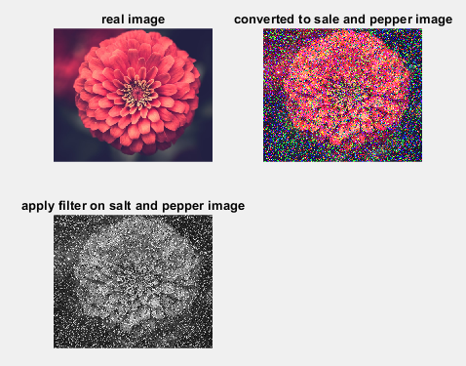

1.1.2 Exercise 2

Add Gaussian noise on grayscale image using MATLAB Commands.

Code:

clear all

i1=imread("pic.png");

i2=rgb2gray(i1);

i3=imnoise(i2,'gaussian',0.25);

subplot(2,2,1),imshow(i1),title("real image");

subplot(2,2,2),imshow(i2),title("converted to garyscale image");

subplot(2,2,3),imshow(i3),title("apply gaussian noise");

Output:

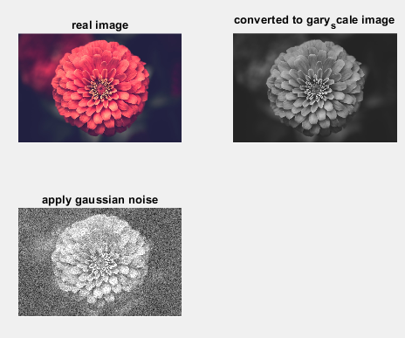

Exercise 3

Apply filter to the Gaussian image using MATLAB Commands.

Code:

close all

clc

i1=imread("pic.png");

i2=imnoise(i1,'gaussian',0.25);

i3=rgb2gray(i2);

subplot(2,2,1),imshow(i1),title("real image");

subplot(2,2,2),imshow(i2),title("converted to gaussian image");

subplot(2,2,3),imshow(i3),title("apply filter on gaussian image");

Output:

