LAB 10: Plotting in Matlab

QUESTION 1:

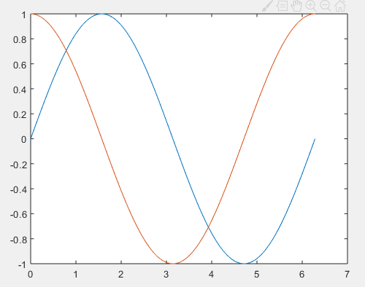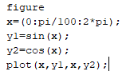

QUESTION:2

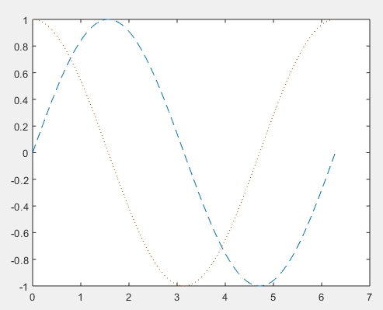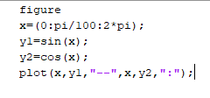

QUESTION 3:

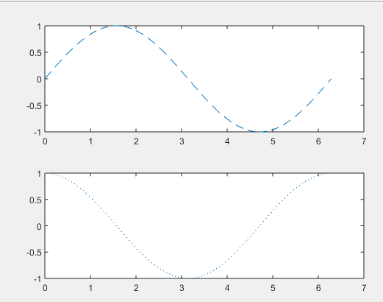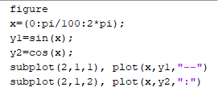

10.4 Exercise

10.4.1 Exercise 1

Create an m-file as follows (note that MATLAB uses angles measured in radians):

% sine_wave_plot.m

% Created by “YOUR Muhammad SAMEER” on “TODAY’S DATE 26/11/2019” clear

x=[0:0.01:4*pi];

y=sin(x);

plot(x,y)

title(&#39;Plot of a Sine Wave&#39;)

ylabel(&#39;y values&#39;)

xlabel(&#39;x values&#39;)

grid on

figure(gcf)

Be sure that the screen shows all three parts:

1) The Script (.m) file.

2) The Command Window, showing that you ran the Script file.

3) The Plot Window, showing the plot.

