**Python**

* Developed By Guido van Rossum

**What is Python: -** Python is a general purpose and high level programming language

* Interpreter language
* Dynamic typing

**Note**: - No braces, no semicolons, everything here is space

**Types: -** 1. Cpython (Python)

2. Jython

**Applications of python:-**

* Web
* Data crawling
* Data analysing
* Data science
* Machine learning
* Artificial Intelligence

**Awesome Python :-** <https://github.com/sameer2425/Awesome-Python>

**Python version :-**

* Python 2 (python 2.x.x)
* Python 3 (python 3.x.x)

**Downloading python**:-

* <https://www.python.org/downloads/windows/>
* <https://www.ics.uci.edu/~pattis/common/handouts/pythoneclipsejava/python.html>

**First program on python interpreter (Hello World):-**

* Print “hello world” (python 2)
* Print (“Hello World”) (python 3)

**Variables in python (Dynamic typing):-**

* a = 1

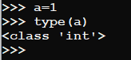

* b = “some word” => string needs to be enclosed in a double or single quotes

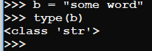

type (variable name) => Give the data type of the variable

**Memory allocation in python :-**

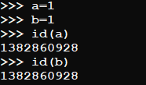

id(variable name) => provide memory address

**Examples**:-

* Add two variable

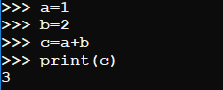

* Swapping

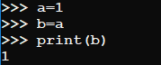

* Strings and integer

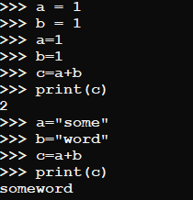

**Execute the Script:-**

* Python <filename.py>
* Interactive Mode: Python interpreter, ipython, IDLE

**Python File Extensions:-**

* .py => Normal python file
* .pyc => compiled bytecode
* .pyw => Python script for windows
* .pyd => python script made as a windows dll

**Python Comments:-**

* single line comment



* Multiline comment

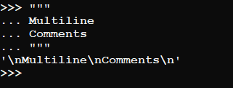

**Shell as a Simple Calculator:-**

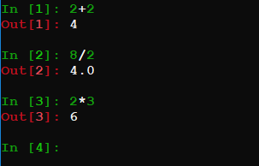

**Order of operations:-**

() => come first Multiplication second

(2+3) * 2 = 5 *2

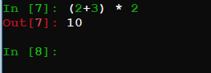

**String Handling:-** Strings => ‘singlequote’ or ”doublequote”

**String operations :-** len () => to find length of a string

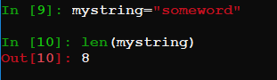

**Access by index:-**

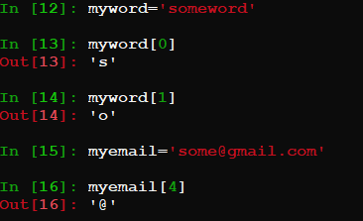

**String slicing :-**

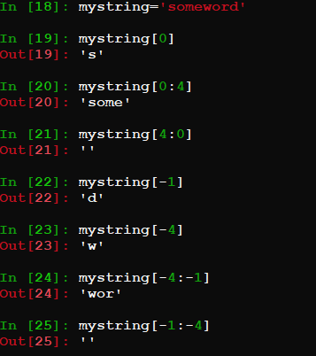

**String operations:-**  upper(), lower(), isupper(), islower(), find()

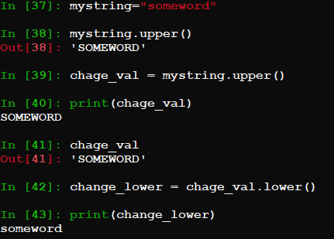

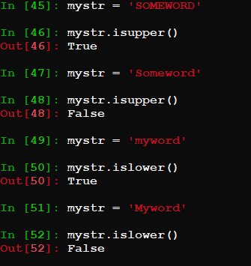

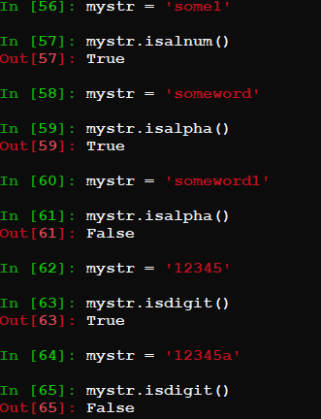

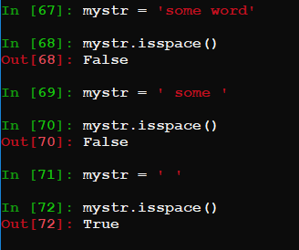

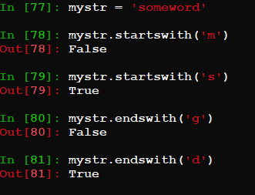

**Python IDE :-**

* **Eclipse** : <https://www.eclipse.org/downloads/>
* **Pycharm** : <https://www.jetbrains.com/pycharm-edu/download>
* **Spyder** : <https://www.spyder-ide.org/>
* Can use Jupyter notebook also

**Jupyter Notebook :-**  web application to execute codes

* <https://jupyter.readthedocs.io/en/latest/install.html>

**Anaconda:-** Provides everything we need for data science and machine learning

* <https://www.anaconda.com/distribution/#download-section>
* Contain core python
* 100+ python libraries
* Spyder and Jupyter Notebook come with package
* Package manager :- conda
* conda install <package_name>

**PIP :-** Pip is a package manager for python to install its libraries

* pip install <package_name>