1. **Introduction**

The Bhaktapur Post is a dedicated digital platform that brings the essence of Bhaktapur to the fingertips of its audience. It provides timely and reliable news, insightful articles, and updates on local events, culture, history, and tourism, showcasing the vibrant heritage of this historic city. Designed to engage both residents and global readers, the portal fosters a deeper connection with Bhaktapur through interactive features, multimedia content, and community-driven stories. With a user-friendly interface and a commitment to authenticity, the Bhaktapur Post serves as a gateway to understanding and celebrating the rich traditions and dynamic life of Bhaktapur.

**1.1- Objectives of case study**

1. To explore the historical development of Bhaktapur Post as an essential communication institution in Nepal.
2. To evaluate its current state and modernization efforts in the digital era.
3. To examine the role of Bhaktapur Post in local and regional economic activities, including trade facilitation and remittance services.
4. To analyze how Bhaktapur Post has contributed to connecting communities in the region.

**2.Background Study**

The **Bhaktapur Post** appears to be a publication closely tied to the cultural and historical heritage of Bhaktapur, a city in Nepal. Bhaktapur, also known as the "City of Devotees," is famous for its rich history, traditional Newar culture, and stunning architectural landmarks such as Nyatapola Temple, Durbar Square, and Dattatreya Square. As a UNESCO World Heritage Site, the city attracts both local and international visitors, adding to its significance as a cultural and historical hub.

While specific details about the establishment and operational history of Bhaktapur Post are limited, its naming suggests a connection to the city's legacy of art, culture, and history. The publication likely aims to reflect and promote the values and traditions associated with Bhaktapur, contributing to the dissemination of news and information within Nepal.

**3. System Analysis**

**3.1- The required model**

A Use Case diagram is a visual representation of the functional requirement of a system, illustrating the interaction between the users (Actor) and system itself.

**Key Components:**

1. **Actors:**
   1. **Admin**: Represents the system administrator with the highest level of privileges.
   2. **Ward**: Represents ward-level users who have specific content management roles.
   3. **Normal User**: Represents regular users who can only view published content.

**2. Use Cases** (Ellipses):

* **Login**: Shared by all actors to access the system.
* **Manage Ward Users**: Exclusively available to the admin to manage user accounts associated with wards.
* **Manage All Contents**: Allows the Admin to oversee and manage all content within the system.
* **CRUD All Content**: Refers to "Create, Read, Update, and Delete" operations on all types of content, available to the Admin.
* **CRUD Ward Content**: Refers to the "Create, Read, Update, and Delete" operations specific to ward-level content, accessible by Ward users and the Admin.
* **View All Published Content**: Available to all users, including Normal Users, for accessing publicly available content.

**3. Relationships**:

* **Admin**:
  + Has access to all use cases, including system-wide content and user management.
* **Ward**:
  + Can log in, manage their specific ward content (CRUD operations), and view published content.
* **Normal User**:
  + Can log in and view all published content, with no management privileges.

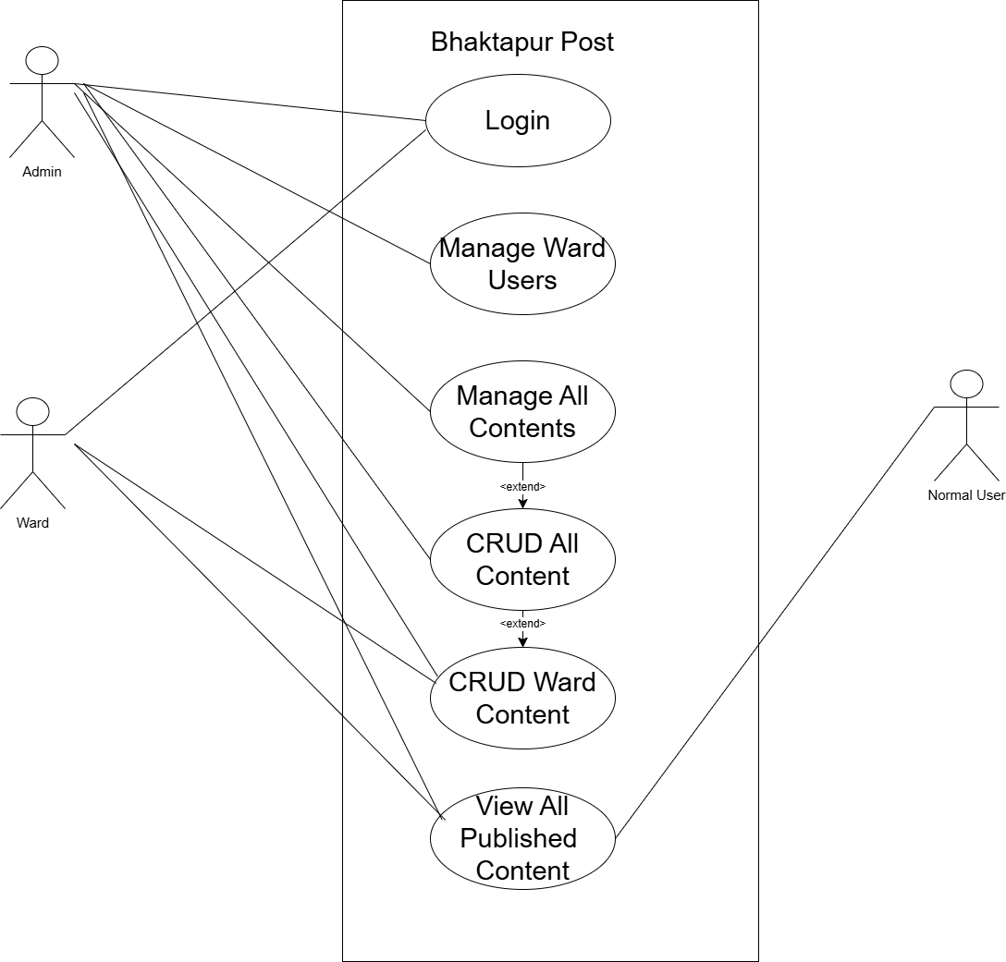

Fig: Use case diagram of Bhaktapur post.

**3.2- The Analysis Model**

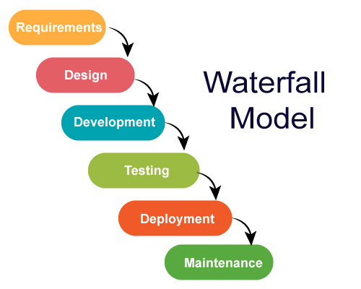

Fig: Waterfall Model

The **Waterfall Model** is a sequential software development methodology that progresses through clearly defined phases: requirements, design, implementation, testing, deployment, and maintenance. Using the **Bhaktapur Post** system as an example, the process begins with the:

* **Requirements phase:** where system functionalities such as user roles (Admin, Ward Officer, Normal User) and features like content management, CRUD operations, and authentication are clearly defined.
* **Design phase:** the architecture is planned, including use case diagrams and database structures to support ward-specific content and user management.
* **implementation phase:** It involves developing the system's modules, such as login, content management, and viewing functionalities, based on the design.
* **testing:** Once complete, the system undergoes rigorous to ensure all features, like role-based access control and data security, function as expected. Following testing, the system is **deployed**, making it accessible to users,
* **maintenance phase:** where updates and bug fixes are handled. The Waterfall Model's structured approach ensures that each phase is completed before moving to the next, providing clarity and minimizing risks for the Bhaktapur Post system.

**4. System Design**

**4.1: The Design Model**

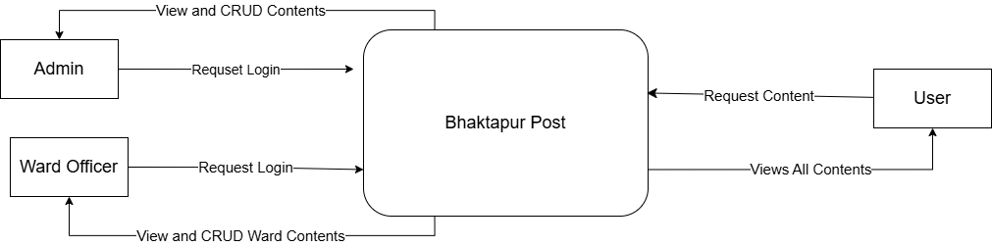

The diagram depicts the contextual flow of interactions between different actors and the Bhaktapur Post system. Here's a detailed description:

**Actors and their Roles:**

1. **Admin**:
   1. Sends a login request to the system to authenticate and access administrative functionalities.
   2. Once logged in, the admin can view and perform CRUD (Create, Read, Update, Delete) operations on all content in the system.
2. **Ward Officer**:
   1. Similar to the Admin, the Ward Officer sends a login request to authenticate and access functionalities.
   2. The Ward Officer has more limited scope and can only view and perform CRUD operations for ward-specific content.
3. **User (Normal User)**:
   1. Requests content from the Bhaktapur Post system.
   2. The User has read-only access, meaning they canview all published content but cannot modify or manage it.

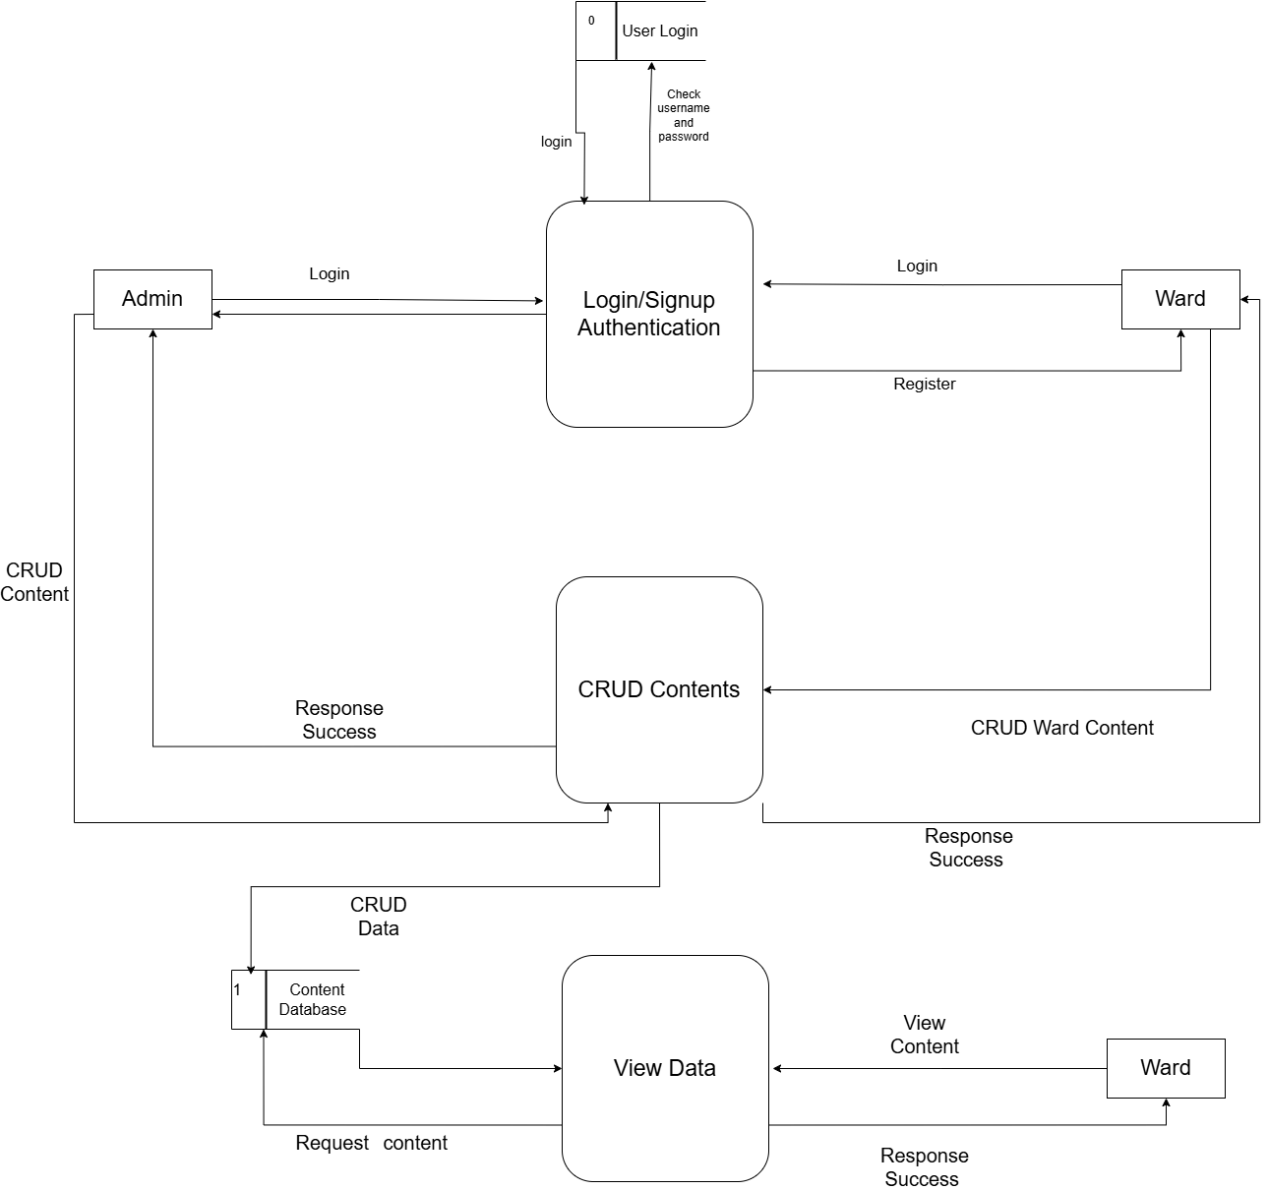

Fig: DFD Diagram

**5. Implementation Model**

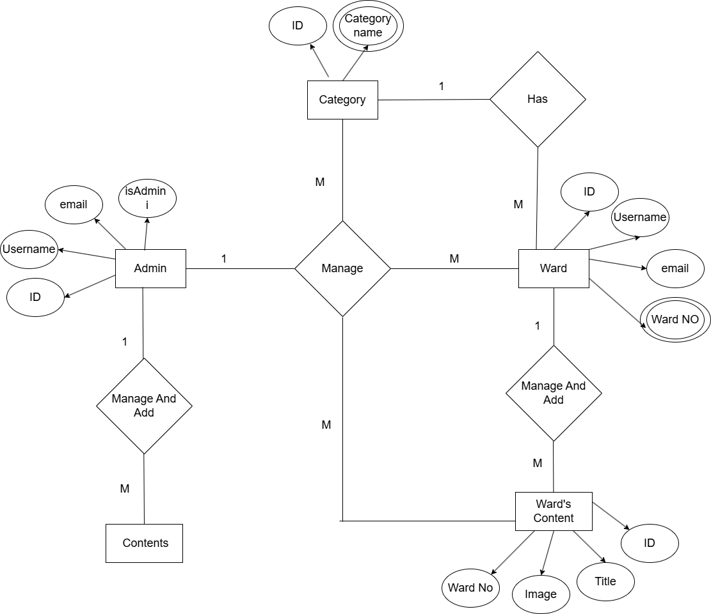

Fig: ER diagram

1. **Conclusion**

The Bhaktapur Post system is a robust and efficient platform designed to streamline the management and dissemination of ward-specific and system-wide content. By incorporating features like role-based access control, CRUD operations, and a user-friendly interface for normal users, the system enhances transparency, efficiency, and accessibility. The implementation of key modules such as Login/Signup Authentication, CRUD Contents, and View Data ensures seamless interaction between Admins, Ward Officers, and Users while maintaining data integrity and security. The system's design, guided by the Waterfall Model, has allowed for a structured and organized development process, ensuring that all requirements are met effectively.

**6.1- Recommendations**

1. **Enhance User Experience**: Introduce a modern and intuitive user interface for better accessibility, especially for normal users who primarily view content.
2. **Improve Security**: Strengthen authentication mechanisms by incorporating multi-factor authentication (MFA).
3. **Continuous Feedback and Updates:** Collect feedback from users to identify pain points and areas for improvement.
4. **Expand Functionality**: Allow Ward Officers to generate automated reports for their wards.
5. **References**

* Bhaktapur website Available: <https://www.bhaktapur.com/>
* Bhaktapur municipality website: <https://daobhaktapur.moha.gov.np/en/post/bhaktapur-municipality>
* Bhaktapur Municipality Facebook page: <https://www.facebook.com/search/top?q=bhaktapur%20municipality>
* Software Engineering Book
* System Analysis Book

*Samriddhi College*

*Lokanthali Bhaktapur, Nepal*

*CASE STUDY OF Bhaktapur Post*

*Submitted By : Submitted to:*

*Unique Shilpakar and Sameer Baiju Madan Bhandari*

***BCA 4th sem***