Dayananda Sagar College of Engineering
Department of Electronics and Communication Engineering
Shavige Malleshwara Hills, Kumaraswamy Layout, Bengaluru – 560 078.
(An Autonomous Institute affiliated to VTU, Approved by AICTE & ISO 9001:2008 Certified)
Accredited by National Assessment and Accreditation Council (NAAC) with ‘A’ grade

Assignment

Program: B.E. | Branch: ECE
Course: Programming in Python | Semester : 5 Section:C
Course Code: 18EC5DEBPP | Date: 23.12.2020

A Report on

Canonical Form Converter
(POS-SOP and SOP-POS)

Submitted by

USN | NAME
1DS18EC156 VISHVENDRA SINGH
1DS18EC143 SAMEER GAUTAM
1DS18EC144 SAURABH SINGH

Faculty In-charge

Prof. Mahesh Kumar

Signature of Faculty In-charge

INTRODUCTION

Digital electronics is a field of electronics involving the study of digital signals and the engineering of devices that use or produce them. This is in contrast to analog electronics and analog signals. Digital electronic circuits are usually made from large assemblies of logic gates, often packaged in integrated circuits. Complex devices may have simple electronic representations of Boolean logic functions. Binary logic deals with binary variables that take 2 discrete values (0 and 1), and with logic operations AND, OR, NOT. Binary logic variables are typically represented as letters: A, B, C ,…,X,Y,Z . The basic syntax of a binary logic function is F(variables) = Expression. For example: F(A, B)=AB+B’. In digital logic, the inputs and output of a function are in the form of binary numbers (boolean values) i.e., the values are either zero (0) or one (1). Therefore, digital logic is also known as ‘Boolean logic’. These inputs and output can be termed as ‘Boolean Variables’. The output boolean variable of a digital signal can be expressed in terms of input boolean variables which forms the ‘Boolean Expression’.
Representation of Boolean expression can be primarily done in two ways:
Sum of Products (SOP) form and Product of Sums (POS) form. Sum of Product form is one of the ways of writing a boolean expression. As the name suggests, it is formed by adding (OR operation) the product terms. These product terms are also called as ‘min-terms’. Min-terms are represented with ‘m’, they are the product (AND operation) of boolean variables either in normal form or complemented form.
Therefore, Sum of Product is sum of minterms and is represented as: F in SOP = m(0, 3)
Here, F is sum of ‘minterm0’ and ‘minterm3’.
As the name suggests, product of sum is formed by multiplying (AND operation) the sum terms. These sum terms are also called as ‘max-terms’. Max-terms are represented with ‘M’, they are the sum (OR operation) of Boolean variables either in normal form or complemented form.
Therefore, POS is product of maxterms and is represented as F in SOP = M(1, 2) Here, F is product of ‘maxterm1’ and ‘max-term2’.
The sum of min-terms and the product of maxterms forms of Boolean expressions are known as canonical forms. Canonical form means that all equivalent functions will have a unique and equal representation. Two functions are equal if and only if they have the same sum of min-terms and the same product of maxterms.
A product term is a term with ANDed literals. Thus, AB, A’B, A’CD are all product terms. A min-term is a special case of a product term where all input variables appear in the product term either in the true or complement form. A sum term is a term with ORed literals. Thus, (A+B), (A’+B), (A’+C+D) are all sum terms. A maxterm is a special case of a sum term where all input variables, either in the true or complement form, are ORed together. The sum of minterms form is a special case of the SOP form where all product terms are minterms. The product of maxterms form is a special case of the POS form where all sum terms are maxterms. The Sum of product and product of sum forms are standard forms for representing Boolean functions.

METHODOLOGY

For SOP to POS Conversion:

First of all we convert each product term to its equivalent binary form (for example: if ABC’ then take 1 for uncomplement variable (A, B) and take 0 for complement variable(C), so binary conversion is 110).
Then we convert binary form to its equivalent decimal form (for ex: 110 = 6) and store it in a list.
Now for POS form, take all those terms which are not present in the list formed during conversion and then convert each term to binary and hence change to SOP form. For example: suppose 5 was not in the list then, 5 in binary is equivalent to 101.
Now, we replace 1 by complement variables (A, C) and 0 by un-complement variables(B), and between the variables we use ‘+’. This gives 101 converted to A’+B+C’. After each individual sum term, we use ‘.’
For more clarity we use brackets between each individual term.
For example: (A’+B+C’).(A+B+C’)

For POS to SOP conversion:

First of all we convert each sum term to its equivalent binary form (for example, if (A+B+C’), then we take 0 for uncomplement variable (A, B) and 1 for complement variable(C), so binary conversion is 011).
Then we convert binary form to its equivalent decimal form (for example: 001 = 1) and store it in a list.
Now for SOP form, we take all those terms which are not present in the list formed during conversion and then we convert each term to binary and hence change to POS form. For example –
Suppose 5 was not in the list then 5 in binary is equivalent to 101.
Now, we replace 0 by complement variables(B) and 1 by un-complement variables (A, C). This gives 101 converted to AB’C. After each individual sum term, we use ‘+’.
For example: AB’C+AB’C’

FLOWCHART

Canonical SOP to Canonical POS:
Assumptions: The input SOP expression is standard/canonical. The variables in SOP expression are continuous i.e. if expression contains variable A then it will have variables B, C respectively and each Product term contains the alphabets in sorted order i.e. ABC (not like BAC).

Input as Sum of Min terms
Conversion of Min terms to Binary
Binary to decimal and Stored in a List
Conversion of Numbers not present in
the List to Binary

Replacing 1 by Complement variable and 0 by Uncomplement Variable by using ‘+’ in between.

Output as POS

Examples:
Enter the SOP Expression: A’B’C+A’BC’+AB’C’+ABC’
Standard POS form of A’B’C+A’BC’+AB’C’+ABC’==> (A+B+C).(A+B’+C’).(A’+B+C’).(A’+B’+C’)

Canonical POS to Canonical SOP:
Assumptions:
The input POS expression is standard. The variables in POS expression are continuous i.e. if expression contains variable A then it will have variables B,C respectively and each Sum term contains the alphabets in sorted order i.e.A + B + C(not like B+A+C).
Input as Product of Max terms
Conversion of Max terms to Binary
(0 for uncomplement and 1 for
complement variable)
Binary to decimal and Stored in a List
Conversion of Numbers not present in
the List to Binary
Replacing 0 by Complement variable and 1 by Uncomplement Variable by
using ‘+’ in between.
Output as SOP

Examples:
Input : (A + B + C).(A + B + C').(A + B' + C).(A' + B + C)
Output : A'BC + AB'C + ABC' + ABC

PROGRAM CODE
(This code is Simulated in Jupyter Notebook)

Code for SOP to POS conversion:
#Canonical POS to SOP conversion
def count_no_alphabets(POS):
i = 0
no_var = 0
# total no. of alphabets before will be equal to alphabets before first '.' character
while (POS[i]!='.'):
# character is a alphabet or not
if (POS[i].isalpha()):
no_var+= 1
i+= 1
return no_var
# maximum terms in an integer
def Cal_Max_terms(Max_terms, POS):
a = ""
i = 0
while (i<len(POS)):
if (POS[i]=='.'):
# binary to decimal conversion
b = int(a, 2)
# append each min term(integer type) into the list
Max_terms.append(b)
# assign empty strings
a =""
i+= 1
elif(POS[i].isalpha()):
# checking whether variable is having complement as superscript
if(i + 1 != len(POS) and POS[i + 1]=="'"):
# concatenating the string with '1'
a += '1'
# incrementing by 2 because 1 for alphabet and another for a symbol "'"
i += 2
else:
# concatenating the string with '0'
a += '0'
i += 1
else:
i+= 1
# append last min term(integer type) into the list
Max_terms.append(int(a, 2))
# conversion of minterms in binary and finally converting it to SOP
def Cal_Min_terms(Max_terms, no_var, start_alphabet):
# declaration of the list
Min_terms =[]
# calculation of total no. of terms formed by all variables max = 2**no_var
max=2**no_var
for i in range(0, max):
# is current term present in max_terms or not
if (Max_terms.count(i)== 0):
# converting integer to binary
b = bin(i)[2:]
# loop used for inserting 0's before the
# binary value so that its length will be
# equal to no. of variables present in
# each product term
while(len(b)!= no_var):
b ='0'+b
# appending the max terms(integer) in the list
Min_terms.append(b)
SOP = ""
# iterated untill minterms are available
for i in Min_terms:
# fetching the variable
value = start_alphabet
# iterate till there are 0's and 1's
for j in i:
# check whether the varailble is complemented or not
if (j =='0'):
# concatenating vaue and complement operator
SOP = SOP + value+ "'"
# check the non complement variable
else:
# concatenating value
SOP = SOP + value
# increment the alphabet by the next adjacent alaphabet
value = chr(ord(value)+1)
# concatenating the "+" operator
SOP = SOP+ "+"
# for discarding the extra '+'
SOP = SOP[:-1]
return SOP
# main function
def main():
# input
POS_expr =input("Enter the POS Expression: ")
Max_terms = []
no_var = count_no_alphabets(POS_expr)
Cal_Max_terms(Max_terms, POS_expr)
SOP_expr = Cal_Min_terms(Max_terms, no_var, POS_expr[1])
print("Standard SOP form of " + POS_expr + " ==> " + SOP_expr)
# Driver code
if __name__=="__main__":
main()

Code for SOP to POS conversion:
#Canonical SOP to POS conversion
# function to calculate no. of variables
# used in SOP expression
def count_no_alphabets(SOP):
i = 0
no_var = 0

# As expression is standard so total no.
# of alphabets will be equal
# to alphabets before first '+' character
while (SOP[i]!='+'):

# checking if character is alphabet
if (SOP[i].isalpha()):
no_var+= 1
i+= 1
return no_var

# function to calculate the min terms in integers
def Cal_Min_terms(Min_terms, SOP):
a =""
i = 0
while (i<len(SOP)):
if (SOP[i]=='+'):

# converting binary to decimal
b = int(a, 2)

# insertion of each min term(integer) into the list
Min_terms.append(b)

# empty the string
a =""
i+= 1
else:

# checking whether variable is complemented or not
if(i + 1 != len(SOP) and SOP[i + 1]=="'"):

# concatenating the string with '0'
a+='0'

# incrementing by 2 because 1 for alphabet and
# another for "'"
i+= 2
else:

# concatenating the string with '1'
a+='1'
i+= 1

# insertion of last min term(integer) into the list
Min_terms.append(int(a, 2))

# function to calculate the max terms in binary then
# calculate POS form of SOP
def Cal_Max_terms(Min_terms, no_var, start_alphabet):

# declaration of the list
Max_terms =[]

# calculation of total no. of terms that can be
# formed by no_var variables
max = 2**no_var
for i in range(0, max):

# checking whether the term is not
# present in the min terms
if (Min_terms.count(i)== 0):

# converting integer to binary and then
# taking the value from 2nd index as 1st
# two index contains '0b'
b = bin(i)[2:]

# loop used for inserting 0's before the
# binary value so that its length will be
# equal to no. of variables present in
# each product term
while(len(b)!= no_var):
b ='0'+b

# appending the max terms(integer) in the list
Max_terms.append(b)

POS =""

# loop till there are max terms
for i in Max_terms:

# before every sum term append POS by '('
POS = POS+"("

# acquire the starting variable came from
# main function in every sum term
value = start_alphabet

# loop till there are 0's or 1's in each max term
for j in i:

# checking for complement variable to be used
if (j =='1'):

# concatenating value, ' and + in string POS
POS = POS + value+"'+"

# checking for uncomplement variable to be used
else:

# concatenating value and + in string POS
POS = POS + value+"+"

# increment the alphabet by 1
value = chr(ord(value)+1)

# for discarding the extra '+' in the last
POS = POS[:-1]

# appending the POS string by ')." after
# every sum term
POS = POS+")."

# for discarding the extra '.' in the last
POS = POS[:-1]
return POS

# main function
def main():
SOP_expr =input("ENTER")
Min_terms =[]
no_var = count_no_alphabets(SOP_expr)
Cal_Min_terms(Min_terms, SOP_expr)
POS_expr = Cal_Max_terms(Min_terms, no_var, SOP_expr[0])
print ("Standard POS form of", SOP_expr, " ==> ", POS_expr )

# driver code
if __name__=="__main__":
main()

SIMULATION AND RESULTS

Canonical POS to SOP conversion
1.

Enter the POS Expression: (A + B).(A'+B')
Standard SOP form of (A + B).(A'+B') ==> A'B+AB'

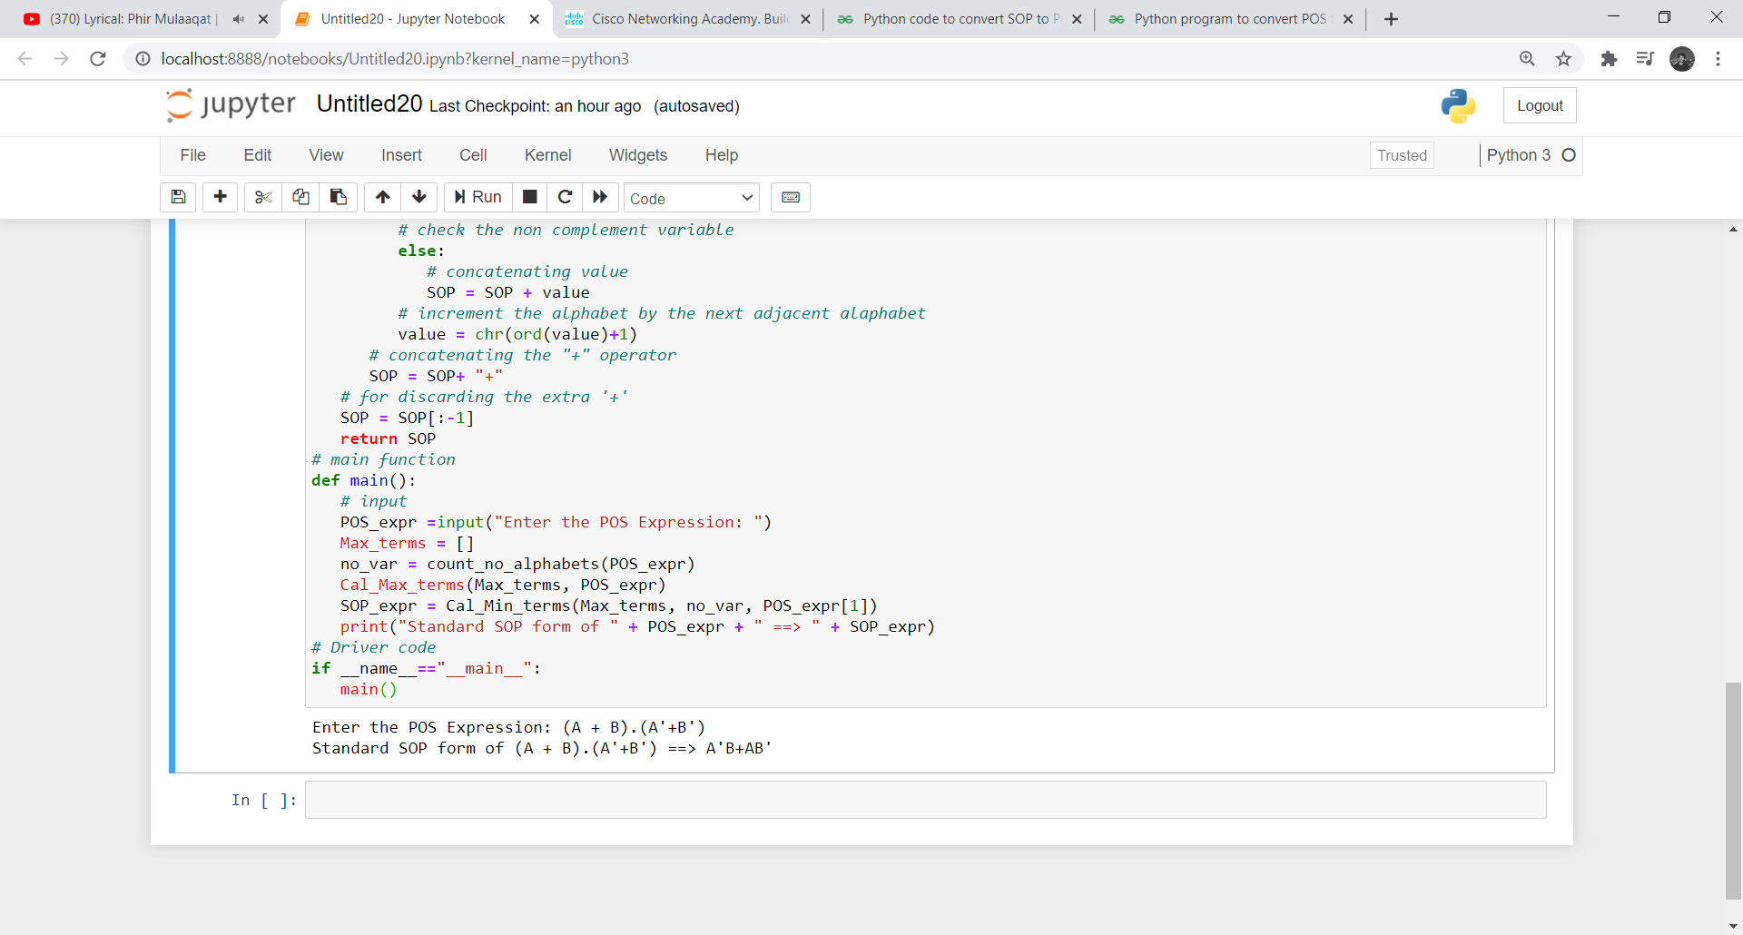
2.

Enter the POS Expression: (A+B+C).(A+B+C’).(A’+B+C).(A’+B’+C’)
Standard SOP form of (A+B+C).(A+B+C’).(A’+B+C).(A’+B’+C’) ==>A’BC’+A’BC+AB’C+ABC’

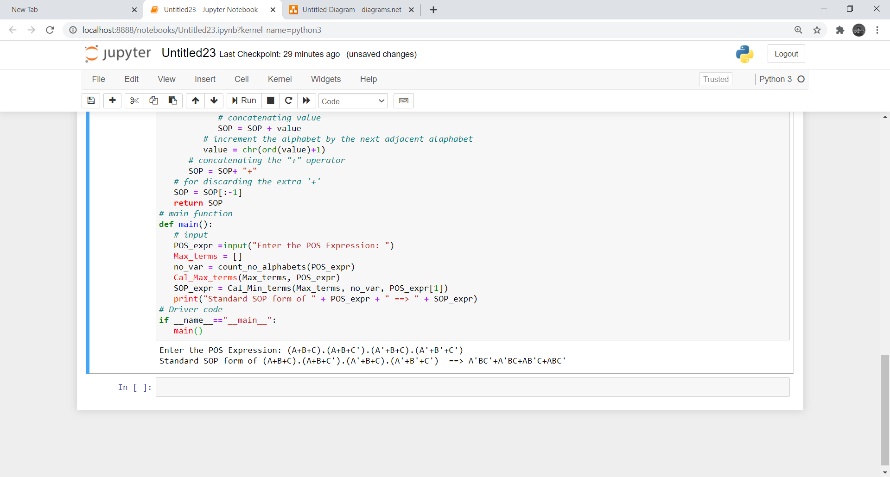

Canonical SOP to POS conversion

1.
Enter the SOP Expression: A’B’C+A’BC’+AB’C’+ABC’
Standard POS form of A’B’C+A’BC’+AB’C’+ABC’==> (A+B+C).(A+B’+C’).(A’+B+C’).(A’+B’+C’)
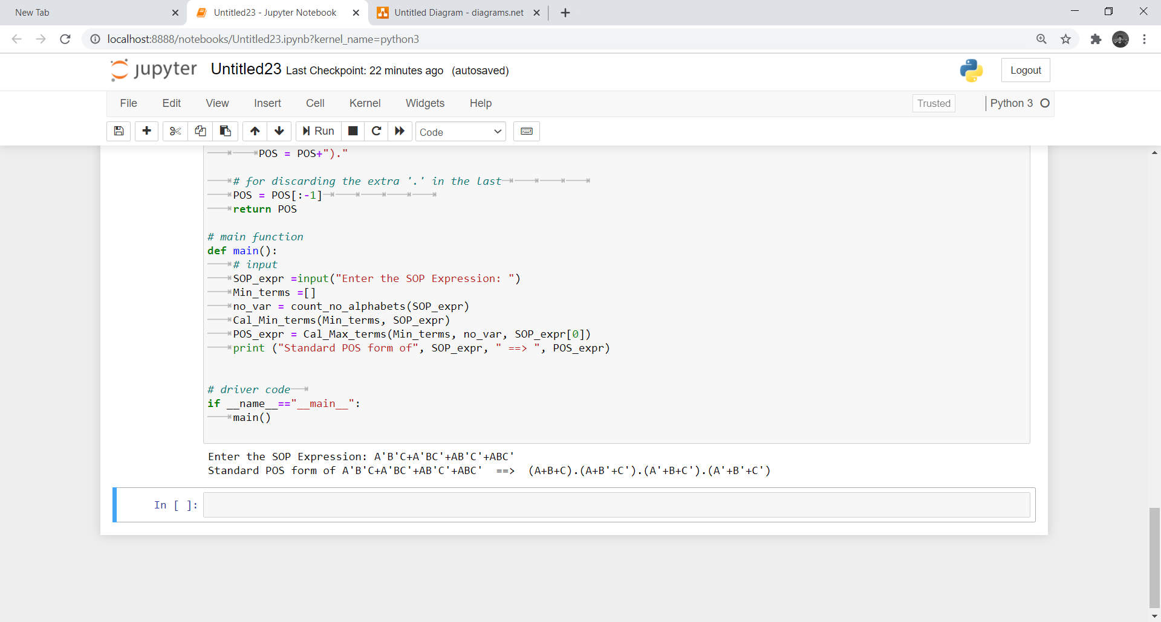
2.
Enter the SOP Expression: A’B+AB’
Standard POS form of A’B+AB’==> (A+B).(A’+B’)
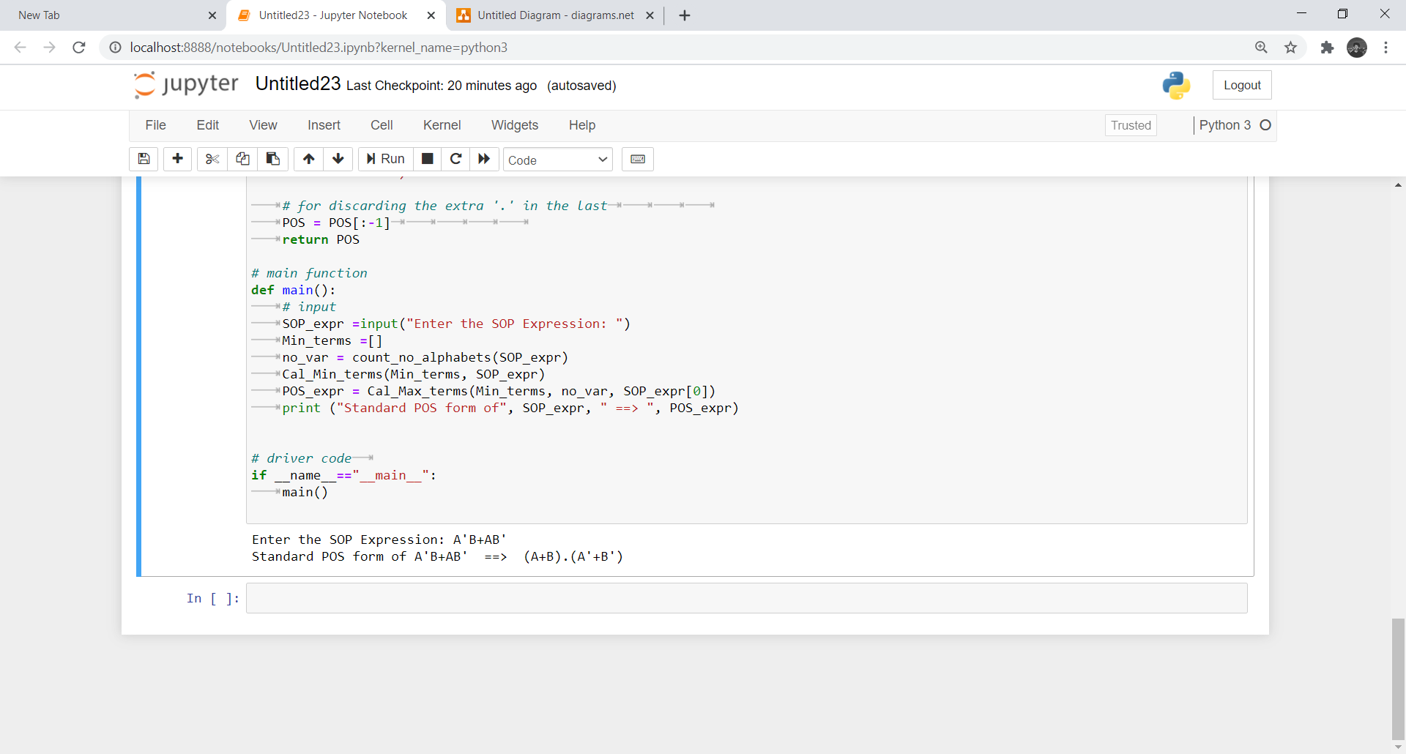

REFERENCES

Websites:

1. https://www.geeksforgeeks.org/python-code-to-convert-sop-to-pos/
2. https://www.geeksforgeeks.org/python-program-to-convert-pos-to-sop/
3. https://github.com/ritik-malik/K-Map-Minimization
4. https://www.javatpoint.com/conversion-between-canonical-forms-in-digital-electronics

