SIDDAGANGA INSTITUTE OF TECHNOLOGY, Tumakuru-3
(An Autonomous institution affiliated to Visvesvaraya Technological University- Belagavi, Approved by AICTE, Accredited by NAAC with ‘A’ Grade, Awarded Diamond College Rating by QS I-GAUGE & ISO 9001:2015 certified )


Theory of Computation Group Activity Report
ON
“Simulation of FA, PDA and TM using JFLAP AND AUTOMATION SIMULATOR”
In the partial fulfilment of the requirements for IV semester,
Bachelor of Engineering in Computer Science and Engineering

Submitted by
SAMEER JAWED 1SI20CS098
PUNEET AR 1SI20CS084
PARNAV 1SI20CS079

Under the guidance of
Dr.Srinivasa K
Assistant Professsor, Department of CSE

Department of Computer Science and Engineering
(Program Accredited by NBA)
Academic Year: 2021-22

INTRODUCTION:

The automaton simulation is done using an automaton simulator and JFLAP. The automaton simulator JFLAP allows us to draw and simulate a variety of theoretical machines, including:

• Deterministic finite automata

• Non-deterministic finite automata

• push-down automata

• Turing machines

An Automaton is an abstract computing device .A “device” need not even be a physical hardware. The study of abstract computing devices, or “machines” is called Automata Theory. A language is a collection of sentences of finite length all constructed from a finite alphabet of symbols. In this simulation, we design an abstract machine to simulate the working of a Deterministic finite automata ,Non-deterministic finite automata, Push down automata, Turing Machine.

About the project:
The automaton simulator is equipped with a GUI that is used to design the Deterministic finite automata , Non deterministic automata, Push down automata , Turing machine quickly and easily. The simulator has the following tools:

State tool-to draw states and designate starting & final state.
Transition tool– to draw transitions between states and designate symbols for which states the transitions apply
Label tool–to name the states present in the automata.
Simulation tool– to run the simulation and either accept or reject the language based on the input entered in the input field.
After designing the deterministic finite automata, Non- deterministic finite automata, Push down automata , Turing machine the simulation is run. During the simulation, input is given symbol by symbol and the transitions are seen for each input symbol and whether the given language is accepted or rejected

DETERMINISTIC FINITE AUTOMATA DFA):
A deterministic ﬁnite automaton (DFA) consists of:
1. A ﬁnite set of states (often denoted Q)
2. A ﬁnite set Σ of symbols (alphabet)
3. A transition function that takes as argument a state and a symbol and returns a state(often denoted δ)
4. A start state often denoted q0
5. A set of ﬁnal or accepting states(often denoted F)
Here q0 ∈ Q and F ⊆Q.
So a DFA is mathematically represented as a quintuple (Q,Σ,δ,q0, F).The transition function δ is a function in which
Q × Σ → Q
Q × Σ is the set of 2-tuples (q, a) with q ∈ Q and a ∈ Σ
.A DFA can be represented using:
• Transition table
• Transition diagram
The → indicates the start state:
The ∗ indicates the ﬁnal state(s)

Acceptance or Rejection in DFA:
A DFA accepts the given language if it reads the language and stops in the accepting state. The DFA rejects the given language if there is also a stop or dead state, in which case the DFA is not accepting the language or stopping at the final state after the given language is finished reading .
An automaton is considered a DFA only if:
•There is only 1 transition for a given symbol from any given state.
•Each possible input determines the resulting state ’q’ uniquely, unlike NFA where some inputs may allow a choice of resulting states.
•The automaton can change state only after reading an input.

Question 1:Draw the DFA to accept the language L={w:n_{a}(w)>=1, n_{b} (w)=2}.
Solution :Note that the string should have exactly two b’s and atleast one a. So, the minimum string that can except dfa may be:
•abb
•bab
•bba
The dfa is shown below:
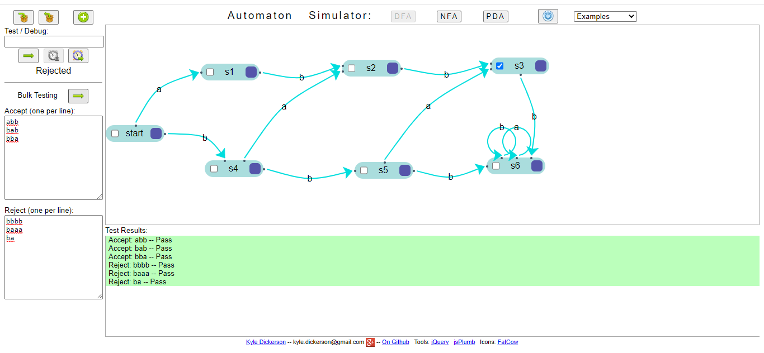

Question 2: Let us”Obtain a DFA to accept the language L={w:|w| mod 5!=0} ∑={a,b}”.
Solution: Here we have to take the length of string so it won’t divisible by 5.
The DFA is shown below:
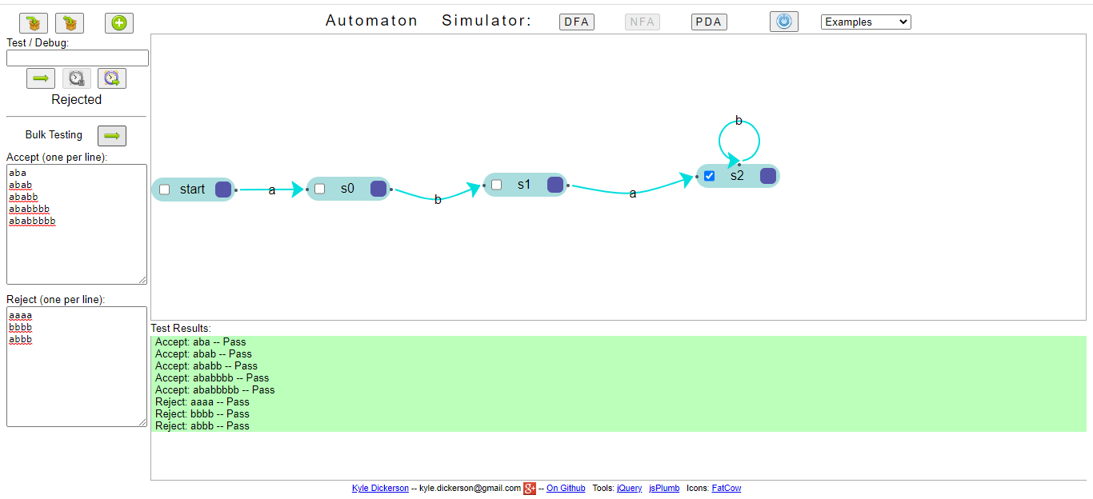

Nondeterministic finite automaton (N.F.A)

• In the automata theory, a nondeterministic finite automaton (NFA) or nondeterministic
finite state machine is a finite state machine where from each state and a given input
symbol the automaton may jump into several possible next states.

• This distinguishes it from the deterministic finite automaton (DFA), where the next
possible state is uniquely determined.

• Although the DFA and NFA have distinct definitions, a NFA can be translated to
equivalent DFA using power set construction, i.e., the constructed DFA and the NFA
recognize the same formal language. Both types of automata recognize only regular
languages

• A NFA is represented formally by a 5-tuple, (Q, Σ, , q0, F), consisting of
1. a finite set of states Q
2. a finite set of input symbols Σ
3. a transition relation : Q × Σ → P(Q).
4. an initial (or start) state q0

Question: Obtain the NFA to accept the following language: L={w|w € abab^{n} where n>=0}
Solution : The machine accept abab^{n} where n>=0 is shown below:

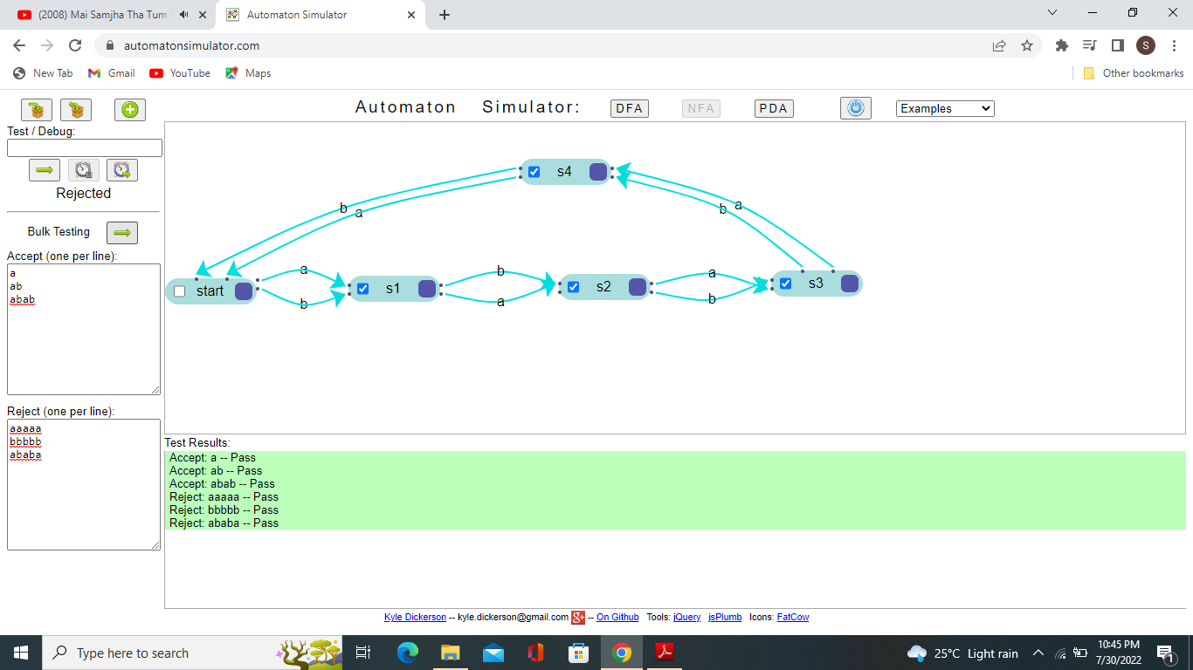

Pushdown automaton (PDA)

• In computer science, a pushdown automaton (PDA) is a type of automaton that uses a
stack for temporary data storage.

• The PDA is used in theories about what can be computed by machines. The PDA is more
capable than finite-state machines but less capable than Turing machines. Because its
input can be described with a formal grammar, it can be used in parser design. There are
two classes of PDAs:

• In deterministic PDAs, the machine has only one possible choice of action for all
situations. Their application is limited to deterministic context-free grammars.

• In nondeterministic PDAs, the automaton can have two or more possible choices of
action for some or all situations. The choices may or may not be mutually exclusive.

• When they are not, the automaton will create branches, each following one of the correct
choices. If more than one of the branches created during the execution of the automaton
complete successfully multiple outputs will be produced. This kind of PDAs can handle
all context-free grammars.

Question : Design the PDA to accept the language L(M)={wCw^{R} | w€(a+b)*}
Solution: The PDA of the following is shown below:

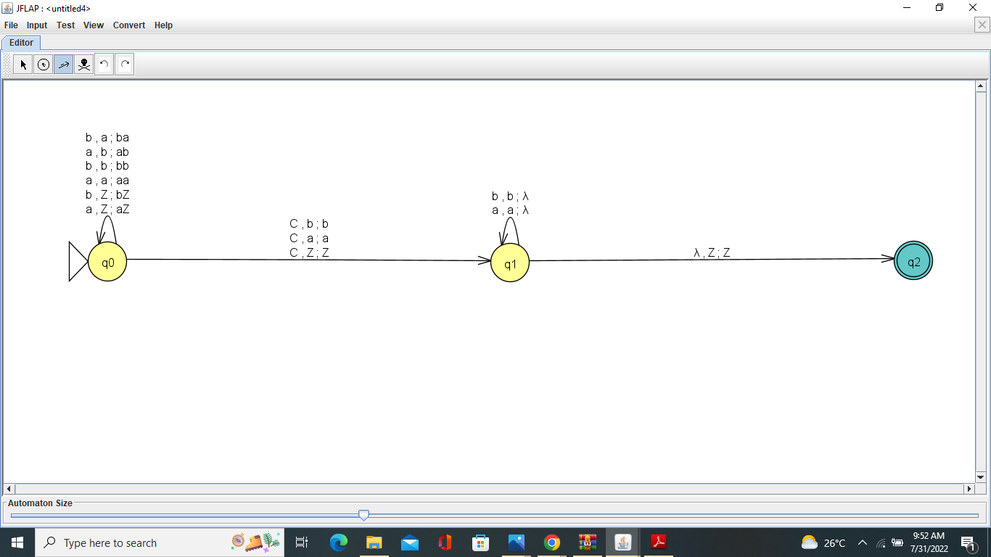

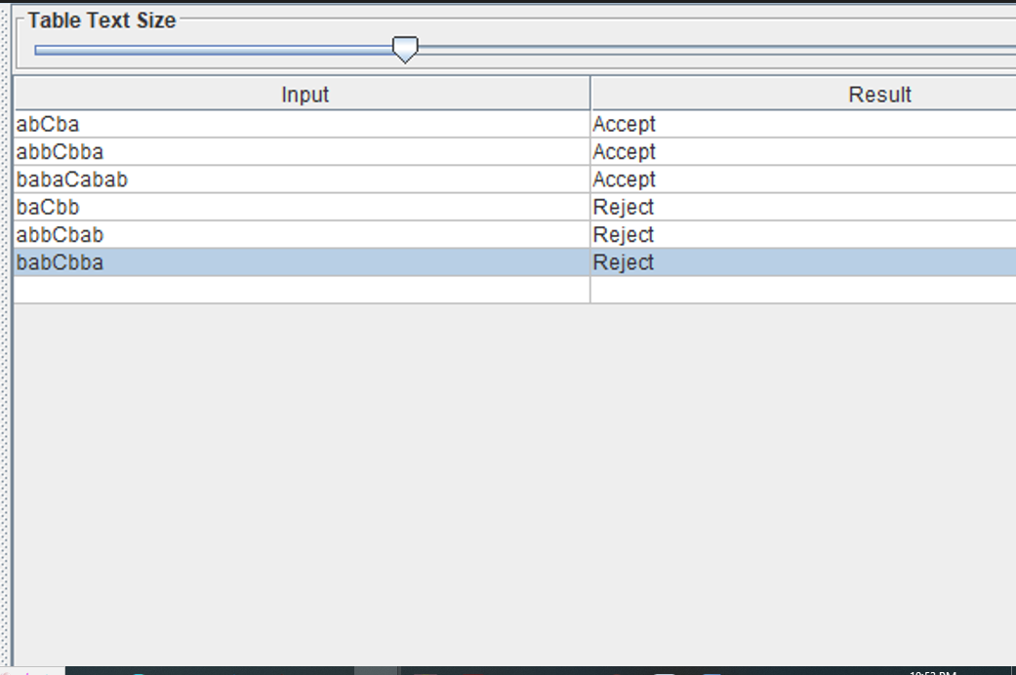

Question : Design the PDA to accept the language L(M)={a^{n}b^{n} n>=1}
Solution: The PDA of the following is shown below:
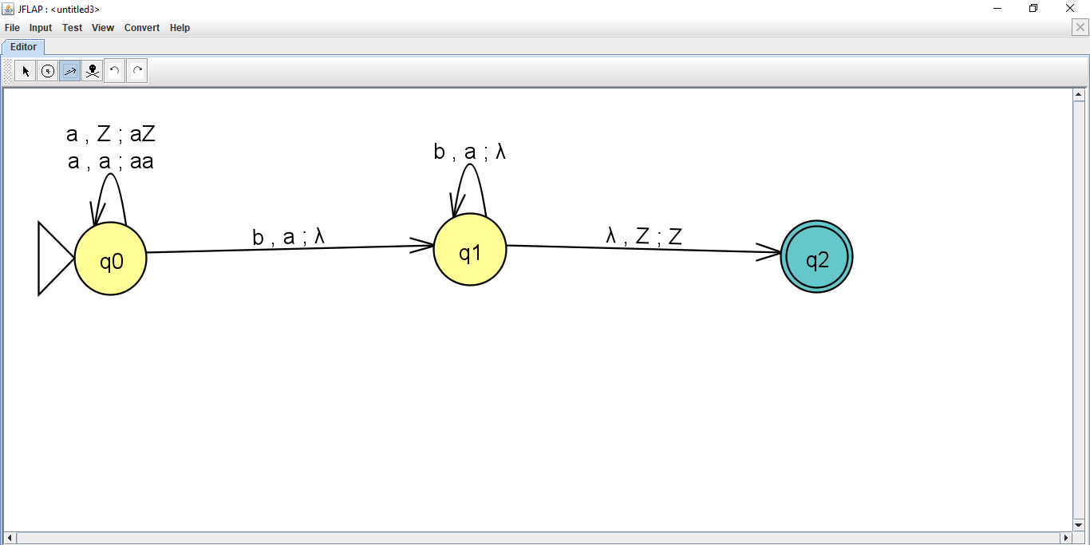

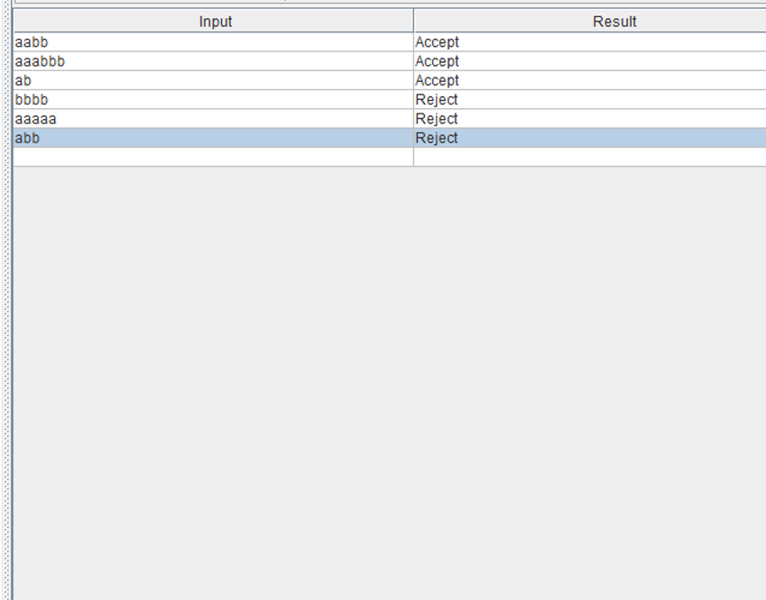

Question : Design a PDA to accept the language L(M)={w|n_{a} (w)=n_{b}(w)}
Solution: The PDA of the following is shown below:

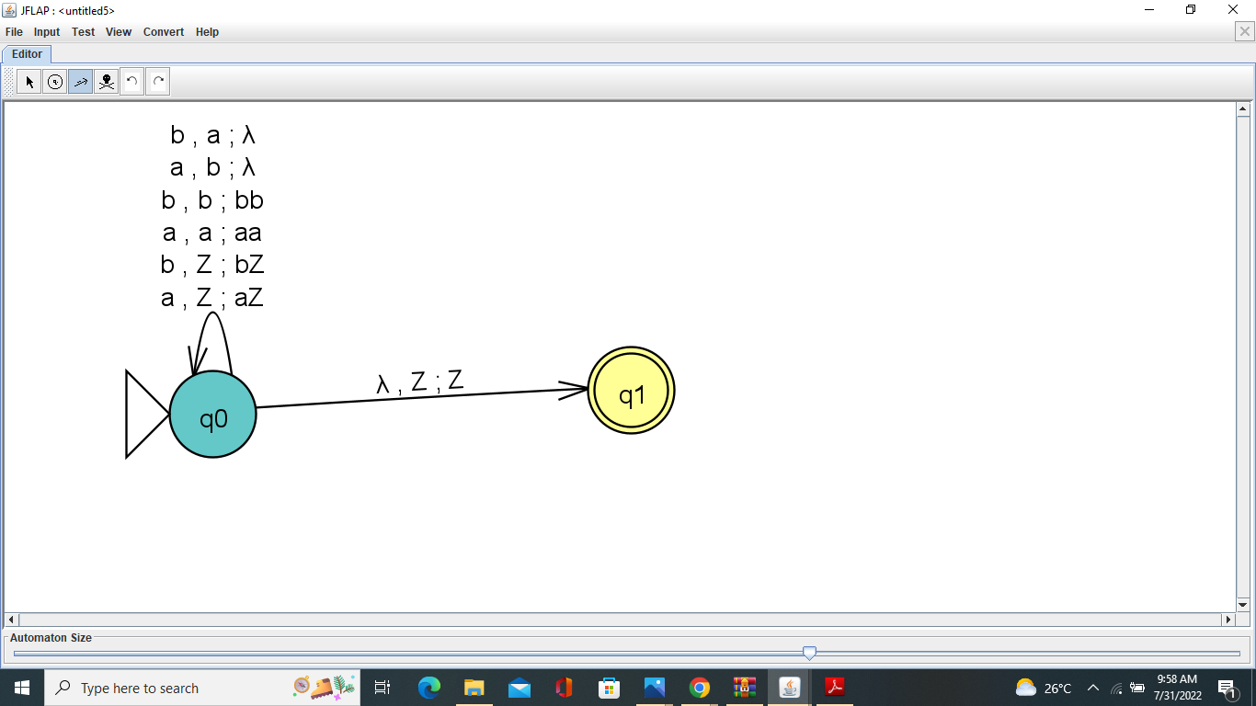

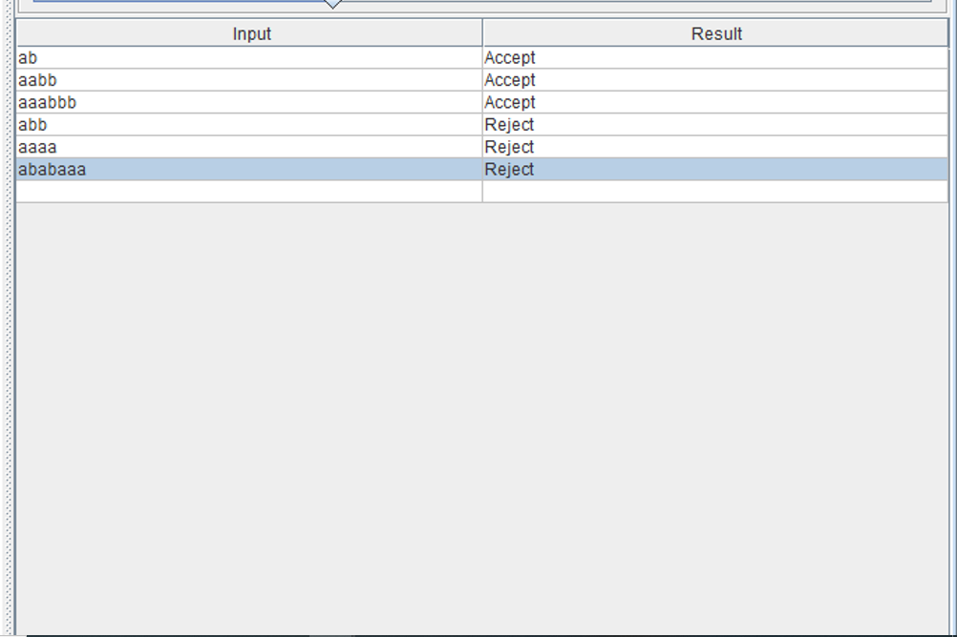

Turing Machine

A turing machine consists of a tape of infinite length on which read and writes operation can be performed. The tape consists of infinite cells on which each cell either contains input symbol or a special symbol called blank. It also consists of a head pointer which points to cell currently being read and it can move in both directions.
A TM is expressed as a 7-tuple (Q, T, B, ∑, δ, q0, F) where:
- Q is a finite set of states
- T is the tape alphabet (symbols which can be written on Tape)
- B is blank symbol (every cell is filled with B except input alphabet initially)
- ∑ is the input alphabet (symbols which are part of input alphabet)
- δ is a transition function which maps Q × T → Q × T × {L,R}. Depending on its present state and present tape alphabet (pointed by head pointer), it will move to new state, change the tape symbol (may or may not) and move head pointer to either left or right.
- q0 is the initial state
- F is the set of final states. If any state of F is reached, input string is accepted.

Question: Design a turing machine for L={0^n1^n|n>=1}
Solution: The TM of the following is shown below:
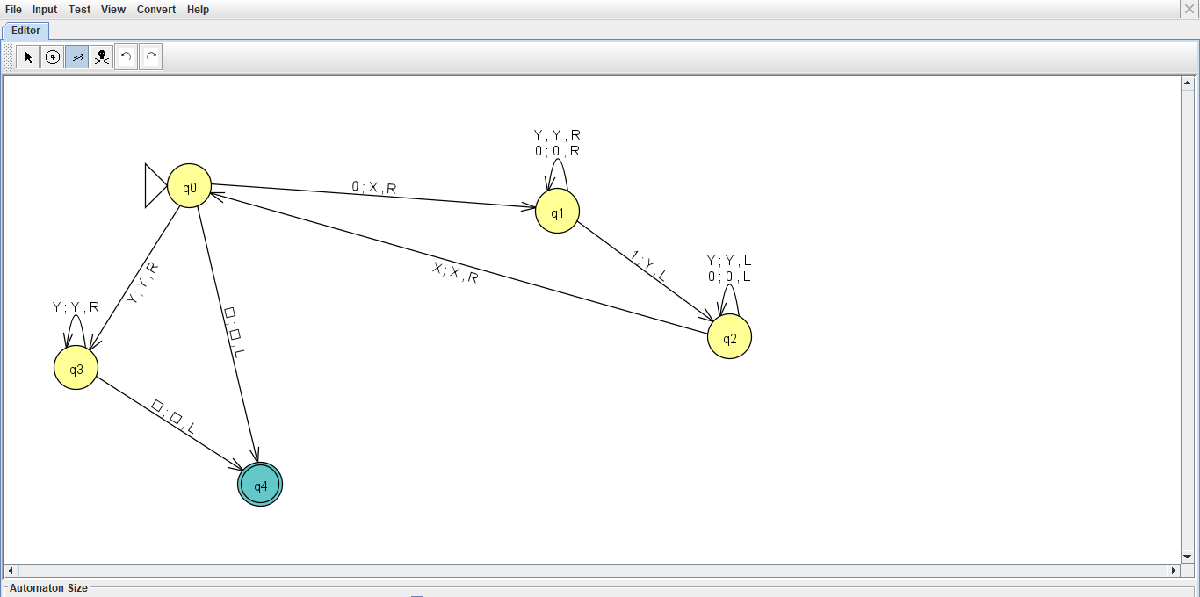

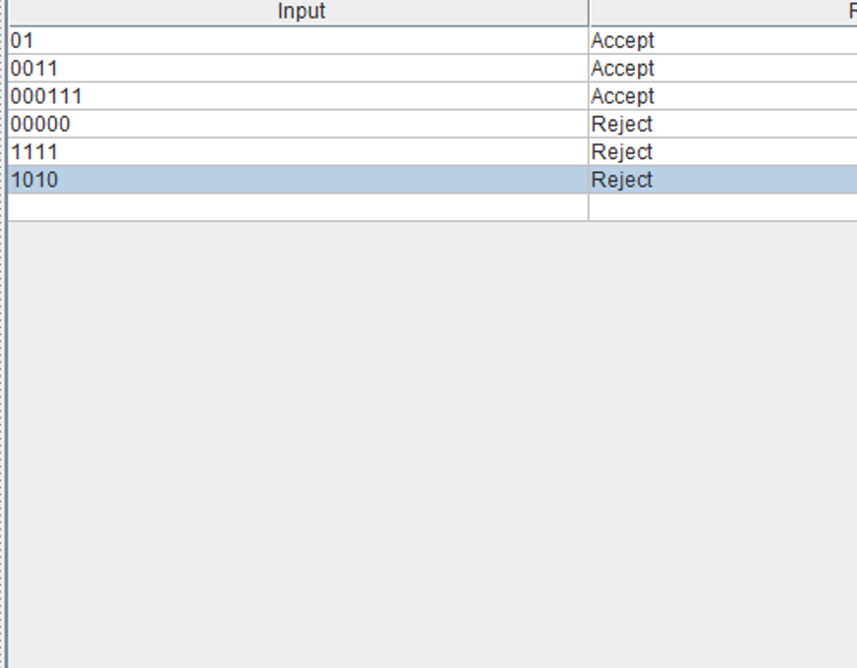

Question: Design a turing machine for L={ ww^{R} | w€(a+b)*}
Solution: The TM of the following is shown below:
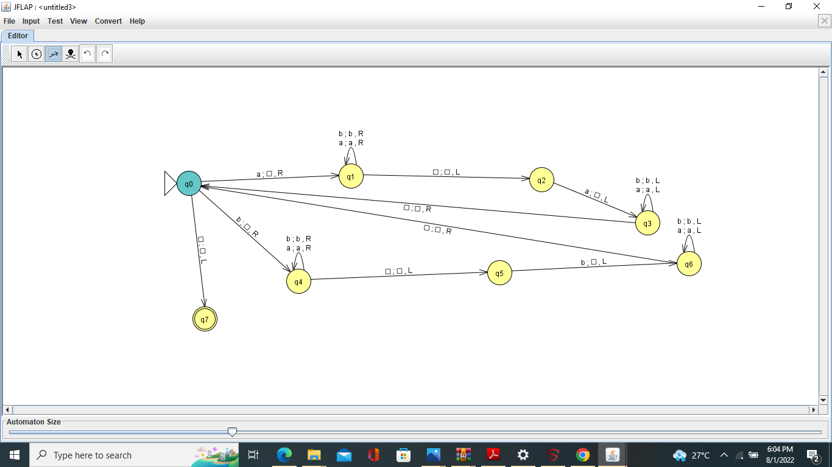

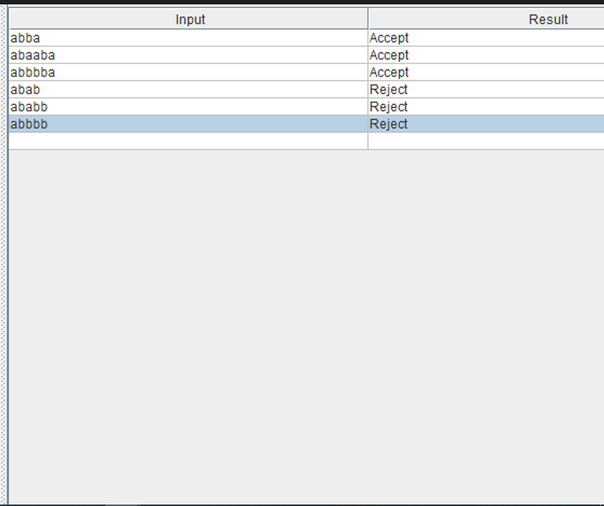

Question: Design a turing machine for L={0^n1^n2^|n>=1}
Solution: The TM of the following is shown below:
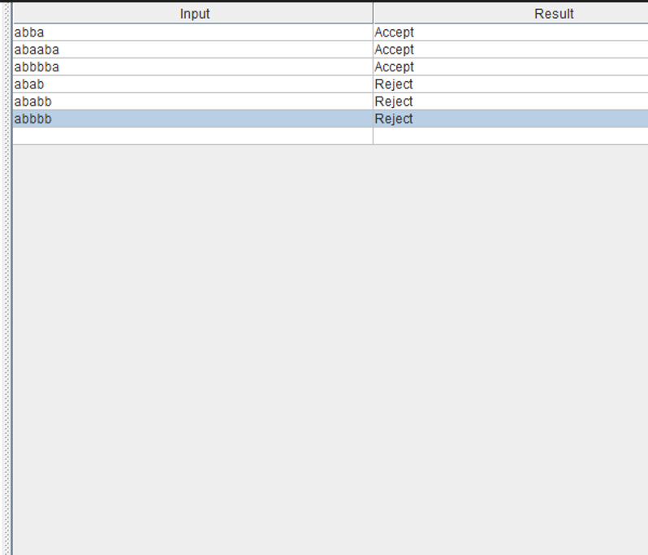

REFERENCES
1.John E.Hopcroft
2. https://www.geeksforgeeks.org

