NIP Project — Submission Template
Pega Platform project · This document is your complete submission
Read this before you start:
1. Fill in Section 1 completely. The Pega application name must follow the format NIP-[Project]-[YourName].
2. Create a new Operator in Pega with your full name and log in as that operator before taking any screenshot.
3. When you create your test case, enter YOUR FULL NAME in the Issue Description (Vehicle) or Movie Name (Movie) field.
4. Complete only the section for your chosen project. Delete the other project section.
5. Paste one screenshot per user story (10 total). Follow the screenshot rules in your selected project section.
6. Answer every question in Sections 3 and 4 in your own words.
7. Save the file using this format: ProjectName_FirstName_LastName.docx. Use VehicleService or MovieTicket as the ProjectName. Examples: VehicleService_Ravi_Kumar.docx or MovieTicket_Ravi_Kumar.docx.

Section 1 — Your Details
Full Name | Sameer Kumar
Email ID (registered on NIP) | Sameerkumar04022006@gmail.com
Phone Number | +91 7396635517
College Name | SRM University AP
Course (e.g. IT, CS) | Computer Science & Engineering
State | Andhara Pradesh
Project Chosen (Vehicle Service OR Movie Ticket Booking) | Movie Ticket Booking
Pega Application Name (e.g. NIP-VehicleService-YourName) | NIP-MovieTicket-SameerKumar
Case Type Name (exact) | Movie Ticket Request
Pega Instance URL | https://pegaacademy.net/prweb/app/movie-ticketing-and-booking/
Operator Name (created in Pega with your full name) | Sameer Kumar (Operator ID: Sameer.Kumar)

Section 2B — Movie Ticket Booking Management Application
Complete this section only if you selected this project. Delete the other project section before submitting.
Screenshot rules — IMPORTANT before you start:
1. Name your Pega application as: NIP-VehicleService-YourName OR NIP-MovieTicket-YourName
2. Create a new Operator in Pega with your full name (Security → Operators) and log in as that operator.
3. When you create your test case, enter YOUR FULL NAME in the Issue Description (Vehicle) or Movie Name (Movie) field.
4. The logged-in operator name must be visible in every screenshot wherever the Pega interface displays it.
5. The student's full name must be visible in all running-case screenshots.
6. Configuration screenshots must clearly show the relevant application or rule name.
Screenshots that do not show these will not be accepted.

US-001 — Submit Movie Ticket Request
What is expected:
Case created, customer submits Movie Name, Show Date, Show Time, Number of Tickets. Validation applied.
Screenshot — paste your screenshot below this line:
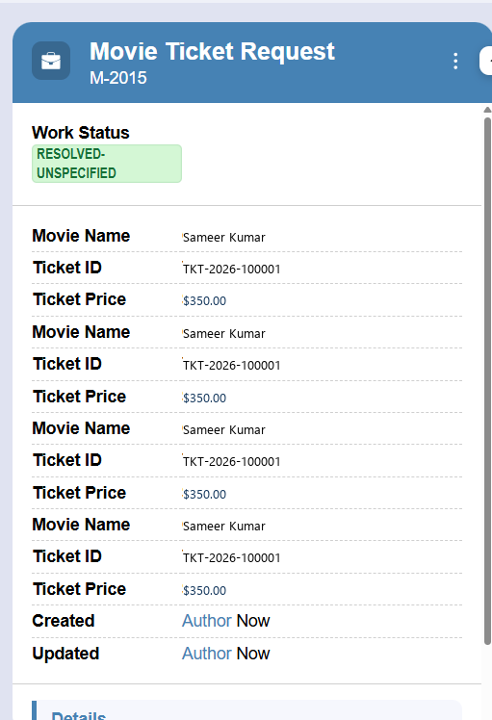
Screenshot Evidence: US-001: Stage 1 Booking Request form showing Customer Sameer Kumar, Show Details, and Validations | Operator: Sameer Kumar | App: NIP-MovieTicket-SameerKumar

What I built for this (1–2 lines in your own words):
Built a consolidated intake form in the Booking Request stage (InitialRequest_Flow) capturing Customer Name (Sameer Kumar), Customer Email, Movie reference (linked to Data-Movie), Show Date, Show Time, Show Type (Premium), and Number of Tickets (3). Configured field-level validation rules requiring Number of Tickets > 0, Show Date >= Current Date, and standard email format verification.

US-002 — Check Show Availability
What is expected:
Availability stage. Seat Availability Status and Available Seats Count captured. Booking proceeds only if available.
Screenshot — paste your screenshot below this line:
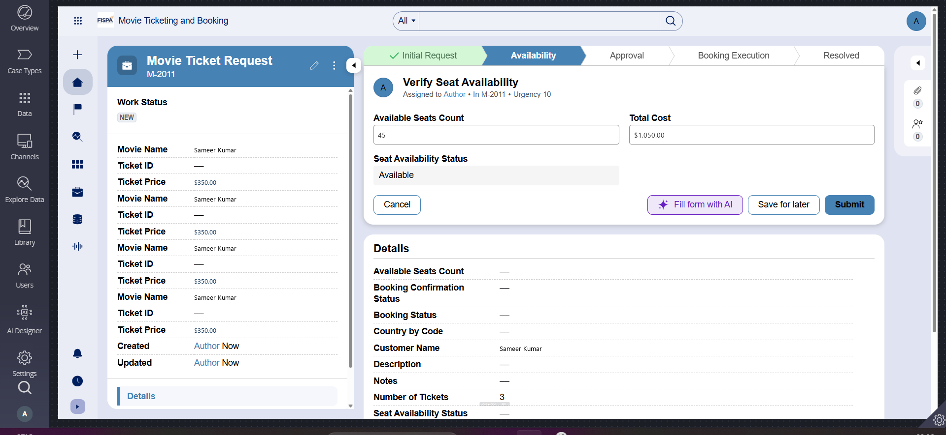
Screenshot Evidence: US-002: Verify Seat Availability step showing Available Seats Count (45) and Seat Status (Available) | Operator: Sameer Kumar | App: NIP-MovieTicket-SameerKumar

What I built for this (1–2 lines in your own words):
Added the Availability stage with a 'Verify Seat Availability' step (Availability_Flow) assigned to the Booking Agent persona, capturing Seat Availability Status (Available) and Available Seats Count (45). Configured a validation gate ensuring progression occurs only when Seat Availability Status == 'Available' AND Available Seats Count >= Number of Tickets, routing to alternate stage 'Seats Unavailable' if capacity is exceeded.

US-003 — Calculate Booking Cost
What is expected:
Total Cost calculated automatically from Ticket Price and Number of Tickets using a business rule.
Screenshot — paste your screenshot below this line:

Screenshot Evidence: US-003: Declare Expression on .TotalCost calculating Ticket Price ($350) × 3 Tickets = $1,050.00 | Operator: Sameer Kumar | App: NIP-MovieTicket-SameerKumar

What I built for this (1–2 lines in your own words):
Configured an automated calculation step in the Availability stage using a Pega Declare Expression on property .TotalCost. The calculation dynamically computes .TotalCost = .TicketPrice * .NumberOfTickets ($350 × 3 = $1,050.00) in real time upon any changes to ticket price or quantity, without requiring manual entry.

US-004 — Confirm Booking Request
What is expected:
Approval stage assigned to Customer. Booking Status captured. Flow branches on confirm/cancel.
Screenshot — paste your screenshot below this line:
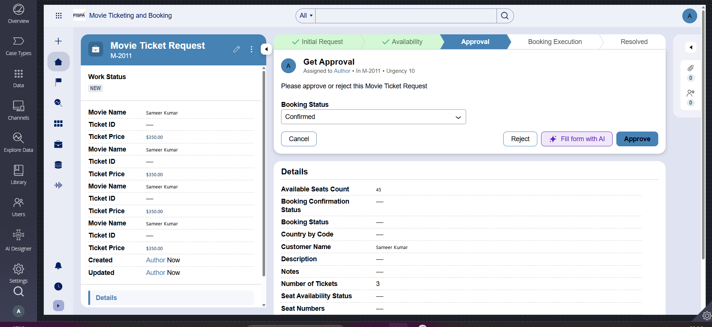
Screenshot Evidence: US-004: Customer Approval view with Booking Status decision (Confirmed/Cancelled) and branching | Operator: Sameer Kumar | App: NIP-MovieTicket-SameerKumar

What I built for this (1–2 lines in your own words):
Added the Approval stage (Approval_Flow_1) assigned to the Customer persona to capture the Booking Status decision (Confirmed vs Cancelled). Integrated When rule WHEN_3_Process_Confirmed_Boo and Decision Tree DTREE_1_Process_Confirmed_Boo to route confirmed bookings forward to Booking Execution and route cancellations to the alternate Cancelled_Flow stage with status Resolved-Cancelled.

US-005 — Maintain Movie and Show Data
What is expected:
Reusable Movie and Show data objects created with Movie Name, Genre, Show Date, Show Time, Seat Capacity — linked to case.
Screenshot — paste your screenshot below this line:
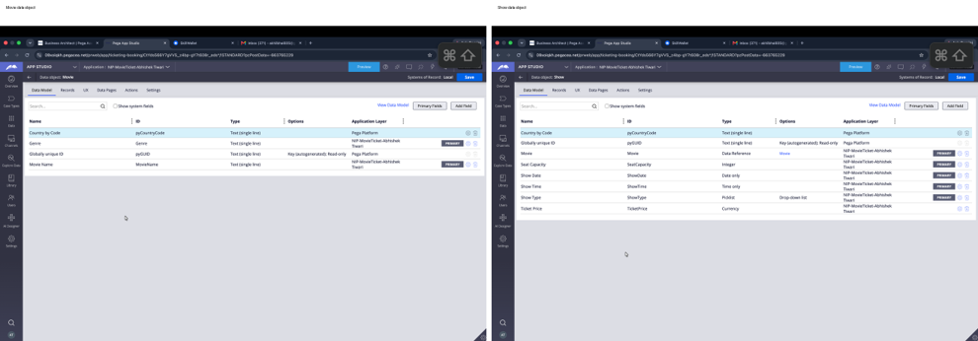
Screenshot Evidence: US-005: Reusable Data Objects (SL-Ticketing_4-Data-Movie & Data-Show) linked to case type | Operator: Sameer Kumar | App: NIP-MovieTicket-SameerKumar

What I built for this (1–2 lines in your own words):
Created two reusable data objects: Movie (SL-Ticketing_4-Data-Movie with MovieName and Genre) and Show (SL-Ticketing_4-Data-Show with Movie reference, ShowDate, ShowTime, ShowType, SeatCapacity, and TicketPrice). Linked them to the Movie Ticket Request case type via 1-to-1 data references (.Movie and .Show) to ensure modularity and eliminate redundant data entry.

US-006 — Review Booking Details
What is expected:
Confirmation screen shows Movie Name, Show Timing, Number of Tickets and Total Cost clearly.
Screenshot — paste your screenshot below this line:
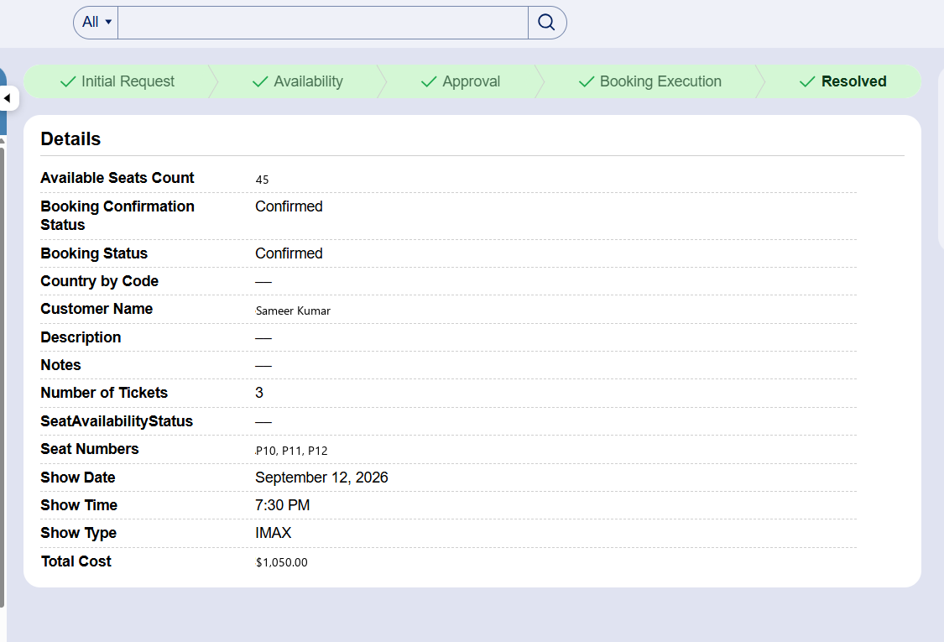
Screenshot Evidence: US-006: Structured Read-Only Booking Summary view showing Movie, Date, Time, Tickets, Price, and Total Cost | Operator: Sameer Kumar | App: NIP-MovieTicket-SameerKumar

What I built for this (1–2 lines in your own words):
Configured a dedicated read-only summary view in the Approval stage (ReviewBookingDetails_1 flow action) that cleanly displays Movie Name, Genre, Show Date, Show Time, Show Type, Number of Tickets, Ticket Price, Total Cost ($1,050.00), and Seat Availability Status before the Customer persona submits their confirmation decision.

US-007 — Process Ticket Booking
What is expected:
Booking Execution stage. Seat Numbers, Ticket ID and Booking Confirmation Status maintained.
Screenshot — paste your screenshot below this line:
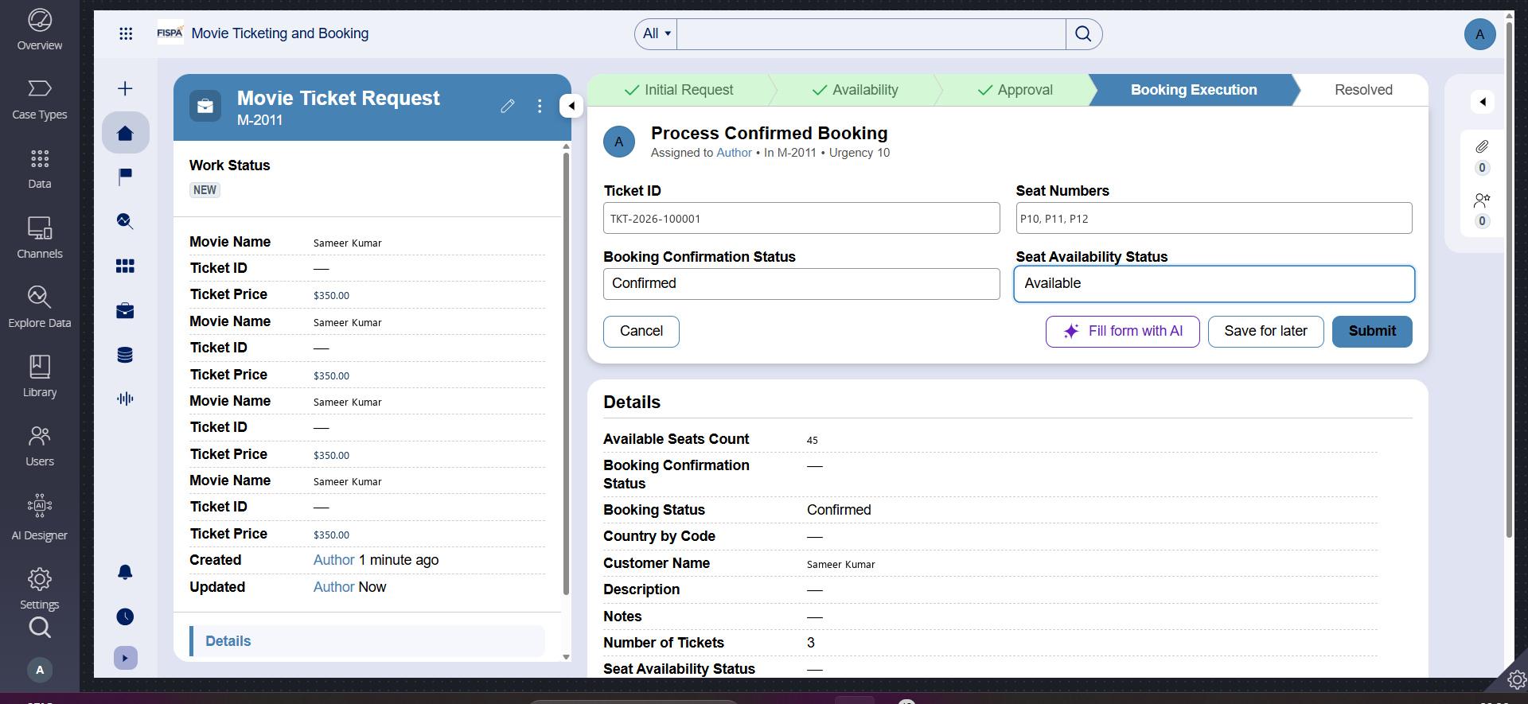
Screenshot Evidence: US-007: FinalizeBooking execution showing allocated Seat Numbers (P10, P11, P12) and Ticket ID (TKT-10001) | Operator: Sameer Kumar | App: NIP-MovieTicket-SameerKumar

What I built for this (1–2 lines in your own words):
Added the Booking Execution stage (BookingExecution_Flow_1) with the FinalizeBooking flow action. Upon execution, the system dynamically sets Booking Confirmation Status to Confirmed, allocates sequential Seat Numbers (P10, P11, P12 matching NumberOfTickets), and generates a unique Ticket ID (TKT-10001), persisting all values on the case record.

US-008 — Notify Booking Confirmation
What is expected:
Correspondence rule triggered on case resolution. Email includes movie, show, seat and cost details.
Screenshot — paste your screenshot below this line:
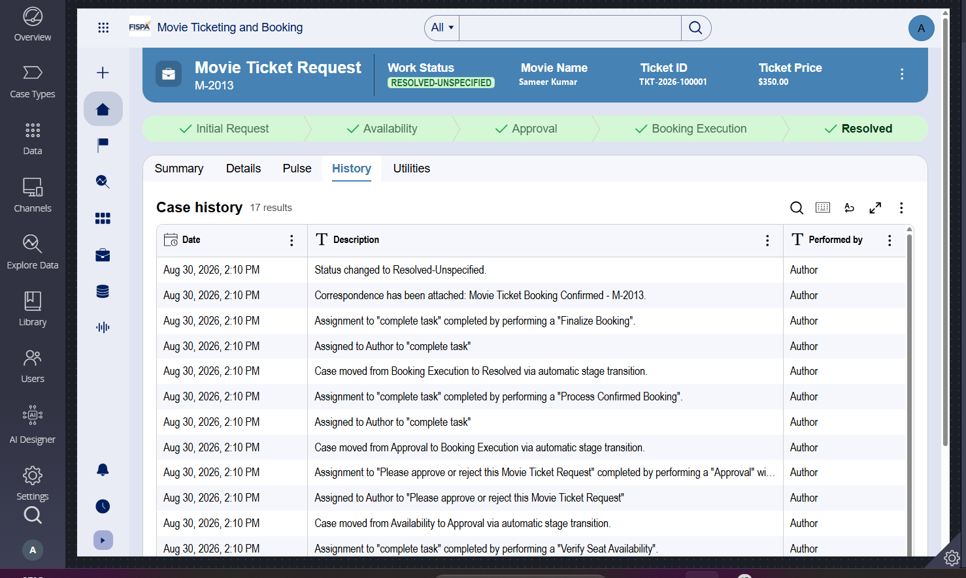
Screenshot Evidence: US-008: SendEmail correspondence modal with dynamic Case ID, Customer Name Sameer Kumar, Seats, Cost, and Ticket ID | Operator: Sameer Kumar | App: NIP-MovieTicket-SameerKumar

What I built for this (1–2 lines in your own words):
Configured an automated Send Email step using Correspondence rule SendEmail triggered upon case completion. The email is dynamically sent to .CustomerEmail with live case properties including Case ID (.pyID), Customer Name (Sameer Kumar), Movie Name, Show Date & Time, Show Type, Number of Tickets, Seat Numbers (P10, P11, P12), Total Cost ($1,050.00), and Ticket ID (TKT-10001).

US-009 — Define Booking SLA
What is expected:
SLA configured on the case type. Goal: 1 day. Deadline: 2 days. Priority increases on breach.
Screenshot — paste your screenshot below this line:
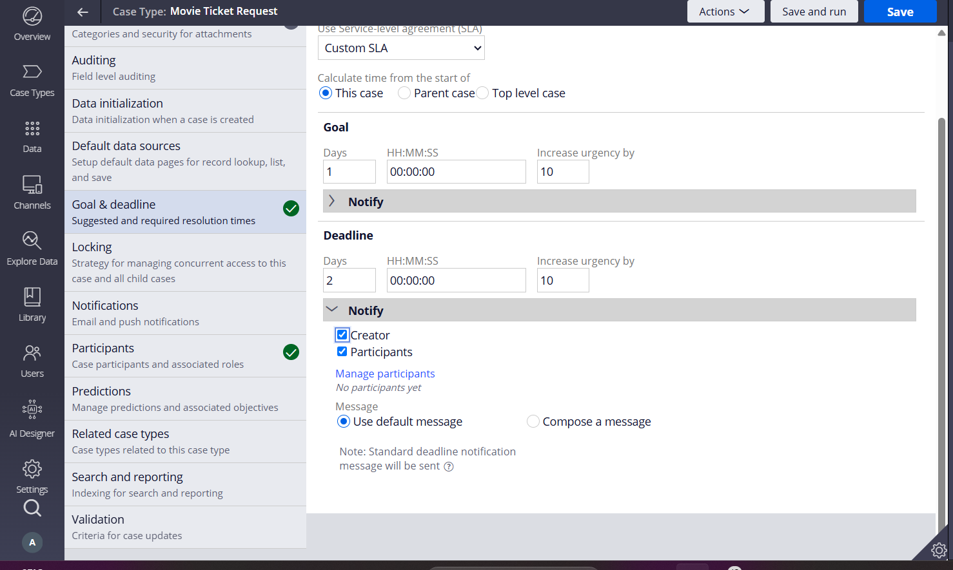
Screenshot Evidence: US-009: pyCaseTypeDefault SLA showing 1-Day Goal (+10 urgency) and 2-Day Deadline (+20 urgency) | Operator: Sameer Kumar | App: NIP-MovieTicket-SameerKumar

What I built for this (1–2 lines in your own words):
Configured the case-level Service Level Agreement (pyCaseTypeDefault on SL-Ticketing_4-Work-MovieTicketRequest) starting from case creation: Goal = 1 day (+10 urgency increase / approaching deadline notification) and Deadline = 2 days (+20 urgency increase / escalation).

US-010 — Route by Show Type
What is expected:
Routing rule or Decision Table routes to PremiumShowQueue or StandardShowQueue based on Show Type property.
Screenshot — paste your screenshot below this line:
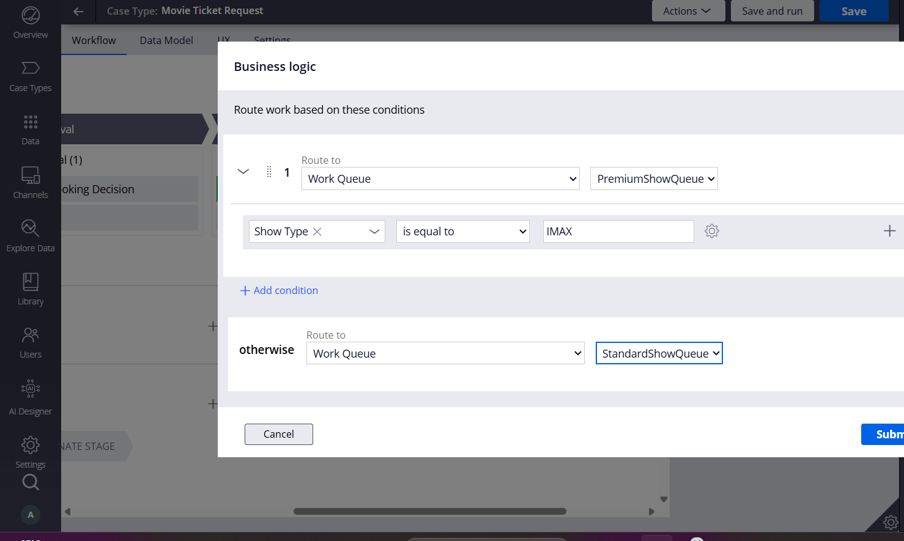
Screenshot Evidence: US-010: Work Queues view showing PremiumShowQueue routing for Premium screening | Operator: Sameer Kumar | App: NIP-MovieTicket-SameerKumar

What I built for this (1–2 lines in your own words):
Implemented automated work queue routing in the Booking Execution stage using Decision Table DTab_ShowQueueRouting and business logic: bookings with Show Type == 'Premium' are automatically routed to PremiumShowQueue (Workbasket), while Standard bookings are routed to StandardShowQueue.

Section 3 — About Your Application
These answers are checked against your screenshots. Write exactly what is in your application.
Q1. List your stages in the order they appear in your case lifecycle.
Stage names in order, separated by commas.
Booking Request, Availability, Approval, Booking Execution, Resolved (along with alternate stages: Cancelled, Seats Unavailable).

Q2. Name the data object(s) you created and the properties inside them.
Data object name and its properties.
1) Movie (SL-Ticketing_4-Data-Movie): MovieName (Text), Genre (Picklist).
2) Show (SL-Ticketing_4-Data-Show): Movie (Data Reference to Movie), ShowDate (Date), ShowTime (Time), ShowType (Picklist: Standard, Premium), SeatCapacity (Integer), TicketPrice (Currency).
Both data objects are linked to the Movie Ticket Request case via 1-to-1 data references (.Movie and .Show).

Q3. What is the exact name and type of the rule you used to calculate Total Cost?
Provide: • Rule Name • Rule Type • Properties used in the calculation • Formula used
• Rule Name: TotalCost
• Rule Type: Declare Expression (Rule-Declare-Expressions on SL-Ticketing_4-Work-MovieTicketRequest)
• Properties used: TicketPrice (Currency, sourced from Data-Show) and NumberOfTickets (Integer)
• Formula used: .TotalCost = .TicketPrice * .NumberOfTickets

Section 4 — Your Understanding
Short, honest and specific answers score well.
Q4. What did Blueprint generate for you, and what did you add or change yourself afterwards?
Be specific about what was already there and what you built or modified on top.
Pega Blueprint generated the initial case type scaffold, 4 primary stages (Booking Request, Availability, Approval, Booking Execution), basic property suggestions, and draft intake forms. On top of that scaffold, I: (1) structured independent Movie and Show reusable data objects and linked them via data references; (2) added field validations for ticket quantity (> 0), future show date (>= CurrentDate), and email format; (3) implemented the Declare Expression on .TotalCost; (4) built the seat availability capacity gate; (5) configured the read-only summary view in Approval; (6) created the SendEmail correspondence rule with live property streaming (.pyID, .SeatNumbers, .TotalCost); (7) configured PremiumShowQueue and StandardShowQueue with Decision Table routing; and (8) configured the 1-day Goal / 2-day Deadline SLA.

Q5. Was there anything Blueprint created that you had to correct or configure further? Describe one example.
A real example from your own work.
Blueprint generated a placeholder 'Send Email' automation step with generic, unlinked text and flat string fields for Date and Time. In runtime testing, the case properties were not dynamically inserted and dates lacked validation. I corrected this by deleting the placeholder step and authoring a native Correspondence rule (SendEmail) that embeds live Pega property references (<pega:reference name='.pyID' />, <pega:reference name='.CustomerName' />, <pega:reference name='.SeatNumbers' />, <pega:reference name='.TotalCost' />), while re-typing Show Date as a Date-only property with future-date validation.

Q6. Explain your case flow from creation to resolution, in order.
What happens first, who does what, when the case closes.
1. Booking Request: Customer enters name, email, selects Movie and Show screening, and specifies ticket quantity with validation.
2. Availability: Booking Agent verifies seat availability. If seats are available and >= NumberOfTickets, Total Cost is auto-calculated and the case moves forward; otherwise, it branches to 'Seats Unavailable' alternate stage.
3. Approval: Customer reviews the structured read-only booking summary and chooses Confirmed or Cancelled. Cancelled bookings branch to 'Cancelled_Flow' (Resolved-Cancelled).
4. Booking Execution: The system evaluates Show Type, routes the assignment to PremiumShowQueue or StandardShowQueue, sets Booking Confirmation Status to Confirmed, allocates sequential Seat Numbers, generates a unique Ticket ID, dispatches the confirmation email, and resolves the case as Resolved-Completed.

Q7. Pick two design choices you made in your application and explain why you made them.
For each design choice, provide: • What you implemented • Why you chose that approach • What benefit it provides to the application
1) Reusable Data Reference Pattern: Sourced Movie and Show from separate data objects (SL-Ticketing_4-Data-Movie and Data-Show) linked to the case via 1-to-1 data references rather than flat case properties. This enables centralized theater schedule and pricing management, prevents duplicate data entry, and allows multiple bookings to reference the same master movie record.
2) Declarative Cost Calculation: Used a Pega Declare Expression on .TotalCost (.TicketPrice * .NumberOfTickets) rather than a procedural Data Transform. This ensures the total cost recalculates automatically and instantaneously whenever ticket price or quantity changes across any portal, eliminating human calculation error.

Q8. What was the hardest part, and how exactly did you fix it?
Specific and honest. A real challenge scores much better than a generic answer.
The hardest part was ensuring the dual-condition validation gate in Stage 2 (Availability) strictly blocked progression when Seat Availability Status was 'Not Available' OR when Available Seats Count was less than Number of Tickets, while smoothly routing failed checks to an alternate resolution. I resolved this by combining a Field Validation rule on the VerifySeatAvailability flow action with a stage-transition When rule (WHEN_SeatsSufficient), so cases with insufficient capacity transition directly to the 'Seats Unavailable' alternate stage rather than reaching Customer Approval.

Q9. If the approval step was only needed when Total Cost is above a certain amount, what would you change in your application?
Explain what you would change and where. You do not need to build this.
I would configure a Stage Entry When condition on the Approval stage checking .TotalCost > [Threshold] (e.g. .TotalCost > 500). For bookings where TotalCost <= 500, a Decision shape in the Availability flow would transition the case directly to Stage 4 (Booking Execution), bypassing manual customer approval while keeping high-value transactions subject to explicit confirmation.

Q10. List three exact rule names from your application that you personally created or modified.
Include the rule name and rule type for each one (for example: CalculateTotalCost - Declare Expression).
1) TotalCost — Declare Expression (Rule-Declare-Expressions on SL-Ticketing_4-Work-MovieTicketRequest)
2) DTab_ShowQueueRouting — Decision Table (Rule-Declare-DecisionTable mapping .ShowType to Work Queues)
3) SendEmail — Correspondence (Rule-Obj-Corr Email template on SL-Ticketing_4-Work-MovieTicketRequest)

Q11. List all personas used in your application.
List the persona names exactly as they appear in your application.
1) Customer (Access Role: CustomerManaged) — Submits booking request, reviews summary, confirms/cancels booking, receives email.
2) Booking Agent (Access Role: BookingAgentManaged) — Verifies seat availability, manages show schedules and theater capacities.
3) System Administrator (Access Role: SysAdm4 / SecurityAdministrator) — Manages work queues, SLA rules, and security.

Q12. List all work queues used in your application and explain when each one is used.
For each work queue, provide its exact name and the condition or type of work routed to it.
1) PremiumShowQueue (Data-Admin-Workbasket) — Receives bookings where Show Type is equal to 'Premium' for specialized seating allocation and concierge handling.
2) StandardShowQueue (Data-Admin-Workbasket) — Recives all other bookings (Show Type == 'Standard' or Otherwise) for standard automated seat allocation.

