**A**

**MINI PROJECT REPORT**

**on**

**STOCK PRICE PREDICTION USING DECISION TREE**

## Submitted to the Faculty of Engineering and Technology

**B. Tech - VI Semester**

By

**MOHAMMED SAMEER**

**B19CS058**

Under the Guidance of

**Dr. C. SRINIVAS**

**Associate Professor**



**Department of Computer Science & Engineering**

## Kakatiya Institute of Technology & Science

**(An Autonomous Institute under Kakatiya University) Warangal (Telangana State)**

**2021-22**



# C E R T I F I C A T E

This is to certify that **MOHAMMED SAMEER** bearing Roll No.: **B19CS058** of the VI Semester B.Tech. Computer Science and Engineering has satisfactorily completed the Mini Project dissertation work entitled **“STOCK PRICE PREDICTION USING DECISION TREE”,** in partial fulfilment of the requirements of B. Tech Degree during this academic year 2021-2022.

**Supervisor**

Dr. C. SRINIVAS

**Associate Professor**

### **Coordinator** **Convener**

Sri. N. C. SANTOSH KUMAR Sri. B. RAJU

**Assistant Professor** **Assistant Professor**

**Head of the Department**

Dr. C. SRINIVAS

**Associate Professor**

# **ACKNOWLEDGMENT**

I extend my sincere and heartfelt thanks to our esteemed counselor/guide **Dr**. **C. SRINIVAS, Associate Professor & Head Department of CSE** for his exemplary guidance, monitoring and consistent encouragement throughout the course at crucial junctures and for showing us the right way.

It is a great privilege for me to here by deep sense of gratitude towards Mini-Project Coordinator **Sri. N. C. SANTOSH KUMAR, Assistant Professor** for guiding and permitting me in successful completion of my work on time.

I am grateful to respected Mini-Project convener **Sri.** **B. RAJU, Assistant Professor** for guiding and permitting me to utilize all the necessary facilities of the Institute.

I would like to extend thanks to **Dr. C. SRINIVAS, Associate Professor & Head of the department of CSE** for allowing me to use the facilities available.

I express my immense delight to **Prof. P. NIRANJAN, Dean, Research and Development** for his kind cooperationand elderly suggestions through out of this Mini -Project work. I am very much thankful for issuing similarity report through Turnitin Anti Plagiarism Software.

I take this Opportunity to express my sincere and heartfelt gratitude to honorable Principal **Prof. K. ASHOKA REDDY** of our institute for granting me permission to do this the Mini-Project.

I am very happy in expressing my sincere thanks to faculty & staff, Department of Computer Science and Engineering, friends and family for the support and encouragement that they have given us during the Mini-Project.

### **MOHAMMED SAMEER**

### **B19CS058**

### **ABSTRACT**

The goal of Stock Market Prediction is to forecast the future value of a company's financial stocks. While proponents of the efficient market hypothesis feel it is impossible to effectively predict stock prices, formal propositions show that accurate modelling and selection of appropriate variables can lead to models that can reliably predict stock prices and stock price movement patterns. One of the most important uses of Machine Learning in finance is stock market forecasting. Machine learning, which produces forecasts based on the values of current stock market indices by training on their prior values, is a recent trend in stock market prediction technologies. Different models are used by machine learning to make prediction easier and genuine. Physical and psychological elements, rational and irrational conduct, and other factors all play a role in the forecast. All of these elements combine to create a vibrant and turbulent stock market. This makes it extremely difficult to accurately estimate stock values. The study focuses on stock value prediction using Regression and Decision Tree based Machine Learning. Open, close, low, high, and volume are all factors to consider.

### **ACRONYMS**

ML : MACHINE LEARNING

DT : DECISION TREE

**TABLE OF CONTENTS**

**Page No.**

**ABSTRACT i**

**ACRONYMS ii**

**TABLE OF CONTENTS iii**

**LIST OF FIGURES iv**

**CHAPTER 1 INTRODUCTION 01** 1.1 INTRODUCTION 01

1.2 OBJECTIVES 02

1.3 METHODOLOGY 02

**CHAPTER 2 LITERATURE SURVEY 03**

**CHAPTER 3 IMPLEMENTATION 05**

3.1 ALGORITHM 05

3.2 SOFTWARE REQUIREMENTS 08

3.3 ARCHITECTURE DIAGRAM OF PROJECT 11

3.4 ALGORITHMS AND FLOWCHARTS 10

**CHAPTER 4 EXPERIMENTATION AND RESULTS 13**

4.1 EXPERIMENTAL WORK 13

4.1.1 IMPLEMENTATION OF MODEL 13

4.2 RESULTS AND OUTPUT 15

**CHAPTER 5 CONCLUSION AND FUTURE SCOPE 17**

5.1 CONCLUSION 17

5.2 FUTURE SCOPE OF WORK 17

**REFERENCES 18**

### **LIST OF FIGURES**

|  |  |  |
| --- | --- | --- |
| Fig. No. | Title | Page No. |
| 1 | Architecture diagram of project | 11 |
| 2 | Decision tree algorithm | 13 |

**CHAPTER 1**

**INTRODUCTION**

### **1 . 1 INTRODUCTION**

A stock market is a public market where you may purchase and sell shares in firms that are publicly traded. The stocks, also known as equities, indicate the company's ownership. The stock exchange acts as a middleman between buyers and sellers of stocks. Machine learning-based stock price prediction assists you in determining the future worth of firm shares and other financial assets traded on an exchange.

The whole point of stock price forecasting is to make a lot of money. It's difficult to predict how the stock market will fare. Physical and psychological elements, rational and irrational conduct, and other factors all play a role in the forecast. All of these elements combine to create a vibrant and turbulent stock market. As a result, It is extremely difficult to accurately estimate stock prices.

Due to the volatility and nonlinear character of financial stock markets, accurately predicting stock market returns is a difficult endeavour. Programmable methods of prediction have shown to be more efficient in predicting stock values since the emergence of artificial intelligence and increasing processing power. Artificial Neural Networks were used in this study to estimate the next day closing price for five companies operating in various industries.

The financial data: open, high, low, and close stock prices are used to create new variables that are used as model inputs. In this project, we used DECISION TREE. DECISION TREES are commonly employed to solve sequence prediction problems and have shown to be effective. to be exceedingly successful.

**1.2 OBJECTIVES**

One of the most compelling arguments for forecasting market movement is that many investors believe that the only time to invest in the market is when it is rising. When the market falls, some investors prefer to stay away and only return when they are convinced that the market will recover again. Stock market values are predicted using machine learning fundamentals, and some algorithms additionally incorporate social sentiment as well as historical data. Predicting short-term market movement requires not only the capacity to correctly predict all of these criteria, but also the ability to predict how the majority of investors will react to each of these events. It is beyond comprehension practically all investors' ability to correctly and repeatedly foresee these events.

The goal of the project is to accurately estimate the values of a basket of equities on the NSE/BSE. We will know which stock to purchase and make a profit if we have an idea of the price of a stock in the market prior to its sale. A successful forecast of a stock's future price could result in a large profit. Stock prices, according to the efficient-market theory, represent all currently accessible information, and any price fluctuations that are not based on newly revealed information are thus fundamentally unpredictable.

## 1.3 METHODOLOGY

• Obtaining the necessary data set

• The text has been pre-processed.

• Vectorization.

• Educating the model

• Assessment of the model

• Results and comparisons

**CHAPTER 2**

**LITERATURE REVIEW**

**2.1 Introduction**

The practise of conducting a detailed and comprehensive assessment of both published and unpublished material from other alternative sources of information is known as a literature survey. This analysis is carried out in the fields that are of particular interest to the individual or researcher. The outcomes of this approach are also reported. This complete process assists the researcher in addressing the crucial and relevant components of the research that were not addressed prior to the research's completion. As a result, doing a literature survey is important for the process of collecting secondary data for the research, which may prove to be incredibly useful in the research as well as developing the project's architecture. There might be There are several reasons for doing a literature survey.

**2.2 Existing System**

Stock price fluctuation prediction is a difficult issue, as the price movement resembles a random walk and is time variable. Researchers have recently applied a variety of AI approaches to make trading judgments. When the operating environment changes, the existing system does not perform well. One of the strategies utilised was the TakagiSugeno (TS) technique, which was used to anticipate the stock market for the following week with a low level of accuracy.

**2.3 Disadvantages of Existing System**

Because the technique is based on bootstrap sampling, the existing system fails when there are rare outcomes or predictors. When the standard classifier is employed, the stock price is uncertain, according to the previous outcomes.

By choosing a suitable time period for their investigation, the existence system reported highly predictive 5 ratings. When the operating environment changes, the existing system does not perform well It is not concerned with external environmental events such as news or social media. It only uses one data source, making it very biased.

**CHAPTER 3**

**IMPLEMENTATION**

3.1 ALGORITHM

Decision Tree Analysis is a general-purpose predictive modelling tool with applications in a variety of fields. In general, decision trees are built using an algorithm that finds multiple ways to segment a data set based on certain conditions. It is one of the most popular and practical supervised learning algorithms. Decision Trees are a non-parametric supervised learning method that can be used for classification and regression. The goal is to learn simple decision rules from data attributes to develop a model that predicts the value of a target variable.

If-then-else sentences are commonly used as decision rules. The rules become more complex as the tree grows deeper, and the model becomes more accurate.

A decision tree is a tree-like graph with nodes representing where we choose an attribute and ask a question, edges representing the responses to the query, and leaves representing the actual output or class label. They are employed with a simple linear decision surface in non-linear decision making.

The examples are classified using decision trees by sorting them along the tree from the root to a leaf node, with the leaf node supplying the classification to the example. Each node in the tree represents a test case for a certain property, and each edge descending from that node represents one of the test case's possible replies. This is a recursive process that is performed for each subtree rooted at the root.

**Proposed Methodologies**:

• Data Collection

• Feature Extraction Module

• Training Module

• Prediction Module

**Data Collection:**

Data gathering is a fundamental module and the project's first stage. It mostly concerns the gathering of the appropriate dataset. The dataset that will be utilised to make market predictions must be filtered in several ways. Data collecting also helps to improve the dataset by incorporating more external data. Our data comprises primarily on stock prices from the prior year. Initially, we will examine the Kaggle 6 dataset, and then, based on the accuracy, we will use the model with the data to accurately analyse the forecasts.

## Feature Extraction Module:

Data pre-processing is a part of data mining, which involves transforming raw data into a more coherent format. Raw data is usually, inconsistent or incomplete and usually contains many errors. The data pre-processing involves checking out for missing values, looking for categorical values, splitting the data-set into training and test set and finally do a feature scaling to limit the range of variables so that they can be compared on common environs.

## Training Module:

Training the machine is similar to feeding the data to the algorithm to touch up the test data. The training sets are used to tune and fit the models. The test sets are untouched, as a model should not be judged based on unseen data. Tuning models are meant to specifically tune the Stock Market Prediction Using Machine Learning Algorithms 30 Published by: Blue Eyes Intelligence Engineering & Sciences Publication Retrieval Number: D6321048419/19©BEIESP hyper parameters like the number of trees in a random forest. We perform the entire cross-validation loop on each set of hyper parameter values. Finally, we will calculate a cross-validated score, for individual sets of hyper parameters. Then, we select the best hyper parameters.

The idea behind the training of the model is that we some initial values with the dataset and then optimize the parameters which we want to in the model. This is kept on repetition until we get the optimal values. Thus, we take the predictions from the trained model on the inputs from the test dataset. Hence, it is divided in the ratio of 80:20 where 80% is for the training set and the rest 20% for a testing set of the data.

**Prediction Module:**

The model is built using a mean square cost function to keep the error constant throughout the process, and accuracy is chosen as the prediction metric. The prediction is represented by a red line, while the actual trend is represented by a blue line. The distance between these two lines indicates how effective the Decision Tree-based model is. When a significant length of time has passed, the prediction approximates the real trend. The more the number of times the system is trained and the larger the dataset used, the higher the accuracy.

**3.2 SPECIFICATIONS FOR SOFTWARE REQUIREMENTS (SRS)**

**3.2.1 User Requirements**

User requirements are those that come from the user’s perspective. We obtain the data from the Kaggle dataset, which will be functioned by the user or utilised for prediction by the user.

**3.2.2 Software Requirements**

Languages : Python, NumPy, Pandas, Matplotlib.

Operating Systems : Windows

Software : Python 3.5

Dependencies : NumPy, OPENCV

Libraries : panda, Keras , scipy , sklearn

Frame work : Flask Web site.

Dataset : Online transaction dataset.

The functions used in python are:

**import numpy as np**

NumPy is a Python package. “Numeric Python” or “Numerical Python” is an acronym for the name. It’s pronounced /nmpa/ (NUM-py) or /nmpi (NUM-pee) less frequently. It’s a Python extension module that’s primarily built in C. This ensures that Numpy’s precompiled mathematical and numerical functions and features are fast to execute.

NumPy also adds strong data structures to the Python programming language, including multi-dimensional arrays and matrices. These data structures ensure that matrices and arrays are used efficiently. The approach is even aimed at large matrices and arrays, which are commonly known as “big data.” A wide library of high-level mathematical functions to operate on these matrices and arrays is also provided by the module.

**Import matplotlib**

Matplotlib is a data visualisation and graphical charting package for Python and its numerical extension NumPy that works across platforms. As a result, it provides an open-source alternative to MATLAB. Matplotlib’s APIs (Application Programming Interfaces) can also be used to incorporate charts in GUI programmes.

In most cases, a Python matplotlib script is constructed so that only a few lines of code are required to generate a visual data plot. Two APIs are overlaid by the matplotlib scripting layer:

Matplotlib is at the top of the pyplot API hierarchy of Python code objects.

Pyplot is an OO (Object-Oriented) API collection of objects that can be assembled more easily than pyplot. This API allows you to use Matplotlib’s backend layers directly.

**3.2.2 Hardware Requirements**

Operating system: Windows 7 or 10.

RAM: 1GB and Higher

Processor: i3processor

Hard Disk: 500GB Dedicated GPU (Graphics processing Unit)

## 3 . 3 Architecture Diagram of Project

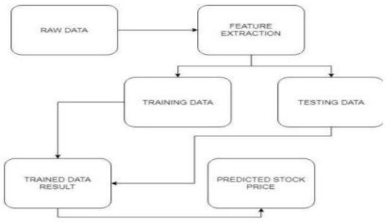

Figure 1. Architecture Diagram

The conversion of raw data into processed data is the initial phase. This is accomplished by feature extraction, as the raw data obtained contains various qualities, but only a handful of them are helpful for prediction. The key attributes are extracted from the entire list of characteristics available in the raw dataset in the first stage, feature extraction. Feature extraction begins with a baseline of measured data and progresses to derived values or features. These traits are meant to be both informative and non-redundant, making learning and generalisation easier. Feature extraction is a dimensionality reduction procedure in which a large number of raw variables are reduced to a smaller number of manageable characteristics while maintaining accuracy presenting the first informational gathering precisely and completely

The feature extraction procedure is followed by a classification procedure in which the data generated after feature extraction is divided into two distinct parts. The problem of classification is determining which category a new observation belongs to. The test data set is used to predict the model’s accuracy, while the training data set is used to train the model. The 14 splitting is done in such a way that the training data keeps a higher percentage than the test data.

**3.4 Algorithms and flowcharts**

Both in contests like Kaggle and in the commercial world, the Decision Tree method has become one of the most widely utilised machine learning algorithms. Both classification and regression problems can benefit from the use of a Decision Tree. A decision tree algorithm executes a series of recursive operations before arriving at the final outcome, and when these activities are plotted on a screen, the visual resembles a large tree, hence the name. Systems that produce classifiers are one of the most extensively utilised strategies in data mining.

Classification algorithms are capable of managing large amounts of data in data mining. It can be used to make categorical class name assumptions, classify information using training sets and class labels, and more Both in contests like Kaggle and in the commercial world, the Decision Tree algorithm has become one of the most used machine learning algorithms. Both classification and regression problems can be solved using a Decision Tree. Before arriving at the end result, a decision tree algorithm undertakes a series of recursive steps, which when plotted on a screen resembles a large tree, hence the name. Data mining systems that produce classifiers are one of the most extensively utilised methodologies. Classification algorithms in data mining can handle enormous amounts of data. It can be used to make categorical class name assumptions, classify information using training sets and class labels, and so on.

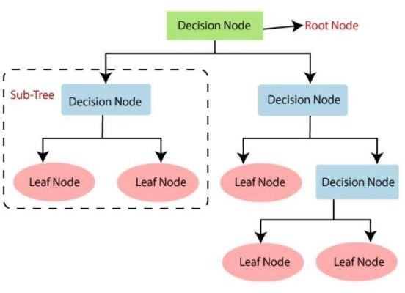

Figure 2: Decision Tree Algorithm

## 

## CHAPTER 4

## EXPERIMENTATION AND RESULTS

In this chapter, implementation of algorithm is described. The implementation using python and its result is displayed.

## 4.1 Experimental Work

## 4.1.1 IMPLEMENTATION OF THE MODEL

## 

## #Install the dependencies

import numpy as np import pandas as pd

from sklearn.tree import DecisionTreeRegressor from sklearn.linear_model import LinearRegression from sklearn.model_selection import train_test_split import matplotlib.pyplot as plt

### **#Load the data**

from google.colab import files uploaded = files.upload()

**#Store the data into a data frame** df = pd.read_csv('TSLA.csv') df.head(6)

### **#Get the number of trading days**

df.shape (2751, 7)

**#Visualize the close price data** plt.figure(figsize=(16,8)) plt.title('tesla')

plt.xlabel('Days') plt.ylabel('Close USD($)')

plt.plot(df['Close']) plt.show()

**#Get the close price** df = df[['Close']] df.head(4)

### **#Create a variable to predict 'x' days out into the future**

future_days = 25

**#create a new column (target) shifted 'x' units/days up** df['Prediction'] = df[['Close']].shift(-future_days) df.tail(4)

### **#create the feature data set (X) and convert it to a numpy array and remove the last 'X' rows/days**

X = np.array(df.drop(['Prediction'], 1)) [:-future_days] print(X)

[[4.778]

[4.766]

[4.392]

... [729.400024]

[738.200012]

[704.73999 ]]

/usr/local/lib/python3.7/dist-packages/ipykernel_launcher.py:2: FutureWarning: In a future version of pandas all arguments of DataFrame.drop except for the argument 'labels' will be keyword-only

### **#Create the target data set (y) and convert it to a numpy array and get all of thev target values except the last 'x' rows/days**

y = np.array(df['Prediction'])[:-future_days] print(y)

[4.252 4.09 3.918 ... 625.219971 623.900024 605.119995]

### #Split the data into 75% training and 25% testing

x_train, x_test, y_train, y_test = train_test_split(X, y, test_size = 0.25)

### **#Create the models**

**#Create the decision tree regressor model**

tree = DecisionTreeRegressor().fit(x_train, y_train)

### **#Create the linear regression model**

lr = LinearRegression().fit(x_train, y_train)

**#Get the last 'x' rows of the feature data set** x_future = df.drop(['Prediction'], 1)[:-future_days] x_future = x_future.tail(future_days)

x_future = np.array(x_future) x_future

/usr/local/lib/python3.7/dist-packages/ipykernel_launcher.py:2: FutureWarning: In a future

version of pandas all arguments of DataFrame.drop except for the argument 'labels' will be keyword-only

array([[662.159973], [630.27002],

[640.390015],

[618.710022],

[611.289978],

[635.619995],

[667.929993],

[661.75],

[691.049988],

[691.619995],

[670.969971],

[683.799988],

[677.02002],

[701.97998],

[762.320007],

[732.22998],

[738.849976],

**#Show the model Decision tree Prediction** tree_Prediction = tree.predict(x_future) print(tree_Prediction)

print()

**#Show the model linear regression Prediction** lr_Prediction = lr.predict(x_future) print(lr_Prediction)

**#Visualize the data** Predictions = tree_Prediction valid = df[X.shape[0]:]

valid['Predictions'] = Predictions plt.figure(figsize=(16,8)) plt.title('Model') plt.xlabel('Days') plt.ylabel('Close USD ($)') plt.plot(df['Close'])

plt.plot(valid[['Close','Predictions']]) plt.legend(['Orig','val','Pred']) plt.show()

.

### **4.3. RESULTS AND DISCUSSION**

### **4.3.1 Result Analysis**

The future prices of the stocks of a company are proven to be with greater accuracy and reliability using machine learning techniques. The primary task of the project being the application of the Decision Tree Model as a means of determining the stock prices. Both the techniques have shown an improvement in the accuracy of predictions, there by yielding positive results with the Decision Tree model proving to be more efficient. The results are quite promising and have led to the conclusion that it is possible to predict stock market with more accuracy and efficiency using machine learning techniques.

#Store the data into a data frame

.

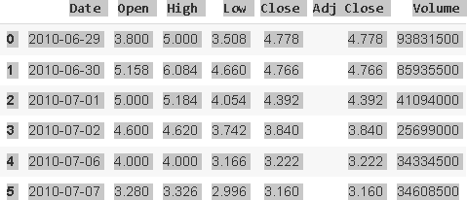

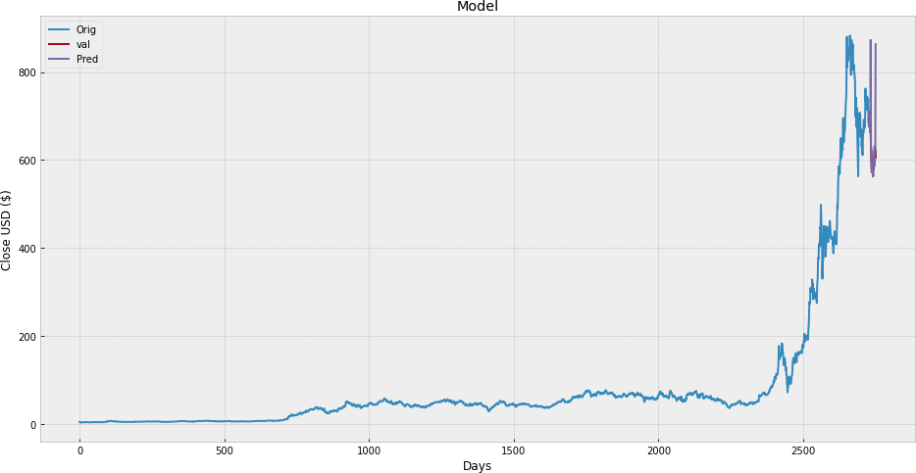

Figure 3 : Final Output

**CHAPTER 5**

**CONCLUSION AND FUTURE SCOPE**

**5.1. CONCLUSIONS**

Overfitting versus actual prediction dilemma Because there is so much uncertainty, it is impossible to believe or rely on predictions alone in industries like the stock market, where the data is dynamic and will never be the same. The ability to forecast a stock's overall trend. We can now better grasp how the market works and utilise it to our advantage to make wise and lucrative decisions thanks to stock market forecasts. Uncertainties cannot be predicted. There are numerous elements that influence the stock market as a whole, as well as a large number of uncertain and unpredictable factors. Unfortunately, we are unable to make predictions about the myriad unknown elements that contribute to the development of the disease .

Overfitting vs. real prediction is a conundrum. It's tough to believe or rely on projections alone in industries like the stock market, where the data is dynamic and never the same. Capacity to forecast a stock's overall trend. We can now better grasp how the stock market works and utilise it to our advantage to make wise and lucrative decisions with the help of stock market predictions. Uncertainties are unavoidable. There are numerous elements that influence the stock market as a whole, as well as a large amount of unpredictability and uncertainty. Regrettably, we are unable to make predictions about the myriad unknown elements that contribute to the development of the disease.

**5.2. FUTURE SCOPE**

The accuracy of the stock market prediction algorithm can be increased in the future by using a much larger dataset than the one currently used. Furthermore, other developing Machine Learning models could be investigated to determine their accuracy rate. Sentiment analysis using Machine Learning to determine how news influences a company's stock prices is also a promising subject. Predictions can also be made using other deep learning-based models. Deep learning models that consider financial news stories as well as financial metrics such as a closing price, trading volume, profit and loss statements, and so on could be developed in the future for possibly better results.

## REFERENCES

[1]. Masoud, Najeb MH. (2017) “The impact of stock market performance upon economic growth”. International Journal of Economics and Financial Issues3 (4): 788–798.

[2].Murkute, Amod and Tanuja Sarode (2015) “Forecasting market price of stock using artificial neural network”. International Journal of Computer Applications124 (12): 11-15.

[3]. S. Sharma and B. Kaushik (2018), “Quantitative analysis of stock market prediction for accurate investment decisions in future,” Journal of Artificial Intelligence, vol. 11, pp. 48–54.

[4]. V. Atanasov, C. Pirinsky, and Q. Wang (2018), “The efficient market hypothesis and investor behavior”.

[5]. S. Agrawal, D. Thakkar, D. Soni, K. Bhimani, and C. Patel, “Stock market prediction using machine learning techniques,” International Journal of Scientific Research in Computer Science, Engineering and Information Technology, 2019.

[6]. M. Afeef, A. Ihsan, and H. Zada, “Forecasting stock prices through univariate arima modeling,” 2018.

[7]. P.-F. Pai and C.-S. Lin, “A hybrid arima and support vector machines model in stock price forecasting,” Omega, vol. 33, no. 6, pp. 497–505, 2018.

[8]. D. Karmiani, R. Kazi, A. Nambisan, A. Shah, and V. Kamble, “Comparison of predictive algorithms: Backpropagation, svm and lstm for stock market,” in 2019 Amity International Conference on Artificial Intelligence (AICAI). IEEE, 2019, pp. 228–234.

[9]. E. Ahmadi, M. Jasemi, L. Monplaisir, M. A. Nabavi, A. Mahmoodi, and P. A. Jam, “New efficient hybrid candlestick technical analysis model for stock market timing on the basis of the support vector machine and heuristic algorithms of imperialist competition and genetic,” Expert Systems with Applications, vol. 94, pp. 21–31, 2018