AI IMAGE CAPTION GENERATOR
A Course Project Report

Submitted in partial fulfillment of the requirements for the course
23CS002PC304 AI Assisted Coding

Submitted by
Sameera Anjum
(2303A52466)

Under the guidance of
Sallauddin Md
Assistant Professor, SoCS & AI

Academic Year: 2025–2026


Department of Computer Science and Artificial Intelligence
SR University
Warangal, Telangana, India
INDEX
- Abstract.................................................................3
- Introduction...........................................................3
- Background............................................................4
- Problem Statement................................................6
- Objectives...............................................................7
- System Architecture................................................8
- Methodology / Algorithm.......................................10
- Prompts Used in AI-Assisted Development…………...12
- Code Implementation...............................................15
- Interface and working Screens……………………….………17
- Results and Discussion..............................................20
- Advantages and Limitations......................................21
- Conclusion................................................................22
- Future Work..............................................................22
- References................................................................23

1. ABSTRACT:
This project presents the design and development of an AI Image Caption Generator as part of the AI Assisted Coding course. The application allows users to upload an image, preview it, and generate an AI-based caption through a responsive web interface. The generated caption can be copied or regenerated, and the system includes proper validation and error handling for a smooth user experience.
The project demonstrates how AI-assisted coding can be used throughout the software development lifecycle, from requirement generation and UI design to backend logic, debugging, documentation, and presentation preparation. Instead of relying only on manual coding, structured prompts were used to collaborate with an AI tool for generating components, improving design decisions, and accelerating development.
The final system is a modern full-stack web application with a dark-themed responsive UI. It highlights the practical use of prompt engineering, AI-supported development, and intelligent application design. This project serves as a real-world example of how AI Assisted Coding can improve productivity, code generation, and documentation quality while still requiring human review and decision-making.

2. INTRODUCTION:
Artificial Intelligence is transforming the way software is developed. Traditionally, developers manually planned system structure, wrote code, debugged issues, and prepared reports and documentation. With the growth of AI-based developer tools, many of these tasks can now be supported through AI Assisted Coding, where the developer guides an AI system using prompts and iterative instructions.
This project focuses on building an AI Image Caption Generator, a web application that automatically generates captions for uploaded images. The system combines frontend design, backend processing, and AI-based image understanding into one practical project. It also serves as a demonstration of how AI can support coding tasks such as:
- project planning
- code generation
- UI creation
- debugging assistance
- documentation writing
- report and PPT preparation
Image captioning is an important AI application that combines computer vision and natural language generation. It enables a machine to interpret the contents of an image and produce a meaningful textual description. Such systems are useful in accessibility, digital media, education, e-commerce, and content management.
This project was developed not only as a web application but also as a case study in AI Assisted Coding. The development process involved using prompts to generate and refine code, design a modern UI, organize the workflow, and prepare the final project documentation.

3. BACKGROUND AND AI ASSISTED CODING CONCEPTS
3.1 Image Captioning Background
Image captioning is a task in artificial intelligence where a system examines an image and generates a descriptive sentence. It combines:
- computer vision, to identify objects, actions, and scenes
- deep learning, to understand image features
- natural language processing, to convert those features into text
Examples of image captioning include:
- “A dog running in a park”
- “Two people sitting at a table”
- “A car parked on a street near a building”
Image captioning has applications in:
- accessibility for visually impaired users
- social media content creation
- automatic metadata generation
- smart photo organization
- educational tools
3.2 AI Assisted Coding Background
AI Assisted Coding is a modern software development approach in which a developer works collaboratively with an AI tool to build applications more efficiently. Instead of manually writing everything from scratch, the developer provides prompts that describe features, requirements, and constraints. The AI then assists by generating code, suggesting improvements, explaining concepts, or preparing documentation.
Important concepts in AI Assisted Coding include:
Prompt Engineering: .
The process of giving clear, structured instructions to the AI system in order to obtain useful and accurate outputs.
Human-in-the-Loop Development: .
Even though AI generates suggestions and code, the human developer still reviews, edits, tests, and validates the final system.
Iterative Refinement: .
Development is performed through multiple prompt-response cycles, where the AI-generated output is refined step by step.
Code Generation Support: .
AI can generate boilerplate code, API structures, component layouts, validation logic, and documentation templates.
Documentation Assistance: .
AI can help prepare reports, summaries, PPT content, and explanation material based on the project.
3.3 Relevance to This Project
This project demonstrates AI Assisted Coding in practice by using AI prompts to:
- define the overall project
- generate the frontend and backend structure
- improve the UI styling
- design error handling
- explain workflow and architecture
- prepare academic report content
- prepare PPT content and summaries
Thus, the project is not only an AI application but also a reflection of AI-assisted software engineering.

4. PROBLEM STATEMENT:
In many digital platforms, users work with large numbers of images that require suitable captions or descriptions. Writing captions manually can be repetitive, time-consuming, and inconsistent. This becomes especially challenging when captions are needed quickly for accessibility, documentation, social media, or content management purposes.
At the same time, modern software development itself can also be time-intensive. Developers must design UI layouts, write backend logic, handle errors, debug issues, and prepare documentation. These repeated development tasks can be improved through AI-assisted coding techniques.
Therefore, there is a need to build a system that not only generates captions for images automatically, but also demonstrates how AI can assist in the development of such a system.
The problem addressed by this project is to design and implement an AI Image Caption Generator that:
- accepts image uploads from users
- previews the image before processing
- generates a suitable AI-based caption
- allows the user to copy or regenerate the caption
- handles invalid inputs and server failures gracefully
- provides a responsive and modern interface
In addition, the project aims to show how AI Assisted Coding can support the process of building such an application through structured prompts and guided generation.

5. OBJECTIVES:
The primary objective of this project is to design and implement a responsive AI Image Caption Generator while demonstrating the practical role of AI Assisted Coding in modern software development.
The specific objectives are as follows:
- To understand the concept of AI-based image caption generation
- To understand the role of AI Assisted Coding in software development
- To build a modern responsive web application with dark-themed UI
- To allow users to upload image files and preview them
- To generate captions automatically using AI
- To provide copy and regenerate options for generated captions
- To implement proper error handling and file validation
- To separate frontend and backend responsibilities in a full-stack design
- To use prompts effectively for code generation and project planning
- To document the prompts used during development
- To analyze the benefits of AI assistance in coding, UI design, and documentation
- To prepare a complete academic report based on the AI-assisted development process
Overall, the project aims to combine AI application development with AI-assisted programming methodology.

6. SYSTEM ARCHITECTURE:
The system architecture of the AI Image Caption Generator consists of the following major modules:
6.1 Input Module
This module allows the user to select and upload an image file from the local device. Supported image formats include JPG, JPEG, and PNG.
6.2 Preview Module
Once the image is selected, the frontend displays a preview so that the user can confirm the uploaded image before generating a caption.
6.3 Frontend Module
The frontend is responsible for:
- user interaction
- upload controls
- displaying preview
- showing loading state
- displaying generated caption
- handling copy and regenerate actions
- showing validation and error messages
6.4 Backend Module
The backend processes incoming image requests, validates files, handles API or model communication, and returns the generated caption to the frontend.
6.5 AI Caption Generation Module
This module takes the uploaded image and generates a textual description based on its visual content. It may be implemented using an image captioning model or an external AI API.
6.6 Output Module
This module displays the caption on the user interface and provides options to:
- copy the caption
- regenerate a caption for the same image
6.7 Error Handling Module
This module ensures robust behavior by handling:
- unsupported file type
- no file selected
- server error
- caption generation failure
- network issue
6.8 Architecture Flow

7. METHODOLOGY / WORKFLOW:
7.1 Development Methodology
The project followed an AI-assisted iterative development methodology. Instead of completing all steps manually from scratch, the system was built through repeated interactions with an AI coding assistant. Each phase of the project was guided through prompts and refined by human review.
The development methodology involved:
- defining the project idea
- generating the initial app structure using prompts
- refining the UI and UX with further prompts
- implementing backend logic
- adding validation and error handling
- testing the flow
- generating documentation and report content
7.2 Application Workflow
The user-facing workflow of the application is as follows:
Step 1: Image Upload
The user selects an image file through the upload area.
Step 2: File Validation
The application checks whether the uploaded file is a valid image.
Step 3: Image Preview
The selected image is previewed in the UI.
Step 4: Caption Request
The user clicks the generate button.
Step 5: Backend Processing
The backend receives and validates the image.
Step 6: AI Caption Generation
The AI module processes the image and generates a caption.
Step 7: Caption Display
The frontend displays the caption in a result section.
Step 8: User Actions
The user can either copy the caption or regenerate a new one.
7.3 AI-Assisted Development Workflow
The AI-assisted coding workflow used in this project can be summarized as:
- Define project requirements in natural language
- Use prompts to generate code structure
- Review AI-generated output
- Refine code and UI through follow-up prompts
- Add missing features such as validation and error handling
- Use AI assistance for documentation and presentation content
- Validate and finalize the project manually
7.4 Algorithm
- Start
- Read image file from user
- Validate file type and presence
- If invalid, show error
- Else preview image
- Send image to backend
- Backend validates image
- Backend forwards image to AI caption generator
- Receive generated caption
- Display caption on frontend
- Enable copy and regenerate options
- Stop

8. PROMPTS USED IN AI-ASSISTED DEVELOPMENT:
8.1 Role of Prompts in This Project
Since this project belongs to the AI Assisted Coding course, prompts were a major part of the development process. Prompts were used to instruct the AI tool to generate code, improve the design, organize the system, and prepare documentation.
Instead of using AI only for code completion, the project used prompts strategically across multiple phases:
- project planning
- UI generation
- backend creation
- validation and debugging
- report writing
- presentation support
This made prompt engineering a core part of the project methodology.
8.2 Major Prompts Used
Prompt 1: Initial Project Generation
“Build a responsive AI Image Caption Generator web app with a modern dark-themed UI. Users should be able to upload an image, preview it, and generate a caption. Display the caption with options to copy or regenerate. Use the required frameworks for frontend and backend. Use clean UI, include error handling. Provide complete code and setup instructions.”
Prompt 2: Frontend UI Prompt
“Create a responsive dark-themed frontend for an AI Image Caption Generator. Include image upload area, image preview, generate caption button, result section, copy button, regenerate button, and error messages.”
Prompt 3: Backend Prompt
“Create a backend API for image upload and caption generation. Validate uploaded files, handle errors properly, and return caption output in JSON format.”
Prompt 4: Error Handling Prompt
“Add robust error handling to the project. Handle invalid image formats, missing uploads, processing failures, and network/server errors.”
Prompt 5: Report Prompt
“Prepare a complete academic project report for the AI Image Caption Generator including abstract, introduction, objectives, architecture, workflow, implementation, results, and conclusion.”
Prompt 6: Presentation Prompt
“Generate PPT content for the AI Image Caption Generator project including title, problem statement, architecture, workflow, features, interface screens, conclusion, and future scope.”
8.3 Benefits of Prompt-Based Development
The prompts helped to:
- speed up coding
- reduce repetitive effort
- generate structured project output
- improve UI design ideas
- prepare documentation more quickly
- support debugging and refinement
8.4 Human Role in AI-Assisted Coding
Although AI generated suggestions and code, the developer was still responsible for:
- selecting the right prompts
- reviewing the generated code
- checking correctness
- refining the final output
- ensuring the system meets project requirements
Thus, the project demonstrates that AI Assisted Coding works best as a collaborative development model rather than a fully automatic replacement.

9. CODE IMPLEMENTATION:
9.1 Overview of Implementation
The project is implemented as a full-stack web application. The frontend provides the user interface, while the backend handles the image upload and caption generation request. The system is organized into modules so that each part of the project remains maintainable and scalable.
9.2 Frontend Implementation
The frontend includes:
- upload component
- image preview component
- generate caption button
- result display section
- copy caption functionality
- regenerate button
- loading indicator
- error alert display
The interface follows a modern dark-themed design and is responsive across screen sizes.
9.3 Backend Implementation
The backend includes:
- API route for image upload
- input validation logic
- file handling support
- AI caption generation request processing
- JSON response formatting
- error handling middleware
9.4 Key Functional Components
Image Upload Logic:
Allows user to choose an image file from the system.
Preview Logic:
Renders the image before submission.
API Request Logic:
Sends the image file to the backend for processing.
Caption Output Logic:
Displays the received caption to the user.
Copy Functionality:
Uses clipboard operations to copy generated text.
Regenerate Functionality:
Triggers a new caption generation request for the same image.
Error Handling Logic:
Displays user-friendly messages during failures.
9.5 AI-Assisted Coding Contribution in Implementation
AI assistance was used to:
- suggest component structure
- create form handling logic
- generate API route structure
- improve CSS styling
- add validation checks
- prepare helper functions
- organize documentation of implementation
9.6 Summary
The implementation successfully integrates AI functionality with web development principles and also reflects the practical use of AI-assisted coding in project creation.
10. INTERFACE AND WORKING SCREENS:
10.1 Home Page / Upload Interface
Description:
This screen shows the initial page of the application with the dark-themed UI, project title, upload area, and action button.
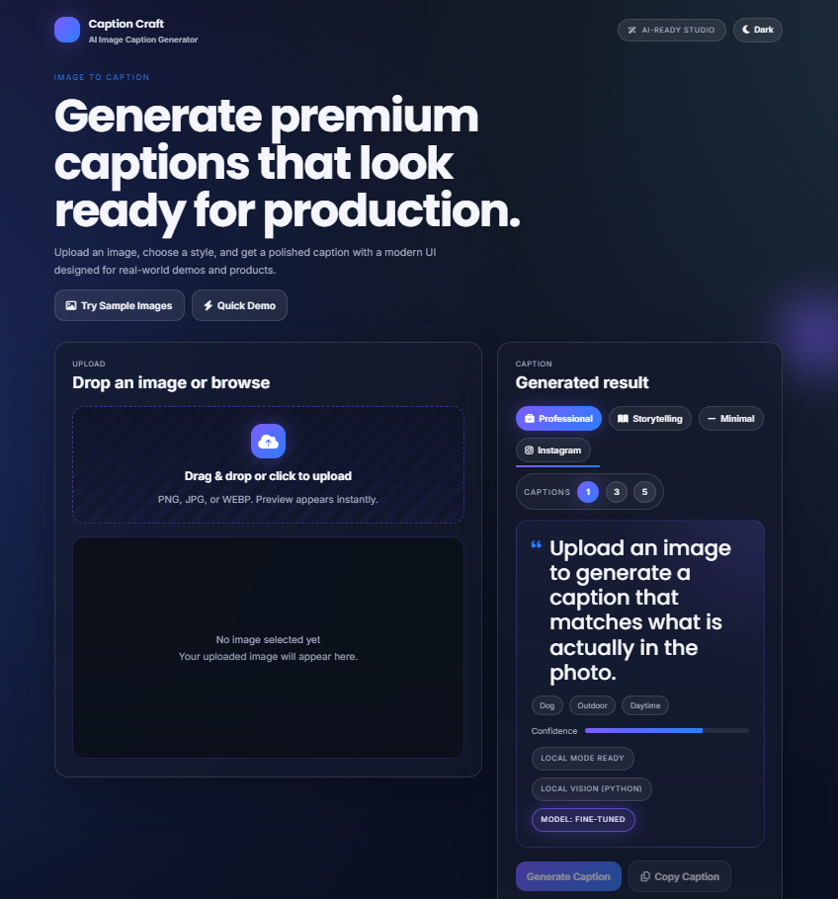
Figure 1: Home page of the AI Image Caption Generator showing the upload section.

10.2 Image Preview Screen
Description:
After selecting an image, the application displays the uploaded image in the preview section before caption generation.
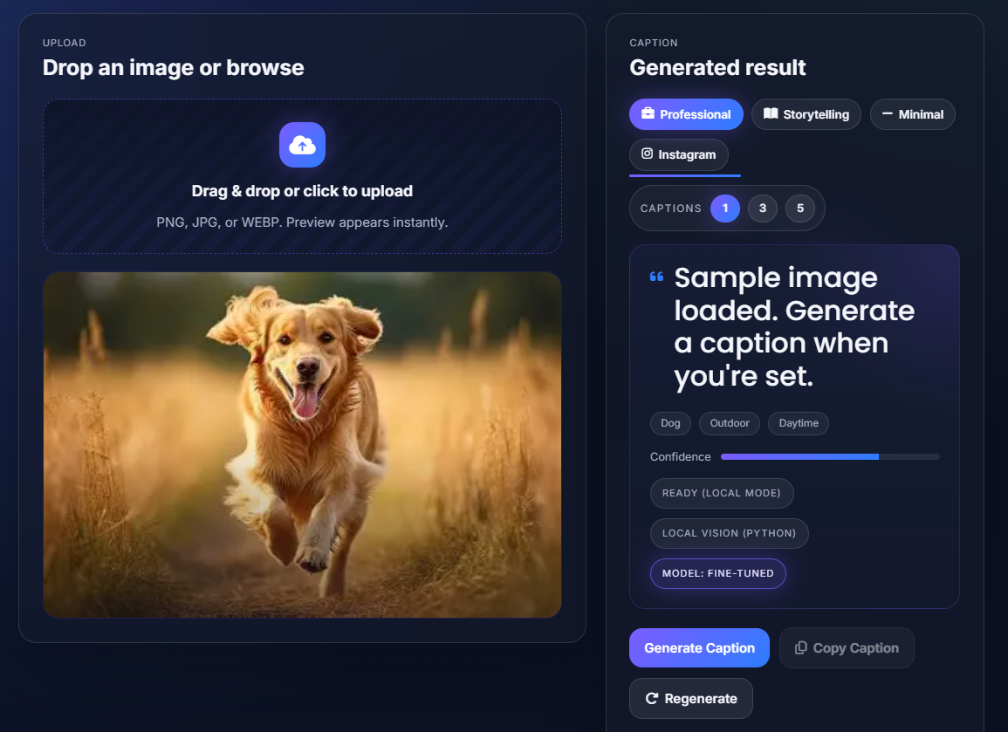
Figure 2: Image preview screen after user uploads an image.
10.3 Loading State Screen
Description:
When the caption is being generated, the UI shows a loading state to inform the user that processing is in progress.
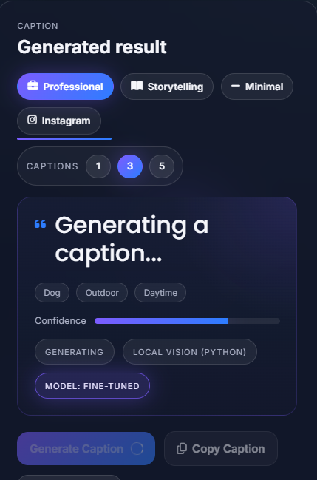
Figure 4: Loading state during caption generation.
10.4 Caption Generation Output Screen
Description:
This screen shows the generated caption displayed below the preview image with copy and regenerate options.
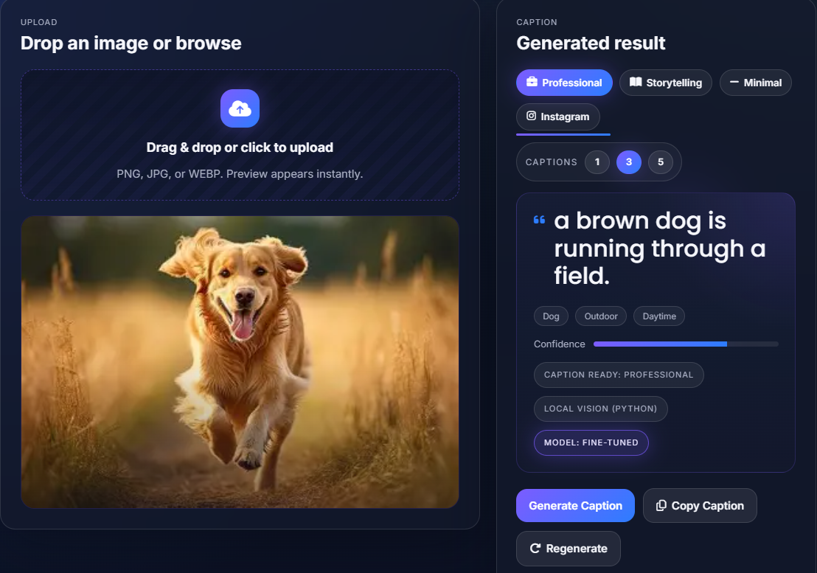
Figure 3: Generated caption displayed with copy and regenerate actions.

11. RESULTS AND DISCUSSION:
11.1 Project Outcome
The project was successfully developed as a responsive full-stack web application. Users can upload an image, preview it, generate a caption, copy the caption, and regenerate it if required.
11.2 Observed Results
The following outcomes were observed:
- the upload flow works correctly
- valid image files are previewed properly
- caption generation process completes successfully
- generated captions are displayed clearly
- copy functionality improves usability
- regenerate option gives flexibility
- error handling prevents invalid operations
- interface remains responsive on different screen sizes
11.3 Discussion in the Context of AI Assisted Coding
From the perspective of AI Assisted Coding, the project demonstrates several important points:
- AI can accelerate the development process through prompt-based code generation
- structured prompts lead to better and more useful outputs
- AI is effective for generating boilerplate, layout ideas, and documentation
- human review remains essential for correctness and quality
- AI assistance is most useful when combined with iterative refinement
The project shows that AI-assisted coding is not only useful for writing code, but also for planning, explaining, documenting, and presenting software projects.
11.4 Educational Value
This project helped in understanding:
- prompt engineering
- AI-supported software development
- frontend-backend integration
- basic AI application design
- report generation using AI assistance
Thus, it strongly aligns with the objectives of the AI Assisted Coding course.
12. ADVANTAGES AND LIMITATIONS:
12.1 Advantages
- Automates image caption generation
- Saves manual effort in writing image descriptions
- Provides a clean and modern user interface
- Supports responsive design across devices
- Includes copy and regenerate functionality
- Demonstrates real-world use of AI in web apps
- Shows practical use of AI Assisted Coding in project development
- Improves productivity through prompt-driven development
12.2 Limitations
- Caption quality depends on the AI model or API used
- Complex images may produce less accurate captions
- Backend/API dependency may affect performance
- AI-generated code still requires human review
- Prompt quality directly affects AI output quality
- Some generated outputs may need refinement or correction
13. CONCLUSION:
This project successfully demonstrates the development of an AI Image Caption Generator as an application project for the AI Assisted Coding course. The system allows users to upload an image, preview it, and generate an AI-based caption using a responsive web interface. Features such as copy, regenerate, and error handling make the application practical and user-friendly.
More importantly, the project highlights the role of AI Assisted Coding in modern software development. Through structured prompts, AI was used to support project planning, frontend generation, backend logic design, validation, and documentation. This reduced development effort and improved productivity while still requiring human review and refinement.
The project therefore serves two purposes:
- it is a working AI-based image captioning web application
- it is a demonstration of prompt-driven development in an academic context
In conclusion, the AI Image Caption Generator is a strong example of how AI tools can be integrated into both the product being built and the process used to build it.
14. FUTURE WORK:
Future improvements to this project may include:
- multilingual caption generation
- voice output of captions
- caption tone options such as short, detailed, or creative
- drag-and-drop upload functionality
- batch image captioning
- user authentication and saved history
- deployment to cloud hosting platforms
- comparison of multiple captioning models
- analytics on prompt effectiveness during development
- deeper integration of AI-assisted debugging and testing workflows

15. REFERENCES:
[1] React Documentation
[2] Node.js Documentation
[3] Express.js Documentation
[4] Tailwind CSS Documentation
[5] Multer Documentation
[6] MDN Web Docs
[7] Research resources on image caption generation
[8] Articles and documentation on AI Assisted Coding
[9] Prompt engineering resources for software development
[10] Online technical resources on AI, computer vision, and NLP

