Problem 1: Please provide the following:

a) Compile the above code and execute serval test cases. Provide output in a separate file.

I executed 3 test cases

1. With duplicates in the values
2. With numbers other than 8, and no duplicates
3. Entered a non integer i.e a character to raise mismatch exception

The screenshots are below:

With duplicate values

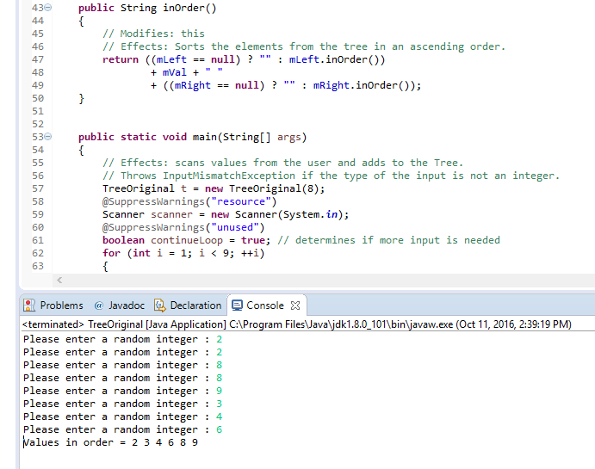

With numbers other than 8, and no duplicates

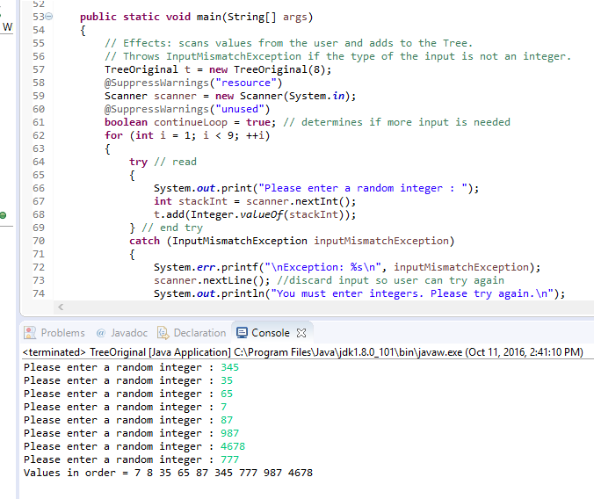

Entered a non integer i.e a character to raise mismatch exception

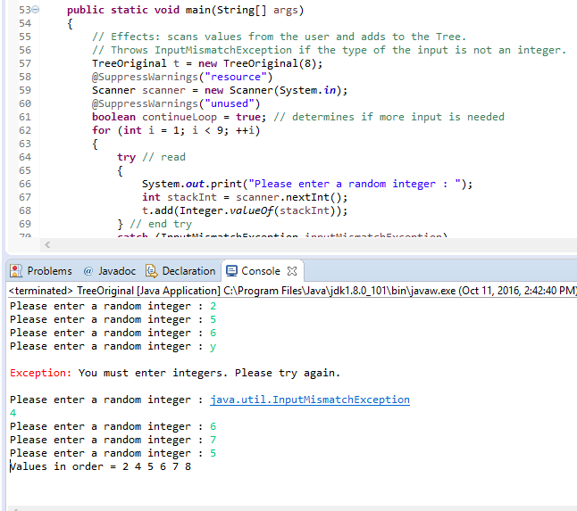

b) The designer and implementer may have missed some exceptions. Provide a descriptive response to how you would approach exceptions for the above implementation.

Firstly, I will modify **add** method to throw DuplicateException when the element is already in the tree.

Secondly, **next**() in iterator throws NoSuchElementException.

c) The designer did not provide a specification. Please provide a specification for the above code.

This is included in the source files.

**Note:** TreeOriginal.java is the source file corresponding to the given code.

My modified version with the Iterator implementation is Tree.java

**Problem 2:**

Please refer to Tree.java, TreeTester.java and TreeClient.java.