Name : sameer roll no:23k5535 section :BCS1D

Q1:
#include <stdio.h>

int main() {

FILE *filePtr = fopen("firstfile.txt", "w");

if (filePtr == NULL) {
printf("Error opening the file.\n");
return 1;
}

fprintf(filePtr, "Name:sameer\n");
fprintf(filePtr, "Roll Number: 23k-5535\n");
fprintf(filePtr, "CGPA: 2.5\n");

fclose(filePtr);

printf("Data written to firstfile.txt successfully.\n");

return 0;
}



Q2:

#include <stdio.h>

int main() {

FILE *filePtr = fopen("firstfile.txt", "r");

if (filePtr == NULL) {
printf("Error opening the file.\n");
return 1;
}

char string[100];
while (fgets(string, sizeof(string), filePtr) != NULL) {
printf("%s", string);
}

fclose(filePtr);

return 0;
}

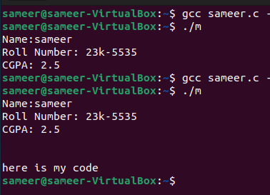

Q4:
#include <stdio.h>
#include <stdlib.h>

int main() {

FILE *namesFile = fopen("names.txt", "r");
FILE *subjectsFile = fopen("subjects.txt", "r");

FILE *outputFile = fopen("name_subj.txt", "w");

if (namesFile == NULL || subjectsFile == NULL || outputFile == NULL) {
printf("Error opening files.\n");
return 1;
}

char name[100], subject[100];

while (fgets(name, sizeof(name), namesFile) != NULL && fgets(subject, sizeof(subject), subjectsFile) != NULL) {

fprintf(outputFile, "Name: %s, Subject: %s\n", name, subject);
}

fclose(namesFile);
fclose(subjectsFile);
fclose(outputFile);

printf("Data written to name_subj.txt successfully.\n");

return 0;
}

Q3:(A):
#include <stdio.h>

int main() {
FILE *file = fopen("firstfile.txt", "r");

if (file == NULL) {
printf("Error opening the file.\n");
return 1;
}

char name[100];

while (fgets(name, sizeof(name), file) != NULL) {

printf("%.4s\n", name);
}

fclose(file);

return 0;
}

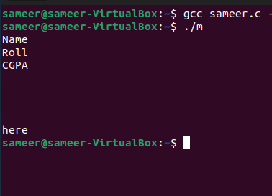

Q3:b)

#include <stdio.h>
#include <string.h>

int main() {
FILE *file = fopen("firstfile.txt", "r");

if (file == NULL) {
printf("Error opening the file.\n");
return 1;
}

char name[100];
int sum = 0;

while (fgets(name, sizeof(name), file) != NULL) {

sum += strlen(name);
}

printf("Sum of lengths: %d\n", sum);

fclose(file);

return 0;
}

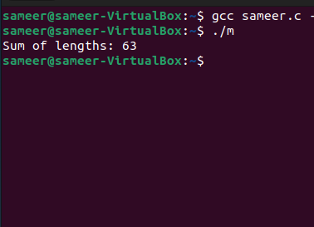

Q3:c)

#include <stdio.h>
#include <string.h>

void print_name_by_length(int length) {
FILE *file = fopen("names.txt", "r");

if (file == NULL) {
printf("Error opening the file.\n");
return;
}

char name[100];

while (fgets(name, sizeof(name), file) != NULL) {

strtok(name, "\n");

if (strlen(name) == length) {
printf("%s\n", name);
}
}

fclose(file);
}

int main() {

print_name_by_length(5);

return 0;
}
