Name: sameer roll no:23k-5535 section :BCS1D

#include <stdio.h>
#include <string.h>

int main() {
char String[100];
printf("Enter a string: ");
fgets(String, sizeof(String), stdin); //using fget function for spacing in string

char *ptr = String;
while (*ptr != '\n' && *ptr != '\0') { //here \o used for null character
ptr++;
}

int length = ptr - String;
printf("Length of the string: %d\n", length);

return 0;
}

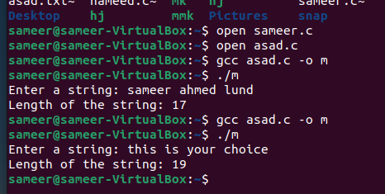

Q:2
#include <stdio.h>
//function defination
void convert(float *fahrenheit) {
*fahrenheit = (*fahrenheit - 32) * 5 / 9;
}

int main() {
float fahrenheit;

printf("Enter the temperature in Fahrenheit: ");
scanf("%f", &fahrenheit);
//calling funnction
convert(&fahrenheit);

printf("Temperature in Celsius: %.2f\n", fahrenheit);

return 0;
}

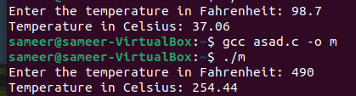

Q.3

#include <stdio.h>

int main() {
char i[] = "Hello, World!";

char my[20];
char *src = i;
char *dest = my;

while (*src != '\0') {
*dest = *src;
src++;
dest++;
}
*dest = '\0';

printf("Copied string: %s\n", my);

return 0;
}
