New-AzureRmResourceGroupDeployment -Name Deployment1 -ResourceGroupName MVP-EUS-PRD-NVA4 -TemplateParameterFile .\PaloAlto-Architecture.parameters.json -TemplateFile .\PaloAlto-Architecture.json

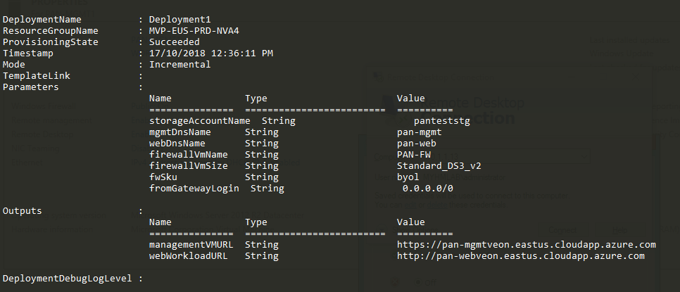

RDP to the Management Server

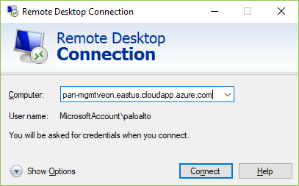

Turn off IE Enhanced Security

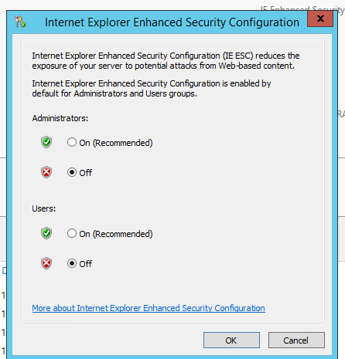

Navigate to <https://10.5.0.4>

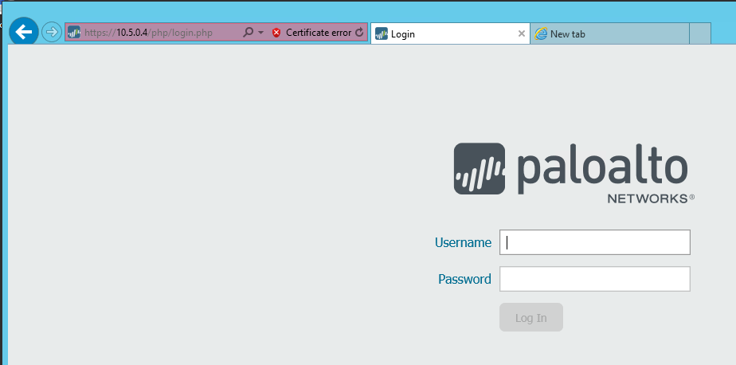

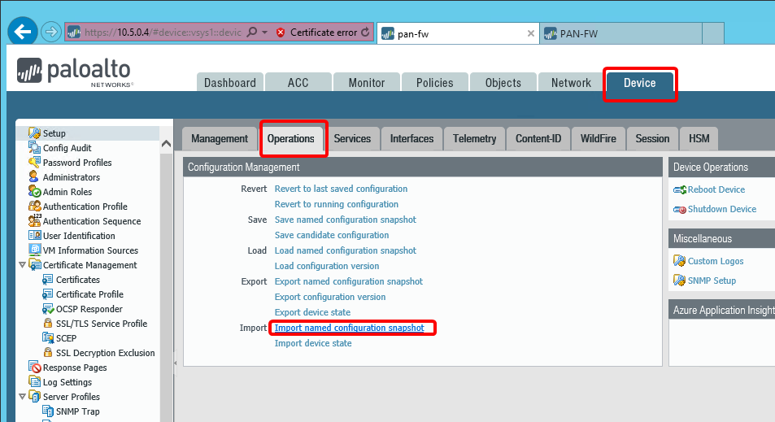

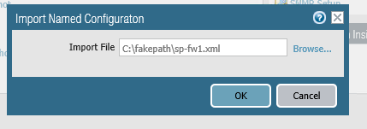

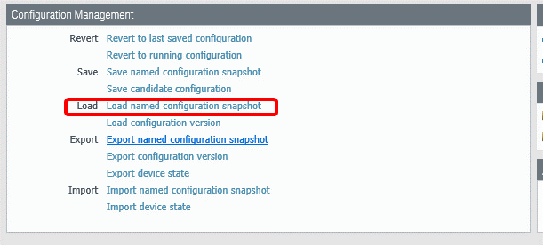

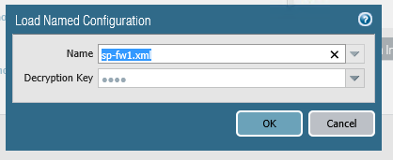

Click Commit and Reboot

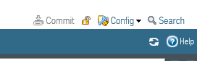

Reboot the device

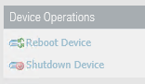

License the server

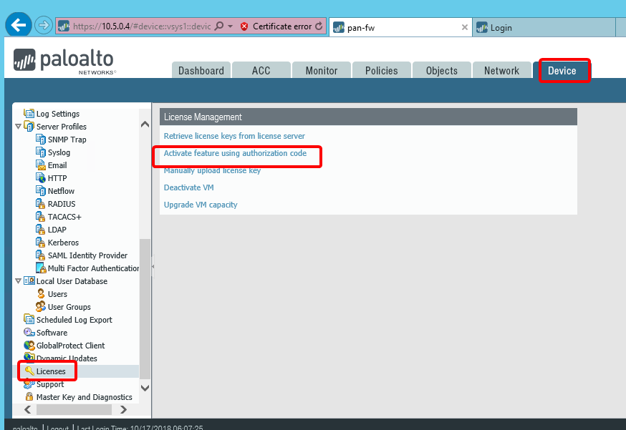

If the appliance doesn’t have internet access, you will need to an offline activation using a .key file.

Do the same for the fw2 as well.