Spotter — Fuel Route Planner
Walkthrough: the API, the client, and the source
Sameer Anamarnath
Source github.com/sameeranamarnath/spotter-fuel-planner (private)
Client https://spotter-fuel-route-web.vercel.app
API https://spotter-fuel-route.vercel.app (docs at /api/v1/docs/)
Screens in this document were rendered from the running application and from the repository at the time of writing, so the figures on them are the real ones.
The same walkthrough is in demo/walkthrough.mp4, a 2:34 captioned video. Its walkthrough.srt carries the spoken lines if you want to record a voiceover over it.
Contents
1. What this is
2. Running it
3. The API contract
4. Planning a route in the app
5. The plan it produces
6. Browsing the catalogue
7. The data model
8. The endpoint
9. The solver
10. Matching stations to the route
11. Resolving place names offline
12. Configuration
13. Deploying
14. The client
15. Tests
16. Where it stops

1. What this is
A fuel route planner: give it a start and a finish inside the USA and it returns the driving route as GeoJSON, the cost-optimal set of fuel stops for a vehicle with a 500-mile range running at 10 MPG, and the total money spent on fuel.
The backend is Django 5.2 with Django REST Framework; the frontend is a React client built with Vite. Stations come from the supplied OPIS price file. A request makes one upstream routing call, and a repeat of the same pair is served from the database.
On screen while you present this
CLIENT | https://spotter-fuel-route-web.vercel.app/ the app you will show in a moment
API | https://spotter-fuel-route.vercel.app/api/v1/docs/ the API you will show in a moment

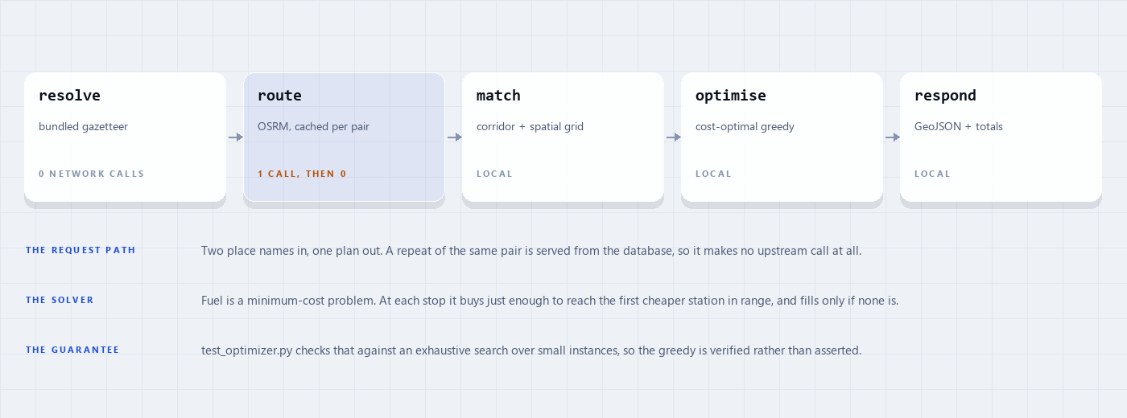
How a plan is produced, end to end.
VOICEOVER So this is the fuel route planner. You give it two places in the US and it comes back with the driving route, the cheapest set of places to refuel for a truck with a 500-mile range doing 10 miles to the gallon, and the total bill. The constraint I cared about most was the upstream calls: a request makes exactly one, and a repeat of the same pair makes none.

2. Running it
One command starts the API in Docker, and the image bakes the fuel catalogue so it serves immediately. The test suite needs no network and no API key, so it behaves the same anywhere.
The client is a separate Vite project: npm install, npm run dev, and it expects the API on port 8000 unless VITE_API_BASE_URL says otherwise.
On screen while you present this
RUN | docker compose up --build in the repository root, then the curl below

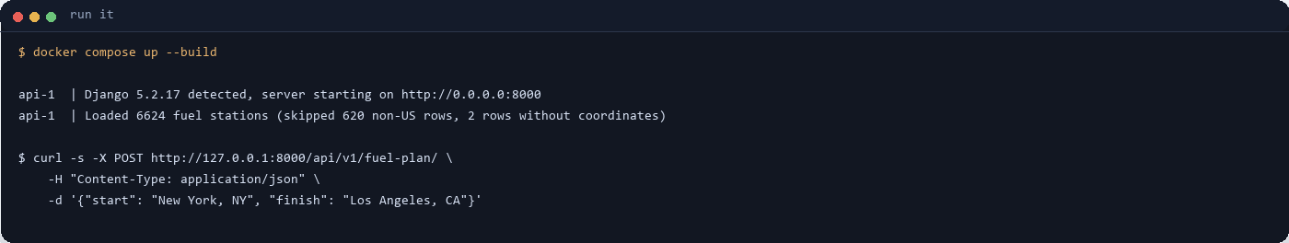
Docker, then a plan request.
VOICEOVER Locally it is one command, docker compose up. The image already has the price file loaded so it serves straight away. The client is a separate npm project and finds the API through one environment variable.

3. The API contract
POST /api/v1/fuel-plan/ takes a start and a finish, each either a place name like “New York, NY” or an explicit latitude and longitude. The response carries the resolved endpoints, the vehicle assumptions, the route, the chosen stops, the summary, and a ready-made GeoJSON FeatureCollection.
Errors are consistent: 400 for a validation problem, 422 for a place that cannot be resolved, 409 when no fuel is reachable, 502 when the upstream provider fails, all with the same {“error”: {“code”, “detail”}} body.
On screen while you present this
OPEN | https://spotter-fuel-route.vercel.app/api/v1/docs/ Swagger, then POST /api/v1/fuel-plan/ → Try it out
OR | https://spotter-fuel-route.vercel.app/api/v1/schema/ the raw OpenAPI 3 document

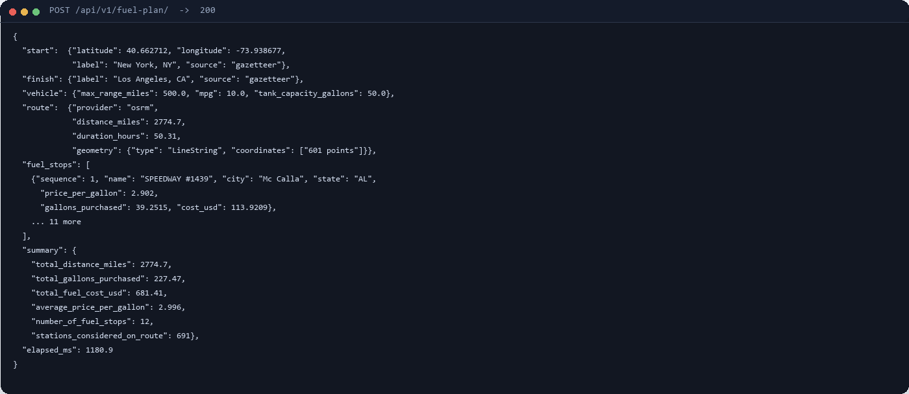
The response, abridged. Real values from the live API.
VOICEOVER The contract is one endpoint. You post two locations and you get the route geometry, the stops with the price and the gallons at each, and the totals. This is abridged, but the numbers are the real live response for New York to Los Angeles.

4. Planning a route in the app
The client is the same planner with a map in front of it. The vehicle chips along the top are read from /api/v1/health/, so the page cannot disagree with the API about the assumptions. Submitting posts the two names and renders what comes back: the route with numbered stop pins, the cost summary, and the manifest.
The basemap is knocked back with a CSS filter and the panels sit on it as frosted glass, so the data stays the loudest thing on the page.
On screen while you present this
OPEN | https://spotter-fuel-route-web.vercel.app/ this exact page, then read on
TYPE | New York, NY → Los Angeles, CA then press Compute optimal plan

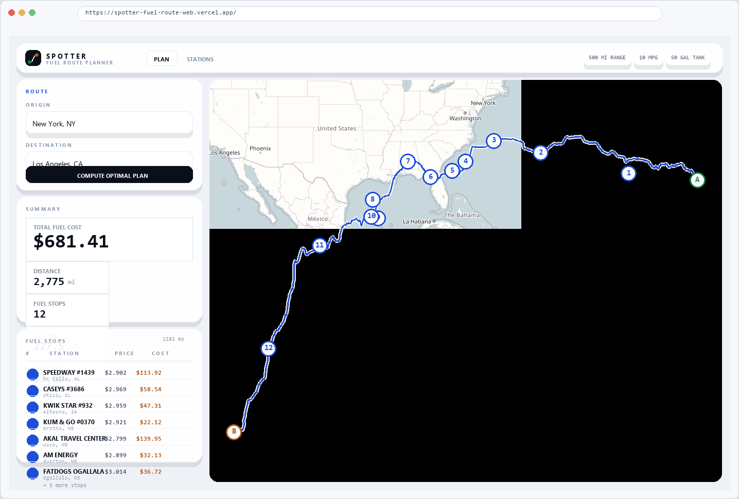
The Plan tab after a request: 12 stops, $681.41, 2,775 miles.
VOICEOVER This is the app. I deliberately did not hardcode the vehicle numbers in the client, those chips come from the health endpoint, so the UI cannot drift from the API. Press the button and you get the map, the cost and the stop list.

5. The plan it produces
Every row is one entry from fuel_stops: the station, the price it charged, the gallons bought there, and what that leg cost. The cheapest stop on this route is $2.90 a gallon against a $3.00 average, which is the whole point of the exercise.
The truck leaves with a full tank and that fuel is treated as a sunk cost, so it is not billed. It is configurable, but it is how trip accounting would sensibly read.
On screen while you present this
OPEN | https://spotter-fuel-route-web.vercel.app/ the same page, scrolled to the manifest
OR | https://spotter-fuel-route.vercel.app/api/v1/fuel-plan/ POST the same pair and read fuel_stops

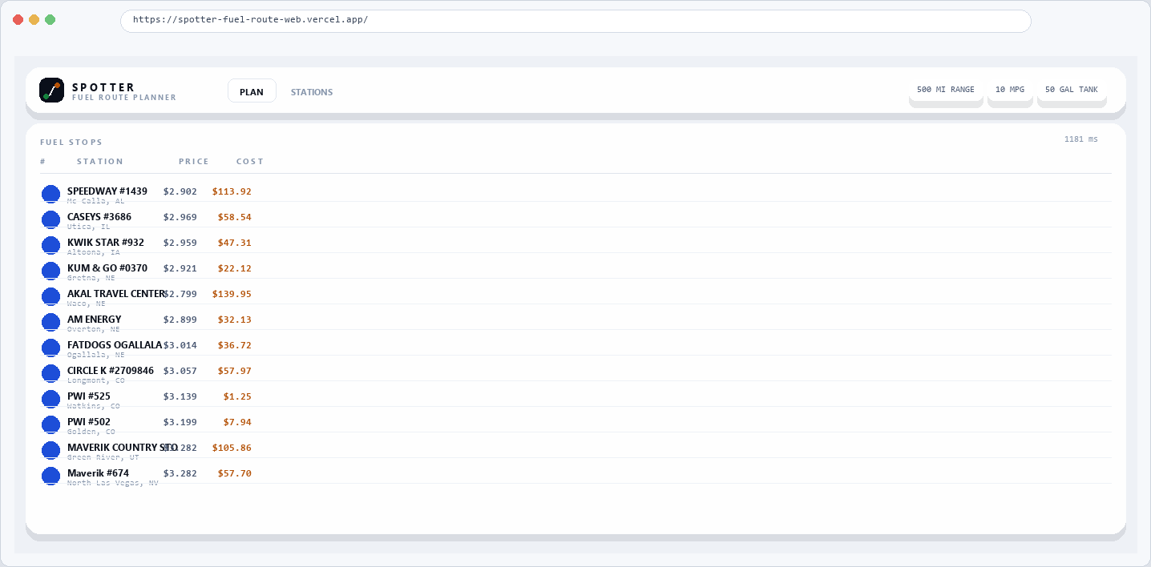
The manifest: 12 stops, 227.5 gallons, $681.41.
VOICEOVER Here is the plan in full. Twelve stops, 227 gallons, 681 dollars and 41 cents. Each row tells you where, what it cost per gallon and how much was bought. The solver is picking the cheap stations and buying just enough to reach them.

6. Browsing the catalogue
The stations endpoint exists so the prices the planner chooses from can be checked. It filters by state, city and maximum price, and pages the results.
On screen while you present this
OPEN | https://spotter-fuel-route-web.vercel.app/ then click the Stations tab along the top
OR | https://spotter-fuel-route.vercel.app/api/v1/stations/?limit=20 the same list as JSON

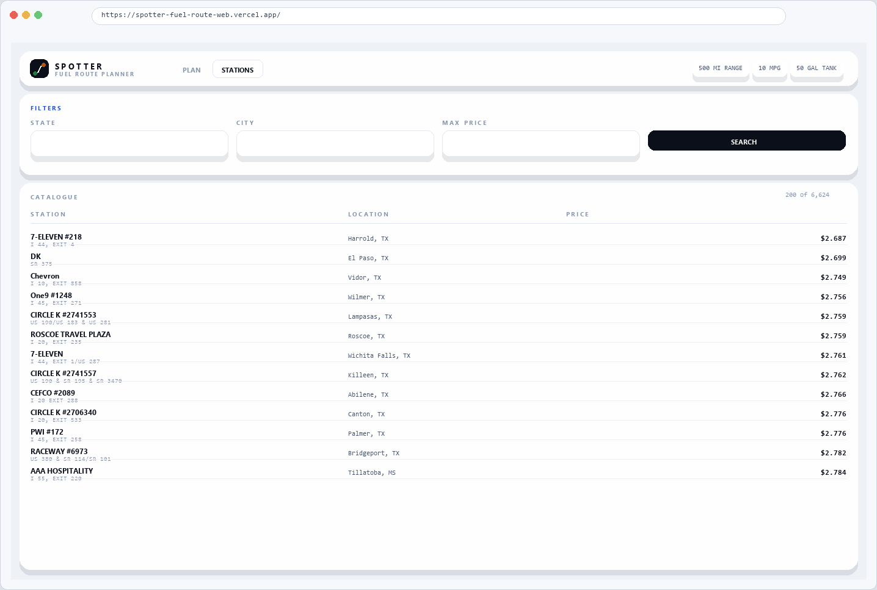
The catalogue, filtered and paged.
VOICEOVER There is a second view for the catalogue. It is mostly there so you can check the prices the planner is working from, filtered by state, city or a maximum price.

7. The data model
Three tables. FuelStation holds the OPIS price list plus coordinates that were derived offline, so the API never geocodes a station at request time. GeocodeCache and RouteCache memoise resolved places and routed pairs, which is what keeps the upstream call count at one and then zero.
On screen while you present this
OPEN | routing/models.py lines 19–48

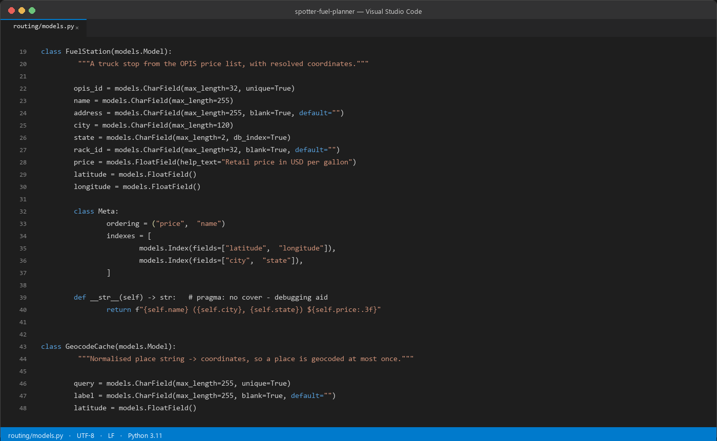
routing/models.py
VOICEOVER Three tables do the work. The stations, and two caches. The caches are the reason the second identical request costs nothing - it is served entirely out of SQLite.

8. The endpoint
The view is deliberately thin: validate through the serializer, hand the two locations to the planner, write the cache headers, return the payload. The interesting work lives in routing/services/, which keeps the HTTP layer readable and the planner testable without a request.
On screen while you present this
OPEN | routing/views.py lines 50–83

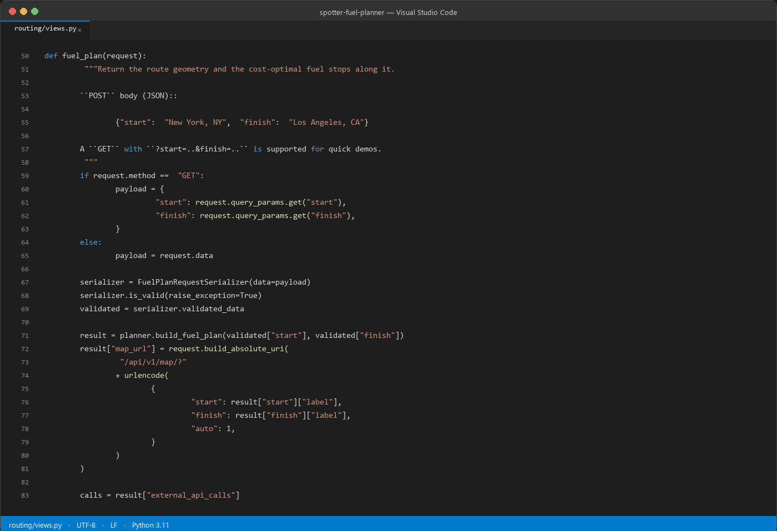
routing/views.py — the fuel-plan endpoint.
VOICEOVER The view does almost nothing on purpose. It validates, calls the planner, sets the cache headers and returns. Everything worth testing sits behind it in services, so it can be tested without going through HTTP.

9. The solver
Fuel is a minimum-cost problem, not a shortest-path one. Buying cheap fuel early only pays if it is cheaper than what lies ahead, so the solver walks the stops with a 500-mile horizon: at each one it buys just enough to reach the first cheaper station in range, and fills the tank only when there is none.
That is the optimal strategy for a fixed tank and consumption, and the tests check it rather than asking you to take it on trust.
On screen while you present this
OPEN | routing/services/optimizer.py lines 132–165

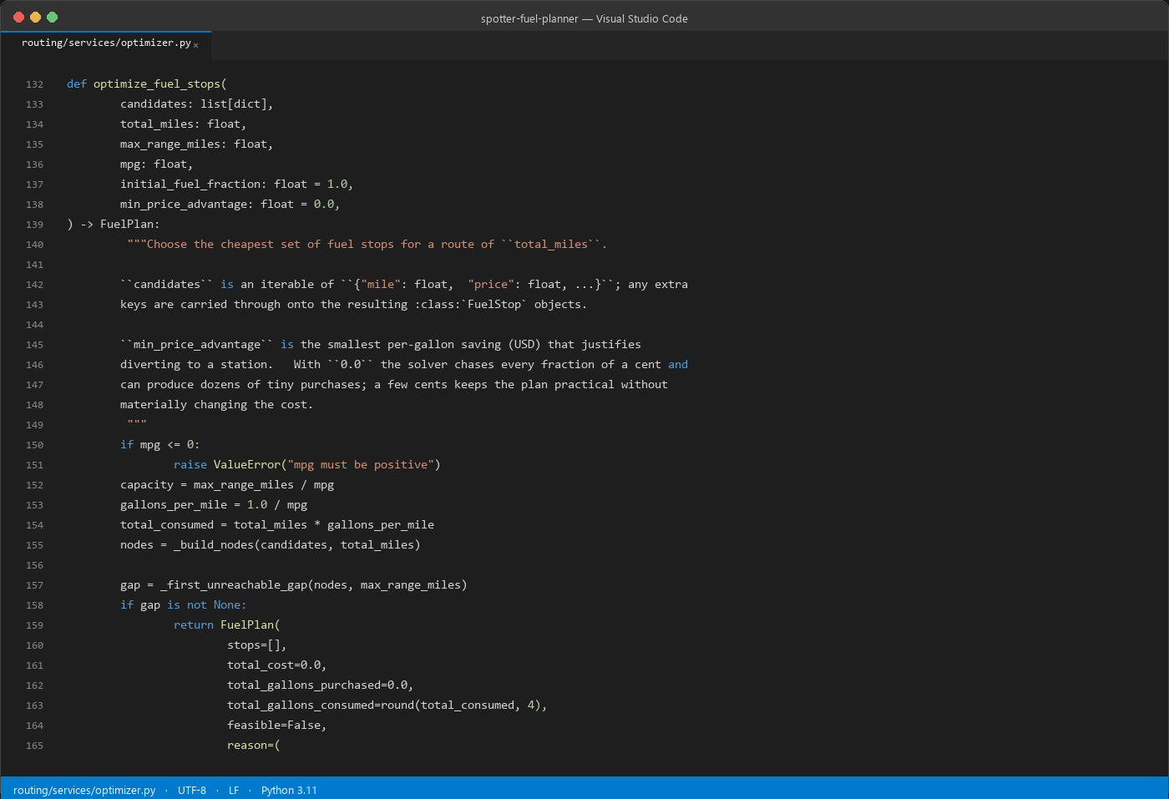
routing/services/optimizer.py — the stop selection.
VOICEOVER This is the piece I would want to talk about. Fuel is a minimum-cost problem, not a shortest-path problem - filling up at every station is not optimal, because carrying fuel you did not need costs money. So at each stop it buys just enough to reach the first cheaper station in range, and only fills the tank if there is nothing cheaper ahead.

10. Matching stations to the route
Testing every station against every route vertex is tens of millions of distance calculations on a cross-country route. Instead the polyline is bucketed into a grid sized from the allowed corridor, so a station only ever compares against the handful of vertices near it, and the comparison itself is a cheap chord term that orders candidates exactly as the great-circle distance would.
This was the hot path when I profiled: matching was 92% of a warm request before it was changed, and about a third of that after.
On screen while you present this
OPEN | routing/services/matching.py lines 45–76

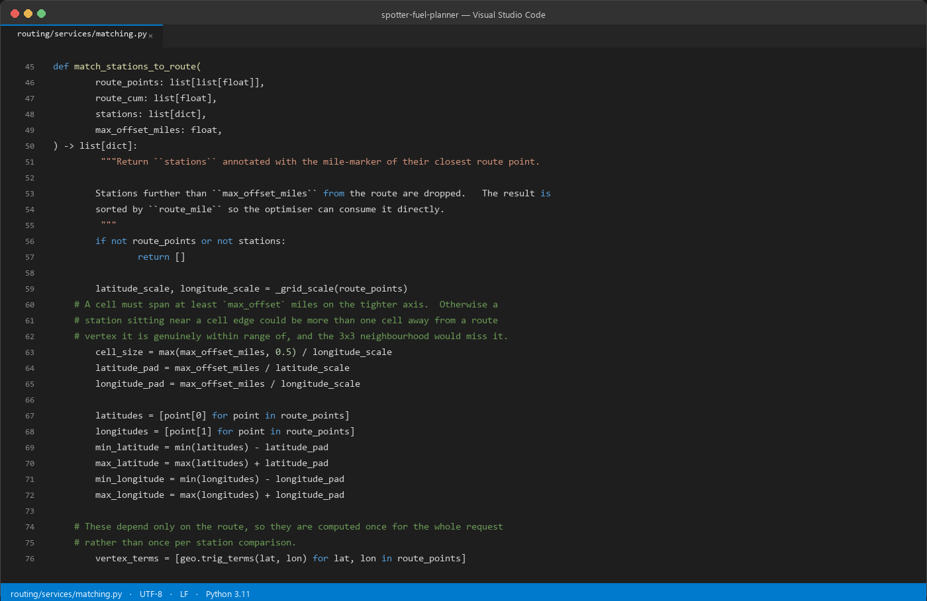
routing/services/matching.py — the spatial grid.
VOICEOVER Station matching was the hot path - it was over ninety percent of a warm request. The naive version is every station against every route vertex. I bucket the route into a grid sized from the corridor, and compare using a chord term that needs no trigonometry but ranks candidates identically.

11. Resolving place names offline
“New York, NY” is looked up in a bundled US Census gazetteer of 50,533 places, so a normal request makes no geocoding call at all and the single routing call is the entire upstream cost. Anything the gazetteer cannot resolve — an address, a landmark, an ambiguous bare city — falls through to the configured provider.
On screen while you present this
OPEN | routing/services/gazetteer.py lines 56–85

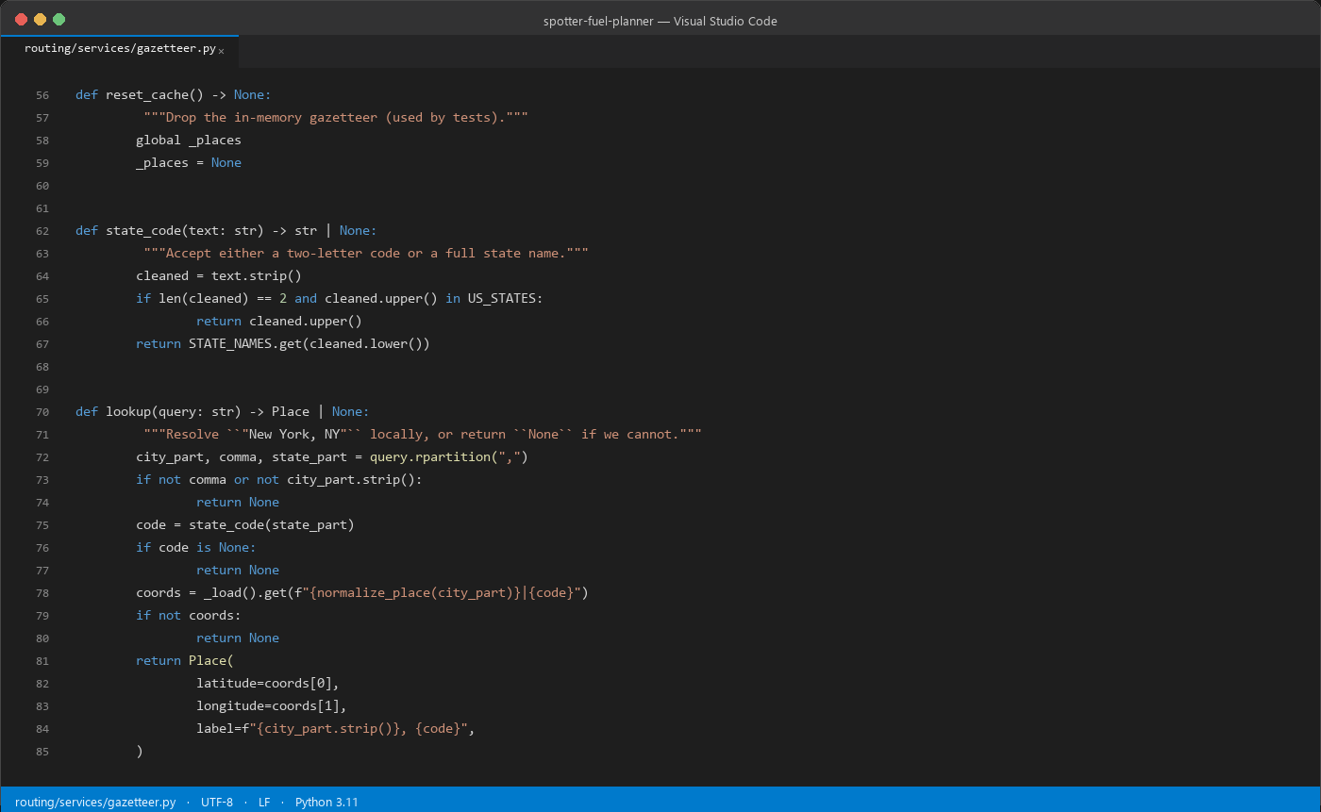
routing/services/gazetteer.py — offline lookup.
VOICEOVER The other half of the call budget is geocoding. City and state names resolve from a bundled Census gazetteer, so a normal request makes no geocoding call at all. Anything unusual falls through to the real provider.

12. Configuration
Every tunable is an environment variable with a working default: the vehicle, the corridor width, the providers, the geometry spacing and the cache. Nothing needs to be edited to change behaviour, and .env.example lists the lot.
On screen while you present this
OPEN | config/settings.py lines 179–208
AND | .env.example the same keys with their defaults

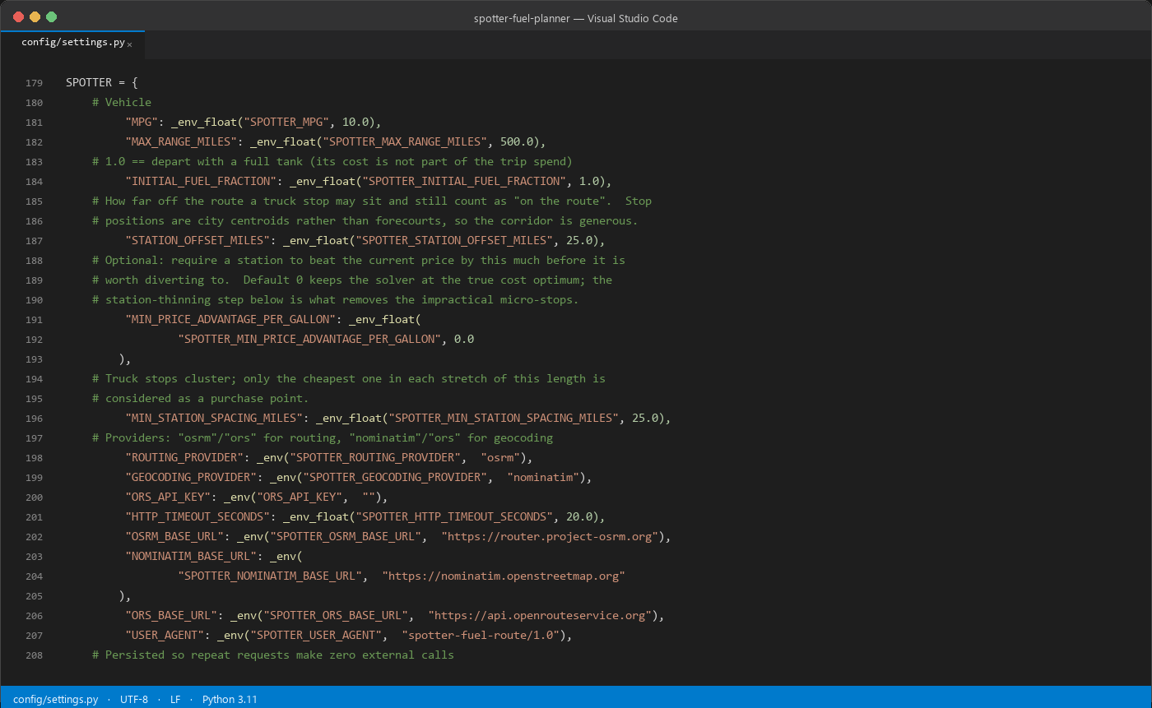
config/settings.py — the SPOTTER block.
VOICEOVER Everything is an environment variable with a sensible default. The vehicle, the corridor width, the providers, the response geometry - so nothing has to be edited to change how it behaves.

13. Deploying
Both halves run on Vercel. One wrinkle worth knowing: Functions get a read-only bundle with a writable /tmp, and this planner writes to its database, so the database is staged into /tmp on the first request of each instance.
Vercel reads either WSGI_APPLICATION or ASGI_APPLICATION, and this project declares both, so the staging hook runs from both entrypoints. With only the WSGI hook the site looks healthy while every database-backed endpoint returns 500.
On screen while you present this
OPEN | config/bootstrap.py lines 33–62
AND | vercel.json the build command and the function budget

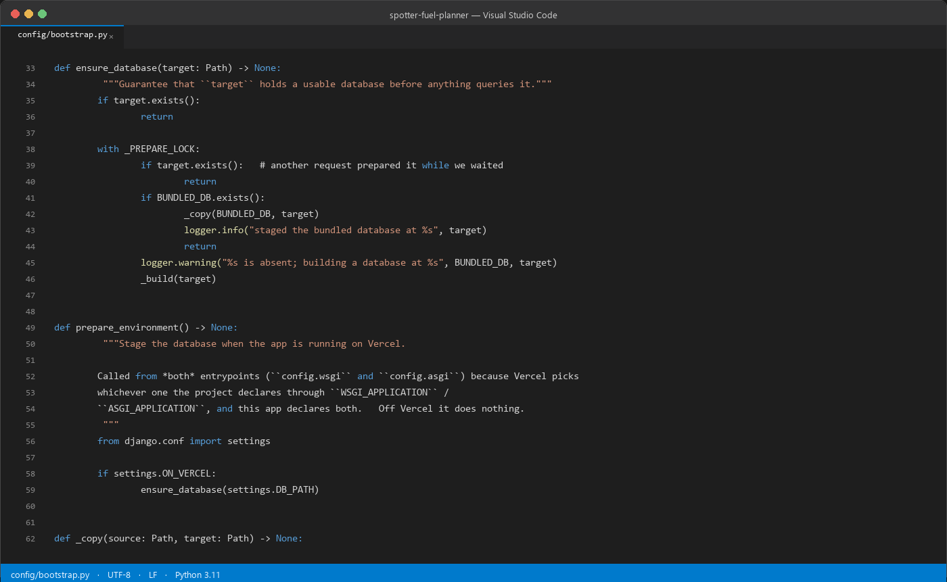
config/bootstrap.py — staging the database for Vercel.
VOICEOVER It is deployed on Vercel, and there was one thing there that bit me. The functions get a read-only bundle, and the planner writes to its database. So on the first request of each instance the database is copied into the writable tmp. Vercel also picks whichever of the two entrypoints you declare, and I declare both, so the hook runs from both.

14. The client
Two components carry most of it. PlannerView posts the request and renders the summary, the manifest and the map; RouteMap owns the Leaflet instance, draws the route with a white casing under the coloured line, and drops a numbered pin at every stop the API returned.
Station names come out of the price file, so anything interpolated into a popup or a table cell is escaped rather than trusted.
On screen while you present this
OPEN | web/src/components/PlannerView.jsx lines 14–41
OPEN | web/src/components/RouteMap.jsx lines 29–58

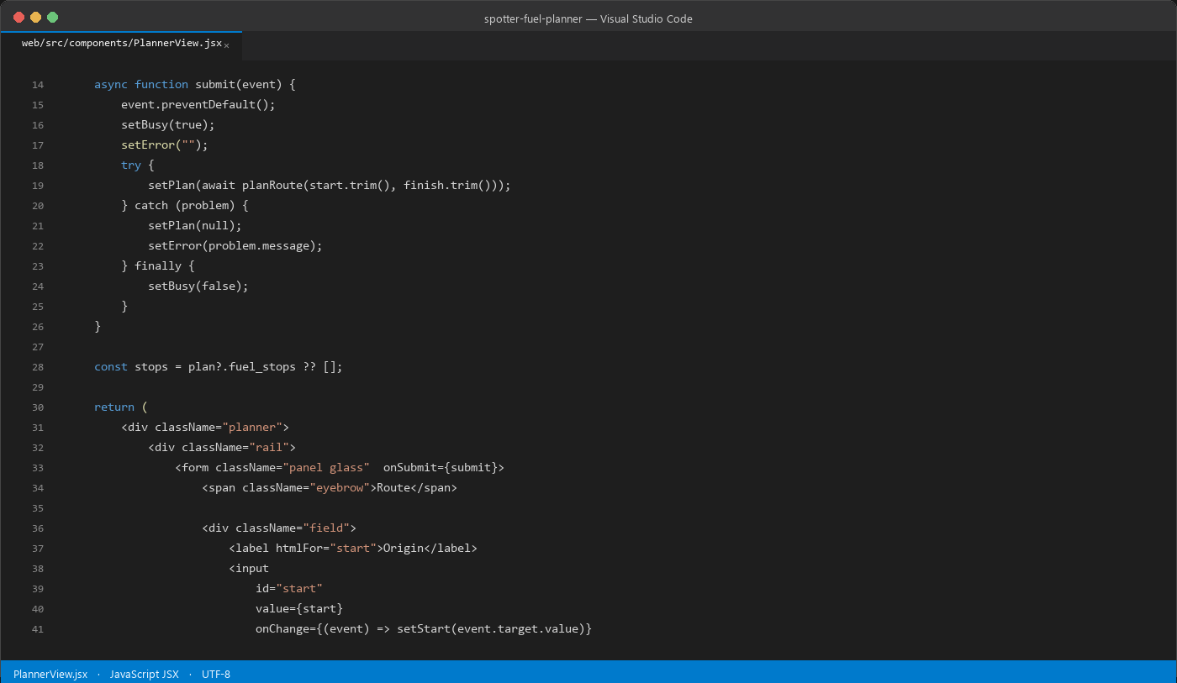
web/src/components/PlannerView.jsx — the request and the result.
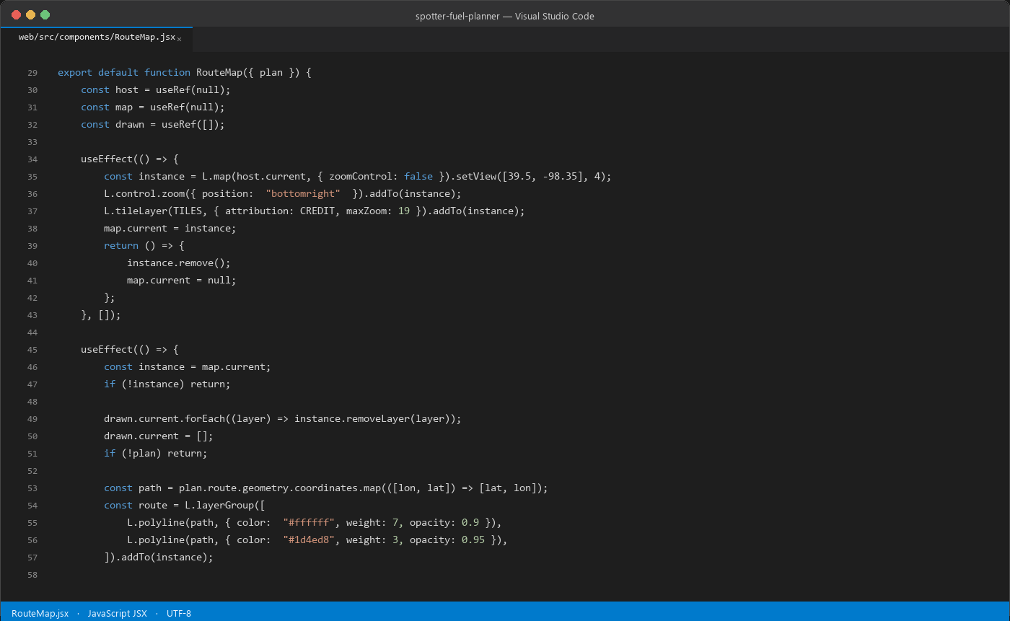
web/src/components/RouteMap.jsx — the Leaflet view.
VOICEOVER On the client it is two components. One posts the request and renders the summary and the manifest, the other owns the map. Names come from the price file, so anything going into a popup or a table cell is escaped rather than trusted.

15. Tests
Seventy tests. The one that matters most cross-checks the solver against an exhaustive search over small instances, so the greedy is verified rather than asserted. The rest cover station matching, offline place resolution, the API contract and the error paths.
None of them touch the network, so CI needs nothing but Python.
On screen while you present this
OPEN | routing/tests/test_optimizer.py lines 122–147
RUN | python manage.py test routing 70 tests, no network needed

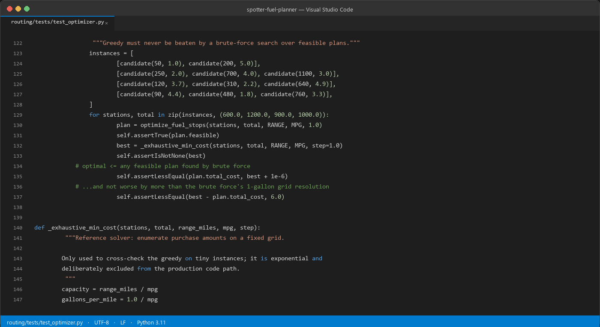
routing/tests/test_optimizer.py — the brute-force cross-check.
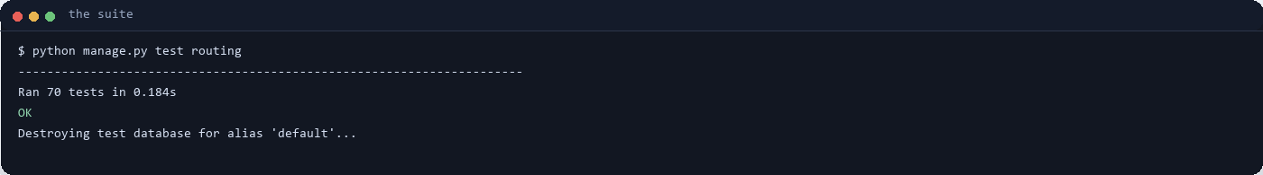
The suite, offline.
VOICEOVER Seventy tests. The one I would point at cross-checks the solver against an exhaustive search on small instances, so the greedy algorithm is verified rather than asserted. None of them need the network.

16. Where it stops
SQLite is the honest weak point: the schema is engine-agnostic, but swapping in Postgres is what you would do before running real traffic, and it would also make the caches shared instead of per-instance on Vercel.
There is no authentication or rate limiting, the caches never expire, and the OpenStreetMap demo servers are fine for this but not for production.
On screen while you present this
OPEN | https://spotter-fuel-route.vercel.app/api/v1/docs/ leave the API docs up while you close

VOICEOVER The honest weak point is SQLite. The schema is engine-agnostic, but Postgres would be the first thing I would add, and on Vercel it would also make the caches shared rather than per-instance. There is no auth or rate limiting either, and the caches never expire.

