

1. Getting Started with Google Maps API

Before you can get started rendering maps, using services you need to have your own Google Developer Project.

If you don’t already have one, you can go to the [**Google APIs Console**](https://console.developers.google.com/) and create your own project. This is free and will allow you to generate your own API key to use within your site.

1. Visit [**https://console.developers.google.com**](https://console.developers.google.com/)
2. 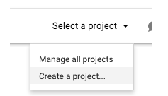Sign in with your Google - i.e. yourname@gmail.com. If you don't have one, you can go to [**accounts.google.com**](https://accounts.google.com/) to create one for free.
3. Click on "Select a Project" and then "Create a Project" in the upper right side of the screen.
4. Name your project something descriptive, such as "GoogleMapsProject"

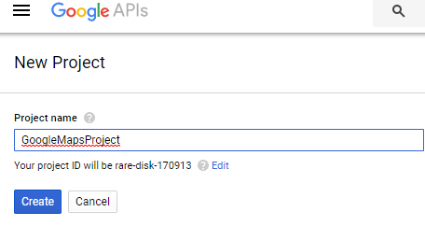

1. Click the "Create" button.
2. Click on the "Google Maps Geocoding API" under "Google Maps APIs"

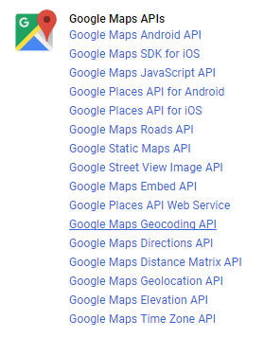

1. Click the "Enable" button

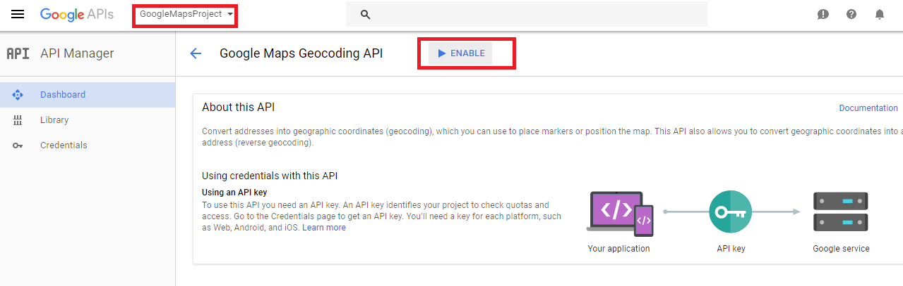

1. Repeat steps 6 and 7 for the following APIs (highlighted in yellow) which we'll use in this course:   
   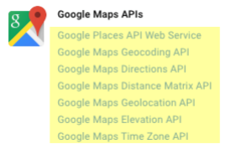
2. Click the “Credentials” menu item on the left of the screen
3. Click the “Create Credentials” button
4. Select “API Key” from the options that appear.  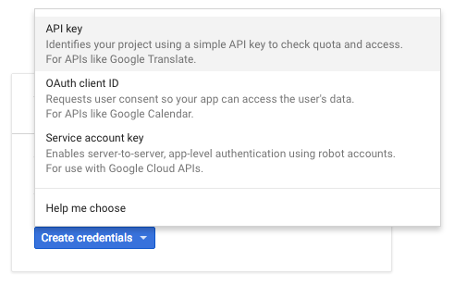
5. Rename your API Key something descriptive, such as MapsAPIKey. It should reflect your intended use of the key. Click the “Create” button

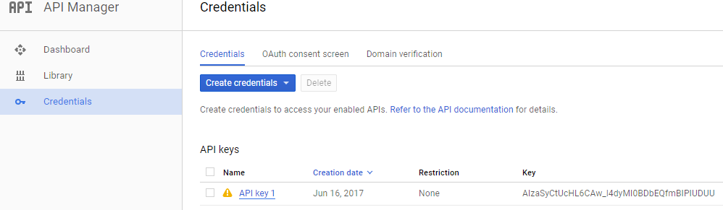

1. Copy this API in a Notepad for ready reference.
2. Now that you have an API key, and the Google Maps APIs are enabled, you are ready to proceed with the course.
3. Getting Started with Twitter API
4. Create Twitter Account
5. To get started with using Twitter API you need to first have your mobile number registered with Twitter. Hence, login to <https://twitter.com/>
6. Go to Profile Icon at the Right side as below. Select Settings and Privacy.

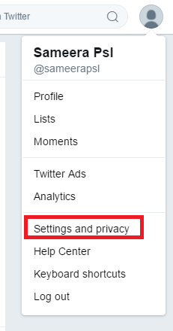

1. Add your mobile number details here.

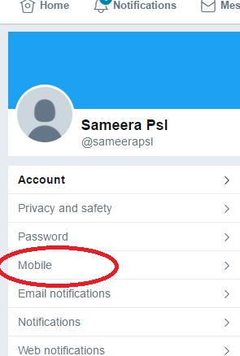

1. Create Twitter Application using URL : <https://apps.twitter.com/>

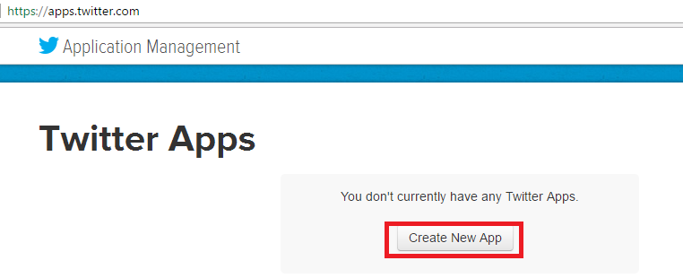

1. Enter Project details and a placeholder website.

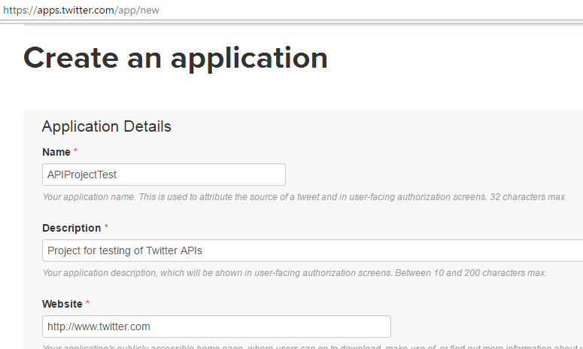

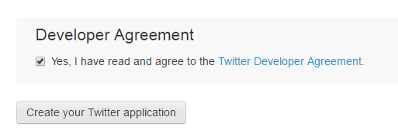

1. Go to Keys and Access Tokens panel, and copy the Consumer Key and Consumer Secret in a notepad for ready reference.

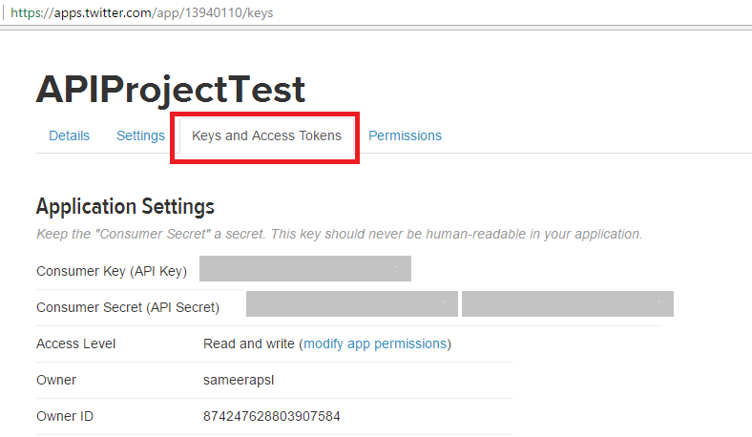

1. On the same page , scroll below to Create Access Token

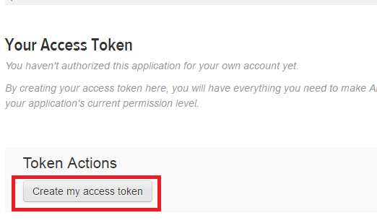

1. Copy the Access Token and Access token secret in the same notepad for ready reference.

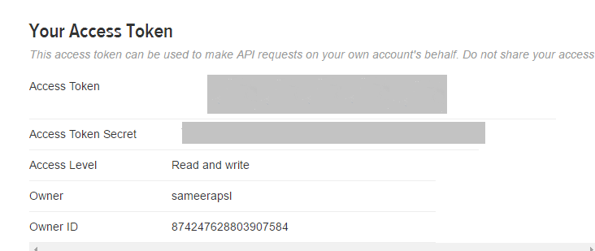

1. Now you are ready to get started with Programming with Twitter API.