
Department of Computer Science and Engineering
KL University, Hyderabad

Project Based Learning (PBL) Detailed Project Report

MotorVibe
Industrial Motor Condition Monitoring and Health Dashboard

Submitted by
Team No: 1
Student ID | Name
2520040039 | N. Hasini
2520040119 | Sameera

Under the guidance of
Dr. Karumuri Sri Rama Murthy
Assistant Professor, Department of CSE, KLU Hyderabad

[Academic year / semester: to be filled]

Abstract
- MotorVibe is a web-based dashboard for monitoring the condition and health of industrial motors.
- Physical sensors attached to the motor measure temperature, vibration and electrical current.
- A Node.js and Express.js backend receives these readings and checks them against defined limits.
- Readings and motor information are stored in a Supabase database.
- A React.js frontend shows live values, parameter trend graphs and a Normal, Warning or Critical health status.
- Operators can identify abnormal operating conditions early and avoid unexpected breakdowns.
- This reduces maintenance cost and improves equipment life.
- Planned enhancements include email or SMS alerts, machine learning fault classification and multi-motor monitoring.

Contents
1. Introduction
2. Problem Description
3. Technologies Used
4. System Architecture
5. Implementation Details
6. Output Screens
7. Testing and Results
8. Future Enhancements
9. Conclusion
References
Appendix A: Team Contributions

1. Introduction

1.1 Overview
MotorVibe is an Industrial Motor Condition Monitoring and Health Dashboard. It helps users track key motor parameters such as temperature, vibration and current, so that potential issues can be identified early and unexpected failures can be avoided.

1.2 Aim
To monitor the condition of industrial motors and detect abnormal operating values before they lead to serious problems.

1.3 Target Users
Plant operators, maintenance teams and industry professionals who are responsible for keeping motors in working order.

1.4 Why It Matters
Motors drive many industrial processes. Early detection of abnormal conditions helps prevent unexpected breakdowns, reduces maintenance cost and improves equipment life.

1.5 Objectives
- Measure temperature, vibration and current of a motor using physical sensors.
- Process and check the readings against defined limits in a backend service.
- Store readings and motor information in a database.
- Display live values, trend graphs and a health status on a web dashboard.

2. Problem Description

2.1 Problem Statement
Industrial motors usually run for long hours, and a failure can stop production. Faults such as overheating, imbalance, misalignment and bearing wear develop gradually. If they are not noticed in time, they can lead to serious damage and downtime.

2.2 Limitations of Periodic Manual Checks
- Inspections happen at intervals, so early warning signs between checks can be missed.
- Readings taken by hand are difficult to compare over time.
- There is no single place to see the current state of the motor.

2.3 Proposed Solution
MotorVibe continuously collects readings from physical sensors, checks them against limits, stores them, and presents them on a web dashboard with trend graphs and a clear Normal, Warning or Critical status.

3. Technologies Used
Layer | Technology | Role in the project
Frontend | React.js | User interface: home page, dashboard, trend graphs and health status panel.
Backend / middleware | Node.js + Express.js | REST API that receives sensor readings, applies limit checks and serves data to the frontend.
Database | Supabase | Hosted PostgreSQL database for motor information and sensor readings.
Data source | Physical sensors | Measure temperature, vibration and current of the motor.
Development tools | VS Code, Git, Postman | Development, version control and API testing.

[Sensor models, microcontroller / gateway and communication method: to be filled by the team.]

4. System Architecture
The system has four parts: the motor with its sensors, a Node.js and Express.js backend, a Supabase database and a React.js frontend.
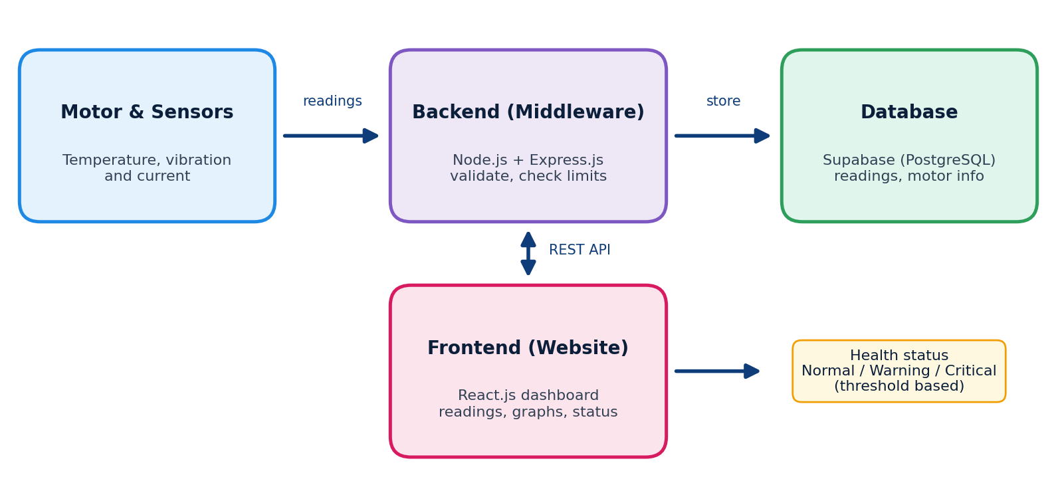
Figure 4.1: MotorVibe system architecture

4.1 Data Flow
- Sensors measure temperature, vibration and current of the motor.
- The Express.js API receives and validates each reading.
- The backend checks the values against limits to determine the health status.
- Readings and status are stored in Supabase.
- The React.js dashboard requests data through the API and displays it.

[Sensor-to-backend link (for example microcontroller and network method): to be filled by the team.]

5. Implementation Details

5.1 Sensor Data Acquisition
Physical sensors measure the motor parameters. The readings are sent to the backend.
Item | Details
Temperature sensor | [model / placement]
Vibration sensor | [model / placement]
Current sensor | [model / placement]
Microcontroller / gateway | [model]
Sampling interval | [value]
Circuit / wiring photo | [insert figure]

5.2 Backend (Node.js + Express.js)
The backend acts as middleware between the sensors, the database and the dashboard. Its responsibilities are:
- Receive sensor readings and validate them.
- Compare values with the defined limits and assign a health status.
- Save readings and motor information in Supabase.
- Provide data to the frontend through REST endpoints.

Endpoint | Method | Purpose
[route] | [GET/POST] | [purpose]
[route] | [GET/POST] | [purpose]
[route] | [GET/POST] | [purpose]
Table 5.1: API endpoints (to be completed from the code)

5.3 Database (Supabase)
Supabase stores the motor information and the readings. The data to be stored is outlined below.
Data | Fields (update to match the actual schema)
Motor information | [motor id, name, other details]
Sensor readings | [reading id, motor id, temperature, vibration, current, health status, timestamp]

5.4 Health Status Logic
The health status is decided by thresholds. The dashboard shows Normal when all parameters are within safe limits, and Warning or Critical when limits are exceeded.
Status | Meaning | Limit values
Normal | All parameters are within safe limits. | [to be filled]
Warning | One or more parameters are approaching or above a limit. | [to be filled]
Critical | One or more parameters are well beyond safe limits. | [to be filled]

5.5 Frontend (React.js)
- Home page: explains the purpose of the website and gives quick access to the dashboard.
- Dashboard: shows live readings of temperature, vibration and current, with the motor health status.
- Parameter trends: a graph that compares values over time; the user can switch between parameters.
- Motor health status panel: shows whether the motor is operating normally or needs attention.
- About page: project information.

6. Output Screens
[Replace each placeholder with a real screenshot of the working website.]
[Insert screenshot: Home page]
Figure 6.1: Home page
[Insert screenshot: Motor dashboard with live readings]
Figure 6.2: Motor dashboard
[Insert screenshot: Parameter trend graph]
Figure 6.3: Parameter trends
[Insert screenshot: Motor health status]
Figure 6.4: Motor health status

7. Testing and Results
The table below lists the checks to be performed and recorded. Fill in the actual outcomes after testing with the physical setup.
Test | Expected result | Actual result | Status
Sensor reading reaches backend | Reading received and accepted | [ ] | [ ]
Reading is saved | Record appears in Supabase | [ ] | [ ]
Values within limits | Status shows Normal | [ ] | [ ]
Value above warning limit | Status shows Warning | [ ] | [ ]
Value above critical limit | Status shows Critical | [ ] | [ ]
Dashboard refresh | Latest values shown | [ ] | [ ]
Trend graph | Values plotted over time | [ ] | [ ]

8. Future Enhancements
- Store historical data for better analysis.
- Add machine learning for fault classification.
- Send alerts by email or SMS for critical conditions.
- Extend to multi-motor and remote monitoring.

9. Conclusion
MotorVibe provides a simple and effective way to monitor industrial motor health. It supports early detection of abnormal conditions, helps reduce downtime and maintenance cost, and supports safer and more reliable operations.

References
- React documentation. https://react.dev
- Node.js documentation. https://nodejs.org/docs
- Express.js documentation. https://expressjs.com
- Supabase documentation. https://supabase.com/docs
[Add motor condition monitoring papers/books and sensor datasheets used.]

Appendix A: Team Contributions
Name | ID | Contribution
N. Hasini | 2520040039 | [to be filled]
Sameera | 2520040119 | [to be filled]

