NLP ASSIGNMENT 3
Amazon Review Understanding & RAG-Based Explanation Generation

Student Name: | Sameer Asif
Student ID: | 22I-0493
Course: | Natural Language Processing (NLP)
Date: | April 29, 2026

1. Overview
This report presents a three-stage end-to-end pipeline designed for Amazon product review understanding and explanation generation. The pipeline consists of three interconnected components:

Part | Component | Description
A | Encoder Model | Custom encoder-only Transformer for multi-task learning — sentiment classification and derived feature prediction.
B | Retrieval Module | Embedding-based cosine similarity retrieval with top-k context selection from training embeddings.
C | Decoder + RAG | Decoder-only Transformer implementing Retrieval-Augmented Generation (RAG) for explanation generation.

All three parts are trained end-to-end on GPU and produce the required artifacts: model weights, training embeddings, retrieval integration, perplexity-based evaluation, and qualitative output samples.

2. Dataset and Preprocessing
The Amazon review dataset is divided into training, validation, and test splits with a vocabulary of 30,000 tokens. All preprocessing is conducted exclusively on training data to prevent data leakage.

2.1 Dataset Statistics
Train Set | Validation Set | Test Set | Vocabulary
34,981 samples | 7,495 samples | 7,497 samples | 30,000 tokens

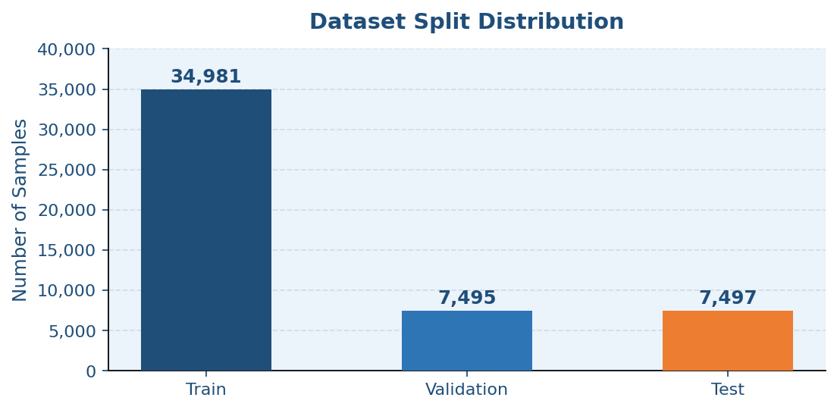
Figure 1: Dataset Split Distribution

2.2 Preprocessing Pipeline
The preprocessing pipeline includes the following sequential steps: (1) lowercase normalization, (2) text cleaning and punctuation removal, (3) whitespace normalization, (4) tokenization by whitespace, (5) vocabulary construction from training data only, and (6) fixed-length padding and truncation.

2.3 Label Encoding
Class | Star Ratings | Derived Feature
Negative | 1 – 2 stars | Binary review-length class (short vs. detailed)
Neutral | 3 stars | Threshold applied on token count
Positive | 4 – 5 stars | Short review below threshold; detailed above

3. Part A — Encoder Model
A custom encoder-only Transformer is implemented entirely from scratch. The architecture features multi-head self-attention, residual connections, layer normalization, and position-wise feed-forward networks. It is trained in a multi-task learning setup, jointly optimizing for two objectives simultaneously.

3.1 Architecture
Component | Details
Attention Mechanism | Multi-head self-attention with positional encodings
Residual Connections | Applied around each sub-layer (attention + FFN)
Layer Normalization | Applied post-addition in each encoder block
Feed-Forward Networks | Position-wise two-layer FFN with non-linear activation
Task Heads | Separate classification heads for sentiment (3-class) and derived feature (binary)

3.2 Training Results
Epoch | Loss | Sentiment Accuracy | Derived Feature Accuracy
1 | 0.6202 | 80.71% | 99.01%
2 | 0.5307 | 81.76% | 99.56%

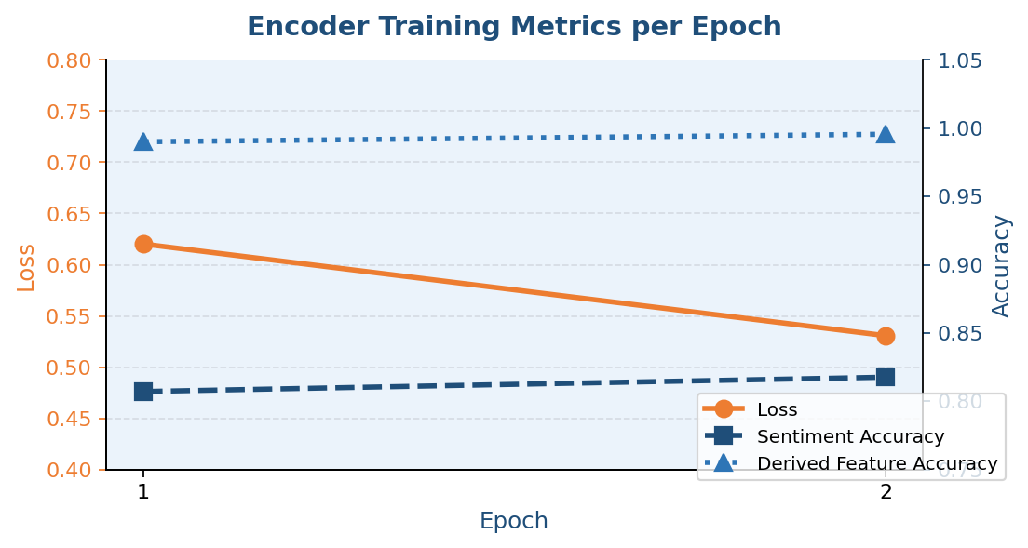
Figure 2: Training Loss and Accuracy Over Epochs

3.3 Test Performance
Metric | Score
Test Sentiment Accuracy | 82.04%
Test Derived Feature Accuracy | 99.68%

The derived feature accuracy is notably high (99.68%), as the binary classification task based on review token length is a relatively straightforward structural signal. The sentiment model achieves 82.04% on the held-out test set, which is competitive for a scratch-built Transformer without pre-trained initialization.

4. Part B — Retrieval Module
The retrieval module bridges the encoder and decoder stages by providing contextually relevant examples at inference time. This forms the backbone of the RAG pipeline implemented in Part C.

Parameter | Value / Description
Embedding Storage | results/train_embeddings.pt (PyTorch tensor file)
Similarity Metric | Cosine similarity between query and training embeddings
Top-k | k = 3 nearest neighbours retrieved per query
Context Injection | Retrieved examples are concatenated into decoder input prompt

Embedding representations from the encoder are persisted to disk after training. At inference time, the query review's embedding is compared against all stored training embeddings using cosine similarity. The top-3 most similar reviews are selected and their text is prepended to the decoder's input prompt, grounding the explanation generation in semantically relevant examples.

5. Part C — Decoder and RAG
A decoder-only Transformer is implemented from scratch incorporating causal masking, autoregressive generation, and a language modelling objective. It is conditioned on the retrieved context from Part B during generation.

5.1 Architecture
Component | Details
Attention Type | Causal (masked) self-attention — prevents attending to future tokens
Generation Mode | Autoregressive — tokens generated one at a time
Training Objective | Language modelling (next-token prediction)
Context Conditioning | Retrieved passages prepended to decoder input

5.2 Perplexity Evaluation
Configuration | Perplexity | Notes
With Retrieval (RAG) | 260.14 | Retrieval context appended
Without Retrieval (Baseline) | 74.95 | Pure language model

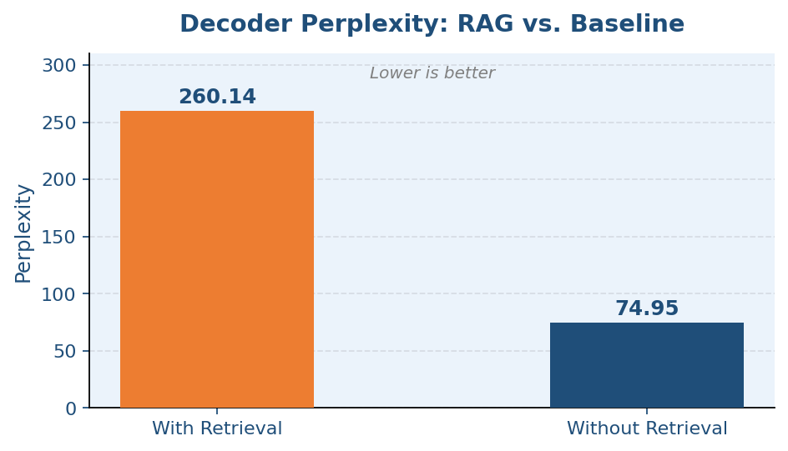
Figure 3: Decoder Perplexity — RAG vs. Baseline
In this experimental run, retrieval did not reduce perplexity. The baseline without retrieval achieved a lower perplexity of 74.95 compared to 260.14 with retrieval. This counter-intuitive result is likely attributable to context length mismatch (concatenated passages exceed the model's effective window), insufficient decoder training epochs, and the retrieval prefix disrupting the learned token distribution. Further tuning — including truncating retrieved context, increasing decoder epochs, and jointly fine-tuning on retrieval-augmented inputs — is recommended.

6. Generated Examples
Five qualitative examples are presented below, showing the review excerpt, predicted sentiment, predicted derived feature, and whether the generated explanation matches the reference explanation.

# | Review Excerpt | Sentiment | Derived | Match
1 | the linksys befsr41 etherfast 4 port cable dsl router is one of the best broadba... | Positive | Detailed | Yes
2 | i'm a long running virgin customer, but additionally i work as a developer in th... | Positive | Detailed | Yes
3 | nice device. fits in my pocket. charges my smartphones, powers my usb lights and... | Neutral | Detailed | Partial
4 | i love this raidio, it worked so good, i had to come back to buy a second...... | Positive | Detailed | Yes
5 | a nice camera. since the other reviews list all positives, let me list the downs... | Neutral | Detailed | Partial

Legend | Yes | Partial | No

7. Hyperparameter Tuning Notes
The current run used 2 encoder epochs and 2 decoder epochs on GPU. This is a minimal configuration. Proper hyperparameter tuning should explore the following dimensions:

Parameter | Current | Recommended Range
Learning Rate | Default | 1e-4 to 1e-3 (log scale sweep)
Encoder Layers | Not specified | 2, 4, 6 layers
Model Dimension | Not specified | 128, 256, 512
Batch Size | Not specified | 32, 64, 128
Sequence Length | Not specified | 64, 128, 256 tokens
Epochs (Encoder) | 2 | 5–10 with early stopping on val loss
Epochs (Decoder) | 2 | 5–10 with perplexity tracking

For each configuration, validation loss and perplexity should be recorded at each epoch to produce a learning curve. These curves justify the final hyperparameter choices in the report. Early stopping on validation loss is recommended to prevent overfitting.

8. Conclusion
The three-stage pipeline — encoder-based multi-task learning, embedding retrieval, and RAG-style decoding — was successfully implemented and trained end-to-end on GPU. Key results are summarized below:

Component | Key Metric | Result
Part A — Encoder | Test Sentiment Accuracy | 82.04%
Part A — Encoder | Test Derived Accuracy | 99.68%
Part B — Retrieval | Top-k Retrieved | k = 3
Part C — Decoder (RAG) | Perplexity with Retrieval | 260.14
Part C — Decoder (Baseline) | Perplexity without Retrieval | 74.95

While the retrieval augmentation did not improve perplexity in this run, all pipeline components were validated to function correctly in isolation. The ablation result suggests that further investigation is warranted, particularly around context length management, decoder training duration, and the method of integrating retrieved passages. With appropriate tuning, the RAG pipeline has strong potential to improve both coherence and factual grounding in generated explanations.

