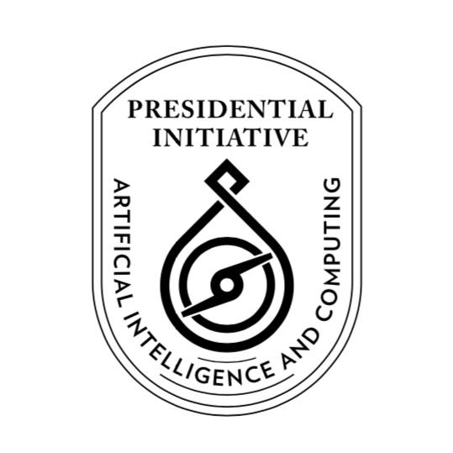

**Presidential Initiative for Artificial Intelligence and Computing (PIAIC)**

https://www.piaic.org

Artificial Intelligence Specialist Program

Course Syllabus

**Quarter I: AI-101 AI for Everyone and Fundamentals of Programming using Python**

First Quarter 2019 (12 Weeks)

**Teaching Team: Inam Ul Haq, Dr. Noman Islam, Anees Ahmed, Nasir Hussain, Muhammad Qasim, Muhammad Ali, Muhammad Hamza Khan, Aqsa Abdul Qadir, Fayyaz Farooq, Gulraeez Gulshan, Hafiz Muhammad Shahid, Jalees Ur Rehman Khan, Komal Aftab, Mansoor Hussain, Mohsin Iqbal, Muhammad Ali, Muhammad Asadullah, Muhammad Hamza Khan, Muhammad Haseeb Amjad, Muhammad Shahzad Ahsan, Muhammad Sohaib, Muhammad Usman, Nehal Ahmed, Ramsha Munawarah Azeemi, Saqib Arfeen, Shafqat Soomro, Shifa-ur-Rehman Jamali, Syed Hamza, Syed Hamza Ali, Syed Muhammad Masab, Syed Wajahat Ali Naqvi, Umair Shahzad and Waqas Ali Munawar**

**Class Sections:**

**Sir Adamjee Institute of Management Sciences**

**Saturday 05:15 PM to 08:15 PM**

**Sunday 12:15 PM to 03:15 PM**

**Sunday 03:30 PM to 06:30 PM**

**Saylani Welfare Headoffice**

**Saturday 03:30 PM to 06:30 PM**

**Saturday 06:45 PM to 09:45 PM**

**Sunday 09:00 AM to 12:00 PM**

**Sunday 12:15 PM to 03:15 PM**

**Sunday 06:45 PM to 09:45 PM**

**Saylani Welfare Gulshan Campus**

**Saturday 09:00 AM to 12:00 PM**

**Saturday 12:15 PM to 03:15 PM**

**Saturday 06:45 PM to 09:45 PM**

**Sunday 09:00 AM to 12:00 PM**

**Sunday 12:15 PM to 03:15 PM**

**Sunday 03:30 PM to 06:30 PM**

**Sunday 06:45 PM to 09:45 PM**

**Sindh Boy Scouts Association**

**Sunday 09:00 AM to 12:00 PM**

**Sunday 06:45 PM to 09:45 PM**

**Course Description:** In this course, you'll learn about basic programming concepts using Python, such as lists, dictionaries, classes, functions and loops, and practice writing clean and readable code with exercises for each topic. You'll also learn how to make your programs interactive and how to test your code safely before adding it to a project. It is a fast-paced, thorough introduction to programming with Python 3.7 that will have you writing programs, solving problems, and making things that work in no time. In this quarter we will also learn Git, the distributed version control system. We will also review Git based GitHub services.

**Please bring a Laptop with you for the Classes (Required, but not mandatory)**

**Preparation for International Microsoft Python Certification:**

[Exam 98-381: Introduction to Programming Using Python by Microsoft](https://www.microsoft.com/en-us/learning/exam-98-381.aspx)

**Textbooks:**

1. [A Smarter Way to Learn Python: Learn it faster. Remember it longer by Mark Myers](https://www.amazon.com/Smarter-Way-Learn-Python-Remember-ebook/dp/B077Z55G3B/ref=sr_1_8)
2. [Learn Version Control with Git: A step-by-step course for the complete beginner by Tobias Günther](https://www.amazon.com/Learn-Version-Control-step-step-ebook/dp/B00K54OL8I/ref=sr_1_3)

**Homework Exercises:**

<http://www.asmarterwaytolearn.com/python/index-of-exercises.html>

**Reference books:**

1. [Python Crash Course: A Hands-On, Project-Based Introduction to Programming by Eric Matthes](https://www.amazon.com/Python-Crash-Course-Hands-Project-Based-ebook/dp/B018UXJ9RI/ref=sr_1_1)
2. [Git Essentials by Ferdinando Santacroce](https://www.amazon.com/Git-Essentials-Ferdinando-Santacroce-ebook/dp/B00WX1CWIC/ref=sr_1_3)

**Certification Exam Learning Material:**

<https://sites.google.com/a/nu.edu.pk/noman-islam/exam-98-381-introduction-to-programming-using-python>

**PIAIC Announcements Facebook Group:** <https://www.facebook.com/groups/piaic/>

**Course Facebook Group:** <https://www.facebook.com/groups/deep.learning.edu/>

**Android and iOS App for Class Attendance and Collaboration:**

**Esox AI by Mr. Asif Shah, Mr. Nasrullah Khan and Mr. Kamran Ali**

**Portal for online and onsite students:**

<https://portal.piaic.org/>

**Grading:**

Students will be graded based on Percentile

<https://en.wikipedia.org/wiki/Percentile>

<https://en.wikipedia.org/wiki/Percentile_rank>

A-Grade: 78- 99 Percentile

B-Grade: 41- 77 Percentile

C-Grade: 23- 40 Percentile

F-Grade: 1 - 22 Percentile

Anyone who is in the bottom 22th Percentile i.e. F Grade will deem to have failed and will not be promoted to the next quarter and will be removed from the program.

Note: Anyone absent from an exam will be deemed to have received a score of zero.

**Course Outline:**

1. **Introduction to Machine Learning, Data Science and AI** (Week 1, 2 and 3)

AI for Everyone

<https://www.coursera.org/learn/ai-for-everyone>

Note: All optional sections in AI for Everyone course are required sections in this course.

Homework: Please watch the above videos at least three times at home

Additional Homework Viewing:

<https://aischool.microsoft.com/en-us/business/learning-paths/introduction-to-ai-technology-for-business-leaders/explore-state-of-the-art-ai-technology/introduction-to-ai-technology>

**AI for Everyone Quiz in Week 3**

Total Questions: 114, Total Time: 150 minutes

1. **Fundamentals of Version Control with Git** (4A)  
   Chapters 1, 2, and 3, Learn Version Control with Git: A step-by-step course for the complete beginner by Tobias Günther

Homework:

<https://www.datacamp.com/courses/introduction-to-git-for-data-science>

**For practice:** <https://try.github.io/levels/1/challenges/1>

1. **Python Programming Part 1** (Weeks 4B, 5 and 6)  
   Chapters 1-20 of **A Smarter Way to Learn Python: Learn it faster. Remember it longer by Mark Myers**

Homework:

<http://www.asmarterwaytolearn.com/python/1.html>

**Programming Assignments will also be given.**

**Python Quiz 1 in Week 6**

1. **Python Programming Part 2** (Weeks 7 and 8)  
   Chapters 21-40 of **A Smarter Way to Learn Python: Learn it faster. Remember it longer by Mark Myers**

Homework:

<http://www.asmarterwaytolearn.com/python/21.html>

**Programming Assignments will also be given.**

**Python Quiz 2 in Week 8**

1. **Python Programming Part 3** (Weeks 9-12)  
   Chapters 41-77 of **A Smarter Way to Learn Python: Learn it faster. Remember it longer by Mark Myers**

Homework:

<http://www.asmarterwaytolearn.com/python/41.html>

**Programming Assignments will also be given.**

**Python Quiz 3 in Week 12**

1. **Python Data Science Project** (Week 12)

**Final Python Quiz**