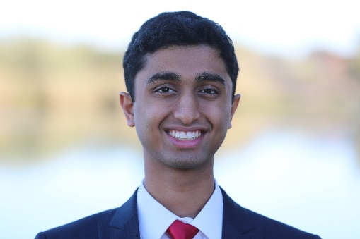Sameer Channar is a Computer Science major at Arizona State University in his third year. He is focused on applying programming and statistics towards medicine, with emphasis on computer vision and machine learning. Serving as the lead intern at the Mathematical Neuro-Oncology lab at Mayo Clinic, Sameer trains neural networks to analyze cancerous brain MRIs and organizes weekly journal clubs for his team. He hones his technical skills through SunHacks hackathons, IBM disaster-relief coding initiatives, and entrepreneurship camps at ASU. On weekends, Sameer can be found volunteering at the Lodestar Day homeless shelter, or helping senior citizens see their grandchildren through Skype at the Sunrise of Gilbert elderly living facility. He also volunteers in the Tempe St. Luke’s hospital emergency room. Once a semester, Sameer hosts a Phoenix-wide table tennis tournament at ASU. Sameer’s combination of engineering and medicine stems from his diverse high school experiences. He enjoyed volunteering for radiologists at Banner Health for two years, but in his senior year, Sameer began working on a ranch at AniCell Biotech, cleaning horse poop and collecting horse milk by hand from pregnant mares. He created a predictive model for horse birthing due dates based on statistical analysis of the milk nutrient levels. His model helped the company care for the horses more efficiently when birthing at night and reduced the danger to the mother and foal. Sameer appreciated the crucial tools that engineering brings to any field, especially medicine, and decided to merge his interests at ASU, intending to pursue medical school with a computer science background. Originally from Chicago, Sameer lives near ASU with his family in Phoenix, Arizona.