Indoor Navigation System

Problem Statement: -

* On every single day we require to move around multiple places in and out of our office, to help in the outside world we got the maps proposed by Google.
* But in here, at the office just to find a different department or an un-heard conference room where we haven't visited before cost us a ton of time.
* On the other hand, as being an evolving and rapid growing company, multiple newly built workspaces would also be accommodated and finding new regions and departments could a difficult thing.

Propose Solution: -

“Find Your Way” is an application that will help you to look for your path in an augmented reality. The app will show virtual arrows on the camera’s live feed, to show the directions towards your destination in real time. This app will help a lot of people to find their way inside of the office irrespective of them being a fresher or experienced one.

Implementation areas: -

* Airports
* Shopping mall
* Office Spaces
* Factories
* Hospitals
* Large Hotels

Informative Points from different Searches: -

* **AR-Core for Android** and **AR-Kit for iPhone** – Their will be an information plate which is scanned, and this allows to locate the exact location of the person in the building.
* We can optimise passenger flows to find the easiest rote possible, increasing the staff productivity in office and hospitals.
* For the maps we can use precalculated paths or any algorithm to find the shortest path.
* We can utilize Wi-Fi fingerprinting, augmented reality (AR), and digital compass technologies in an integrated Android-based app. Specifically, we can use the Wi-Fi fingerprinting method to determine user position, augmented reality to display real-time navigation information, and a compass to determine destination direction.
* The algorithm that we can use is **A* Search Algorithm**, this is mainly based on the using **heuristic** (enabling a person to discover or learn something for themselves.) methods to achieve optimality and completeness, and is a variant of the best-first algorithm. This internally use the graph search algorithms like Dijkstra’s algorithm in a more optimum way.
* Now a drawback to use the heuristic algorithms is one that is designed to solve a problem in a faster and more efficient fashion than traditional methods by sacrificing optimality, accuracy, precision, or completeness for speed (This will give the best fit solution or one most close to it, for the problem).
* There must be AR Core installed for android devices whereas AR Kit in the iPhone, with good amount of processing power.
* Our possible approaches: -
  + via pre-defined elements which the app recognizes

Creating a 3D model of the whole area according to the 2D map, then additional capturing multiple photos of the area and training the model using image recognition techniques, from which it will recognise the path via live camera (position based on visual objects)

* **Disadvantage**: -Performance issue for the real time identification of the images and finding the path.
  + via smartphone compass – attention: can be very inaccurate due to disturbances
  + via external signals
    - Bluetooth beacons-Bluetooth Beacons broadcast their identifier to nearby portable electronic devices.
      * **Disadvantage**: -But this technology enables smartphones/tablets and other devices to perform actions and navigation when only near to a beacon.
    - Wi-Fi Positioning System- WPS uses the characteristics of nearby wi-fi hotspots and other wireless access points to find where a device is located. The most common and widespread localization technique used for positioning is based on measuring the intensity of the received signal and the method of RSSI fingerprinting using SSID internally.

We can investigate the Angle of arrival, Time of arrival for more accuracy.

* + - * **Disadvantage**: -But the accuracy depends on the number of the access points whose positions have been entered into the database.
    - Visible Light Communication (VLC)) -This is a  is a data communications variant which uses [visible light](https://en.wikipedia.org/wiki/Visible_light) between 400 and 800 [THz](https://en.wikipedia.org/wiki/Hertz) (780–375 nm). VLC is a subset of [optical wireless communications](https://en.wikipedia.org/wiki/Optical_wireless_communications) technologies.
    - Radio Frequency Identification Tags (RFID) - RFID uses electromagnetic fields to automatically identify and track tags attached to objects.
      * **Disadvantage**: - But a large amount of data may be generated that is not useful for managing indoor navigation or other applications and makes the system inefficient.

AR based navigating system

Flow Work: -

In our proposed system the heart of the project goes with AR Core SDK which basically takes the real-world objects as input through the camera and converts them into logical and unique features. **AR Core SDK** has a special property called **places learning model** which is based on Machine Learning which helps it to extract the features from real world objects. AR Core also uses **motion tracking** which also helps in the **extraction of features** in accordance with the **movement and orientation** of the phone. So, this is how are proposed system works: -

* Firstly, the user will open an application based on AR.
* This app will intimate the user either to create his own map/route or will ask him/her if the user needs assistance with navigation.
* If the user clicks on the create map, then the user automatically will be asked the name of source and destination and will be asked to start his/her camera.
* After the camera is initialised the application using AR Core will start extracting features from the camera input and user will be asked for marking waypoints at the place where feature extraction has been completed.
* This will complete the mapping phase.
* If the user clicks on assist me for indoor navigation the user will be next asked for destination.
* Once the destination has been taken the camera will be initialised and features from current location of the user will be extracted.
* These features will be matched with the various features already present in the database and if a match is found the system will get the users current location.
* After this the system will start the route planning algorithm and will find the best route from various routes that have already been mapped.
* If no route is found to the destination the user will get a prompt message that either the entered destination is wrong, or no route has been found for the entered destination.
* This route will lead the user to the destination.

The major advantage that our system has, is that it is adaptive because the user input will be taken as a video feed other than AR camera feed and will be analysed if the place has added some new objects or features, if yes then those features will also be added to the database. And other major problem that exists is if there is an environment where no noticeable/unique objects are present for example: stairs of a building then we’ll be taking the help of QR-codes which will act as features for these kinds of environment.

System Architecture: -

In our proposed system we have two phases: -

**Mapping Phase: -** In this phase the real time mapping of the route occurs, in this phase the we map the features present on the route and place them in a json format in the database. Below given is the implementation level milestones for this phase: -

* Extraction of features
* Initialization of the camera for scanning real time objects
* Features will be uploaded in the database in JSON format
* Marking of waypoints.

**Testing Phase: -** In this phase we will take the user input from the user for the destination and then route planning algorithm will map the most suitable route from the user’s current position to the destination. Below given is the implementation level milestones for this phase: -

* User input will be taken.
* Camera will be initialized for showing the route to the users.
* Route planning algorithm will find the best route possible from the current position.
* The marked waypoints will be shown on the mobile screen using arrows.

The Diagram: -

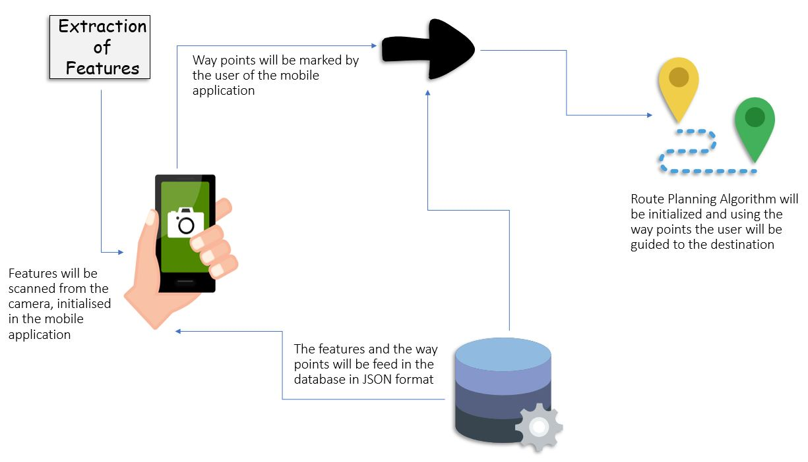

WI-FI based Navigating System

Flow Work

In most cases it is easy to install a Wi-Fi positioning system, since Wi-Fi access points already exist in many buildings. For example, existing customer hotspots, cash register systems and routers from shops can be used. The calibration of position determination works with a one-time reference measurement in the run-up, where the signal strength of the Wi-Fi networks is determined.

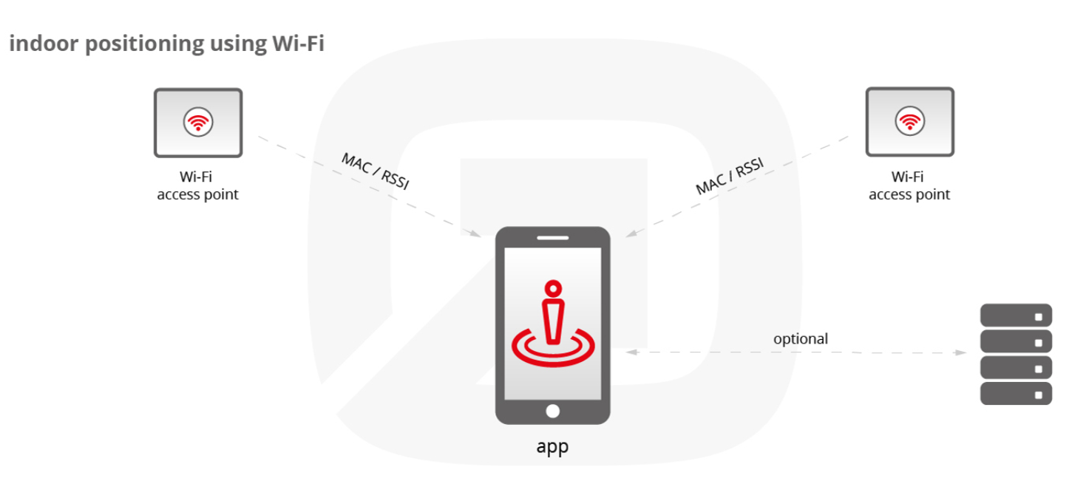

* For positioning, the so-called fingerprinting method is used. The strength of the Wi-Fi signals (received signal strength indication, RSSI) and the MAC address (media access control) are significant.
* For a client-based solution, the position is determined directly on a mobile device. A smartphone app calculates the current position based on the signal strength and MAC address. Optionally, the position data can be sent to a server for further processing.
* When a server-based solution is applied, no app is required, all Wi-Fi capable devices are detected by the Locator Nodes and Wi-Fi tracking is possible.

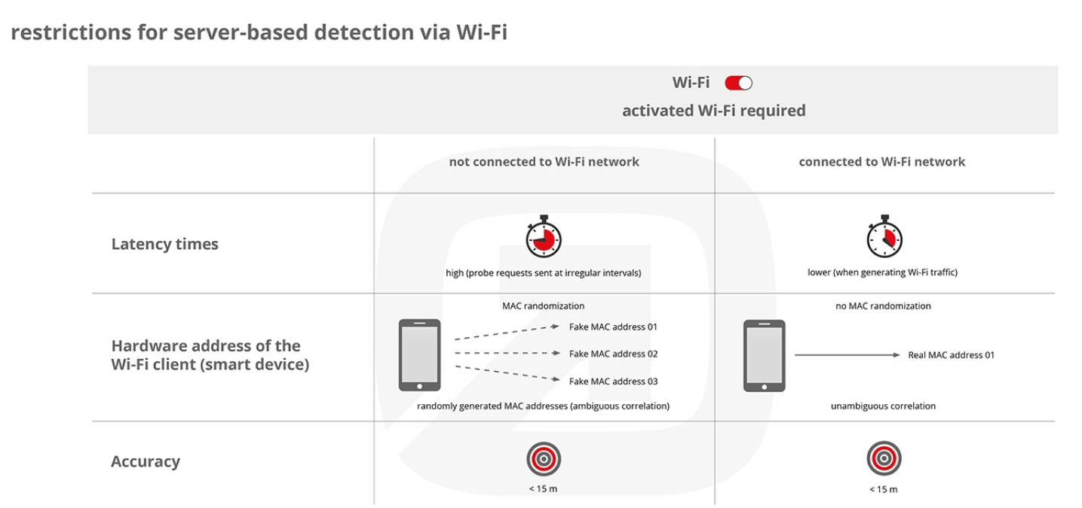

* The position data can also be used for analysis purposes. Either the data calculated on the smartphone can be sent to the backend, or a server-based solution can be used. The collected data provides important insights, for example into visitor behavior, and can uncover optimization potential for processes.
* In addition to people who are carrying Wi-Fi enabled devices, assets such as medical devices in hospitals or laptops in office buildings can be tracked by attaching Wi-Fi tags. Thereby, they can always be found easily and are furthermore protected against theft.

**Pros**

* existing Wi-Fi infrastructure can be used
* enabled Wi-Fi is enough
* large range (up to 150m)
* detects floor level

**Cons**

* relatively inaccurate (5-15m)
* no constant latency times
* use of randomized MAC address when smartphone is not connected to Wi-Fi network

Trying for the Combination of AR core augmented reality and Wi-Fi positioning system

The Wi-Fi fingerprinting method to determine user position, augmented reality to display real-time navigation information, and a compass to determine destination direction.