ALGT ERP

Document Management System (DMS)

End-User Manual

Document Control
Version: 1.0
Purpose: End-User manual for DMS module

Table of Contents
Note: In Word, you can insert an automatic Table of Contents here via References > Table of Contents.

1. Introduction
Welcome to the ALGT ERP Document Management System (DMS) User Manual. The purpose of this manual is to guide users through the features and functionalities of the DMS module. This manual is intended for all employees who need to upload, review, or manage company documents.
The DMS module helps you quickly store and retrieve documents securely, ensuring all information is correctly recorded. Note that while AI helps automate certain extraction tasks, human review is always required before any document is approved.

2. What Is the DMS Module?
The DMS stores, organizes, reviews, tracks, and retrieves company documents in a centralized location.
Common examples of documents you might manage include:
- employee documents
- vehicle documents
- company certificates
- project documents
- insurance documents
- compliance documents
- expiry documents
- renewal documents

3. User Roles and Responsibilities
Your ability to view and modify documents depends on your role. Typical responsibilities include:
- Uploaders add documents into the system via the Inbox.
- Reviewers check the information on documents before saving them to the main repository.
- Managers monitor document expiry and renewals to ensure compliance.
- Admin users maintain document categories, types, metadata fields, tags, and retention rules.

4. Getting Started
To begin using the DMS module:
- Navigate to the ALGT ERP login page.
- Enter your email and password.
- Click 'Sign in'.
- Once logged in, click on the 'DMS' item in the main sidebar to open the Document Management System.
Note: If you cannot see the DMS menu, contact your administrator to ensure you have the correct permissions.

5. DMS Navigation Overview
The DMS sidebar contains all the menus needed to navigate the system:
- Dashboard: Overview of system health and metrics.
- All Documents: The main repository of all approved documents.
- Upload Inbox: Where new documents wait for review.
- Expiry & Renewals: Track documents that need to be renewed.
- Notifications: Alerts for tasks that need your attention.
- DMS Admin: Settings and configuration for administrators.

6. DMS Dashboard
The DMS Dashboard is your starting point. It provides a quick summary of:
- Total document counts across different categories.
- Pending documents waiting for review in the Inbox.
- Expiring documents that require immediate attention.
- Recent activity and AI processing statuses.
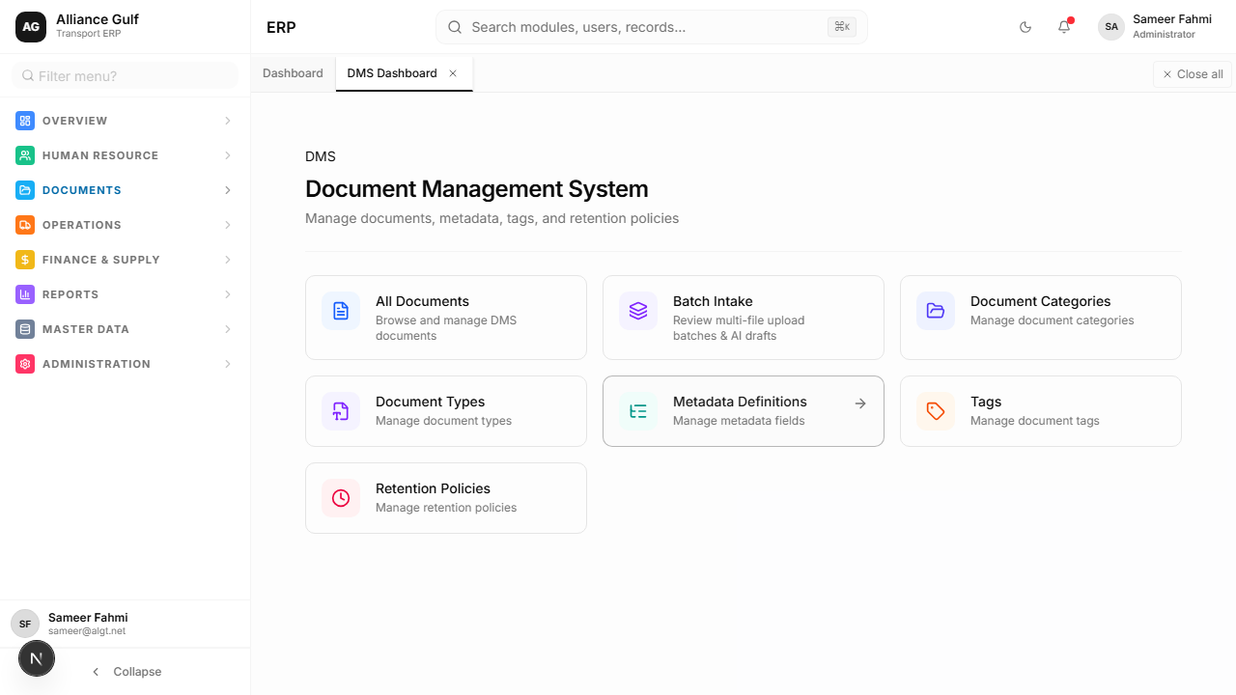
Figure 1 — DMS Dashboard overview

7. All Documents
To view all approved and stored documents, navigate to 'All Documents'.
This list shows the status, title, and key details for each document. You can open any document by clicking on its row or using the available action buttons.
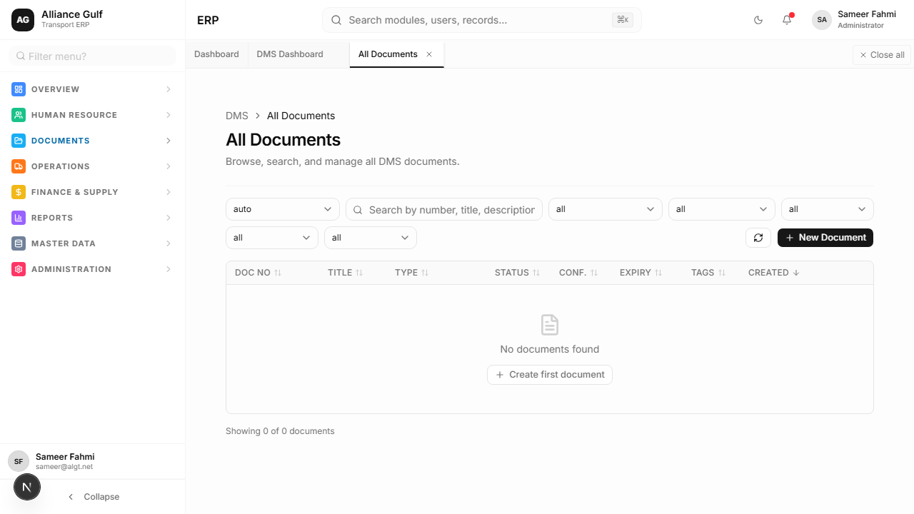
Figure 2 — All Documents list

8. Searching and Filtering Documents
Finding documents is easy using the search and filter tools:
- Use the search bar to find documents by name, number, or keyword.
- Apply filters to narrow down the list by category, document type, status, owner, or expiry date.
- Clear filters to return to the full list.
Example: If you need to find an employee's passport, search for the employee's name and filter by the 'Passport' document type.

9. Viewing a Document Record
When you open a document, you will see its detailed record. This screen contains:
- Document information section: Shows the core details.
- Preview/Download area: Allows you to view the file visually.
- Metadata fields: Specific data points extracted from the document.
- Status: Current lifecycle status.
- AI Tabs: Information or summaries generated by the AI.
[Image not captured: Figure 3 — Document record or detail page]

10. Upload Inbox
The Upload Inbox contains files that have been uploaded but are not yet approved. When you upload a file, it sits here until a reviewer checks it.
You should check the Inbox regularly to process pending items.
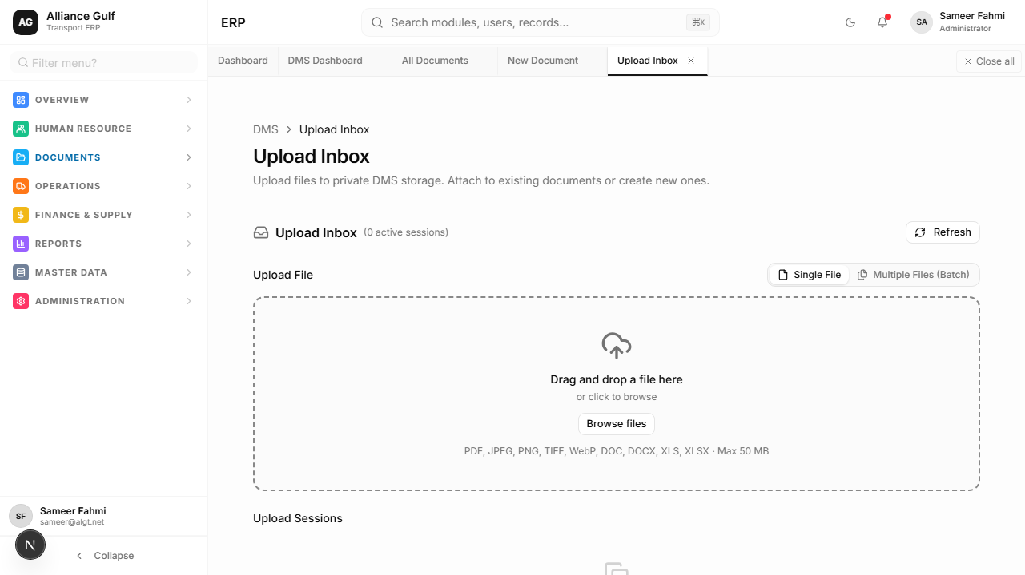
Figure 4 — Upload Inbox

11. Uploading a Single Document
Follow these steps to upload a single document:
- Open the Upload Inbox or the New Document screen.
- Select the file you wish to upload.
- Choose the appropriate document category and type.
- Use 'Upload & Fill' if available to let the AI extract details.
- Wait for the AI to process the document.
- Review the extracted details carefully.
- Correct any wrong fields manually.
- Click 'Approve and Save' when finished.
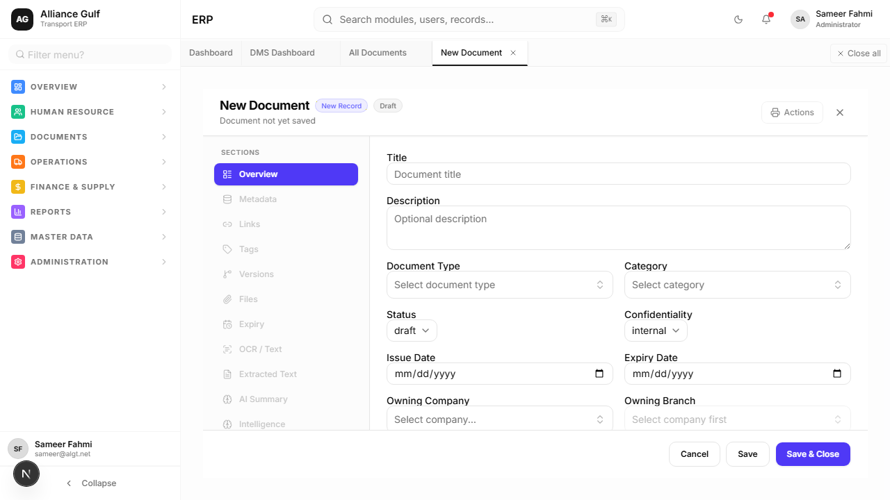
Figure 5 — Single document upload workflow

12. Uploading Multiple Documents / Batch Intake
When you have many documents, use the Batch Intake feature:
- Navigate to Batch Intake.
- Upload multiple files at once.
- The system processes them in a batch. You can review the batch results to see which succeeded and which failed.
- Handle failed or incomplete items individually.
Warning: Always double-check to avoid uploading the same documents twice.
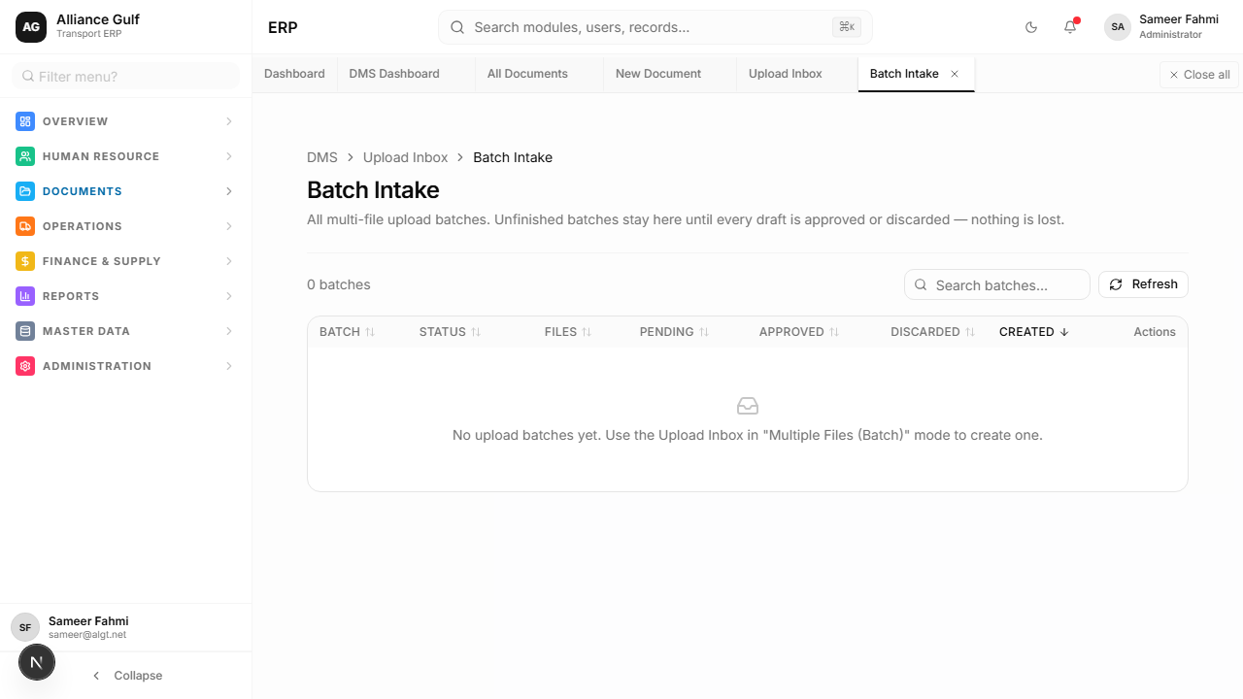
Figure 6 — Batch Intake workflow

13. Intake Review
The review step is critical. You must read the extracted fields and compare them with the visual preview of the document.
- If the AI made a mistake, correct the field immediately.
- If there are warnings, resolve them before proceeding.
- Do not approve documents that are missing critical information.
[Image not captured: Figure 7 — Intake Review screen]

14. Document Information and Metadata
Metadata is the information that helps the system classify, search, track, and manage the document. Common examples of metadata include:
- document number
- issue date
- expiry date
- owner company
- employee name
- vehicle number
- document type
- status

15. AI Features in DMS
The DMS includes AI to assist you:
- AI reads documents and helps fill information automatically.
- AI can suggest the best document type or category.
- AI can summarize documents or extract text.
- AI may detect missing or conflicting information.
Important: AI helps prepare suggestions. Users must review the result before approving, saving, sending, or using it. AI does not replace human review.

16. Reviewing AI Suggestions
When AI provides suggestions:
- Check all AI-filled fields against the document preview.
- Correct any wrong values.
- Do not approve if important fields are missing.
- Ask your supervisor or an admin if you are unsure.
Warning: AI suggestions are helpful, but the user is responsible for the final review.

17. Approving and Saving Documents
Clicking 'Approve & Save' commits the document to the system. Once saved, the document becomes officially stored, searchable by others, and tracked for expiry. Always ensure all details are correct before clicking save.

18. Expiry and Renewal Tracking
Documents like licenses and insurance expire. To track them:
- Navigate to the Expiry & Renewals screen.
- Identify documents that have expired or will expire soon.
- Use renewal filters to prioritize urgent items.
- Take action by uploading the renewed document to replace the expiring one.
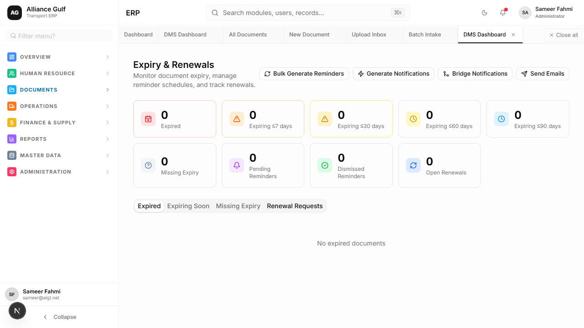
Figure 8 — Expiry & Renewals screen

19. DMS Notifications
The Notifications screen alerts you to important events, such as:
- Expiry reminders for documents you own.
- Pending review notifications when new files are uploaded.
- Alerts regarding background AI processing.
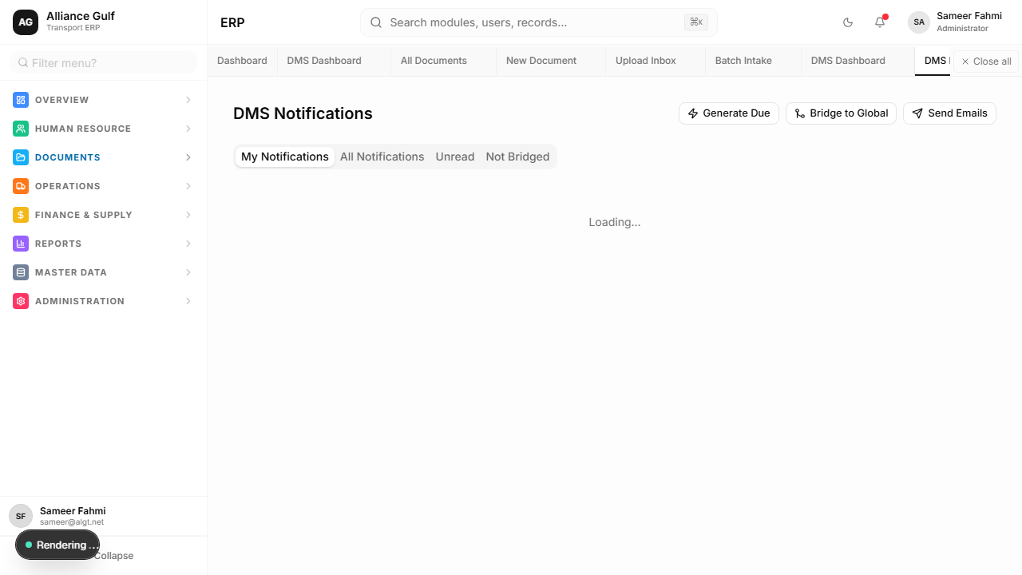
Figure 9 — Notifications screen

20. DMS Admin Screens
Admin screens control how the DMS is organized. Only authorized users should change admin settings.
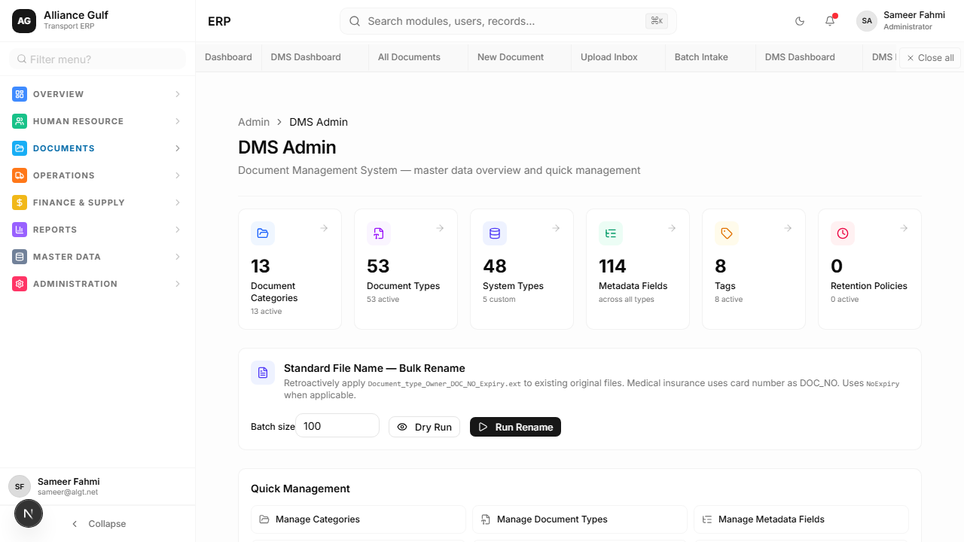
Figure 10 — DMS Admin overview

21. Document Categories
Document Categories are a high-level grouping of documents (e.g., HR, Finance, Operations).
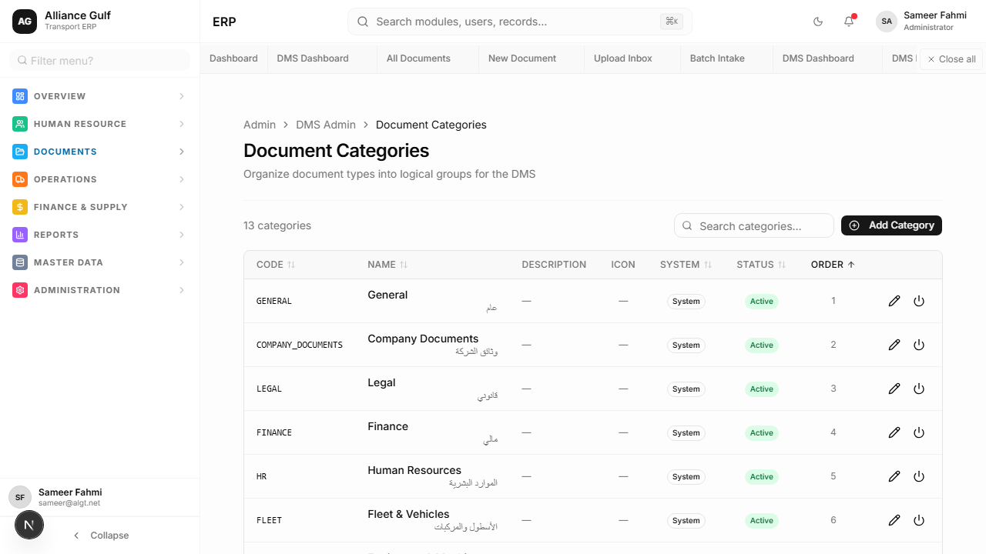
Figure 11 — Document Categories screen

22. Document Types
Document Types are a specific type of document under a category (e.g., Passport, Invoice, Contract).
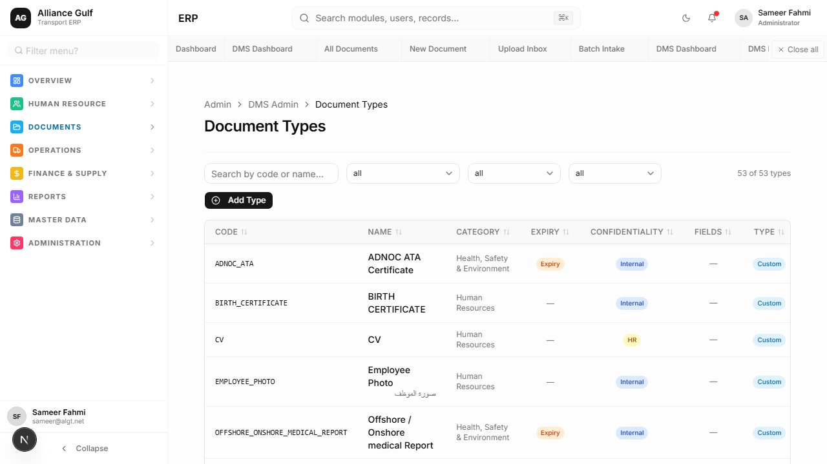
Figure 12 — Document Types screen

23. Metadata Definitions
Metadata Definitions specify the exact fields the system expects to be filled for a particular document type.
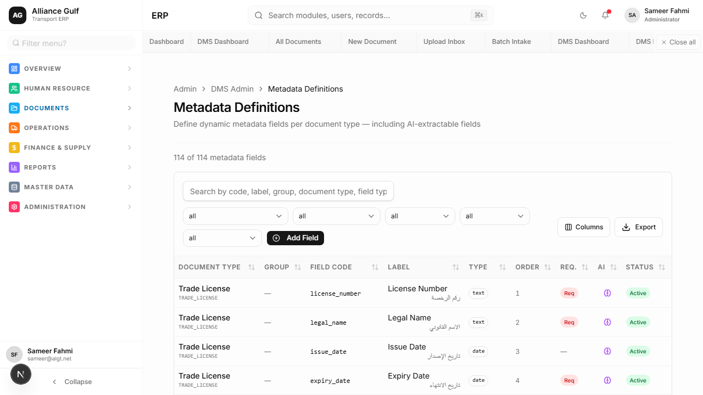
Figure 13 — Metadata Definitions screen

24. Tags
Tags are custom labels used to group, flag, or find documents quickly.

25. Retention Policies
Retention Policies define the rules for how long documents should be kept before they are archived or deleted for compliance.

26. AI Intelligence
The AI Intelligence screen is an area to review AI behavior, AI processing, insights, or intelligence settings.
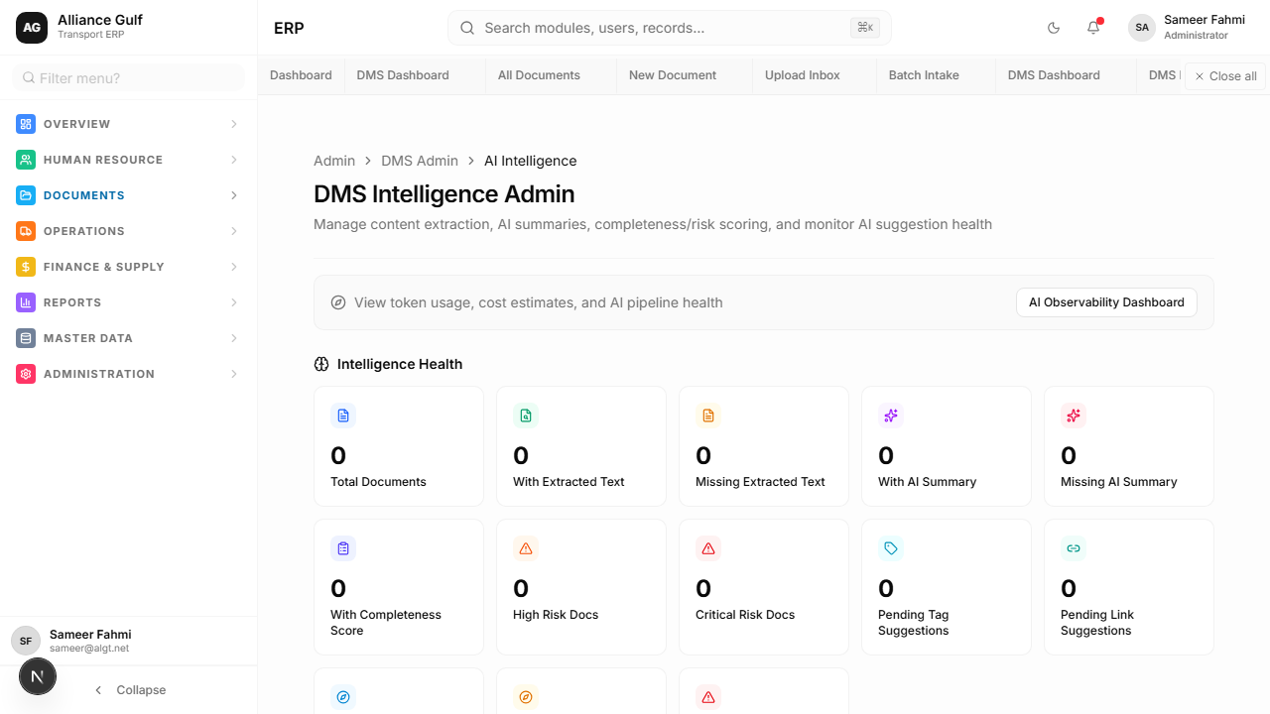
Figure 14 — AI Intelligence screen

27. Common User Scenarios
Here are walkthroughs for common tasks:
- Upload a new employee document: Go to Upload, select file, choose HR category, review AI extraction, and approve.
- Find a document by name: Go to All Documents, type the name in the search bar.
- Check documents expiring this month: Go to Expiry & Renewals, apply the 'This Month' filter.
- Correct a wrong AI suggestion: During Intake Review, simply click the incorrect field, type the correct value, and save.

28. Best Practices
- Upload clear scans to help the AI read the document accurately.
- Use the correct document type so the right metadata fields are requested.
- Always review AI suggestions before approving.
- Complete expiry dates where required to ensure proper tracking.
- Use search before uploading if you are unsure if the document already exists.

29. Common Mistakes to Avoid
- Uploading unclear, blurry, or extremely dark documents.
- Selecting the wrong document type.
- Trusting AI without checking the values manually.
- Leaving expiry dates empty on critical licenses.
- Approving documents before properly reviewing them.
- Uploading duplicates of documents that are already approved.

30. Troubleshooting
If you encounter issues, try these common solutions:
- I cannot see the DMS menu: Review your permissions with the administrator.
- Upload failed: Check the file type and refresh the page.
- AI did not fill the fields: The scan may be blurry; fill the fields manually.
- I cannot approve the document: Check if any required fields are missing.
- Search does not find my document: Ensure you have cleared any old filters.
If problems persist, contact ERP support/admin.

31. Frequently Asked Questions
Q: Can I edit a document after it is approved?
A: Yes, authorized users can update metadata on approved documents.
Q: What file types are supported?
A: Generally, PDFs, JPGs, and PNGs are supported for AI extraction.
Q: How long are documents kept?
A: This depends on the Retention Policy set by the administrator.
Q: Does the AI always get it right?
A: No, the AI makes suggestions. Human review is always required.
Q: Why is my document flagged as expiring?
A: The system automatically tracks the 'Expiry Date' field and flags documents approaching that date.
Q: Can I upload 100 documents at once?
A: Yes, use the Batch Intake feature for bulk uploads.
Q: How do I know what a document type requires?
A: The system will highlight required fields during the upload review.
Q: Who can see my uploaded documents?
A: Access is controlled by roles; generally, managers and admins have wider access.
Q: What if I uploaded the wrong file?
A: If it hasn't been approved, you can delete it from the Inbox.
Q: Does the system notify me before expiry?
A: Yes, notifications are generated based on the settings for that document type.

32. Glossary
DMS: Document Management System.
Document Category: High-level grouping (e.g., HR).
Document Type: Specific classification (e.g., Passport).
Metadata: Information about the document used for tracking.
OCR: Optical Character Recognition (reading text from images).
AI Suggestion: Automatically extracted data awaiting review.
Intake: The process of receiving and reviewing a new document.
Batch Intake: Uploading many documents simultaneously.
Approve & Save: Finalizing a document into the system.
Expiry: The date a document is no longer valid.
Retention Policy: Rules dictating how long to keep records.
Tag: A simple label for easy grouping.

33. Appendix — Screenshot Reference
Figure 1 — DMS Dashboard overview
Figure 2 — All Documents list
Figure 3 — Document record or detail page
Figure 4 — Upload Inbox
Figure 5 — Single document upload workflow
Figure 6 — Batch Intake workflow
Figure 7 — Intake Review screen
Figure 8 — Expiry & Renewals screen
Figure 9 — Notifications screen
Figure 10 — DMS Admin overview
Figure 11 — Document Categories screen
Figure 12 — Document Types screen
Figure 13 — Metadata Definitions screen
Figure 14 — AI Intelligence screen

