**DATASET :**

**HP1.txt = Harry Potter and the soccer’s stone**

**NAMO1.txt = US SPEECH by Narendra Modi**

**NAMO_gst.txt = Speech on GST by Narendra Modi**

**Our project is structured as below**:

**Markov**

* **Markov.py** (The below commands are there in markov.py file also as comments)

* + **python3 markov.py -w database/w3_small.db -n 3 --test --coca --predict a baby ------------------->** will give the ordered dictonary for the next word with the word count
  + **python3 markov.py -w database/big/w3.db -n 3 -words 100 --predict are you ------------------->** will give the ordered dictionary along with the predicted paragraph of 100 words with w3.db as the database and -n 3 tells that you want the third word after giving **“a baby”** as input.
  + We can use **python3 markov.py -w database/big/w4.db -n 4 -words 100 --predict are you** to predict the fourth word
  + Sometimes though you give 100 words to predict , it only predicts a few, it’s because , since its a store and predict model, if no word is found in database it gives empty output.
  + Execution is also shown in results in ppt.

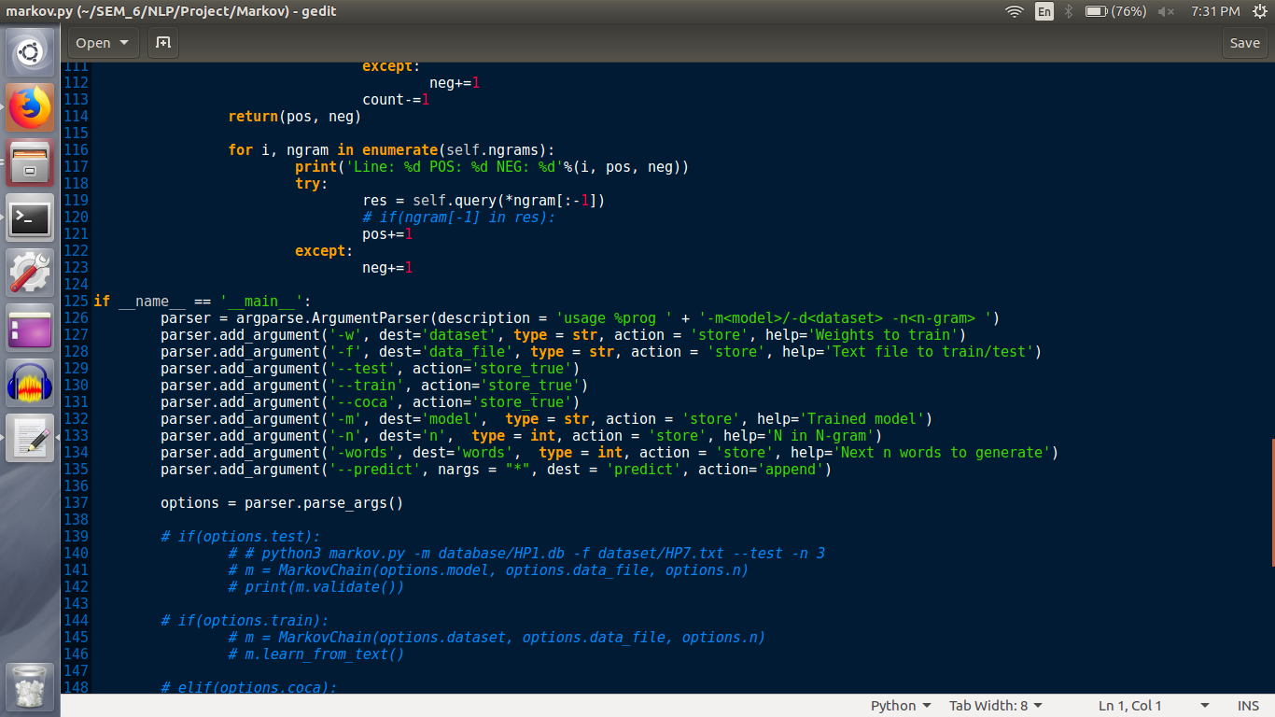

* **Server.py**
* **Client.py**
* **Readme.md**
* **database (folder)**
  + **SQL Database created with wikipeida corpus for testing**
* **dataset(folder)**
  + **big(folder) has the coca n-gram dataset**
  + **spoken(folder) has the spoken english dataset**
* **Clt.py**
* **Store.py** -> will store all the sql .db files
* **File_process.py** -> will process all the text dataset files

· **char_by_char**:

* History5.p -> saved model
* Model5.h5 -> saved weights
* Graphs for accuracy and loss
* rnn4.py which was used to train the model
* Testing jupyter notebook to performing testing
* Dataset HP2.txt

· **word_by_word**:

o **Harry Potter**: Input File: HP1.txt

**Adam**:*****

**RMSprop**:****

o **US Speech**: Input File: NAMO1.txt

* **3 word** *****
* **Sentence** *****

o **Speech on GST**: Input File: NAMO_GST.txt

* **3 word** *****
* **Sentence** *****

**NOTE:**

* Each folder in word by word folder tells the dataset first and then inner folder names the approach.
* Before executing the test notebooks, please check the file path of dataset.
* Every folder has its required dataset text file embedded. Its not mentioned in the project file structure.
* ONLY USE THE TEST FILE IN ALL FOLDERS.

Each folder with ***** contains

* .ipynb: -> original file
* .h5, .json: -> Saved Model
* Graphs for accuracy and loss
* Predicted text
* Test file to perform any test cases
  + Every test notebook has its particular statement like: print(generate_seq(loaded_model, tokenizer, 2, 'because her sister and', 15)) where the **last parameter** is the **number of words to predict**.
  + Please use the particular code line as shown in test notebook to test using generate_seq function.

**Note :** Do not perform any changes in the original jupyter notebook , as it requires to train the model again. Any testing should be performed in the test.ipynb file.