Section A: Answers to the three SQL queries

SQL Task 1
Write a query to find the top 3 products with the highest total sales (based on units
sold) from the train table.

SELECT item_nbr,sum(units) from train group by item_nbr order by sum(units) desc limit 3;

SQL Task 2
Using the key table, write a query to join the sales data (train) with the correct
weather station using store_nbr.

SELECT T.item_nbr,T.store_nbr,T.units,W.* FROM train AS T JOIN
key AS K ON T.store_nbr = K.store_nbr
JOIN
weather AS W ON K.station_nbr = W.station_nbr where T.date=W.date;

SQL Task 3
Write a query to return daily sales and average temperature (tavg) for one of the top 3
products.

SELECT T.units,W.tavg FROM train AS T JOIN
key AS K ON T.store_nbr = K.store_nbr
JOIN
weather AS W ON K.station_nbr = W.station_nbr where T.date=W.date and T.item_nbr=45 order by T.units desc;

Section B: Summary of R steps

Data cleaning choices

Lot of data in database was missing so it had to be identified and imputed with function
imputeMissingData in R code. Three techniques were used for imputing first one is to carry forward
previous value, second one was next observation carried backward and third one was to take mean value of relevant data.

Feature Creation Rationale

Two features were created known as is_weekend and is_rainy_day to see if it had any impact on units sold.

1. is_weekend (Binary: 1 = Saturday/Sunday, 0 = Weekday)
This feature captures differences in customer shopping behaviour across the week. Sales are often higher on weekends due to increased footfall, more leisure shopping, and bulk purchasing. Including this variable helps separate weather effects from natural weekly demand patterns—for example, higher sales on a rainy Saturday may be partly due to the weekend rather than weather alone.
2. is_rainy_day (Binary derived from codesum)
This feature flags whether meaningful rainfall occurred (weather codes containing “RA|TS|GR|SH|DZ”). Rain can significantly influence shopping habits—either increasing demand for certain products (e.g., indoor goods, umbrellas) or reducing store visits. Converting precipitation into a simple binary improves interpretability and helps the model capture behavioural shifts tied to rainy conditions more clearly than raw values alone.

Model-building approach

Three Models Linear Regression, Linear Regression Ridge and Decision Trees were evaluated for regression analysis.

Section C: Report

Model Performance Evaluation

Three Models Linear Regression, Linear Regression Ridge and Decision Trees were evaluated for 3 top selling products in weather data set given in database. For Top selling Product 1(Item Number 45) Decision Trees Model did well with MAE of 13.13.For Top selling Product 2(Item Number 9) Decision Trees performed good with MAE of 9.27.Again Decision Trees model performed great on Top selling Product 3(Item Number 5) with MAE of 11.22.

Model Evaluation Table

Model Type | Item Number | RMSE | MAE | R-SQUARED
Linear Regression | 45 | 26.967055 | 20.608791 | 0.365361
Linear Regression | 9 | 17.487074 | 12.977196 | 0.083873
Linear Regression | 5 | 20.329870 | 16.004282 | 0.204599
Linear Regression Ridge | 45 | 27.015608 | 20.639585 | 0.363923
Linear Regression Ridge | 9 | 17.483541 | 12.966045 | 0.084087
Linear Regression Ridge | 5 | 20.359487 | 15.977654 | 0.203320
Decision Trees | 45 | 18.237497 | 9.641909 | 0.709718
Decision Trees | 9 | 12.231212 | 6.631110 | 0.551806
Decision Trees | 5 | 14.911484 | 8.538569 | 0.572131

Variable Importance as per Decision Tree Model

Item Number 45

Overall
sunset 7.07503378
sunrise 6.79303271
stnpressure 3.79741189
depart 2.49373111
wetbulb 2.12514240
sealevel 2.10859266
tavg 2.00558127
avgspeed 1.97029693
dewpoint 1.60757522
heat 1.55539722
snowfall 0.89259226
is_weekend 0.61324952
resultspeed 0.35351152
cool 0.32407653
resultdir 0.04375252
preciptotal 0.00000000
is_rainy_day 0.00000000

Item Number 9

Overall
sunrise 7.60452669
sunset 5.44529592
depart 3.48531475
stnpressure 3.17538324
tavg 2.36743046
wetbulb 1.81200086
snowfall 1.74428715
sealevel 1.51580142
dewpoint 1.29408357
heat 1.20468675
avgspeed 1.03252857
cool 0.99629124
is_weekend 0.19257691
resultdir 0.17542645
preciptotal 0.16370542
resultspeed 0.12814626
is_rainy_day 0.09633339

Item Number 5

Overall
sunrise 8.70526027
sunset 5.67964263
stnpressure 3.64159327
depart 3.14962707
tavg 2.58819917
heat 1.94286070
wetbulb 1.82109919
dewpoint 1.45460021
snowfall 1.10245472
cool 0.99442464
resultdir 0.49307282
sealevel 0.46473051
avgspeed 0.43956577
resultspeed 0.43808455
is_weekend 0.39427044
preciptotal 0.19591393
is_rainy_day 0.06103275

Spearman Correlation Coefficients

Item Number | Sunrise | Sunset
45 | -0.127824 | 0.307717
9 | -0.248646 | 0.333456
5 | -0.191838 | 0.375083

Model Summary

Linear Regression(Item Number 45)

Call:
lm(formula = units ~ tavg + depart + wetbulb + dewpoint + heat +
cool + sunrise + sunset + snowfall + preciptotal + stnpressure +
sealevel + resultspeed + resultdir + avgspeed + is_weekend +
is_rainy_day, data = train_df)

Residuals:
Min 1Q Median 3Q Max
-70.735 -17.427 -7.661 10.531 115.433

Coefficients:
Estimate Std. Error t value Pr(>|t|)
(Intercept) -1.441e+07 2.825e+05 -51.023 < 2e-16 ***
tavg 4.683e-01 6.673e-02 7.019 2.30e-12 ***
depart 2.046e-01 3.958e-02 5.168 2.38e-07 ***
wetbulb -3.830e-01 6.661e-02 -5.750 9.05e-09 ***
dewpoint -1.458e-01 3.923e-02 -3.716 0.000203 ***
heat 1.110e-01 6.221e-02 1.784 0.074441 .
cool -1.581e-01 6.668e-02 -2.370 0.017776 *
sunrise 3.401e-03 9.416e-05 36.119 < 2e-16 ***
sunset 4.716e-03 7.899e-05 59.712 < 2e-16 ***
snowfall -1.923e+00 7.328e-01 -2.624 0.008708 **
preciptotal -2.228e+00 5.162e-01 -4.317 1.59e-05 ***
stnpressure -8.659e+00 1.241e-01 -69.755 < 2e-16 ***
sealevel 6.391e+00 1.129e+00 5.659 1.54e-08 ***
resultspeed 5.927e-01 9.973e-02 5.942 2.85e-09 ***
resultdir -1.407e-01 1.846e-02 -7.621 2.61e-14 ***
avgspeed -2.392e-01 1.099e-01 -2.176 0.029578 *
is_weekend 4.725e+00 3.767e-01 12.542 < 2e-16 ***
is_rainy_day -2.279e-01 4.321e-01 -0.528 0.597835
---
Signif. codes: 0 ‘***’ 0.001 ‘**’ 0.01 ‘*’ 0.05 ‘.’ 0.1 ‘ ’ 1

Residual standard error: 26.57 on 24643 degrees of freedom
Multiple R-squared: 0.3779, Adjusted R-squared: 0.3775
F-statistic: 880.6 on 17 and 24643 DF, p-value: < 2.2e-16

Linear Regression Ridge(Item number 45)

Coefficient Feature
X.Intercept. -1.182190e+07 X.Intercept.
X.Intercept..1 0.000000e+00 X.Intercept..1
tavg 1.276237e-01 tavg
depart 1.893621e-01 depart
wetbulb -1.697552e-01 wetbulb
dewpoint -1.835447e-01 dewpoint
heat -7.431227e-02 heat
cool 1.988525e-02 cool
sunrise 2.580197e-03 sunrise
sunset 4.074732e-03 sunset
snowfall -2.014523e+00 snowfall
preciptotal -3.159983e+00 preciptotal
stnpressure -8.239198e+00 stnpressure
sealevel 5.164275e+00 sealevel
resultspeed 3.142557e-01 resultspeed
resultdir -1.433232e-01 resultdir
avgspeed 4.841525e-02 avgspeed
is_weekend 4.258551e+00 is_weekend
is_rainy_day -4.944287e-01 is_rainy_day

Length Class Mode
a0 1 -none- numeric
beta 18 dgCMatrix S4
df 1 -none- numeric
dim 2 -none- numeric
lambda 1 -none- numeric
dev.ratio 1 -none- numeric
nulldev 1 -none- numeric
npasses 1 -none- numeric
jerr 1 -none- numeric
offset 1 -none- logical
call 6 -none- call
nobs 1 -none- numeric

Decision Trees(Item Number 45)

Call:
rpart(formula = units ~ tavg + depart + dewpoint + wetbulb +
heat + cool + sunrise + sunset + snowfall + preciptotal +
stnpressure + sealevel + resultspeed + resultdir + avgspeed +
is_weekend + is_rainy_day, data = train_df, method = "anova")
n= 24661

CP nsplit rel error xerror xstd
1 0.26024892 0 1.0000000 1.0000888 0.008884639
2 0.05649208 1 0.7397511 0.7398286 0.009059221
3 0.05590050 2 0.6832590 0.6954524 0.008513184
4 0.04185868 3 0.6273585 0.6274713 0.007773638
5 0.01000000 8 0.4180651 0.4184033 0.006489598

Variable importance
stnpressure sunset depart snowfall sunrise avgspeed resultdir sealevel
46 19 17 4 4 2 1 1
resultspeed dewpoint tavg
1 1 1

Node number 1: 24661 observations, complexity param=0.2602489
mean=22.85297, MSE=1134.232
left son=2 (18580 obs) right son=3 (6081 obs)
Primary splits:
stnpressure < 28.77169 to the right, improve=0.26024890, (0 missing)
sunset < 1775494000 to the left, improve=0.09892368, (0 missing)
sunrise < 1775453000 to the right, improve=0.04041649, (0 missing)
dewpoint < 46.03428 to the right, improve=0.04029666, (0 missing)
wetbulb < 45.5 to the right, improve=0.02859765, (0 missing)
Surrogate splits:
avgspeed < 16.75 to the left, agree=0.763, adj=0.039, (0 split)
sunset < 1775501000 to the left, agree=0.761, adj=0.032, (0 split)
resultspeed < 16.35 to the left, agree=0.759, adj=0.024, (0 split)
sealevel < 29.595 to the right, agree=0.755, adj=0.007, (0 split)
sunrise < 1775457000 to the left, agree=0.754, adj=0.003, (0 split)

Node number 2: 18580 observations, complexity param=0.05649208
mean=13.02395, MSE=777.345
left son=4 (7499 obs) right son=5 (11081 obs)
Primary splits:
stnpressure < 29.625 to the right, improve=0.10940590, (0 missing)
sunset < 1775501000 to the left, improve=0.09194995, (0 missing)
snowfall < 0.008152133 to the right, improve=0.07191486, (0 missing)
sunrise < 1775453000 to the right, improve=0.02886522, (0 missing)
wetbulb < 43.5 to the right, improve=0.01838619, (0 missing)
Surrogate splits:
snowfall < 0.008152133 to the right, agree=0.652, adj=0.139, (0 split)
dewpoint < 70.5 to the right, agree=0.642, adj=0.114, (0 split)
sunrise < 1775454000 to the right, agree=0.641, adj=0.111, (0 split)
wetbulb < 74.5 to the right, agree=0.621, adj=0.061, (0 split)
sealevel < 30.365 to the right, agree=0.616, adj=0.050, (0 split)

Node number 3: 6081 observations, complexity param=0.0559005
mean=52.88472, MSE=1027.581
left son=6 (512 obs) right son=7 (5569 obs)
Primary splits:
sunset < 1775492000 to the left, improve=0.25022860, (0 missing)
stnpressure < 24.605 to the right, improve=0.07862938, (0 missing)
snowfall < 0.008152133 to the left, improve=0.05630112, (0 missing)
sunrise < 1775451000 to the right, improve=0.02734483, (0 missing)
is_weekend < 0.5 to the left, improve=0.02660895, (0 missing)

Node number 4: 7499 observations
mean=1.813708, MSE=120.2321

Node number 5: 11081 observations, complexity param=0.04185868
mean=20.61041, MSE=1079.442
left son=10 (10501 obs) right son=11 (580 obs)
Primary splits:
sunset < 1775501000 to the left, improve=0.07371205, (0 missing)
snowfall < 0.008152133 to the right, improve=0.06946130, (0 missing)
depart < 1.876488 to the right, improve=0.03639726, (0 missing)
sealevel < 30.165 to the left, improve=0.02691056, (0 missing)
sunrise < 1775448000 to the left, improve=0.02372231, (0 missing)

Node number 6: 512 observations
mean=0, MSE=0

Node number 7: 5569 observations
mean=57.74681, MSE=841.2844

Node number 10: 10501 observations, complexity param=0.04185868
mean=18.51405, MSE=984.7235
left son=20 (2538 obs) right son=21 (7963 obs)
Primary splits:
snowfall < 0.008152133 to the right, improve=0.06536980, (0 missing)
sunset < 1775492000 to the left, improve=0.06164984, (0 missing)
depart < 1.876488 to the right, improve=0.03122784, (0 missing)
sealevel < 30.165 to the left, improve=0.03078359, (0 missing)
sunrise < 1775455000 to the left, improve=0.02383154, (0 missing)
Surrogate splits:
stnpressure < 28.77669 to the left, agree=0.806, adj=0.197, (0 split)
preciptotal < 2.295 to the right, agree=0.781, adj=0.095, (0 split)
heat < 36.5 to the right, agree=0.781, adj=0.093, (0 split)
tavg < 28.5 to the left, agree=0.780, adj=0.089, (0 split)
sunrise < 1775457000 to the right, agree=0.776, adj=0.073, (0 split)

Node number 11: 580 observations
mean=58.56552, MSE=1274.173

Node number 20: 2538 observations
mean=4.3026, MSE=300.6011

Node number 21: 7963 observations, complexity param=0.04185868
mean=23.04358, MSE=1117.882
left son=42 (1311 obs) right son=43 (6652 obs)
Primary splits:
sunset < 1775492000 to the left, improve=0.09361691, (0 missing)
depart < 1.876488 to the right, improve=0.08140660, (0 missing)
sunrise < 1775454000 to the left, improve=0.05036566, (0 missing)
sealevel < 30.165 to the left, improve=0.02643128, (0 missing)
dewpoint < 32.5 to the right, improve=0.01828084, (0 missing)
Surrogate splits:
tavg < 10.5 to the left, agree=0.835, adj=0.001, (0 split)
dewpoint < -6.5 to the left, agree=0.835, adj=0.001, (0 split)
wetbulb < 9.5 to the left, agree=0.835, adj=0.001, (0 split)
heat < 51.5 to the right, agree=0.835, adj=0.001, (0 split)

Node number 42: 1311 observations
mean=0, MSE=0

Node number 43: 6652 observations, complexity param=0.04185868
mean=27.58509, MSE=1212.92
left son=86 (2293 obs) right son=87 (4359 obs)
Primary splits:
depart < 1.876488 to the right, improve=0.14966730, (0 missing)
sunrise < 1775448000 to the left, improve=0.04324879, (0 missing)
sealevel < 30.165 to the left, improve=0.04054429, (0 missing)
dewpoint < 32.5 to the right, improve=0.03058133, (0 missing)
wetbulb < 40.5 to the right, improve=0.02904196, (0 missing)
Surrogate splits:
tavg < 85.5 to the right, agree=0.683, adj=0.081, (0 split)
cool < 20.5 to the right, agree=0.683, adj=0.080, (0 split)
sealevel < 29.825 to the left, agree=0.676, adj=0.061, (0 split)
avgspeed < 12.05 to the right, agree=0.666, adj=0.030, (0 split)
resultspeed < 12.05 to the right, agree=0.662, adj=0.019, (0 split)

Node number 86: 2293 observations
mean=9.008286, MSE=570.952

Node number 87: 4359 observations, complexity param=0.04185868
mean=37.35719, MSE=1273.591
left son=174 (1956 obs) right son=175 (2403 obs)
Primary splits:
depart < 1.376488 to the left, improve=0.40630510, (0 missing)
sunrise < 1775448000 to the left, improve=0.05768589, (0 missing)
stnpressure < 29.385 to the right, improve=0.03166587, (0 missing)
sunset < 1775493000 to the right, improve=0.02558324, (0 missing)
avgspeed < 3.95 to the right, improve=0.01463061, (0 missing)
Surrogate splits:
sunrise < 1775451000 to the left, agree=0.678, adj=0.282, (0 split)
sunset < 1775499000 to the right, agree=0.616, adj=0.143, (0 split)
resultdir < 24.5 to the right, agree=0.606, adj=0.122, (0 split)
avgspeed < 6.45 to the right, agree=0.574, adj=0.050, (0 split)
stnpressure < 28.985 to the left, agree=0.569, adj=0.040, (0 split)

Node number 174: 1956 observations
mean=12.14366, MSE=693.5913

Node number 175: 2403 observations
mean=57.88057, MSE=807.0257

n= 24661

node), split, n, deviance, yval
* denotes terminal node

1) root 24661 27971290.0 22.852970
2) stnpressure>=28.77169 18580 14443070.0 13.023950
4) stnpressure>=29.625 7499 901620.8 1.813708 *
5) stnpressure< 29.625 11081 11961290.0 20.610410
10) sunset< 1.775501e+09 10501 10340580.0 18.514050
20) snowfall>=0.008152133 2538 762925.6 4.302600 *
21) snowfall< 0.008152133 7963 8901694.0 23.043580
42) sunset< 1.775492e+09 1311 0.0 0.000000 *
43) sunset>=1.775492e+09 6652 8068345.0 27.585090
86) depart>=1.876488 2293 1309193.0 9.008286 *
87) depart< 1.876488 4359 5551585.0 37.357190
174) depart< 1.376488 1956 1356665.0 12.143660 *
175) depart>=1.376488 2403 1939283.0 57.880570 *
11) sunset>=1.775501e+09 580 739020.5 58.565520 *
3) stnpressure< 28.77169 6081 6248722.0 52.884720
6) sunset< 1.775492e+09 512 0.0 0.000000 *
7) sunset>=1.775492e+09 5569 4685113.0 57.746810 *

Linear Regression(Item Number 9)

Call:
lm(formula = units ~ tavg + depart + wetbulb + dewpoint + heat +
cool + sunrise + sunset + snowfall + preciptotal + stnpressure +
sealevel + resultspeed + resultdir + avgspeed + is_weekend +
is_rainy_day, data = train_df)

Residuals:
Min 1Q Median 3Q Max
-23.775 -10.740 -6.132 2.373 69.992

Coefficients:
Estimate Std. Error t value Pr(>|t|)
(Intercept) -4.076e+06 1.935e+05 -21.065 < 2e-16 ***
tavg 1.069e-01 4.654e-02 2.298 0.0216 *
depart 1.248e-01 2.807e-02 4.447 8.75e-06 ***
wetbulb -8.887e-02 4.818e-02 -1.845 0.0651 .
dewpoint -1.470e-01 2.752e-02 -5.343 9.26e-08 ***
heat -6.363e-02 4.170e-02 -1.526 0.1271
cool 4.881e-03 4.402e-02 0.111 0.9117
sunrise 2.722e-04 6.229e-05 4.370 1.25e-05 ***
sunset 2.024e-03 5.699e-05 35.507 < 2e-16 ***
snowfall 3.064e-01 5.177e-01 0.592 0.5539
preciptotal -2.062e+00 3.571e-01 -5.775 7.78e-09 ***
stnpressure 3.109e-02 8.648e-02 0.360 0.7192
sealevel 3.465e+00 7.896e-01 4.388 1.15e-05 ***
resultspeed -3.223e-01 6.921e-02 -4.656 3.24e-06 ***
resultdir -3.203e-02 1.288e-02 -2.487 0.0129 *
avgspeed 4.300e-01 7.611e-02 5.649 1.63e-08 ***
is_weekend 2.755e-01 2.641e-01 1.043 0.2969
is_rainy_day 1.879e+00 2.990e-01 6.286 3.33e-10 ***
---
Signif. codes: 0 ‘***’ 0.001 ‘**’ 0.01 ‘*’ 0.05 ‘.’ 0.1 ‘ ’ 1

Residual standard error: 17.6 on 22269 degrees of freedom
Multiple R-squared: 0.08996, Adjusted R-squared: 0.08926
F-statistic: 129.5 on 17 and 22269 DF, p-value: < 2.2e-16

Linear Regression Ridge(Item number 9)

Coefficient Feature
X.Intercept. -3.828167e+06 X.Intercept.
X.Intercept..1 0.000000e+00 X.Intercept..1
tavg 4.598965e-02 tavg
depart 1.238621e-01 depart
wetbulb -5.331717e-02 wetbulb
dewpoint -1.244892e-01 dewpoint
heat -6.714288e-02 heat
cool 2.961805e-02 cool
sunrise 2.263511e-04 sunrise
sunset 1.928564e-03 sunset
snowfall 1.218162e-01 snowfall
preciptotal -1.825909e+00 preciptotal
stnpressure -4.503912e-02 stnpressure
sealevel 3.422690e+00 sealevel
resultspeed -2.568939e-01 resultspeed
resultdir -2.785339e-02 resultdir
avgspeed 3.633304e-01 avgspeed
is_weekend 4.415534e-01 is_weekend
is_rainy_day 1.507432e+00 is_rainy_day

Length Class Mode
a0 1 -none- numeric
beta 18 dgCMatrix S4
df 1 -none- numeric
dim 2 -none- numeric
lambda 1 -none- numeric
dev.ratio 1 -none- numeric
nulldev 1 -none- numeric
npasses 1 -none- numeric
jerr 1 -none- numeric
offset 1 -none- logical
call 6 -none- call
nobs 1 -none- numeric

Decision Trees(Item Number 9)

Call:
rpart(formula = units ~ tavg + depart + dewpoint + wetbulb +
heat + cool + sunrise + sunset + snowfall + preciptotal +
stnpressure + sealevel + resultspeed + resultdir + avgspeed +
is_weekend + is_rainy_day, data = train_df, method = "anova")
n= 22287

CP nsplit rel error xerror xstd
1 0.09464263 0 1.0000000 1.0000732 0.01354345
2 0.06508551 1 0.9053574 0.9055801 0.01235729
3 0.03790168 2 0.8402719 0.8407290 0.01225593
4 0.02487826 4 0.7644685 0.7659363 0.01245749
5 0.01000000 9 0.6400772 0.6419505 0.01161527

Variable importance
stnpressure sunset sunrise depart wetbulb snowfall tavg heat
24 18 14 14 6 5 5 5
sealevel dewpoint
4 4

Node number 1: 22287 observations, complexity param=0.09464263
mean=9.728496, MSE=340.0123
left son=2 (9956 obs) right son=3 (12331 obs)
Primary splits:
sunset < 1775494000 to the left, improve=0.094642630, (0 missing)
sunrise < 1775454000 to the right, improve=0.078775440, (0 missing)
snowfall < 0.008152133 to the left, improve=0.052757630, (0 missing)
stnpressure < 29.655 to the left, improve=0.007125093, (0 missing)
depart < 1.376488 to the left, improve=0.006759287, (0 missing)
Surrogate splits:
sunrise < 1775454000 to the right, agree=0.769, adj=0.483, (0 split)
stnpressure < 28.935 to the left, agree=0.626, adj=0.163, (0 split)
dewpoint < 39.5 to the left, agree=0.590, adj=0.081, (0 split)
wetbulb < 48.5 to the left, agree=0.585, adj=0.071, (0 split)
heat < 10.5 to the right, agree=0.584, adj=0.070, (0 split)

Node number 2: 9956 observations
mean=3.415327, MSE=144.9258

Node number 3: 12331 observations, complexity param=0.06508551
mean=14.82572, MSE=439.3629
left son=6 (11667 obs) right son=7 (664 obs)
Primary splits:
stnpressure < 26.34 to the right, improve=0.09103509, (0 missing)
snowfall < 0.008152133 to the left, improve=0.08839985, (0 missing)
depart < 1.376488 to the left, improve=0.04537320, (0 missing)
sunrise < 1775455000 to the right, improve=0.04525627, (0 missing)
sunset < 1775495000 to the right, improve=0.01485133, (0 missing)

Node number 6: 11667 observations, complexity param=0.03790168
mean=13.31696, MSE=404.9329
left son=12 (7628 obs) right son=13 (4039 obs)
Primary splits:
snowfall < 0.008152133 to the left, improve=0.05343234, (0 missing)
sunrise < 1775455000 to the right, improve=0.03737963, (0 missing)
stnpressure < 29.745 to the left, improve=0.03624100, (0 missing)
depart < 1.376488 to the left, improve=0.03527821, (0 missing)
sunset < 1775496000 to the left, improve=0.01955485, (0 missing)
Surrogate splits:
stnpressure < 29.625 to the left, agree=0.767, adj=0.326, (0 split)
heat < 26.5 to the left, agree=0.690, adj=0.103, (0 split)
tavg < 38.5 to the right, agree=0.688, adj=0.100, (0 split)
wetbulb < 33.5 to the right, agree=0.681, adj=0.079, (0 split)
dewpoint < 16.5 to the right, agree=0.672, adj=0.052, (0 split)

Node number 7: 664 observations
mean=41.33584, MSE=301.5423

Node number 12: 7628 observations, complexity param=0.02487826
mean=9.932223, MSE=378.2056
left son=24 (995 obs) right son=25 (6633 obs)
Primary splits:
stnpressure < 29.755 to the right, improve=0.03173759, (0 missing)
sunrise < 1775455000 to the right, improve=0.02668677, (0 missing)
depart < 1.376488 to the left, improve=0.01684689, (0 missing)
sunset < 1775501000 to the left, improve=0.01559000, (0 missing)
dewpoint < 69.5 to the right, improve=0.01014593, (0 missing)
Surrogate splits:
dewpoint < 72.5 to the right, agree=0.883, adj=0.099, (0 split)
sealevel < 30.445 to the right, agree=0.873, adj=0.029, (0 split)
wetbulb < 15.5 to the left, agree=0.870, adj=0.004, (0 split)
tavg < 13 to the left, agree=0.870, adj=0.001, (0 split)
heat < 47.5 to the right, agree=0.870, adj=0.001, (0 split)

Node number 13: 4039 observations, complexity param=0.03790168
mean=19.70933, MSE=392.9108
left son=26 (1797 obs) right son=27 (2242 obs)
Primary splits:
stnpressure < 29.745 to the left, improve=0.20289880, (0 missing)
tavg < 63.5 to the left, improve=0.07876467, (0 missing)
sunrise < 1775455000 to the right, improve=0.06777985, (0 missing)
wetbulb < 58.5 to the left, improve=0.06224734, (0 missing)
sunset < 1775496000 to the left, improve=0.05979850, (0 missing)
Surrogate splits:
sealevel < 29.865 to the left, agree=0.683, adj=0.288, (0 split)
sunrise < 1775455000 to the right, agree=0.671, adj=0.260, (0 split)
tavg < 61.59147 to the left, agree=0.654, adj=0.221, (0 split)
sunset < 1775496000 to the left, agree=0.643, adj=0.199, (0 split)
wetbulb < 53.60267 to the left, agree=0.635, adj=0.179, (0 split)

Node number 24: 995 observations
mean=0.9869347, MSE=45.50435

Node number 25: 6633 observations, complexity param=0.02487826
mean=11.27408, MSE=414.3093
left son=50 (1730 obs) right son=51 (4903 obs)
Primary splits:
sunrise < 1775455000 to the right, improve=0.035663860, (0 missing)
sunset < 1775496000 to the left, improve=0.017963310, (0 missing)
depart < 1.376488 to the left, improve=0.013588890, (0 missing)
stnpressure < 28.805 to the right, improve=0.012709250, (0 missing)
dewpoint < 68.5 to the right, improve=0.004177791, (0 missing)
Surrogate splits:
sunset < 1775496000 to the left, agree=0.869, adj=0.497, (0 split)
wetbulb < 38.5 to the left, agree=0.753, adj=0.053, (0 split)
tavg < 47.5 to the left, agree=0.752, adj=0.050, (0 split)
heat < 17.5 to the right, agree=0.752, adj=0.048, (0 split)
dewpoint < 31.5 to the left, agree=0.748, adj=0.032, (0 split)

Node number 26: 1797 observations
mean=9.736227, MSE=293.3773

Node number 27: 2242 observations
mean=27.70294, MSE=329.0697

Node number 50: 1730 observations
mean=4.80289, MSE=203.1675

Node number 51: 4903 observations, complexity param=0.02487826
mean=13.55741, MSE=468.8202
left son=102 (558 obs) right son=103 (4345 obs)
Primary splits:
sunrise < 1775448000 to the left, improve=0.050349110, (0 missing)
depart < 1.376488 to the left, improve=0.046443040, (0 missing)
dewpoint < 35.5 to the right, improve=0.014600830, (0 missing)
wetbulb < 40.5 to the right, improve=0.012324350, (0 missing)
heat < 13.5 to the left, improve=0.009745874, (0 missing)
Surrogate splits:
sealevel < 30.485 to the right, agree=0.886, adj=0.002, (0 split)

Node number 102: 558 observations
mean=0, MSE=0

Node number 103: 4345 observations, complexity param=0.02487826
mean=15.2985, MSE=502.3917
left son=206 (1677 obs) right son=207 (2668 obs)
Primary splits:
depart < 1.376488 to the left, improve=0.04722061, (0 missing)
dewpoint < 65.5 to the right, improve=0.01535016, (0 missing)
wetbulb < 53.10267 to the right, improve=0.01337270, (0 missing)
heat < 7.5 to the left, improve=0.01197621, (0 missing)
tavg < 59.5 to the right, improve=0.01169290, (0 missing)
Surrogate splits:
resultdir < 25.5 to the right, agree=0.664, adj=0.128, (0 split)
tavg < 61.09147 to the left, agree=0.651, adj=0.095, (0 split)
heat < 1.5 to the right, agree=0.650, adj=0.094, (0 split)
dewpoint < 52.5 to the left, agree=0.648, adj=0.088, (0 split)
cool < 0.5 to the left, agree=0.643, adj=0.076, (0 split)

Node number 206: 1677 observations
mean=9.155039, MSE=360.88

Node number 207: 2668 observations, complexity param=0.02487826
mean=19.16004, MSE=552.7056
left son=414 (1931 obs) right son=415 (737 obs)
Primary splits:
depart < 1.876488 to the right, improve=0.36228900, (0 missing)
dewpoint < 52.5 to the right, improve=0.06605478, (0 missing)
wetbulb < 53.10267 to the right, improve=0.06293004, (0 missing)
heat < 3.5 to the left, improve=0.06262975, (0 missing)
tavg < 61.09147 to the right, improve=0.06248446, (0 missing)
Surrogate splits:
tavg < 61.59147 to the right, agree=0.796, adj=0.261, (0 split)
heat < 5.5 to the left, agree=0.796, adj=0.261, (0 split)
wetbulb < 51.5 to the right, agree=0.789, adj=0.236, (0 split)
dewpoint < 42.5 to the right, agree=0.778, adj=0.198, (0 split)
sealevel < 30.125 to the left, agree=0.778, adj=0.197, (0 split)

Node number 414: 1931 observations
mean=10.41792, MSE=378.6886

Node number 415: 737 observations
mean=42.06513, MSE=283.7624

n= 22287

node), split, n, deviance, yval
* denotes terminal node

1) root 22287 7577854.00 9.7284960
2) sunset< 1.775494e+09 9956 1442882.00 3.4153270 *
3) sunset>=1.775494e+09 12331 5417784.00 14.8257200
6) stnpressure>=26.34 11667 4724352.00 13.3169600
12) snowfall< 0.008152133 7628 2884952.00 9.9322230
24) stnpressure>=29.755 995 45276.83 0.9869347 *
25) stnpressure< 29.755 6633 2748114.00 11.2740800
50) sunrise>=1.775455e+09 1730 351479.80 4.8028900 *
51) sunrise< 1.775455e+09 4903 2298626.00 13.5574100
102) sunrise< 1.775448e+09 558 0.00 0.0000000 *
103) sunrise>=1.775448e+09 4345 2182892.00 15.2985000
206) depart< 1.376488 1677 605195.70 9.1550390 *
207) depart>=1.376488 2668 1474619.00 19.1600400
414) depart>=1.876488 1931 731247.70 10.4179200 *
415) depart< 1.876488 737 209132.90 42.0651300 *
13) snowfall>=0.008152133 4039 1586967.00 19.7093300
26) stnpressure< 29.745 1797 527199.00 9.7362270 *
27) stnpressure>=29.745 2242 737774.20 27.7029400 *
7) stnpressure< 26.34 664 200224.10 41.3358400 *

Linear Regression(Item Number 5)

Call:
lm(formula = units ~ tavg + depart + wetbulb + dewpoint + heat +
cool + sunrise + sunset + snowfall + preciptotal + stnpressure +
sealevel + resultspeed + resultdir + avgspeed + is_weekend +
is_rainy_day, data = train_df)

Residuals:
Min 1Q Median 3Q Max
-34.459 -13.108 -6.690 9.353 79.269

Coefficients:
Estimate Std. Error t value Pr(>|t|)
(Intercept) -1.172e+07 2.262e+05 -51.819 < 2e-16 ***
tavg 1.694e-01 5.045e-02 3.357 0.000788 ***
depart 2.525e-02 3.191e-02 0.791 0.428675
wetbulb -1.478e-01 5.051e-02 -2.926 0.003441 **
dewpoint -4.254e-03 2.964e-02 -0.144 0.885872
heat 2.107e-02 4.683e-02 0.450 0.652684
cool -8.570e-02 5.082e-02 -1.686 0.091751 .
sunrise 2.588e-03 7.513e-05 34.441 < 2e-16 ***
sunset 4.013e-03 6.325e-05 63.447 < 2e-16 ***
snowfall -1.274e+00 6.250e-01 -2.039 0.041476 *
preciptotal -1.393e+00 3.947e-01 -3.530 0.000416 ***
stnpressure -3.487e+00 9.711e-02 -35.914 < 2e-16 ***
sealevel 5.762e+00 8.901e-01 6.473 9.77e-11 ***
resultspeed 2.710e-01 7.831e-02 3.460 0.000541 ***
resultdir -6.648e-02 1.451e-02 -4.581 4.65e-06 ***
avgspeed -1.541e-01 8.664e-02 -1.779 0.075269 .
is_weekend 1.465e+00 2.978e-01 4.920 8.69e-07 ***
is_rainy_day -6.247e-01 3.384e-01 -1.846 0.064903 .
---
Signif. codes: 0 ‘***’ 0.001 ‘**’ 0.01 ‘*’ 0.05 ‘.’ 0.1 ‘ ’ 1

Residual standard error: 20.42 on 23607 degrees of freedom
Multiple R-squared: 0.2083, Adjusted R-squared: 0.2077
F-statistic: 365.3 on 17 and 23607 DF, p-value: < 2.2e-16

Linear Regression Ridge(Item number 5)

Coefficient Feature
X.Intercept. -1.032914e+07 X.Intercept.
X.Intercept..1 0.000000e+00 X.Intercept..1
tavg 6.990501e-02 tavg
depart 1.483570e-02 depart
wetbulb -6.239511e-02 wetbulb
dewpoint -4.042782e-02 dewpoint
heat -3.259503e-02 heat
cool -3.869865e-02 cool
sunrise 2.187754e-03 sunrise
sunset 3.626771e-03 sunset
snowfall -1.164784e+00 snowfall
preciptotal -1.598349e+00 preciptotal
stnpressure -3.249186e+00 stnpressure
sealevel 5.075981e+00 sealevel
resultspeed 1.798709e-01 resultspeed
resultdir -7.080237e-02 resultdir
avgspeed -6.673606e-02 avgspeed
is_weekend 1.640918e+00 is_weekend
is_rainy_day -5.373105e-01 is_rainy_day

Length Class Mode
a0 1 -none- numeric
beta 18 dgCMatrix S4
df 1 -none- numeric
dim 2 -none- numeric
lambda 1 -none- numeric
dev.ratio 1 -none- numeric
nulldev 1 -none- numeric
npasses 1 -none- numeric
jerr 1 -none- numeric
offset 1 -none- logical
call 6 -none- call
nobs 1 -none- numeric

Decision Trees(Item Number 5)

Call:
rpart(formula = units ~ tavg + depart + dewpoint + wetbulb +
heat + cool + sunrise + sunset + snowfall + preciptotal +
stnpressure + sealevel + resultspeed + resultdir + avgspeed +
is_weekend + is_rainy_day, data = train_df, method = "anova")
n= 23625

CP nsplit rel error xerror xstd
1 0.14020811 0 1.0000000 1.0000696 0.010526868
2 0.05576236 1 0.8597919 0.8598780 0.009707441
3 0.03805264 2 0.8040295 0.8050817 0.009745864
4 0.02439260 3 0.7659769 0.7668081 0.009521187
5 0.02438861 4 0.7415843 0.7446845 0.009585602
6 0.02434632 5 0.7171957 0.7446845 0.009585602
7 0.01623043 6 0.6928494 0.6950039 0.009520356
8 0.01304428 8 0.6603885 0.6259064 0.008875119
9 0.01292631 9 0.6473442 0.6050634 0.008531460
10 0.01089933 14 0.5803888 0.5844447 0.008161445
11 0.01000000 15 0.5694895 0.5755109 0.008057059

Variable importance
sunset sunrise stnpressure depart snowfall tavg wetbulb heat
25 22 13 12 12 4 4 4
dewpoint avgspeed cool
2 1 1

Node number 1: 23625 observations, complexity param=0.1402081
mean=14.84753, MSE=526.4902
left son=2 (10709 obs) right son=3 (12916 obs)
Primary splits:
sunset < 1775494000 to the left, improve=0.140208100, (0 missing)
stnpressure < 28.77169 to the right, improve=0.077964580, (0 missing)
sunrise < 1775453000 to the right, improve=0.052870930, (0 missing)
snowfall < 0.008152133 to the right, improve=0.037008120, (0 missing)
resultdir < 22.5 to the right, improve=0.008456432, (0 missing)
Surrogate splits:
sunrise < 1775453000 to the right, agree=0.813, adj=0.587, (0 split)
snowfall < 0.008152133 to the right, agree=0.646, adj=0.219, (0 split)
tavg < 61.59147 to the left, agree=0.618, adj=0.157, (0 split)
heat < 6.5 to the right, agree=0.616, adj=0.153, (0 split)
wetbulb < 49.5 to the left, agree=0.608, adj=0.135, (0 split)

Node number 2: 10709 observations, complexity param=0.01292631
mean=5.411897, MSE=245.2216
left son=4 (5723 obs) right son=5 (4986 obs)
Primary splits:
snowfall < 0.008152133 to the right, improve=0.04119094, (0 missing)
sunrise < 1775455000 to the left, improve=0.04099578, (0 missing)
stnpressure < 28.77169 to the right, improve=0.03576517, (0 missing)
sunset < 1775492000 to the left, improve=0.03265000, (0 missing)
depart < -4.5 to the right, improve=0.01118022, (0 missing)
Surrogate splits:
sunset < 1775493000 to the right, agree=0.657, adj=0.264, (0 split)
wetbulb < 62.5 to the left, agree=0.608, adj=0.157, (0 split)
stnpressure < 26.34 to the left, agree=0.607, adj=0.156, (0 split)
dewpoint < 52.5 to the left, agree=0.606, adj=0.153, (0 split)
depart < 1.876488 to the left, agree=0.605, adj=0.152, (0 split)

Node number 3: 12916 observations, complexity param=0.05576236
mean=22.67087, MSE=624.6747
left son=6 (9236 obs) right son=7 (3680 obs)
Primary splits:
stnpressure < 28.77169 to the right, improve=0.08596493, (0 missing)
sunrise < 1775448000 to the left, improve=0.05338661, (0 missing)
depart < 1.376488 to the left, improve=0.03354210, (0 missing)
dewpoint < 44.5 to the right, improve=0.03107381, (0 missing)
wetbulb < 43.5 to the right, improve=0.02663374, (0 missing)
Surrogate splits:
avgspeed < 15.45 to the left, agree=0.734, adj=0.067, (0 split)
resultspeed < 15.45 to the left, agree=0.727, adj=0.041, (0 split)
sunset < 1775501000 to the left, agree=0.726, adj=0.037, (0 split)
dewpoint < 17.5 to the right, agree=0.725, adj=0.035, (0 split)
sealevel < 29.685 to the right, agree=0.722, adj=0.023, (0 split)

Node number 4: 5723 observations, complexity param=0.01292631
mean=2.445396, MSE=116.9526
left son=8 (4179 obs) right son=9 (1544 obs)
Primary splits:
stnpressure < 28.685 to the right, improve=0.094783960, (0 missing)
sunset < 1775493000 to the right, improve=0.027785330, (0 missing)
dewpoint < 46.03428 to the right, improve=0.013578530, (0 missing)
wetbulb < 61.5 to the right, improve=0.008770980, (0 missing)
sunrise < 1775454000 to the left, improve=0.008092456, (0 missing)
Surrogate splits:
sunrise < 1775454000 to the right, agree=0.814, adj=0.312, (0 split)
sunset < 1775490000 to the right, agree=0.795, adj=0.240, (0 split)
sealevel < 29.365 to the right, agree=0.731, adj=0.002, (0 split)
avgspeed < 20 to the left, agree=0.730, adj=0.001, (0 split)

Node number 5: 4986 observations, complexity param=0.01292631
mean=8.816887, MSE=370.7557
left son=10 (3328 obs) right son=11 (1658 obs)
Primary splits:
sunset < 1775493000 to the left, improve=0.106414100, (0 missing)
sunrise < 1775455000 to the left, improve=0.095317880, (0 missing)
stnpressure < 28.765 to the right, improve=0.066367580, (0 missing)
avgspeed < 16.85 to the left, improve=0.009446024, (0 missing)
dewpoint < 60.5 to the right, improve=0.008321290, (0 missing)
Surrogate splits:
stnpressure < 29.885 to the left, agree=0.689, adj=0.063, (0 split)
sunrise < 1775458000 to the left, agree=0.675, adj=0.024, (0 split)
dewpoint < 72.5 to the left, agree=0.670, adj=0.007, (0 split)
avgspeed < 21.95 to the left, agree=0.669, adj=0.004, (0 split)
resultspeed < 21.75 to the left, agree=0.668, adj=0.003, (0 split)

Node number 6: 9236 observations, complexity param=0.03805264
mean=18.04526, MSE=549.6164
left son=12 (1920 obs) right son=13 (7316 obs)
Primary splits:
snowfall < 0.008152133 to the right, improve=0.09324023, (0 missing)
sunrise < 1775450000 to the left, improve=0.05673489, (0 missing)
stnpressure < 29.765 to the right, improve=0.04896667, (0 missing)
wetbulb < 43.5 to the right, improve=0.01474094, (0 missing)
tavg < 57.5 to the right, improve=0.01444459, (0 missing)
Surrogate splits:
stnpressure < 28.77669 to the left, agree=0.820, adj=0.136, (0 split)
preciptotal < 1.955 to the right, agree=0.808, adj=0.078, (0 split)
wetbulb < 76.5 to the right, agree=0.794, adj=0.008, (0 split)
heat < 43.5 to the right, agree=0.793, adj=0.005, (0 split)
tavg < 19.5 to the left, agree=0.793, adj=0.005, (0 split)

Node number 7: 3680 observations, complexity param=0.02438861
mean=34.28016, MSE=624.5788
left son=14 (918 obs) right son=15 (2762 obs)
Primary splits:
depart < 1.876488 to the right, improve=0.13198180, (0 missing)
stnpressure < 24.63 to the right, improve=0.08079682, (0 missing)
snowfall < 0.008152133 to the left, improve=0.07692174, (0 missing)
dewpoint < 49.5 to the right, improve=0.02759887, (0 missing)
resultspeed < 5.05 to the right, improve=0.02667344, (0 missing)
Surrogate splits:
tavg < 82.5 to the right, agree=0.773, adj=0.089, (0 split)
wetbulb < 67.5 to the right, agree=0.772, adj=0.085, (0 split)
cool < 17.5 to the right, agree=0.772, adj=0.085, (0 split)
dewpoint < 60.5 to the right, agree=0.765, adj=0.057, (0 split)
sunset < 1775501000 to the right, agree=0.763, adj=0.050, (0 split)

Node number 8: 4179 observations
mean=0.421632, MSE=19.26085

Node number 9: 1544 observations, complexity param=0.01292631
mean=7.922927, MSE=340.2771
left son=18 (1419 obs) right son=19 (125 obs)
Primary splits:
sunrise < 1775455000 to the left, improve=0.523041800, (0 missing)
sunset < 1775494000 to the right, improve=0.119699500, (0 missing)
is_weekend < 0.5 to the left, improve=0.005575983, (0 missing)
stnpressure < 24.135 to the right, improve=0.003351016, (0 missing)
resultdir < 29.5 to the left, improve=0.002992429, (0 missing)
Surrogate splits:
snowfall < 0.03315213 to the left, agree=0.924, adj=0.056, (0 split)
depart < 2.5 to the left, agree=0.922, adj=0.040, (0 split)
sunset < 1775489000 to the right, agree=0.922, adj=0.040, (0 split)
stnpressure < 26.45 to the left, agree=0.920, adj=0.016, (0 split)

Node number 10: 3328 observations
mean=4.383413, MSE=222.2671

Node number 11: 1658 observations, complexity param=0.01292631
mean=17.71592, MSE=550.1612
left son=22 (1144 obs) right son=23 (514 obs)
Primary splits:
sunrise < 1775455000 to the left, improve=0.20795150, (0 missing)
sunset < 1775493000 to the right, improve=0.13277550, (0 missing)
stnpressure < 29.815 to the right, improve=0.12311500, (0 missing)
wetbulb < 46.5 to the right, improve=0.02286529, (0 missing)
tavg < 51.5 to the right, improve=0.02120464, (0 missing)
Surrogate splits:
sunset < 1775493000 to the right, agree=0.755, adj=0.208, (0 split)
tavg < 52.5 to the right, agree=0.746, adj=0.181, (0 split)
wetbulb < 45.5 to the right, agree=0.745, adj=0.179, (0 split)
heat < 12.5 to the left, agree=0.745, adj=0.179, (0 split)
dewpoint < 36.5 to the right, agree=0.729, adj=0.126, (0 split)

Node number 12: 1920 observations
mean=4.071354, MSE=184.5913

Node number 13: 7316 observations, complexity param=0.0243926
mean=21.71255, MSE=580.7177
left son=26 (1505 obs) right son=27 (5811 obs)
Primary splits:
sunrise < 1775450000 to the left, improve=0.071413690, (0 missing)
depart < 1.376488 to the left, improve=0.054529010, (0 missing)
resultdir < 21.5 to the right, improve=0.009165349, (0 missing)
sunset < 1775501000 to the left, improve=0.007764347, (0 missing)
sealevel < 30.215 to the left, improve=0.007226548, (0 missing)
Surrogate splits:
sunset < 1775501000 to the right, agree=0.851, adj=0.274, (0 split)
preciptotal < 5.16 to the right, agree=0.795, adj=0.001, (0 split)
sealevel < 29.515 to the left, agree=0.795, adj=0.001, (0 split)
resultspeed < 17.95 to the right, agree=0.795, adj=0.001, (0 split)

Node number 14: 918 observations
mean=18.53159, MSE=629.0094

Node number 15: 2762 observations, complexity param=0.02434632
mean=39.51448, MSE=513.2751
left son=30 (515 obs) right son=31 (2247 obs)
Primary splits:
depart < 1.376488 to the left, improve=0.21361000, (0 missing)
stnpressure < 28.31 to the right, improve=0.03325080, (0 missing)
snowfall < 0.008152133 to the left, improve=0.02714091, (0 missing)
sunrise < 1775448000 to the left, improve=0.02554454, (0 missing)
is_weekend < 0.5 to the left, improve=0.01525055, (0 missing)
Surrogate splits:
sunrise < 1775448000 to the left, agree=0.822, adj=0.045, (0 split)
snowfall < 0.03315213 to the right, agree=0.822, adj=0.043, (0 split)
sunset < 1775501000 to the right, agree=0.819, adj=0.029, (0 split)
stnpressure < 28.765 to the right, agree=0.815, adj=0.008, (0 split)

Node number 18: 1419 observations
mean=3.963354, MSE=115.7252

Node number 19: 125 observations
mean=52.872, MSE=690.9916

Node number 22: 1144 observations
mean=10.54633, MSE=251.9891

Node number 23: 514 observations
mean=33.67315, MSE=844.757

Node number 26: 1505 observations
mean=9.058472, MSE=407.7255

Node number 27: 5811 observations, complexity param=0.01623043
mean=24.98985, MSE=573.3093
left son=54 (1608 obs) right son=55 (4203 obs)
Primary splits:
depart < 1.376488 to the left, improve=0.039215470, (0 missing)
stnpressure < 29.785 to the right, improve=0.017944500, (0 missing)
sunset < 1775500000 to the left, improve=0.017447420, (0 missing)
tavg < 82.5 to the left, improve=0.007494086, (0 missing)
cool < 17.5 to the left, improve=0.007423384, (0 missing)
Surrogate splits:
dewpoint < 75.5 to the right, agree=0.724, adj=0.001, (0 split)
resultspeed < 22.95 to the right, agree=0.724, adj=0.001, (0 split)
avgspeed < 23.25 to the right, agree=0.724, adj=0.001, (0 split)

Node number 30: 515 observations
mean=17.64272, MSE=579.4646

Node number 31: 2247 observations
mean=44.52737, MSE=363.3351

Node number 54: 1608 observations, complexity param=0.01089933
mean=17.324, MSE=599.6991
left son=108 (377 obs) right son=109 (1231 obs)
Primary splits:
stnpressure < 29.855 to the right, improve=0.14058620, (0 missing)
sunset < 1775500000 to the left, improve=0.02530349, (0 missing)
cool < 17.5 to the left, improve=0.02160035, (0 missing)
tavg < 82.5 to the left, improve=0.02160035, (0 missing)
dewpoint < 72.5 to the right, improve=0.01984147, (0 missing)
Surrogate splits:
dewpoint < 72.5 to the right, agree=0.801, adj=0.151, (0 split)
wetbulb < 74.5 to the right, agree=0.778, adj=0.053, (0 split)
sealevel < 30.465 to the right, agree=0.766, adj=0.003, (0 split)

Node number 55: 4203 observations, complexity param=0.01623043
mean=27.92267, MSE=532.1289
left son=110 (1676 obs) right son=111 (2527 obs)
Primary splits:
depart < 1.876488 to the right, improve=0.122114000, (0 missing)
sunset < 1775499000 to the left, improve=0.021952310, (0 missing)
sunrise < 1775450000 to the right, improve=0.012841830, (0 missing)
wetbulb < 33.5 to the right, improve=0.009059909, (0 missing)
tavg < 38.5 to the right, improve=0.007914103, (0 missing)
Surrogate splits:
sunrise < 1775455000 to the right, agree=0.659, adj=0.144, (0 split)
sealevel < 29.935 to the left, agree=0.638, adj=0.093, (0 split)
tavg < 82.5 to the right, agree=0.635, adj=0.084, (0 split)
cool < 17.5 to the right, agree=0.634, adj=0.082, (0 split)
avgspeed < 12.05 to the right, agree=0.632, adj=0.077, (0 split)

Node number 108: 377 observations
mean=0.7320955, MSE=51.27305

Node number 109: 1231 observations
mean=22.40536, MSE=657.5278

Node number 110: 1676 observations, complexity param=0.01304428
mean=18.02446, MSE=611.1277
left son=220 (388 obs) right son=221 (1288 obs)
Primary splits:
stnpressure < 29.725 to the right, improve=0.15840760, (0 missing)
sunset < 1775499000 to the left, improve=0.04335426, (0 missing)
sealevel < 29.995 to the right, improve=0.03533444, (0 missing)
dewpoint < 63.5 to the left, improve=0.03479943, (0 missing)
resultdir < 21.5 to the right, improve=0.03465653, (0 missing)
Surrogate splits:
dewpoint < 71.5 to the right, agree=0.815, adj=0.201, (0 split)
wetbulb < 75.5 to the right, agree=0.780, adj=0.049, (0 split)
avgspeed < 1.55 to the left, agree=0.770, adj=0.005, (0 split)

Node number 111: 2527 observations
mean=34.48753, MSE=371.6563

Node number 220: 388 observations
mean=0.09793814, MSE=3.712058

Node number 221: 1288 observations
mean=23.42469, MSE=668.1372

n= 23625

node), split, n, deviance, yval
* denotes terminal node

1) root 23625 12438330.000 14.84753000
2) sunset< 1.775494e+09 10709 2626078.000 5.41189700
4) snowfall>=0.008152133 5723 669319.700 2.44539600
8) stnpressure>=28.685 4179 80491.080 0.42163200 *
9) stnpressure< 28.685 1544 525387.800 7.92292700
18) sunrise< 1.775455e+09 1419 164214.100 3.96335400 *
19) sunrise>=1.775455e+09 125 86373.950 52.87200000 *
5) snowfall< 0.008152133 4986 1848588.000 8.81688700
10) sunset< 1.775493e+09 3328 739704.800 4.38341300 *
11) sunset>=1.775493e+09 1658 912167.200 17.71592000
22) sunrise< 1.775455e+09 1144 288275.500 10.54633000 *
23) sunrise>=1.775455e+09 514 434205.100 33.67315000 *
3) sunset>=1.775494e+09 12916 8068298.000 22.67087000
6) stnpressure>=28.77169 9236 5076257.000 18.04526000
12) snowfall>=0.008152133 1920 354415.200 4.07135400 *
13) snowfall< 0.008152133 7316 4248530.000 21.71255000
26) sunrise< 1.77545e+09 1505 613626.900 9.05847200 *
27) sunrise>=1.77545e+09 5811 3331500.000 24.98985000
54) depart< 1.376488 1608 964316.200 17.32400000
108) stnpressure>=29.855 377 19329.940 0.73209550 *
109) stnpressure< 29.855 1231 809416.700 22.40536000 *
55) depart>=1.376488 4203 2236538.000 27.92267000
110) depart>=1.876488 1676 1024250.000 18.02446000
220) stnpressure>=29.725 388 1440.278 0.09793814 *
221) stnpressure< 29.725 1288 860560.700 23.42469000 *
111) depart< 1.876488 2527 939175.400 34.48753000 *
7) stnpressure< 28.77169 3680 2298450.000 34.28016000
14) depart>=1.876488 918 577430.600 18.53159000 *
15) depart< 1.876488 2762 1417666.000 39.51448000
30) depart< 1.376488 515 298424.300 17.64272000 *
31) depart>=1.376488 2247 816414.100 44.52737000 *

Top Selling Product 1 (Sunset Sensitive Item)

For Product Item Number 45, Sunset is the strongest driver of sales. In the Decision Trees model, Sunset has the top variable importance (Please refer to Decision Tree Model Variable Importance for Item Number 45 (Overall Sunset 7.07503378))among weather variables and a positive Spearman correlation coefficient(0.307717) indicating that units sold increase as Sun sets late.
For Item 45, the linear regression assigns sunset a coefficient of 4.716e-03 (p < 2e-16), meaning each additional second of later sunset is associated with approximately 0.005 more units sold per store per day. Converting to hourly terms: each additional hour of later sunset is associated with ~ 17 more units sold. Item Number 45 is a summer product.

Top Selling Product 2 (Sunrise sensitive Item)

For Product Item number 9, Sunrise shows the strongest influence on sales. The output indicates a negative Spearman correlation coefficient(-0.248646)(Refer highest variable importance in a Decision Tree Model Variable Importance for Item Number 9 (Overall Sunrise 7.60452669)), meaning sales decrease as sun rises late. Operationally, this implies demand spikes as sun rises early at the given store location. For Item 9, the linear regression assigns sunrise a coefficient of 2.722e-04 (p=1.25e-05), meaning each additional second of early sunrise is associated with approximately 0.00027 more units sold per store per day. Converting to hourly terms: each early hour of later sunrise is associated with ~ 1 more units sold. Item Number 9 is a summer product.

Top Selling Product 3 (Sunrise sensitive Item)

For Product Item number 5, Sunrise (negative relationship with Spearman correlation coefficient(-0.191838)) exert the strongest influence(Please refer to highest variable importance for Item Number 5 in Decision Tree Model (Sunrise Overall 8.70526027)). The Spearman correlation coefficient for Sunrise is negative, indicating that sales decrease as sun rises late. Compared with other weather predictors (e.g., wind speed, temperature), sunrise variable shows the strongest statistical contribution and explanatory power in the model. From a business perspective, this suggests the product is sun sensitive so inventory planning should align with seasonal sunrise predictions. For Item 5, the linear regression assigns sunrise a coefficient of 2.588e-03 (p < 2e-16), meaning each additional second of early sunrise is associated with approximately 0.0025 more units sold per store per day. Converting to hourly terms: each additional hour of early sunrise is associated with ~ 9 more units sold. Item Number 5 is a summer product.
Visualisations:

1.Feature Correlation Matrix

Feature co relationship matrix showing relationship between various weather features involved for predicting units sold for Item.

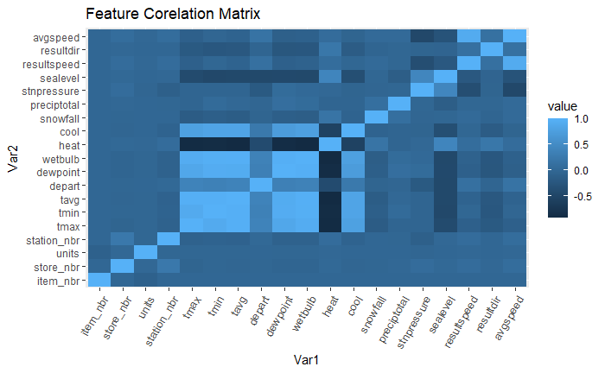

3.Feature Importance as per Linear Regression

Feature Importance chart for showing relative feature importance for Item Number 45(Top selling product number 1)

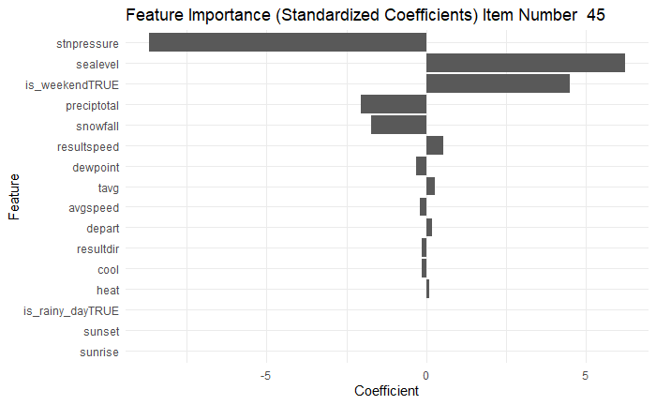
Feature Importance chart for showing relative feature importance for Item Number 9(Top selling product number 2)
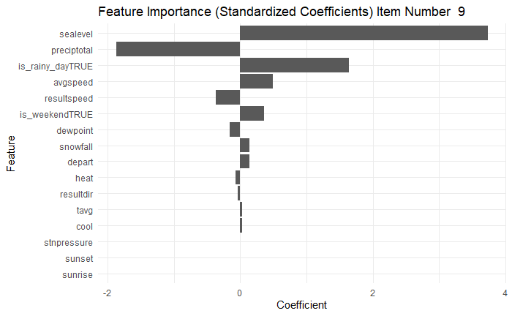

Feature Importance chart for showing relative feature importance for Item Number 5(Top selling product number 3)
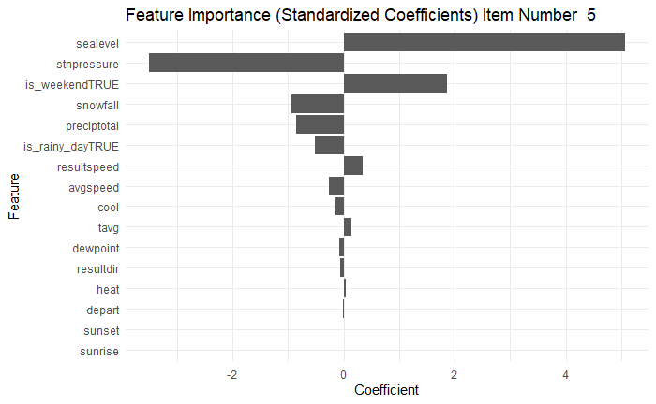

5.Scatter Plots
Scatter Plot showing relationship between sunset timings and units sold for Item Number 45

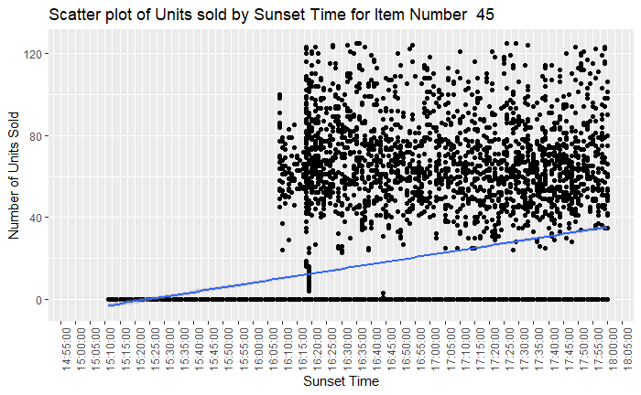

Scatter plot showing relationship between Sunrise and units sold for Item Number 9

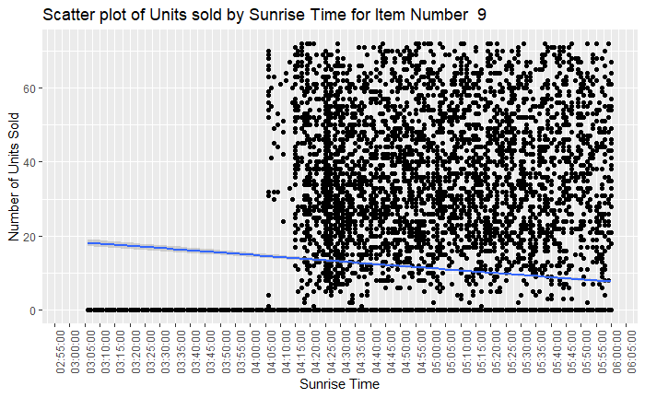

Scatter plot showing relationship between Sunrise and units sold for Item Number 5

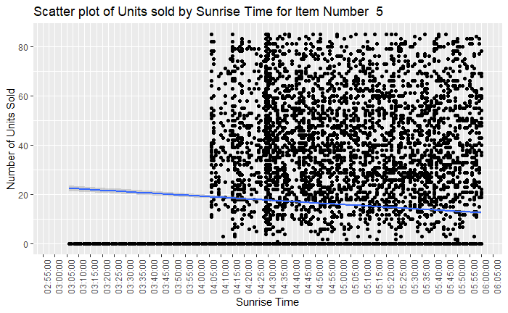

Business Recommendations:

1.Implement Sunset based stock for Item Number 45:

If the Sunset time is late then increase stock of Item number 45.During late sunset event stores need to cater to increase in units sold on such occasions.

2.Implement Region-Specific Weather-Triggered Replenishment:

Instead of a uniform, nationwide inventory policy, create localised inventory triggers based on the weather station closest to each of the 45 stores. For products identified as "hot weather sensitive" (e.g., beverages, sunscreen), set automatic restocking alerts when regional forecasts predict 3+ consecutive days of temperatures above a specific threshold. In Stores located where sunrise is predicted to be early supply more quantity of Item Number 9&Item number 5 and in regions where sunrise is late maintain less stock.

3.Optimise Early Sunrise Inventory for SKUs:

Analyse the top 3 best-selling products to identify their behaviour 1–3 days before a weather event (e.g., late sunrise). For Item number 5&Item Number 9, increase safety stock levels in the 48 hours leading up to the forecast of early sunrise to avoid stock outs.

4.Optimise Inventory based on Weather Data:

Retailers should increase inventory for high-demand products like Item Number 45 during longer daylight periods, as these strongly influence sales.

5.Reallocate Inventory Between Stores Based on Forecasts:

If a severe weather event is predicted, move inventory from a store expected to have low demand to a store likely to experience high demand for a product (e.g., shifting Item number 45 from early sunset region to a late sunset region and shifting Item Number 9 and Item Number 5 from late sunrise location to early sunrise location).

6.Run targeted promotions on weekends:

Retailers should increase staffing and run promotions on weekends when demand is consistently higher especially for Item Number 45 and Item Number 5.

Appendix:

Decision Trees

Decision Tree for units sold for Item Number 45(Top selling product number 1)

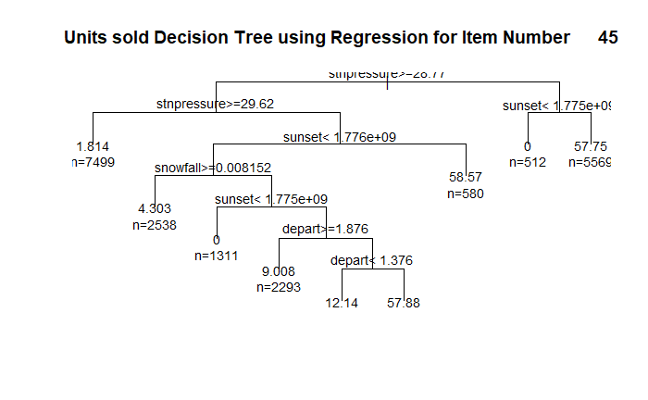

Decision Tree for units sold for Item Number 9(Top selling product number 2)

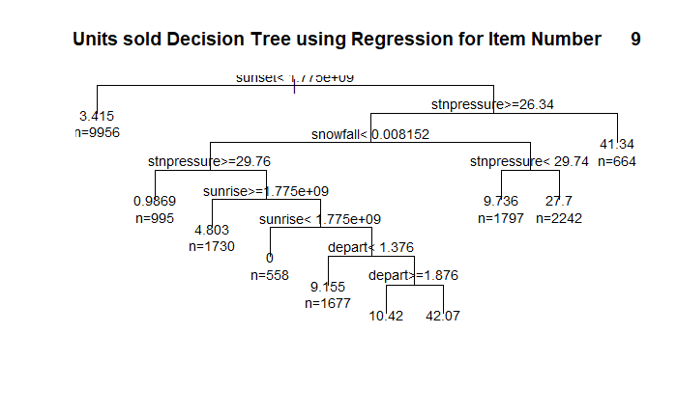
Decision Tree for units sold for Item Number 5(Top selling product number 3)
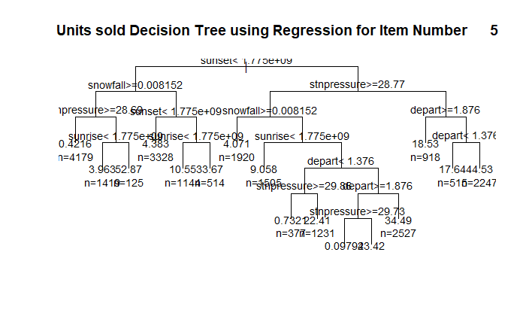
Line Charts
Line chart showing relationship between Sunrise time and units sold for Item Number 45

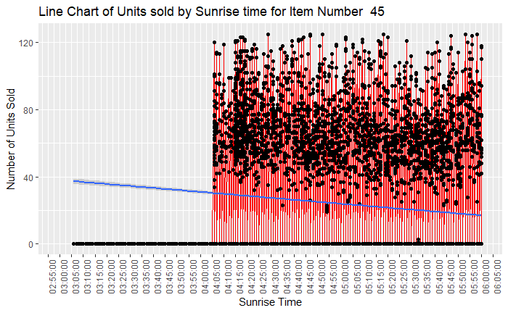

Line chart showing relationship between Sunset timing and units sold for Item Number 45

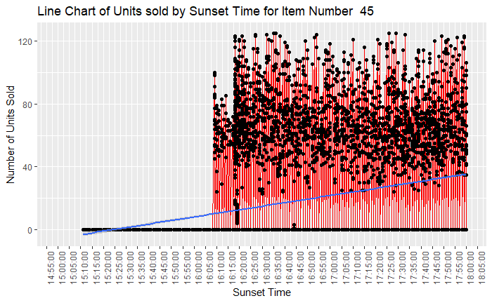

Line chart showing relationship between Sunrise time and units sold for Item Number 9

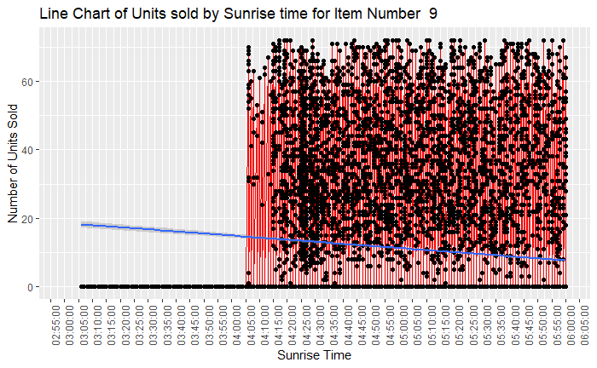

Line chart showing relationship between Sunset timing and units sold for Item Number 9

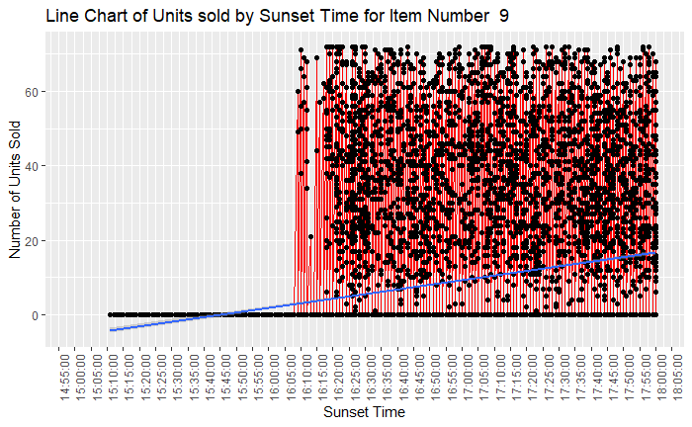

Line chart showing relationship between Sunrise time and units sold for Item Number 5

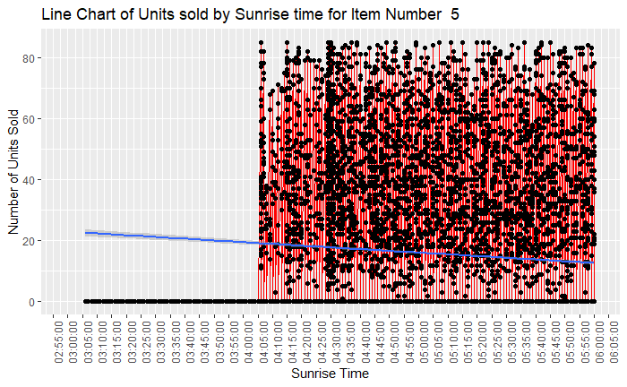

Line chart showing relationship between Sunset timing and units sold for Item Number 5

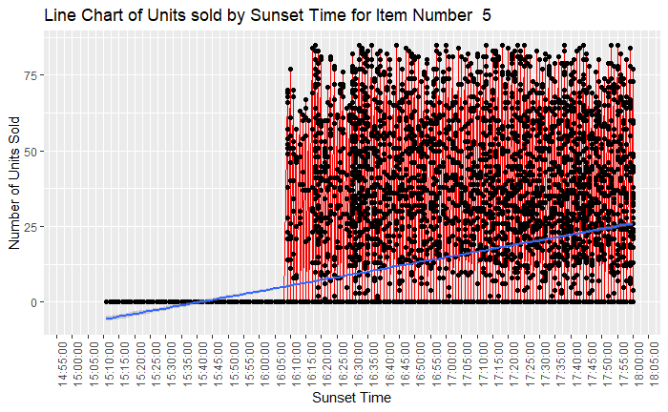

Scatter Plots

Scatter plot showing relationship between Sunrise and units sold for Item Number 45

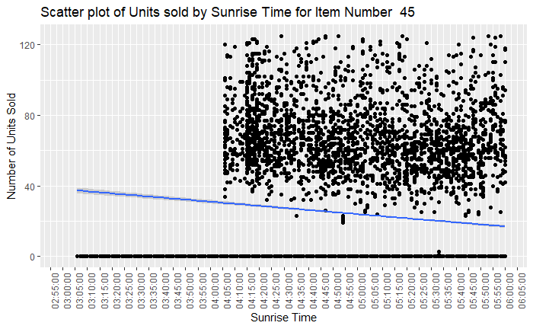
Scatter Plot showing relationship between sunset timings and units sold for Item Number 9
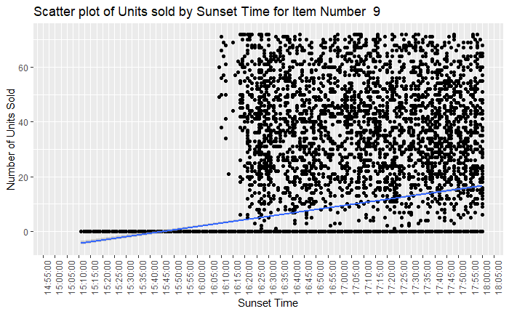
Scatter Plot showing relationship between sunset timings and units sold for Item Number 5

