MUNTEJ MOBILE
Business Requirements Document
v1.0 · October 2026 · Draft for development team

1. Overview
Muntej is an AI task assistant for managers and employees in Saudi SMEs and enterprises. The manager creates a task once, by voice or text, and Muntej handles assignment, follow-up, reminders, collection of evidence and reporting. The manager only steps in for decisions.
- Primary user: Managers who want results without chasing people.
- Secondary user: Employees who receive tasks, update with one tap and get credit for their work.
- Principle: Muntej is the brain's assistant, not a project management tool. No boards, columns or manual Gantt charts.

2. Sprint plan
24 screens split into 3 sprints. Sprint length to be confirmed with the development team.
Sprint | Theme | Screens | Exit criteria
Sprint 1 | Core "Create & Forget" | 01, 02, 03, 04, 06, 14, 15, 18 | 5 pilot managers send tasks unprompted for 14 days; 70% of tasks closed with evidence.
Sprint 2 | Capture everywhere & insights | 12, 13, 07, 10, 09, 16, 17, 05 | 40% of tasks enter automatically; managers open the dashboard 3× per week.
Sprint 3 | Workspaces, fairness & agents | 19, 20, 21, 24, 11, 08, 22, 23 | First paying customer; an enterprise client (e.g. SPL) signs a paid pilot.

3. Screens by sprint

Sprint 1 — Core "Create & Forget"
Goal: A manager says a task once; Muntej assigns it, follows up and closes it with evidence.
01 Home  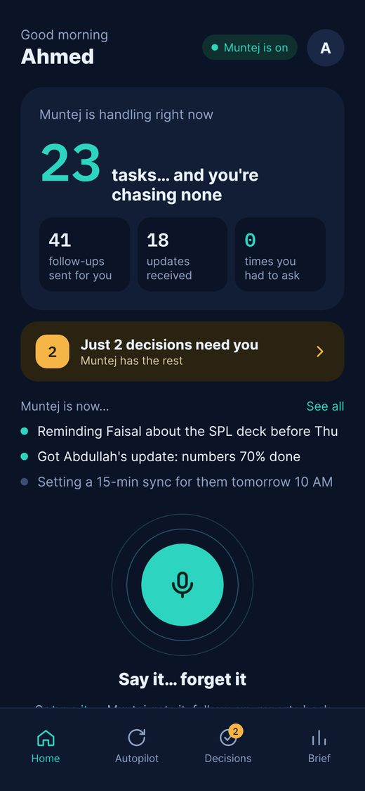  Voice-first home. One big mic button to capture a task, a live count of tasks Muntej is handling, what it is doing right now, and how many decisions need the manager. | 02 Capture  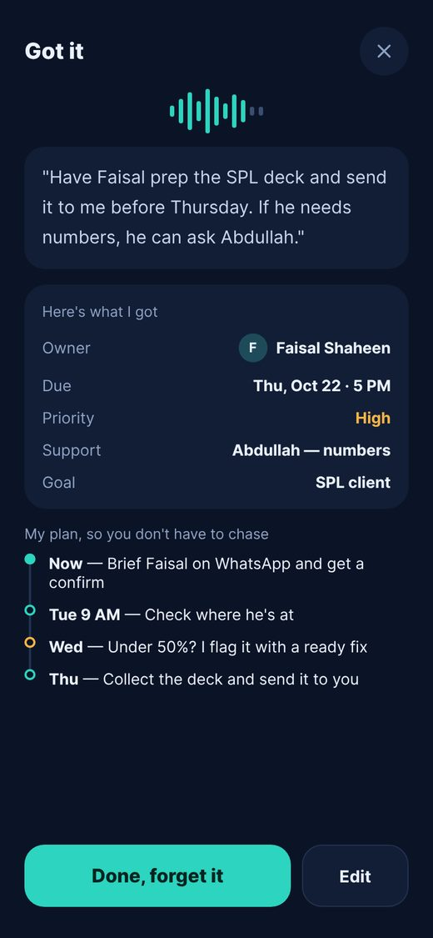  Muntej shows what it understood from one sentence (owner, deadline, priority, helper, goal) and its follow-up plan. One tap: "Got it, forget it". Manager can edit before confirming. | 03 Autopilot  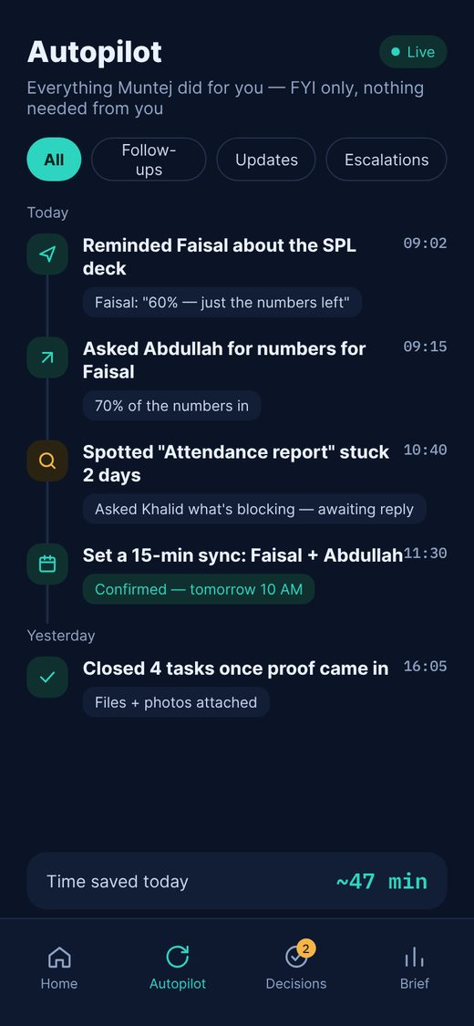  Read-only feed of everything Muntej did on the manager's behalf: reminders sent, updates received, meetings arranged, tasks closed. Shows time saved.
04 Decisions  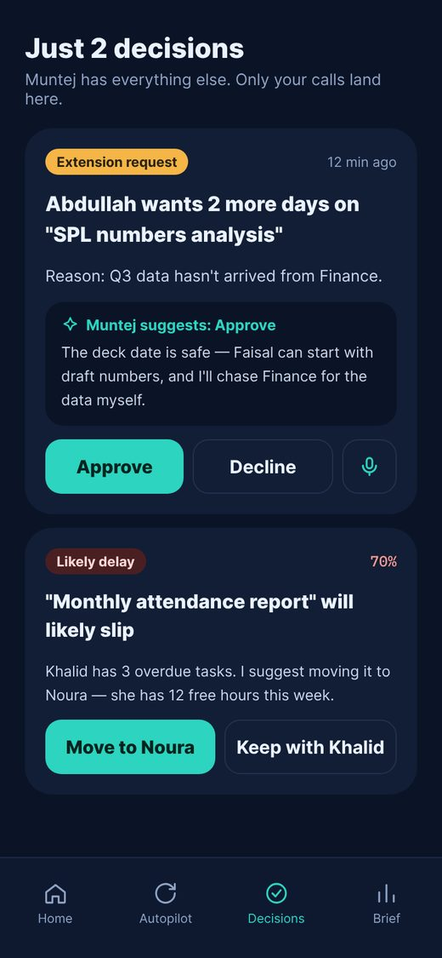  Only exceptions reach the manager (extension requests, delay risks), each with an AI recommendation and one-tap approve/reject or voice reply. | 06 Employee chat  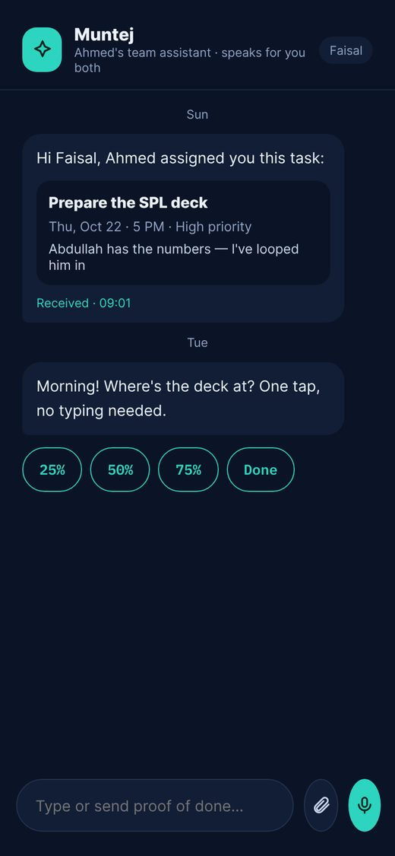  Employees receive tasks and follow-ups in chat (in-app or WhatsApp) and update progress with one tap (25/50/75/Done) or by sending the deliverable. | 14 Task detail  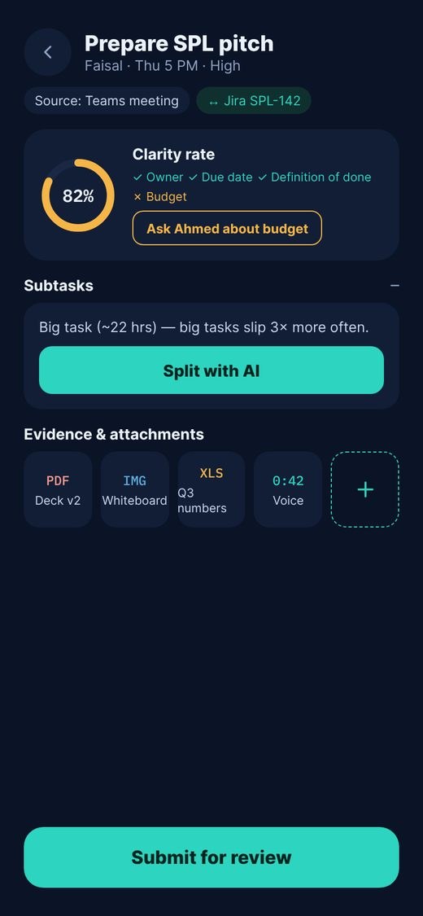  Clarity rate per task (owner, deadline, definition of done, budget) with "ask the manager" for missing info; AI split of big tasks into subtasks; evidence attachments (files, images, voice).
15 Review loop  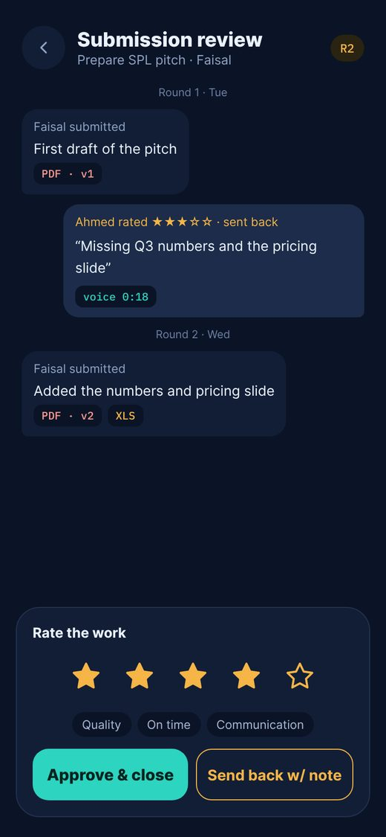  Employee submits; manager rates (1–5 stars) and approves or returns with a note. The loop repeats round by round until approved, then the rating is logged to performance. | 18 Alerts  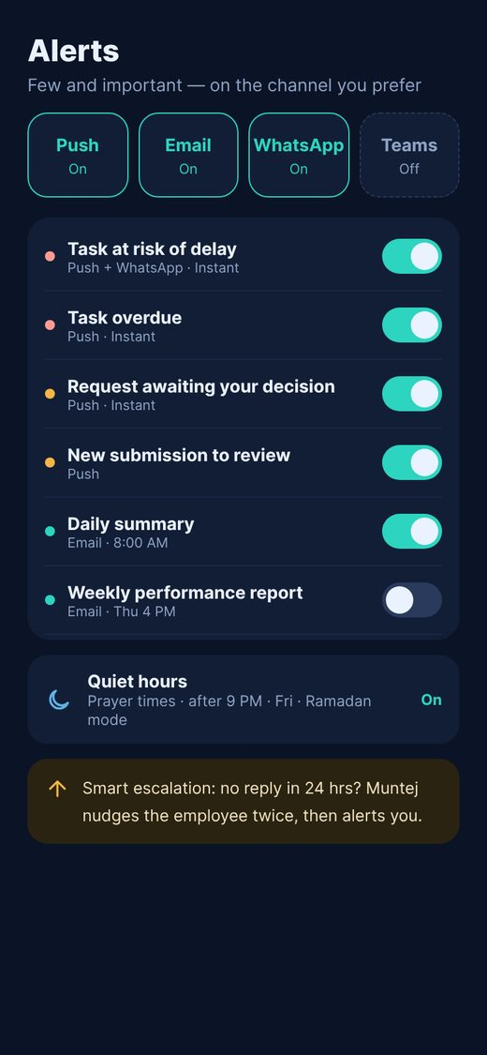  Notification channels (Push, Email, WhatsApp, Teams), alert rules with toggles, quiet hours (prayer times, after hours, Ramadan mode) and smart escalation after 24h of no reply.

Sprint 2 — Capture everywhere & insights
Goal: Tasks flow in automatically from every channel and managers get answers without asking.
12 Sources  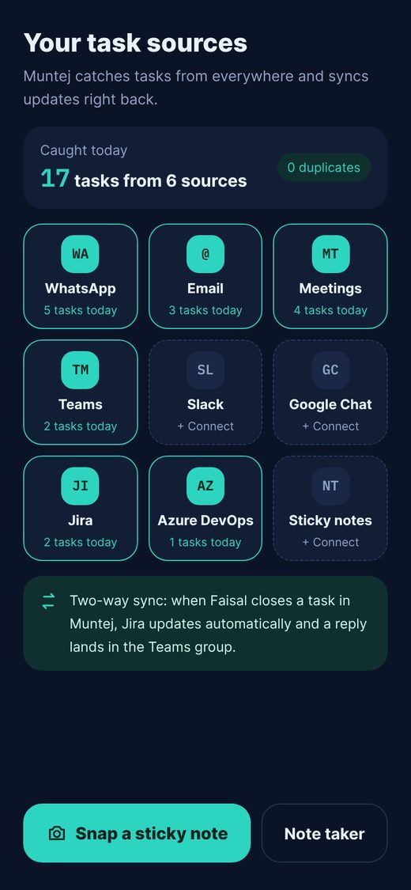  Connect WhatsApp, Email, Meetings, Teams, Slack, Google Chat, Jira, Azure DevOps and sticky-note scanning. Tasks are captured without duplicates, and status syncs back to the source. | 13 Note Taker  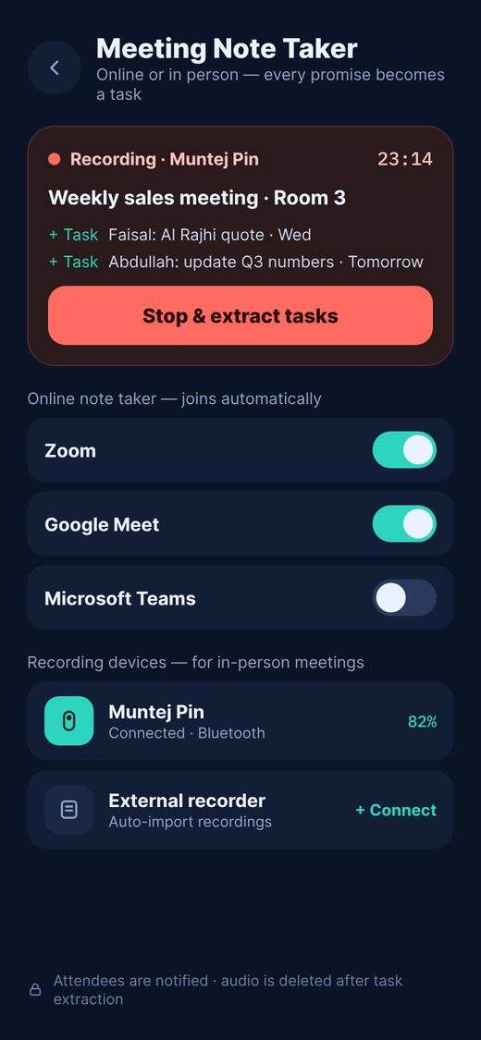  Auto-join bots for Zoom, Google Meet and Teams, plus recording devices for in-room meetings. Live task capture during the meeting; attendees are notified and audio is deleted after extraction. | 07 Promise Catcher  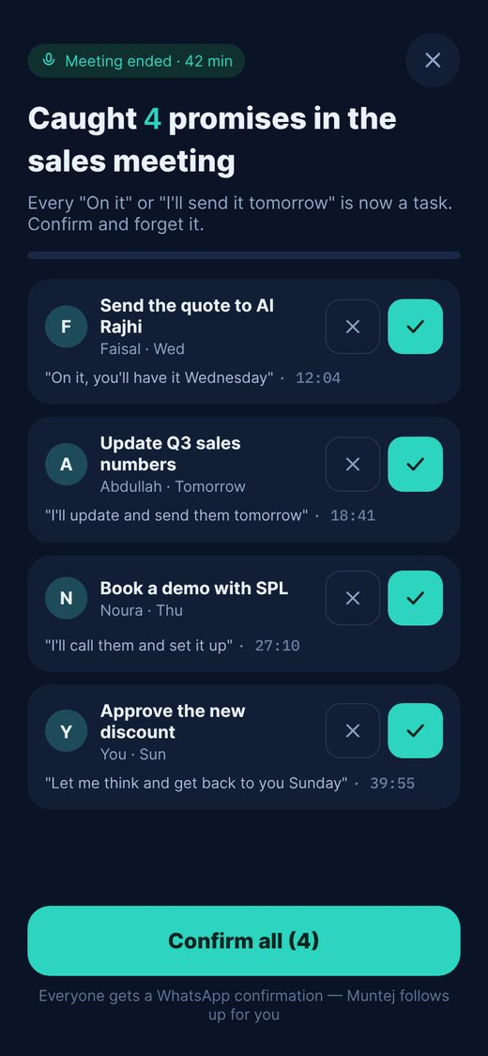  After a meeting, every spoken commitment ("I'll send it tomorrow") becomes a suggested task with the exact quote and timestamp. Confirm, skip or confirm all.
10 Evidence progress  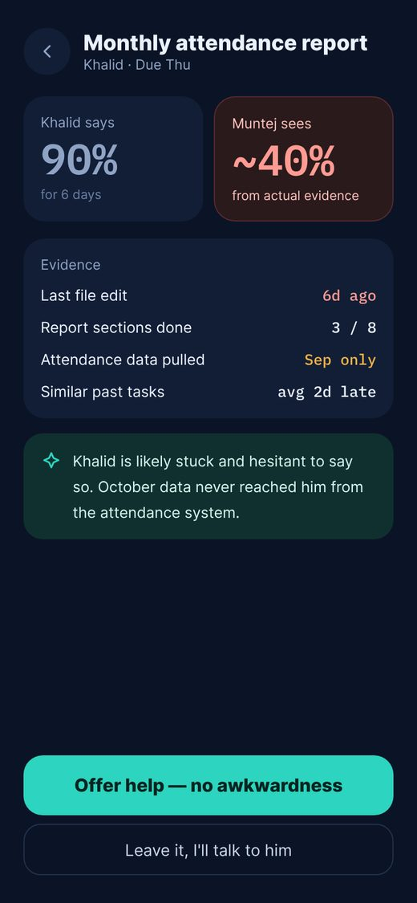  Progress is estimated from real signals (file activity, completed sections, data received) instead of self-reporting, and Muntej offers help when an employee looks stuck. | 09 Reverse follow-up  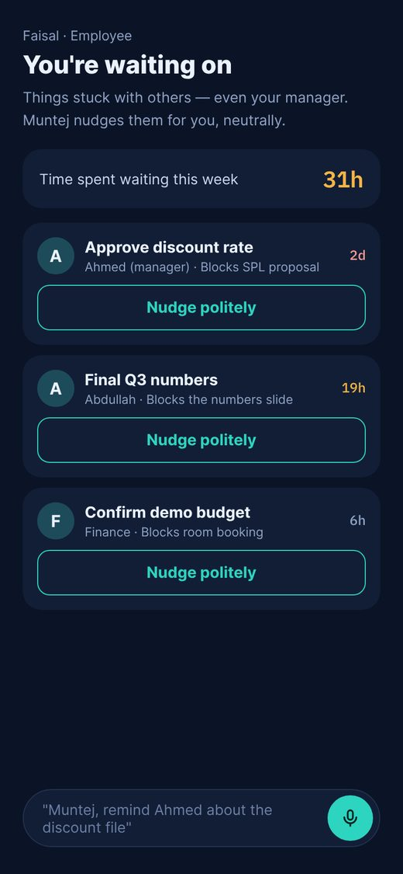  Employees see what they are waiting on (including their manager) and ask Muntej to nudge politely on their behalf. | 16 Dashboard  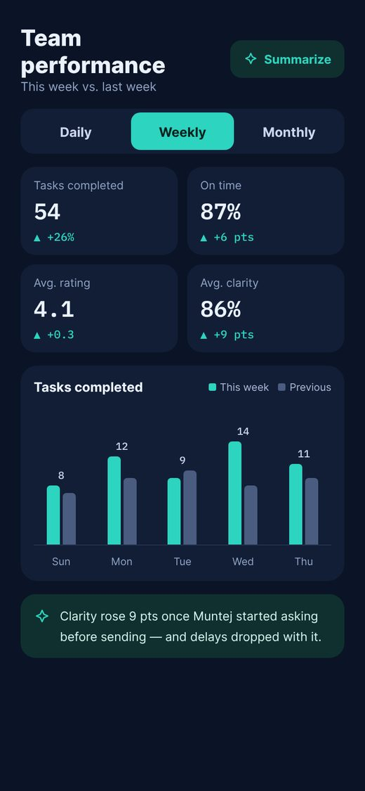  Daily / weekly / monthly KPIs (completed, on-time %, rating, clarity) with comparison to the previous period, a trend chart and one AI insight.
17 Summaries  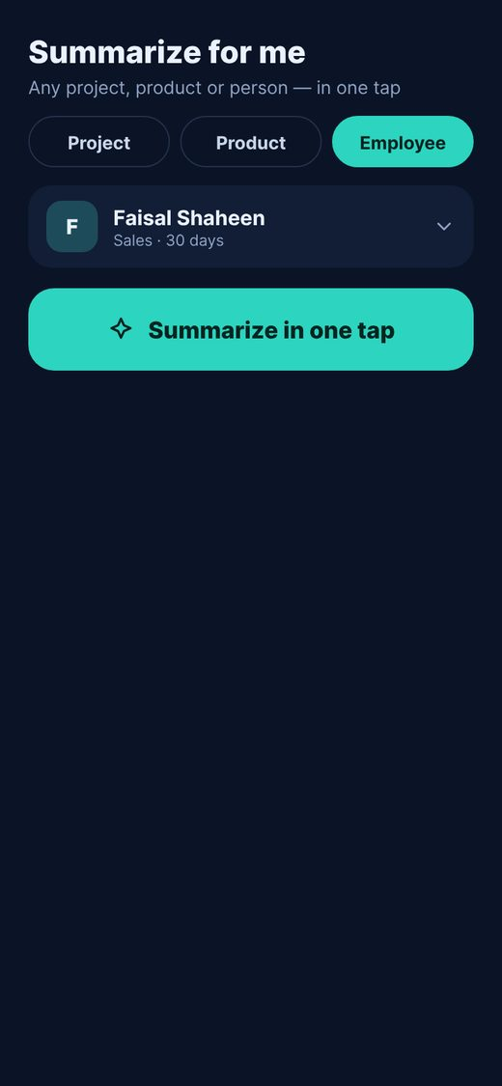  One-tap summary for any project, product or employee, with listen / PDF / share. For employees, Muntej drafts feedback the manager can send and log. | 05 Weekly brief  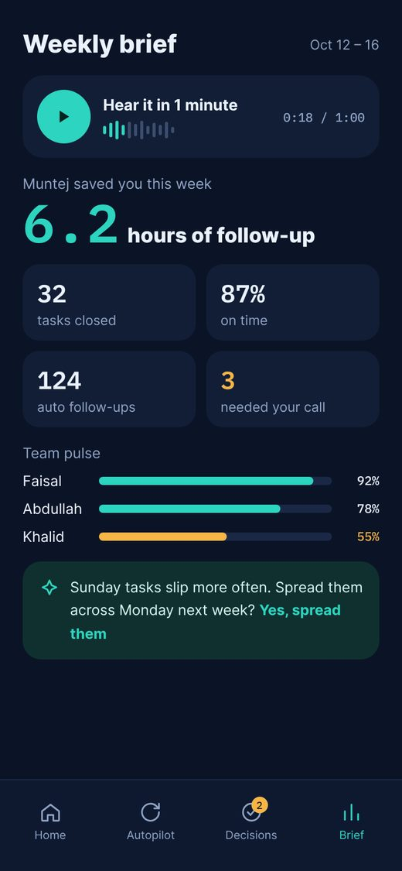  60-second audio summary, hours saved, team pulse and one predictive suggestion the manager can accept with one tap.

Sprint 3 — Workspaces, fairness & agents
Goal: Scale to multiple products and teams, keep workload fair, and automate repeated routines.
19 Workspaces  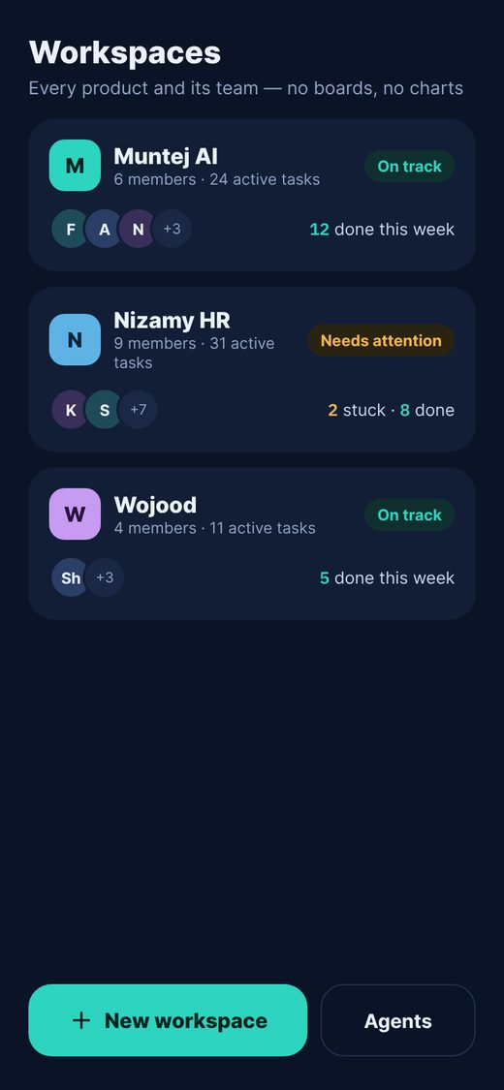  Each product is a workspace with its members, health status and weekly wins. No boards or columns: tasks are routed to workspaces automatically. | 20 New workspace  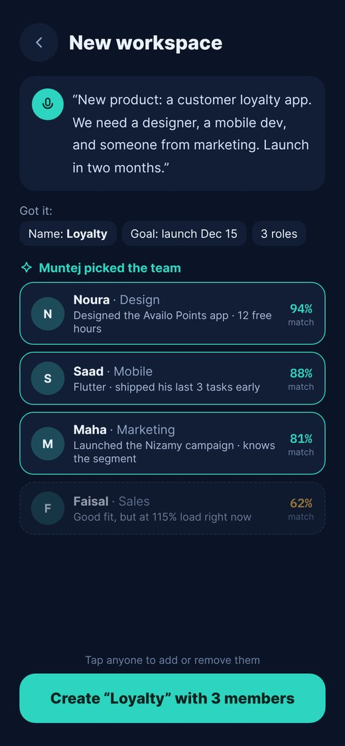  Describe the product in one sentence; AI suggests the team with a match % and reason (skills, past work, free capacity). Manager adds/removes with one tap. | 21 Achievements timeline  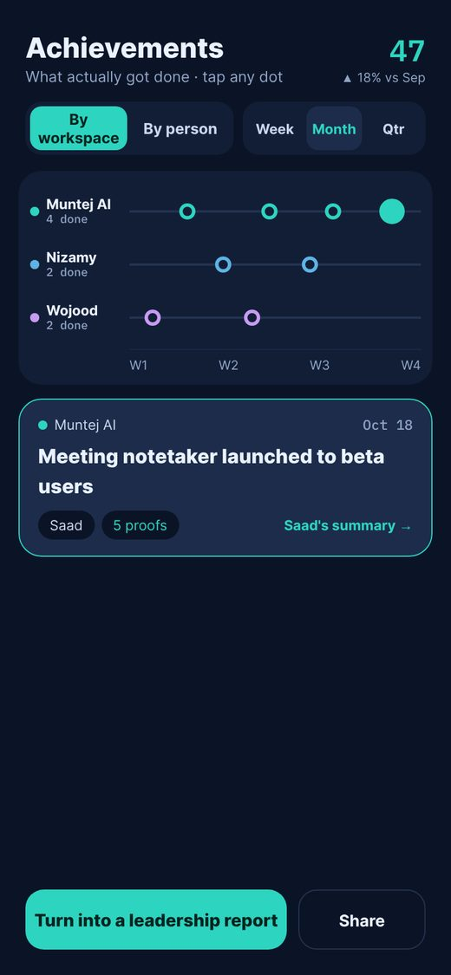  One-page timeline of what was actually achieved, viewed by workspace or by employee, with week / month / quarter zoom and evidence per achievement.
24 Roadmap  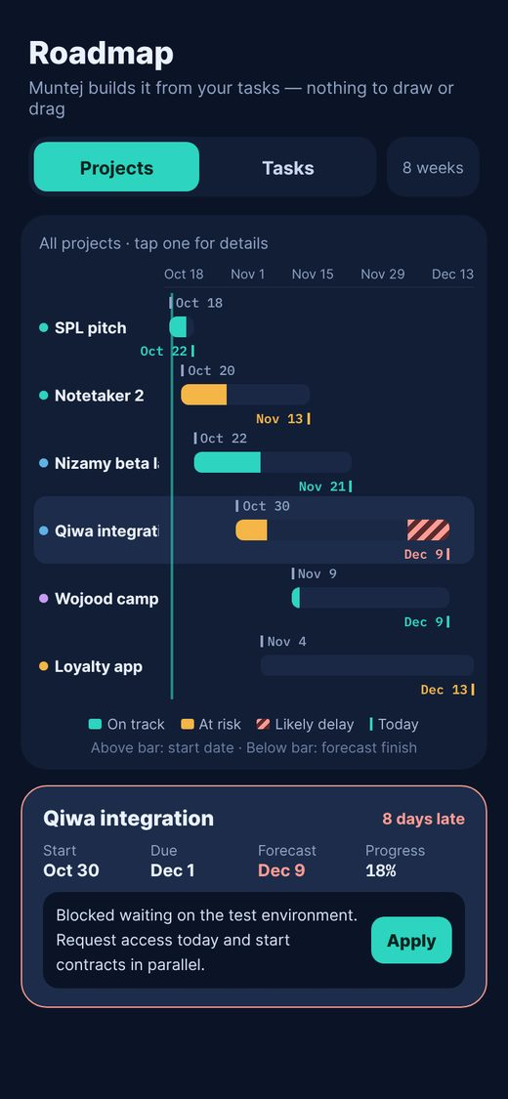  Auto-built roadmap of projects and their tasks showing start date and expected close date, with AI delay forecast and a one-tap fix. No manual drawing. | 11 Load Radar  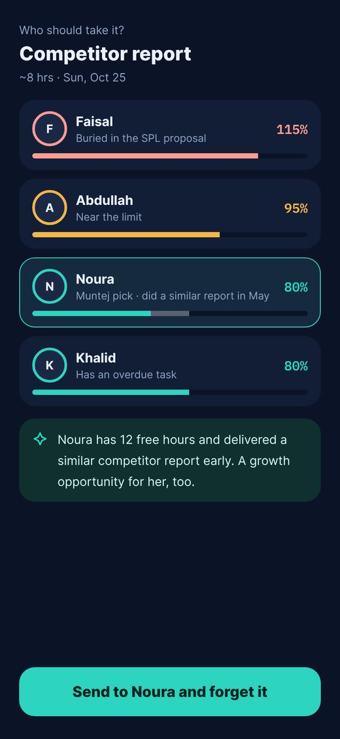  When assigning, shows each person's current load and the impact of the new task, and recommends the best fit to avoid burnout. | 08 Polite Pushback  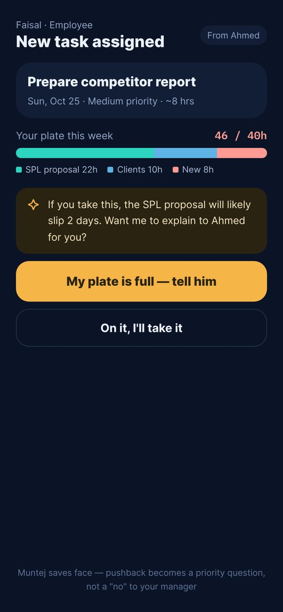  An employee can say "my plate is full"; Muntej asks the manager a priority question on their behalf, keeping it face-saving.
22 Agents  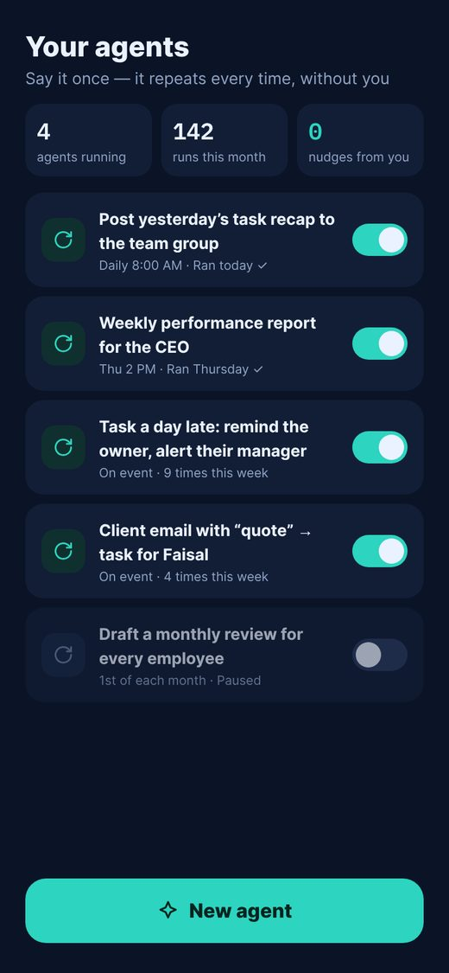  List of routines that run automatically (scheduled or event-based), with on/off toggles and run history. | 23 New agent  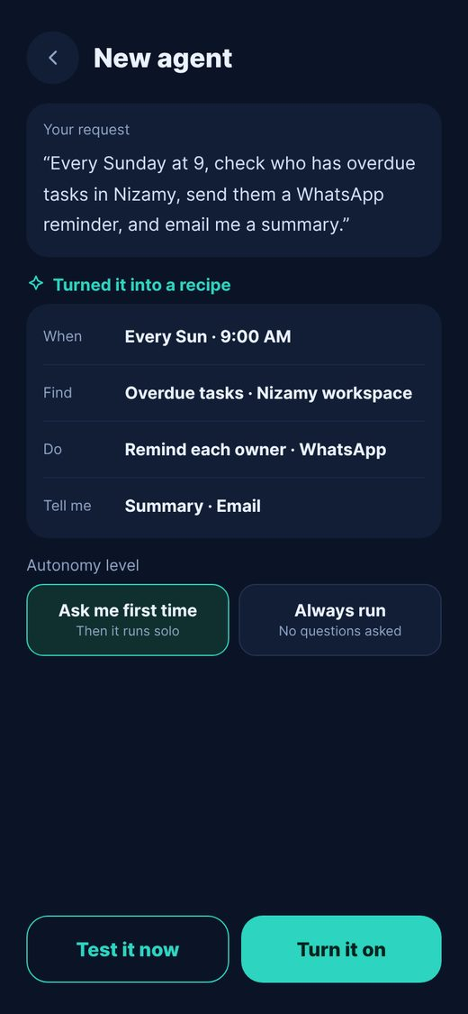  The user writes a routine as a prompt; Muntej converts it into a recipe (when / find / do / notify), runs a test, and the user picks autonomy: "ask me the first time" or "always run".

4. Non-functional requirements
- Language: Arabic (RTL) and English (LTR), with Saudi conversational Arabic for messages.
- Platforms: Native iOS and Android; WhatsApp works as a full channel for employees without the app.
- Privacy: Compliant with Saudi PDPL; explicit consent for meeting recording; audio deleted after task extraction.
- Audit & control: Every action Muntej takes is logged and can be undone.
- Access: Employee-level timelines and summaries are visible only to the employee and their direct manager.

5. Success metrics
- North star: Number of times the manager had to ask anyone about a task (target: zero).
- Adoption: Tasks sent per manager per week without prompting.
- Quality: Average clarity rate and on-time completion %.
- Value: Follow-up hours saved per manager per week.

