Landing Page Feedback

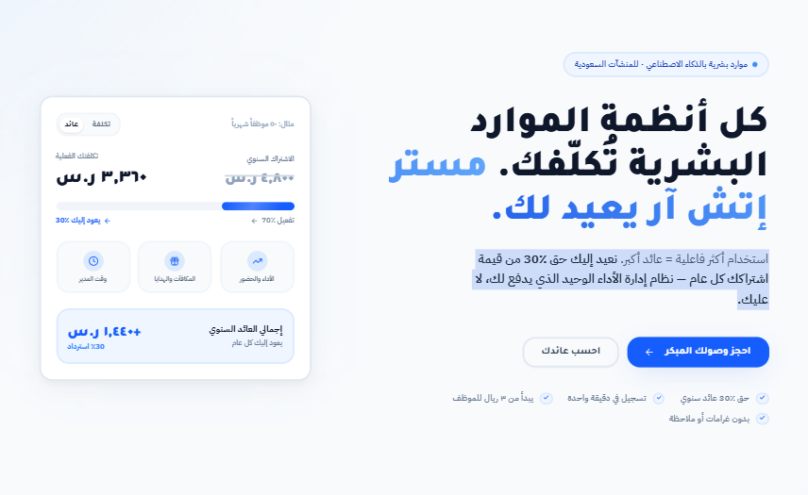
General Note
The landing page is a good first version, especially from a visual and positioning direction.
The ROI angle is strong and can work well as a hook.
However, the page currently needs better balance between:

ROI message and actual HR product value.
Right now, the visitor may understand that Mr. HR gives financial return, but may not quickly understand what the system actually helps them manage day to day.

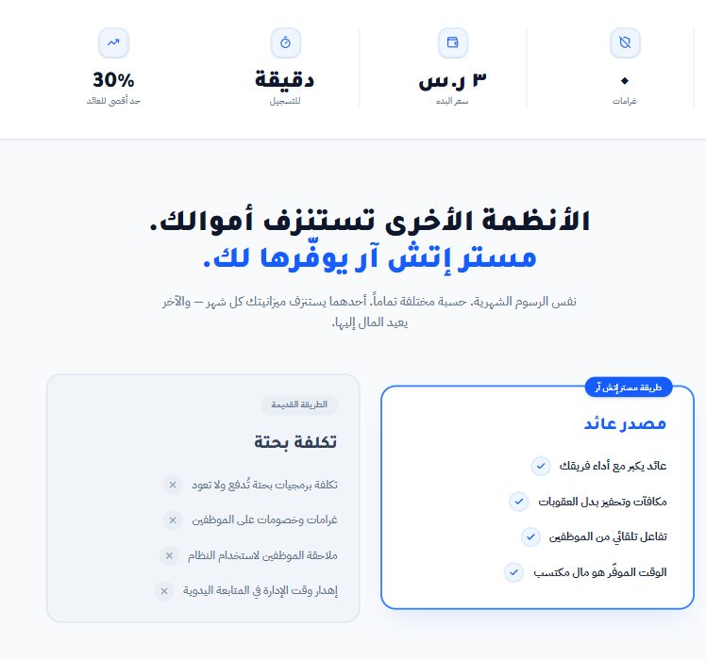
1. Positioning Balance
The ROI message is strong, but it is repeated too much across the page.
Current feeling: The page sounds mainly about return, money back, and financial value.
Suggested direction: Keep ROI as the main hook, but make it clearer earlier that Mr. HR is also a practical HR system for Saudi companies.
Suggested positioning:
Mr. HR is a Saudi AI-powered HR system that helps companies manage attendance, employee services, performance, rewards, and HR insights — while turning better performance into measurable business value.

2. Product Value Should Appear Earlier
After the hero section, the page should quickly answer:
What does Mr. HR actually offer?
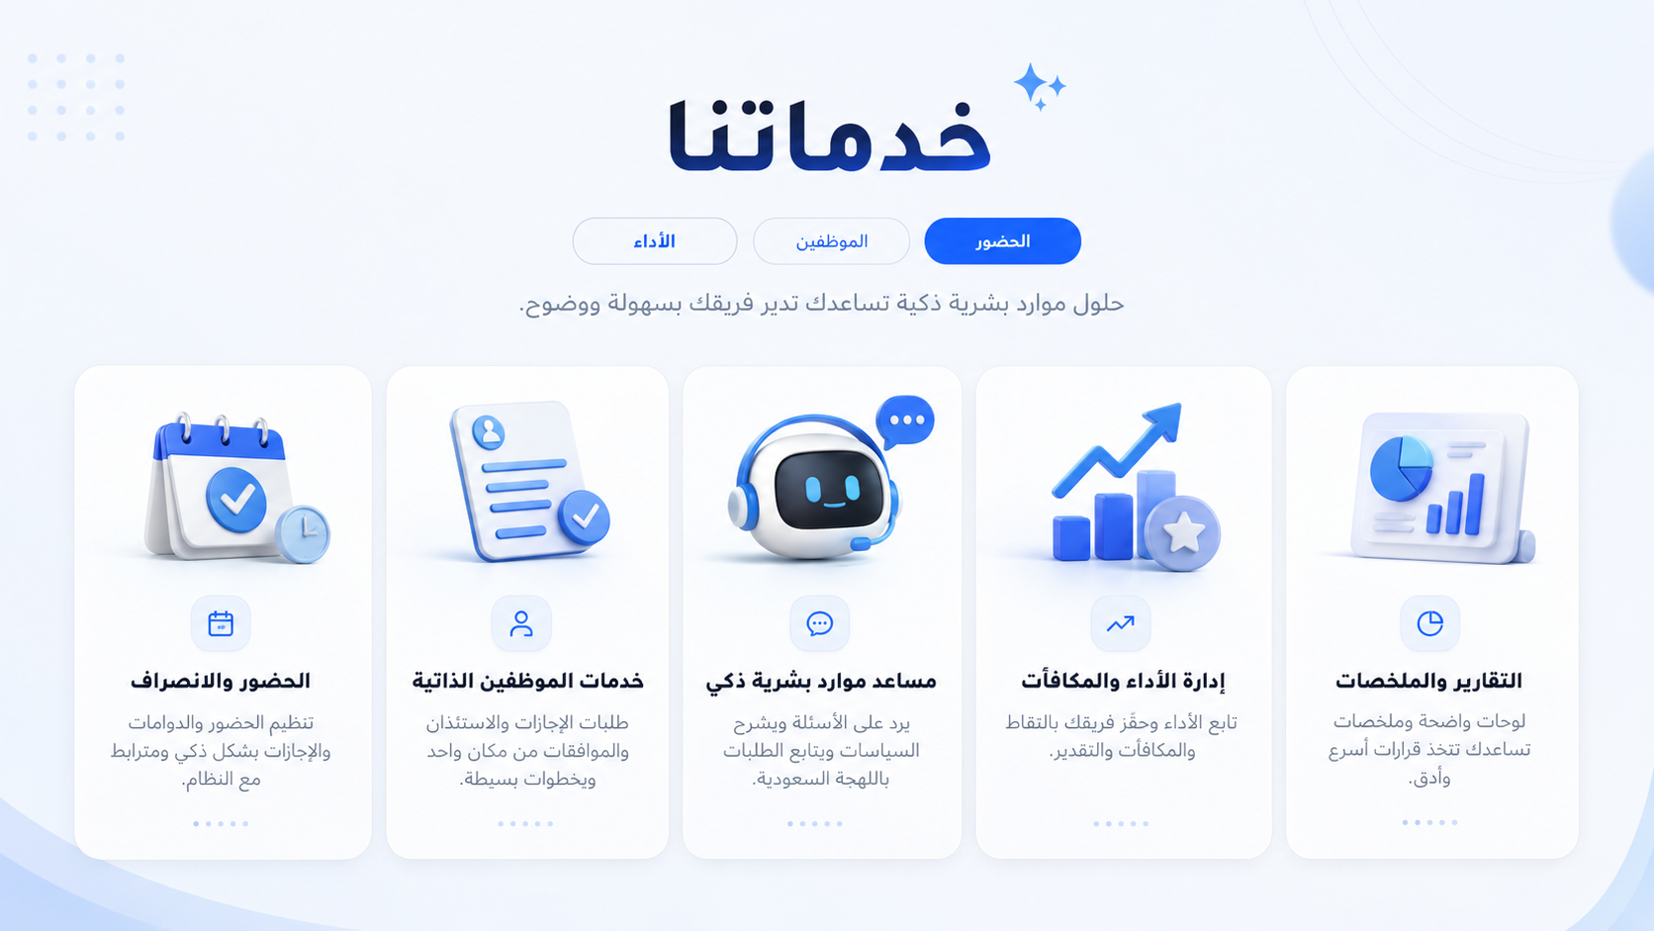
Suggested section title: What Mr. HR Helps You Manage
This is an example of how the core services can be displayed clearly using compact service cards.

Feature Area | Suggested Arabic Title | notes
Attendance | إدارة الحضور والانصراف | سجّل حضور الموظفين بطرق تحقق موثوقة مثل الموقع، الوجه، البصمة، أو الصوت.
Employee Services | خدمات الموظفين الذاتية | الإجازات، الاستئذان، تبديل الشفتات، والطلبات اليومية من مكان واحد.
AI Assistant | مساعد موارد بشرية ذكي | مساعد يفهم الموظفين والمدراء باللهجة السعودية ويجاوب على الأسئلة والطلبات.
Performance | متابعة الأداء والالتزام | تابع ساعات العمل، الالتزام، الحضور، ومؤشرات أداء الفريق بوضوح.
Rewards | المكافآت والتحفيز | حفّز الموظفين بالنقاط، التقدير، بطاقات الهدايا، والمكافآت.
Reports | تقارير وملخصات ذكية | تقارير تساعد الإدارة تفهم أداء الفريق وتتخذ قرارات أسرع.
Tasks | متابعة المهام قريباً | إدارة ومتابعة المهام بالذكاء الاصطناعي كجزء من تطوير المنتج القادم.

3. Copy & Tone
The Arabic copy is strong in some parts, but some sentences feel heavy or AI-generated.
Suggested tone direction: Simple, direct, Saudi, and human.
The copy should feel like it is speaking to a Saudi business owner or HR manager in a clear and practical way.
Examples:
Current Text | Suggested Text | Note
حضور وتحقق متعدد | إدارة الحضور والانصراف بطرق تحقق موثوقة | More clear and practical.
خدمات ذاتية ذكية | خدمات الموظفين الذاتية | Easier to understand.
حوافز ومؤشرات أداء | إدارة الأداء والمكافآت | More direct.
تحفيزي — ليس عقابياً | تحفيزي وليس عقابي | More natural Arabic.
بدون غرامات أو ملاحظة | نظام يركز على التحفيز بدل العقوبات | Current phrase is unclear.
ذكاء اصطناعي باللهجة السعودية | مساعد موارد بشرية ذكي يفهم اللهجة السعودية | More useful and human.

4. Recommended Improvements
To make the landing page clearer and more convincing, I suggest focusing on three areas:
Area | Recommendation
Trust & Local Relevance | Add trust points that show Mr. HR is designed for the Saudi work environment, understands Saudi Arabic, supports daily HR operations, and is suitable for small and growing businesses.
UX / Layout | Make the page easier to scan by adding a clear services section near the top, using compact feature cards, reducing long text blocks, and keeping detailed explanations lower on the page.
ROI Clarity | Clarify what the 30% return means: cash return, discount, system credit, rewards value, estimated savings, or performance-based value. This will make the ROI promise more credible.

Suggested page flow:
- Hero section
- What Mr. HR does
- Core HR services
- ROI model
- ROI calculator
- Detailed features
- Early access form

Final Summary
The landing page is a strong starting point visually, and the ROI angle is a good differentiator.
The main improvement is to make the product value clearer from the first scroll. The visitor should quickly understand that Mr. HR is a practical HR system for attendance, employee services, AI support, performance, rewards, and reports .. then the ROI message will feel stronger and more believable.

