LINUX MINI PROJECT
PROJECT AT A GLANCE
A practical demonstration of how Linux commands can organise student information, find records quickly, separate course-wise lists, and prepare a combined report.
01  STORE  Student records | 02  SEARCH  Find a record | 03  SORT  Arrange names | 04  REPORT  Combine files
TOOLS USED • mkdir • touch • echo • grep • cut • sort • cat

Student Record Search
and Management System
A command-line project using basic Ubuntu/Linux commands

Submitted by | Sameer Kumar Jha
Course | Bachelor of Computer Applications (BCA)
UID | 25BCA10297
Section | 25BCA-1-A
Platform | Ubuntu Linux

PROJECT DOCUMENTATION

1. Introduction
Student information is often maintained in registers or separate files. Finding one student's details, checking a course-wise list, or preparing a combined report can take time when records are handled manually. This mini project demonstrates how common Linux commands can make these simple tasks quicker and more organised.
The Student Record Search and Management System is a small, file-based project. It stores student details in text files and uses Linux commands to search, filter, extract, sort, display, and combine records. It does not use a programming language, database, or shell script.

2. Problem Statement
In a small college class or department, student records may be stored in paper registers or scattered text files. Manually locating a particular student, separating students by course, arranging names alphabetically, and preparing a final list can be repetitive and error-prone. The problem is to organise student records in a simple way and make common record-handling tasks easier using only basic Linux commands.

3. What We Are Going to Do

We will create a small folder-based record system with three text files and two report files.
File / Folder | Purpose
records/students.txt | Main file containing all 10 student records.
records/bca.txt | Filtered list containing BCA students.
records/bba.txt | Filtered list containing BBA students.
reports/sorted.txt | Student records arranged alphabetically by name.
reports/final_report.txt | Combined report containing the filtered course .
Each record follows this format:
Student_ID,Name,Course,Semester,Percentage

Example: 101,Sameer Jha,BCA,3,75

4. How We Will Do It

- Create the project folder and the records/reports subfolders.
- Create the three text files used to store the main list and course-wise lists.
- Enter 10 sample student records into students.txt.
- Use grep to separate BCA and BBA students into their own files.
- Use cut to extract a particular column, such as student names.
- Use sort to arrange the records alphabetically.
- Use head, tail, and less to view the records and reports.
- Combine the course-wise files into one final report.

5. Project Folder Structure
Student_Management/
├── records/
│ ├── students.txt
│ ├── bca.txt
│ └── bba.txt
└── reports/
├── sorted.txt
└── final_report.txt

6. Commands and What They Do

Command | Purpose | Example
mkdir | Creates a directory. | mkdir records
cd | Moves into a directory. | cd Student_Management
touch | Creates an empty file. | touch students.txt
echo | Adds text to a file when used with redirection. | echo "101,Sameer Jha,BCA,3,75" >> students.txt
ls | Lists files and folders. | ls
grep | Searches for matching text/patterns. | grep ',BCA,' students.txt
cut | Extracts selected columns/fields. | cut -d ',' -f2 students.txt
sort | Sorts lines in a file. | sort students.txt
head / tail | Shows the first / last lines. | head -n 3 students.txt
less | Opens a file for scrolling. | less students.txt
cat | Displays or combines file contents. | cat bca.txt bba.txt
mv | Moves or renames a file. | mv sorted.txt alphabetic.txt
chmod | Changes file permissions. | chmod 640 final_report.txt
egrep / fgrep | Searches using extended / fixed-string matching. | egrep 'BCA|BBA' students.txt
history | grep | Finds a previous command in terminal history. | history | grep "grep"

7. Implementation: Commands, Steps and Output

Step 1 — Create the project folders and files
Open the Ubuntu Terminal and run these commands:
mkdir Student_Management
cd Student_Management
mkdir records reports
cd records
touch students.txt bca.txt bba.txt
cd ..

This creates the required folder structure and empty text files.
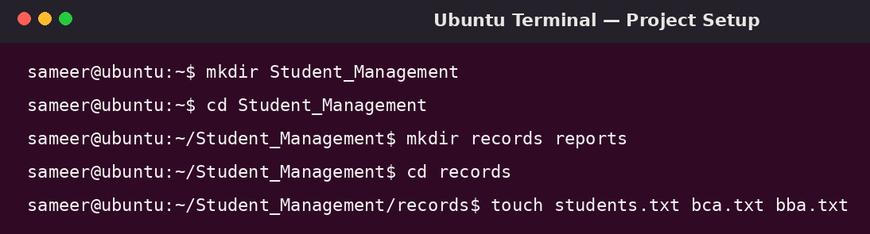
Illustrative Ubuntu-style terminal view showing project setup commands.

Step 2 — Enter student records
Move into the records folder and add the sample records. The >> operator appends each line to the file.
cd records
echo "101,Sameer Jha,BCA,3,75" >> students.txt
echo "102,Rahul Kumar,BBA,2,80" >> students.txt
echo "103,Aman Singh,BCA,3,85" >> students.txt
echo "104,Priya Sharma,BCA,5,90" >> students.txt
echo "105,Neha Verma,BBA,2,78" >> students.txt
echo "106,Rohit Kumar,BCA,3,88" >> students.txt
echo "107,Anjali Gupta,BBA,4,92" >> students.txt
echo "108,Karan Singh,BCA,5,81" >> students.txt
echo "109,Sneha Kumari,BBA,3,86" >> students.txt
echo "110,Arjun Raj,BCA,3,79" >> students.txt
cat students.txt

The cat command displays the contents of students.txt so we can verify that the records were entered.
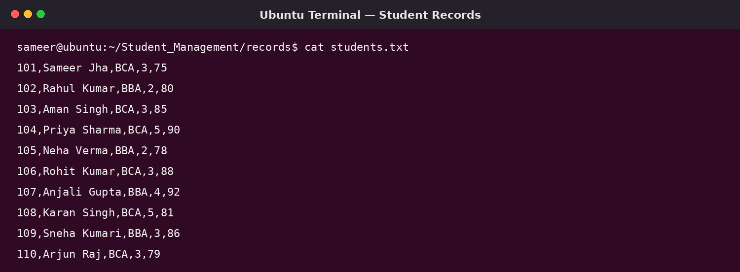
Illustrative Ubuntu-style terminal view of the main student file.

Step 3 — Separate students by course
Use grep to find the course name in each record. The > operator writes the matching lines into a new file.
grep ",BCA," records/students.txt > records/bca.txt
grep ",BBA," records/students.txt > records/bba.txt
cat records/bca.txt
cat records/bba.txt

Now the BCA and BBA records are available separately. This avoids manually copying each student's details.

Step 4 — Search and extract information
grep "^103," records/students.txt
cut -d ',' -f2 records/students.txt
egrep ",(BCA|BBA)," records/students.txt
fgrep "Sameer Jha" records/students.txt

The first command finds the record with ID 103. The cut command extracts the second field (student name). egrep searches using an extended pattern, while fgrep searches for an exact fixed text string.
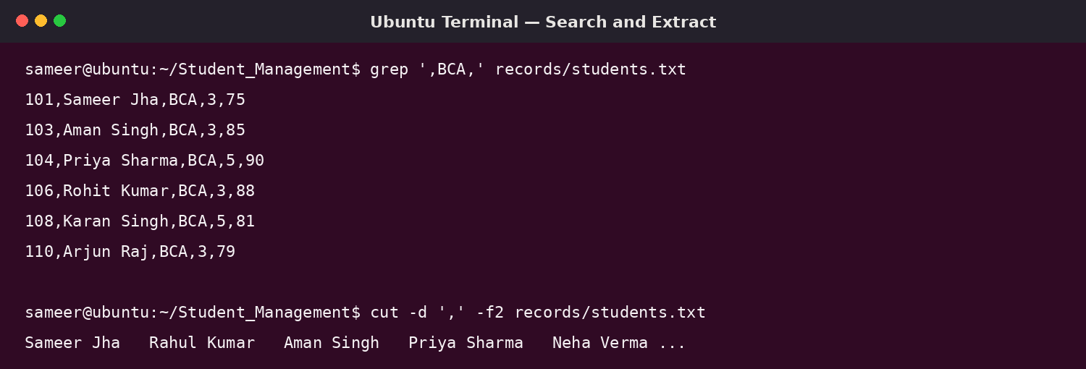
Illustrative Ubuntu-style terminal view demonstrating search and extraction.

Step 5 — Sort and view records
sort -t ',' -k2,2 records/students.txt > reports/sorted.txt
head -n 3 reports/sorted.txt
tail -n 3 reports/sorted.txt
less reports/sorted.txt

The sort command uses the comma as the field separator and sorts by the second field (Name). The sorted result is saved in sorted.txt. head displays the first three lines, tail displays the last three, and less allows the user to scroll through the file. Press q to exit less.

Step 6 — Create the final combined report
cat records/bca.txt records/bba.txt > reports/final_report.txt
head -n 5 reports/final_report.txt
cat reports/final_report.txt

The cat command combines the BCA and BBA files in the order supplied and writes the result to final_report.txt. The > symbol creates or overwrites the destination file. Use >> when you want to append instead.
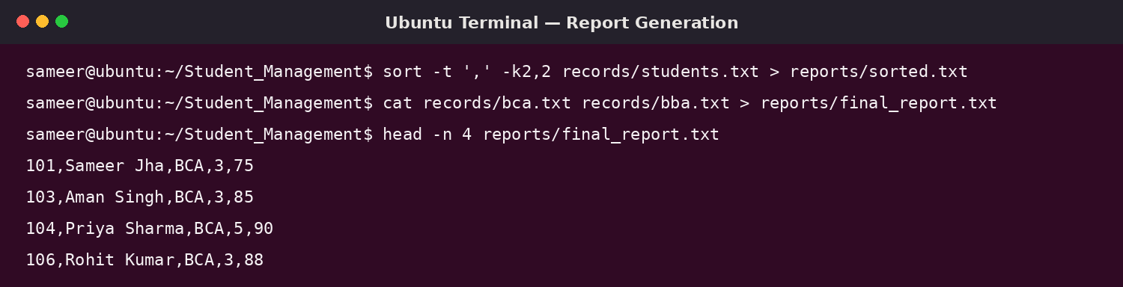
Illustrative Ubuntu-style terminal view showing sorting and report generation.

8. Example Output
Example: searching for student ID 103 produces the matching record:
$ grep "^103," records/students.txt
103,Aman Singh,BCA,3,85

Example: extracting the names (second field) produces a list of student names:
$ cut -d ',' -f2 records/students.txt
Sameer Jha
Rahul Kumar
Aman Singh
Priya Sharma
Neha Verma
Rohit Kumar
Anjali Gupta
Karan Singh
Sneha Kumari
Arjun Raj

9. How This Simplifies a Real-World Issue
In a small class or department, a staff member may need to find a student's record, prepare a course-wise list, or arrange names alphabetically. Doing this manually takes time and can lead to copying mistakes. With this project, the staff member can search by ID or name using grep, separate courses using grep, extract names using cut, and sort the list using sort. The final report can be created by combining files with cat. These operations make basic record handling faster, repeatable, and easier to verify.

10. Limitations and Possible Improvements
- This is a learning project, not a secure production student database.
- Records are stored as plain text, so there is no automatic validation or multi-user access control.
- For a larger institution, a database-backed application would be more suitable.
- The project can be extended later with more course files, additional search fields, and clearer report formats.

11. Conclusion
The Student Record Search and Management System demonstrates that Linux commands can perform useful file management and text-processing tasks without writing a program. By combining commands such as mkdir, touch, echo, grep, cut, sort, head, tail, less, and cat, student records can be organised, searched, filtered, and reported in a simple and practical way.

