Q.1(i)
Solution:
Let number of girls = x, number of boys = y
Total students = 10 and number of girls is 4 more than the number of boys.
∴ x + y = 10 ... (i)
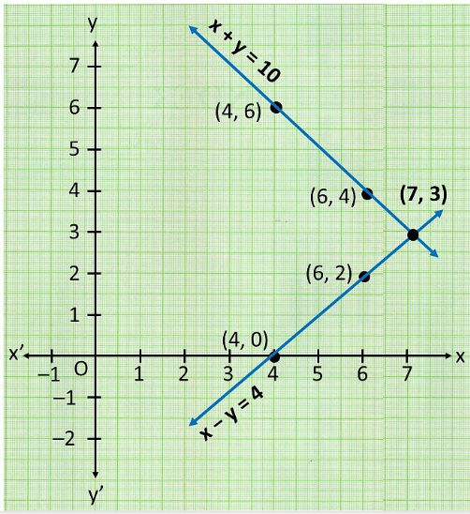
& x = y + 4
Or x − y = 4 ... (ii)
For graph, find points:
From (i): x + y = 10
x | 4 | 6
y | 6 | 4

From (ii): x − y = 4 → x = y + 4
x | 4 | 7
y | 0 | 3

Lines intersect at point (7, 3)

Girls = 7, Boys = 3

Q.1(ii)
Solution:
Let cost of 1 pencil = ₹x, cost of 1 pen = ₹y
Since, 5 pencils and 7 pens together cost ₹50, whereas 7 pencils and 5 pens together cost ₹46.
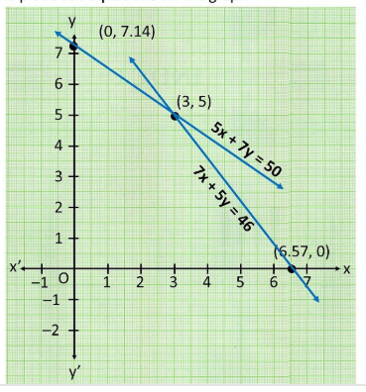
∴ 5x + 7y = 50 ... (i)
& 7x + 5y = 46 ... (ii)
For graph, find points:
From (i): 5x + 7y = 50
x | 3 | 0
y | 5 | 7.14

From (ii): 7x + 5y = 46
x | 6.57 | 3
y | 0 | 5

Lines intersect at point (3, 5)

Cost of 1 pencil = ₹3, Cost of 1 pen = ₹5

Q.2(i) 5x − 4y + 8 = 0 and 7x + 6y − 9 = 0
The given equations are:
5x – 4y + 8 = 0 .... (1)
7x + 6y - 9 = 0 .... (2)
On comparing the equations with ax + by + c = 0, we have
a₁ = 5, b₁ = −4, c₁ = 8
a₂ = 7, b₂ = 6, c₂ = −9
$\frac{a1}{a2}= \frac{5}{7}$ , $\frac{b1}{b2}= \frac{-4}{6}$ $= \frac{-2}{3}$

Since $\frac{a1}{a2} ≠ \frac{b1}{b2}$ Unique Solution Condition

Lines intersect at a point.

Q.4(iii) 2x + y − 6 = 0, 4x − 2y − 4 = 0

The given equations are:
2x + y – 6 =0 …… (1)
4x – 2y – 4 = 0 …… (2)
On comparing the equations with ax + by + c = 0, we have
a₁ = 2, b₁ = 1, c₁ = −6
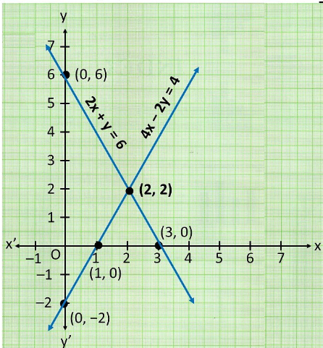
a₂ = 4, b₂ = −2, c₂ = −4
$\frac{a1}{a2}= \frac{2}{4}$ , $\frac{b1}{b2}= \frac{1}{-2}$

a₁/a₂ = 2/4 = 1/2, b₁/b₂ = 1/(−2) = −1/2
Since $\frac{a1}{a2} ≠ \frac{b1}{b2}$
Lines intersect (unique solution)
∴ Our system is consistent
Solving graphically:
From 2x + y = 6:
x | 0 | 3
y | 6 | 0

From 4x − 2y = 4 → 2x − y = 2:
x | 0 | 1
y | −2 | 0

Lines intersect at (2, 2)

Consistent: x = 2, y = 2

Q.5
Solution:
Let length = x m, width = y m
Given that Length = Width + 4
∴ x = y + 4
Or x − y = 4 ... (i)
Also half perimeter = 36
∴ $\frac{1}{2}×$ 2(Length + Breadth) = 36
x + y = 36 ... (ii)

Adding (i) and (ii), we have
2x = 40
x = 20, put x = 36 in (ii)
y = 36 − 20
y = 16

Hence, Length = 20 m, Width = 16 m

Q.7 Draw the graphs of the equations x − y + 1 = 0 and 3x + 2y − 12 = 0. Determine the coordinates of the vertices of the triangle formed by these lines and the x-axis, and shade the triangular region.
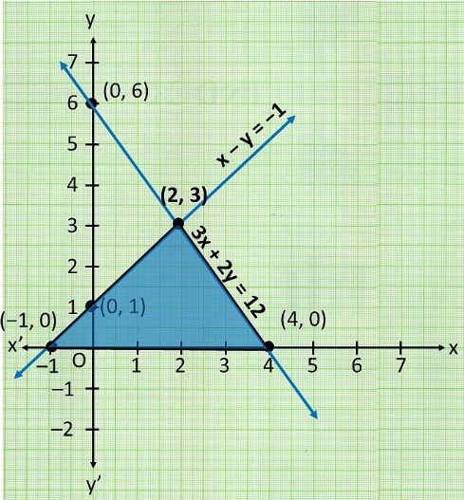
Solution:
Equation 1:
x − y + 1 = 0
→ y = x + 1

x | 0 | −1
y | 1 | 0

Equation 2:
3x + 2y − 12 = 0
→ y = (12 − 3x)/2
x | 0 | 4
y | 6 | 0

Finding vertices:
• Line 1 cuts x-axis (y = 0): x + 1 = 0 → x = −1. Point: (−1, 0)
• Line 2 cuts x-axis (y = 0): 3x = 12 → x = 4. Point: (4, 0)
• Lines intersect: From tables, both pass through (2, 3). Point: (2, 3)

Vertices of triangle: (−1, 0), (4, 0), (2, 3)

EXERCISE 3.2
Q.1(i) Solve by substitution method: x + y = 14, x − y = 4
Solution:
The given equations are
x + y = 14 …. (i)
x − y = 4 …. (ii)
From equation (i)
x = 14 – y ... (iii)
Substitute in (ii): (14 − y) − y = 4
14 − 2y = 4
2y = 10
y = 5
From (iii):
x = 14 − 5 = 9
x = 9
x = 9, y = 5

EXERCISE 3.3

Q.1(i) Solve by elimination method: x + y = 5, 2x − 3y = 4
Solution:
The given equations are:
x + y = 5 ... (i)
2x − 3y = 4 ... (ii)
Multiply (i) by 2:
2x + 2y = 10 ... (iii)
Subtract (ii) from (iii):
5y = 6
Or y = $\frac{6}{5}$ put y = $\frac{6}{5}$ in (i)

x = 5 − $\frac{6 }{5}$ = $\frac{25-6 }{5}$ = $\frac{19 }{5}$
x = $\frac{19 }{5}$, y = $\frac{6 }{5}$

EXAMPLE 1

Example 1 Check graphically whether x + 3y = 6 and 2x − 3y = 12 is consistent.
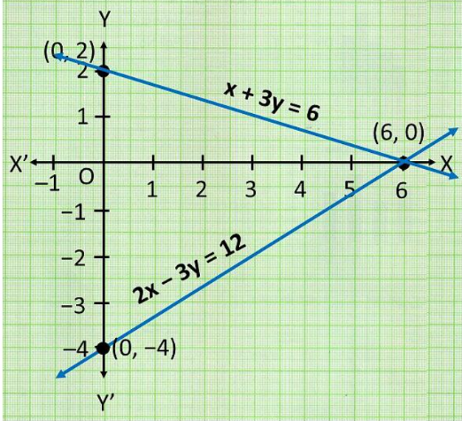
Solution:
Equation 1: x + 3y = 6
x | 0 | 6
y | 2 | 0

Equation 2: 2x − 3y = 12
x | 0 | 6
y | −4 | 0

Lines intersect at (6, 0).
Consistent. Solution: x = 6, y = 0

Exercise 3.1

replace Q1(i) and Q1(ii)

replace Q2(i)

Follow the same writing style to other parts of Q1

replace Q.4(iii)

Follow the same writing style to other parts of Q1

replace Q.5
replace Q.7

Exercise 3.2

replace Q1(i)

Follow the same writing style to other questions in this exercise

Exercise 3.3

replace Q1(i)

Follow the same writing style to other questions in this exercise

replace EXAMPLE 1

Strict note: please replace fractions everywhere, write fractions like $\frac{p}{q}$ not like p/q

