**COMSATS University Islamabad, Lahore** **Campus**

**Assignment-II- Spring 2023**

|  |  |  |  |  |  |  |  |  |  |  |
| --- | --- | --- | --- | --- | --- | --- | --- | --- | --- | --- |
| Course Title: | Software Project Management | | | | | Course Code: | CSE494 | | Credit Hours: | 3(2,1) |
| Course instructor/s: | Sobia Usman | | | | Programme Name: | | BS Software Engineering | | | |
| Semester: | 7th | Batch: | SP20-BSE | Section: | A & B | | Date: | 4-4-2023 | | |
| **Dead Line** | **10-4-2023** | | | | **Maximum Marks:** | | | **10** | | |

**Question:**

Consider your Final Year Project and perform the following tasks.

1. Describe main functionalities of your project in sequence. Note down the flow of activities to mention the sequential integration among components.
2. Identify each activity with some alphabet and write down the predecessor activity according to the flow of your project in a table.

For-example:

|  |  |  |  |
| --- | --- | --- | --- |
| Functionalities | Activities | Predecessors | Duration |
| Login | A | -- |  |
| Wrong password | B | A |  |
| Validate password | C | A |  |
| View product | D | C |  |
| Add product | E | C, D |  |

1. Make CPM network diagram.
2. Apply forward pass on CPM diagram.
3. Show backward pass on CPM diagram.
4. Identify Critical Path.

Software Project Management

Theory Assignment # 2

SUBMITTED BY:

|  |  |
| --- | --- |
| nAME | ROLL NO |
| sAMEER REHMAN | SP20-BSE-050 |
| muhammad aashir bilal | SP20-BE-054 |

1. **Functionalities**

* User authentication
* Student enrollment
* Course management
* Lesson management
* Quiz management
* Progress tracking
* Feedback and reporting

1. **Flow of Activities**

|  |  |  |  |
| --- | --- | --- | --- |
| **Activities** | **Alphabet** | **Predecessor Activities** | **Duration** |
| User authentication | A | -- | 5 |
| Student enrollment | B | A | 4 |
| Course management | C | B | 5 |
| Lesson management | D | C | 6 |
| Quiz management | E | C | 3 |
| Progress tracking | F | D, E | 4 |
| Feedback and reporting | G | F | 2 |

1. **CPM Network Diagram**

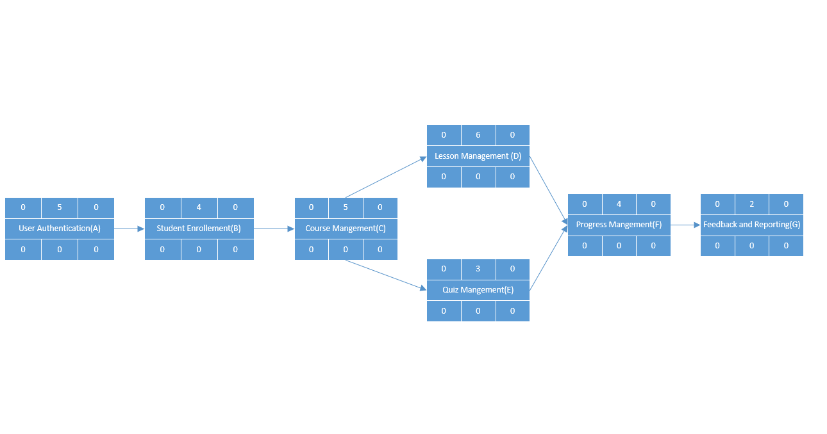

**Figure 1 :CPM Network Diagram**

1. **Forward Pass**

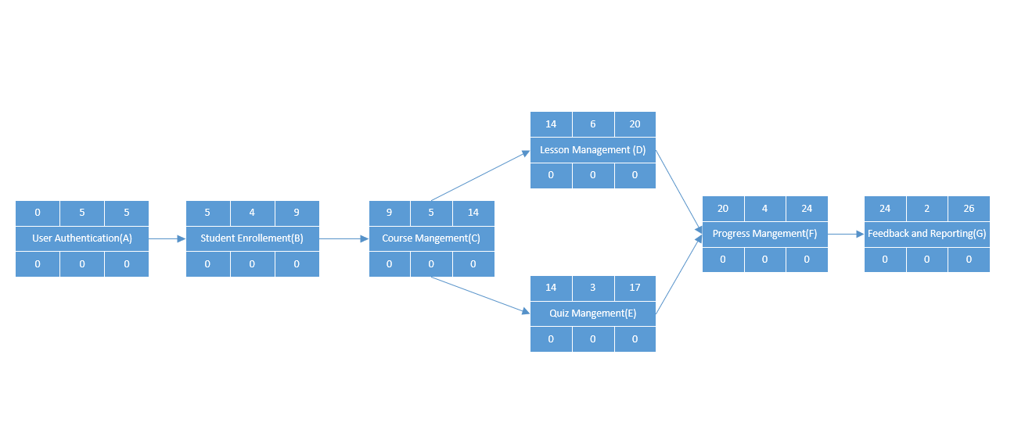

**Figure 2 : Forward Pass**

1. **Backward Pass**

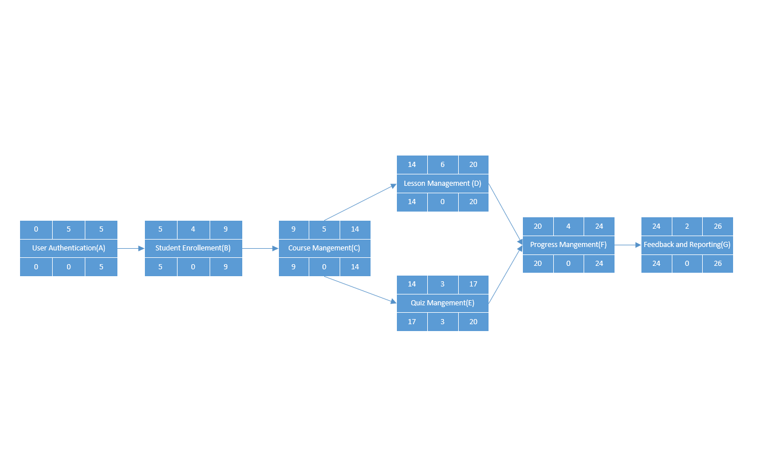

**Figure 3 : Backward Pass**

1. **Critical Path**

**A – B – C -D – F – G the Longest Path (26)**