**System Analysis and Design**

H15030

Table of Contents

Table of Figures 2

Table of Tables 2

Introduction 3

Objective of the Project 3

Requirement Specification 4

**Functional Requirements** 4

**Non-Functional Requirements** 9

**Constraints** 10

Description of the Proposed System 10

**System Architecture:** 11

**Key Features and Functionality:** 11

**User Profiles and Authentication** 11

**Property Listings and Search** 11

**Rental Applications and Communication** 11

**Digital Rental Agreements and Payments** 11

**User Dashboards and Analytics** 11

**Security and Compliance** 11

Logical Model Design 12

**Context Diagram:** 12

**Data Flow Diagram:** 13

# Table of Figures

**Figure 1 :Context Diagram** 12

**Figure 2 : Data Flow Diagram** 13

# Table of Tables

**Table 1 : Functional Requirements** 6

Table 2 : Non-Functional Requirements 10

Table 3 : Constraint Table 11

# Introduction

The Realestate.au Rental System represents a groundbreaking solution aimed at revolutionizing the property rental landscape. In a world portrayed by powerful urbanization and developing living inclinations, the requirement for a proficient and client driven stage for land owners, leaseholders, and realtors has never been more articulated. In the ongoing land rental situation, challenges proliferate for all partners. Land owners frequently face troubles in really exhibiting their properties to likely tenants, while leaseholders explore through a labyrinth of postings, frequently missing essential data to go with informed choices. Realtors, then again, wrestle with dealing with a horde of property subtleties and rental applications, prompting shortcomings in the rental cycle.

The Realestate.au Rental Framework looks to extensively address these difficulties. Via consistently incorporating progressed innovative highlights (Nasreen et al., 2022), the framework will engage land owners to make point by point property postings, complete with pictures, determinations, and rental terms. Leaseholders will profit from an easy to understand interface, empowering them to look, channel, and apply for properties that line up with their inclinations. Realtors will find their undertakings smoothed out, with devices for productive correspondence, computerized arrangement the board, and secure installment handling.

This task intends to improve on the property rental excursion as well as cultivate straightforwardness, trust, and accommodation among all gatherings included. Through cautious thought of both utilitarian and non-practical necessities, the Realestate.au Rental Framework will focus on information security, framework execution, and client experience. As we set out on this undertaking, we imagine a future where property rentals are presently not a wellspring of vulnerability and disappointment. The Realestate.au Rental Framework is ready to turn into a distinct advantage, reshaping the rental scene and setting new principles of greatness in the land business.

# Objective of the Project

The primary goal of the Realestate.au Rental System project is to design, develop, and implement a robust, user-friendly, and technologically advanced platform that addresses the intricate challenges currently faced by property owners, renters, and real estate agents in the property rental domain (Gruszka et al., 2017). The project aims to achieve the following comprehensive objectives:

1. **Streamlined Property Listing and Search:** Create an intuitive and efficient property listing mechanism that empowers property owners to showcase their offerings comprehensively, accompanied by high-quality images, detailed specifications, and accurate rental terms. Simultaneously, provide renters with a sophisticated property search interface, enabling them to filter and locate suitable properties based on location, size, amenities, and budget.
2. **Enhanced User Experience:** Develop a seamless, user-centric interface that ensures an unparalleled experience for all users. Intuitive navigation, easy-to-understand icons, and a responsive design will be incorporated to facilitate effortless interaction and engagement.
3. **Efficient Communication and Collaboration:** Implement a robust communication platform that facilitates real-time interaction between property owners, renters, and real estate agents. Enable instant messaging, scheduling of property visits, and direct communication channels to foster effective collaboration and information exchange.
4. **Automated Rental Application Processing:** Integrate an automated application processing system that enables renters to submit applications digitally, complete with essential documents and references. Property owners and agents can efficiently review, process, and respond to applications, reducing administrative burdens and expediting the rental decision-making process.
5. **Secure and Convenient Agreement Management:** Design a secure, digital agreement management module that generates legally binding rental agreements, enables e-signatures, and securely stores documents. This feature will enhance transparency and eliminate paperwork, ensuring compliance with legal regulations.
6. **Seamless Payment Handling:** Incorporate a reliable and secure payment processing system, allowing renters to make online rent payments and security deposits effortlessly. Property owners and agents will benefit from streamlined financial transactions and timely rent collection.
7. **Data Security and Privacy:** Implement stringent data security measures to safeguard sensitive user information, rental agreements, and financial details. Employ encryption, authentication, and authorization protocols to ensure the utmost privacy and protection of user data.
8. **Scalability and Future-Readiness:** Design the system architecture with scalability in mind, enabling it to accommodate a growing user base and an expanding portfolio of properties. Utilize technologies and frameworks that allow for easy integration of future enhancements and updates.
9. **Comprehensive Reporting and Analytics:** Develop a comprehensive reporting and analytics module that provides insights into user activity, property performance, application trends, and financial data. This feature will assist property owners and agents in making informed decisions and refining their strategies.
10. **Positive Industry Impact:** Ultimately, the Realestate.au Rental System aims to redefine the property rental landscape, fostering efficiency, transparency, and trust among all stakeholders. By delivering an innovative and reliable platform, the project endeavors to contribute positively to the real estate industry and set new standards for property rental processes.

Through the meticulous execution of these comprehensive objectives, the Realestate.au Rental System aspires to become a pioneering solution that transforms property rental into a seamless, secure, and user-friendly experience for property owners, renters, and real estate agents alike.

# Requirement Specification

## **Functional Requirements**

The purpose of functional requirements in Software Engineering is to identify the functionality of component components in a manner that is feasible for the client as well as for the development team by (Malan et al., 2001). It varies from software to software. They define the specific behaviors, interactions, and capabilities that a system or software application must possess in order to fulfill its intended purpose and meet the needs of its users. Functional requirements outline the "what" of a system, detailing the specific functions, features, and operations that users can expect to interact with.

**Table 1 : Functional Requirements**

|  |  |
| --- | --- |
| No. | Functional Requirement |
| 1 | User registration and login functionality. |
| 2 | Differentiate user roles: property owners, renters, real estate agents. |
| 3 | User profile management with editable contact information. |
| 4 | Password recovery mechanism through email. |
| 5 | Property owners can create, edit, and manage property listings. |
| 6 | Property search by location, amenities, size, and price range. |
| 7 | Real-time search suggestions and autocomplete. |
| 8 | Renters can submit rental applications with personal details. |
| 9 | Attach supporting documents to rental applications. |
| 10 | Property owners receive notifications of new rental applications. |
| 11 | Real-time messaging system for communication between users. |
| 12 | Schedule property visits through the platform. |
| 13 | Virtual property tours for remote viewing. |
| 14 | Property owners can review and accept/reject rental applications. |
| 15 | Generate digital rental agreements with customizable clauses. |
| 16 | E-signatures for all parties involved in rental agreements. |
| 17 | Store and manage rental agreements securely. |
| 18 | Online payment processing for rent and security deposits. |
| 19 | Multi-currency and multiple payment method support. |
| 20 | Renters receive payment receipts for transactions. |
| 21 | User-friendly dashboard for property owners to manage listings and applications. |
| 22 | Dashboard for renters to track applications, view agreements, and make payments. |
| 23 | Real estate agents can manage multiple properties and applications. |
| 24 | Comprehensive reporting for property owners and agents (rental income, application statistics). |
| 25 | Visual analytics and data insights for informed decision-making. |
| 26 | Responsive design for seamless mobile and tablet access. |
| 27 | Dedicated mobile applications for iOS and Android platforms. |
| 28 | Advanced property listing details, including images and videos. |
| 29 | Property comparison functionality for renters. |
| 30 | Automated property listing expiration and renewal notifications. |
| 31 | Real-time availability updates for listed properties. |
| 32 | Property owners can set viewing availability for prospective renters. |
| 33 | Integration with mapping APIs for property location visualization. |
| 34 | Save favorite properties for quick access and comparison. |
| 35 | Multi-language support for a diverse user base. |
| 36 | Property owners can set rental prices based on configurable parameters. |
| 37 | Support for both residential and commercial property listings. |
| 38 | Real estate agents can schedule and manage property showings. |
| 39 | Seamless integration with social media platforms for sharing listings. |
| 40 | Automated email notifications for application updates, agreements, and payments. |
| 41 | Secure document storage and retrieval for renters and property owners. |
| 42 | Built-in chatbots for answering frequently asked questions. |
| 43 | User rating and reviews for property owners and real estate agents. |
| 44 | Integration with third-party property inspection services. |
| 45 | Support for property tours and open houses. |
| 46 | Real estate agents can manage multiple rental agreements concurrently. |
| 47 | Offer property insurance options for renters. |
| 48 | Support for property owner verification and background checks. |
| 49 | Integration with local property regulations and legal requirements. |
| 50 | Real-time currency conversion for international property listings. |
| 51 | Integration with credit scoring agencies for renters' financial assessments. |
| 52 | Property owners can specify preferred contact methods for inquiries. |
| 53 | Automated notifications for upcoming rent due dates. |
| 54 | Integration with neighborhood and locality information (schools, public services). |
| 55 | Advanced property filtering based on specific amenities (e.g., swimming pool, gym). |
| 56 | Interactive floor plans and 3D property visualization. |
| 57 | Property owners can set rules and guidelines for renters. |
| 58 | Real estate agents can manage property inventory and availability. |
| 59 | Integration with property maintenance services for repair requests. |
| 60 | Property owners can specify preferred payment methods and currencies. |
| 61 | Renters can submit maintenance requests through the platform. |
| 62 | Integration with property management software for real estate agents. |
| 63 | Support for property owner and agent background checks. |
| 64 | Property owners can promote special offers and discounts. |
| 65 | Integration with utilities companies for easy setup of services. |
| 66 | Advanced property analytics for rental market trends. |
| 67 | Renters can provide feedback on property showings and tours. |
| 68 | Property owners can specify lease terms and renewal conditions. |
| 69 | Real estate agents can create and manage marketing campaigns for properties. |
| 70 | Integration with home staging and interior design services. |
| 71 | Renters can submit online reviews and ratings for properties. |
| 72 | Property owners can receive rent payments in multiple installments. |
| 73 | Real estate agents can track and manage leads generated from listings. |
| 74 | Integration with property tax assessment databases. |
| 75 | Integration with property value estimation tools. |
| 76 | Renters can request virtual property tours with real-time interaction. |
| 77 | Property owners can offer flexible lease durations. |
| 78 | Real estate agents can create property marketing materials (brochures, flyers). |
| 79 | Integration with energy efficiency assessment services. |
| 80 | Renters can submit inquiries for property-specific information. |
| 81 | Property owners can set specific showing availability for real estate agents. |
| 82 | Integration with legal services for rental agreement review. |
| 83 | Integration with property survey and appraisal services. |
| 84 | Renters can request additional property media or information. |
| 85 | Property owners can provide incentives for early rent payments. |
| 86 | Real estate agents can track and manage rental income for property owners. |
| 87 | Integration with local transportation and commuting options. |
| 88 | Integration with property tax payment services. |
| 89 | Renters can inquire about lease termination and renewal options. |
| 90 | Property owners can offer furnished and unfurnished property options. |
| 91 | Real estate agents can schedule property inspections for maintenance. |
| 92 | Integration with legal dispute resolution services. |
| 93 | Integration with property renovation and remodeling services. |
| 94 | Renters can inquire about pet-friendly property options. |
| 95 | Property owners can set specific property access hours for showings. |
| 96 | Integration with eviction prevention and resolution services. |
| 97 | Integration with property tax assessment appeal services. |
| 98 | Renters can request additional property documentation. |
| 99 | Property owners can offer rent-to-own and lease-purchase options. |
| 100 | Real estate agents can manage multiple client portfolios. |

## **Non-Functional Requirements**

Non-functional requirements, on the other hand, describe how a system should function. Describes the system's quality or attributes (Glinz & M., 2007). As a result, these requirements cover everything left over from the functional requirements

Table 2 : Non-Functional Requirements

|  |  |
| --- | --- |
| No. | Non-Functional Requirement |
| 1 | **Usability:** The user interface should be intuitive and user-friendly, ensuring easy navigation and task completion. |
| 2 | **Performance:** All pages and functions should load within an average of 3 seconds. |
| 3 | **Data Security**: Personally, identifiable information (PII) must be encrypted during transmission and storage. |
| 4 | **Reliability:** The system should have an uptime of at least 99.9%, excluding scheduled maintenance periods. |
| 5 | **Technology Stack:** The system should use well-established programming languages and frameworks. |
| 6 | **Accessibility**: Adhere to Web Content Accessibility Guidelines (WCAG) for users with disabilities. |
| 7 | **Data Validation**: Input fields should be validated to prevent injection attacks and ensure integrity. |
| 8 | **Scalability:** The architecture should accommodate a 20% growth in users and listings over 2 years. |
| 9 | Compliance: Adhere to industry regulations and legal requirements for property rentals and data protection. |
| 10 | Training and Documentation: Provide comprehensive user documentation and conduct training sessions. |

## **Constraints**

Table 3 : Constraint Table

|  |  |
| --- | --- |
| Name | Description |
| Budget Constraint | Develop and implement the Realestate.au Rental System within the allocated budget for the project. |
| Timeframe Constraint | Complete all development, testing, and deployment phases within the specified project timeline. |
| Technology Stack Constraint: | Utilize the technology stack and programming languages specified in the project guidelines. |
| Data Security and Privacy Regulations: | Adhere to legal and regulatory requirements concerning data security and user privacy, ensuring compliance throughout the system. |
| Scalability Constraint: | Design the system architecture to accommodate future growth in terms of users, listings, and features. |

# Description of the Proposed System

The Realestate.au Rental System is a cutting-edge digital platform poised to transform the property rental landscape by offering property owners, renters, and real estate agents a seamless, secure, and user-centric experience. Leveraging the power of advanced technologies, user-centric design principles, and robust database management, the proposed system is set to revolutionize the way property rentals are conducted.

## **System Architecture:**

At the core of the system lies a meticulously designed architecture that harmonizes various components for optimal performance and scalability. The user interface and interactions will be crafted using Figma, a versatile design tool, ensuring a visually appealing, intuitive, and consistent user experience across all devices and screen sizes. The sleek and responsive design will allow users to effortlessly navigate through property listings, submit applications, and engage in real-time communication.

The SQL database will serve as the reliable backbone of the system, storing crucial information such as user profiles, property details, rental agreements, and communication logs. SQL's robust data management capabilities will ensure data integrity, security, and efficient retrieval, essential for the complex operations of a property rental platform.

## **Key Features and Functionality:**

### **User Profiles and Authentication**

Users will be able to register, create profiles, and log in securely. Role-based authentication will distinguish property owners, renters, and real estate agents, granting tailored access to functionalities.

### **Property Listings and Search**

Property owners will use the system to create comprehensive listings, including high-resolution images, detailed descriptions, and pricing information. Renters will have the ability to search, filter, and compare properties based on location, size, amenities, and budget.

### **Rental Applications and Communication**

Renters can submit rental applications, attaching necessary documents and references. A real-time messaging system will facilitate seamless communication between users, enabling property visits and negotiation.

### **Digital Rental Agreements and Payments**

The system will generate legally binding digital rental agreements, complete with customizable clauses and e-signature functionality. Online payment gateways will enable secure and convenient rent payments and security deposits.

### **User Dashboards and Analytics**

Personalized user dashboards will empower property owners, renters, and agents to manage listings, applications, agreements, and payments. Comprehensive analytics and visual insights will provide users with valuable data to make informed decisions.

### **Security and Compliance**

Security is of paramount importance, and the system will implement industry-standard encryption protocols to safeguard sensitive data, including PII and financial information. Compliance with data protection regulations and local property rental laws will be meticulously adhered to, ensuring that user privacy and legal requirements are upheld

# Logical Model Design

## **Context Diagram:**

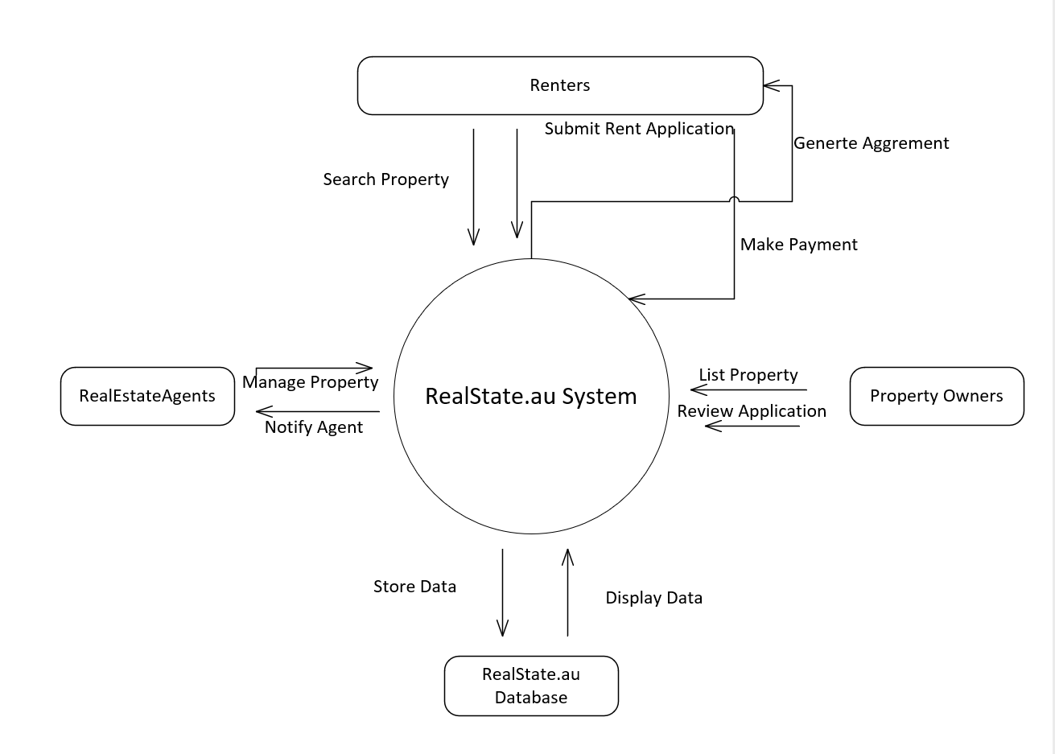

**Figure 1 :Context Diagram**

## **Data Flow Diagram:**

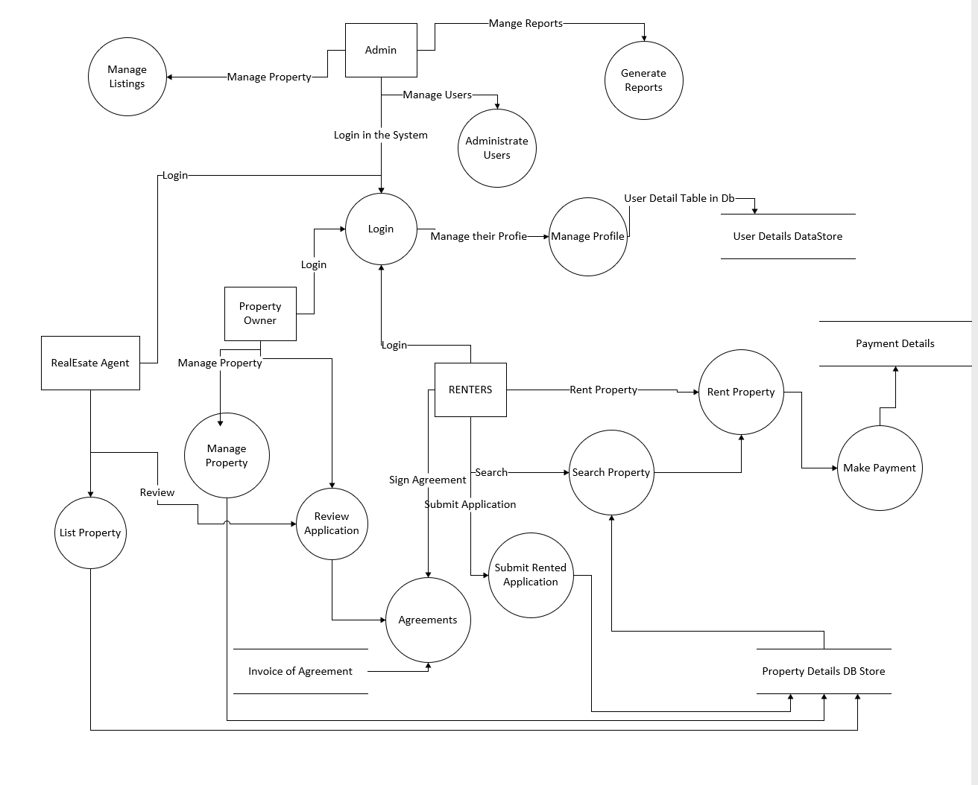

**Figure 2 : Data Flow Diagram**

Process Descriptions for Key Processes:

**User Interaction:**

**Description:** Represents user interactions with the system, including actions like property search, application submission, and property management.

**Inputs:** User input data (search criteria, application details, property information).

**Outputs**: Processed data for relevant use cases.

**Data Flows:** User input data flows to the system, and processed data flows to relevant processes and data stores.

**Property Listing:**

**Description:** Manages the listing of properties by Property Owners.

**Inputs:** Property details provided by Property Owners.

**Outputs:** Stored property data in the database.

**Data Flows:** Property data flows from Property Owners to the database for storage.

**Rental Application:**

**Description:** Handles the submission of rental applications by Renters.

**Inputs:** Application details and documents submitted by Renters.

**Outputs:** Stored application data in the database.

**Data Flows**: Application data flows from Renters to the database for storage.

**Application Review:**

**Description:** Reviews and evaluates rental applications submitted by Renters.

**Inputs**: Rental applications stored in the database.

**Outputs:** Updated application status.

**Data Flows:** Application data is retrieved from the database for review, and updated status is stored back in the database.

# References

* Glinz, M., 2007, October. On non-functional requirements. In *15th IEEE international requirements engineering conference (RE 2007)* (pp. 21-26). IEEE. Available at: <http://csis.pace.edu/~marchese/CS775/Papers/glinz_nonfunc_req.pdf>
* Gruszka, A., Jupp, J.R. and De Valence, G., 2017. Digital Foundations: How Technology is Transforming Australia's Construction Sector (Pp.).Available at: <https://opus.lib.uts.edu.au/bitstream/10453/124861/1/Digital-Foundations-ConstructionTech-Report.pdf>
* Malan, R. and Bredemeyer, D., 2001. Functional requirements and use cases. *Bredemeyer Consulting* (Pp.2). Available at: <https://citeseerx.ist.psu.edu/document?repid=rep1&type=pdf&doi=aceaa41855c38aebe7c823e60e94b39506a92b99>
* Nasreen, Z., Gurran, N. & Shrestha, P., 2022. Platform informality: online rental housing markets in Sydney, Australia. 10th State of Australasian Cities National Conference, 1-3 December 2021, Melbourne, Australia (pp.3). Available at: <https://apo.org.au/node/316344>