In this project, we are going to connect 2 departments of a small company with each department containing at least 2 PCs using switches and routers. The work environment to be used is Packet Tracer. All the required IP configurations for the PCs from each department to send and receive packets will be configured statically.

**Hardware Requirements**

· We need 1 router, 2 switches, and a minimum 2 PCs as hardware.

· Switc1 is named as accounts for the accounts department subnet.

· Switch 2 is named as Payroll for the payroll department subnet.

· The PCs in Accounts department are Acc1 and Acc2.

· The PCs in Payroll department are Prl1 and Prl2.

· Each department has also been given a router and a printer.

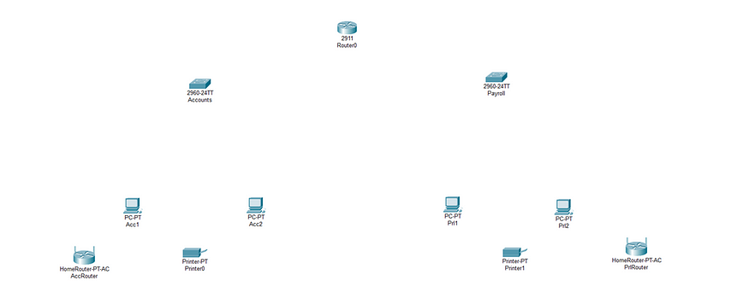

Fig 1: Hardware

**Set up the physical cables**

· We have used copper straight-through (ethernet) cables to connect the devices.

· From Gigabit ethernet port of the router to fast ethernet port of the switches.

· From fast ethernet port of the switches to the fast ethernet port of the end devices (PCs & Printers).

· From Fast ethernet port of the switch to the internet port of the wireless router.

**Configure the devices**

1. **Router**

Ø Open the cli of the router.

Ø en [enable command]

Ø config t [enter configuration mode]

Ø int range gig0/0–1

Ø no shutdown [activates the gigabit ethernet ports on the router]

Ø exit

Ø int gig0/0 [enter config mode for gigabit ethernet port 0]

Ø ip address 192.168.40.1 255.255.255.128 [specify the ip address and subnet mask for gig0/0]

Ø exit

Ø int gig0/1 [enter config mode for gigabit ethernet port 1]

Ø ip address 192.168.40.129 255.255.255.128 [specify the ip address and subnet mask for gig0/0]

Ø do wr [builds the configuration]

Ø exit

Ø do sh start [displays the configuration]

Since we are not using a DHCP server here. We provide static IP addresses from the subnets for each device in the subnet

Subnet 1 : 192.168.40.0/25 [Accounts]

Subnet 2 : 192.168.40.128/25 [Payroll]

After assigning IP static addresses to the end devices we are able to ping a pc in payroll from a pc in accounts

**2. Configuring Wireless access points to both the subnets**

Ø Use a wireless access point device AP-PT

Ø Connect the switch (fastethernet) and WAP (port0)

Ø Add wireless devices like laptops to both the subnet

Ø Set static IP address from the subnets for the wireless devices and the default gateway of the subnets router interfaces

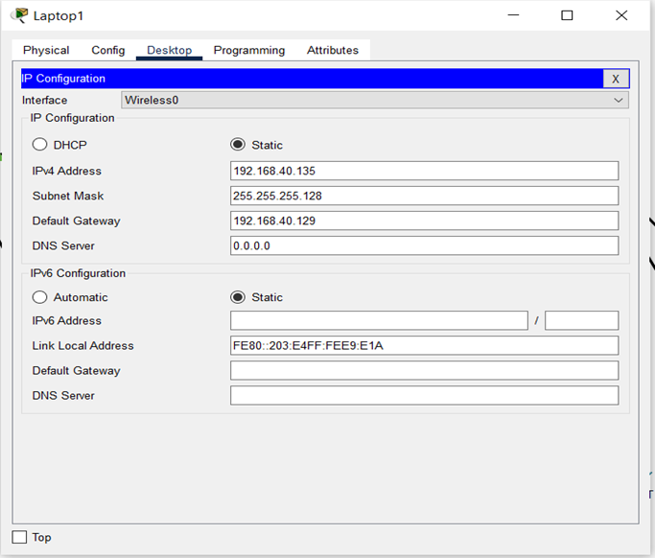

Ø Set up the wireless network with WPA2-PSK security on both access points.

Ø Connect to the network from the pc wireless icon on both laptops.

Ø Test the connection.

From the above images we can see that both laptops are able to communicate with their own network and the external network.

The completed network is shown below.

Fig 2: Completed Network Diagram