PET Check MCP Server — Summary
Developed by — Sameer Kolhatkar

Overview
PET Check is a Model Context Protocol (MCP) server for operating the PET environment from Cursor. It does not implement its own SSH layer; it reuses the unix-server MCP stack (CommandExecutor, connection pools, audit logging) to run commands on remote PET hosts.

Purpose
It gives the AI agent safe, structured tools to manage:
- Kubernetes/OCP pods (TCK8S and TCMS)
- WebLogic (ABP-FULL) on CM servers
- PET daemons (from .Op9DmnMonitor.cfg)
- CM WebLogic application property files
Configuration: Uses the same UNIX_CONFIG_FILE and MCP_SECRETS_AES_KEY as unix-server.

Tools (7 total)
Tool | What it does
tck8s_pods | Check/stop/start/restart K8S resources in tks-in02-pet1-tc via PET_RT_ADMIN
tcms_pods | Same for TCMS pods in tc-product-k8s-tks-in02-pet1
weblogic_server | Check/stop/start/restart WebLogic ABP-FULL on CM hosts (e.g. CM31-Server_CM_Prepaid)
daemon | Manage daemons by COMMON_NAME from .Op9DmnMonitor.cfg
list_pet_daemons | List all configured daemon entries
list_cm_servers | List CM WebLogic machine names from unix-server config
cm_wl_properties | List/read/preview/apply property files under ${HOME}/JEE/ABPProduct/config_files/ABP-FULL/ABPServer

Typical Use Cases
- Check or restart CR pods (cr1, ela2, etc.)
- Restart TCMS deployments (usage-management)
- Ping or clean-restart WebLogic on a CM server
- Check/start/stop PET daemons
- Update CM application properties with preview + backup + approval

Examples
- Check CR pods: tck8s_pods action=check, resource_name=cr1
- Restart TCMS deployment: tcms_pods action=restart, resource_name=usage-management
- Ping WebLogic: weblogic_server action=check, cm_server=CM31, cm_type=prepaid
- Clean restart WL: weblogic_server action=restart, machine_name=CM31-Server_CM_Prepaid, clean_cache=true
- Check daemon: daemon action=check, common_name=MY_DAEMON
- List CM property files: cm_wl_properties action=list, cm_server=CM31, cm_type=prepaid
- Preview property change: cm_wl_properties action=preview, file_name=application.properties, changes=[{key: foo, value: bar}]

In short: PET Check is a PET-focused operations layer on top of unix-server SSH, exposing environment-specific tools so Cursor can manage pods, WebLogic, daemons, and config files without raw SSH commands.

Use Cases:

Prompt:
Check the value of amdocs.cm9.um.disable.ssl.validation in JEE/ABPProduct/config_files/ABP-FULL/ABPServer/CM1Environment.properties in all CM WL of PET. Only show defined values.

Output

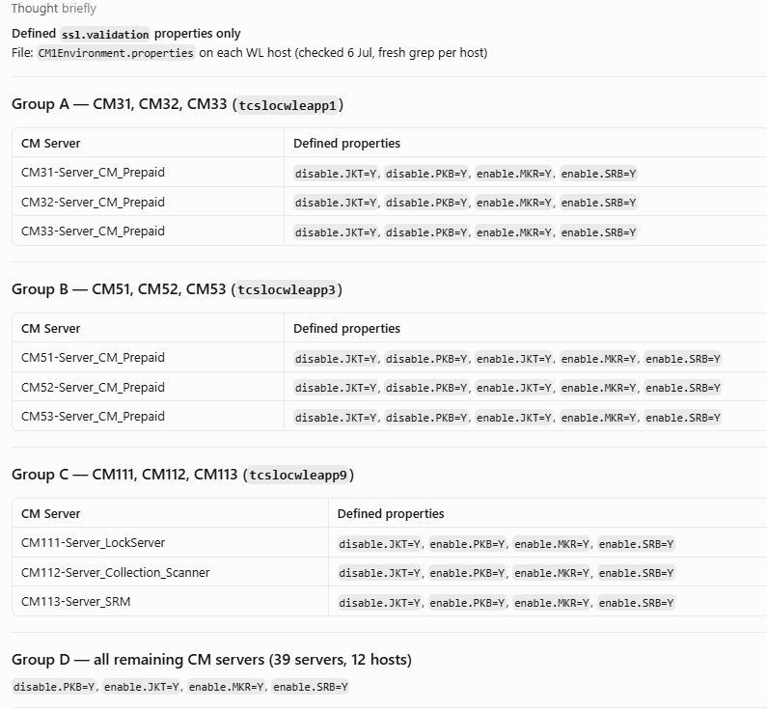

Prompt
Check all CM_WebServices WebLogic servers, then scan their logs for CM1-000259 and deployment errors.

Output
