HelpDesk

(User Manual)
Introducing Seasia Prodacker HelpDesk: Elevating Employee Support
HelpDesk is our new ticketing system for all IT and administrative-related issues, poised to enhance efficiency and streamline communication within our organization. The new ticket system aims to provide a centralized and organized approach to managing support requests, ensuring that all reported issues are promptly addressed and resolved. This system will enable us to track, prioritize, and efficiently handle a wide range of IT and administrative tasks.
Below are the steps to create a new incident on HelpDesk for an end user:

Logging On: - Once the user has logged in to the Seasia Prodacker, select Help Desk from the left side panel.
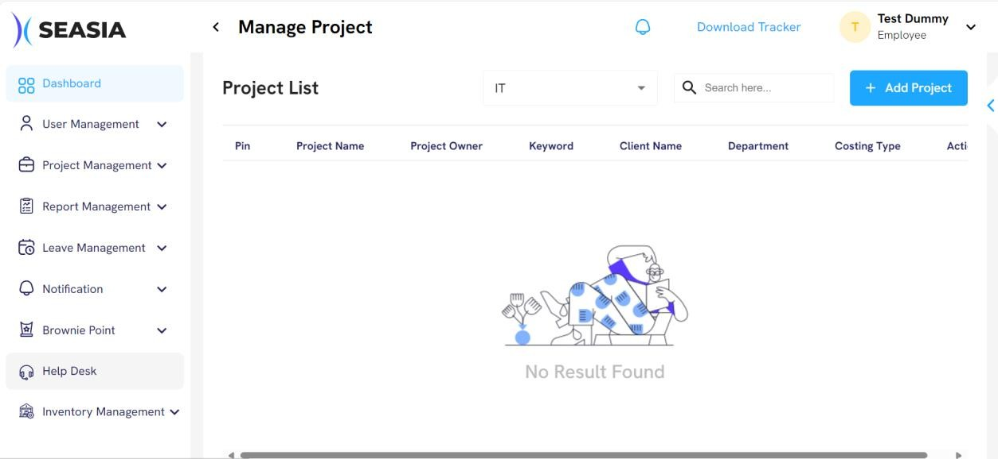

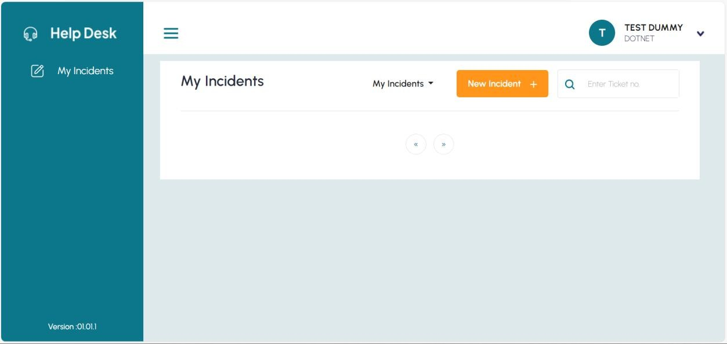

Features and Details: -
- Ticket or Incident Creation: - The user can create an incident or ticket for the IT issue that he or she is experiencing in accordance with the relevant categories. If he or she selects a category where manager approval is mandatory, the user add an email of the manager then they will create a ticket. When the user creates a ticket, it is presented in the User's My Incidents tab. The status of the ticket will be displayed on the ticket, and for more information, the user can access the ticket to see the description, generated by, Department, started date, time, and which IT handler is assigned to it.

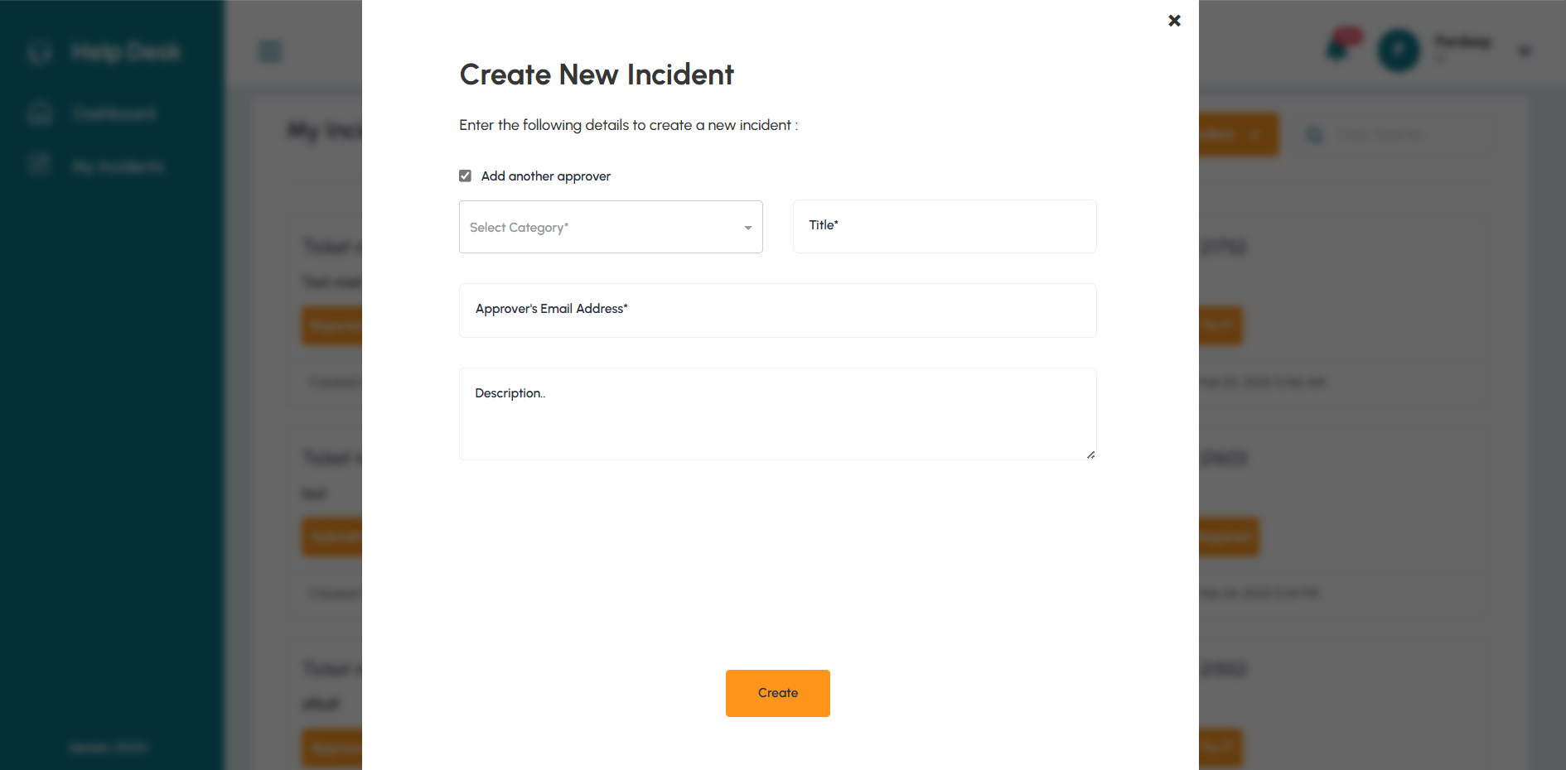

There are three fields in above New Incident form:

  - Add another approver: The user clicks the checkbox if the category requires another approval.
  - Categories: Users can select relevant categories for their issue.
  - Title: In the Title field, users will provide the incident's title.
  - Approver’s Email Address: The user adds our respective manager's email.
  - Description: In the description field, users can provide detailed information about the incident.

- TrackingandLogging: - After the incident is created, the ticket is routed to IT resources based on their level. If the ticket is accepted by an IT resource, the status of the ticket is changed to ongoing. If an IT resource at level three is unable to pick up the ticket within the SLA provided by their HOD in that category, the ticket will move forward after that SLA (time). Here's a full record of each ticket's status. This covers the periods when actions were taken, any messages posted, and any changes made to the ticket's status.
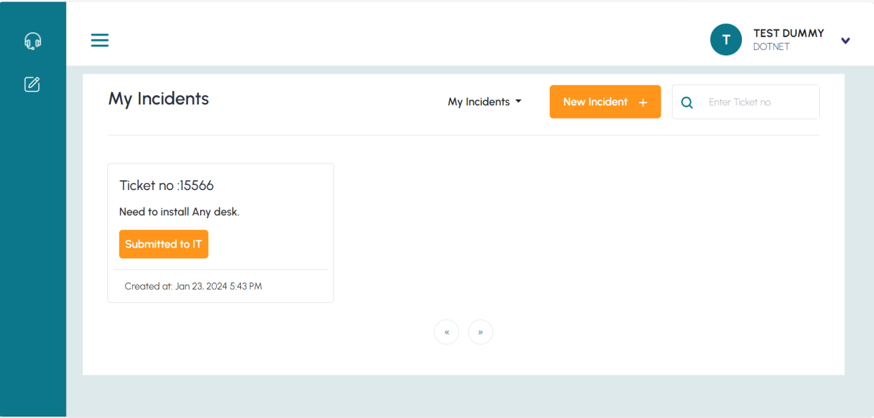

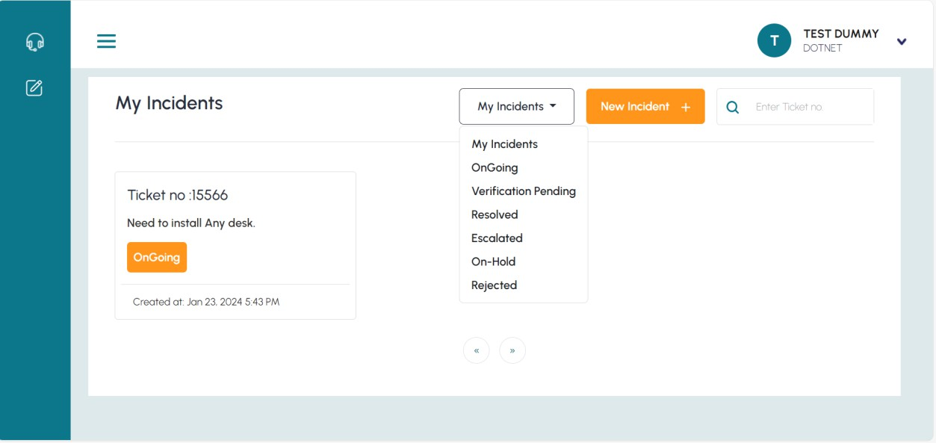
- In the above image, you can see that after accepting, the ticket status changes.
- You may also see a list of tickets that are present in certain buckets by selecting status from the drop down.
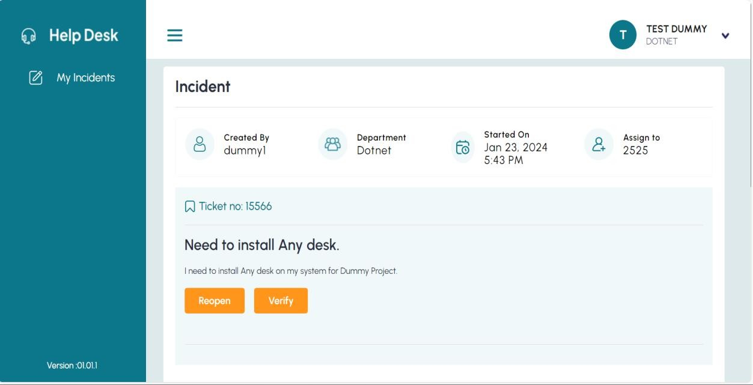
- After an incident is completed by IT Resources, users can check the Verification pending bucket for two options: Reopen and Verify. If the problem has been resolved, click Verify. If not, click Reopen to restart the ticket.

Messaging and Notification:
In this module, users can communicate end-to-end with the IT resource assigned to resolve the ticket. They can also message if additional information is required (i.e. IP address, Email, Password etc.)
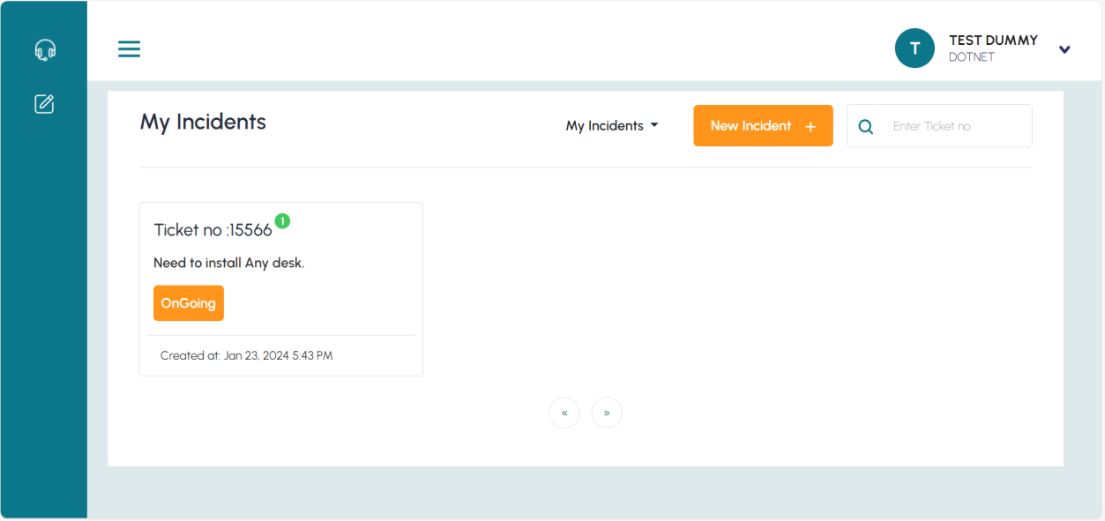
When a new message or any additional requirement is received from the IT resource, it will appear in the corner of the relevant ticket that is shown in below figure.

Ticket details and message service:
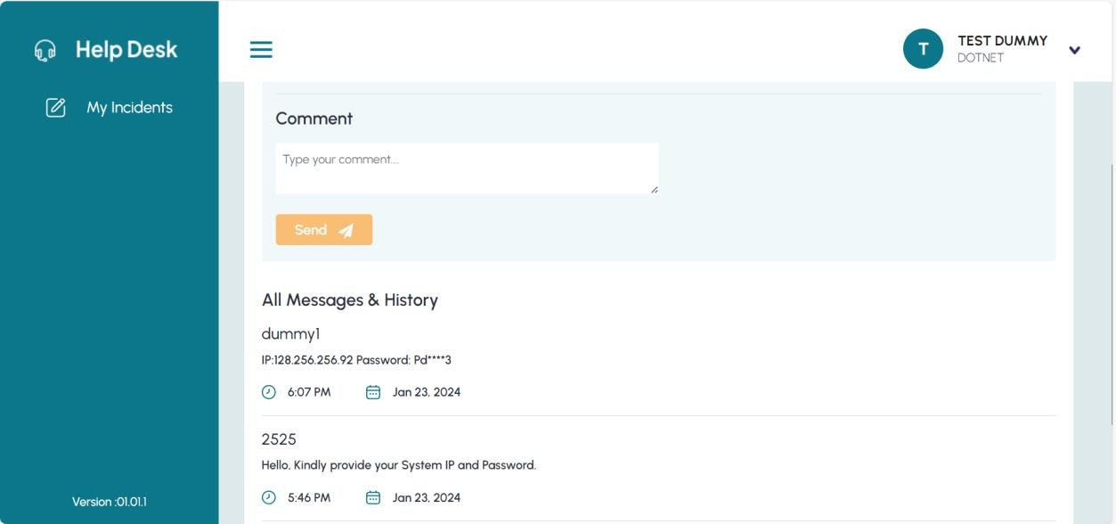
By clicking on the ticket, the user can review the information, see the new message, and respond to the appropriate IT resource. And also, can see when and who is changing the status.

Quick recap: Steps to create new incident -
User can create new incident by
  - At My Incidents under User “New Incident+” option is present.
  - Clicking on “New Incident+” icon Incident form gets opened.
  - Enter details for New Incident creation

- Add another approver (If mandatory, then select the checkbox.)
    - Select Categories
    - Enter Title
    - Approver’s Email Address (If mandatory, then add the manager email)
    - Write description
    - Click on create
  - The added ticket will appear on the same page in a ticket form.

