Conceptual Modelling on Zillow Condo Dataset

Sameer Kumar
MS, AIT
GMU, FX VA

Sivashaswat Allada
MS, DAEN
GMU, FX VA

Ahmed Alshaibani
MS,AIT
GMU, FX VA

Abstract— Basic guidelines for the preparation of a technical work representing paper on conceptual modelling of housing dataset. Effective prediction of most frequent and important semantic characteristics of the housing data to utilize and analyze the trends for ontological modelling which can be further accessed via web technologies for ease of specific requirement extraction by the consumers. The modelling involves relevant N-gram extraction through series of filter application and LDA modelling performed for dominant topic extraction. Concluding to a conceptual model for identifying precise features for every housing region. To provide advantage to Zillow over other property search organizations.
Keywords—Conceptual Modelling, Latent Dirichlet Allocation, Semantic Web, Textual Analysis.

Introduction
Conceptual modelling can be referred to as a representation of any system that utilizes concepts and ideas. It indeed is utilized over many fields. The fields range from sciences to economics stretching to software development. These conceptual models can be optimized and be used to represent different unique ideas and facts. Distinguishing between conceptual model and model to represent concepts are two different procedures. Conceptual modeling is used to describe the physical and featural aspects the any world entity in an abstract way. For instance, a conceptual model can used to represent relationships of entities among a database in a software development environment. One can say, conceptual models can represent similarities or relationships between objects in a system like users with their administrative accounts. Conceptual models are helpful in several ways by contributing and fulfilling few objectives:
- Intensify the understanding and detailing of the representative system or environment.
- Advocate efficient scheme to convey details and knowledge about the relationships and features of the system to the whole crew.
- Reference point for system identification and specification is provided to the designers for ease of understanding.
- Documentation of the system is also carried out for future prospective.
Conceptual models must follow certain regulations for ease of usage and updating of the data without complicated technicalities. For implementing the said function, conceptual models must follow rules:
- To be available openly to all the members of the team to encourage collaboration and iteration.
- To be effortlessly changeable to facilitate updating of the data to recent changes.
- Must consist of written and visual formats of conclusion to grab better understanding of the attributes and concepts.
- To initiate and pin relevant terms and concepts to be used in modelling throughout the project.
- To furnish and supply baseline structure for all related entities to be taken into consideration for the model.
Latent Dirichlet Allocation is useful in representing data documents as combination or collection of topics that convey or pour words with certain realistic probabilities. It is simply a statistical model which conveys explanations about a few observed datapoints based on some non-observed which gives insights about the reason behind the similarities of data points. Moreover, in Latent Dirichlet allocation every document is being presented via combination of several topics where each of the documents are classified with topics based on LDA procedure. It is like LSA (Latent semantic analysis) but only difference would be latent Dirichlet allocation have a scant Dirichlet prior. This sparse Dirichlet prior gives insights that the documents being used has a small list of topics and the topics use only frequent words. With a smaller number of words in each topic, the result of latent Dirichlet allocation is efficient and better for accurate words and highly efficient document tagging.
Often termed as topic modelling, it is distinguishable from the rule-based approach of text mining. It is technically an unsupervised learning algorithm of extracting sets of words called as topics from big textual data. These topic modelling practices are useful in documentation, organization of huge pile of data texts, feature selection and many more.
Semantic Web is the idea for the extension of current web in which information is provided in a defined format that enables computers and users to operate on data in web and link in a way that it is used more effectively for discovery, automation, integration and employ over a range of applications. The ability of semantic web technologies like semantic triple store and information standards together with transformation utilities and visualization tools to change accordingly, allows the consolidation of user produced content with that exist in digital repositories, web services and non-semantic data such as “legacy” databases. These technologies provide a fabrication having ability to support self-governing and collective employment in variety of teaching and learning upbringing.
The reforming potential of semantic web has widely-held applications in education that are pertained with augmentation of search, resource detection and the progress of system to match the online learning materials. The origin of semantic web has significant impact on the potential implementation in education. The initial significant impact is the fast growth of “Web 2.0” or “social web” applications and their widespread adoption reflected in the educational anticipation of faculty and students. Focus and guidance of few current works on the linguistic net for Education into fields labeled as the “social semantic” web. The quality of being intricate and compounded, of the embryonic affiliation amid “Social” and “Semantic” web blueprints are epitomized by vocation on the affiliation amid the unceremonious “folksonomies” of Social-net appliances and the validated, adept ontologies which are fundamental to Linguistic web developments. The secondary substantial improvement is the restructuring of certain sematic web endeavor as a part of development to “linked web of data”. The thought of, associated web of information has muffled the hindrance to implementation and to the fulfillment of anticipated assistance of an ample assortment of Semantic Web skills. In educational situations that involved university education of masters has rendered capable of more sensible approval of the skills with the conceivability to enrich prevailing methods and appliances but deprived of pressure of complete commitment with the more reliable semantic Web revelation.
Ontology is a repository of knowledge that defines the relationships between the concepts specified along with concept definition. OWL (ontology web language) is used for knowledge representation of the concepts specified in repository. Ontology and the semantic web express and enable semantic relation among the entities specified. Semantic relations are meaningful association between two or more set of entities.
Text Analysis can be defined as parsing of texts for the machine to understand the meaning of the context and extract machine readable facts. The sole purpose of text analysis can be referred to create structured text data or clean data out of huge pile of unstructured data set. It can be defined as the process of cleaning, slicing and dicing of huge heaps of unstructured, heterogenous documents and converting them to a much easier and readable format of data chunks. It helps you discover hidden patterns or interesting facts about the data which can be used for further analysis of the data text.
Semantic similarity is a standard called for a set of documents where likeliness or similarity is defined by the distance between them based on the similar meaning or semantic data rather the similarity is defined by their syntactical representation. The strength of similarity between these sets of documents is defined using mathematical tools which are simply numerical values obtained by comparing data related to their meaning and nature.
Semantic closeness can be assessed by characterizing a topological comparability, by utilizing ontologies to characterize the separation between terms/ideas. For instance, an innocent measurement for the correlation of ideas requested in an in part requested set and spoke to as hubs of a coordinated non-cyclic chart (e.g., a scientific classification), would be the most limited way connecting the two idea hubs. In view of content investigations, semantic relatedness between units of dialect (e.g., words, sentences) can likewise be evaluated utilizing factual means, for example, a vector space model to connect words and literary settings from an appropriate content corpus.

Literature Review

Text Semantic Similarity
Numerous undertaking in NLP remain to profit by strong proportions of semantic comparability for units over the dimension of individual words. Rich semantics assets for instance, WordNet give neighborhood semantic data at the lexical dimension. In any case, viably joining this data to process scores for expressions or sentences is an open issue. The calculations totals neighborhood relatedness data by means of a random walk over a diagram developed from a hidden lexical asset. The stationary conveyance of the diagram walk shapes a “semantic Signature” that can be looked at to another such circulation to get a relatedness score for writings. On a reword acknowledgment errand, the calculation accomplishes an 18.5% relative decrease in blunder rate over a vector-space benchmark. We additionally demonstrate that the chart walk likeness between writings has corresponding an incentive as an element for perceiving literary entailment, making strides on a focused benchmark framework.
Talking about the random walk experiment, providing some insights about the behavior of it on text passages. For instance, let’s take a quick example of a random text “I ate a salad and spaghetti”. No measure dependent on lexical character would distinguish cover between the sentence given and another value consisting the word food. However, on the off chance that every content is given as contribution to the random walk, nearby relatedness joins starting with single word then onto the next enabling the distribution molecule to investigate adjacent parts of the semantic space. The quantity of non-zero components in the two vectors increments, in the end meeting to a stationary conveyance for which the two vectors have many shared non-zero sections.
The random walk framework helps in converting and smoothing the basic distribution of words in the larger lexical space. This can be related to the sense of query expansion utilized in information extraction. The most basic information retrieval technique uses a model which implements a bag of words with additional words with similar meaning. In the framework, the extraction/expansion is like the first step of the walk sequence.
Prior work has been formulated for random walk sequence on several different categories of textual data. These categories have applications to the query extraction, word-sense disambiguation, email resolution. These works that has been performed for devaluating the working of the random walk algorithm displayed that similarity measures tend to picture success with the measure of textual implication. Glickman portraited that many entailment issues can be resolved using the model consisting of bag of words along with web co-occurrence statistics.
Budanitsky and Hirst also provided an aerial view of several knowledge-based measures taken into course from wordnet along with many other data sources being utilized in simultaneous implementation to it. Other work in the department of semantic similarity can be phrased upon the work of Mihalcea, who formulated an algorithm for the usual problem of checking the similarity and meaning two text passages which in turn lead to the discovery and coining of the term text semantic similarity.

Ontology-based semantic similarity
With the tremendous accomplishment of the Information Society and the World Wide Web, the amount of textual electronic information available ha significantly increased. As a result, computer understanding of text has acquired great interest in the research community in order to enable a proper exploitation, management, classification or retrieval of textual data. A standout amongst the most essential issues when expecting to translate printed information is the evaluation of semantic similarity between terms because, as it has been exhibited in mental analyses it goes about as a crucial sorting out guideline by which people arrange and order objects.
Note that two distinct ideal models can be found in the writing. On one hand, semantic closeness states how systematically almost two terms are, on the grounds that they share a few parts of their significance (e.g. canines and felines are like the broaden they are vertebrates). Then again, the broader idea of semantic relatedness does a bit much depend on an ordered connection (e.g. vehicle and wheel or pencil and paper). Other non-ordered connections are likewise considered. Despite its handiness, hearty estimations of semantic similarities/relatedness between literary terms remains a testing assignment. Numerous works have been proposed in the most recent years, particularly with the expanding enthusiasm on the semantic web and the advancement of ontologies. Proposed strategies go for naturally surveying a numerical score between a couple of terms as per the semantic proof saw in one or few information sources, which are utilized as semantic foundation.
Ontologies give formal determination of a mutual conceptualization. Being machine readable and built from the accord of a network of clients or area specialists, they speak to a truly dependable and organized learning source. Because of this reason, and on account of activities, for example, the semantic web, which brought to the creation of thousands of domain ontologies. Ontologies are widely exploited in knowledge-based systems and, more absolutely, to register semantic similarity.
A paradigmatic model is WordNet, a domain independent and broadly useful thesaurus that portrays and arranges in excess of 100,000 general English ideas, which are semantically organized in an ontological manner. It contains words (things, action words, descriptors and verb modifiers) that are connected to sets of intellectual equivalent words (synsets), each communicating an idea (i.e., a word sense). Synsets are connected by methods for applied semantic and lexical relations, for example, synonymy, hypernymy (is-a), six kinds of meronymy (some portion of), antonymy, correlative, etc. The foundation of the system of words is the sub Sumption pecking order which accounts in excess of an 80% of all the displayed semantic connections, with a most extreme profundity of 16 hubs. The outcome is a system of seriously related words, where the diagram model can be misused to decipher the importance of the idea. Indeed, WordNet has been utilized as the foundation cosmology in every single related work.
Ontologies can be viewed as a coordinated chart in which ideas are interrelated for the most part by methods for ordered (is-an) and, at times, non-ordered connections. By mapping input terms to ontological ideas by methods for their printed names, a direct technique to figure their likeness is to register the base Path Length associating their relating ontological hubs by means of is-a connections. The more drawn out the way, the more semantically far the terms are.

Collocations
A Collocation is an articulation comprising of at least two words that compare to some ordinary method for conveying speech or things. On the other hand, it can be recalled as “Collocation of a given word are articulation of the ongoing or standard spots of that word”. Collocations are described by constrained compositionality. We call a characteristics dialect articulation compositional if the importance of the expression can be anticipated from the significance of the parts. Collocations are not completely compositional in that there is typically a component of importance added to the mix.
There is extensive cover between the idea of collocation and thoughts like term, specialized term and terminological phrase. The three are normally utilized when collocations are separated from specialized spaces (in a procedure called phrasing extraction). The reader be cautioned, however, that the word term has an alternate importance in data recovery. There, it alludes to the two words and expressions. Collocations are vital for various applications: regular dialect age (to ensure that t he yield sounds normal and slip-ups like incredible tea or to take a choice are evaded), computational lexicography (to consequently identify the critical collocations to be recorded in word reference section), parsing (so that preference can given to parses with natural collocation), and corpus linguistic research, for example, the investigation/study of social wonders like the reinforcement of cultural stereotypes through dialect.
Without a doubt, the least difficult strategy for discovering collocations in a content corpus is counting. On the off chance that two words happen together a great deal, that is a proof that they have an un common capacity that isn’t just clarified as the capacity that outcomes from their combination. Typically, simply choosing the most as often as possible happening bigrams isn’t extremely intriguing. In natural language processing research, there have been created three fundamental procedures for programmed learning restriction on word usage: statistical or factual, rule-based and hybrid techniques. As a rule, a computer framework is required to break down a machine-comprehensible content or a corpus characterized as a gathering of machine discernible writings. The framework must have the capacity to remove mixes in which words are grammatically related and decide to what extent the appearance of one word in a sentence relies on another word or a set of words. Such feature is referred to as Cohesion or association.

Model implementation
Developing a conceptual model for the Zillow data set by implementing various natural language paradigms namely:
- Topic Modelling
- Bi-gram Collocation
- Semantic Similarity
- Ontological Mapping
Extracting the domains that differentiate qualities of every location region the dataset provides and mapping them onto an ontology for ease of usage and further web application to smoothen the search process for consumers.

Data
The data comprises of different condo features and reviews about different location in Virginia state. The data set consist of 5 different attributes, each corresponding to different feature related to the location. Following are the different features/attribute of the dataset being utilized:
- URL/Zillow Location
- Condo Description
- Owner Description
- Additional Details
- User Reviews
The different attributes being provided gives insight about various aspects or features of the condo locations. The first attribute gives details about URL associated with the information of condo along with the one of the important properties of each detailing which is the “location”. Different locations associated with every condo can be extracted from the first column of the dataset. Secondly, Condo description provides default checkboxes associated with the condo over all for instance, bedroom, bathrooms, kitchen, amenities, dishwasher etc. These features are associated with every condo.
Thirdly, Owner description gives insights about specific condo and its relevant property according to the house owner. There may be different amenities and features associated with every condo such as nearby school, walking grocery shopping, sun ruse facing etc. These descriptions can be utilized if the model needs to be created based on the owner specifications.
Furthermore, fourth attribute deals with the additional features the condo has associated with it. Except for the regular features like bedroom, bathroom, kitchen etc. there may be extra bonus/additional features that the owners provide which can formulated for extra charge or as per specific user/renter needs. These additional features may include swimming pool, tennis court, jacuzzi, terrace, furniture, garden etc.
Lastly, the most important attribute in the data set is the user reviews. Data provided here deals with the needs of different users based upon their search of condos and the type of house they are looking for. These include many different views of users based on specific location as it can give insights about the type of house users are looking for in each location. For instance, Leesburg is more searched for town house condos, shopping grocery etc. and Ashburn is more related to walking schools, school bus stand etc.
The work implemented in this project has taken into consideration the first and last attributes of the dataset as these were necessary to articulate the model which could help refine user their search for specific features in every location and can help them narrow down the search for condos.

Data Pre-processing
The dataset provided consists of five different attributes and only two of those are utilized for modelling. Therefore, the other three columns needed to be dropped and only the two important ones are taken into consideration. The resulting dataset consist of Location attribute and the user reviews attribute and further pre-processing is being implemented on that. The first column of the dataset consists of numerous un-necessary details and texts which are not required and only the location part is vital. For the said task, the data set is compared to another file consisting of every location that falls under Virginia. Moving forward, only the part that matches the location file is saved into a new column in the data frame and the rest is not taken into consideration. This way the whole data set is refined, and only specific locations are being obtained in the first attribute of the condos.
Moreover, the user review attribute consists of huge amount of textual data which contains many stop words, punctuations, un-necessary numbers, frequent words, special characters etc. These needed to be removed for precise N-gram extraction from it for semantic similarity implementation. Different techniques are implemented for the removal of these un-necessary data items from the attribute and therefore resulting in clean data set.
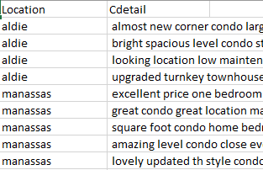
Figure 1: Cleaned Dataset

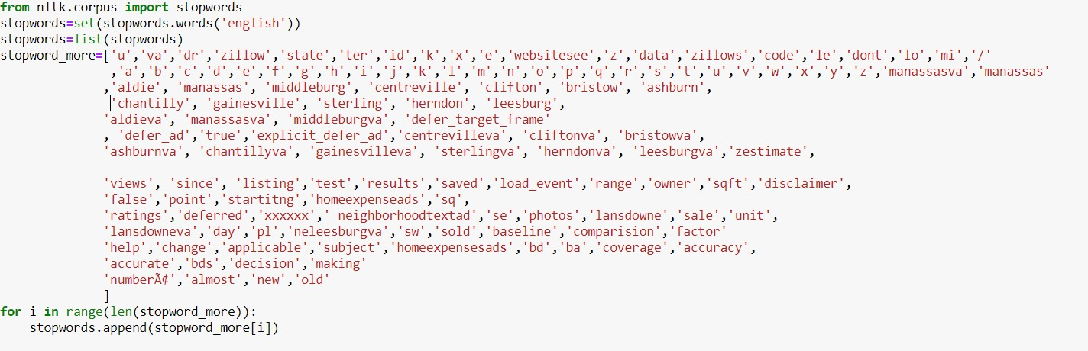
Figure 2: Additional Stop word List

The above figure shows the two important attributes to work upon for modelling and collocation and eventually creating the conceptual model. The insights extracted from the above figure could be that the dataset consists of 11 different locations in Virginia ranging between Leesburg, Ashburn, Sterling, Middleburg, Clifton, Bristow, Aldie, Manassas, Centerville, Herndon and Gainesville. “Cdetail” deals with the user reviews about each condo being provided but the data given here is cleaned of stop words, punctuations, special characters, numbers etc. Now each detail represents features being asked for by the users for that location, but the user still uses the name of location in the reviews which is also not required for N-gram allocation and similarly, few more words which are talked immensely with no co-relation with the data. These frequent words are generated and then removed all together by adding them to the stop word list by organizing a separate list of these frequent words and removing them all at once.
NLTK package is utilized for the cleaning of the dataset. It includes tokenization of the textual data and lemmatizing and stemming being implemented on it for mixing similar meaning words having different spelling. Afterwards, the tokenized data consists of relevant words along with all the gibberish characters, numbers, stop words etc. which are then removed by implementing the English stop words list and comparison of both together.
Moving forward, the removal of frequent words which leads to ambiguity in the data set for N-gram allocation is implemented. Part of speech (POS) tagging is implemented to find out the nouns and pick the most frequent words out of it in every location. These frequent words are then removed from each location increasing the domain information available in it. Figure 2 shows the additional words that were added to the
English stop word corpus for removal of the frequent words from the data set. POS tagging concluded these frequent words for removal and data cleaning did the job for removing these items from the data set.

Bi-gram & Tri-gram Collocation
On completion of the Data cleaning and removal of all the un-necessary data items from the data set, we move on to the implementation of N-gram collocation. The data set consists of 108 different user reviews about mixed locations on which the implementation of collocation needed to be done. Though the data set consists of only 11 different locations over the whole 108 items therefore before applying the Bi-gram implementation, the data set is combined and divided into 11 different data items together to co-relate all the similar region details of the condos. For instance, 56 different reviews about condos in Leesburg area are combined to form a single data item on which further implementations are done.
The bi-grams & tri-grams are generated along with their count in the specific location reviews which is important for putting a filter on it for selecting the most favorable out of the heap. The threshold value selected to filter out necessary Bi-grams & Tri-grams was 30. The value is user defined based on the number of N-grams generated in different locations. The value needed to be chosen precisely as few of the location had a very low number of N-gram generation where as others had numerous numbers of it. So, if a higher value would have been selected then the these less frequent locations would have fade off from the list of N-gram generations.
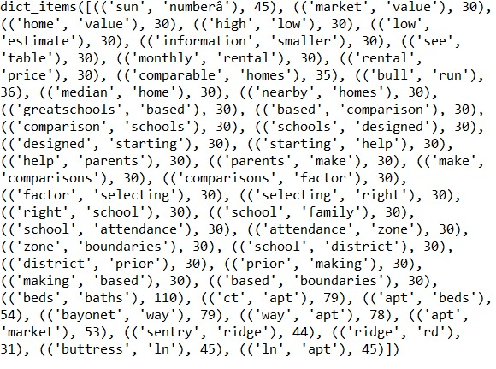
Figure 3: Bi-grams Collocation
Figure 3 depicts the useful Bi-grams being generated for location “Aldie” after the threshold application and the list includes all those bi-grams which equals to the value of 30. Similarly, bi-grams for all other locations are also generated with the same implementation.
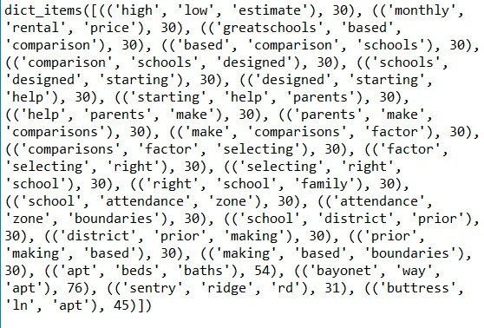
Figure 4: Tri-grams Collocation
The above figure 4 displays the Tri-grams being generated for the same threshold value and location “Aldie”.

Semantic Similarity on N-grams
Semantic similarity is calculated on bi-grams and tri-grams to obtain the most co-related N-grams for every location. These obtained values are the most feasible and like each other and therefore can be used as top features for modelling purpose in ontology. For carrying out the similarity measures, package “spacy” is implemented with its English model for running the similarity measure on the n-grams being generated. It creates the tokens and vectorize them to calculate the similarity based on distance between the two. Different distance measures can be considered to calculate the similarity such as Euclidian distance, Manhattan distance etc.
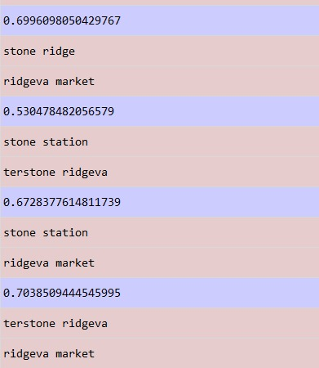
Figure 5: Semantic Similarity Bi-grams
The above figure depicts the similarity measures being calculated on bi-grams together. For instance, “stone ridge” and “ridgeva market” have a semantic score 0.699. The score ranges from 0 to 1 and the higher the score is obtained, the n-grams are more semantically like each.
Similarly, the tri-grams are also generated based on the semantic measures and co-relation amongst every location.

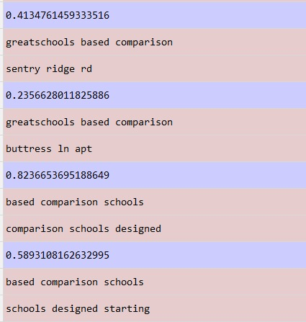
Figure 6: Semantic Similarity Tri-grams

Latent Dirichlet Allocation
Latent Dirichlet allocation is a technique implemented for topic modelling. These LDA technique is utilized to obtain topic for different
documents to assign them some meaning. These topics can be generated in multiple ways using different allocation measures. LDA implemented in this project uses Bi-gram phrase model using the Gensim library or package. The latent Dirichlet allocation is optimized upon document being converted into bag of words after the tokenization of the data set. These bags of words set document generates various models which contributes to model selection based on some score.
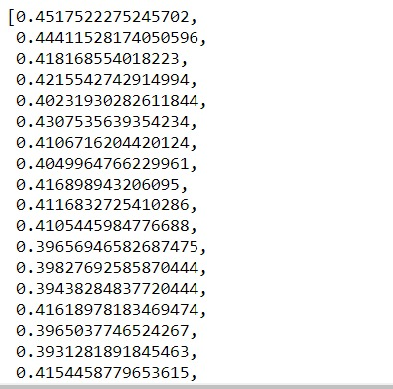
Figure 7: Coherence scores

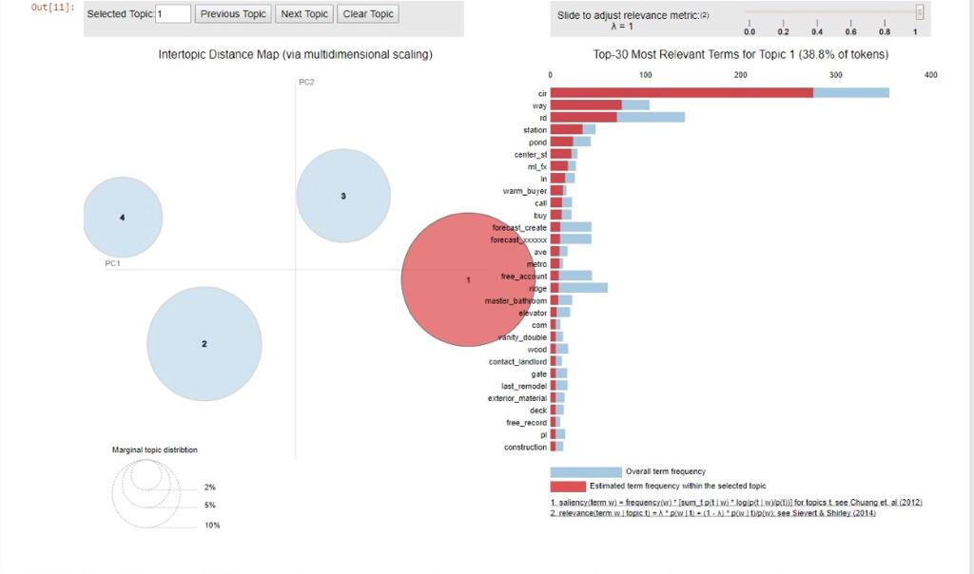
Figure 8: Visualization to depict relevant terms in each topic

For selection of best model and topics based on that, the implementation executes 21 different model based on Bi-gram phrase for the data set and obtain different coherence scores for them based on which the precise model is chosen, and the topics related to it. Figure 7 gives you the list of coherence scores for 21 different models executed. The best model is chosen based on the graph plotted against the number of topics and coherence scores. 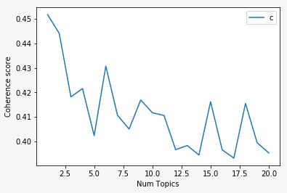
Figure 9: Coherence Score vs Topic number
Figure 9 depicts the graph between the 21 different topics being executed or build and the coherence score for each one of them. The optimum value of K (topic number) is chosen by the first drop in the graph which concludes to 3 as the optimum number which depicts total number of topics to be 4 as the value starts from 0 and goes on to 3.
Figure 8 gives insight about the four different topics generated through LDA and depicts the frequent and important terms in each one of them. It displays the top 30 most relevant terms for each topic and helps in deciding the dominant features for every location separately.

Ontology Modelling
Ontology refers to the representation, formal naming, categorical definition, properties, features, objects, relations among the concepts, object co-relation, entities that validate one or many domains. Ontology is created to organize the information generated into structured data and knowledge. For instance, google uses the knowledge graph for describing information to us which is also considered to be an ontology.
We formulated the ontology in protégé. It is a software to create ontologies based on given classes, axioms, subclasses, objects properties etc. Using RDF, OWL languages to help one create these ontologies.
So, features for every location to map onto the ontology were formed using the LDA generated relevant topics and semantic similarity measure tokens. Topics picked up from the LDA modelling are compared to the semantically produced n-grams and checked if the value of semantic score is higher than at least 50% of the range and depicts meaningful value to be considered as a feature then it is chosen. Out of hundreds of co-related words/features, we extracted 5-6 features for every location to relate it together with others.

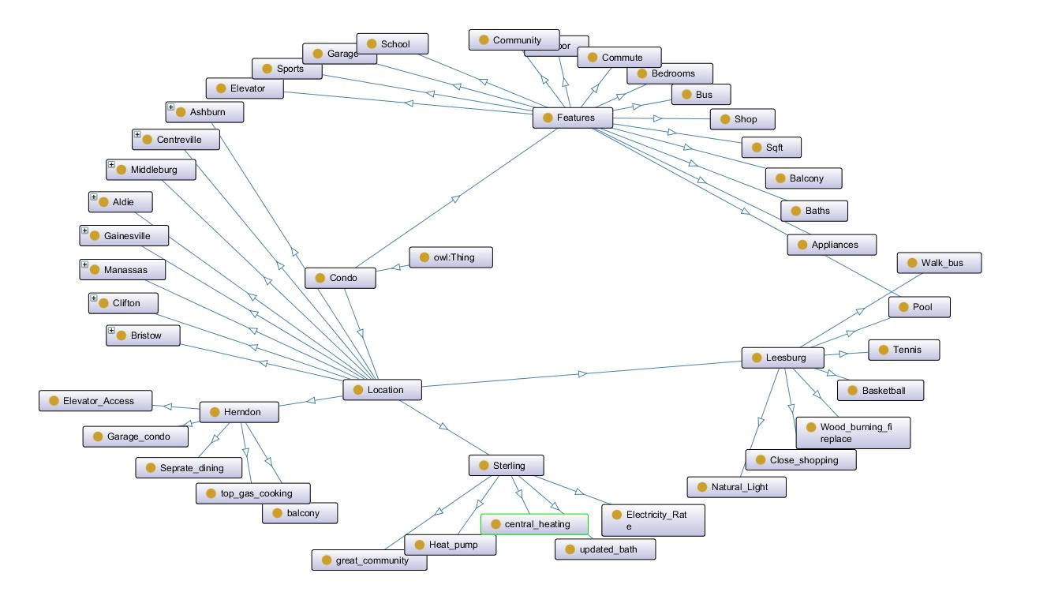
Figure 10: Condo Ontology

Figure 10 shows the ontology created in protégé to show conceptual modelling and feature depiction. The ontology is created for “condo”. Condo being the base class inherits two sub-classes namely “Location” and “Features”. Location consists of all the 11 different locations being extracted from the data given.
Features are the most relevant 10 features extracted common between all the locations such as bedroom, bathroom, balcony, garage, balcony, school, grocery etc. These features are the most talked about details by users in the reviews provided. These can be utilized as filtering for search based upon the user demands. Locations have subclasses of different regions extracted which in turn have more subclasses as top 5-6 features extracted of that location.
Moreover, each region has few specific features related to it which were the most relevant and semantically higher in value to be considered as the top property being talked about. It consists of both semantically similar bi-grams as well as tri-grams. Common details such as pool which is present in features and specific to Leesburg also maps together without overlapping.
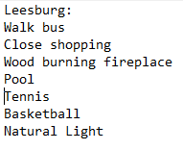
Figure 11: Features relevant to Leesburg
As shown in figure 11, these are the few features co-related and extracted for every location to represent top-notch details about that location.

Conclusion
Wrapping up all together, performing various natural language techniques including Topic modelling, N-gram collocation, Semantic similarity and ontological modelling to extract relevant features for every location of the condo dataset to infer and give insights about the user demands for querying and searching specific house as per their own needs. We concluded that in association with semantic similarity and topic modelling, it provides better contextual knowledge and ways to extract the features that are relevant and meaningful which indeed assists in developing the ontological model for the given dataset.

future scope
The pre-processing needs to be developed a bit more precisely depending upon the type of dataset being used as developing an accurate corpus for removal of words which ae un-necessary is a major step in extracting useful data. Generating a better pre-processing corpus. Secondly, proper POS tagging must be implemented for not just nouns but for others as well so that only the relevant tokens can be extracted through similarity measures. Lastly, this conceptual model (ontology) can be mapped or uploaded via web application to be accessed by the users and filter out the features according to their need and all this data easily available online with just a click.

review of survey papers

The amazing power of word vectors
The amazing power of word vectors | the morning paper helped us to know how important to consider and utilize the bag of words model, and we only considered to used bigram representation in ours case. Bag of words output made us to calculate the coherence score by using genism package which hold bigram phrases of the reviews, which help us to calculate the coherence score to find out the number of topics across all the condominium.
Moreover, bag of words model comes handy because we were dealing with text, and it helps us on tokenize and vectorize the reviews. Systems cannot understand texts like human, so we need to have to model our text where it makes sense to them for the sake to get some useful performance. Bag of words will count each word based on how many timers it appears in each review. Vectorizing was essential to use because we need to convert text to numbers for topic modeling. We needed text to be represent by numbers, so the system can compute the coherence score mathematically. The bag of words term helped us to save time because we were about to try to write a few lines of codes to count words. Bag of words is a build in model in python that can do it better than building a code that might not give better result than bag of words. Finally, bag of words model is efficient when the dataset is not extremely huge. So, in our case, the amount of our data should be suitable, so that why we considered bag of words.

Background Knowledge for Ontology Construction:
This paper draws our attentions on what approach we can use to have some knowledge on how we build our ontology. It was talking about using bag of words to find similarities between documents. Bag of words build a vocabulary then define word weight. Then, find similarities between documents.
In our case, we used SpaCy to find similarities. We grouped our reviews based on locations. we used NLTK package to find bigram and trigram for each grouped text reviews. Then, SpaCy used to find semantics similarities based on bigram and trigram to observe the semantics similarities’ value. Higher the number means more similiter and vice versa. Similarities model gave us a hint what is important to consider, and what is not to disregard. We build our ontology based on the similarities results. We took the idea of our approach form this paper, but we tweaked our approach slightly. We targeted the highest similarities. To this point, it was the best case to undertake this approach initially.

Semi-automatic Ontology Construction based on Patterns:
This paper was giving enormous details about using ontology. It helps us on understanding why we need to build an ontology in first place. We have learned that building an ontology will give us a comprehensive view of our system, and how our system will behave when on business. Moreover, building ontologies helps in spotting overlooked errors that have been made while building the system, so we can correct them. Therefore, having a visual representation is very recommended otherwise, we will not be able to evaluate our system.
More benefits we have learned from this paper. First, when developing an anthology will make other people easily perceive what is this system about and what is expected from it after we built our ontology, we could easily show what is our project all about because we have something visual to show, and we can trace down our ontology to go deeper in explaining. For example, we cloud show on what locations there are condos, and we can show different features of condos. Second, it helps developer to make corrections to them if needed. For example, if an ontology classes are overlapping, we can easily spot that to correct them. lastly, it can be reusable by other developers to adjust or expanding the models. Sometimes, developer do not start from scratch to build an ontology, so someone might be able to come up with an idea that would improve our ontology. Therefore, building an ontology was an essential to build.
Moreover, this paper discussed about patters that could be exist in ontologies. So, we learned that ontologies are not only about to be able to share a common understanding among people about the system. However, it can help developer to spot patters that were not paying attention. In our case, it was hard for us to infer the reviews, but when we built an ontology, we noticed that large number of condos are having same features. However, we noticed that there are many condos having the same features that the most do, but they have more amenities especially for disable people, what attractions near condos. Customers might be selective when picking a condo.

team member roles

Sameer Kumar
Implementation of Data pre-processing and conceptual modelling of ontology in protégé.

Sivashaswat Allada
Implementation of Semantic similarity and topic modelling through LDA.

Ahmed Alshaibani
Implementing N-gram collocation and identification of stop words and ire-relevant n-grams.

Survey Paper
This task is a group effort by all the three members of the group based on three different survey paper being utilized.

references
[1] Powell-Morse, A. (2018). Conceptual Models - What Are They and How Can You Use them? [online] Airbrake Blog. Available at: https://airbrake.io/blog/sdlc/conceptual-model [Accessed 12 Dec. 2018].

[2] Science, D., Python, B. and Bansal, S. (2018). Beginners Guide to Topic Modeling in Python. [online] Analytics Vidhya. Available at: https://www.analyticsvidhya.com/blog/2016/08/beginners-guide-to-topic-modeling-in-python/ [Accessed 12 Dec. 2018].

[3] Towards Data Science. (2018). Topic Modeling and Latent Dirichlet Allocation (LDA) in Python. [online] Available at: https://towardsdatascience.com/topic-modeling-and-latent-dirichlet-allocation-in-python-9bf156893c24 [Accessed 12 Dec. 2018].

[4] Onto text. (2018). What is Text Analysis. [online] Available at: https://www.ontotext.com/knowledgehub/fundamentals/text-analysis/ [Accessed 12 Dec. 2018].

[5] Guo, Z. and Barbosa, D. (2018). Robust named entity disambiguation with random walks. Semantic Web, 9(4), pp.459-479.

[6] Nlp.stanford.edu. (2018). [online] Available at: https://nlp.stanford.edu/fsnlp/promo/colloc.pdf [Accessed 12 Dec. 2018].

[7] Sánchez, D., Batet, M., Isern, D. and Valls, A. (2012). Ontology-based semantic similarity: A new feature-based approach. Expert Systems with Applications, 39(9), pp.7718-7728.

[8] Protege.stanford.edu. (2018). [online] Available at: https://protege.stanford.edu/publications/ontology_development/ontology101.pdf [Accessed 12 Dec. 2018].

[9] Anon, (2018). Word Vectors and Semantic Similarity · spaCy Usage Documentation. [online] Available at: https://spacy.io/usage/vectors-similarity [Accessed 12 Dec. 2018].

[10] Allada, S. (2013). Applying Semantic Web Technologies to Enhance the Learning of Contemporary Dance. [online] Iaster.com. Available at: http://www.iaster.com/uploadfolder/13ApplyingSemanticWebTechnologiestoEnhancetheLearningofContemporaryDanceGM24Sept13VITCopy/13Applying%20Semantic%20Web%20Technologies%20to%20Enhance%20the%20Learning%20of%20Contemporary%20Dance%20GM24Sept13VIT%20Copy.pdf [Accessed 12 Dec. 2018].

