**SAMEER KUSHWAHA**

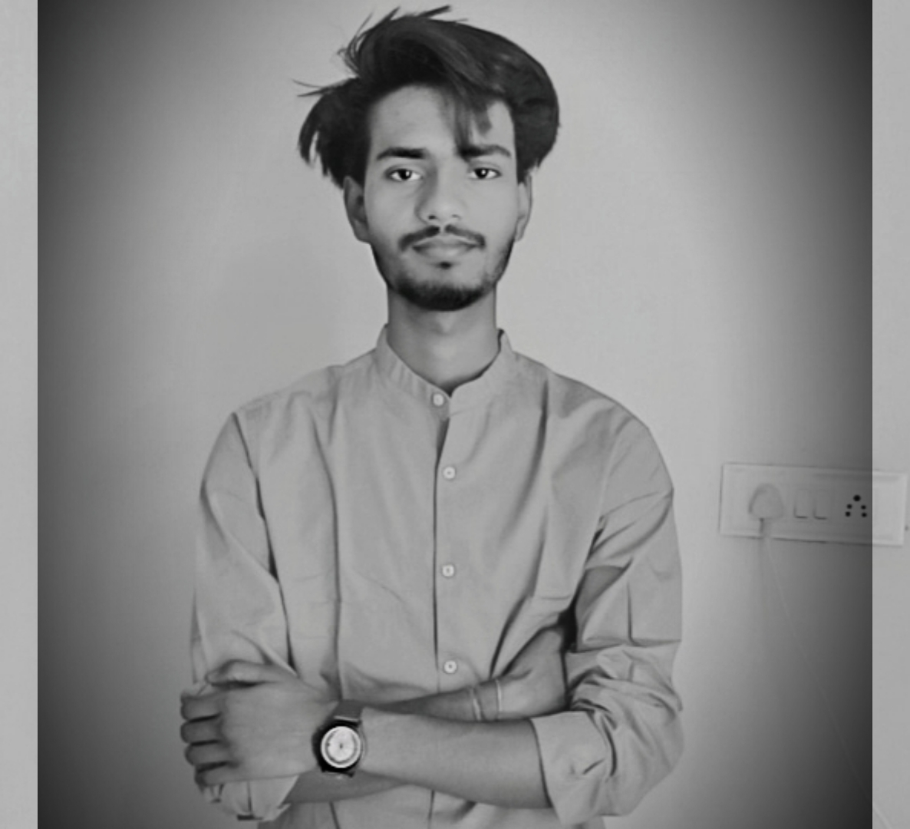

Mathura, +91 7394943432, [sameer.kushwaha_cs22@gla.ac.in](mailto:sameer.kushwaha_cs22@gla.ac.in)

LinkedIn: <https://www.linkedin.com/in/sameerkushwaha124/>, GitHub: https://github.com/sameerkushwaha-124

# EDUCATION

**Bachelor of Technology in Computer Science, *GLA University, Mathura, 7.86 CGPA*** June 2026

**Intermediate, JIC, Ramkola, 81.6%** May 2022

**High School, Bhabha Educational Institute, Ramkola, *80%*** May 2020

# INTERNSHIP/ TRAINING EXPERIENCE __________________________________________________________________

**Job Oriented Value Added Course, GLA University, Mathura** June 2024 – July 2024

*Dr. Ram Manohar Nisarg*

*JOVAC Trainee*

* Learnt basics of Python libraries and basics of development.
* Post completing the training, created a Project named “GLA Chatbot “, by using LLM.

# PROJECTS

**GitHub Link/** https://github.com/sameerkushwaha-124/GLA-ChatBot

* Led a team of six to develop a chatbot using Python and ML tools, focusing on NLP and machine learning to create an intelligent and user-friendly conversational agent.
* Python libraries and some machine learning tools.

# SKILLS

**Technical Professional**

C, C++ Effective Communication Skills

Java, React Team Work

Mongo DB Interpersonal Skills

# PROFESSIONAL ACHIEVEMENTS/ INSIGHTS

* Certified in Java with DSA and System Design.
* Attended workshop on Java programming (Physics Wallah Private Limited).

# CO-CURRICULAR ACTIVITIES

* Participated in Smart India Hackathon (GLA, October, 2022).
* 400+ problems including Leetcode and other.

**DECLARATION________________________________________________________________________________________**

I hereby declare that all the above mentioned information is true and correct to the best of my knowledge.