***WEB APPLICATION OF BUSSINESS MANAGEMENT***

**A**

**Major Project Report**

**Submitted in Partial fulfillment for the award of**

**Bachelor of Engineering**

**Submitted to**

**RAJIV GANDHI PROUDYOGIKI VISHWAVIDYALAYA**

**BHOPAL (M.P)**



**Submitted by**

***PRIYANKA (0186CS141074)***

***SAMEER REZA KHAN (0186CS141094)***

***SIMRAN GUJRATI (0186CS141105)***

***VAISHALI KAHAR (0186CS141115)***

**Under the supervision of**

***PROF.RUPALI CHAURE***



**DEPARTMENT OF COMPUTER SCIENCE AND ENGINEERING**

**SAGAR INSTITUTE OF RESEARCH TECHNOLOGY & SCIENCE, BHOPAL**

**SESSION-2017-18**

Front page

Certificate (college)

Acknowledgement

Abstract

Table of content

1. List of figures

2. List of tables

3. Introduction

3.1 Objective

3.2 Purpose

3.3 Scope

3.4 Problem identification

3.5 Methodology

3.5 Software Requirements

3.6 Hardware Requirements

4. System design

4.1 Use Case Diagram

4.2 Class Diagram

4.3 Sequence Diagram

4.2 E-R Diagram

4.3 Collaboration Diagram

4.5 Data flow Diagram

4.6 Flow Chart

4.7 Activity Diagram

4.8 Database Design

5. Input forms

6. Output forms

7. Reports

8. Testing

9. Limitations

10. Conclusion & Future enhancements

11. References

***Font Size:- Font – 12 Times New Roman***

***Title – 14 Bold Times New Roman***

***Subtitle – 12 Bold Times New Roman***

***File color: Sliver Word on Black Background***

***File binding: Hard binding***

***No of copies to be submitted: 1(From Each Group) (with one CD of Project’s Software)***

**SAGAR INSTITUTE OF RESEARCH TECHNOLOGY & SCIENCE**

**DEPARTMENT OF COMPUTER SCIENCE AND ENGINEERING**



### CERTIFICATE

This is to certify that the work embodied in this report entitled **WEB APPLICATION OF BUSSINESS MANAGEMENT** has been satisfactorily completed by **PRIYANKA, SAMEER REZA KHAN, SIMRAN GUJRATI, VAISHALI KAHAR.** It is a bonafide piece of work, carried out under our/my guidance in the **Department of Computer Science & Engineering**, **Sagar Institute of Research, Technology & Science, Bhopal** for the partial fulfillment of the Bachelor of Engineering during the academic year 2017-18.

**Head of Department Project Coordinator Project Guide Dr. Amit Shrivastava Prof. Rupali chaure Prof. Rupali chaure**

# ACKNOWLEDGEMENT

**The completion of this project work could be possible with continued & dedicated efforts & guidance of large number of faculty & staff members of the Institute. We acknowledge our gratitude to all of them. The acknowledgement however will be incomplete without specific mention as follows:**

**We express our profound sense of gratitude to our project guide Prof. Rupali chaure for their continuous encouragements & guidance during the project period.**

**We also express our sincere thanks to the HOD (CSE) Dr. Amit Shrivastava for encouragement & providing all the facilities in the department.**

**We would like to extend our gratitude to the Director Dr. Manish Manoria for their valuable encouragement & approval of the project work.**

**We are thankful to all staff members of the CSE department and my friends for their timely help co-operation and suggestion for my project work. Lastly but not the least, we must express thanks to our family, without their moral support it was impossible for us to complete this minor/major project work.**

**Submitted by:**

**Priyanka (0186cs141074)**

**Sameer Reza Khan (0186cs141094)**

**Simran Gujrati (0186cs141105)**

**Vaishali Kahar (0186cs141115)**

***ABSTRACT***

Inventory management is primarily about specifying the size and placement of stocked goods. Inventory management is required at different locations within a facility or within multiple locations of a supply network to protect the regular and planned course of production against the random disturbance of running out of materials or goods. The scope of inventory management also concerns the fine lines between replenishment lead time, carrying costs of inventory, asset management, inventory forecasting, inventory valuation, inventory visibility, future inventory price forecasting, physical inventory, available physical space for inventory, quality management, replenishment, returns and defective goods and demand forecasting. Balancing these competing requirements leads to optimal inventory levels, which is an on-going process as the business needs shift and react to the wider environment.

**LIST OF FIGURE**

**LIST OF TABLES**

**3. INTRODUCTION**

**I**nventory management involves a retailer seeking to acquire and maintain a proper merchandise assortment while ordering, shipping, handling, and related costs are kept in check.

The technique of inventory proportionality is most appropriate for inventories that remain unseen by the consumer. As opposed to "keep full" systems where a retail consumer would like to see full shelves of the product they are buying so as not to think they are buying something old, unwanted or stale; and differentiated from the "trigger point" systems where product is reordered when it hits a certain level; inventory proportionality is used effectively by just-in-time manufacturing processes and retail applications where the product is hidden from view.

One early example of inventory proportionality used in a retail application in the United States is for motor fuel. Motor fuel (e.g. gasoline) is generally stored in underground storage tanks. The motorists do not know whether they are buying gasoline off the top or bottom of the tank, nor need they care. Additionally, these storage tanks have a maximum capacity and cannot be overfilled. Finally, the product is expensive. Inventory proportionality is used to balance the inventories of the different grades of motor fuel, each stored in dedicated tanks, in proportion to the sales of each grade. Excess inventory is not seen or valued by the consumer, so it is simply cash sunk (literally) into the ground.

The word 'inventory' can refer to both the total amount of goods and the act of counting them. Many companies take an inventory of their supplies on a regular basis in order to avoid running out of popular items. Others take an inventory to insure the number of items ordered matches the actual number of items counted physically. Shortages or overages after an inventory can indicate a problem with theft (called 'shrinkage' in retail circles) or inaccurate accounting practices. To avoid these manual discrepancies we use computerized inventory system.

**3.1 Objective:**

Our project ‘Web Application For Business Management’ mainly deals with these problems. This web application is developed in java, html, css, php programming language which will help to user create our account and register the site, hoie information.

**3.2 Purpose:**

Inventory is the total amount of goods and/or materials contained in a store or factory at any given time. Store owners need to know the precise number of items on their shelves and storage areas in order to place orders or control losses. Factory managers need to know how many units of their products are available for customer orders. Restaurants need to order more food based on their current supplies and menu needs. All of this business relies on an inventory count to provide answers.

The word 'inventory' can refer to both the total amount of goods and the act of counting them. Many companies take an inventory of their supplies on a regular basis in order to avoid running out of popular items. Others take an inventory to insure the number of items ordered matches the actual number of items counted physically. Shortages or overages after an inventory can indicate a problem with theft (called 'shrinkage' in retail circles) or inaccurate accounting practices. To avoid these manual discrepancies we use computerized inventory system.

The proposed “INVENTORY MANAGMENT” is economically feasible because

* The system requires very less time factors.
* The system will provide fast and efficient automated environment instead of slow and error prone manual system, thus reducing both time and man power spent in running the system.
* The system will have GUI interface and very less user-training is required to learn it.
* The system will provide service to view various information for proper managerial decision making.

**3.3 scope:**

Inventory Management is designed to meet the dictates of market place and support the company’s Strategic Plan.

Inventory management is primarily about specifying the size and placement of stocked goods. Inventory management is required at different locations within a facility or within multiple locations of a supply network to protect the regular and planned course of production against the random disturbance of running out of materials or goods. The scope of inventory management also concerns the fine lines between replenishment lead time, carrying costs of inventory, asset management, inventory forecasting, inventory valuation, inventory visibility, future inventory price forecasting, physical inventory, available physical space for inventory, quality management, replenishment, returns and defective goods and demand forecasting.

**3.4 Problem identification:**

Inventory Management system provides information to efficiently manage the flow of materials, effectively utilize people and equipment, coordinate internal activities and communicate with customers. Inventory Management does not make decisions or manage operations; they provide the information to managers who make more accurate and timely decisions to manage their operations.

The software is leveraging the powers of the internet to increase its usability. It helps the company to manage its products, services over the internet via a website.

**3.5 Methodology:**

**3.6 Software Requirement:**

**Supporting tools:**

Blue print foundry 4.0,Microsoft @ Word 2007,

**3.7 Hardware Requirement:**

Here's What You Need to Use the inventory management system system:  
  
 •   20GBHDD  
 •   256MBRAM  
 •   PentiumIVProcessor  
 •   InputDevices:Keyboard,Mouse  
 •   OutputDevices:Monitor,Printer

**4. SYSTEM DESIGN**

**4.1** **Use Case Diagram: LOG IN PAGE**

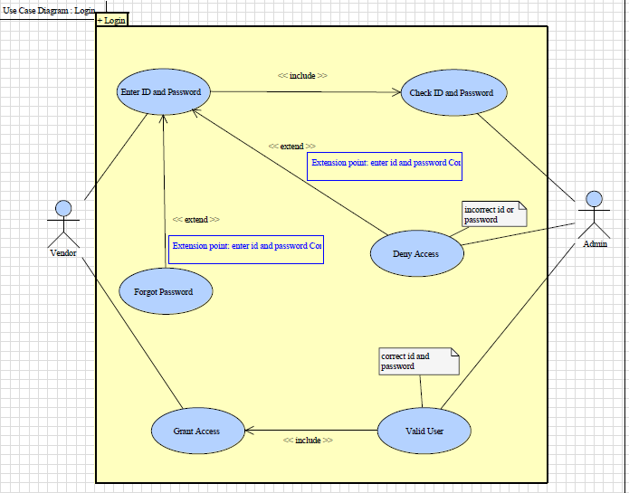

**4.2 Class Diagram**

**4.3 Sequence Diagram**

**4.4 E-R Diagram**

**4.5 Data Flow Diagram**

**4.6 Activity Diagram**

**5. Input forms**

**6. Output forms**

**7. Reports**

**8. Testing**

**9. Limitations**

* Increase complexity /effort
* More difficult to built 3 tier architecture rather then a 2 tier.
* Points of communication are doubled
* Maintenance tools are currently inadequate for maintaining server libraries.

**10. Conclusion & Future enhancements**

We have observed that our system that is Inventory Management and Costing would be of immense help to the client as currently everything is done manually, which results in a lot of time consumption, is error prone and also increases economic burden in the form of salaries paid to the workers. Moreover such a manual system of managing inventory is quite unstructured. Our system would be efficient, accurate and easy to use.

**11. References**

This text belongs to all the team workers and is intended for the project in-charge, Zensar Technologies and the people who want knowledge about various modules of Inventory Management System. This report contains the overview of the whole system in which each feature is examined according to its precedence.