**TASK1: CREATE AN AZURE KEY VAULT**

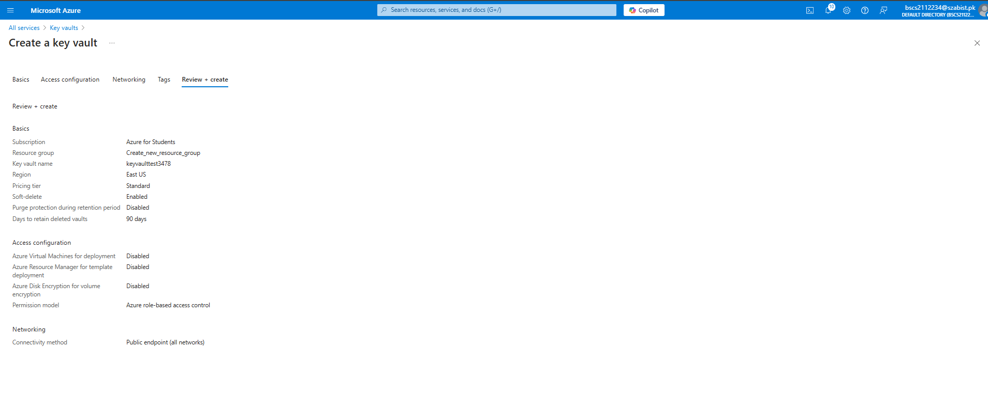

**TASK2: ADD A SECRET TO THE KEY VAULT**

