What is a one to one foreign key relationship?
One to one relationship refers to the relationship between two entities/tables A and B in which one item/row of A may be linked with only one item/row of B, and vice versa. The relationship is established by adding the primary key field/column of one entity/table into another as a foreign key.
For instance, in this tutorial, a library has only one address, and an address is the address of only one library. id column of address table is added into the library table as address_id foreign key column to enforce the one to one relationship.

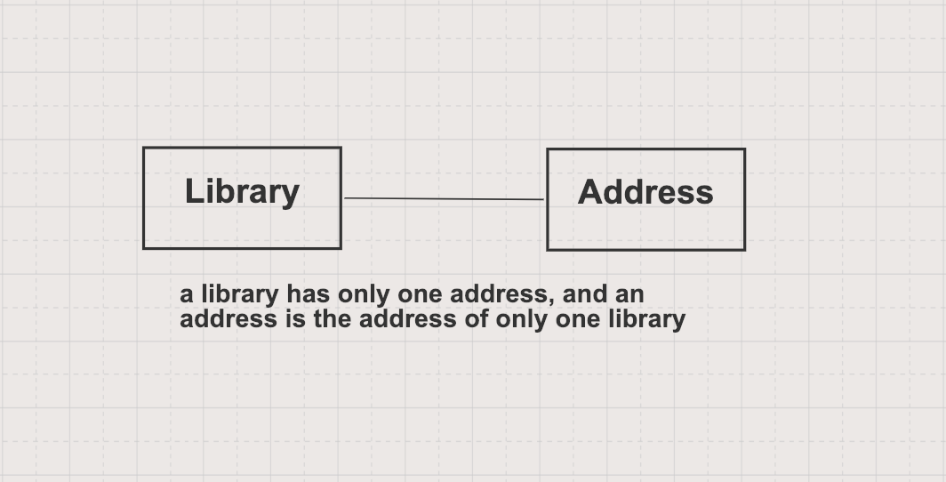

Define JPA Entities
JPA Entity is defined with @Entity annotation, represent a table in your database.
jpa-hibernate/one-to-one-foreign-key/src/main/java/com/hellokoding/springboot/jpa/book/Library.java
package com.hellokoding.springboot.jpa.book;

import lombok.Data;

import javax.persistence.*;

@Data

@Entity
public class Library {
@Id
@GeneratedValue(strategy = GenerationType.IDENTITY)
private Integer id;

private String name;

@OneToOne(cascade = CascadeType.ALL)
@JoinColumn(unique = true)
private Address address;

public Library(String name, Address address) {
this.name = name;
this.address = address;
this.address.setLibrary(this);
}
}
jpa-hibernate/one-to-one-foreign-key/src/main/java/com/hellokoding/springboot/jpa/book/Address.java
package com.hellokoding.springboot.jpa.book;

import lombok.Data;

import javax.persistence.*;

@Data

@Entity
public class Address {
@Id
@GeneratedValue(strategy = GenerationType.IDENTITY)
private Integer id;

private String street;

private String zipCode;

@OneToOne(mappedBy = "address")
private Library library;

public Address(String street, String zipCode) {
this.street = street;
this.zipCode = zipCode;
}
}
Each entity field is corresponding to the table's column.
@Id declares the entity/table identifier/primary key.
@OneToOne defines a one-to-one relationship between 2 entries/tables. mappedBy is annotated on the inverse entity/table of the relationship, its value is referred to the relationship owner/parent entity/table.
@JoinColumn(unique = true) enforces the unique constraint on the foreign key address_id of the table library ensuring that 1 address belongs to only 1 library.

