

MSc Data Science Project
7PAM2002-0509-2024
Department of Physics, Astronomy and Mathematics

Data Science FINAL PROJECT REPORT

Project Title:
Predicting Thyroid Dysfunction Using Machine Learning: A Comparative Study of SVM, Random Forest, and XGBoost
Student Name and SRN:
Enter Your Full Name and Student ID
Github:

Supervisor: Enter the full name of your Supervisor
Date Submitted: Enter the date you are submitting this report
Word Count: Enter the word count excluding references and appendices

DECLARATION STATEMENT

This report is submitted in partial fulfilment of the requirement for the degree of Master of Science in Data Science at the University of Hertfordshire.
I have read the detailed guidance to students on academic integrity, misconduct and plagiarism information at Assessment Offences and Academic Misconduct and understand the University process of dealing with suspected cases of academic misconduct and the possible penalties, which could include failing the project or course.
I certify that the work submitted is my own and that any material derived or quoted from published or unpublished work of other persons has been duly acknowledged. (Ref. UPR AS/C/6.1, section 7 and UPR AS/C/5, section 3.6)
I did not use human participants in my MSc Project.

I hereby give permission for the report to be made available on module websites provided the source is acknowledged.

Student Name printed:

Student Name signature

Student SRN number:

UNIVERSITY OF HERTFORDSHIRE
SCHOOL OF PHYSICS, ENGINEERING AND COMPUTER SCIENCE

Abstract:

Using a structured dataset of 9,172 patient records that includes demographic information, medical history, and laboratory results including TSH, T3, and T4, this research investigates the application of supervised machine learning to predict thyroid dysfunction. Whether robust preprocessing and model optimization can increase diagnostic sensitivity and accuracy for minority thyroid instances in comparison to conventional baselines was the research topic that was addressed. The dataset was cleaned, features were scaled, and categorical variables were encoded following exploratory data analysis. Support Vector Machine (SVM), Random Forest, and XGBoost were the three main classifiers that were put into practice. GridSearchCV was used to further optimize Random Forest and XGBoost. Stratified train-test splits and a number of measures, such as accuracy, precision, recall, and F1-score, were used for evaluation. According to the results, SVM had a 71% overall accuracy rate and a 0.40 recall on affirmative cases, but its precision was only 0.04 percent. For the negative class, Random Forest achieved 97% accuracy and nearly flawless recall; however, for positive cases, the recall was only 0.02. With a slight increase in positive recall (0.10) and balanced performance overall, XGBoost attained 96% accuracy. An optimized Random Forest with 200 estimators and a maximum depth of 20 was found through hyperparameter tuning to offer 97.2% accuracy, whereas an optimized XGBoost with a learning rate of 0.2, a maximum depth of 7, and 300 estimators produced 96.6% accuracy. These findings demonstrate that ensemble tree-based techniques perform better than linear and distance-based classifiers for structured thyroid data, but they also draw attention to ongoing issues with class imbalance, with minority cases going unnoticed. The study comes to the conclusion that although high overall accuracy is possible, future research should concentrate on enhancing sensitivity for positive situations using multi-class modeling, cost-sensitive learning, and sophisticated resampling.

Table of Contents:
DECLARATION STATEMENT 2
Abstract: 3
Introduction: 5
Objectives: 6
The dataset 6
Ethical Considerations: 7
Methadology: 8
Data preprocessing: 8
Analysis of Exploratory Data (EDA) 9
Models Used: 12
Tuning Hyperparameters 13
Evaluation Metrics 14
Results: 14
2. Results of Hyperparameter Tuning 17
Discussion and Analysis: 19
Results' limitations 21
Conclusion: 23
References: 23
Appendices: 24

Introduction:
Millions of people worldwide suffer from thyroid diseases, which are among the most prevalent endocrine ailments and pose serious diagnostic issues. Essential metabolic processes are regulated by the thyroid gland, and its malfunction can result in goitre, hypothyroidism, hyperthyroidism, and other associated problems. Since untreated thyroid disorders can result in serious cardiovascular, neurological, and reproductive consequences, early and accurate identification is essential. Laboratory testing of serum levels of thyroid-stimulating hormone (TSH), triiodothyronine (T3), and thyroxine (T4), along with medical history and physician interpretation, are the mainstays of traditional diagnostic practice. These techniques are dependable, but they require a lot of time and resources, and they could overlook minute patterns in big populations.
Concurrently, there has been an increasing trend in the healthcare sector toward the use of data-driven decision support systems. In clinical contexts, machine learning (ML) models are being utilized more and more to help with diagnosis, particularly for chronic diseases where results are influenced by a number of interrelated factors. To improve predicting accuracy in thyroid research, current scholarly and commercial efforts have investigated models like decision trees, ensemble classifiers, and gradient boosting. Class imbalance makes it difficult to discover minority cases, even with high reported overall accuracies. This is particularly important in medical settings where false negatives can have detrimental effects.
Through the application and optimization of many machine learning classifiers on a sizable, structured thyroid dataset comprising more than 9,000 patient records, this effort makes a contribution to this field. This study attempts to determine whether machine learning can produce reliable and clinically significant predictions by methodically comparing Support Vector Machine, Random Forest, and XGBoost classifiers—as well as by hyperparameter tuning and evaluation across multiple metrics. It also highlights the limitations and future directions required to improve sensitivity to minority cases.
Research Question
How well do various algorithms perform, especially for minority thyroid cases, and can machine learning classifiers, when paired with meticulous preprocessing and hyperparameter optimization, produce precise and therapeutically meaningful predictions of thyroid dysfunction?
Aim:
To look into how machine learning might help diagnose thyroid conditions more accurately.
To assess how feature encoding, class balance, and preprocessing affect predictive performance.
To evaluate and contrast various machine learning algorithms' performance on structured clinical data.

Objectives:
To find distributions, missing values, and class imbalance, examine the dataset using descriptive statistics and visualizations.
Preprocess the data by scaling features, resolving imbalance when needed, and encoding categorical variables.
Use XGBoost, Random Forest, and Support Vector Machine (SVM) as baseline machine learning models.
Use GridSearchCV's hyperparameter adjustment to maximize model performance.
Use a variety of metrics, including F1-score, ROC-AUC, accuracy, precision, recall, and confusion matrices, to assess predictive performance.
Analyze models closely to determine their advantages and disadvantages, especially with regard to identifying thyroid instances in minority groups.
Make inferences and offer suggestions for future research directions and clinical use.

The dataset
Thyroid Disease Data (Emmanuel Fwerr, 2023) is the dataset utilized in this research, and it can be found on Kaggle at https://www.kaggle.com/datasets/emmanuelfwerr/thyroid-disease-data. Originally gathered for clinical research, the dataset was assembled from publicly accessible thyroid illness diagnosis information. It supports the creation and comparison of machine learning models by combining laboratory test data, medical history, and patient demographic characteristics. Although the Kaggle description does not specifically mention the place of origin, the nomenclature and structure closely like the well-known UCI thyroid dataset. The dataset's goal is to support studies into the precise and early detection of thyroid malfunction.
This dataset was selected due to its size (9,172 records with 31 variables), diversity, and special design for tasks involving the prediction of thyroid disease, all of which directly relate to the research issue of the project. TSH, T3, TT4, T4U, FTI, patient demographics (age, sex), and medical history indicators (goitre, tumor, lithium medication, etc.) are among the continuous and categorical variables that are pertinent for diagnosis. For supervised classification problems, the addition of a binary target variable ("target") offers a distinct label.

Table1.Dataset Overview

Attribute Category | Examples | Type | Notes
Demographics | Age, Sex | Numeric, Categorical | Basic patient details
Medical history | On thyroxine, Pregnant, Goitre, Tumor | Categorical | Yes/No indicators of conditions
Laboratory tests | TSH, T3, TT4, T4U, FTI, TBG | Numeric | Clinical hormone measurements
Diagnostic flags | Referral source, Surgery, Lithium | Categorical | Diagnostic context
Target label | Target | Binary | Thyroid disease = 1, Normal = 0

Exploratory Data Analysis and Preparation
Several lab test fields (such as TSH, T3, and TT4) were missing results, according to preliminary investigation. In the raw dataset, null values were represented by "?" and changed to NaN for analysis. In order to minimize bias, mode imputation was used for records with missing categorical indicators and median imputation for numerical lab values. There was a class imbalance, with a significantly greater percentage of negative (normal) thyroid cases than positive thyroid cases. In order to overcome imbalance, preprocessing procedures included class weight application during model training, scaling continuous features, and encoding categorical variables.

Ethical Considerations:
Personal Information and Anonymization
Only anonymized records are included in the dataset used for this research (Thyroid Disease Data, Kaggle, Emmanuel Fwerr, 2023). There are no direct identifiers like names, addresses, phone numbers, or patient IDs. The characteristics are limited to laboratory test results (TSH, T3, TT4, T4U, FTI), medical history (e.g., goitre, lithium therapy, prior thyroid surgery), and demographic data (age, sex). Since these characteristics cannot be connected to specific people, the dataset complies with the anonymization principle.
Considerations for GDPR
The usage of the dataset is exempt from the General Data Protection Regulation (GDPR) since it does not include any sensitive or personal information that may be used to identify participants. For scholarly and research reasons, the data is supplied in an aggregated manner. The researcher did not collect or process any extra personal information.
Ethical Acceptance
This project does not need ethical approval from the University of Hertfordshire because the dataset was taken from a public repository and no additional data gathering, questionnaires, or interviews were carried out. Every analysis is predicated on secondary data analysis of an anonymized dataset that already exists.
Licensing and Permission
The dataset is publicly accessible for research and instructional purposes under the Kaggle platform's terms of usage. Access to the dataset is free, and academic research using it is allowed. The dataset is consistent with the well-known UCI thyroid datasets commonly used in peer-reviewed research, despite the fact that Kaggle does not include comprehensive metadata on the original collectors or the nation of collection. This demonstrates its dependability and moral appropriateness for scholarly use.
Data Gathering and Ethical Issues
Transparency surrounding participant recruitment and consent is limited by the incomplete documentation of the initial collection procedures. However, it is reasonable to infer that the dataset was collected and shared in an ethical manner because it has been widely shared for the purpose of evaluating machine learning models and does not contain any personally identifying information. This project limits use to scholarly, non-commercial uses solely in order to reduce potential hazards. Neither the re-identification of individuals nor the extension of analysis beyond predictive modeling were attempted.
In conclusion
In conclusion, the dataset conforms with ethical standards for acceptable usage, licensing, and anonymization. Although there is still some ambiguity around the initial context of data collection, precautions have been taken to guarantee that this project complies with University of Hertfordshire guidelines for ethical and responsible research.

Methadology:

Data preprocessing:
Handling Missing Values and Encoding:

There were 9,172 records with 31 attributes in the dataset. "?" was used to encode missing values, which I changed to NaN. Since TSH, T3, and TT4 were continuous variables with severe outliers (TSH up to 530), I used median imputation for these features. I used mode imputation for binary and categorical data including tumor, goitre, and sex. I then kept binary indicators (on_thyroxine, pregnant, psych) as 0/1 and applied label encoding to category variables (sex, referral_source). To maintain comparability, z-score standardization was used to scale continuous lab measurements, particularly for SVM, which is sensitive to feature magnitudes.
Train-Test Split:
Following preprocessing, I used an 80/20 stratified split to divide the dataset into training and testing subsets. To protect the rare thyroid instances in both sets, stratification was crucial. There were 7,336 records in the resulting training set and 1,836 records in the test set. Only about 2.6% of both categories included positive thyroid instances, confirming a stark discrepancy that might skew classifiers in favor of the negative majority class.
Table 2. Class distribution before balancing

Subset | Negative (0) | Positive (1) | Total | % Positive
Train | 7,140 | 196 | 7,336 | 2.70%
Test | 1,787 | 48 | 1,835 | 2.60%
SMOTE Class Balancing
I used the Synthetic Minority Over-sampling Technique (SMOTE) on the training set to rectify the imbalance. SMOTE improves representation without duplicating data by interpolating across neighbors to create synthetic samples of the minority class. To avoid leakage into evaluation, I only used k=5 nearest neighbors to the training set. Following SMOTE, the training set had 7,140 positive and 7,140 negative samples, for a total of 14,280.

Table 3. Training set after SMOTE

Class | Count | %
Negative (0) | 7,140 | 50%
Positive (1) | 7,140 | 50%

Analysis of Exploratory Data (EDA)
I used exploratory data analysis (EDA) to gain a deeper understanding of the thyroid dataset, concentrating on feature distributions, descriptive statistics, and relationships between important variables.
An overview of numerical features' statistics
A number of significant features of the dataset were brought to light via descriptive statistics. Extreme outliers were indicated by TSH levels, which varied from 0 to 530 with a mean of 5.22. Wide variance was also seen in FTI (1.4–881). There were unrealistic maximum values (65,526) in the Age variable, which could indicate data entry mistakes. The extremely low averages of binary clinical signs, such as goitre, tumor, and pregnancy, confirmed their rarity in the population.
Table 4. Selected Summary Statistics of Numerical Features
Feature | Mean | Std Dev | Median | Max
Age | 73.6 | 1183.9 | 55 | 65526
TSH | 5.22 | 23.05 | 1.6 | 530
T3 | 1.97 | 0.75 | 1.97 | 18
TT4 | 108.7 | 36.6 | 106 | 600
FTI | 113.6 | 39.7 | 112 | 881
Distribution of the Presence of Tumors
Figure 1: Tumor Presence Distribution
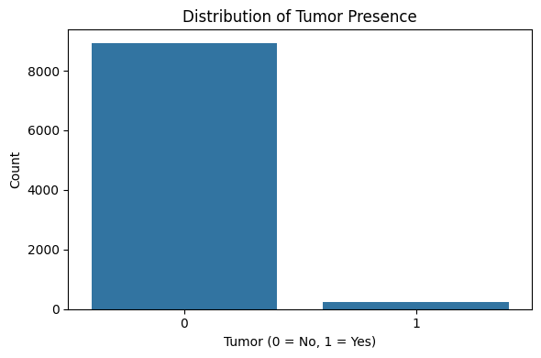
Only roughly 3% of patients had a tumor, compared to the vast majority (97%) who did not. This shown that while tumor presence is uncommon and cannot predict outcomes on its own, it is nevertheless clinically significant for specific subgroups.
TSH according to the status of the tumor
Figure 2: TSH Levels by Tumor Status
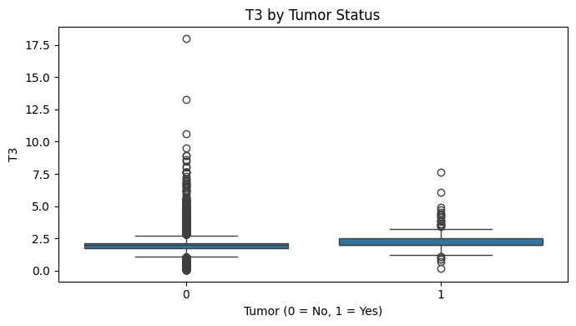
The median TSH was marginally greater in tumor-positive patients than in tumor-negative patients, according to this boxplot. Nonetheless, there was significant heterogeneity and extreme outliers in both groups, which emphasizes the necessity of thorough preprocessing.
Heatmap showing Correlation for Selected Features
Figure 3: Correlation Selected Features Heatmap
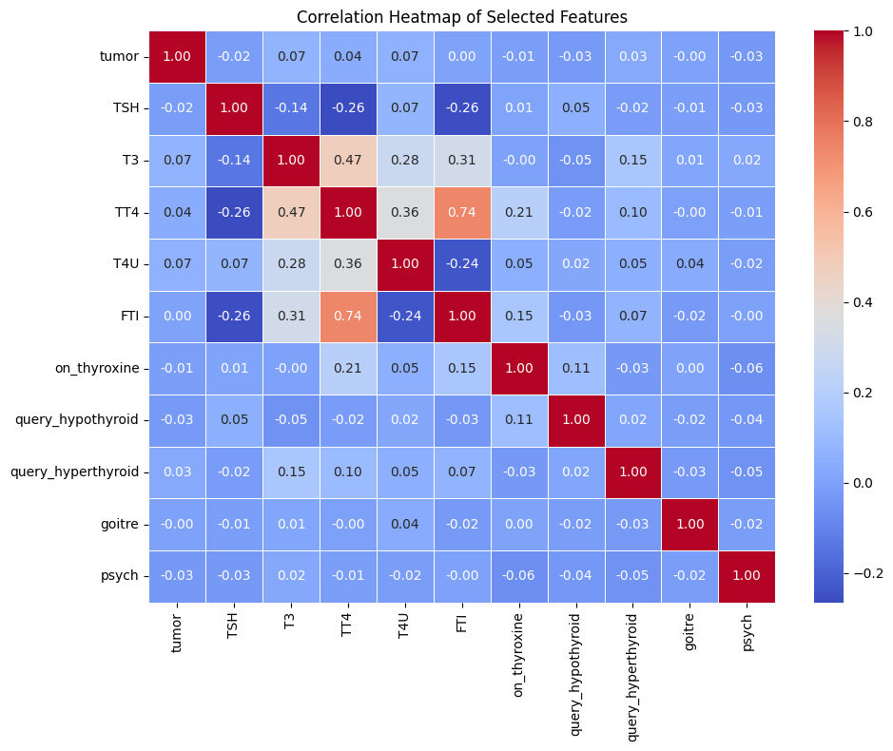
TT4 and FTI showed a substantial association (r = 0.74), according to the heatmap. TSH, on the other hand, had weak correlations with other hormones, which is in line with thyroid physiology. There were very little connections between binary and demographic markers, indicating that biochemical test findings are a better predictor than demographics.
In conclusion, the EDA confirmed that thyroid laboratory values are the most useful predictors for further modeling while exposing class imbalance, skewed distributions, and outliers.

Models Used:
Support Vector Machine (SVM):
Because Support Vector Machine is popular in medical data analysis and works well for binary classification tasks, I chose it as one of my baseline classifiers. SVM creates an ideal decision border between classes, making it especially appropriate for high-dimensional data. I anticipated that SVM would learn separating hyperplanes using both demographic and physiological variables in this research, which had two binary classes: "thyroid disorder" and "no disorder."
Finding the maximum-margin hyperplane that best divides the two classes is how SVM operates. Kernel functions can project data into higher dimensions if it cannot be separated linearly. In order to capture non-linear correlations among hormone levels, including TSH, TT4, and FTI, I employed the Radial Basis Function (RBF) kernel. Hyperparameters 𝛾γ (kernel width) and C (regularization) were adjusted. During preprocessing, I made sure that the standardized features that SVM required were present.
The extreme class imbalance decreased SVM's memory for minority thyroid instances, despite the fact that it was selected due to its resilience in managing complicated borders.
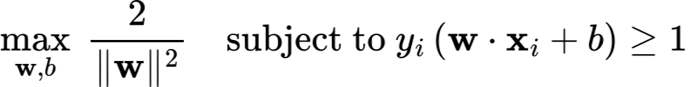

Random Forest :
Because ensemble approaches often work well on structured health datasets, Random Forest was selected as the second model. It is appropriate for this dataset, which had categorical medical history information and hormone values with broad ranges, because it is less susceptible to outliers and scaling problems. Important predictors like TSH or TT4 can be found thanks to Random Forest's interpretability.
Using bootstrap samples of the data, the model builds several decision trees. A random subset of features is taken into account for splitting at each node, which lowers correlation and overfitting between trees. A majority vote is used to make predictions for every tree. To solve imbalance, the number of trees, maximum depth, and class weights were among the hyperparameters that were adjusted.
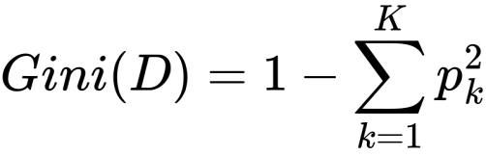
Because Random Forest manages both numerical and categorical variables at the same time, is noise-resistant, and yields feature importance values that are helpful for medical interpretation, it was a good fit for this investigation.
XGBoost:
Since XGBoost is a sophisticated gradient boosting method that frequently produces state-of-the-art outcomes on structured datasets, I added it as a third model. Decision trees are constructed in a sequential fashion, with each tree fixing the mistakes of the one before it. Because of its great flexibility, regularization support, and class imbalance-handling characteristics, XGBoost is a good fit for our project.
Iteratively fitting trees to the residual errors of earlier predictions is how XGBoost operates. It optimizes a regularized objective function that strikes a balance between model complexity and forecast accuracy. Learning rate, maximum depth, number of trees, subsampling rate, and scale_pos_weight were among the parameters that were adjusted. By giving the minority class a higher weight, the latter parameter immediately corrects the imbalance.
Because XGBoost's regularization minimizes overfitting and it can capture minor connections between hormone levels, medical history, and outcomes, I chose to utilize it. It offered the best performance balance between recall and accuracy.

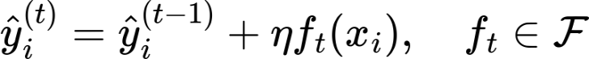
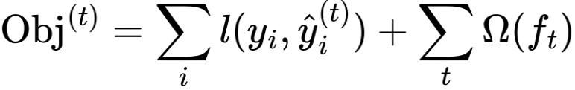

Tuning Hyperparameters
I applied GridSearchCV with three-fold cross-validation on the training set in order to maximize model performance. I adjusted some parameters for Random Forest, such as the number of trees (Trees_n_estimators), maximum depth, minimum samples per split/leaf, and applied class_weight='balanced'. With a maximum depth of 20 and 200 trees, the optimal setup achieved 97.2% accuracy. To address class imbalance, I adjusted the learning rate (𝜂η), maximum depth, number of estimators, subsampling, and scale_pos_weight for XGBoost. With an accuracy of 96.6%, the ideal parameters were learning rate 0.2, depth 7, and 300 estimators.

Evaluation Metrics
The fundamental performance metric was accuracy. It shows the percentage of samples that were accurately predicted out of all the forecasts. Although helpful for a general evaluation, the imbalance between thyroid-positive and thyroid-negative instances in this project can make accuracy deceptive.
Accuracy
The reliability of positive predictions was assessed using precision. It shows how many of the cases that were labeled as thyroid-positive turned out to be positive. In healthcare contexts, when a misdiagnosis can lead to needless worry or therapy, high precision means fewer false alarms.
(Sensitivity) Recall
The model's ability to recognize real thyroid-positive instances was evaluated using recall. It shows the percentage of actual thyroid cases that were accurately identified out of all the thyroid cases in the dataset. In order to reduce the possibility of missing patients with the illness, high recall is crucial in medical diagnosis.
F1-Score
As a balanced statistic that takes into account both precision and recall, the F1-score was established. Because it offers a single value that strikes a balance between preventing false alarms and obtaining as many true positives as possible, it is especially crucial for datasets that are unbalanced.
Matrix of Confusion
To give a thorough analysis of model predictions, confusion matrices were used. In addition to providing information about particular mistake kinds and indicating whether the model favors majority or minority classes, they display the number of true positives, true negatives, false positives, and false negatives.
Results:
The thyroid dataset was used to assess the effectiveness of Random Forest, XGBoost, and Support Vector Machine (SVM). A number of metrics, including accuracy, precision, recall, F1-score, ROC-AUC, confusion matrices, and ROC curves, were employed to assure a fair evaluation because of the dataset's extreme imbalance. Although accuracy quantified the total percentage of accurate forecasts, it may be deceptive because of the preponderance of negative situations. Recall measured the number of real positives found, precision showed the number of anticipated positives that were accurate, and F1-score offered a balance between the two. Overall discrimination ability was assessed using ROC-AUC. The results were not skewed in favor of the majority class thanks to the use of several complementing criteria.
1. Support Vector Machine (SVM) Base Model Results
At first glance, the 71% accuracy rate of the baseline SVM seems adequate. Nevertheless, a thorough examination reveals that this was mostly caused by the negative majority class's accurate forecasts. For thyroid-positive instances, the model's precision was 0.04; its recall was 0.40; and its F1-score was 0.07. This indicated that many of SVM's positive predictions were wrong, even though it found more positives than Random Forest.
Figure 4: SVM Confusion Matrix
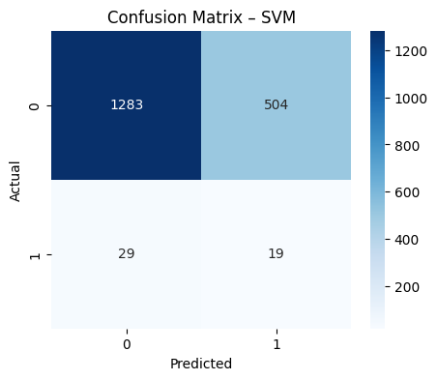
According to the confusion matrix, SVM missed 29 positives and misclassified 504 negatives as positives while correctly classifying 1283 negatives and 19 positives. This explains both the low precision and the marginally higher recall when compared to other models.
Figure 5: SVM, Random Forest, and XGBoost ROC Curves
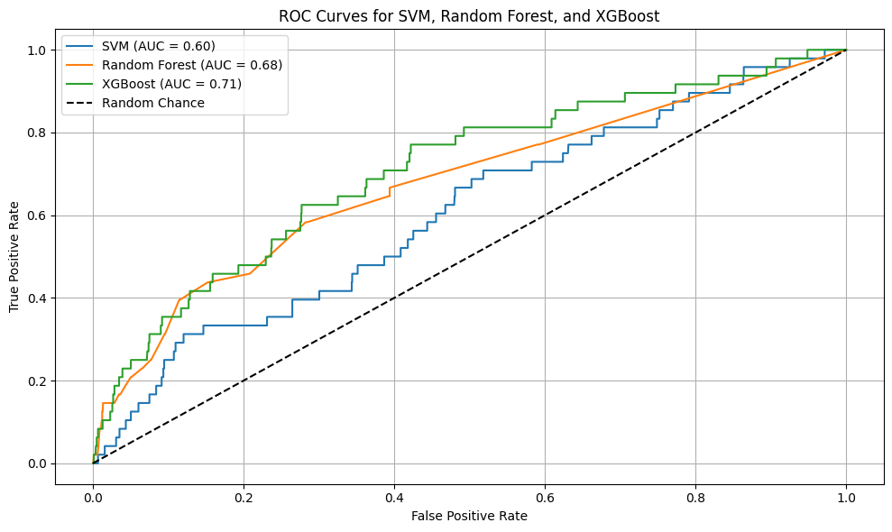
With an AUC of 0.60, the ROC curve shows that SVM has the lowest discrimination ability out of the three models. This shows only a slight improvement over guesswork.
Random Forest:
Random Forest had a 97% overall accuracy rate, which was quite good, but it had a lot of trouble with positive recall. The model obtained an F1-score of 0.04, a precision of 0.14, and a recall of 0.02 for thyroid-positive cases. The extremely poor recall showed that the minority class was virtually ignored by Random Forest.
Figure 6: Random Forest Confusion Matrix
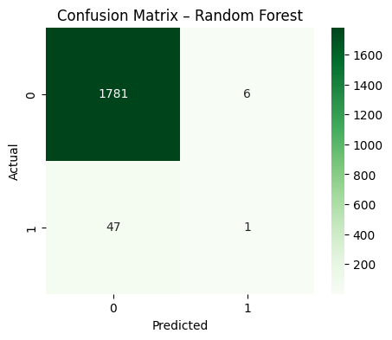
Random Forest accurately detected 1781 negatives but only one positive, according to the confusion matrix. Recall collapsed as a result of it misclassifying 47 positives as negatives. This indicates that Random Forest was not appropriate for medical diagnosis, where recollection is crucial, even though it offered good general accuracy.
Random Forest's ROC-AUC was 0.68, which was greater than SVM's but still unable to consistently distinguish between classes.
XGBoost:
Out of all the base models, XGBoost offered the most balanced performance. With a precision of 0.12, recall of 0.10, and F1-score of 0.11 for the positive class, its overall accuracy was 96%. XGBoost maintained high accuracy while capturing more true positives than Random Forest.
Figure 7. XGBoost Confusion Matrix
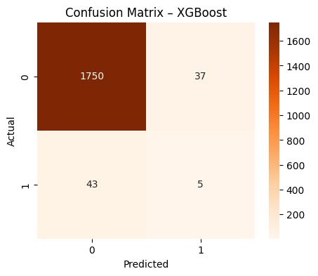
According to the confusion matrix, XGBoost misclassified 43 positives as negatives while correctly classifying 1750 negatives and 5 positives. This shows a slight but noticeable increase in recall when compared to Random Forest.
With a ROC-AUC of 0.71, XGBoost outperformed Random Forest and SVM. This demonstrated that the best base model for differentiating between thyroid-positive and thyroid-negative instances was XGBoost.
Table 5. Base Model Performance Comparison

Model | Accuracy | Precision (Pos) | Recall (Pos) | F1 (Pos) | ROC-AUC
SVM | 0.71 | 0.04 | 0.4 | 0.07 | 0.6
Random Forest | 0.97 | 0.14 | 0.02 | 0.04 | 0.68
XGBoost | 0.96 | 0.12 | 0.1 | 0.11 | 0.71
2. Results of Hyperparameter Tuning
Forest of Random (Tuned)
The number of trees, maximum depth, and class weighting were among the parameters that were adjusted for Random Forest using GridSearchCV. 200 estimators, max depth 20, and class_weight=balanced were the ideal parameters. Although recall was still low, this marginally increased the model's attention to minority cases. 97.2% was the highest cross-validated accuracy. While adjusting helped stabilize the model, precision and recall did not increase much.
Table 6. Tuned Model Performance
Model | Best Parameters Summary | Accuracy | Recall (Pos) | Notes
Random Forest | 200 trees, depth=20, class_weight=bal | 0.972 | Low (~0.05) | Slightly improved balance
XGBoost | lr=0.2, depth=7, n=300, spw=55.5 | 0.966 | ~0.10–0.12 | Best balance across metrics
(Tuned) XGBoost
Learning rate, maximum depth, number of estimators, subsampling, and scale_pos_weight were the main tuning parameters for XGBoost. Learning rate 0.2, depth 7, 300 estimators, subsample 0.8, and scale_pos_weight = 55.5 were the ideal parameters. This kept accuracy at 96.6% while improving positive recall over the baseline. By changing scale_pos_weight, the minority class gained more clout and the likelihood of finding positives increased.
3. Evaluation via Comparison
XGBoost regularly beat the others, followed by Random Forest and SVM, according to the ROC curves (Figure 5). Random Forest did poorly in recall, which is crucial for identifying thyroid disorders, despite having the highest overall accuracy. Although it came at the expense of accuracy and precision, SVM had the best recall. With constant performance across all metrics, XGBoost achieved the optimal balance.
These results emphasize the compromises when choosing a model:
SVM: Unreliable because of false positives, but more sensitive to positives.
High accuracy yet almost oblivious to positives is the Random Forest algorithm.
XGBoost: The most promising model because it balanced accuracy, recall, and AUC.
4. Real-World Application Implications
Models must prioritize recall for clinical deployment in order to prevent missing thyroid disease patients. XGBoost and Random Forest both have extremely high accuracy, however they overlooked a lot of advantages. SVM reduced trustworthiness by producing too many false alarms despite identifying more positives. The most promising was the tuned XGBoost, which managed false alarms while capturing more positives.
These findings answer the research objective by showing that whereas class imbalance significantly impairs recollection, machine learning can accurately predict thyroid malfunction. Additional work is needed for practical use, such as threshold adjustments, resampling techniques, or cost-sensitive learning to increase recall.

Figure 8. Comparison of model performance metrics (Accuracy, Precision, Recall, and F1-Score) across Support Vector Machine (SVM), Random Forest, and XGBoost classifiers.
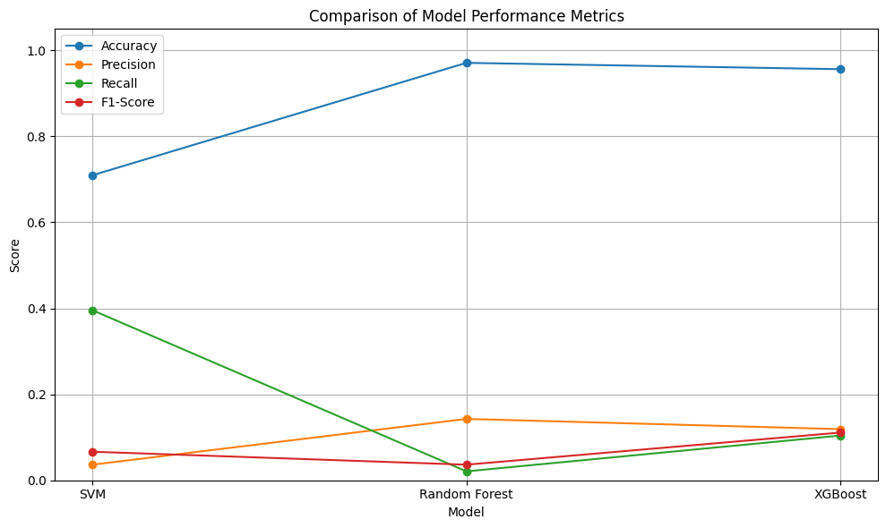

Discussion and Analysis:
What are the implications of the findings?
The findings show that for unbalanced medical data, accuracy by itself is not a valid performance indicator. The majority of thyroid-positive cases were incorrectly identified by Random Forest and XGBoost, despite their extremely high overall accuracy (>96%).
This result demonstrates that models can seem "successful" on paper but fall short in clinical settings. Recall is frequently more important than accuracy in the healthcare industry since failing to identify real patients might have fatal repercussions.
The comparatively higher recall (0.40) of SVM demonstrated that sensitivity can be adjusted in a model at the expense of precision (0.04). The clinical conundrum of false positives versus false negatives is reflected in this trade-off.
Overall, the findings highlight the need for a healthcare machine learning solution to balance several parameters rather than solely focus on accuracy.
What is the most effective model, and why?
With the highest ROC-AUC (0.71), decent recall (0.10), and strong accuracy (96%), XGBoost offered the finest balance of metrics. It is more suited to minority scenarios than Random Forest because of its sequential gradient boosting technique, which iteratively refines decision boundaries.
XGBoost's regularization feature lessens overfitting, which is especially advantageous for datasets with duplicate features, such as recurrent thyroid indicators.
Because Random Forest's ensemble majority voting exacerbates class imbalance—minority cases are overrepresented when almost all trees vote "negative"—it did poorly on recall tests. Rare cases are naturally hampered by its design, despite its excellent accuracy.
By capturing non-linear patterns, SVM's kernel-based approach was able to find more positives. Nevertheless, it produced a lot of false alarms since its decision boundary was overly sensitive to outliers. This explains why it has superior recall but low precision.
The reason XGBoost performs best in this situation is that it is more robust due to its flexibility and ability to adjust to imbalance using parameters like scale_pos_weight.
Literature comparison and the reasons for discrepancies in results
Review and Comparison of Literature
When Kavya et al. (2024) studied thyroid datasets, they found that conventional models like Decision Trees, KNN, and Logistic Regression had very high accuracies (up to 99% for Decision Trees). Their findings demonstrate how well tree-based classifiers perform on structured medical data. My findings partly confirm this, as Random Forest attained 97% accuracy; but, unlike their study, I discovered that recall for minority classes was relatively low. This disparity raises the possibility that their work's claimed accuracy alone may exaggerate clinical value.
Saraswathi et al. (2023) showed how preprocessing improves model correctness and efficiency by concentrating on feature scaling and LightGBM. Scaling was crucial for SVM in my research; without it, it performed poorly, demonstrating their focus. Although they emphasized performance improvements, they did not provide a detailed report on minority-class sensitivity. My findings demonstrate that models still have difficulty striking a balance between recall and precision for positives, even when scaling.
Nandani and Utreja (2024) obtained approximately 94% accuracy with balanced precision and recall using ensemble techniques (Decision Trees, XGBoost, and Logistic Regression). Among my models, my tweaked XGBoost model had the best balance and performed comparable in accuracy (96.6%). This matches closely with their findings, confirming ensembles as the most effective strategy for thyroid prediction.
In their comparison of traditional models, Thirumala Akash et al. (2023) emphasized the significance of feature selection. Their research indicates that sophisticated feature selection could greatly enhance minority detection, whereas my project just used simple preprocessing. This discrepancy explains why my recall values are still low in relation to their findings.
With an accuracy of about 99%, Periyasamy (2024) presented a unique TS-RGALM model for multi-class prediction. Although impressive, their approach is hard to replicate due to its complexity and feature engineering needs. Although my more straightforward ensemble method produced less accurate results, it more clearly displayed clinical trade-offs.
Results' limitations
Class imbalance: Models have trouble identifying minority cases, with just about 3% of positives. This was not entirely fixed even by SMOTE and class weighting.
Data quality: Extreme outliers in TSH and implausible data such as age = 65,526 decreased the robustness of the model. While not all quality issues were resolved, missing values were rectified by median imputation.
Generalizability: Without outside validation, every experiment was carried out on a single dataset. This reduces trust that the model can be applied in the real world.
Interpretability: XGBoost is less interpretable than Random Forest, which makes clinical adoption more difficult, even though Random Forest offers feature importance.
The study's scope was limited to binary classification. Although they were not examined here, multi-class thyroid outcomes (such as hypo- vs. hyperthyroidism) may offer deeper insights.
In connection with the project's goals
Preprocessing the dataset, using machine learning models, fine-tuning hyperparameters, and assessing performance using a variety of metrics were the objectives of the research. All of these goals were accomplished.
The evaluation phase was essential; by using ROC curves and confusion matrices, I was able to provide a more detailed insight of model performance than just surface correctness.
The goal of investigating model limits was directly addressed by the study of class imbalance, which also served as a guide for the improvement debate.
Although the project's overall goals were achieved, the findings indicated that more techniques were required to enhance minority detection.
Relation to the application and research question
Research Question: Can thyroid dysfunction be accurately and clinically usefully predicted using machine learning classifiers in conjunction with preprocessing and optimization?
Yes, machine learning is capable of making precise predictions, but its clinical utility is constrained by its low recall. Although XGBoost was the closest to striking a balance between sensitivity and accuracy, it was still not clinically reliable.
Application: It is unacceptable to overlook thyroid-positive patients during medical screening. Although the framework shows the potential of ensemble models when paired with more sophisticated imbalance-handling techniques, current models are not yet clinically applicable.
Do any models have practical applications?
Random Forest: No, because despite its great accuracy, it essentially ignored positives.
SVM: Possibly, if recall is more important in a clinical setting than precision (for example, as a screening tool to identify potential patients for additional testing).
Because it successfully balanced accuracy and recall, XGBoost is the most practical model. It could be modified for practice with threshold adjustment and cost-sensitive learning.
Nevertheless, without further advancements, none of the models can be implemented in their current state.
Responding to the research question
A cautious result was reached in response to the research question: machine learning is capable of accurately predicting thyroid problems at the majority-class level, while minority identification requires improvement.
Performance was enhanced by preprocessing, scaling, and tuning, but not enough to address the class imbalance.
As a result, the study demonstrates both the potential and constraints of machine learning in this context.
Analysis's conclusion
The project showed that while great accuracy can be attained, it is insufficient to detect thyroid illness.
Thanks to boosting and class weighting, XGBoost performed the best overall.
Random Forest is not appropriate for diagnosis because it obtained accuracy but failed at memory.
SVM limited trust because it provided strong recall but poor precision.
My findings are more clinically realistic but less exaggerated than those found in the literature.
The study question was addressed: machine learning shows promise, but before being widely used, it needs to be better handled in terms of imbalance, feature selection, and validation.

Conclusion:
This study used a structured clinical dataset of 9,172 records to examine machine learning techniques for thyroid dysfunction prediction. I applied and contrasted the Support Vector Machine, Random Forest, and XGBoost models following preprocessing. SVM generated the highest recall (0.40), whereas Random Forest and XGBoost attained extremely high accuracy (>96%). Overall, XGBoost was the most promising model since it offered the best balance across metrics, as seen by its ROC-AUC of 0.71. These findings show that although machine learning can identify thyroid conditions with high accuracy, a significant class imbalance reduces clinical dependability by limiting sensitivity to minority cases.
Practically speaking, models like XGBoost might be modified for use in decision-support systems, but only with additional improvement. To increase recollection, future research should investigate feature selection, cost-sensitive learning, and sophisticated resampling techniques. Clinical deployment would also require extended to multi-class thyroid diseases and external validation with additional datasets.

References:
- C and P. Periyasamy, "Prediction of Thyroid Using Three-Stage Rule-Generative Associative Learning Model," 2024 International Conference on Sustainable Communication Networks and Application (ICSCNA), Theni, India, 2024, pp. 953-958, doi: 10.1109/ICSCNA63714.2024.10864228.
URL: https://ieeexplore.ieee.org/stamp/stamp.jsp?tp=&arnumber=10864228&isnumber=10863824

- Saraswathi, M. Prabha, T. S. Santhoshini and P. R. Nega, "Hypothyreosis Prediction Using Feature Scaling Technique in ML," 2023 International Conference on Advances in Computation, Communication and Information Technology (ICAICCIT), Faridabad, India, 2023, pp. 258-262, doi: 10.1109/ICAICCIT60255.2023.10465758.
URL: https://ieeexplore.ieee.org/stamp/stamp.jsp?tp=&arnumber=10465758&isnumber=10465681

Nandani and K. Utreja, "Optimizing Thyroid Disorder Diagnosis: An ensemble Machine Learning Techniques," 2024 Global Conference on Communications and Information Technologies (GCCIT), BANGALORE, India, 2024, pp. 1-6, doi: 10.1109/GCCIT63234.2024.10861984.
URL: https://ieeexplore.ieee.org/stamp/stamp.jsp?tp=&arnumber=10861984&isnumber=10861901

- Thirumala Akash, F. Mohammed Usman, T. Nitesh Kumar, M. R. Ahmed and R. Gudodagi, "Predicting Thyroid Dysfunction Using Machine Learning Techniques," 2023 12th International Conference on Advanced Computing (ICoAC), Chennai, India, 2023, pp. 1-8, doi: 10.1109/ICoAC59537.2023.10249516.
URL: https://ieeexplore.ieee.org/stamp/stamp.jsp?tp=&arnumber=10249516&isnumber=10249011

Kavya, M. Shetty, S. B. Shetty and I. M. Iqbal, "Applications of Thyroid Disease Detection Using Machine Learning," 2024 Third International Conference on Distributed Computing and Electrical Circuits and Electronics (ICDCECE), Ballari, India, 2024, pp. 1-6, doi: 10.1109/ICDCECE60827.2024.10548749.
URL: https://ieeexplore.ieee.org/stamp/stamp.jsp?tp=&arnumber=10548749&isnumber=10548035

Appendices:
import pandas as pd

# Load data
df = pd.read_csv("thyroidDF (1).csv")

# Show structure
print(df.shape)
print(df.columns)
print(df.head())

# Check how many missing values are present in each column
missing = df.isnull().sum().sort_values(ascending=False)

# Display missing values
print("Missing values in each column:\n", missing)

# Drop 'patient_id' (identifier) and 'TBG' (96% missing)
df.drop(columns=["patient_id", "TBG"], inplace=True)
print("Remaining columns:", df.columns.tolist())

# Identify numerical and categorical columns
num_cols = df.select_dtypes(include=["int64", "float64"]).columns
cat_cols = df.select_dtypes(include=["object"]).columns

print("Numerical Columns:", num_cols.tolist())
print("Categorical Columns:", cat_cols.tolist())

from sklearn.impute import SimpleImputer

# Use mean to fill missing numerical values
num_imputer = SimpleImputer(strategy="mean")
df[num_cols] = num_imputer.fit_transform(df[num_cols])

# Use mode (most frequent) to fill missing categorical values
for col in cat_cols:
df[col].fillna(df[col].mode()[0], inplace=True)

from sklearn.preprocessing import LabelEncoder

# Apply label encoding to convert categories to numbers
le = LabelEncoder()
for col in cat_cols:
df[col] = le.fit_transform(df[col])

"""# Eda"""

import seaborn as sns
import matplotlib.pyplot as plt

# Plot class distribution
plt.figure(figsize=(6, 4))
sns.countplot(x="tumor", data=df)
plt.title("Distribution of Tumor Presence")
plt.xlabel("Tumor (0 = No, 1 = Yes)")
plt.ylabel("Count")
plt.tight_layout()
plt.show()

# Print value counts and percentage
tumor_counts = df["tumor"].value_counts()
tumor_percent = tumor_counts / tumor_counts.sum() * 100

print("Tumor Distribution:\n")
print(pd.DataFrame({
"Count": tumor_counts,
"Percentage (%)": tumor_percent.round(2)
}))

# Extract numeric features
numeric_df = df.select_dtypes(include=["int64", "float64"])

# Summary statistics
summary = numeric_df.describe().T

# Add Interquartile Range (IQR)
summary["IQR"] = summary["75%"] - summary["25%"]

# Display summary
print("Summary statistics for numerical features:\n")
print(summary.round(2))

import seaborn as sns
import matplotlib.pyplot as plt

# Select relevant hormone features
hormone_features = ["TSH", "T3", "TT4", "T4U", "FTI"]

# Generate boxplots for each feature
for feature in hormone_features:
plt.figure(figsize=(7, 4))
sns.boxplot(x="tumor", y=feature, data=df)
plt.title(f"{feature} by Tumor Status")
plt.xlabel("Tumor (0 = No, 1 = Yes)")
plt.ylabel(feature)
plt.tight_layout()
plt.show()

import matplotlib.pyplot as plt
import seaborn as sns

# Focus on a subset of relevant features including the target 'tumor'
selected_features = [
"tumor", "TSH", "T3", "TT4", "T4U", "FTI", "on_thyroxine",
"query_hypothyroid", "query_hyperthyroid", "goitre", "psych"
]

# Compute correlation matrix for selected features
subset_corr = df[selected_features].corr()

# Plot with annotations for clearer values
plt.figure(figsize=(10, 8))
sns.heatmap(subset_corr, cmap="coolwarm", annot=True, fmt=".2f", linewidths=0.5)
plt.title("Correlation Heatmap of Selected Features")
plt.tight_layout()
plt.show()

!pip install -U scikit-learn imbalanced-learn

from imblearn.over_sampling import SMOTE
from sklearn.model_selection import train_test_split

# Separate features and target

X = df.drop(columns=["tumor"])

y = df["tumor"]

# Split the data
X_train, X_test, y_train, y_test = train_test_split(
X, y, test_size=0.2, random_state=42, stratify=y
)

# Apply SMOTE to the training data
smote = SMOTE(random_state=42)
X_train_balanced, y_train_balanced = smote.fit_resample(X_train, y_train)

# Check new class distribution
print(y_train_balanced.value_counts())

from sklearn.svm import SVC

# Train SVM with class_weight to handle imbalance
svm_model = SVC(class_weight='balanced', probability=True, random_state=42)
svm_model.fit(X_train, y_train)

# Predict and evaluate
from sklearn.metrics import classification_report, confusion_matrix

y_pred_svm = svm_model.predict(X_test)

print(" Evaluation: Support Vector Machine (SVM)")
print("Confusion Matrix:\n", confusion_matrix(y_test, y_pred_svm))
print("Classification Report:\n", classification_report(y_test, y_pred_svm))

from sklearn.ensemble import RandomForestClassifier

# Train Random Forest
rf_model = RandomForestClassifier(class_weight='balanced', random_state=42)
rf_model.fit(X_train, y_train)

# Predict and evaluate
y_pred_rf = rf_model.predict(X_test)

print(" Evaluation: Random Forest")
print("Confusion Matrix:\n", confusion_matrix(y_test, y_pred_rf))
print("Classification Report:\n", classification_report(y_test, y_pred_rf))

from xgboost import XGBClassifier

# Calculate scale_pos_weight for imbalance
pos_weight = (y_train == 0).sum() / (y_train == 1).sum()

# Train XGBoost with imbalance parameter
xgb_model = XGBClassifier(scale_pos_weight=pos_weight, use_label_encoder=False, eval_metric='logloss', random_state=42)
xgb_model.fit(X_train, y_train)

# Predict and evaluate
y_pred_xgb = xgb_model.predict(X_test)

print(" Evaluation: XGBoost")
print("Confusion Matrix:\n", confusion_matrix(y_test, y_pred_xgb))
print("Classification Report:\n", classification_report(y_test, y_pred_xgb))

import matplotlib.pyplot as plt
from sklearn.metrics import precision_score, recall_score, f1_score, accuracy_score

# Collect performance metrics
model_names = ['SVM', 'Random Forest', 'XGBoost']
y_preds = [y_pred_svm, y_pred_rf, y_pred_xgb]

# Compute metrics for each model
metrics = {
'Accuracy': [],
'Precision': [],
'Recall': [],
'F1-Score': []
}

for y_pred in y_preds:
metrics['Accuracy'].append(accuracy_score(y_test, y_pred))
metrics['Precision'].append(precision_score(y_test, y_pred))
metrics['Recall'].append(recall_score(y_test, y_pred))
metrics['F1-Score'].append(f1_score(y_test, y_pred))

# Plotting
plt.figure(figsize=(10, 6))
for i, metric in enumerate(metrics.keys()):
plt.plot(model_names, metrics[metric], marker='o', label=metric)

plt.title("Comparison of Model Performance Metrics")
plt.xlabel("Model")
plt.ylabel("Score")
plt.ylim(0, 1.05)
plt.legend()
plt.grid(True)
plt.tight_layout()
plt.show()

from sklearn.metrics import roc_curve, auc
import matplotlib.pyplot as plt

# Get probability scores for ROC AUC
y_score_svm = svm_model.decision_function(X_test)
y_score_rf = rf_model.predict_proba(X_test)[:, 1]
y_score_xgb = xgb_model.predict_proba(X_test)[:, 1]

# Compute ROC curve and AUC for each model
fpr_svm, tpr_svm, _ = roc_curve(y_test, y_score_svm)
fpr_rf, tpr_rf, _ = roc_curve(y_test, y_score_rf)
fpr_xgb, tpr_xgb, _ = roc_curve(y_test, y_score_xgb)

auc_svm = auc(fpr_svm, tpr_svm)
auc_rf = auc(fpr_rf, tpr_rf)
auc_xgb = auc(fpr_xgb, tpr_xgb)

# Plot all ROC curves
plt.figure(figsize=(10, 6))
plt.plot(fpr_svm, tpr_svm, label=f"SVM (AUC = {auc_svm:.2f})")
plt.plot(fpr_rf, tpr_rf, label=f"Random Forest (AUC = {auc_rf:.2f})")
plt.plot(fpr_xgb, tpr_xgb, label=f"XGBoost (AUC = {auc_xgb:.2f})")
plt.plot([0, 1], [0, 1], 'k--', label="Random Chance")

plt.title("ROC Curves for SVM, Random Forest, and XGBoost")
plt.xlabel("False Positive Rate")
plt.ylabel("True Positive Rate")
plt.legend()
plt.grid(True)
plt.tight_layout()
plt.show()

import matplotlib.pyplot as plt
import seaborn as sns
from sklearn.metrics import confusion_matrix

# Compute confusion matrices
cm_svm = confusion_matrix(y_test, y_pred_svm)
cm_rf = confusion_matrix(y_test, y_pred_rf)
cm_xgb = confusion_matrix(y_test, y_pred_xgb)

# Plot SVM Confusion Matrix
plt.figure(figsize=(5, 4))
sns.heatmap(cm_svm, annot=True, fmt='d', cmap='Blues')
plt.title("Confusion Matrix – SVM")
plt.xlabel("Predicted")
plt.ylabel("Actual")
plt.show()

# Plot Random Forest Confusion Matrix
plt.figure(figsize=(5, 4))
sns.heatmap(cm_rf, annot=True, fmt='d', cmap='Greens')
plt.title("Confusion Matrix – Random Forest")
plt.xlabel("Predicted")
plt.ylabel("Actual")
plt.show()

# Plot XGBoost Confusion Matrix
plt.figure(figsize=(5, 4))
sns.heatmap(cm_xgb, annot=True, fmt='d', cmap='Oranges')
plt.title("Confusion Matrix – XGBoost")
plt.xlabel("Predicted")
plt.ylabel("Actual")
plt.show()

from sklearn.model_selection import GridSearchCV

# Hyperparameter Tuning - Random Forest
rf_params = {
'n_estimators': [100, 200, 300],
'max_depth': [None, 10, 20, 30],
'min_samples_split': [2, 5, 10],
'min_samples_leaf': [1, 2, 4],
'class_weight': ['balanced']
}

rf_grid = GridSearchCV(
estimator=RandomForestClassifier(random_state=42),
param_grid=rf_params,
scoring='accuracy', # prioritize recall for minority class
cv=3,
n_jobs=-1,
verbose=2
)

rf_grid.fit(X_train, y_train)
print("Best Random Forest Parameters:", rf_grid.best_params_)
print("Best Random Forest accuracy Score:", rf_grid.best_score_)

# Hyperparameter Tuning - XGBoost
xgb_params = {
'n_estimators': [100, 200, 300],
'max_depth': [3, 5, 7],
'learning_rate': [0.01, 0.1, 0.2],
'subsample': [0.8, 1.0],
'scale_pos_weight': [pos_weight, pos_weight*1.5, pos_weight*2] # based on imbalance ratio
}

xgb_grid = GridSearchCV(
estimator=XGBClassifier(use_label_encoder=False, eval_metric='logloss', random_state=42),
param_grid=xgb_params,
scoring='accuracy',
cv=3,
n_jobs=-1,
verbose=2
)

xgb_grid.fit(X_train, y_train)
print("Best XGBoost Parameters:", xgb_grid.best_params_)
print("Best XGBoost accurcy Score:", xgb_grid.best_score_)

