SKILL 4
LINEAR REGRESSION AND REGULARISATION
One Piece Bounty Prediction Project

Aim
To build and compare linear regression models with polynomial features and regularisation, and evaluate their ability to predict the log-transformed bounty values in the One Piece dataset.

Software / Requirements
Python, Jupyter Notebook or VS Code, pandas, NumPy, Matplotlib/Seaborn, scikit-learn and joblib; the supplied dataset and project files.

Procedure
- Load and inspect the bounty dataset, and review missing or unknown bounty entries.
- Prepare the target as log10(bounty) and use the documented exclusions and cleaned rows.
- Create rank- and name-related features and generate polynomial features.
- Compare OLS, Ridge, Lasso and ElasticNet using training, test and cross-validation metrics.
- Use cross-validation to select polynomial degree and regularisation parameters.
- Review model metrics, coefficient sparsity, ablation results and residual diagnostics.

Dataset and Features
The summary records 142 rows used. Twenty entries with unknown bounties were set aside, two low-bounty outliers were removed, and one yen-denominated bounty was excluded. The target is log10(bounty in Berries). Features include log_rank, name_len, word_count, has_initial, is_charlotte, is_placeholder and vowel_ratio.

Results
Model | Train R² | Test R² | Test RMSE | Non-zero coefficients
OLS | 0.962 | 0.857 | 0.254 | 35
Ridge | 0.952 | 0.934 | 0.172 | 35
Lasso | 0.940 | 0.957 | 0.140 | 7
ElasticNet | 0.938 | 0.956 | 0.140 | 7
Selected configuration: degree 2 polynomial features; ElasticNet alpha = 0.02219 and l1_ratio = 0.99. Test R² = 0.956, test RMSE = 0.140 log10 units, and the reported typical miss factor is approximately 1.32×.

Observation
In this experiment, I used the One Piece bounty dataset to study linear regression and regularisation techniques. The target variable was converted to log10 bounty, and the model used rank and name-related features. After setting aside entries with unknown bounties and excluding the specified outliers and yen-denominated bounty, 142 rows were used.
Polynomial features of degree 2 were selected through cross-validation. I compared OLS, Ridge, Lasso and ElasticNet. OLS performed well on training data but its test score dropped, indicating overfitting. Regularised models improved generalisation. ElasticNet gave a test R² of 0.956 and a test RMSE of 0.140 in log10 units, with seven non-zero coefficients. Lasso achieved a similar test score and also retained seven coefficients, while Ridge reduced coefficient sizes without setting them exactly to zero.
The ablation results showed that rank was much more predictive than name-only clues. However, rank is derived from bounty ordering, so it can leak information about the target and should not be treated as an independent real-world predictor. The residual plots and model-comparison charts helped assess prediction quality and model behaviour. Overall, regularisation controlled the polynomial model's complexity, but the rank leakage is an important limitation when interpreting the results.

Conclusion
Regularisation improved the generalisation of the polynomial regression models. ElasticNet provided a strong test score while retaining a compact set of coefficients. The result must be interpreted carefully because rank is derived from bounty ordering and therefore leaks information about the target; name-only clues were weak predictors.

Figures
Figure 1. Exploratory data analysis
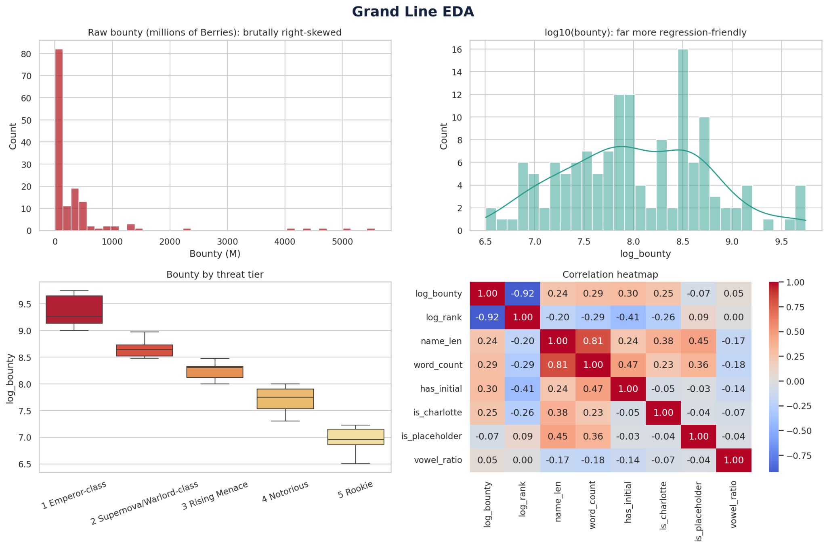
Figure 2. Model comparison
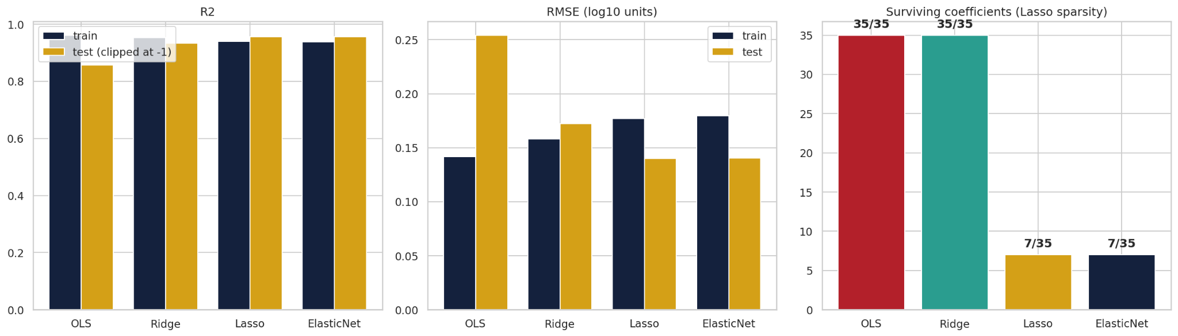
Figure 3. ElasticNet prediction and residual diagnostics
