SKILL 5: LOGISTIC REGRESSION CLASSIFICATION
Project: One Piece Bounty Classification

Aim
To explore the One Piece bounty dataset, engineer name-based features, and review a Logistic Regression model for classifying characters into standard- and high-bounty groups.

Apparatus / Software
- Python 3 with Jupyter Notebook or VS Code
- Pandas and NumPy for data handling
- Matplotlib for charts
- Scikit-learn for classification workflow
- Provided CSV data and saved model file

Procedure
- Load and inspect the bounty CSV, checking missing and non-numeric values.
- Prepare usable Berry bounty records and derive features from character names.
- Apply the documented threshold of 332,500,000 Berries to form the binary target.
- Review the StandardScaler and Logistic Regression model workflow and validation outputs.
- Compare the reported metrics and interpret the generated figures.

Observation
The supplied report describes 165 raw records and 144 usable Berry records. The high-bounty threshold is 332,500,000 Berries, with 108 standard-bounty and 36 high-bounty records in the report. The reported held-out accuracy is 0.7241 and ROC AUC is 0.6364. Because the high-bounty class is smaller, accuracy alone is not enough; precision, recall, F1, ROC AUC, and cross-validation should also be reviewed.

Results
Metric | Reported value
Accuracy | 0.7241
Precision | 0.4286
Recall | 0.4286
F1 score | 0.4286
ROC AUC | 0.6364
Average precision | 0.6082
Log loss | 0.5372

Conclusion
The project demonstrates a baseline classification workflow using engineered name features and Logistic Regression. The reported results indicate moderate predictive performance, so probability thresholds and class-sensitive metrics should be considered carefully. Correlations are exploratory rather than causal evidence.

Figures
Figure 1. Distribution of numeric bounty values.
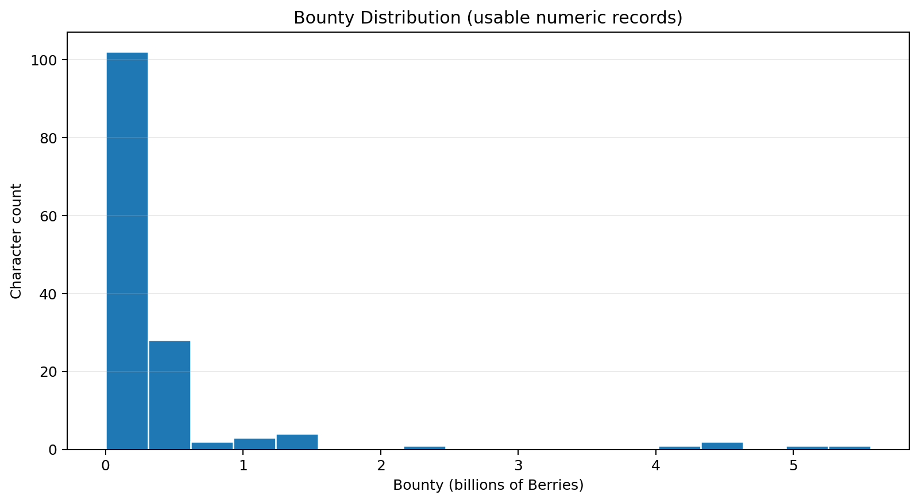
Figure 2. Class counts at the documented threshold.
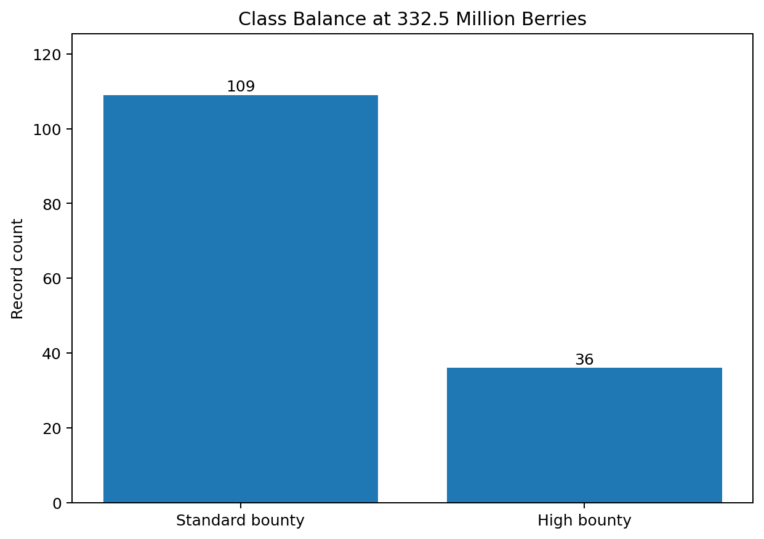
Figure 3. Exploratory feature correlations.
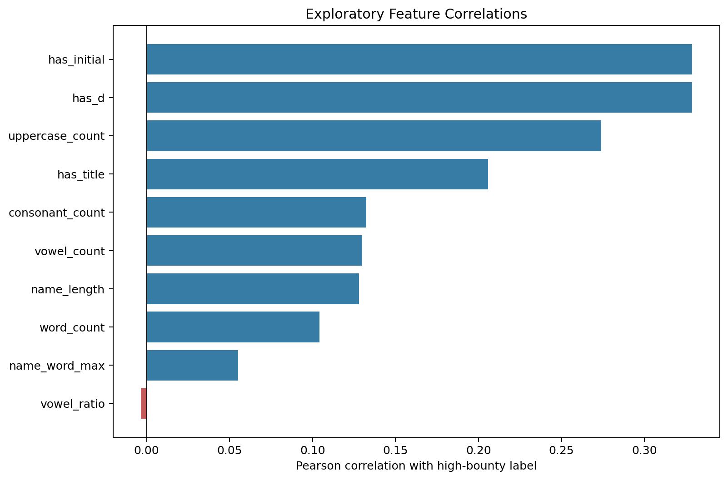
Figure 4. Classification metrics from the supplied report.
