

Assignment 1

User Interface Design



September 30, 2015

SAMEER SAPRA

6845382

Table of Contents

Desktop Metaphors 2

Design 2

Affordances 2

Map 2

Feedback 2

Metaphors 2

Force user actions 2

Automatic Learning 2

Context Detail 3

Usability 3

Effectiveness 3

Efficiency 3

Users 3

Consistency 3

Feedback 3

Navigation mechanisms 3

User Drive 3

Storyboard 4

Wireframe 5

Workbench 5

Progress Bar 6

Opening Google Chrome Metaphor 7

# Desktop Metaphors

In this application, there are 8 desktop metaphors used on windows 7 operating system. Below are the 8 desktop metaphors

1. Google Chrome
2. Unity3d
3. Safari
4. Visual Studio 2012
5. Notepad
6. Wamp server
7. Trash
8. Microsoft Word 2012
9. Progress Bar( Gauge )

# Design

This application has been designed somewhat like windows 7 to give the user windows 7 experience. It has a start button which will list all the executables installed on the computer. Apart from the list, 8 desktop metaphors also been added which can be started by clicking it.

## Affordances

For each running application, there will be 3 dialog buttons minimize, maximize and close. Minimize lets you minimize the screen keeping the application running. Maximize lets you increase the size of the window. Close lets you close the application.

## Map

Each application has different option to go for like cut, copy, run and properties etc. There are many options refer the storyboard.

## Feedback

Each application will provide some feedback to help user what going on with the application. For example, if mouse is hovered over the icon then it’s going to show the name of the application.

## Metaphors

There is a gauge metaphor whenever an application is opened. This is to let the user know the status of the application.

## Force user actions

This application is designed in way that no invalid user input is taken. It’s all the clicking of the mouse and performing the action.

## Automatic Learning

The user will always get the same interface no matter what conditions are.

## Context Detail

Each user will be given the feedback where the user is so that he is not lost while using the application.

# Usability

## Effectiveness

This application lets you run the application and perform the desired the functionality with it. For example google metaphor lets you open the google chrome window completing the task initiated by the user.

## Efficiency

Users won’t have to use extra effort in order to use this application because it has been designed from the end user perspective. The interface is pretty much similar to windows 7, so it won’t take any time to get used to the system.

## Users

This application can be easily used by the users who have used windows before, but it won’t also take much time if any non –windows user uses it.

## Consistency

Each application starts with a progress bar, giving user the feedback of the application. None of the application will start without giving any feedback like “can’t start the application” or “successfully started the application”.

## Feedback

Whenever user interacts with the system, feedback is provided to let the user know what he is doing and whether he is doing it correctly or not.

## Navigation mechanisms

User can anytime exit the application by clicking the cross dialog button.

## User Drive

There will be help guide for each functionality to help the user how to do the task.

# Storyboard

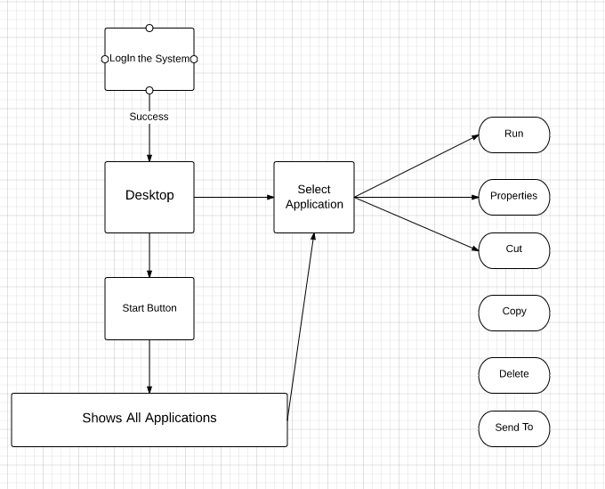

# Wireframe

## Workbench

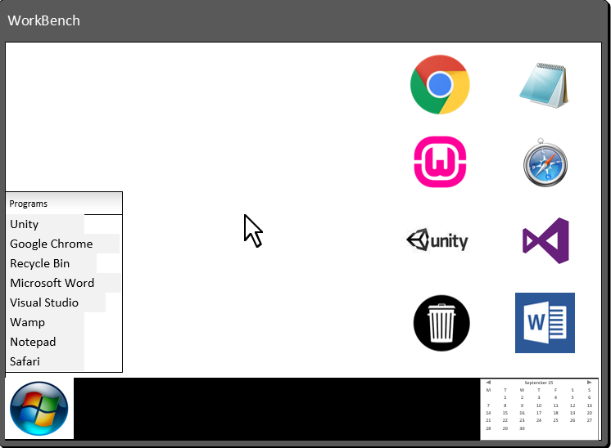

## Progress Bar

This progress bar is shown whether user tries to open an application.

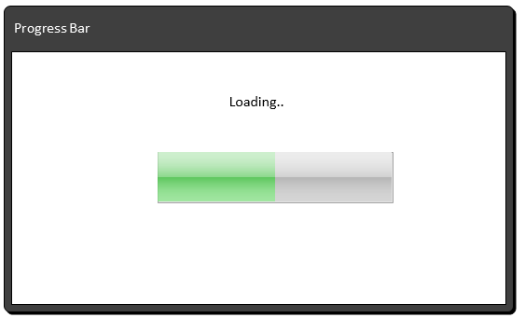

## Opening Google Chrome Metaphor

