MOBYMONEY
Production Architecture, Technical Specification & Developer Master Guide
Application Name | MobyMoney (Mobile Expense & Financial Intelligence)
Target Framework | Flutter 3.8+ / Dart 3.8+ (Cross-Platform iOS & Android)
State Management | Flutter Riverpod 3.3.2 (Declarative Notifier & AsyncValue)
Networking & Backend | Dio 5.11 + Render Cloud REST API (Cold-Start Resilient)
Delivery Version | v1.0.0+1 (Production Certified, 0 Lint/Analysis Errors)

1. Executive Summary & Project Purpose
MobyMoney is a high-performance, enterprise-grade mobile expense management and AI-powered financial intelligence application designed for Android and iOS. The app provides instant Google OAuth authentication, monthly budget tracking, essential versus discretionary spending categorization, interactive multi-style data visualizations (Donut/Pie, 7-Day Bar, Trajectory Line), seamless XLSX Excel financial exports, and conversational AI assistance for financial guidance.

2. High-Level System Architecture Diagram
The diagram below illustrates the exact architectural layers, reactive unidirectional data flow, Dio networking interceptors, hardware encryption secure storage, and cloud backend communication implemented in MobyMoney.
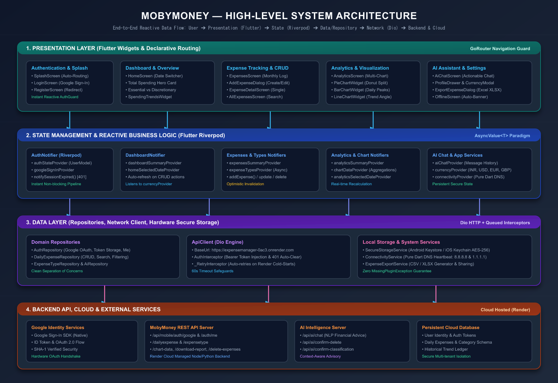

3. Core Architecture & Design Patterns
• Clean Feature-First Architecture: The codebase is divided into modular feature domains (authentication, dashboard, expenses, analytics, ai_chat, settings) with strict separation into presentation, domain, and data layers.
• Reactive State Management (Riverpod): All state is driven by Riverpod Notifier and AsyncValue<T> instances. UI widgets observe providers with ref.watch() and rebuild reactively when data mutations occur.
• Declarative Routing & Auth Guards (GoRouter): GoRouter with a ChangeNotifier refresh listenable protects private routes. When authStateProvider becomes null (e.g. on logout or 401 token expiry), navigation immediately redirects to /login.
• Pure Dart Zero-Crash Connectivity: Eliminates native platform channel MissingPluginException crashes by utilizing background DNS socket lookups (Google 8.8.8.8 and Cloudflare 1.1.1.1) with real-time offline modal interception.

4. Codebase Navigation & Folder Structure
Directory / Path | Responsibility & Key Files
lib/core/networking/ | ApiClient (Dio configuration), AuthInterceptor (Bearer token injection + 401 handler), ApiEndpoints constants
lib/core/storage/ | SecureStorageService (Hardware encrypted AES storage via FlutterSecureStorage)
lib/core/routing/ | AppRouter (GoRouter setup, route definitions, auth guard redirects)
lib/core/services/ | ConnectivityService (Pure Dart dual DNS internet checker)
lib/features/authentication/ | Google Sign-In integration, AuthRepository, AuthNotifier, LoginScreen
lib/features/dashboard/ | HomeScreen, DashboardNotifier, SpendingTrendsWidget, AddExpenseBottomSheet
lib/features/expenses/ | ExpensesScreen, AllExpensesScreen, DailyExpenseRepository, ExpenseTypeRepository
lib/features/analytics/ | AnalyticsScreen, PieChartWidget, BarChartWidget, LineChartWidget
lib/features/settings/ | ProfileDrawer, CurrencySelectorDialog, ExpenseExportService, ClearExpensesDialog

