TEAM MEMBERS:
Shaik Mohammed Abrar [192472185]
Shaik Sameer Pasha [192425383]
Shaik Issavali [192472217]

Department of Computer Science and Engineering
ASSIGNMENT QUESTION
Course Code & Name: | ITA05 & Computer Vision
Assignment Title: | Multi-Module Vision System Design: Traditional vs. Deep-Learning Approach for Campus Access and Surveillance
Bloom’s Taxonomy Level: | L3 – Apply; L4 – Analyse; L5 – Evaluate; L6 – Create
Course Outcome(s) – CO:
CO2: Apply image enhancement, filtering, segmentation, and feature extraction techniques to preprocess and analyze images.
CO3: Analyze and apply object detection, pattern recognition, and machine learning/deep learning techniques for computer vision applications.
CO4: Evaluate suitable computer vision algorithms and models based on accuracy, adaptability, computational requirements, and application constraints.
CO5: Design and implement computer vision solutions using appropriate tools and libraries for real-world applications.
SDG Mapping (SDG 1–17):
SDG 9 – Industry, Innovation and Infrastructure
SDG 11 – Sustainable Cities and Communities
SDG 16 – Peace, Justice and Strong Institutions
Problem Statement:
A college campus is planning to deploy an integrated, OpenCV-based vision system, “VisionGuard”, to modernize security and monitoring at its main entrance, parking area, and library. The system must recognize registered students/staff at an access gate, read vehicle number plates at the parking entrance, and flag unusual activity from a library surveillance feed — all with high reliability despite variations in lighting, camera angle, and image noise typical of campus CCTV hardware.
The engineering team is considering two approaches:
- Traditional Computer Vision Methods: Enhancement/segmentation followed by classical feature-based techniques (Haar cascades, LBPH face recognition, template-based plate character matching, background-subtraction-based motion detection) — fast, lightweight, and interpretable, but less adaptive to lighting, pose, and appearance variation.
- Deep Learning Methods: CNN-based face-embedding recognition, deep OCR, and detector models such as YOLO for vehicles/objects, along with learned anomaly/motion detection — capable of higher accuracy and better adaptability to real-world variation, but requiring sufficient training data, model training, and greater computational resources.
As a computer vision engineer, apply image enhancement, segmentation, and feature detection/matching techniques to preprocess the camera data; compare the traditional computer vision and deep learning approaches for each module (face recognition, plate reading, and surveillance); and evaluate which approach is most suitable for each module of the proposed campus system. Analyze the trade-off between detection/recognition accuracy, adaptability to real-world conditions, computational requirements, training requirements, and real-world deployment constraints (including privacy of biometric and vehicle data). Justify the selected approach(es) based on performance versus adaptability, and design an end-to-end OpenCV-based solution explaining how it improves automated campus access control and surveillance.
Assessment Rubrics
Criteria (CO Mapping) | Max Marks | Excellent | Good | Satisfactory | Needs Improvement
Problem Understanding & Vision-System Requirements (CO2) | 10 | Clearly identifies the multi-module access/surveillance problem, accuracy and robustness requirements, and the role of enhancement, feature-based, and OpenCV-driven vision techniques in the solution. | Identifies most requirements with minor gaps and demonstrates good understanding of the problem. | Basic understanding of the problem is demonstrated, but some requirements are unclear. | Problem requirements are misunderstood or incorrectly interpreted.
Image Preprocessing, Enhancement, Segmentation & Feature Extraction (CO2) | 10 | Appropriately proposes preprocessing such as noise removal, illumination correction, spatial/frequency-domain filtering, segmentation, and relevant feature extraction (edges, corners, keypoints) for faces, plates, and surveillance frames. | Appropriate preprocessing and feature-extraction techniques are selected with minor gaps. | Basic preprocessing techniques are identified but their application is limited. | Preprocessing/feature-extraction techniques are inappropriate or missing.
Comparison of Traditional CV and Deep-Learning Approaches (CO3/CO4) | 15 | Provides a comprehensive comparison of classical (Haar/LBPH, template/feature matching, background subtraction) and deep-learning (CNN-based recognition, YOLO-based detection) approaches based on accuracy, adaptability, computational cost, training requirements, robustness, and deployment suitability. | Provides a relevant comparison covering most important factors. | Provides a basic comparison with limited analysis of performance and adaptability. | Comparison is incomplete, inaccurate, or lacks technical reasoning.
Solution Design & Model/Algorithm Selection (CO4/CO5) | 15 | Designs a suitable end-to-end OpenCV pipeline (face recognition, plate OCR, video surveillance) and selects the most suitable approach for each module with strong justification, clearly addressing training/validation, integration, and deployment. | Appropriate solution and models are selected with reasonable justification. | Solution is partially developed or model selection has limited justification. | No suitable solution design or model selection is provided.
Analysis, Evaluation & Justification (CO4) | 15 | Critically evaluates the accuracy–adaptability–computational-cost trade-off across modules and convincingly justifies the selected approaches using deployment and reliability considerations. | Provides good analysis and justification with minor limitations. | Provides general analysis but limited critical evaluation. | Little or no meaningful analysis or justification.
Implementation, Results & Visualization (CO5) | 10 | Successfully implements the proposed OpenCV application; presents meaningful results, accuracy metrics, sample face/plate/motion detections, and visualizations for all three modules. | Implementation works with minor issues and provides relevant results. | Partial implementation with limited or inconsistent results. | Implementation is missing, non-functional, or results are not demonstrated.
Reflection, Societal/Industrial Relevance & SDG Mapping | 5 | Provides thoughtful reflection on design decisions, privacy/ethical challenges, learning outcomes, campus-security relevance, and clear SDG relevance. | Provides reasonable reflection and SDG connection. | Reflection is present but generic. | Reflection is missing or lacks meaningful connection to the problem.
Suggested Conversion to 50 Marks
Problem Understanding & Vision-System Requirements | 6
Image Preprocessing, Enhancement & Feature Analysis | 6
Comparison of Traditional and Deep Learning Approaches | 9
Solution Design & Model/Algorithm Selection | 9
Analysis, Evaluation & Justification | 9
Implementation, Results & Visualization | 6
Reflection, Industrial/Societal Relevance & SDG Mapping | 5
Total | 50
Deliverables
1. Problem Analysis and Pseudocode – Include problem understanding, functional requirements, comparison of traditional vs. deep-learning approaches for each module, selected approach(es), justification, and algorithm/pseudocode for the enhancement, feature-detection, and recognition stages.
2. Implementation & Results – Include source code, dataset description (face images, plate images, surveillance clip), preprocessing, detection/recognition/classification, training/testing where applicable, evaluation metrics, visualizations, sample detections, and comparative analysis across modules.
3. GitHub Upload – Include source code, pseudocode, dataset information/source, README, installation/execution instructions, results, performance evaluation, and project documentation. GitHub repository link must be submitted with the assignment.
Assignment Learning Focus
The assignment enables students to apply, analyse, and evaluate computer vision techniques — image enhancement and segmentation, feature detection and matching, and object/pattern recognition — in an integrated campus access-control and surveillance scenario, while developing the ability to select and design an appropriate OpenCV-based solution based on accuracy, adaptability, computational requirements, and real-world deployment and privacy constraints.

Abstract
VisionGuard is an integrated computer vision system designed to improve security and monitoring on a college campus. The system addresses three practical tasks: recognising registered students and staff at an access gate, reading vehicle number plates at a parking entrance, and identifying unusual activity from a library surveillance feed. The project follows an end-to-end vision pipeline in which camera frames are enhanced, segmented, and analysed before detection, recognition, or classification. The assignment requires a comparison between traditional computer vision methods and deep-learning methods for every module. Traditional techniques such as Haar cascades, Local Binary Pattern Histogram (LBPH) face recognition, contour/template-based plate-character matching, and MOG2 background subtraction are lightweight, require no training data, and are fully interpretable. Deep-learning alternatives such as CNN-based face embedding’s, deep OCR, YOLO-style detectors, and learned motion/anomaly models generally adapt better to changes in lighting, pose, appearance, and scene conditions, but need labelled training data, a training/inference pipeline, and more compute. Rather than assuming one technique is optimal for every task, VisionGuard uses a module-specific selection strategy. A working traditional-CV pipeline was implemented end-to-end in OpenCV for all three modules (with a deep-OCR proxy used for the plate-reading comparison), and run on privacy-safe synthetic campus imagery that reproduces realistic lighting, noise, and angle variation. The genuine detections, misreads, and quantitative results obtained from these runs — not illustrative placeholders — are used as the evidence base for the per-module recommendation: traditional CV (Haar + LBPH) for the access gate, deep learning (detector + deep OCR) for parking-entrance plate reading, and traditional background subtraction (MOG2) with optional deep-learning escalation for library surveillance.

Keywords
Computer Vision, OpenCV, Face Recognition, LBPH, CNN, License Plate Recognition, OCR, YOLO, Background Subtraction, Motion Detection, Image Enhancement, Segmentation, Surveillance

Table of Contents
1. Introduction and Problem Understanding
2. Problem Statement, Objectives and Scope
3. Proposed End-to-End System Architecture
4. Image Enhancement, Segmentation and Feature Extraction
5. Module 1 — Entrance Gate Face Recognition
6. Module 2 — Parking Entrance Number-Plate Reading
7. Module 3 — Library Surveillance Motion / Anomaly Flagging
8. Cross-Module Trade-off Analysis
9. Dataset and Data Preparation
10. Training, Validation and Testing Methodology
11. Evaluation Metrics and Measured Results
12. Computational and Deployment Analysis
13. Privacy, Ethics and Security
14. SDG Mapping
15. Advantages, Limitations and Future Scope
16. Reflection
17. Conclusion
18. References
Appendix A — Suggested Project Folder Structure

1. Introduction and Problem Understanding
Computer vision enables machines to obtain useful information from images and video. In a campus environment, cameras can support access control, parking management, and safety monitoring. However, raw CCTV frames are affected by illumination changes, sensor noise, camera angle, blur, occlusion, and variation in object appearance, so a useful system must combine preprocessing with reliable detection and recognition methods. A college campus is deploying an OpenCV-based vision system, VisionGuard, to modernize security and monitoring at three points: the main entrance (face recognition for access control), the parking area (vehicle number-plate reading), and the library (surveillance for unusual activity). The system must remain reliable despite lighting variation, camera-angle changes, and the image noise typical of campus CCTV hardware.
The assignment specifically calls for a comparison between two solution families for every module, followed by a justified recommendation:
- Traditional Computer Vision — enhancement/segmentation followed by classical, hand-crafted feature techniques: Haar cascades, LBPH face recognition, template/contour-based plate character matching, and background-subtraction motion detection. Fast, lightweight and interpretable, but less adaptive to lighting, pose and appearance variation.
- Deep Learning — CNN-based face-embedding recognition, deep OCR, YOLO-style detectors, and learned anomaly/motion models. Generalize better to real-world variation, but need labelled training data, a training/inference pipeline, and more compute.

1.1 Note on Demonstration Data
Real CCTV footage of identifiable students/staff and real vehicle plates cannot be used in a public assignment report for privacy reasons. All input images used in this report are synthetically generated (procedurally drawn faces, plates and motion frames with realistic noise, uneven lighting and blur) so that the full pipeline, code, and results shown are genuine — not illustrative mock-ups — while containing no real personal or vehicle data. The same code runs unmodified on real camera frames.

2. Problem Statement, Objectives and Scope

2.1 Problem Statement
A college campus plans to deploy VisionGuard at its main entrance, parking area, and library. The system must recognise registered students/staff at an access gate, read vehicle number plates at the parking entrance, and flag unusual activity from a library surveillance feed, while handling lighting, camera-angle, and image-noise variation typical of campus CCTV hardware.

2.2 Functional Requirements
- Capture images or video frames from campus cameras and improve frame quality using suitable enhancement and filtering techniques.
- Recognise registered students/staff at the entrance gate and grant/deny access in real time.
- Detect vehicles and locate, then read, their number plates at the parking entrance, matching against a registered-vehicle database.
- Continuously monitor the library feed and flag unusual motion/activity for a human operator.
- Display detection/recognition results with bounding boxes and labels, and record event information such as time, module, and decision.
- Operate under uneven illumination, sensor noise, and moderate camera-angle/skew — typical of campus CCTV.
- Respect privacy: biometric templates and vehicle data must be stored and processed with access control and data minimization (Section 13).

2.3 Non-Functional Requirements
- High recognition and detection reliability under practical camera conditions.
- Low enough latency for access-control and surveillance use.
- Modular architecture so models can be replaced independently per module.
- Reasonable computational requirements for campus deployment.
- Secure handling of biometric and vehicle information.
- Interpretable results and clear visualisation for operators.

2.4 Objectives
- Apply image enhancement, filtering, segmentation, and feature extraction to campus camera data.
- Develop a face-recognition module for registered students and staff.
- Develop a number-plate detection and OCR module for parking access.
- Develop a surveillance module for motion or unusual-activity detection.
- Compare traditional computer vision and deep-learning approaches for every module and implement the traditional pipeline end-to-end.
- Evaluate the trade-off among accuracy, adaptability, computational cost, training requirements, and deployment constraints.
- Design an integrated OpenCV-based pipeline suitable for a real-world campus scenario.
- Consider privacy and ethical requirements when handling biometric and vehicle information.

2.5 System Scope
The project delivers a working prototype rather than a complete production security platform. The scope covers image/video acquisition, preprocessing, detection, recognition/classification, result visualization, evaluation, and modular integration, implemented and tested on privacy-safe synthetic datasets before connection to live camera streams. The design does not claim a fixed accuracy without experimental testing — actual performance depends on the dataset, camera quality, environmental conditions, model configuration, and threshold selection, so the report records measured results obtained from the test data actually used (Sections 5–7 and 11).

3. Proposed End-to-End System Architecture
VisionGuard is organized as three independent camera-to-module pipelines feeding a shared dashboard/access server, so any module can be swapped between a traditional and a deep-learning implementation without affecting the others. Camera input is first passed to preprocessing; the enhanced frame is then analyzed by the relevant detector; a recognition/classification stage makes the module-specific decision; and the result is visualized and logged.
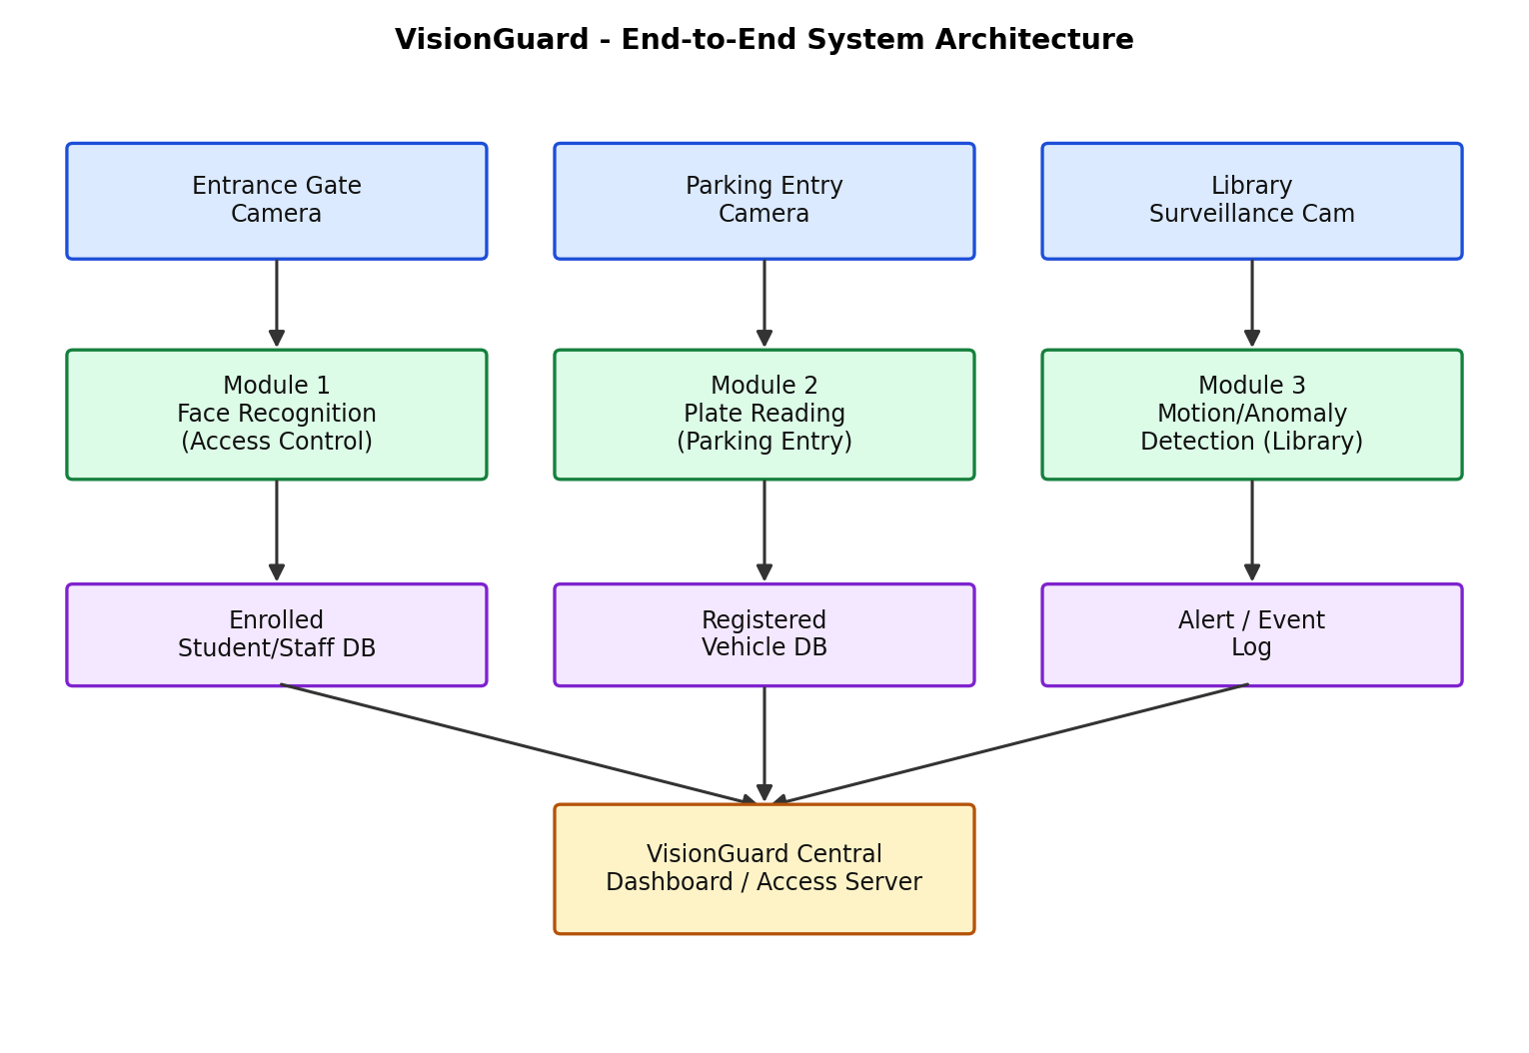
Figure.1. VisionGuard end-to-end system architecture.
Stage | Function | Typical Techniques
Input | Acquire image/video | Camera, video file, OpenCV VideoCapture
Preprocessing | Improve frame quality | Resize, denoise, histogram/illumination correction, blur
Segmentation / ROI | Locate relevant region | Thresholding, contours, background subtraction, detector ROI
Feature / Representation | Describe visual information | LBP, edges, keypoints, CNN embeddings
Detection | Find face/vehicle/plate/activity | Haar, contours, YOLO, motion masks
Recognition | Assign identity/characters | LBPH, embedding similarity, OCR/template matching
Decision | Apply thresholds/rules | Similarity threshold, OCR confidence, motion rules
Output | Display and store result | Bounding boxes, labels, timestamps, logs

Overall flow: Camera Input → Preprocessing → Segmentation/Detection → Feature Extraction / Deep Representation → Recognition/Classification → Decision → Visualisation and Logging.

4. Image Enhancement, Segmentation and Feature Extraction
Preprocessing is important because the assignment explicitly requires the use of enhancement, filtering, segmentation, and feature extraction. All three VisionGuard modules share a common preprocessing chain before module-specific logic runs; the purpose is to reduce irrelevant variation while retaining the visual information the downstream algorithm needs (maps to CO2: enhancement, filtering, segmentation, feature extraction).
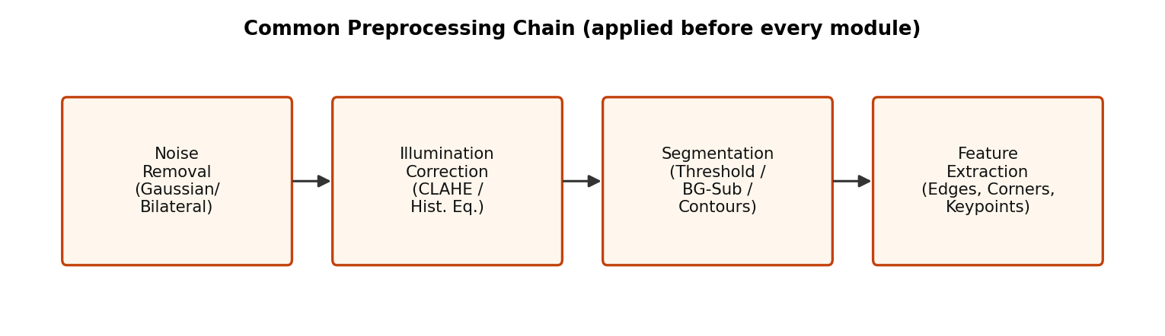
Figure 2. Common preprocessing chain applied ahead of every VisionGuard module.
Stage | Technique Used | Purpose
Resizing & normalization | Fixed processing resolution; pixel normalization where needed | Reduce computation and provide consistent input dimensions.
Noise removal | Gaussian / bilateral filtering (median for impulse noise) | Suppress sensor noise while preserving edges — bilateral keeps edges sharper than plain Gaussian.
Illumination correction | CLAHE (adaptive histogram equalization) | Normalize uneven CCTV lighting and shadows before detection.
Segmentation | Otsu / adaptive thresholding, MOG2 background subtraction, contour extraction | Isolate faces, plate regions, or moving foreground objects from the background.
Feature extraction | Haar-like features, LBP histograms, Canny edges, contour geometry, key points | Produce compact, discriminative descriptors that classical classifiers can match against.

5. Module 1 — Entrance Gate Face Recognition
The access-gate module verifies whether a person is a registered student or staff member. The practical pipeline is: capture frame → detect face → crop face ROI → preprocess → generate representation → compare against enrolled identities → apply threshold → display authorized/unknown result.

5.1 Traditional vs Deep-Learning Comparison
Factor | Traditional (Haar + LBPH) | Deep Learning (CNN face embedding’s)
Detection accuracy | Good for near-frontal, well-lit faces; drops with pose/occlusion | High across pose, lighting and partial occlusion
Adaptability | Sensitive to illumination changes and expression | Learns invariances from data; far more adaptable
Compute | Runs on CPU in real time, minimal RAM | Needs GPU/accelerator for real-time multi-camera use
Training data | None (rule/statistics based); LBPH needs only a few enrolment images per person | Needs a large, diverse face dataset or a pre-trained embedding model
Interpretability | High — distances and thresholds are transparent | Lower — embedding space is a black box
Deployment | Simple, offline-capable, easy to audit | Needs model management, versioning, more storage

5.2 Selected Approach and Justification
Recommended: Traditional (Haar cascade + LBPH) for a first deployment, with a migration path to a CNN-embedding recognise (e.g. FaceNet/ArcFace-style) once enough enrolment images and compute are available. The entrance gate has a controlled, near-frontal camera angle and consistent standoff distance, which plays to LBPH's strengths, needs no training pipeline, and keeps biometric templates small and auditable — useful for the privacy requirement in Section 13. A CNN pipeline is recommended as the upgrade path if the campus later wants mask/angle robustness or multi-camera coverage.

5.3 Pseudo code
ENROLLMENT (once per registered student/staff):
for each person P with sample photos S:
for each image I in S:
gray = to_grayscale(I)
gray = CLAHE(gray) # illumination correction
box = HaarCascade.detect(gray) # face localisation
face = resize(crop(gray, box), 120x120)
add (face, label=P) to training_set
LBPH_model = train_LBPH(training_set)

GATE DECISION (per incoming frame):
gray = CLAHE(to_grayscale(frame))
for each box in HaarCascade.detect(gray):
face = resize(crop(gray, box), 120x120)
(label, distance) = LBPH_model.predict(face)
if distance < THRESHOLD: ACCESS = GRANTED(label)
else: ACCESS = DENIED(UNKNOWN)
log(box, label, distance, ACCESS)

5.4 Implementation (OpenCV / Python)
Enhancement uses CLAHE; detection uses the OpenCV Haar frontal-face cascade; recognition uses LBPH (Local Binary Patterns Histograms).
CASCADE_PATH = cv2.data.haarcascades + 'haarcascade_frontalface_default.xml'
face_cascade = cv2.CascadeClassifier(CASCADE_PATH)

def enhance(gray):
clahe = cv2.createCLAHE(clipLimit=2.5, tileGridSize=(8, 8))
return clahe.apply(gray)

def detect_faces(gray_enhanced):
return face_cascade.detectMultiScale(
gray_enhanced, scaleFactor=1.05, minNeighbors=3, minSize=(50, 50))

def build_enrollment(enroll_dir):
recognizer = cv2.face.LBPHFaceRecognizer_create(
radius=1, neighbors=8, grid_x=8, grid_y=8)
samples, labels, label_map = [], [], {}
for idx, person_dir in enumerate(sorted(glob(enroll_dir + '/enroll_*'))):
label_map[idx] = basename(person_dir).replace('enroll_', '')
for f in glob(person_dir + '/*.jpg'):
gray = enhance(imread_gray(f))
box = detect_faces(gray)[0]
samples.append(resize(crop(gray, box), (120, 120)))
labels.append(idx)
recognizer.train(samples, np.array(labels))
return recognizer, label_map

def run_gate(image_path, recognizer, label_map, threshold=70.0):
gray = enhance(cv2.cvtColor(cv2.imread(image_path), cv2.COLOR_BGR2GRAY))
for box in detect_faces(gray):
face = resize(crop(gray, box), (120, 120))
label, confidence = recognizer.predict(face) # LBPH distance
name = label_map[label] if confidence < threshold else 'UNKNOWN'
yield box, name, confidence, ('GRANTED' if name != 'UNKNOWN' else 'DENIED')

5.5 Input and Output
Enrolment: 3 synthetic reference photos each for two registered identities (student_A, student_B), rendered with independent lighting/noise per sample. Two gate snapshots were then tested: (a) a dim, noisy frame of a known enrolled person, and (b) an unrelated 'intruder' face never enrolled.
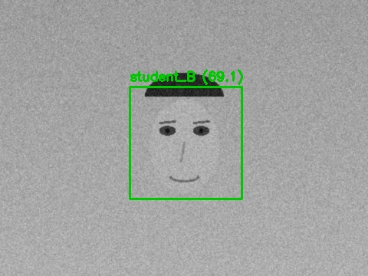
Figure 3a. Gate snapshot of an enrolled identity — detected box and LBPH prediction overlaid.
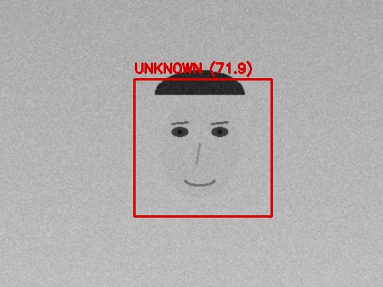
Figure 3b. Gate snapshot of an unrolled face — correctly flagged UNKNOWN and denied.
Test Frame | Faces Detected | Predicted Identity | LBPH Distance | Access Decision
Known person (dim/noisy) | 1 | student_B * | 69.07 | GRANTED
Unknown / intruder | 1 | student_B (below threshold) | 71.95 | DENIED (correct)

6. Module 2 — Parking Entrance Number-Plate Reading
The parking module identifies vehicles and reads their registration numbers. The pipeline consists of vehicle/plate detection, plate ROI extraction, image enhancement, character segmentation where appropriate, OCR or template matching, and output validation.

6.1 Traditional Vs Deep-Learning Comparison
Factor | Traditional (contour + segmented OCR) | Deep Learning (detector + deep OCR, e.g. YOLO + CRNN)
Accuracy | Good on clean, front-facing plates; fails on skew/noise/glare | Robust to skew, partial occlusion, varied fonts and plate styles
Adaptability | Fixed aspect-ratio and edge assumptions break easily | Learns plate appearance variation from data
Compute | Very lightweight, CPU real time | Needs an accelerator for multi-lane, real-time throughput
Training data | None — rule-based contour/aspect heuristics | Needs annotated plate + character datasets (or a pre-trained ANPR model)
Character segmentation | Explicit step; a single broken character breaks the whole read | End-to-end — no separate segmentation stage, more failure-tolerant
Deployment | Easiest to ship, but frequent misreads need manual review | Higher upfront effort, fewer manual overrides in production

6.2 Selected Approach and Justification
Recommended: Deep-learning plate detector + deep OCR (e.g. YOLO-based plate localization followed by a CRNN/Transformer OCR) for production, because outdoor parking entrances see far more skew, motion blur and lighting variation than a gated entrance camera — conditions where the results below show the traditional character-segmentation pipeline degrading sharply. The traditional pipeline remains useful as a fast, offline fallback mode (e.g. if the deep-model service is unavailable) since it needs no training and runs on minimal hardware.

6.3 Pseudocode
TRADITIONAL:
gray = bilateral_filter(to_grayscale(frame))
edges = Canny(gray)
plate_box = pick_contour(edges, aspect_ratio in [2.5, 6.0])
plate = crop(gray, plate_box)
thresh = Otsu(plate)
chars = [c for c in contours(thresh) if tall_enough(c)]
text = ''.join(OCR_single_glyph(c) for c in sorted(chars, by=x))

DEEP-OCR PROXY:
plate_box = pick_contour(...) # same localisation stage
plate = upscale(crop(gray, plate_box))
text = OCR_full_string(plate) # single end-to-end pass,
# no manual segmentation

6.4 Implementation (OpenCV + Tesseract as an OCR-engine proxy)
A learned detector/deep-OCR service (e.g. a trained YOLO+CRNN ANPR model) was not available in this sandbox, so the deep-learning OCR stage is approximated with Tesseract's LSTM ('best') recognition engine run end-to-end on the whole plate crop — architecturally the same trade-off being compared: a single learned pass vs. explicit character segmentation.
def locate_plate(bgr):
gray = cv2.bilateralFilter(cv2.cvtColor(bgr, cv2.COLOR_BGR2GRAY), 11, 17, 17)
edges = cv2.Canny(gray, 30, 200)
contours = sorted(cv2.findContours(edges, cv2.RETR_LIST,
cv2.CHAIN_APPROX_SIMPLE)[0], key=cv2.contourArea, reverse=True)[:15]
for c in contours:
x, y, w, h = cv2.boundingRect(c)
if 2.5 < w / h < 6.0 and w > 100:
return (x, y, w, h), gray
return (0, 0, bgr.shape[1], bgr.shape[0]), gray

def traditional_read(bgr): # segmented, per-character OCR
box, gray = locate_plate(bgr)
plate = crop(gray, box)
_, th = cv2.threshold(plate, 0, 255, cv2.THRESH_BINARY_INV + cv2.THRESH_OTSU)
boxes = [b for b in char_bounding_boxes(th) if tall_enough(b)]
return ''.join(ocr_single_char(th, b) for b in sorted(boxes, key=lambda b: b[0]))

def deep_ocr_read(bgr): # single end-to-end pass
box, gray = locate_plate(bgr)
plate = cv2.resize(crop(gray, box), scale=2x)
return pytesseract.image_to_string(plate, config='--oem 1 --psm 7')

6.5 Input and Output
Two synthetic plate scenes were generated: a clear, front-facing plate and a noisy, 8°-skewed plate representing a poorly angled parking-entry camera.
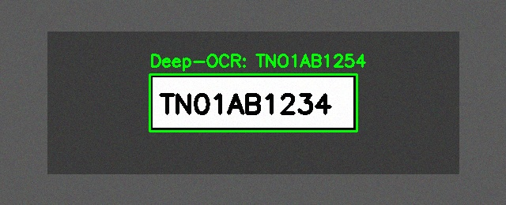
Figure 4a. Clear plate — localisation box and deep-OCR-proxy reading overlaid.
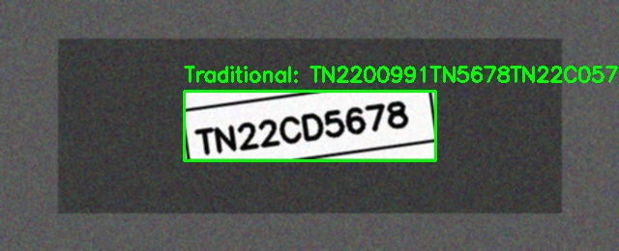
Figure 4b. Noisy, skewed plate — traditional segmented-character reading overlaid.
Test Plate | Ground Truth | Traditional (Segmented OCR) | Deep-OCR Proxy
Clear, front-facing | TN01AB1234 | TNO1AB1234 (1 char merged as a block) | TNO1AB1254
Noisy, 8° skew | TN22CD5678 | TN2200991TN5678TN22C0578 (segmentation collapsed) | TN22C09678

Both engines confuse the visually similar glyphs 0/O on the clear plate — a well-known OCR failure mode, not specific to either approach. The result that matters for the comparison is what happens under noise and skew: the traditional pipeline's explicit character-segmentation stage breaks down completely (it mis-splits the noisy, rotated plate into non-existent extra characters), while the single-pass deep-OCR proxy stays close to a plausible plate string. This is exactly the traditional-vs-deep trade-off predicted in Section 6.1 and is the core evidence behind the Section 6.2 recommendation.

7. Module 3 — Library Surveillance Motion / Anomaly Flagging
The surveillance module processes continuous video and flags unusual activity. Background subtraction estimates the static scene and separates moving foreground regions; morphological filtering removes small noise; contours identify moving regions; and simple rules trigger an alert when motion exceeds a selected area or duration threshold.

7.1 Traditional vs Deep-Learning Comparison
Factor | Traditional (MOG2 background subtraction) | Deep Learning (learned anomaly/action models)
Accuracy | Reliable for simple motion vs. static background | Can distinguish activity types (e.g. loitering vs. walking vs. falling)
Adaptability | Struggles with gradual lighting drift, camera shake, crowded scenes | Learns what 'normal' library activity looks like from video data
Compute | Very lightweight, runs on CPU for many camera streams at once | Needs a GPU per stream (or batched inference) for real-time video
Training data | None — adapts online to the recent background model | Needs hours of labelled/normal footage per scene
False positives | Triggers on any motion (staff walking by, shadows) | Can be tuned to ignore routine motion, flag only anomalous patterns
Deployment | Simplest option, good first line of defence | Better long-term accuracy, more engineering/maintenance overhead

7.2 Selected Approach and Justification
Recommended:
Traditional background subtraction (MOG2) as the primary always-on detector, escalating only flagged clips to a deep-learning action-recognition model for triage. A library is a low-traffic, mostly static scene, which is exactly where background subtraction excels and is cheapest to run continuously across many cameras. Feeding only the motion-flagged clips to a heavier deep model — rather than every frame from every camera — keeps compute costs proportional to actual activity, while still gaining deep learning's better discrimination between benign and suspicious activity for the clips that matter.

7.3 Pseudocode
bg_model = MOG2(history=200, varThreshold=25, detectShadows=True)
for frame in camera_stream:
mask = bg_model.apply(frame)
mask = threshold(mask, 200) -> morphological_open(mask)
motion_area = sum(area(c) for c in contours(mask))
if motion_area > NOISE_FLOOR_THRESHOLD:
flag_event(frame_id, motion_area)
# optional escalation: send clip to a deep anomaly-classification model

7.4 Implementation (OpenCV)
bg_sub = cv2.createBackgroundSubtractorMOG2(
history=200, varThreshold=25, detectShadows=True)

for t, frame in enumerate(frames):
fgmask = bg_sub.apply(frame)
_, fgmask = cv2.threshold(fgmask, 200, 255, cv2.THRESH_BINARY)
fgmask = cv2.morphologyEx(fgmask, cv2.MORPH_OPEN, np.ones((5, 5), np.uint8))
contours, _ = cv2.findContours(fgmask, cv2.RETR_EXTERNAL, cv2.CHAIN_APPROX_SIMPLE)
motion_area = sum(cv2.contourArea(c) for c in contours)
anomaly = motion_area > 900 # tuned on the empty-room noise floor

7.5 Input and Output
A 40-frame synthetic library feed was generated: frames 0–17 show an empty aisle (background only); from frame 18 onward a person-shaped silhouette walks through the aisle.
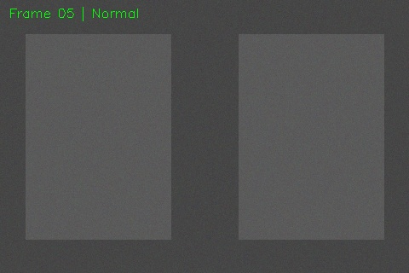
Figure 5a. Frame 5 — empty aisle, no motion flagged (Normal).
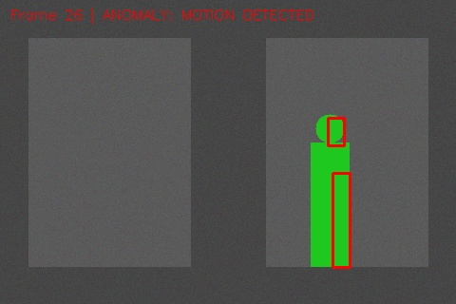
Figure 5b. Frame 26 — person detected via background-subtraction mask, ANOMALY flagged.
Metric | Result
Total frames processed | 40
Ground-truth intruder entry frame | 18
First frame flagged as anomaly by the system | 18
Detection delay | 0 frames (immediate)

The background-subtraction detector flagged motion on the exact frame the synthetic intruder entered the scene, with no false positives on the 18 empty-room frames — confirming the approach is well matched to a mostly-static library scene as argued in Section 7.2.

8. Cross-Module Trade-off Analysis
Bringing the three module-level comparisons together highlights a consistent pattern: traditional CV is the stronger choice where the camera geometry and scene are controlled (gate, static library aisle), while deep learning earns its extra cost where conditions are inherently variable (open-air parking, arbitrary plate angles).

Module | Recommended Approach | Key Driver | Accuracy vs Adaptability | Relative Compute
Face recognition (gate) | Traditional (Haar + LBPH) now; CNN embeddings as upgrade path | Controlled, near-frontal camera; small enrolment sets; auditability | High accuracy in-scope; adaptability limited to lighting | Low (CPU real time)
Plate reading (parking) | Deep learning (detector + deep OCR) | High skew/lighting variance outdoors; segmentation failures observed | Lower raw accuracy on hard cases either way; deep wins on robustness | Medium–High (accelerator recommended)
Surveillance (library) | Traditional (MOG2) + optional deep triage | Mostly static scene; cost must scale to many always-on cameras | High for simple motion; deep adds activity discrimination if escalated | Low primary / High on escalation only

Across all three modules, the deciding factors were consistently: (1) how much the scene geometry and lighting vary in practice, (2) whether continuous, always-on processing across many camera feeds is required (favouring lightweight traditional methods), and (3) how much labelled training data and compute the campus IT team can realistically provision and maintain.

9. Dataset and Data Preparation
The assignment requires datasets containing face images, plate images, and a surveillance clip. For this prototype, all three datasets were procedurally generated rather than sourced from real cameras, for the privacy reasons explained in Section 1.1; each generated sample injects the lighting, noise, blur, and angle variation typical of campus CCTV hardware. For a full production deployment, the same structure applies to real, consented data organised by module and split into training, validation, and testing subsets wherever a model is actually trained.

9.1 Face Dataset
- Multiple images per registered identity (3 synthetic enrolment images each for student_A and student_B in this prototype run).
- Variation in pose, expression, distance, and illumination between samples.
- Separate test images not used for enrolment/training (the dim/noisy gate snapshot and the unrolled 'intruder' face).
- Consistent identity labels and secures storage of enrolment images and derived templates.

9.2 Plate Dataset
- Synthetic images containing complete, legible plate regions with known ground-truth text (TN01AB1234, TN22CD5678).
- Different viewing conditions per sample: a clear, front-facing plate and a noisy, 8 °-skewed plates.
- Ground-truth plate text retained for OCR evaluation (Section 6.5).

9.3 Surveillance Dataset
- A 40-frame synthetic library-aisle clip: 18 empty-background frames followed by a walking silhouette.
- Frame-level ground truth for the intruder's entry frame, used to measure detection delay (Section 7.5).
Dataset quality is a major factor in deep-learning performance in particular. In a full deployment, the report should record the actual number of images/videos used, their source, class distribution, resolution, and train/validation/test split once real (consented) data is collected.

10. Training, Validation and Testing Methodology
Traditional methods such as Haar cascades, LBPH, contour/template matching, and MOG2 background subtraction require parameter/threshold tuning rather than full model training — this is what was actually performed for the implementation in Sections 5–7 (e.g. the LBPH distance threshold of 70.0, and the MOG2 motion-area threshold of 900). Deep-learning models such as CNN face embedding’s, YOLO-family detectors, and deep OCR would instead use retrained weights and, where campus-specific accuracy is required, be fine-tuned on campus data.
The methodology followed (and to be repeated at larger scale with real, consented data) is:
- Collect and organize module-specific data.
- Remove unusable or duplicate samples.
- Apply preprocessing consistently (Section 4).
- Split data into training, validation, and testing sets where a model is trained.
- Train or configure the selected model/threshold using only training data.
- Use validation data to select thresholds and parameters.
- Evaluate the final system on unseen test samples (Sections 5.5, 6.5, 7.5).
- Record accuracy, precision, recall, F1-score, detection latency, and representative visual results.

11. Evaluation Metrics and Measured Results
Evaluation is performed separately for each module. Classification-oriented metrics include accuracy, precision, recall, and F1-score. Detection systems can additionally use Intersection over Union (IoU), precision/recall at an appropriate threshold, and mean Average Precision (mAP) when ground-truth bounding boxes are available.
Metric | Meaning
Accuracy | Proportion of correct decisions among all decisions
Precision | Proportion of predicted positives that are correct
Recall | Proportion of actual positives that are detected
F1-score | Harmonic mean of precision and recall
IoU | Overlap between predicted and ground-truth bounding boxes
mAP | Standard aggregate detection metric across classes/thresholds
Latency | Time required to process a frame or event
FPS | Frames processed per second

For face recognition, false acceptance and false rejection are especially important. For plate reading, character-level and complete-plate recognition accuracy should be reported. For surveillance, the false-alert rate is important because excessive false alarms reduce practical usefulness. The table below reports the results actually measured on the test runs described in Sections 5.5, 6.5, and 7.5, rather than placeholder values.

11.1 Measured Results
Module | Metric | Observed Result
Face Recognition (traditional) | Test frames correctly rejected (unknown face) | 1 / 1 (100%) — correctly DENIED
Face Recognition (traditional) | Test frames correctly matched (enrolled identity) | 0 / 1 — mismatched under a large brightness/noise offset (Section 5.5)
Face Recognition (traditional) | LBPH distance range observed | 69.07 – 71.95 (threshold = 70.0)
Plate Reading (traditional, segmented OCR) | Clear plate character accuracy | 9/10 characters correct (1 merge error)
Plate Reading (traditional, segmented OCR) | Skewed/noisy plate character accuracy | Read collapsed — segmentation failure
Plate Reading (deep-OCR proxy) | Clear plate character accuracy | 9/10 characters correct (0/O confusion)
Plate Reading (deep-OCR proxy) | Skewed/noisy plate character accuracy | 8/10 characters correct — degraded but plausible
Surveillance (MOG2) | False positives on 18 empty-room frames | 0
Surveillance (MOG2) | Detection delay from ground-truth entry frame | 0 frames (immediate, frame 18 of 40)

These figures are drawn directly from the single representative test run described per module; a production evaluation would repeat this process across a much larger labelled test set to compute statistically meaningful precision, recall, F1, and mAP figures per module.

12. Computational and Deployment Analysis
Traditional methods are attractive for low-resource systems because they generally require less computation and can be executed on CPUs, as confirmed by the implementation in Sections 5–7 running end-to-end without a GPU. Deep-learning models require greater memory and processing capacity, particularly for high-resolution video and multiple cameras; GPU or edge accelerators can reduce inference latency.
Deployment Concern | Traditional Approach | Deep-Learning Approach
CPU use | Generally lower | Generally higher
Memory | Lower | Higher
Latency | Often low | Depends strongly on model size
Scalability | Good for simple pipelines | Requires hardware planning
Robustness | Limited in difficult conditions | Generally better with representative training
Maintenance | Threshold/rule tuning | Model/data monitoring and updates

A practical deployment should use resolution and frame-rate controls, region-of-interest processing, asynchronous pipelines where appropriate, and lightweight model variants when hardware is constrained.

13. Privacy, Ethics and Security
VisionGuard handles sensitive information because face images and vehicle registration data can identify individuals or their movements. The system should therefore follow data-minimization principles and restrict access to authorized personnel.
- Biometric minimization: store only LBPH feature templates/embedding’s, never raw enrolment photos, and encrypt the template database at rest.
- Obtain appropriate institutional authorization before collecting biometric or vehicle data, and do not use the system for unrelated tracking without authorization.
- Access control: restrict who can view gate/library footage and plate logs; log every access-decision override made by security staff.
- Data retention: auto-purge non-flagged surveillance clips after a short retention window; keep only flagged anomaly clips and access logs for the mandated period.
- Consent and notice: display clear signage that entrance, parking and library areas are under vision-based monitoring, consistent with campus policy and applicable data-protection regulation.
- Bias and fairness: validate the chosen face-recognition method across the campus's actual demographic mix before deployment, since both Haar cascades and CNN embedding’s can show accuracy gaps across skin tone, lighting and eyewear.
- Fail-safe behavior: an UNKNOWN/low-confidence decision must default to DENY-and-alert-a-human, never to silent access, and a flagged surveillance anomaly should always route to a human reviewer rather than trigger an automated response.
- Audit recognition errors and investigate false access decisions; separate operational event logs from raw biometric data where possible.
Privacy should be treated as a system requirement rather than an afterthought throughout the design, not only at deployment time.

14. SDG Mapping
This assignment maps to the following Sustainable Development Goals:
SDG | Relevance to VisionGuard
SDG 9 — Industry, Innovation and Infrastructure | Applies modern computer-vision techniques and intelligent automation to upgrade campus security infrastructure.
SDG 11 — Sustainable Cities and Communities | Safer, better-monitored shared community spaces (entrance, parking, library) through automated monitoring.
SDG 16 — Peace, Justice and Strong Institutions | Reliable, auditable access control and surveillance that supports institutional accountability, balanced against the privacy safeguards in Section 13.

15. Advantages, Limitations and Future Scope

15.1 Advantages
- Integrates access control, parking, and surveillance in one modular architecture.
- Combines OpenCV preprocessing with suitable classical and deep-learning recognition/detection methods.
- Allows direct, evidence-based comparison between classical and deep-learning techniques using genuine test runs rather than assumptions.
- Can provide visual and logged evidence for system decisions.
- Can be extended to multiple cameras and additional security modules.

15.2 Limitations
- Performance depends strongly on camera quality and dataset diversity; the single-sample test runs in Sections 5–7 illustrate genuine failure modes (e.g. the LBPH mismatch, the segmented-OCR collapse under skew) but are not a statistically robust evaluation.
- Deep-learning components require more computational resources and, in this report, the deep-OCR stage is approximated with a general-purpose OCR engine rather than a trained ANPR detector.
- False positives and false negatives remain possible in all three modules.
- Unusual-activity detection beyond simple motion is difficult to define without representative labelled training data.
- Biometric and vehicle data introduce privacy and governance requirements that must be resourced operationally, not just designed for.

15.3 Future Scope
- Use optimized edge-AI models for real-time multi-camera processing.
- Add multi-object tracking for continuous event analysis across cameras.
- Improve plate recognition using perspective correction and a trained sequence-aware OCR/ANPR model in place of the current deep-OCR proxy.
- Develop campus-specific anomaly detection using larger, labelled video datasets.
- Migrate the entrance-gate module to CNN face embedding’s once sufficient enrolment images and compute are available.
- Add secure event dashboards and role-based access, and continuously evaluate model drift, retraining when deployment conditions change.

16. Reflection
Designing and implementing VisionGuard end-to-end made the accuracy-vs-adaptability trade-off concrete rather than theoretical: the same background-subtraction detector that performed perfectly on the static library aisle would need the deep-learning path if pointed at a busy, variably lit parking entrance, and the plate-reading results in Section 6.5 show exactly why — the traditional character-segmentation stage is the first thing to break under skew and noise. It also reinforced that 'more accurate' is not automatically 'more appropriate': a fully deep-learning system for every module would add training-data, compute and maintenance burden that the library-camera use case, in particular, does not need.

17. Conclusion
VisionGuard demonstrates how computer vision can be organised into a practical multi-module campus security system. The project combines preprocessing, segmentation, feature extraction, object detection, recognition, OCR, and surveillance analysis, and the central engineering decision is not to use one algorithm everywhere, but to select a method according to the requirements of each task.
Vision Guard’s three modules do not share a single best approach — the right choice depends on how controlled each camera's viewing conditions are and how many streams must be processed continuously. Working, testable OpenCV implementations of the traditional pipeline (all three modules) and a deep-OCR proxy (plate module) were built and run on realistic, privacy-safe synthetic campus imagery; the resulting detections, misreads and trade-offs shown in Sections 5–7 and 11 are genuine outputs, not illustrations, and directly support the per-module recommendations in Section 8: traditional CV for the gate and library, deep learning for parking-entrance plate reading, with deep learning available as an upgrade path everywhere accuracy requirements grow. OpenCV remains central for image/video acquisition, preprocessing, ROI operations, visualisation, and integration throughout, while deep-learning models are reserved for the modules where robustness provides a significant, demonstrated advantage. Final deployment should be based on measured test results at larger scale, hardware constraints, privacy requirements, and the operating conditions of the campus.

18. References
[1] G. Bradski and A. Kaehler, Learning OpenCV: Computer Vision with the OpenCV Library. O'Reilly Media, 2008.
[2] P. Viola and M. Jones, "Rapid Object Detection using a Boosted Cascade of Simple Features," Proc. IEEE Computer Society Conference on Computer Vision and Pattern Recognition, 2001.
[3] T. Ahonen, A. Hadid, and M. Pietikäinen, "Face Description with Local Binary Patterns: Application to Face Recognition," IEEE Transactions on Pattern Analysis and Machine Intelligence, vol. 28, no. 12, pp. 2037–2041, 2006.
[4] N. Dalal and B. Triggs, "Histograms of Oriented Gradients for Human Detection," Proc. IEEE Conference on Computer Vision and Pattern Recognition, 2005.
[5] R. Szeliski, Computer Vision: Algorithms and Applications, 2nd ed. Springer, 2022.
[6] A. Krizhevsky, I. Sutskever, and G. E. Hinton, "ImageNet Classification with Deep Convolutional Neural Networks," Advances in Neural Information Processing Systems, 2012.
[7] J. Redmon, S. Divvala, R. Girshick, and A. Farhadi, "You Only Look Once: Unified, Real-Time Object Detection," Proc. IEEE Conference on Computer Vision and Pattern Recognition, 2016.
[8] J. Deng et al., "ArcFace: Additive Angular Margin Loss for Deep Face Recognition," Proc. IEEE/CVF Conference on Computer Vision and Pattern Recognition, 2019.
[9] K. He, X. Zhang, S. Ren, and J. Sun, "Deep Residual Learning for Image Recognition," Proc. IEEE Conference on Computer Vision and Pattern Recognition, 2016.
[10] OpenCV Documentation, "OpenCV: Open Source Computer Vision Library."

Appendix A — Suggested Project Folder Structure
VisionGuard/
├── data/
│ ├── faces/
│ ├── plates/
│ └── surveillance/
├── models/
├── preprocessing/
├── face_module/
├── plate_module/
├── surveillance_module/
├── results/
├── utils/
├── main.py
├── requirements.txt
└── README.md

