Chapter 5

Ask First, Act Later
Program 02: Financial Action Guardrail
The refund limit in Program 02 is a rule guardrail at the action position. It runs before the tool and blocks the call.

Back to the $4,800 Refund
Chapter 1 opened with an agent that issued a refund of $4,800 when its instructions said never to go above $500. Program 01 would not have helped. There was no personal data in that message and nothing to redact. The failure was not about what came in. It was about what the agent decided to do.
This chapter fixes that failure, and it is the first program where the agent can actually change something in the world.
That is a real line to cross. Program 01 could embarrass you. Program 02 can move money.

What This Program Teaches
The agent here can issue refunds. A customer writes a message, the model reads it, and if a refund seems appropriate the model asks for the refund tool to be called. Between that request and the money leaving the account, a guardrail checks whether the action is allowed.
An action guardrail is a check that runs after the model has chosen an action and before that action is carried out.
The word action is doing the work here. An input guardrail cleans text. An action guardrail stops behaviour. It is the difference between protecting the model from the user and protecting the business from the model.
Along the way this program introduces four things you will use in every later chapter.
What you learn | Where you see it
Tools | A Python function the model is allowed to request
Tool calls | The model's request, which is not the same as the action
Conditional edges | Edges that read the state and choose a path
The guarded loop | Agent, guardrail, tool, back to the agent

The Main Idea
One sentence carries this entire chapter, and it is the sentence this whole book is built on.
The model proposes. The guardrail decides. The tool executes.
Fig 5.1: A tool call is a request, not an action. The guardrail sits between the request and the tool.
Read that picture carefully, because most people misread how tool calling works. When a model calls a tool, nothing happens. The model cannot reach into your systems. All it produces is a structured message that says I would like to run issue_refund with these arguments.
Something in your code then decides whether to honour that request. In a basic agent, that something is a line that runs every request without asking. In a guarded agent, that something is a guardrail.
This is very good news. It means the safest point in the whole system is already sitting in your code, not in the model. You do not have to persuade the model to behave. You only have to write the check.

Four Nodes
Program 02 has four nodes. One calls the model, one validates, and two carry out the two possible outcomes.
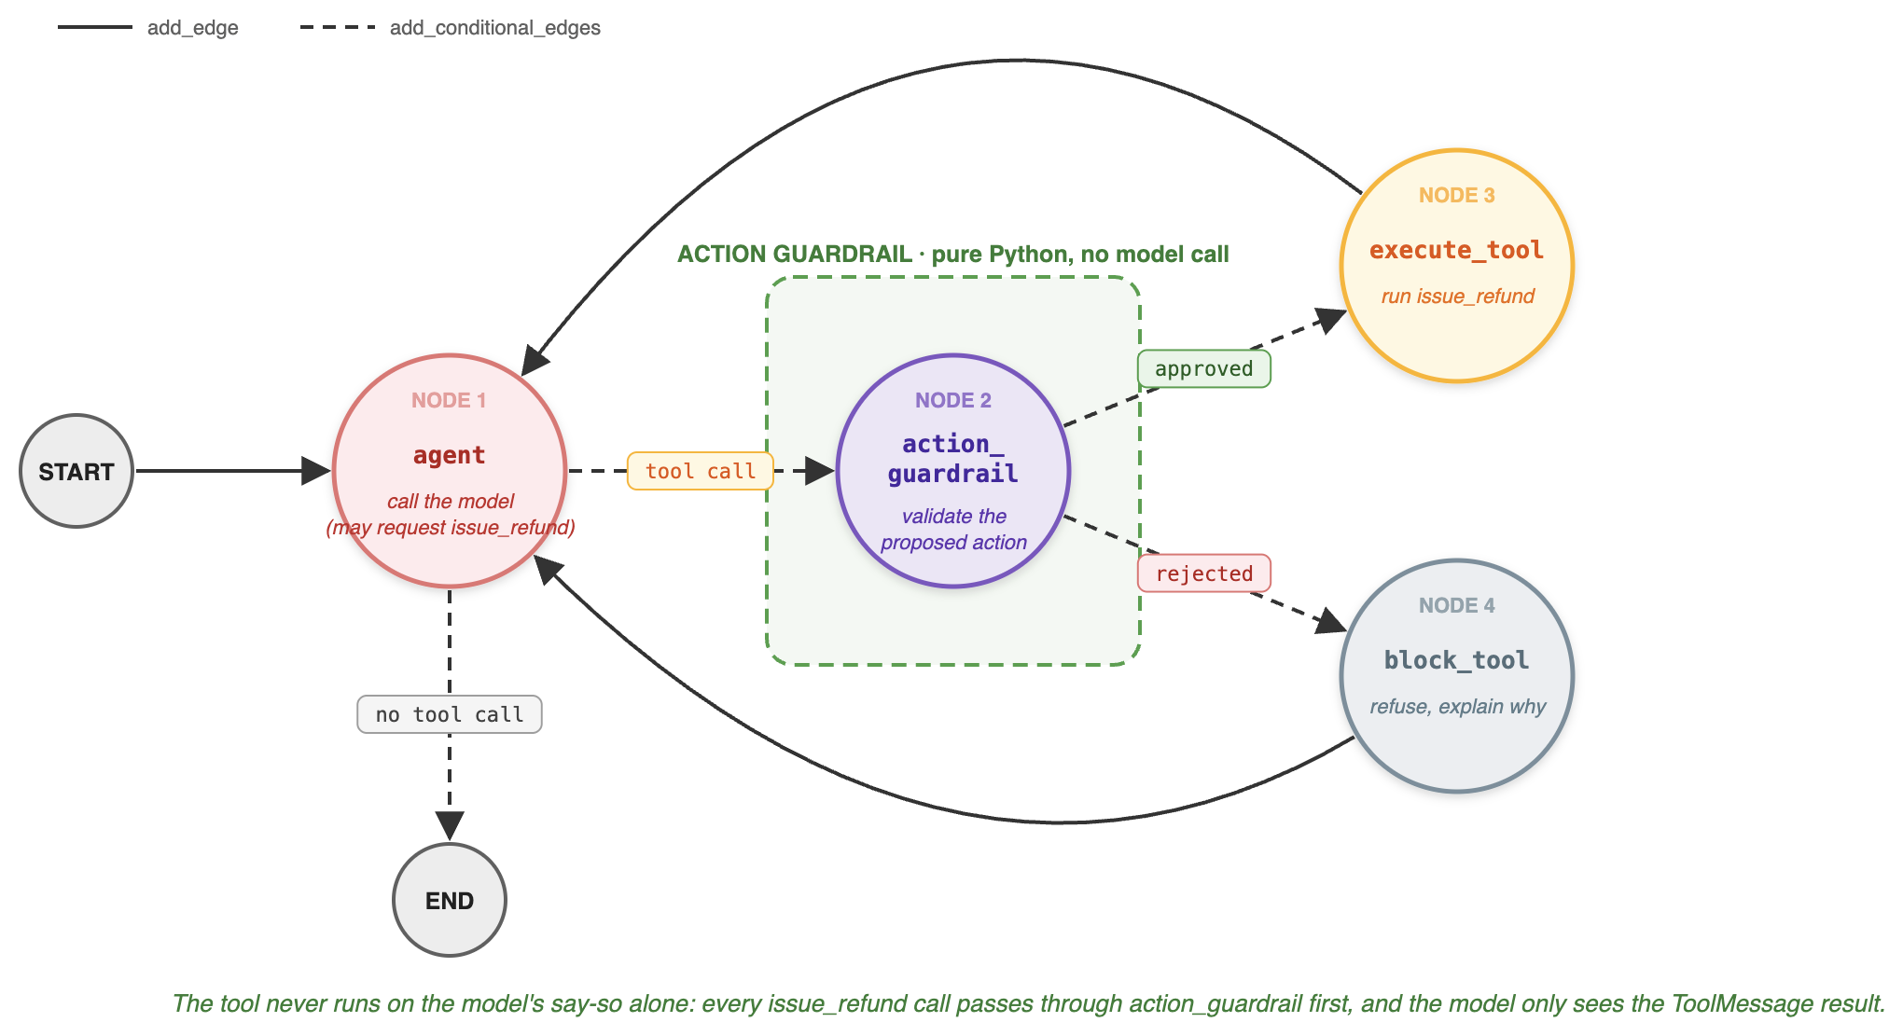
Fig 5.2: The model proposes a refund tool call. The action guardrail decides whether it really runs. Both outcomes return to the agent.
Node | What it does | When it runs
agent | Calls the model, which may request a refund | Every turn
action_guardrail | Validates the proposed tool call | Only when a tool was requested
execute_tool | Runs issue_refund for real | Only when the guardrail approved
block_tool | Refuses and explains why | Only when the guardrail rejected

The dashed box marks the guardrail, and as in Program 01 it is plain Python with no model call inside it. The dashed arrows are conditional edges, which are new in this chapter. A plain edge always goes to the same place. A conditional edge asks a function where to go next.
Notice that both outcomes loop back to the agent. A blocked refund is not the end of the conversation. The model is told what happened so it can explain the situation to the customer, which is how a refusal becomes a sentence a person can understand instead of an error nobody sees.

The Tool
A tool is an ordinary Python function that the model is allowed to request.
@tool
def issue_refund(invoice_id: str, amount: float) -> str:
"""Issue a refund for an invoice."""
return f"Refund of ${amount:.2f} issued for invoice {invoice_id}."
The model is told about this tool by binding it:
model_with_tools = model.bind_tools([issue_refund])
Binding a tool tells the model that this function exists, what it is called, and what arguments it takes. It does not give the model the power to run it. That distinction is the foundation of every action guardrail in this book.

The State
The state in Program 02 carries the conversation plus everything the guardrail decided.
class AgentState(TypedDict):
messages: Annotated[list[AnyMessage], add_messages]

tool_name: str # what the model asked for
tool_args: dict # the arguments it supplied
action_allowed: bool # the guardrail's decision
guardrail_reason: str # why it decided that
The messages field uses add_messages, which appends rather than overwrites, so the conversation grows as the graph runs.
The other four fields are the guardrail's working notes. Writing the decision and the reason into the state, rather than acting on them immediately, is what lets the next edge route on them, the block node explain them, and your logs record them. A decision that lives only inside a function is a decision nobody can see.
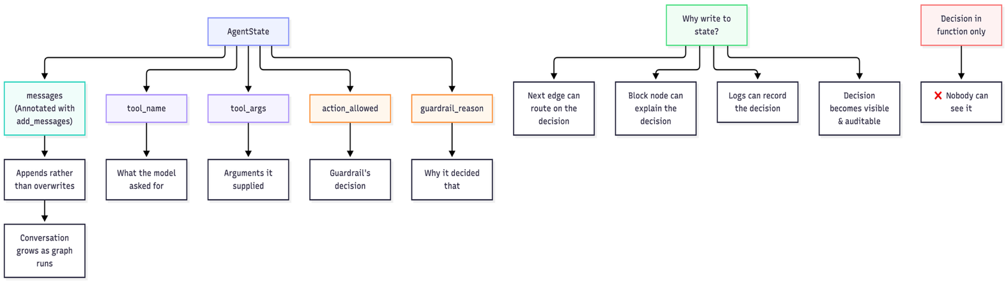
Fig 5.3: Internal working of AgentState

Two Decisions, Two Routing Functions
This program makes two separate decisions, and each one is a small function that returns the name of the next node.

Decision one: did the model ask for a tool?
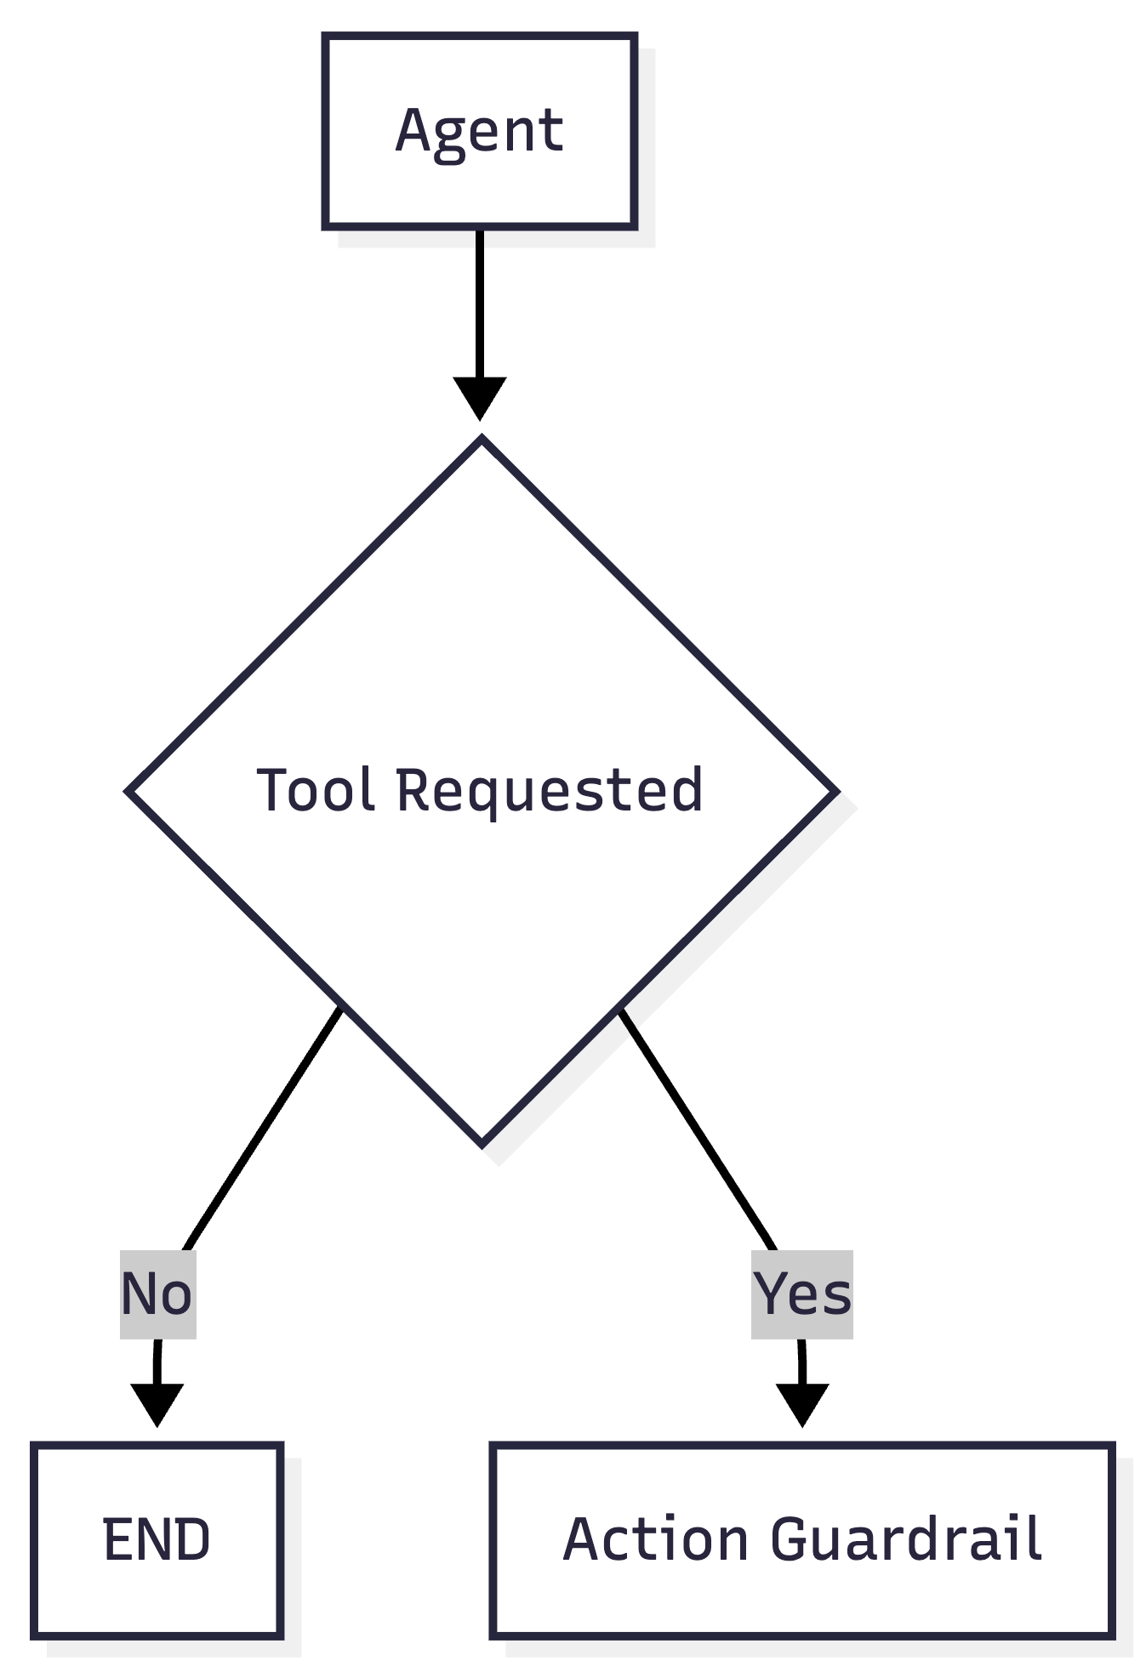
Fig 5.4: After the agent node: only tool calls go to the guardrail.
def route_after_agent(state):
last_message = state["messages"][-1]

if last_message.tool_calls:
return "action_guardrail"

return END
If the model just replied with text, the turn is over. If it asked for a tool, the request goes to the guardrail. There is no third path. A tool call cannot reach the tool without passing the check, and that is a property of the graph, not a promise in a prompt.

Decision two: did the guardrail allow it?
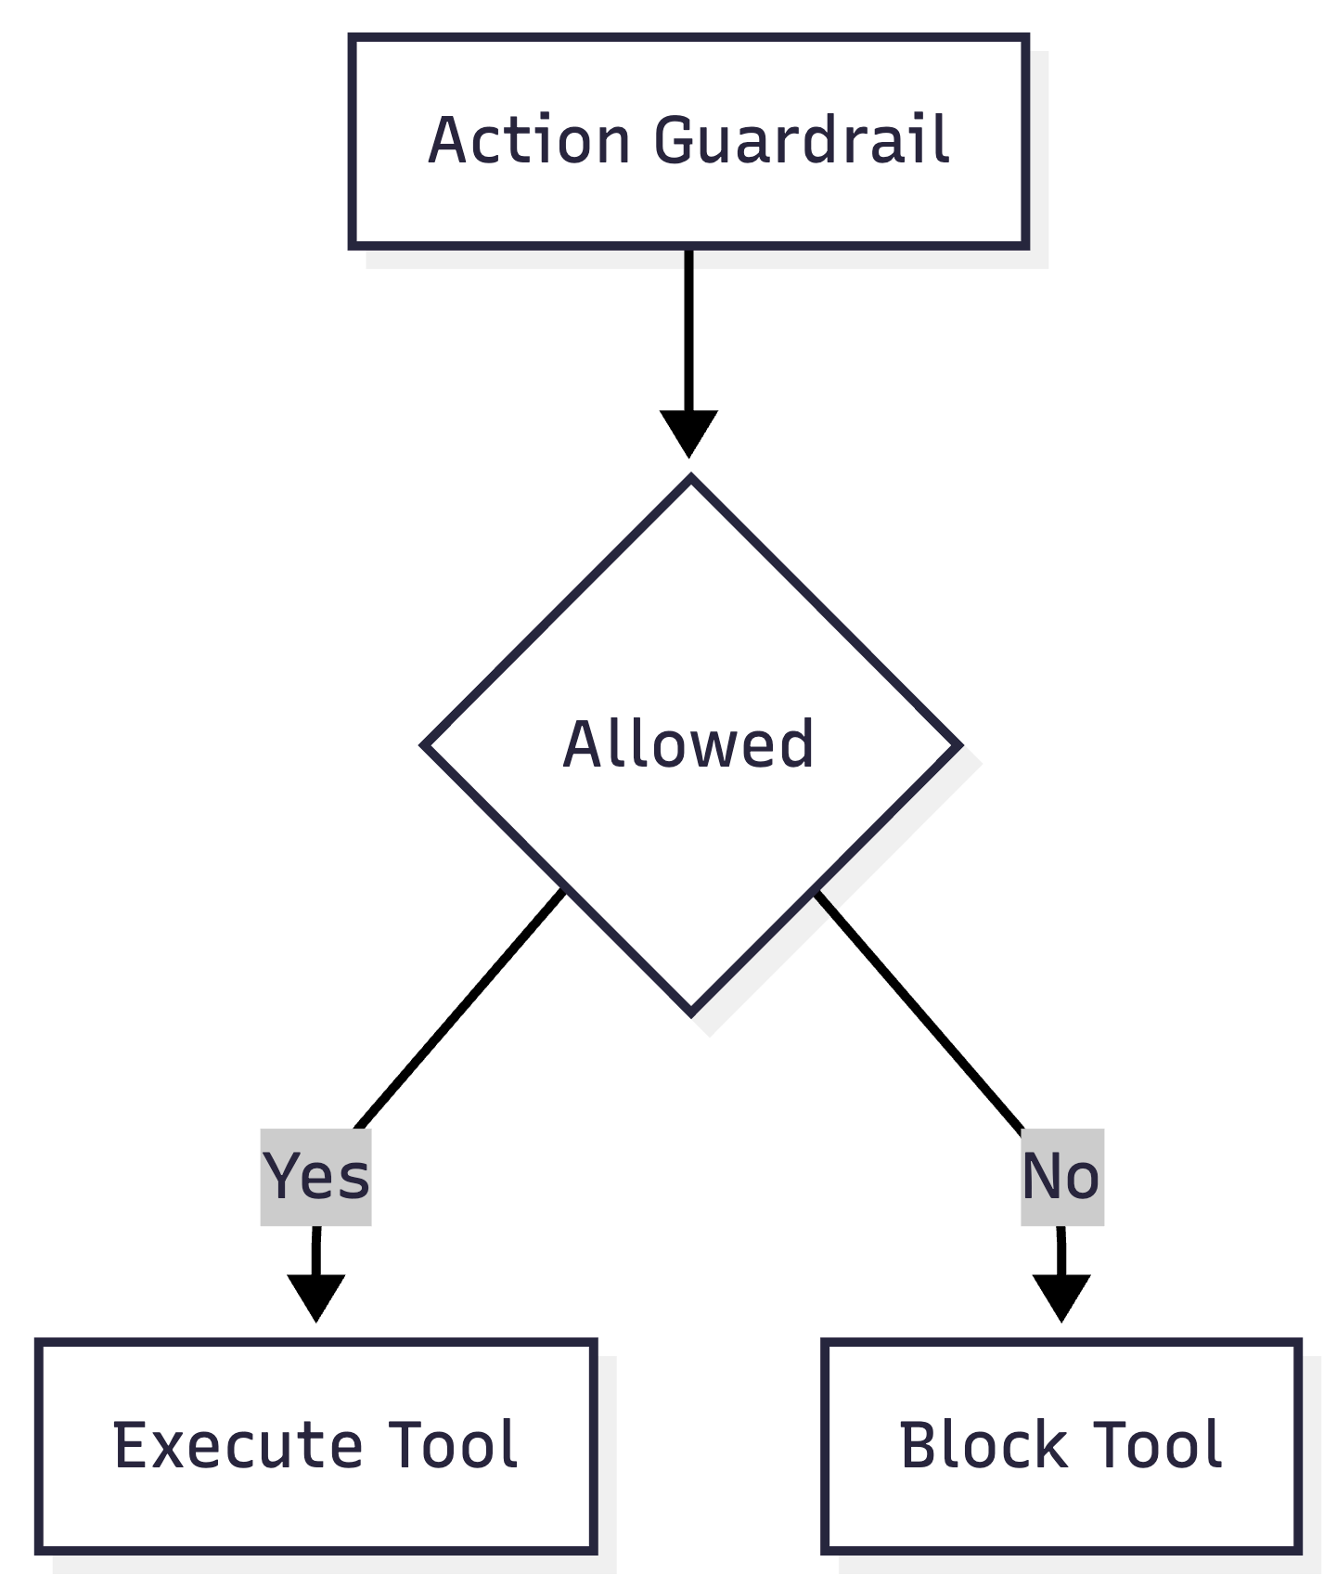
Fig 5.5: After the guardrail: approved calls run, rejected calls are refused.
def route_after_guardrail(state):
if state["action_allowed"]:
return "execute_tool"

return "block_tool"
That is the whole control flow of a guarded agent.

The Guardrail Itself
The policy is the part worth arguing about, so it lives on its own, in guardrail.py, as a plain function.
def assess_financial_risk(tool_name, tool_args):
if tool_name != "issue_refund":
return {"allowed": False,
"reason": f"Tool {tool_name} is not allowed."}

amount = tool_args.get("amount", 0)

if amount <= 0:
return {"allowed": False,
"reason": "Refund amount must be greater than zero."}

if amount > 500:
return {"allowed": False,
"reason": "Refunds above $500 require additional approval."}

return {"allowed": True,
"reason": "Refund is within the allowed limit."}
Everything from this chapter is visible here. It returns a decision and a reason. It denies any tool it does not recognise. It checks the shape of the amount before the size of it. It never calls a model.
Following Chapter 3, the next improvement is to lift 500 into a named constant and add a code to each decision, so the number can be found in one place and the blocks can be counted in your dashboards.

What Happens When a Refund Is Blocked
A blocked refund is not silence. The block node writes a tool result explaining the refusal:
tool_message = ToolMessage(
content=f"Refund was not executed. Reason: {state['guardrail_reason']}",
tool_call_id=tool_call["id"],
)
Two reasons this matters.
- The conversation stays honest. The model sees that the refund did not happen and tells the customer so. Without this, the model assumes its request succeeded and cheerfully confirms a refund that never took place, which is worse than refusing.
- The protocol requires it. Every tool call in a turn must be answered with a result. Leave one unanswered and the next model call fails.
That second point has a sharp edge, and Program 02 handles it explicitly. A model can request several tools in one turn. This program validates and executes only the first one, so every remaining call is answered with a refusal:
def reject_extra_tool_calls(tool_calls):
return [
ToolMessage(
content="Refund was not executed. Reason: only one refund "
"action is processed per turn.",
tool_call_id=tool_call["id"],
)
for tool_call in tool_calls[1:]
]
This is a policy decision dressed as a technical detail, and it is the kind of thing that decides whether a guardrail actually holds. If you validate the first call and quietly execute the rest, an agent can issue five refunds in one turn while your guardrail reports that everything was checked. One call per turn is a safe default. Validating every call in a loop is the other correct answer. Doing neither is how agents surprise people.

A Complete Run
Two requests, same agent.
Request | Guardrail decision | What the customer is told
Refund $200 for invoice INV 1001 | Allowed, within the limit | The refund has been issued
Refund $900 for invoice INV 1002 | Blocked, above $500 | The refund needs additional approval

Now try to argue with it. Tell the agent you are a manager. Tell it the limit was raised yesterday. Tell it the customer is threatening to leave. The model may well be persuaded, and it will try the tool call again. The guardrail will return the same answer every time, because it is not listening to the conversation. It is reading a number.
You can talk a model into anything. You cannot talk an if statement into anything.

Testing It
As in Chapter 3, the policy is tested without a model.
@pytest.mark.parametrize("amount", [0.01, 100, 499.99, 500])
def test_amount_within_limit_is_allowed(amount):
d = g.validate_financial_action("issue_refund", {"amount": amount})
assert d["allowed"] is True

def test_unknown_tool_is_denied():
d = g.validate_financial_action("delete_account", {"amount": 10})
assert d["allowed"] is False
The second test is the one to keep an eye on. Today the agent has one tool. When somebody adds a second one next quarter, that test is what stops it from being callable without a policy. A denial by default is a decision you make once and benefit from for years.

What This Guardrail Still Does Not Do
Program 02 checks one action against one limit. Everything below is a real gap, and each one has its own chapter.
Gap | Why it matters | Where it is handled
No sense of risk | A $10 refund and a $499 refund get identical treatment | Chapter 6
No way to ask a person | Above the limit, the only answer is no | Chapter 7
No memory of earlier refunds | Five refunds of $400 all pass | Chapter 12
No identity check | Nothing ties the invoice to this customer | Part III
Not safe on retry | The same refund can run twice | Part III

This is the honest shape of guardrail work. Each program closes one gap properly rather than pretending to close all of them at once.

Five Ways This Goes Wrong
- Checking after the tool runs. A validation that runs on the result is a report, not a guardrail. The money already moved.
- Letting the tool police itself. When the refund function carries its own limit, the policy is invisible from outside and every new tool gets its own private version of the rule.
- Blocking without telling the model. Silence makes the model confirm refunds that never happened. Always return a reason.
- Validating one call and running the others. The most common real gap in tool calling agents, and the reason Program 02 answers every extra call with a refusal.
- Keeping the limit in the prompt as well. Two copies drift apart. Put the number in the guardrail and let the prompt say that limits exist and the system enforces them.

Where This Goes Next
Program 02 knows only two answers: yes and no. But a $10 refund and a $5,000 refund are not the same kind of event, and treating them the same way means you are either too strict for small things or too loose for large ones.
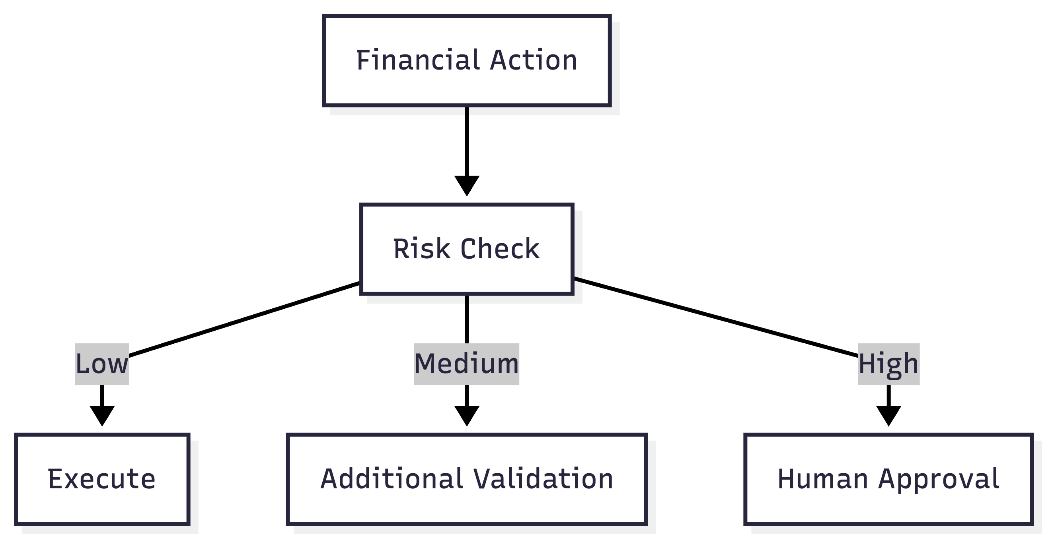
Fig 5.5: The next step: one check becomes three paths.
The next program scores the risk of the action first and then routes on that score. Low risk goes straight through. Medium risk gets extra validation. High risk needs a person. That is Chapter 6, and it uses exactly the conditional edges you have just seen.

Try It Yourself
- Run the agent with a refund of $200, then $900. Read the difference in what the customer is told.
- Try to talk it into the $900 refund. Watch the guardrail return the same answer every time.
- Add a second tool, such as cancel_order, bind it to the model, and ask the agent to use it. It will be blocked, because the guardrail recognises only one tool. Decide what the policy for the new tool should be before you write the code that allows it.
- Change the guardrail to validate every tool call in the turn instead of only the first. Then ask for two refunds in one message and compare the two behaviours.

Key Takeaways
- A tool call is a request, not an action. Your code decides whether it becomes real, which means the safest checkpoint already sits outside the model.
- An action guardrail runs after the model chooses and before the tool runs.
- Conditional edges turn a decision into a path. Two routing functions of three lines each are the whole control flow.
- Write the decision and the reason into the state, so the graph can route on it, the customer can be told, and your logs can record it.
- Every tool call in a turn needs an answer. Validate every call or execute only one, and never validate one while running the rest.
- Keep the policy in the guardrail, not in the tool and not in the prompt.
- One limit is not a risk model. That is the next chapter.
In further chapter’s the agent stops treating every refund the same way and starts asking how risky is this before deciding what to do.

