Chapter 6

Not All Risk Is Equal
Program 03: Risk Routing Guardrail
The risk guardrail in Program 03 is a rule guardrail at the action position. It runs before the tool and sends the action down one of three paths.

The Problem With One Line
Program 02 works, and within a week of shipping it the support team has two complaints. The first is that the agent is annoying. A customer asks for $8 back on a duplicated charge and the agent handles it in four seconds. A customer asks for $600 on a cancelled subscription and the agent refuses, the customer escalates, and a human does in ten minutes what the agent could have prepared in one.
The second complaint is the opposite. A refund of $499 goes through with no scrutiny at all. Nobody checks the invoice, nobody checks that it exists, nobody checks anything. It is one cent below the line, so the guardrail waves it past.
The team's instinct is to move the limit. Raise it to $1,000 and support stops complaining. Lower it to $100 and the risk goes down. Both are wrong, because the problem is not where the line sits.
A single limit says every action below it is fine and every action above it is impossible. Real risk is not shaped like that.
Risk is a slope. A $10 refund, a $300 refund and a $5,000 refund are three different kinds of event, and they deserve three different amounts of scrutiny. This chapter gives the guardrail more than two answers.

What This Program Teaches
The agent here still issues refunds. What changes is what happens after the model asks for one. Instead of a single yes or no, the guardrail first decides how risky the request is, and that decision chooses the path the request takes through the graph.
A risk guardrail classifies a proposed action into a risk level and sends each level down a different path.
The word route is doing the work here. An action guardrail has one exit that matters: blocked or not. A risk guardrail has several, and the guardrail's job shifts from judging to sorting. Sorting is a much better fit for real policy, because most organisations already work this way. A support agent can approve a small refund alone, needs a second pair of eyes for a medium one, and sends a large one to a manager.
Two things arrive with this program.
What you learn | Where you see it
Risk levels | A classification written in code, not asked of the model
Routing on a decision | One guardrail with three exits instead of two

Five Nodes, Three Paths
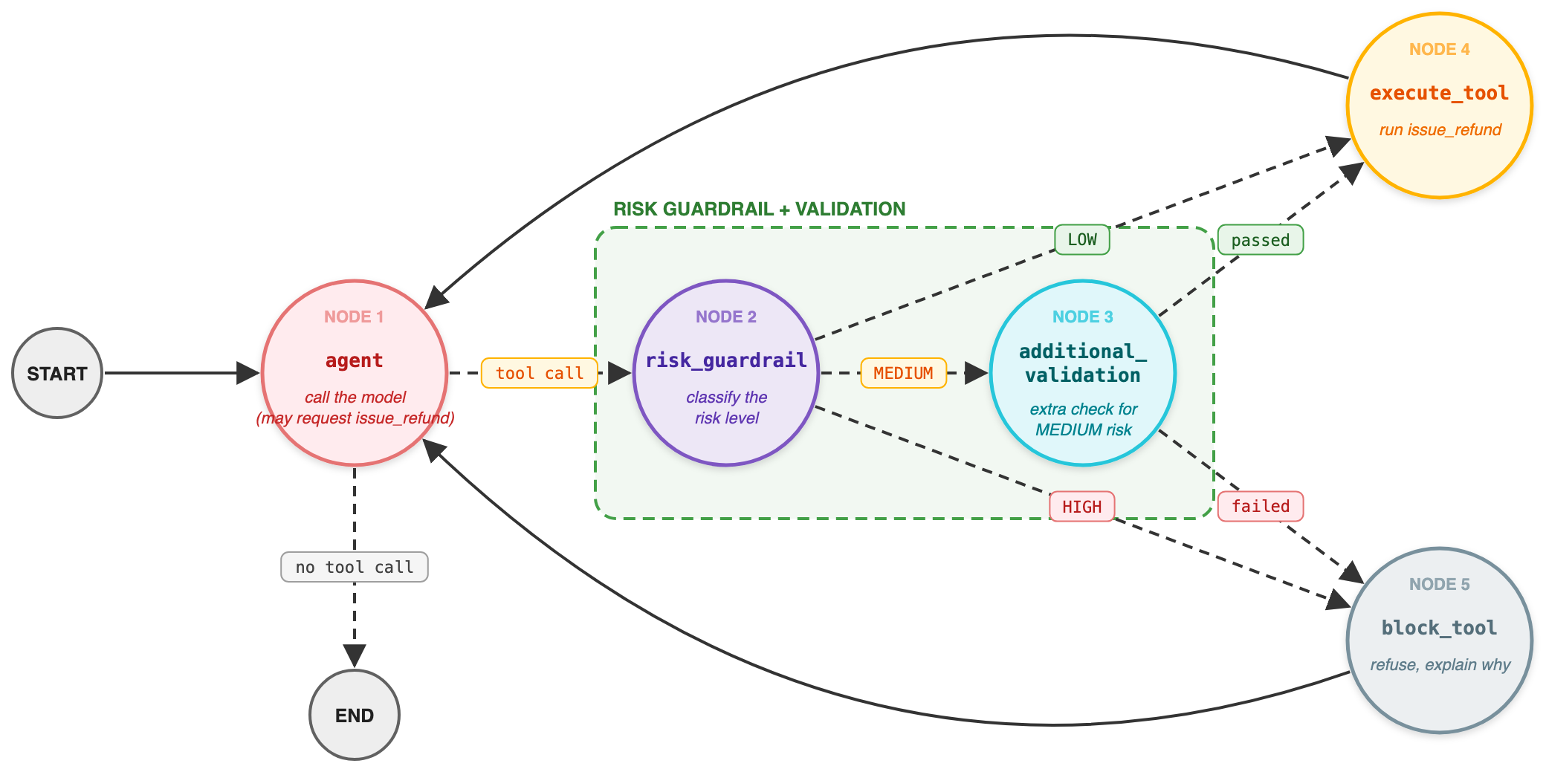
Fig 6.1: The risk guardrail classifies each refund as low, medium or high, and routes it down a different path. Medium gets a second check.
The dashed arrows are conditional edges, as in Chapter 5. What is new is that one of them now has three destinations rather than two.
Node | What it does | What it writes to state
agent | Calls the model, which may request a refund | messages
risk_guardrail | Classifies the proposed call as low, medium or high | tool_name, tool_args, risk_level, guardrail_reason
perform_additional_validation | Runs a stricter check, only for medium risk | validation_passed, validation_reason
execute_tool | Runs issue_refund for real | messages
block_tool | Refuses and explains why | messages

Read the paths in the figure rather than the list. Low risk goes straight to the tool. Medium risk takes a detour through a second check and only then reaches the tool, or gets blocked. High risk never touches the tool at all.

Three Tiers
The policy now reads as a table instead of a number.
Risk level | When | What happens | Why
Low | $100 or less | Execute immediately | Small, reversible, high volume
Medium | $100.01 to $500 | Extra validation, then execute | Worth a second look, not worth a person
High | Above $500, or anything invalid | Block | Needs authority the agent does not have

Here is the classifier. It returns a level and a reason, rather than a yes and a reason.
def assess_financial_risk(tool_name, tool_args):
if tool_name != "issue_refund":
return {"risk_level": RiskLevel.HIGH,
"reason": f"Tool {tool_name} is not allowed."}

amount = tool_args.get("amount", 0)

if amount <= 0:
return {"risk_level": RiskLevel.HIGH,
"reason": "Refund amount must be greater than zero."}

if amount <= 100:
return {"risk_level": RiskLevel.LOW,
"reason": "Refund is within the low risk limit."}

if amount <= 500:
return {"risk_level": RiskLevel.MEDIUM,
"reason": "Refund requires additional validation."}

return {"risk_level": RiskLevel.HIGH,
"reason": "Refund requires human approval."}
Notice what happens to anything the function does not understand. An unknown tool is high risk. A missing amount is high risk. A negative amount is high risk. Uncertainty always lands in the strictest tier, which is failing closed from Chapter 2 expressed as a classification.
Notice also who is doing the classifying. Not the model. The risk level is computed from the arguments by a function that reads a number and compares it to a constant. A customer can write the most convincing message ever typed and the level will not move. If you ask the model how risky is this, you have handed the decision back to the thing you were trying to guard.
Never ask the model how dangerous its own request is.

The Second Check
Medium risk is the interesting tier, because medium does not mean probably fine. It means allowed if the details hold up. So something has to check the details.
def perform_additional_validation(tool_args):
invoice_id = tool_args.get("invoice_id", "")

if not invoice_id:
return {"valid": False, "reason": "Invoice ID is missing."}

if not invoice_id.startswith("INV"):
return {"valid": False, "reason": "Invoice ID format is invalid."}

return {"valid": True, "reason": "Additional validation passed."}
This check asks a different question from the risk classifier. The classifier asked how large is this. The validation asks does this refer to something real. In the repo it only checks the format of the invoice number, which is what a teaching example can do without a database. In your system this is the place where a check earns its keep, by asking whether the invoice exists, whether it belongs to this customer, whether it has already been refunded, and whether it is old enough to be closed.
That is the real value of a medium tier. It gives you somewhere to put the checks that are too slow or too expensive to run on every request but too important to skip on a large one.

Turning a Level Into a Path
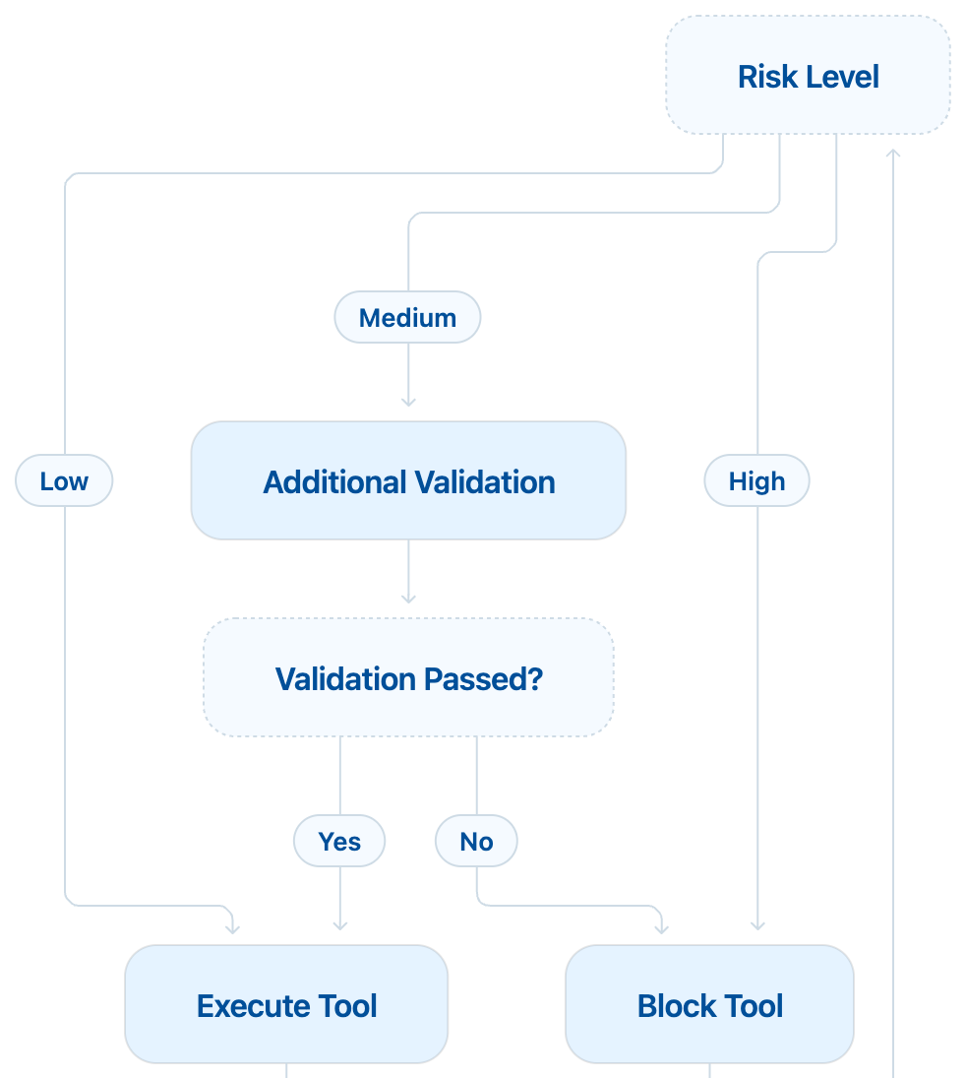
Fig 6.2: One classification, three exits, with a second decision on the medium path.
Two routing functions do the work, and both are small.
def route_by_risk(state):
if state["risk_level"] == RiskLevel.LOW:
return "execute_tool"

if state["risk_level"] == RiskLevel.MEDIUM:
return "additional_validation"

return "block_tool"

def route_after_validation(state):
if state["validation_passed"]:
return "execute_tool"

return "block_tool"
Note the shape of the first function. Low and medium are named explicitly, and everything else falls through to block. If a new tier is added next year and somebody forgets to update this function, the new tier is blocked rather than executed. Write your routing so that forgetting is safe. When these functions are wired into the graph, the possible destinations are declared as well:
builder.add_conditional_edges(
"risk_guardrail",
route_by_risk,
{
"execute_tool": "execute_tool",
"additional_validation": "additional_validation",
"block_tool": "block_tool",
},
)
That map is worth a moment. It is a list of the only places this guardrail is allowed to send a request. A routing function cannot invent a destination, and a reader can see every path out of the guardrail without reading the function at all.

Where Do the Thresholds Come From?
$100 and $500 are not magic numbers, and you should not copy them. Three ways to find yours, in order of usefulness.
- Copy the authority you already have. Most companies already know what a support agent can approve alone, what needs a second person, and what needs a manager. Those three numbers are your tiers, they are already agreed, and using them means your agent follows the policy the business actually has.
- Look at your own data. Pull last year's refunds and look at the distribution. In most businesses the great majority sit far below the number people argue about in meetings. If ninety five percent of refunds are under $60, a low tier at $100 buys you speed on almost everything while leaving the rare large ones properly guarded.
- Ask what can be undone. An action you can reverse in a day tolerates a lower tier than one that is final. Money leaving a closed account is not the same as a credit against a future invoice, even at the same amount.
Two practical rules. Three tiers is usually right, five is a committee, and seven means nobody knows what any of them mean. And write the thresholds as named constants at the top of the file, so the policy can be read by someone who does not read Python.

What Tiers Buy You
- Friction that matches the stakes. Small requests stay fast, which is what makes the agent worth having. Large requests get the scrutiny, which is what makes it safe to keep.
- A place to put expensive checks. A database lookup you would never run on every request is perfectly reasonable on a medium one.
- An answer for the auditor. Every action now carries a recorded level and a reason. When someone asks why this refund went through without review, the answer is a row, not a shrug.

A Complete Run
Request | Level | Path | Outcome
Refund $80 for INV 1001 | Low | Straight to the tool | Refunded
Refund $300 for INV 1001 | Medium | Validation, then the tool | Refunded
Refund $300 for ORDER 22 | Medium | Validation fails | Blocked, invoice format invalid
Refund $900 for INV 1002 | High | Never reaches the tool | Blocked, needs approval
Call delete_account | High | Never reaches the tool | Blocked, unknown tool

The third row is the one to show people. Same amount as the second, same tier, different outcome, and the difference has nothing to do with how the request was phrased.

Testing It
Tiers are boundaries, and boundaries are where bugs live. Test each edge from both sides.
@pytest.mark.parametrize("amount, level", [
(0.01, RiskLevel.LOW),
(100, RiskLevel.LOW),
(100.01, RiskLevel.MEDIUM),
(500, RiskLevel.MEDIUM),
(500.01, RiskLevel.HIGH),
])
def test_risk_tiers(amount, level):
d = g.assess_financial_risk("issue_refund", {"amount": amount})
assert d["risk_level"] == level

def test_unknown_tool_is_high_risk():
d = g.assess_financial_risk("delete_account", {"amount": 10})
assert d["risk_level"] == RiskLevel.HIGH
Five lines of parameters describe your entire refund policy, in a form that a reviewer can check in a minute and a test runner can check forever.

Five Ways This Goes Wrong
- Asking the model for the level. The model is the thing being guarded. A customer who writes this is urgent, my flight is tomorrow should not be able to change a risk score.
- Tiers chosen for convenience. If the thresholds were picked so that nothing ever gets blocked in the demo, you have tiers in name only.
- A medium check that checks nothing. Validation that always passes is a speed bump for engineers and a decoration for everyone else. If you cannot say what the medium check would reject, delete the tier.
- No default tier. Any input the classifier does not recognise must land in the strictest tier, not the friendliest one.
- Recording the level and losing the reason. Six months later, low is not an explanation. Low because the amount was $42 is.

Where This Goes Next
Look again at the high tier. The reason says it requires human approval, and then the agent blocks it. Nobody is actually asked. The customer is told no, and if they persist a human eventually does the work by hand, outside the system, with no record of why.
That is a gap, not a policy. The next program adds the missing path: the agent pauses, a person decides, and the agent resumes with that decision recorded. That is Chapter 7, and it is the first time the graph stops mid run and waits.

Try It Yourself
- Run refunds of $80, $300 and $900 and follow the path each one takes.
- Send $300 with an invoice of ORDER 22 and watch the medium path block it. Same tier, different answer.
- Move the thresholds into named constants, then set the low limit to $20 and run the tests. The failures are your policy change, written down.
- Add a fourth tier, such as very high above $5,000, but change only the classifier and not the routing function. The new tier is blocked, because the routing function sends everything it does not recognise to block_tool. That is the safe failure you designed in earlier.

Key Takeaways
- One limit gives you two answers. Real policy needs a slope, not a line.
- A risk guardrail classifies first and routes second, so scrutiny matches stakes.
- The level is computed in code from the arguments, never asked of the model.
- Unknown tools, missing values and anything unrecognised belong in the strictest tier.
- The medium tier is where expensive checks earn their keep, because they run only when they matter.
- Derive thresholds from the approval levels your business already uses, then check them against your own data.
- Write routing so that forgetting to update it blocks rather than allows.
In Chapter 7 the high tier stops meaning no and starts meaning ask someone.

