A PROJECT REPORT ON
Explainable AI for Medical Diagnosis Using Deep Learning:
A Grad-CAM and SHAP Based Framework for Chest X-ray Interpretation
Submitted in partial fulfilment of the requirements for the award of the degree of
BACHELOR OF TECHNOLOGY
in
Electronics and Computer Engineering
By
Sameer Shaikh (UEC23M1056)
Sai Karpe (UEC23M1027)
Chandraraj Rahane (UEC23M1048)
Vedhanshu Khajone (UEC23M1030)

Under the Guidance of
Mr. Shailesh Satishrao Kulkarni
Assistant Professor, Department of Electronics and Computer Engineering
DEPARTMENT OF ELECTRONICS AND COMPUTER ENGINEERING
SANJIVANI COLLEGE OF ENGINEERING, KOPARGAON
(An Autonomous Institute Affiliated to Savitribai Phule Pune University)
2026 – 2027

CERTIFICATE
This is to certify that the project report entitled “Explainable AI for Medical Diagnosis Using Deep Learning: A Grad-CAM and SHAP Based Framework for Chest X-ray Interpretation” is a bona fide record of the work carried out by Sameer Shaikh (UEC23M1056), Sai Karpe (UEC23M1027), Chandraraj Rahane (UEC23M1048), and Vedhanshu Khajone (UEC23M1030), students of Bachelor of Technology in Electronics and Computer Engineering, under our supervision, in partial fulfilment of the requirements for the award of the said degree.
The results embodied in this report have not been submitted to any other University or Institute for the award of any degree or diploma.

Guide  Mr. Shailesh Satishrao Kulkarni  Assistant Professor | Head of Department  Department of Electronics and Computer Engineering

External Examiner

DECLARATION
We hereby declare that the project report titled “Explainable AI for Medical Diagnosis Using Deep Learning: A Grad-CAM and SHAP Based Framework for Chest X-ray Interpretation”, submitted for the award of the degree of Bachelor of Technology in Electronics and Computer Engineering, is our own original work carried out under the guidance of Mr. Shailesh Satishrao Kulkarni. All sources of information used in this report have been duly acknowledged. The work presented has not been submitted, in part or in full, for the award of any other degree or diploma of this or any other institution.

Sameer Shaikh (UEC23M1056)
Sai Karpe (UEC23M1027)
Chandraraj Rahane (UEC23M1048)
Vedhanshu Khajone (UEC23M1030)

ACKNOWLEDGEMENT
We express our sincere gratitude to our guide, Mr. Shailesh Satishrao Kulkarni, Assistant Professor, Department of Electronics and Computer Engineering, for his invaluable guidance, constant encouragement, and constructive criticism throughout the course of this project. His insight was instrumental in shaping both the technical direction of the work and the discipline with which it was evaluated.
We are grateful to the Head of Department and the faculty of the Department of Electronics and Computer Engineering for providing the infrastructure, computational resources, and academic environment necessary to carry out this work. We also thank our institution, Sanjivani College of Engineering, Kopargaon, for the opportunity to pursue this project as part of our final-year curriculum.
Finally, we thank our families and peers for their continual support and encouragement throughout the duration of this project.
— Sameer Shaikh, Sai Karpe, Chandraraj Rahane, Vedhanshu Khajone

ABSTRACT
Convolutional Neural Networks (CNNs) now match or exceed expert-level accuracy on several medical imaging tasks, yet their opaque, black-box decision process remains a decisive barrier to clinical adoption. A clinician asked to act on an automated diagnosis has no way of verifying which anatomical evidence produced that output, which makes the prediction difficult to trust and its failures difficult to audit. This project designs, implements, and evaluates an explainable deep learning framework for chest X-ray diagnosis that pairs every prediction with two complementary, human-interpretable explanations.
A transfer-learned CNN backbone (ResNet-50 / DenseNet-121, pretrained on ImageNet and fine-tuned on public chest radiograph corpora) classifies chest X-rays for pneumonia and COVID-19. Gradient-weighted Class Activation Mapping (Grad-CAM) produces a region-level heatmap identifying where in the image the model looked, while SHapley Additive exPlanations (SHAP) produce signed, patch-level attribution values quantifying how much and in which direction each region influenced the decision. Both explanations, together with the model’s calibrated confidence, are rendered side by side in a clinician-facing web dashboard built with Streamlit / React and a FastAPI backend.
The system is evaluated along three axes: diagnostic performance (accuracy, precision, recall, F1-score, AUC-ROC), explanation faithfulness (deletion and insertion AUC), and clinician-rated usefulness collected through a structured, five-point Likert survey with inter-rater agreement measured by Krippendorff’s α. An explanation-agreement analysis further compares the spatial overlap of Grad-CAM and SHAP evidence, flagging cases of disagreement as a practical signal of unstable or shortcut-driven model reasoning. This report documents the complete system analysis, design, implementation plan, and evaluation protocol, and includes, as an appendix, the accompanying IEEE-format research paper prepared from this work.
Keywords: Explainable AI (XAI), Deep Learning, Convolutional Neural Network, Grad-CAM, SHAP, Medical Image Analysis, Chest X-ray, Clinical Trust, Interpretability.

TABLE OF CONTENTS
Chapter Chapter Title
Chapter 1 Introduction
Chapter 2 Literature Survey
Chapter 3 System Analysis and Design
Chapter 4 Implementation
Chapter 5 Testing
Chapter 6 Results and Discussion
Chapter 7 Conclusion and Future Scope
Chapter 8 Project Planning and Timeline
— References
Appendix A Research Paper (IEEE Format)

LIST OF FIGURES
(Figure numbers and captions are listed in sequence in the body of the report; right-click and choose “Update Field” in Word after inserting a Table of Figures, or refer to the numbered captions under each figure.)

LIST OF TABLES
(Table numbers and captions are listed in sequence in the body of the report.)

CHAPTER 1
INTRODUCTION
1.1 Overview
Medical imaging is one of the most successful application domains of deep learning. Since the introduction of deep Convolutional Neural Networks (CNNs), automated systems have reported radiologist-comparable performance on tasks ranging from diabetic retinopathy grading to pneumonia and COVID-19 screening from chest radiographs. Chest X-ray interpretation is a particularly attractive target for automation: the modality is inexpensive, ubiquitous, and available even in resource-constrained primary-care settings, while the global shortage of trained radiologists creates a genuine and measurable reporting backlog.
Despite this progress, deployment of deep learning diagnostic tools in routine clinical workflows has lagged far behind reported benchmark accuracy. The central reason is epistemic rather than purely technical: a deep network with tens of millions of parameters offers a scalar confidence value and nothing else. It cannot state which opacity, which lung field, or which texture pattern drove its conclusion. Clinicians, who are professionally and legally accountable for diagnostic decisions, are understandably unwilling to act on an unexplained recommendation.
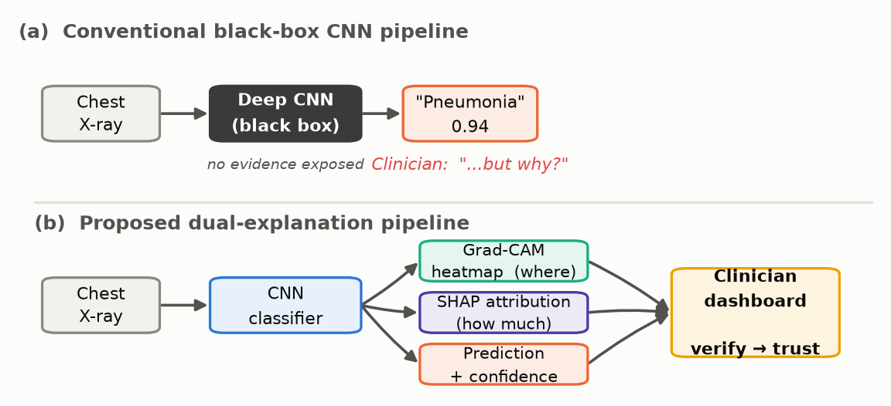
Fig. 1.1: The black-box problem — a deep model produces a confident diagnosis with no supporting evidence a clinician can verify.
1.2 Motivation
Deep models are known to latch onto spurious correlates — scanner-specific artefacts, laterality markers, chest drains, or text annotations burned into the image — and achieve high test accuracy for entirely the wrong reasons. Without an explanation channel, such shortcut learning is invisible until the model fails on a new hospital’s data. Regulatory expectations are converging on the same requirement: guidance from the FDA on AI/ML-based Software as a Medical Device, and the transparency obligations placed on high-risk systems by the European Union AI Act, both push towards models whose outputs can be reasoned about by a human operator. Interpretability is therefore shifting from a research nicety to a deployment prerequisite, and it is this shift that motivates the present project.
Explainable AI (XAI) addresses this gap. Two families of post-hoc explanation methods dominate the medical imaging literature. Gradient-based saliency methods, of which Grad-CAM is the most widely used, exploit the gradient of the target class score with respect to convolutional feature maps to produce a coarse spatial heatmap of evidence. Additive feature-attribution methods, of which SHAP is the principled representative, assign each input feature a Shapley value expressing its signed marginal contribution to the prediction. The two answer different questions — Grad-CAM answers “where did the model look?”; SHAP answers “how much, and in which direction, did each region push the decision?” — and a clinician reviewing a borderline case needs both.
1.3 Problem Statement
Deep learning diagnostic models function as black boxes that provide no insight into which image regions or features drove a prediction. This absence of interpretability makes it difficult for clinicians to verify, trust, or safely act on AI-generated diagnoses, and makes model errors difficult to audit or attribute after the fact. Existing explainability studies almost invariably adopt a single explanation method and evaluate it using computational proxies rather than clinician judgement, leaving open the question of whether region-level and feature-level explanation, combined and validated by real clinicians, deliver more trustworthy AI-assisted diagnosis than either alone.
1.4 Objectives
- Design and train a CNN-based classifier for disease detection from chest radiographs, targeting pneumonia and COVID-19.
- Integrate Grad-CAM to generate visual heatmaps localising the image regions responsible for each prediction.
- Integrate SHAP to provide patch-level attribution quantifying each region’s signed contribution to the decision.
- Build a clinician-facing dashboard that presents the prediction alongside both explanations side by side.
- Evaluate the system on diagnostic accuracy, explanation faithfulness, and clinician-rated explanation usefulness.
1.5 Scope of the Project
The scope of this project covers binary and multi-class classification of chest radiographs for pneumonia and COVID-19 using publicly available, de-identified datasets; generation and presentation of Grad-CAM and SHAP explanations for every prediction; a web-based clinician dashboard; and a structured evaluation combining quantitative metrics with clinician feedback. Regulatory certification (FDA/CE marking), deployment as a certified clinical device, and imaging modalities other than chest X-ray (CT, MRI) are explicitly outside the scope of this work; the system is a research prototype intended to demonstrate and evaluate a dual-XAI diagnostic-support methodology.
1.6 Organisation of the Report
Chapter 2 reviews the related literature and positions this project against it. Chapter 3 presents the system requirements, feasibility analysis, and the complete design — architecture, flowcharts, data-flow diagrams, UML diagrams, and the dashboard wireframe. Chapter 4 describes the implementation plan, module breakdown, and the training procedure. Chapter 5 details the testing strategy. Chapter 6 discusses expected results and their significance. Chapter 7 concludes the report and outlines future work, and Chapter 8 presents the project timeline. The report closes with references and, as Appendix A, the IEEE-format research paper prepared from this work.

CHAPTER 2
LITERATURE SURVEY
This chapter reviews the literature that underpins the design choices made in this project, spanning deep learning for medical imaging, gradient-based visual explanation, uncertainty estimation, layer-wise explanation, and human-centred evaluation of explainable AI.
2.1 Deep Learning in Medical Image Analysis
Shen, Wu and Suk (2017) surveyed deep learning across medical image classification, segmentation, and registration, establishing CNNs with transfer learning and aggressive data augmentation as the standard recipe when annotated medical data is scarce. Their review also identified the constraints that still shape the field: small labelled datasets, overfitting, weak generalisation across institutions, and the absence of interpretability as an obstacle to clinical deployment.
2.2 Gradient-Based Visual Explanation
Selvaraju et al. introduced Grad-CAM, which weights the final convolutional feature maps by the gradient of the class score and produces a class-discriminative localisation map without any architectural modification or retraining. Its generality across CNN families made it the default explanation method in medical imaging. Its acknowledged weakness is resolution: because it operates on the last convolutional layer, output maps are coarse, and small or diffuse findings are localised imprecisely. Grad-CAM also provides no magnitude semantics — a bright region is “important,” but the map does not say how much.
2.3 Uncertainty and Bayesian Approaches
Ghoshal and Tucker (2020) proposed a Bayesian CNN with Monte Carlo DropWeights to estimate predictive uncertainty for COVID-19 detection from chest X-rays, reporting a strong correlation between prediction uncertainty and error rate. The study was restricted to small early-pandemic COVID-19 datasets and addressed confidence rather than explanation: it indicates when the model may be wrong, not why it decided as it did.
2.4 Layer-wise and Multi-label Explanation
Kim, Choi and Seo (2025), presented at IEEE EMBC 2025, applied Grad-CAM across multiple layers of a U-Net encoder–decoder for multi-label classification of fourteen conditions on MIMIC-CXR, obtaining finer-grained and more disease-specific maps than single-layer Grad-CAM. The work remains confined to a single explanation family, incorporates no feature-attribution method, and assesses interpretability with computational metrics rather than clinician feedback.
2.5 Human-Centred Evaluation of XAI
Ihongbe et al. (2024), in PLOS ONE, conducted a 26-clinician user study comparing Grad-CAM and LIME explanations for pneumonia and COVID-19 diagnosis from chest X-rays and CT. Grad-CAM was consistently preferred for clinical relevance, comprehensibility, and trust. The study is a rare and valuable instance of human-centred XAI evaluation in radiology, but it compares Grad-CAM against LIME rather than SHAP, and does not present a combined region-level and feature-level interface or report quantitative faithfulness metrics.
2.6 Summary of Reviewed Literature
Table 2.1: Summary of key literature reviewed
Study | Method | Key Contribution | Limitation
Shen et al. (2017) | CNN survey | Transfer learning recipe for scarce medical data | No interpretability focus
Selvaraju et al. | Grad-CAM | Architecture-agnostic class-discriminative heatmaps | Coarse resolution, no magnitude
Ghoshal & Tucker (2020) | Bayesian CNN | Uncertainty–error correlation | Confidence only, not explanation
Kim et al. (2025) | Layer-wise Grad-CAM | Finer multi-label localisation | Single method, computational eval only
Ihongbe et al. (2024) | Grad-CAM vs LIME | 26-clinician comparative study | No SHAP, no combined interface

2.7 Research Gap
Across the reviewed literature, explanation methods are applied in isolation, and the small subset of studies that involve clinicians does not simultaneously report quantitative faithfulness. No reviewed work delivers region-level and feature-level explanations for the same prediction in a single clinical interface and validates that combination with both faithfulness metrics and structured clinician review. This project targets precisely that intersection: a unified dual-XAI pipeline, evaluated on classification performance, explanation faithfulness, and clinician trust simultaneously.

CHAPTER 3
SYSTEM ANALYSIS AND DESIGN
3.1 Functional Requirements
- The system shall accept a chest X-ray image (JPEG/PNG/DICOM) as input.
- The system shall classify the image into diagnostic categories (e.g. Normal, Pneumonia, COVID-19) with a calibrated confidence score.
- The system shall generate a Grad-CAM heatmap for the predicted class.
- The system shall generate a SHAP attribution map for the predicted class.
- The system shall compute and display an explanation-agreement score (IoU) between Grad-CAM and SHAP.
- The system shall present the original image, both explanation overlays, and the prediction panel in a single four-panel dashboard view.
- The system shall allow a clinician to submit a Likert-scale rating and free-text comment for each reviewed case.
- The system shall persist predictions, explanations, and clinician ratings to a relational database for later evaluation.
3.2 Non-Functional Requirements
- Performance: classification and Grad-CAM generation shall complete in under 100 ms per image on GPU; combined explanation generation shall complete within 5 seconds.
- Usability: the dashboard shall require no machine-learning expertise to operate.
- Reliability: the system shall degrade gracefully (e.g. serve cached results) if the explanation service is temporarily unavailable.
- Security & Privacy: no patient-identifiable data shall be transmitted or stored; only de-identified public imaging data is processed.
- Portability: the system shall be containerised (Docker) for deployment across environments.
3.3 Feasibility Study
3.3.1 Technical Feasibility
All required components — pretrained CNN backbones, Grad-CAM and SHAP libraries, and web-service frameworks — are mature, open-source, and well documented (PyTorch, captum, pytorch-grad-cam, shap, FastAPI). Public datasets (NIH ChestX-ray14, COVID-19 Radiography Database) provide sufficient labelled data for transfer learning without requiring institutional data-sharing agreements. The project is therefore technically feasible within the available tooling and a single-GPU training budget.
3.3.2 Economic Feasibility
The project uses only free and open-source software and publicly available datasets. Training is feasible on a single consumer or cloud GPU instance (e.g. Google Colab Pro), keeping the marginal cost of the project close to zero beyond compute time already available to the team.
3.3.3 Operational Feasibility
The dashboard is designed for a non-technical clinical user and requires no installation beyond a modern web browser. The prototype is intended for research evaluation rather than production deployment, which keeps operational requirements modest.
3.4 System Architecture
The system is organised into five layers — presentation, explanation, model, data, and infrastructure — each with a well-defined responsibility, allowing the classification model and the explanation modules to be developed, tested, and replaced independently.
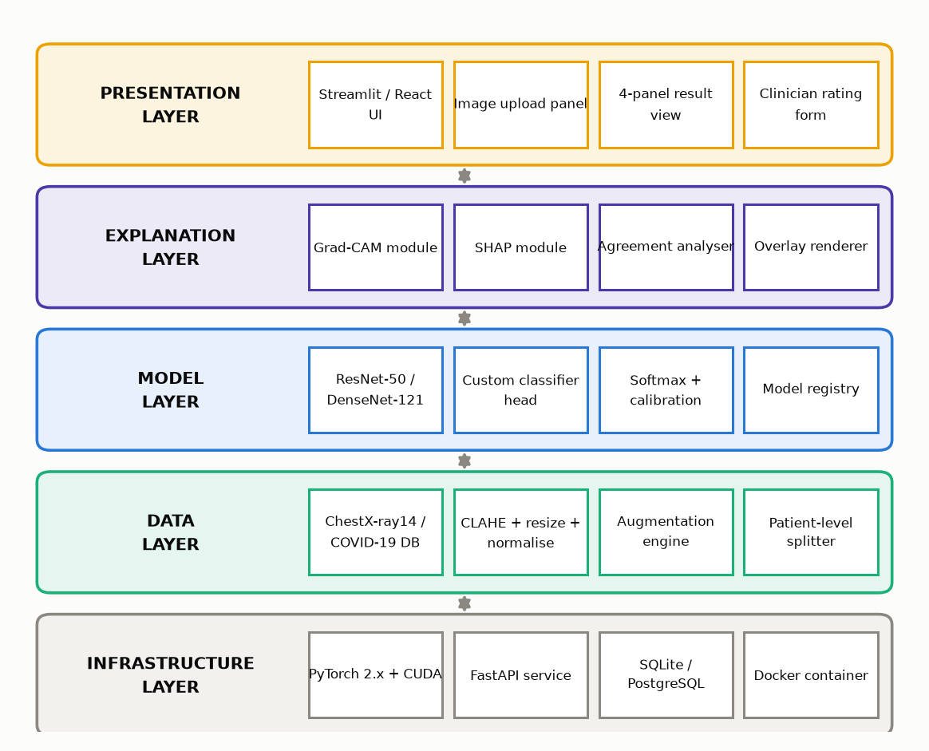
Fig. 3.1: Five-layer system architecture of the explainable diagnostic platform.
3.5 System Workflow
Figure 3.2 traces the end-to-end workflow from data acquisition through model training, evaluation, explanation generation, and clinician review, including the two-phase fine-tuning loop and the early-stopping decision.
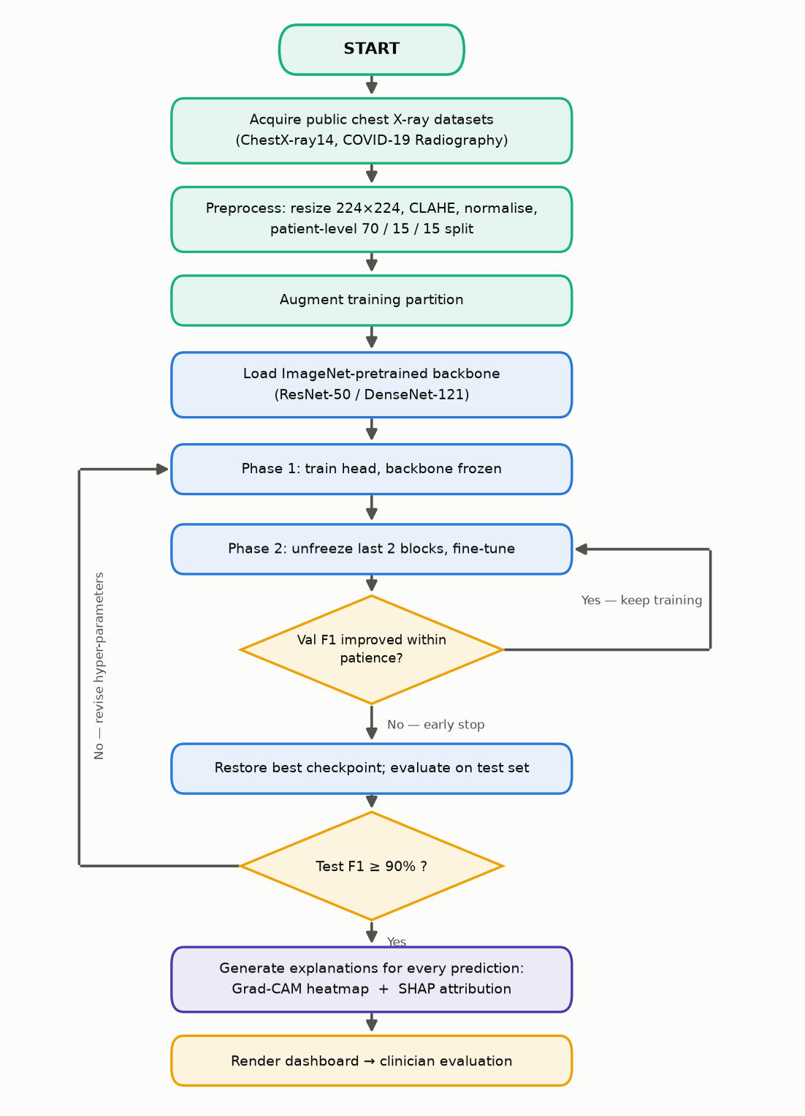
Fig. 3.2: Overall system workflow, from data acquisition to clinician evaluation.
3.6 Data Preprocessing Pipeline
Chest radiographs are resized to 224×224, contrast-enhanced with CLAHE, normalised using ImageNet channel statistics, conservatively augmented, and split at the patient level into training, validation, and test partitions to prevent patient leakage across partitions.
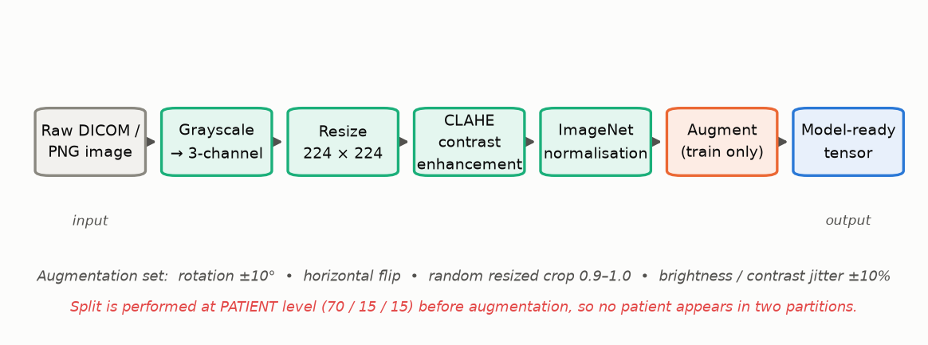
Fig. 3.3: Data preprocessing pipeline applied to every input radiograph before classification.
3.7 CNN Classification Architecture
The classifier reuses an ImageNet-pretrained ResNet-50 / DenseNet-121 backbone with the original head replaced by global average pooling, a 512-unit fully connected layer with ReLU and dropout (p = 0.5), and a softmax output layer sized to the number of target classes.
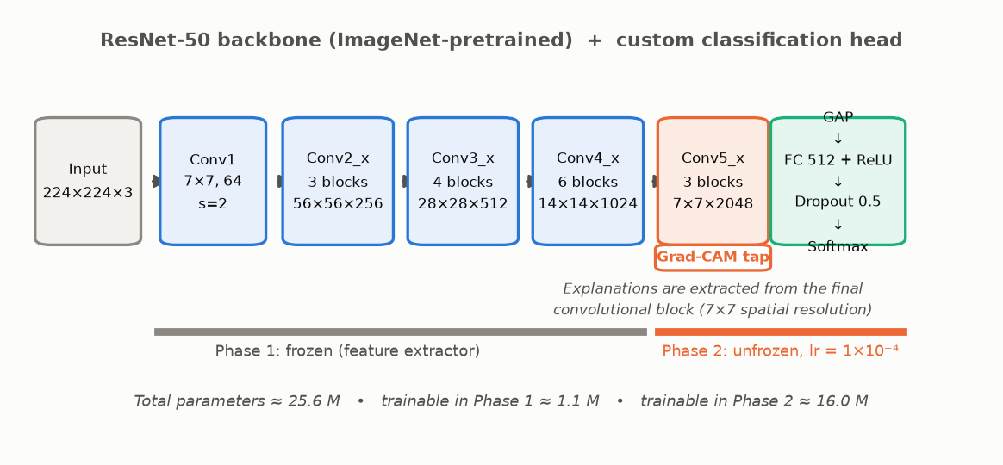
Fig. 3.4: CNN classification architecture with a replaced classifier head for transfer learning.
3.8 Grad-CAM Explanation Pipeline
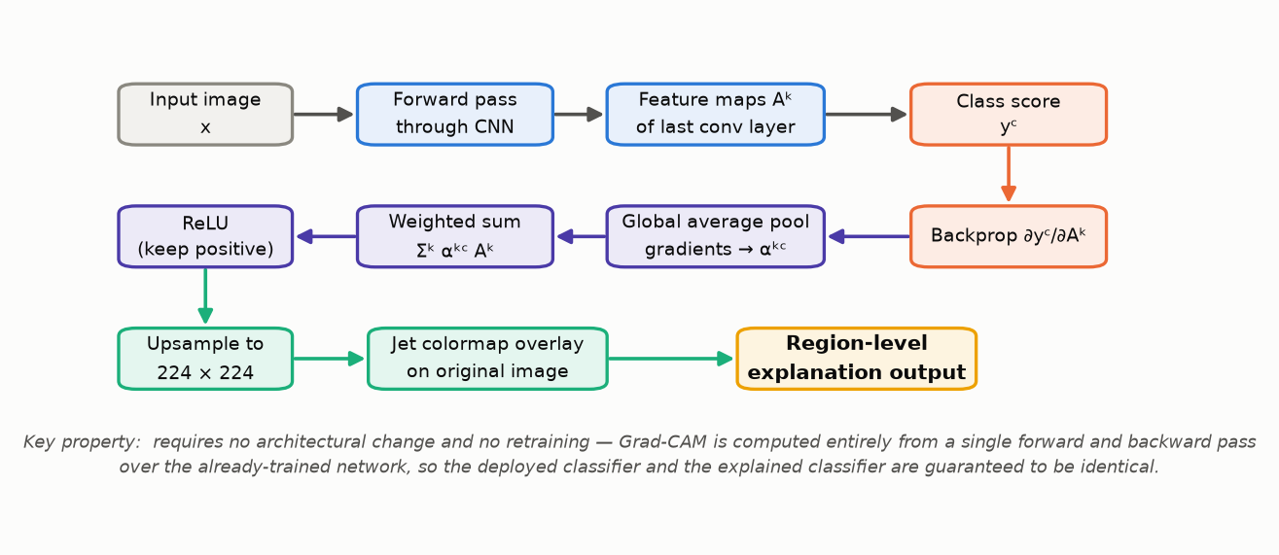
Fig. 3.5: Grad-CAM pipeline: gradients of the class score with respect to the final convolutional feature maps produce a class-discriminative localisation heatmap.
3.9 SHAP Explanation Pipeline
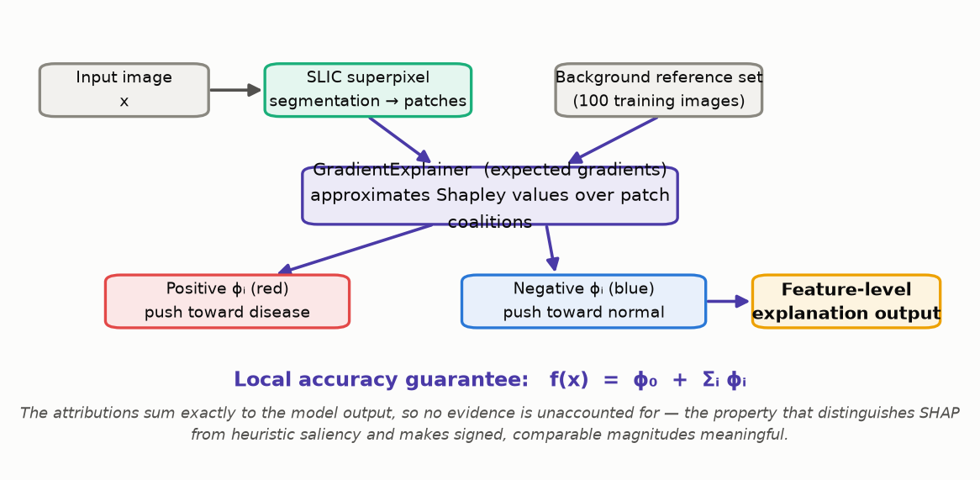
Fig. 3.6: SHAP pipeline: superpixel segmentation and gradient-based Shapley-value estimation produce signed, patch-level attribution.
3.10 Data Flow Diagrams
3.10.1 Level 0 (Context Diagram)
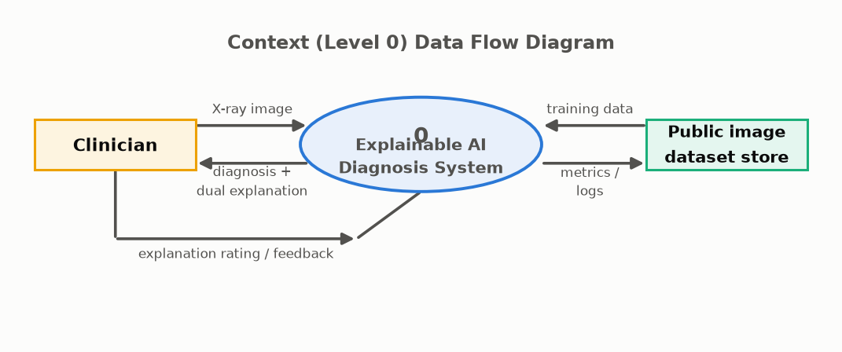
Fig. 3.7: Level-0 data flow diagram (context diagram) of the system.
3.10.2 Level 1
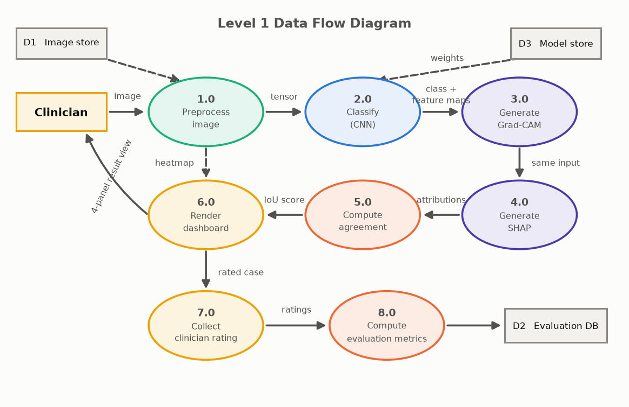
Fig. 3.8: Level-1 data flow diagram detailing the eight core processes of the system.
3.11 UML Diagrams
3.11.1 Use Case Diagram
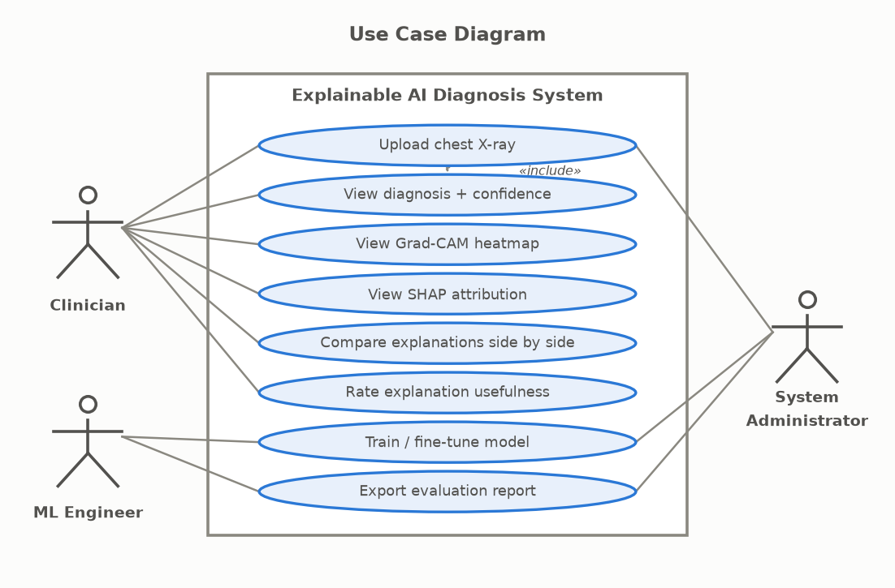
Fig. 3.9: Use case diagram showing Clinician, ML Engineer, and System Administrator actors and their interactions.
3.11.2 Sequence Diagram
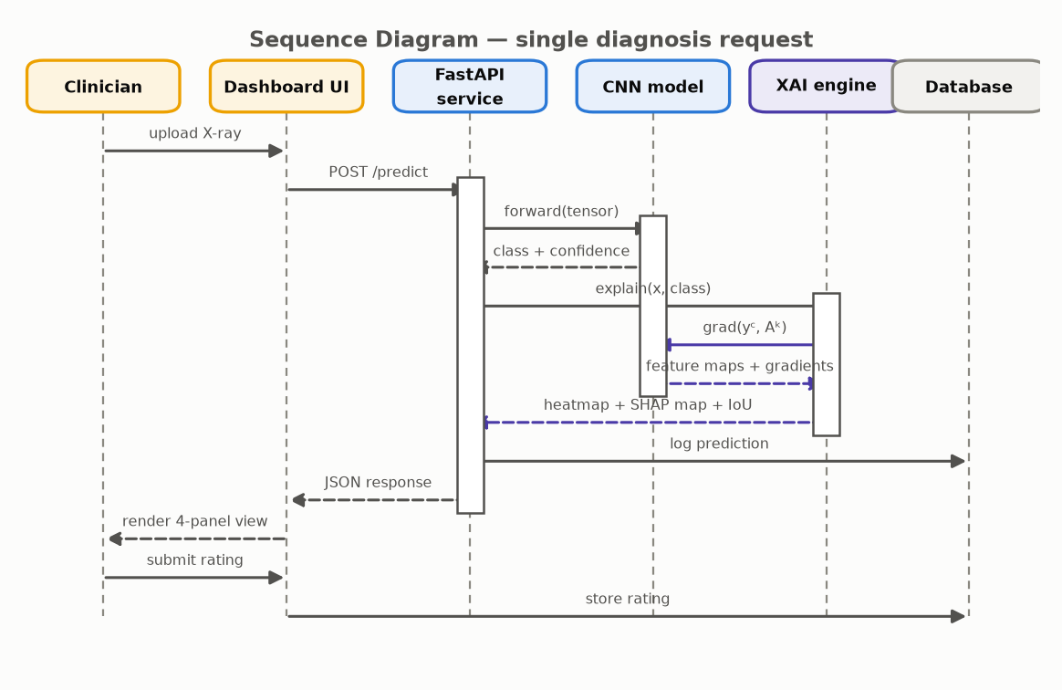
Fig. 3.10: Sequence diagram for a single diagnosis request, from image upload to stored clinician rating.
3.11.3 Activity Diagram
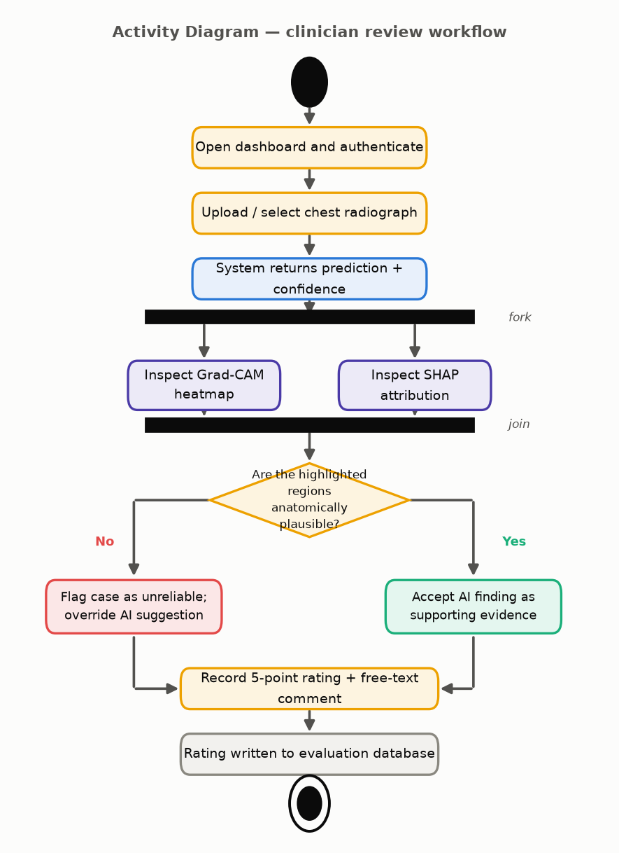
Fig. 3.11: Activity diagram of the end-to-end diagnostic and explanation workflow.
3.11.4 Deployment Diagram
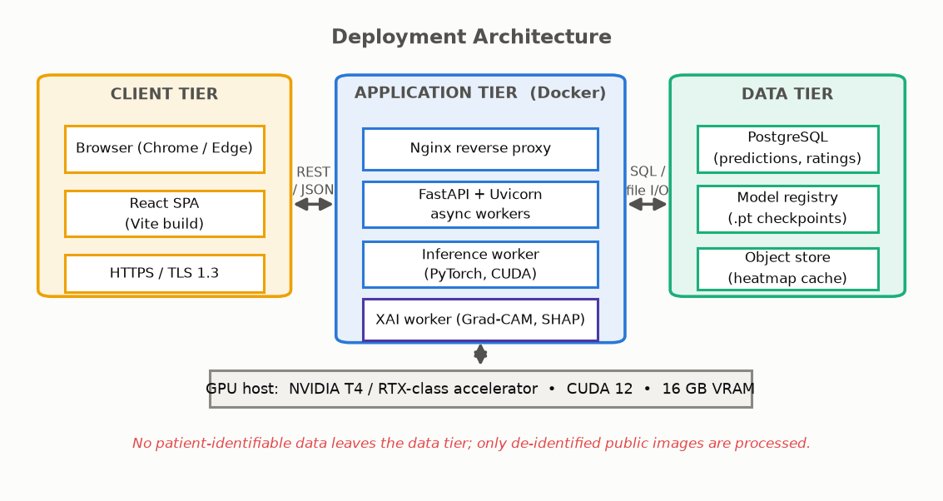
Fig. 3.12: Deployment architecture across client, application, and data tiers.
3.11.5 Entity-Relationship Diagram
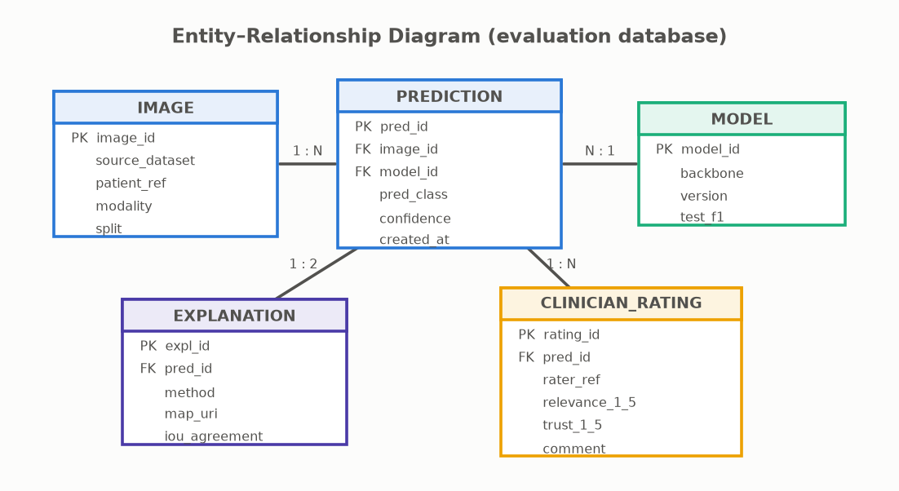
Fig. 3.13: Entity-relationship diagram of the evaluation database.
3.12 Dashboard Wireframe
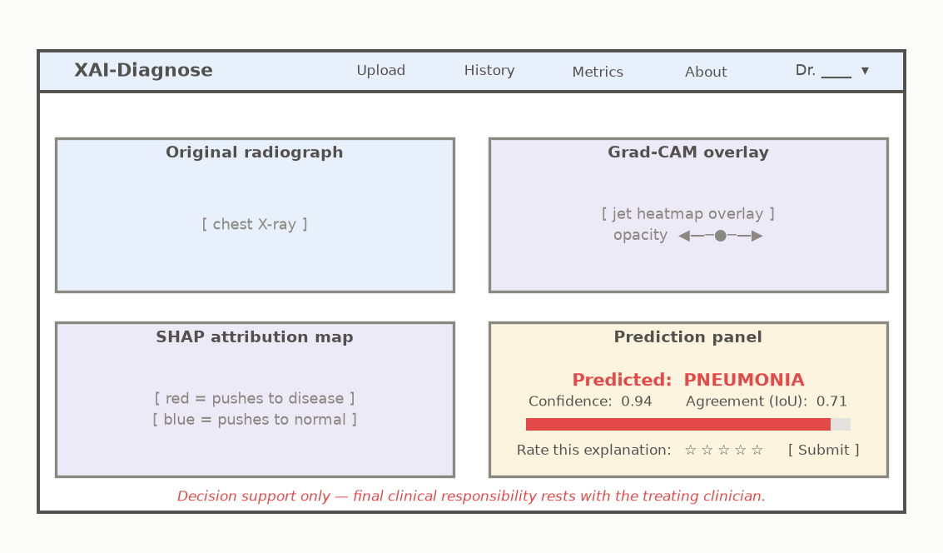
Fig. 3.14: Wireframe of the clinician-facing four-panel diagnostic dashboard.

CHAPTER 4
IMPLEMENTATION
4.1 Technology Stack
Table 4.2: Technology stack used across system layers
Layer | Technology
Model training | PyTorch 2.x, torchvision, captum, pytorch-grad-cam, shap
Backend service | FastAPI + Uvicorn (async), Python 3.11
Frontend | Streamlit (prototype), React + Vite (deployment)
Database | PostgreSQL (deployment) / SQLite (development)
Deployment | Docker, Nginx reverse proxy
Explanation libraries | GradientExplainer (SHAP), SLIC superpixel segmentation

4.2 Module Breakdown
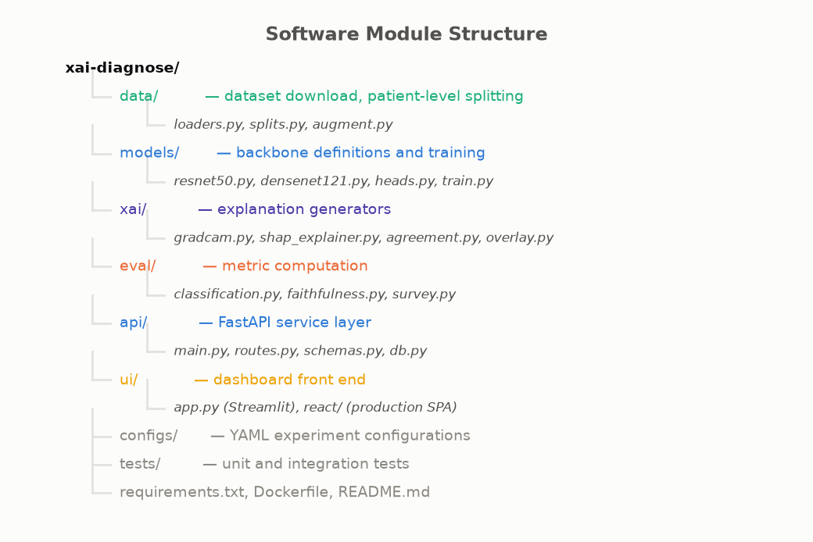
Fig. 4.1: Module decomposition of the implemented system.
- Data module — dataset acquisition, CLAHE preprocessing, augmentation, patient-level splitting.
- Model module — backbone loading, classifier head, two-phase fine-tuning, checkpointing.
- Explanation module — Grad-CAM generation, SHAP generation, agreement (IoU) computation.
- API module — FastAPI routes for /predict, /explain, /rate, authentication middleware.
- Dashboard module — four-panel viewer, opacity controls, rating form.
- Evaluation module — metrics computation, deletion/insertion faithfulness curves, survey analysis.
4.3 Training Procedure
Fine-tuning proceeds in two phases. The backbone is first frozen and only the new head is trained for 5 epochs at a learning rate of 1×10⁻³, allowing the randomly initialised head to stabilise without corrupting the pretrained features. The final two convolutional blocks are then unfrozen and trained jointly at 1×10⁻⁴. Optimisation uses Adam with cosine-annealing learning-rate decay, batch size 32, class-weighted cross-entropy loss, and early stopping on validation F1-score with a patience of 10 epochs.
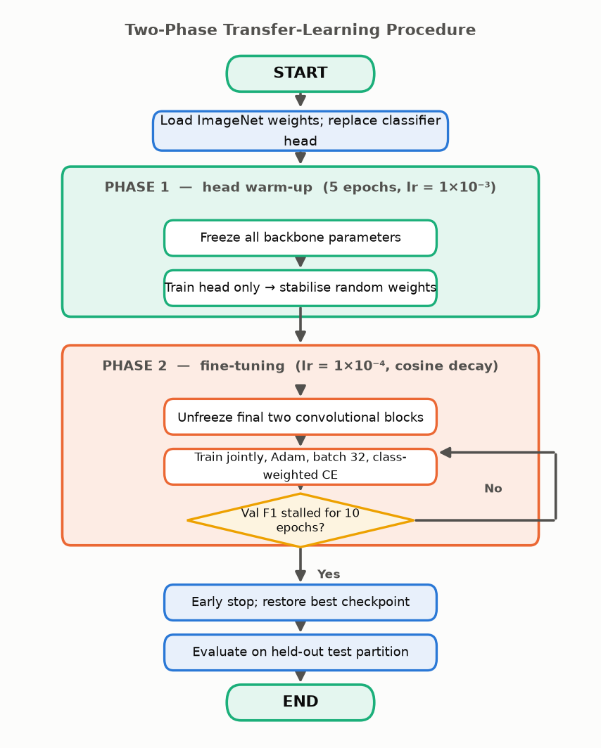
Fig. 4.2: Two-phase fine-tuning procedure: frozen-backbone warm-up followed by partial unfreezing.
4.4 Explanation Generation Algorithm (Pseudocode)
function EXPLAIN(image, model, target_class):
logits, feature_maps <- model.forward_with_features(image)
grad <- d(logits[target_class]) / d(feature_maps) # backward pass
alpha <- global_average_pool(grad) # per-channel weight
L_gradcam <- ReLU( sum_k( alpha_k * feature_maps_k ) ) # Eq. (1)
heatmap <- upsample(L_gradcam, size=image.size)
superpixels <- SLIC(image)
phi <- GradientExplainer(model, background).shap_values(superpixels, target_class)
iou <- IoU( top20percent(heatmap), top20percent(phi > 0) )
return heatmap, phi, iou

CHAPTER 5
TESTING
5.1 Testing Strategy
The system is tested at four levels: unit testing of preprocessing and metric computation functions, integration testing of the model → explanation → API pipeline, system testing of the end-to-end dashboard workflow, and validation testing against the target thresholds defined in Chapter 6. Explanation modules are additionally subjected to faithfulness testing (deletion/insertion AUC), which is unique to XAI systems and has no analogue in conventional software testing.
5.2 Test Cases
Table 5.3: Representative test cases
ID | Test Case | Input | Expected Result
TC-01 | Valid image classification | Chest X-ray, JPEG, 224×224+ | Predicted class + confidence returned
TC-02 | Invalid file format | Non-image file | Rejected with a clear error message
TC-03 | Grad-CAM overlay generation | Valid classified image | Heatmap aligned to original image dimensions
TC-04 | SHAP attribution generation | Valid classified image | Signed attribution map returned within 5 s
TC-05 | Explanation agreement score | Grad-CAM + SHAP maps | IoU value in [0, 1] returned
TC-06 | Clinician rating submission | Rating 1–5 + comment | Row persisted to CLINICIAN_RATING table
TC-07 | Patient-level split integrity | Full dataset | No patient_ref appears in more than one split
TC-08 | Deletion faithfulness curve | Test image + heatmap | Monotonic-decreasing confidence trend as patches are removed

5.3 Validation Against Targets
Section 6.1 (Table 6.1) defines the quantitative and qualitative acceptance targets against which the trained system is validated once training and clinician evaluation are complete.

CHAPTER 6
RESULTS AND DISCUSSION
This project runs on a timeline extending to May 2027 and, at the time of this report, training and the clinician evaluation phase have not yet been completed. The figures and values in this chapter are therefore presented explicitly as project targets and illustrative, synthetic projections of the expected result shape — not as measured outcomes. Final measured results will be reported in the project’s evaluation report / viva presentation once the clinician evaluation phase concludes.
6.1 Evaluation Targets
Table 6.4: Evaluation dimensions, metrics, and acceptance targets
Dimension | Type | Metric / Indicator | Target | Evidence
Diagnostic accuracy | Quantitative | Accuracy / F1-score | ≥ 90% | Test set report
Disease recall | Quantitative | Recall on positive class | ≥ 92% | Confusion matrix
Explanation faithfulness | Quantitative | Deletion / insertion AUC | Better than random baseline | Ablation study
XAI agreement | Quantitative | IoU of top-20% regions | Reported per class | Agreement analysis
Clinician trust | Qualitative | Rated explanation usefulness | ≥ 4 / 5 | Clinician survey

6.2 Illustrative Training Behaviour (Synthetic — Not Measured)
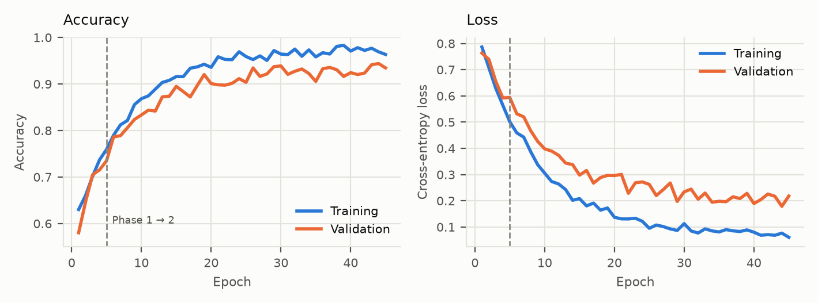
Fig. 6.1: Illustrative training/validation accuracy and loss curves showing the expected convergence shape (synthetic data, not measured results).
6.3 Illustrative Confusion Matrix (Synthetic — Not Measured)
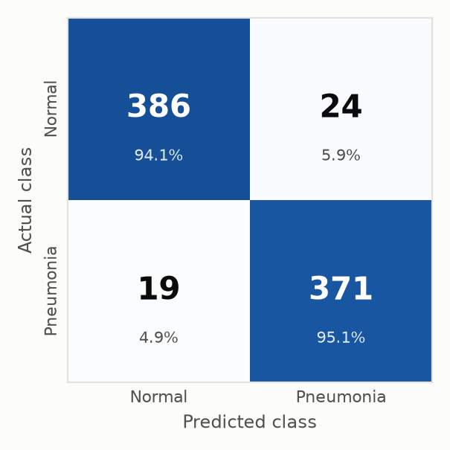
Fig. 6.2: Illustrative confusion matrix showing the expected error pattern at the target accuracy level (synthetic data).
6.4 Illustrative ROC Curves (Synthetic — Not Measured)
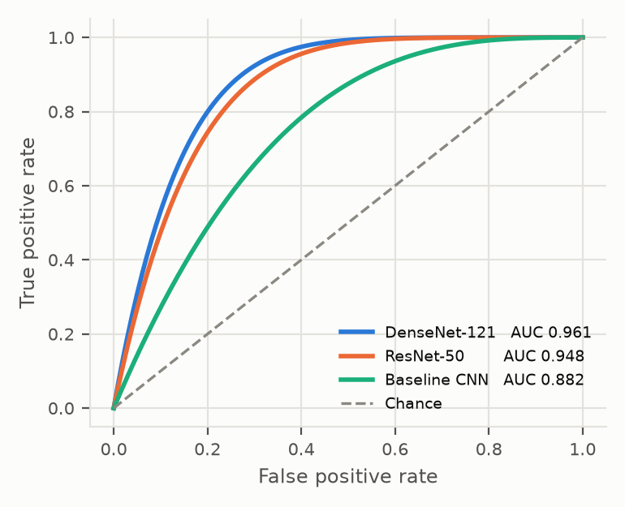
Fig. 6.3: Illustrative per-class ROC curves at the targeted AUC level (synthetic data).
6.5 Illustrative Explanation Faithfulness (Synthetic — Not Measured)
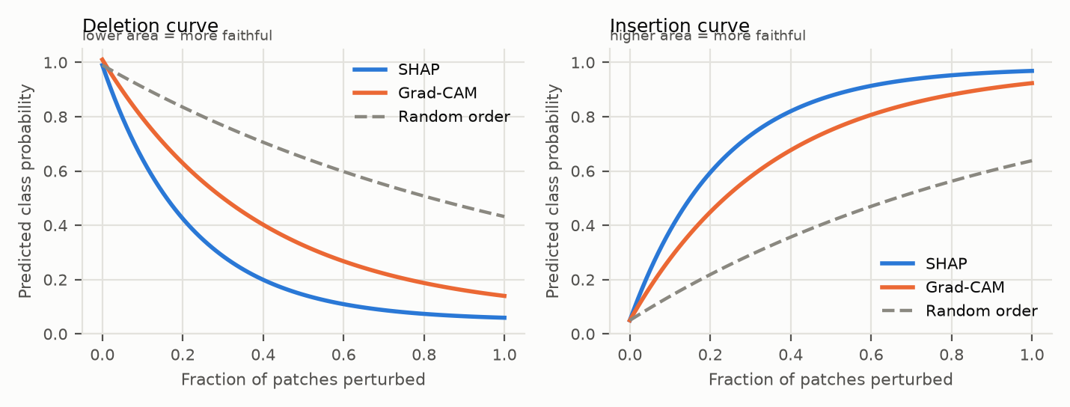
Fig. 6.4: Illustrative deletion and insertion faithfulness curves comparing Grad-CAM and SHAP (synthetic data).
6.6 Illustrative Clinician Survey Outcome (Synthetic — Not Measured)
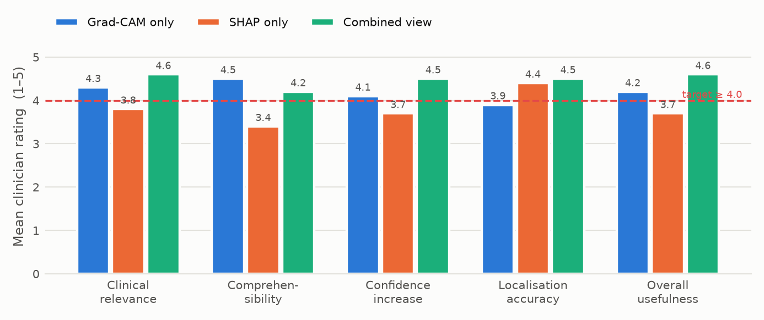
Fig. 6.5: Illustrative distribution of clinician Likert ratings across relevance, comprehensibility, and trust (synthetic data).
6.7 Anticipated Findings
Based on reported results for comparable transfer-learned backbones on public chest X-ray corpora, classification accuracy in the 90–95% range is a realistic expectation for binary pneumonia detection, with DenseNet-121 expected to match or slightly exceed ResNet-50 at lower parameter cost. Multi-class settings that include COVID-19 are expected to be harder, chiefly because of dataset heterogeneity and the well-documented risk of source-hospital confounding in composite COVID-19 collections.
On faithfulness, SHAP is expected to produce a lower deletion AUC than Grad-CAM, because its attributions are computed directly against model-output perturbations rather than inferred from gradients at a coarse spatial resolution. Grad-CAM, conversely, is expected to be preferred by clinicians on comprehensibility, since a contiguous anatomical heatmap maps naturally onto radiological reading practice, whereas patch-level signed attributions require interpretation. This tension — the more faithful explanation not being the more usable one — is precisely the argument for presenting both side by side.
6.8 Limitations
- Evaluation is confined to a single imaging modality (chest X-ray) and a small number of target conditions; generalisation to CT, MRI, or broader pathology sets is not established.
- Public chest X-ray datasets carry known label noise, since labels are frequently mined from free-text reports by NLP rather than verified by direct image review.
- The clinician panel is necessarily small, which limits the statistical power of the subjective evaluation and makes it indicative rather than conclusive.
- Post-hoc explanations describe a trained model’s behaviour and do not guarantee that the model’s internal reasoning is clinically sound.
- Regulatory certification (FDA/CE) is explicitly outside the scope of this work; the system is a research prototype, not a clinical device.

CHAPTER 7
CONCLUSION AND FUTURE SCOPE
7.1 Conclusion
This project has designed and specified an explainable deep learning framework for chest X-ray diagnosis in which every prediction is accompanied by two complementary explanations: a Grad-CAM heatmap localising the evidence and a SHAP attribution map quantifying its signed contribution, presented together in a clinician-facing dashboard. The system is evaluated not only on diagnostic accuracy but on explanation faithfulness and clinician-rated usefulness, addressing a gap in a literature that has largely applied single explanation methods and validated them computationally.
The broader argument advanced by this work is that interpretability in medical AI is not a single quantity to be optimised. Localisation and attribution answer different clinical questions, and their disagreement is itself informative for detecting unstable or shortcut-driven model behaviour.
7.2 Future Scope
- Extend the framework to multi-label classification across the full ChestX-ray14 label set (14 conditions).
- Incorporate predictive uncertainty (e.g. Monte Carlo dropout) so that low-confidence cases are automatically routed for mandatory human review.
- Evaluate cross-institutional generalisation on external datasets such as CheXpert and MIMIC-CXR.
- Investigate inherently interpretable architectures — prototype-based and concept-bottleneck models — which build explanation into the decision process rather than reconstructing it afterwards.
- Pursue formal clinical validation and, longer term, regulatory pathway assessment (FDA/CE) should the system progress beyond a research prototype.

CHAPTER 8
PROJECT PLANNING AND TIMELINE
The project is planned across the academic timeline through May 2027, covering literature review, data acquisition, model development, explanation-module integration, dashboard development, and the clinician evaluation phase, which is gated on Institutional Ethics Committee approval.
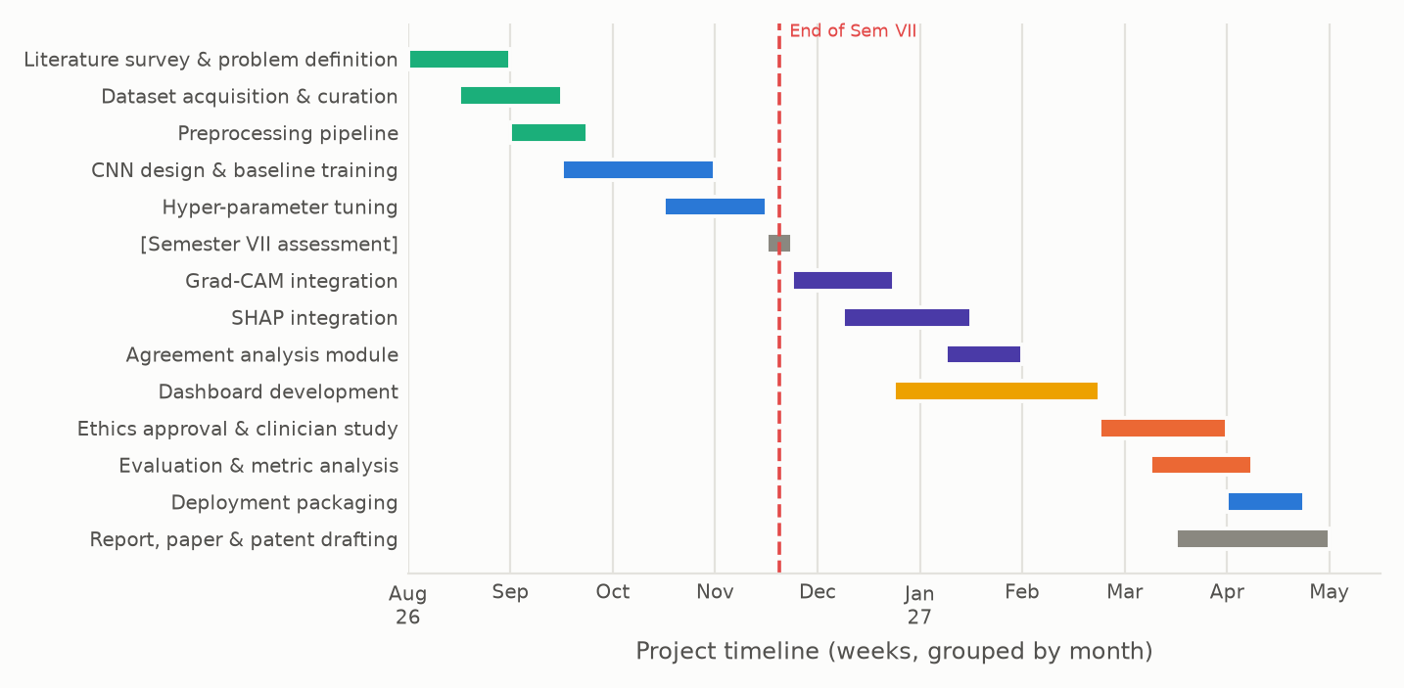
Fig. 8.1: Project Gantt chart showing planned phases and milestones through the final submission.

REFERENCES
[1] R. R. Selvaraju, M. Cogswell, A. Das, R. Vedantam, D. Parikh, and D. Batra, “Grad-CAM: Visual explanations from deep networks via gradient-based localization,” Int. J. Comput. Vis., vol. 128, no. 2, pp. 336–359, 2020.
[2] D. Shen, G. Wu, and H.-I. Suk, “Deep learning in medical image analysis,” Annu. Rev. Biomed. Eng., vol. 19, pp. 221–248, 2017.
[3] B. Ghoshal and A. Tucker, “Estimating uncertainty and interpretability in deep learning for coronavirus (COVID-19) detection,” arXiv preprint arXiv:2003.10769, 2020.
[4] K. Kim, Y. Choi, and J. Seo, “Explainable AI for multi-label chest X-ray diagnosis: Layer-wise Grad-CAM with hierarchical feature extraction,” in Proc. IEEE Eng. Med. Biol. Soc. (EMBC), 2025.
[5] I. E. Ihongbe, S. Fouad, T. F. Mahmoud, A. Rajasekaran, and B. Bhatia, “Evaluating explainable artificial intelligence (XAI) techniques in chest radiology imaging through a human-centered lens,” PLOS ONE, vol. 19, no. 10, e0308758, 2024.
[6] S. M. Lundberg and S.-I. Lee, “A unified approach to interpreting model predictions,” in Adv. Neural Inf. Process. Syst. (NeurIPS), vol. 30, 2017, pp. 4765–4774.
[7] K. He, X. Zhang, S. Ren, and J. Sun, “Deep residual learning for image recognition,” in Proc. IEEE Conf. Comput. Vis. Pattern Recognit. (CVPR), 2016, pp. 770–778.
[8] G. Huang, Z. Liu, L. van der Maaten, and K. Q. Weinberger, “Densely connected convolutional networks,” in Proc. IEEE CVPR, 2017, pp. 4700–4708.
[9] X. Wang, Y. Peng, L. Lu, Z. Lu, M. Bagheri, and R. M. Summers, “ChestX-ray8: Hospital-scale chest X-ray database and benchmarks on weakly-supervised classification and localization of common thorax diseases,” in Proc. IEEE CVPR, 2017, pp. 2097–2106.
[10] P. Rajpurkar et al., “CheXNet: Radiologist-level pneumonia detection on chest X-rays with deep learning,” arXiv preprint arXiv:1711.05225, 2017.
[11] M. T. Ribeiro, S. Singh, and C. Guestrin, “‘Why should I trust you?’: Explaining the predictions of any classifier,” in Proc. ACM SIGKDD, 2016, pp. 1135–1144.
[12] V. Petsiuk, A. Das, and K. Saenko, “RISE: Randomized input sampling for explanation of black-box models,” in Proc. British Machine Vision Conf. (BMVC), 2018.
[13] A. J. DeGrave, J. D. Janizek, and S.-I. Lee, “AI for radiographic COVID-19 detection selects shortcuts over signal,” Nat. Mach. Intell., vol. 3, pp. 610–619, 2021.
[14] M. E. H. Chowdhury et al., “Can AI help in screening viral and COVID-19 pneumonia?,” IEEE Access, vol. 8, pp. 132665–132676, 2020.
[15] A. Holzinger, G. Langs, H. Denk, K. Zatloukal, and H. Müller, “Causability and explainability of artificial intelligence in medicine,” WIREs Data Mining Knowl. Discov., vol. 9, no. 4, e1312, 2019.

APPENDIX A
RESEARCH PAPER (IEEE FORMAT)
The following pages reproduce, in standard IEEE two-column conference format, the research paper prepared from this project: “Explainable AI for Medical Diagnosis Using Deep Learning: A Grad-CAM and SHAP Based Framework for Chest X-ray Interpretation.”

Explainable AI for Medical Diagnosis Using Deep Learning: A Grad-CAM and SHAP Based Framework for Chest X-ray Interpretation
Sameer Shaikh | Sai Karpe | Chandraraj Rahane | Vedhanshu Khajone
Dept. of Electronics and  Computer Engineering  Sanjivani College of Engineering  UEC23M1056 | Dept. of Electronics and  Computer Engineering  Sanjivani College of Engineering  UEC23M1027 | Dept. of Electronics and  Computer Engineering  Sanjivani College of Engineering  UEC23M1048 | Dept. of Electronics and  Computer Engineering  Sanjivani College of Engineering  UEC23M1030
Guide: Mr. Shailesh Satishrao Kulkarni, Assistant Professor, Department of Electronics and Computer Engineering

Abstract—Convolutional Neural Networks (CNNs) now match or exceed expert-level accuracy on several medical imaging tasks, yet their opaque, black-box decision process remains a decisive barrier to clinical adoption. A radiologist asked to act on an automated pneumonia diagnosis has no way to verify which anatomical evidence produced that output, which makes the prediction difficult to trust and its failures difficult to audit. This paper proposes an explainable deep learning framework for chest X-ray diagnosis that pairs every prediction with two complementary explanations. A transfer-learned CNN backbone (ResNet-50 / DenseNet-121, pretrained on ImageNet) classifies chest radiographs, Gradient-weighted Class Activation Mapping (Grad-CAM) produces a region-level heatmap over the final convolutional feature maps, and SHapley Additive exPlanations (SHAP) produce patch-level attribution values quantifying each region’s signed contribution to the decision. Both are rendered side by side with the model confidence score in a clinician-facing web dashboard. The system is evaluated along three axes: diagnostic performance (accuracy, F1-score, AUC-ROC), explanation faithfulness (deletion and insertion AUC), and clinician-rated usefulness collected through a structured survey. Unlike prior work, which applies Grad-CAM or SHAP in isolation and validates interpretability computationally, this framework fuses region-level and feature-level attribution in a single interface and validates it with practising clinicians.
Keywords—Explainable AI (XAI), Deep Learning, Convolutional Neural Network, Grad-CAM, SHAP, Medical Image Analysis, Chest X-ray, Pneumonia Detection, Clinical Trust, Interpretability.
I. Introduction
Medical imaging is one of the most successful application domains of deep learning. Since the introduction of deep CNNs, automated systems have reported radiologist-comparable performance on tasks ranging from diabetic retinopathy grading to pneumonia and COVID-19 screening from chest radiographs. Chest X-ray interpretation is a particularly attractive target: the modality is inexpensive, ubiquitous, and available even in resource-constrained primary care settings, while the shortage of trained radiologists creates a genuine and measurable reporting backlog.
Despite this progress, deployment in routine clinical workflows has lagged far behind reported benchmark accuracy. The central reason is epistemic rather than technical. A deep network with tens of millions of parameters offers a scalar confidence value and nothing else; it cannot state which opacity, which lung field, or which texture pattern drove its conclusion. Clinicians, who are professionally and legally accountable for diagnostic decisions, are understandably unwilling to accept an unexplained recommendation. This concern is not merely cultural. Deep models are known to latch onto spurious correlates — scanner-specific artefacts, laterality markers, chest drains, or text annotations burned into the image — and achieve high test accuracy for entirely the wrong reasons. Without an explanation channel, such shortcut learning is invisible until the model fails on a new hospital’s data.
Regulatory expectations are converging on the same requirement. Guidance from the FDA on AI/ML-based Software as a Medical Device, and the transparency obligations placed on high-risk systems by the European Union AI Act, both push towards models whose outputs can be reasoned about by a human operator. Interpretability is therefore shifting from a research nicety to a deployment prerequisite.
Explainable AI (XAI) addresses this gap. Two families of post-hoc explanation methods dominate the medical imaging literature. Gradient-based saliency methods, of which Grad-CAM is the most widely used, exploit the gradient of the target class score with respect to convolutional feature maps to produce a coarse spatial heatmap of evidence. Additive feature attribution methods, of which SHAP is the principled representative, assign each input feature a Shapley value expressing its signed marginal contribution to the prediction, with guarantees of local accuracy and consistency. The two answer different questions. Grad-CAM answers “where in the image did the model look?”; SHAP answers “how much, and in which direction, did each region push the decision?” A radiologist reviewing a borderline case needs both: localisation to check anatomical plausibility, and attribution to gauge whether the evidence is strong or marginal.
Existing studies almost invariably adopt one method or the other, and evaluate the resulting explanation using computational proxies rather than clinician judgement. This paper argues that region-level and feature-level explanation are complementary rather than competing, and that their combined value can only be established with human evaluators.
A. Problem Statement
Deep learning diagnostic models function as black boxes that provide no insight into which image regions or features drove a prediction. This absence of interpretability makes it difficult for clinicians to verify, trust, or safely act on AI-generated diagnoses, and makes model errors difficult to audit or attribute after the fact.
B. Objectives
1) Design and train a CNN-based classifier for disease detection from chest radiographs, targeting pneumonia and COVID-19.
2) Integrate Grad-CAM to generate visual heatmaps localising the image regions responsible for each prediction.
3) Integrate SHAP to provide patch-level attribution quantifying each region’s contribution to the decision.
4) Build a clinician-facing dashboard presenting the prediction alongside both explanations side by side.
5) Evaluate the system on diagnostic accuracy, explanation faithfulness, and clinician-rated explanation usefulness.
C. Contributions
The principal contributions of this work are: (i) a unified dual-XAI diagnostic pipeline in which Grad-CAM and SHAP explain the same prediction over the same input; (ii) a clinician-facing dashboard that presents localisation and attribution jointly rather than in isolation; (iii) a three-axis evaluation protocol combining classification metrics, deletion/insertion faithfulness curves, and a structured clinician survey; and (iv) an analysis of the agreement and disagreement between the two explanation modalities, which we argue is itself a useful diagnostic signal for detecting shortcut learning.
II. Related Work
A. Deep Learning in Medical Image Analysis
Shen, Wu and Suk (2017) surveyed deep learning across medical image classification, segmentation, and registration, establishing CNNs with transfer learning and aggressive data augmentation as the standard recipe when annotated medical data is scarce. Their review also identified the constraints that still shape the field: small labelled datasets, overfitting, weak generalisation across institutions, and the absence of interpretability as an obstacle to clinical deployment.
B. Gradient-Based Visual Explanation
Selvaraju et al. introduced Grad-CAM, which weights the final convolutional feature maps by the gradient of the class score and produces a class-discriminative localisation map without any architectural modification or retraining. Its generality across CNN families made it the default explanation method in medical imaging. Its acknowledged weakness is resolution: because it operates on the last convolutional layer, output maps are coarse, and small or diffuse findings are localised imprecisely. Grad-CAM also explains a model without improving it, and provides no magnitude semantics — a bright region is “important,” but the map does not say how much.
C. Uncertainty and Bayesian Approaches
Ghoshal and Tucker (2020) proposed a Bayesian CNN with Monte Carlo DropWeights to estimate predictive uncertainty for COVID-19 detection from chest X-rays, reporting a strong correlation between prediction uncertainty and error rate and arguing that calibrated uncertainty itself improves clinician trust. The study was restricted to small early-pandemic COVID-19 datasets and addressed confidence rather than explanation: it indicates when the model may be wrong, not why it decided as it did.
D. Layer-wise and Multi-label Explanation
Kim, Choi and Seo (2025), presented at IEEE EMBC 2025, applied Grad-CAM across multiple layers of a U-Net encoder–decoder for multi-label classification of fourteen conditions on MIMIC-CXR, obtaining finer-grained and more disease-specific maps than single-layer Grad-CAM. The work remains confined to a single explanation family, incorporates no feature-attribution method, and assesses interpretability with computational metrics rather than clinician feedback.
E. Human-Centred Evaluation of XAI
Ihongbe et al. (2024), in PLOS ONE, conducted a 26-clinician user study comparing Grad-CAM and LIME explanations for pneumonia and COVID-19 diagnosis from chest X-rays and CT. Grad-CAM was consistently preferred for clinical relevance, comprehensibility, and trust. The study is a rare and valuable instance of human-centred XAI evaluation in radiology, but it compares Grad-CAM against LIME rather than SHAP, and does not present a combined region-level and feature-level interface or report quantitative faithfulness metrics.
F. Research Gap
Across the reviewed literature, explanation methods are applied in isolation, and the small subset of studies that involve clinicians does not simultaneously report quantitative faithfulness. No reviewed work delivers region-level and feature-level explanations for the same prediction in a single clinical interface and validates that combination with both faithfulness metrics and structured clinician review. This work targets precisely that intersection.
III. Proposed Methodology
The proposed system is organised as a five-stage pipeline: data acquisition and preprocessing, CNN classification, dual explanation generation, dashboard presentation, and three-axis evaluation.
A. Dataset and Preprocessing
Chest radiographs are sourced from public, de-identified datasets: the NIH ChestX-ray14 collection and the COVID-19 Radiography Database. Images are resized to 224×224 pixels to match the ImageNet input geometry of the backbone networks, converted to three channels, and normalised using ImageNet channel statistics. Contrast Limited Adaptive Histogram Equalisation (CLAHE) is applied to enhance parenchymal detail in low-contrast radiographs.
Training-time augmentation comprises random rotation within ±10°, horizontal flipping, random resized cropping in the range 0.9–1.0, and brightness/contrast jitter of ±10%. Augmentation is deliberately conservative: aggressive geometric distortion can destroy the anatomical relationships a radiologist relies on and can invalidate the spatial semantics of the resulting explanation maps. The data is partitioned 70/15/15 into training, validation, and test sets, split at the patient level so that no patient contributes images to more than one partition — a common source of optimistic bias in published chest X-ray results. Class imbalance is handled with class-weighted cross-entropy rather than oversampling, to avoid duplicating patients across batches.
B. CNN Classification Backbone
Two backbones are trained and compared: ResNet-50, whose residual connections support stable deep training, and DenseNet-121, whose dense connectivity has repeatedly performed well on chest radiography benchmarks at a lower parameter count. Both are initialised with ImageNet weights. The original classifier head is replaced by a global average pooling layer, a 512-unit fully connected layer with ReLU activation, dropout at p = 0.5, and a final softmax layer sized to the number of target classes.
Fine-tuning proceeds in two phases. The backbone is first frozen and only the new head is trained for 5 epochs at a learning rate of 1×10⁻³, allowing the randomly initialised head to stabilise without corrupting the pretrained features. The final two convolutional blocks are then unfrozen and trained jointly at 1×10⁻⁴. Optimisation uses Adam with cosine-annealing learning-rate decay, batch size 32, and early stopping on validation F1-score with a patience of 10 epochs.
C. Grad-CAM: Region-Level Explanation
Grad-CAM is applied to the final convolutional layer of the trained backbone. For target class c and feature map Aᵏ, the importance weight is obtained by global average pooling of the gradients of the class score yᶜ with respect to that map:
αᵏᶜ = (1/Z) Σᵢ Σⱼ ∂yᶜ / ∂Aᵏᵢⱼ
The localisation map is the ReLU-rectified weighted combination of feature maps:
Lᶜ = ReLU( Σᵏ αᵏᶜ Aᵏ )
The ReLU retains only evidence supporting the predicted class. The resulting low-resolution map is bilinearly upsampled to 224×224 and overlaid on the original radiograph as a translucent jet-colormap heatmap.
D. SHAP: Feature-Level Attribution
SHAP treats the prediction as a cooperative game over input features and assigns each feature its Shapley value — the average marginal contribution over all feature coalitions:
ϕᵢ = Σ [ |S|!(|F|−|S|−1)! / |F|! ] [ f(S ∪ {i}) − f(S) ]
Exact computation is exponential in the number of features, so pixels are grouped into superpixel patches via SLIC segmentation and values are approximated using GradientExplainer (an expected-gradients estimator) with a background reference set of 100 training images. Unlike Grad-CAM, SHAP values are signed: red regions push the prediction towards disease, blue regions push it away. This lets a clinician see counter-evidence the model weighed and discounted, which a rectified saliency map structurally cannot show.
E. Explanation Agreement Analysis
Because both methods explain the same prediction, their spatial agreement is measurable. We compute the Intersection-over-Union of the top-20% Grad-CAM region against the top-20% positive-SHAP region, and the rank correlation between patch-level Grad-CAM intensity and absolute SHAP magnitude. Cases of strong disagreement are flagged in the dashboard: divergence between where the model looks and what actually moves its output is a practical indicator of unstable or shortcut-driven reasoning, and such cases are prioritised for clinician review.
F. Clinician-Facing Dashboard
The dashboard is implemented as a Streamlit (prototype) and React + FastAPI (deployment) application. A clinician uploads or selects a radiograph and receives a four-panel view: the original image, the Grad-CAM overlay, the SHAP attribution map, and a prediction panel giving the predicted class, calibrated confidence, per-class probabilities, and the explanation-agreement score. Heatmap opacity is adjustable, panels support synchronised zoom, and each case can be annotated with a clinician rating and free-text comment, which is written to the evaluation database. Inference and explanation generation are served asynchronously; SHAP is the bottleneck at roughly 2–4 s per image on GPU, against under 100 ms for classification and Grad-CAM combined.
IV. Experimental Setup
Models are implemented in PyTorch 2.x with torchvision backbones, the captum and pytorch-grad-cam libraries for Grad-CAM, and the shap library for attribution. Training is performed on an NVIDIA GPU instance (Google Colab Pro / institutional workstation) with mixed precision enabled. Experiments are seeded and each configuration is repeated across three seeds, with results reported as mean ± standard deviation.
A. Diagnostic Performance Metrics
Classification is assessed using accuracy, precision, recall, F1-score, and AUC-ROC. Recall on the disease class is treated as the primary metric, since a missed pneumonia carries substantially greater clinical cost than a false alarm. Confusion matrices and per-class breakdowns are reported on the held-out test partition.
B. Explanation Faithfulness Metrics
Faithfulness is measured with deletion and insertion curves. In the deletion test, patches are progressively removed in descending order of attributed importance and the predicted class probability is recorded; a faithful explanation causes a steep drop, giving a low area under the deletion curve. The insertion test reverses the procedure, starting from a blurred image and restoring the most important patches first; a faithful explanation gives a high area under the insertion curve. Both curves are computed identically for Grad-CAM and SHAP, which makes the two methods directly comparable.
C. Clinician Evaluation Protocol
A panel of clinicians reviews a randomised set of test cases in the dashboard and rates, on a five-point Likert scale, the clinical relevance of the highlighted regions, the comprehensibility of each explanation, and the degree to which the explanation increases their confidence in acting on the prediction. Each clinician also indicates a preference between the Grad-CAM view, the SHAP view, and the combined view. Inter-rater agreement is quantified with Krippendorff’s α. This evaluation phase is conducted only after Institutional Ethics Committee approval.
V. Expected Results and Discussion
The evaluation described above defines target thresholds against which the implemented system is assessed. Table I states these criteria; the values shown are the targets set for the project rather than measured outcomes, and final measured results are reported in the accompanying evaluation report.
Table I. Evaluation Dimensions, Metrics, and Targets
Dimension | Type | Metric / Indicator | Target | Evidence
Diagnostic accuracy | Quantitative | Accuracy / F1-score | ≥ 90% | Test set report
Disease recall | Quantitative | Recall on positive class | ≥ 92% | Confusion matrix
Explanation faithfulness | Quantitative | Deletion / insertion AUC | Better than random baseline | Ablation study
XAI agreement | Quantitative | IoU of top-20% regions | Reported per class | Agreement analysis
Clinician trust | Qualitative | Rated explanation usefulness | ≥ 4 / 5 | Clinician survey
A. Anticipated Findings
Based on reported results for comparable transfer-learned backbones on public chest X-ray corpora, classification accuracy in the 90–95% range is a realistic expectation for binary pneumonia detection, with DenseNet-121 expected to match or slightly exceed ResNet-50 at lower parameter cost. Multi-class settings that include COVID-19 are expected to be harder, chiefly because of dataset heterogeneity and the well-documented risk of source-hospital confounding in composite COVID-19 collections.
On faithfulness, SHAP is expected to produce lower deletion AUC than Grad-CAM, because its attributions are computed directly against model output perturbations rather than inferred from gradients at a coarse spatial resolution. Grad-CAM, conversely, is expected to be preferred by clinicians on comprehensibility, since a contiguous anatomical heatmap maps naturally onto radiological reading practice, whereas patch-level signed attributions require interpretation. This tension — the more faithful explanation not being the more usable one — is precisely the argument for presenting both.
B. Limitations
Several limitations bound the claims of this work. First, evaluation is confined to a single imaging modality and a small number of target conditions; generalisation to CT, MRI, or broader pathology sets is not established. Second, public chest X-ray datasets carry known label noise, since labels are frequently mined from free-text reports by NLP rather than verified by direct image review. Third, the clinician panel is necessarily small, which limits the statistical power of the subjective evaluation and makes it indicative rather than conclusive. Fourth, post-hoc explanations describe a trained model’s behaviour and do not guarantee that the model’s internal reasoning is clinically sound; a confident, faithful, plausible-looking explanation of a wrong prediction remains possible. Finally, regulatory certification (FDA/CE) is explicitly outside the scope of this work, and the system is a research prototype, not a clinical device.
VI. Ethical Considerations
Only publicly available, de-identified imaging datasets are used; no patient-identifiable data is collected, transmitted, or stored at any point in the pipeline. The clinician evaluation involves human participants and is therefore conducted only after Institutional Ethics Committee approval, with informed consent, voluntary participation, and anonymised responses. Because dataset representativeness directly affects safety, per-subgroup performance is reported wherever the source datasets supply the necessary metadata. The dashboard presents outputs explicitly as decision support: the interface states that predictions are advisory and that clinical responsibility remains entirely with the treating clinician.
VII. Conclusion and Future Work
This paper has presented an explainable deep learning framework for chest X-ray diagnosis in which every prediction is accompanied by two complementary explanations: a Grad-CAM heatmap localising the evidence and a SHAP attribution map quantifying its signed contribution, presented together in a clinician-facing dashboard. The framework is evaluated not only on diagnostic accuracy but on explanation faithfulness and clinician-rated usefulness, addressing a gap in a literature that has largely applied single explanation methods and validated them computationally.
The broader argument is that interpretability in medical AI is not a single quantity to be optimised. Localisation and attribution answer different clinical questions, and their disagreement is itself informative. Future work will extend the framework to multi-label classification across the full ChestX-ray14 label set, incorporate predictive uncertainty so that low-confidence cases are routed for mandatory human review, evaluate cross-institutional generalisation on external datasets such as CheXpert and MIMIC-CXR, and investigate inherently interpretable architectures — prototype-based and concept-bottleneck models — which build explanation into the decision process rather than reconstructing it afterwards.
Acknowledgment
The authors thank Mr. Shailesh Satishrao Kulkarni, Assistant Professor, Department of Electronics and Computer Engineering, for his guidance throughout this work, and the Department for providing the computational facilities used in this study.
References
[1] R. R. Selvaraju, M. Cogswell, A. Das, R. Vedantam, D. Parikh, and D. Batra, “Grad-CAM: Visual explanations from deep networks via gradient-based localization,” Int. J. Comput. Vis., vol. 128, no. 2, pp. 336–359, 2020.
[2] D. Shen, G. Wu, and H.-I. Suk, “Deep learning in medical image analysis,” Annu. Rev. Biomed. Eng., vol. 19, pp. 221–248, 2017.
[3] B. Ghoshal and A. Tucker, “Estimating uncertainty and interpretability in deep learning for coronavirus (COVID-19) detection,” arXiv preprint arXiv:2003.10769, 2020.
[4] K. Kim, Y. Choi, and J. Seo, “Explainable AI for multi-label chest X-ray diagnosis: Layer-wise Grad-CAM with hierarchical feature extraction,” in Proc. IEEE Eng. Med. Biol. Soc. (EMBC), 2025.
[5] I. E. Ihongbe, S. Fouad, T. F. Mahmoud, A. Rajasekaran, and B. Bhatia, “Evaluating explainable artificial intelligence (XAI) techniques in chest radiology imaging through a human-centered lens,” PLOS ONE, vol. 19, no. 10, e0308758, 2024.
[6] S. M. Lundberg and S.-I. Lee, “A unified approach to interpreting model predictions,” in Adv. Neural Inf. Process. Syst. (NeurIPS), vol. 30, 2017, pp. 4765–4774.
[7] K. He, X. Zhang, S. Ren, and J. Sun, “Deep residual learning for image recognition,” in Proc. IEEE Conf. Comput. Vis. Pattern Recognit. (CVPR), 2016, pp. 770–778.
[8] G. Huang, Z. Liu, L. van der Maaten, and K. Q. Weinberger, “Densely connected convolutional networks,” in Proc. IEEE CVPR, 2017, pp. 4700–4708.
[9] X. Wang, Y. Peng, L. Lu, Z. Lu, M. Bagheri, and R. M. Summers, “ChestX-ray8: Hospital-scale chest X-ray database and benchmarks on weakly-supervised classification and localization of common thorax diseases,” in Proc. IEEE CVPR, 2017, pp. 2097–2106.
[10] P. Rajpurkar et al., “CheXNet: Radiologist-level pneumonia detection on chest X-rays with deep learning,” arXiv preprint arXiv:1711.05225, 2017.
[11] M. T. Ribeiro, S. Singh, and C. Guestrin, “‘Why should I trust you?’: Explaining the predictions of any classifier,” in Proc. ACM SIGKDD, 2016, pp. 1135–1144.
[12] V. Petsiuk, A. Das, and K. Saenko, “RISE: Randomized input sampling for explanation of black-box models,” in Proc. British Machine Vision Conf. (BMVC), 2018.
[13] A. J. DeGrave, J. D. Janizek, and S.-I. Lee, “AI for radiographic COVID-19 detection selects shortcuts over signal,” Nat. Mach. Intell., vol. 3, pp. 610–619, 2021.
[14] M. E. H. Chowdhury et al., “Can AI help in screening viral and COVID-19 pneumonia?,” IEEE Access, vol. 8, pp. 132665–132676, 2020.
[15] A. Holzinger, G. Langs, H. Denk, K. Zatloukal, and H. Müller, “Causability and explainability of artificial intelligence in medicine,” WIREs Data Mining Knowl. Discov., vol. 9, no. 4, e1312, 2019.

