A PROJECT REPORT ON
Explainable AI for Medical Diagnosis Using Deep Learning:
A Grad-CAM and SHAP Based Framework for Chest X-ray Interpretation
Submitted in partial fulfilment of the requirements for the award of the degree of
BACHELOR OF TECHNOLOGY
in
Electronics and Computer Engineering
By
Sameer Shaikh (UEC23M1056)
Sai Karpe (UEC23M1027)
Chandraraj Rahane (UEC23M1048)
Vedhanshu Khajone (UEC23M1030)

Under the Guidance of
Mr. Shailesh Satishrao Kulkarni
Assistant Professor, Department of Electronics and Computer Engineering
DEPARTMENT OF ELECTRONICS AND COMPUTER ENGINEERING
SANJIVANI COLLEGE OF ENGINEERING, KOPARGAON
(An Autonomous Institute Affiliated to Savitribai Phule Pune University)
2026 – 2027

CERTIFICATE
This is to certify that the project report entitled “Explainable AI for Medical Diagnosis Using Deep Learning: A Grad-CAM and SHAP Based Framework for Chest X-ray Interpretation” is a bona fide record of the work carried out by Sameer Shaikh (UEC23M1056), Sai Karpe (UEC23M1027), Chandraraj Rahane (UEC23M1048), and Vedhanshu Khajone (UEC23M1030), students of Bachelor of Technology in Electronics and Computer Engineering, under our supervision, in partial fulfilment of the requirements for the award of the said degree.
The results embodied in this report have not been submitted to any other University or Institute for the award of any degree or diploma.

Guide  Mr. Shailesh Satishrao Kulkarni  Assistant Professor | Head of Department  Department of Electronics and Computer Engineering

External Examiner

DECLARATION
We hereby declare that the project report titled “Explainable AI for Medical Diagnosis Using Deep Learning: A Grad-CAM and SHAP Based Framework for Chest X-ray Interpretation”, submitted for the award of the degree of Bachelor of Technology in Electronics and Computer Engineering, is our own original work carried out under the guidance of Mr. Shailesh Satishrao Kulkarni. All sources of information used in this report have been duly acknowledged. The work presented has not been submitted, in part or in full, for the award of any other degree or diploma of this or any other institution.

Sameer Shaikh (UEC23M1056)
Sai Karpe (UEC23M1027)
Chandraraj Rahane (UEC23M1048)
Vedhanshu Khajone (UEC23M1030)

ACKNOWLEDGEMENT
We express our sincere gratitude to our guide, Mr. Shailesh Satishrao Kulkarni, Assistant Professor, Department of Electronics and Computer Engineering, for his invaluable guidance, constant encouragement, and constructive criticism throughout the course of this project. His insight was instrumental in shaping both the technical direction of the work and the discipline with which it was evaluated.
We are grateful to the Head of Department and the faculty of the Department of Electronics and Computer Engineering for providing the infrastructure, computational resources, and academic environment necessary to carry out this work. We also thank our institution, Sanjivani College of Engineering, Kopargaon, for the opportunity to pursue this project as part of our final-year curriculum.
Finally, we thank our families and peers for their continual support and encouragement throughout the duration of this project.
— Sameer Shaikh, Sai Karpe, Chandraraj Rahane, Vedhanshu Khajone

ABSTRACT
Convolutional Neural Networks (CNNs) now match or exceed expert-level accuracy on several medical imaging tasks, yet their opaque, black-box decision process remains a decisive barrier to clinical adoption. A clinician asked to act on an automated diagnosis has no way of verifying which anatomical evidence produced that output, which makes the prediction difficult to trust and its failures difficult to audit. This project designs, implements, and evaluates an explainable deep learning framework for chest X-ray diagnosis that pairs every prediction with two complementary, human-interpretable explanations.
A transfer-learned DenseNet-121 backbone (ImageNet-pretrained, fine-tuned in two stages on the Kermany paediatric chest radiograph corpus of 5,856 images) classifies chest X-rays for pneumonia. Seven explanation methods are implemented behind a single registry — Grad-CAM, Grad-CAM++, Score-CAM, Integrated Gradients, Occlusion, SHAP, and an intrinsic attention map read directly from the pooling head — so that explanations are compared on measured evidence rather than assumed to be equivalent. Grad-CAM answers where the model looked; SHAP assigns signed, patch-level attributions quantifying how much and in which direction each region influenced the decision. Every prediction additionally carries a split-conformal prediction set with a calibrated coverage guarantee, and the system abstains explicitly whenever that set is not a single label. All of this is served through a clinician-facing case reader built with Flask.
The system is evaluated along three axes: diagnostic performance (AUROC with bootstrap confidence intervals, sensitivity, specificity, Brier score, conformal coverage), explanation faithfulness (deletion and insertion AUC, ROAD), and explanation trustworthiness (the cascading- and label-randomization sanity checks of Adebayo et al.). A shortcut-learning audit probes whether the classifier relies on image borders, laterality markers, or global image statistics rather than lung-field evidence. The headline result is that the most faithful explanation is not the most expensive one: Grad-CAM records the best deletion AUC of the seven methods at 0.7 s per image, while Integrated Gradients and SHAP score worst on faithfulness despite costing 3.5 s and 29.8 s, and Integrated Gradients additionally fails the sanity checks. This report documents the complete system analysis, design, implementation, and measured evaluation, and includes the accompanying IEEE-format research paper as an appendix.
Keywords: Explainable AI (XAI), Deep Learning, Convolutional Neural Network, Grad-CAM, SHAP, Integrated Gradients, Sanity Checks, Conformal Prediction, Medical Image Analysis, Chest X-ray, Clinical Trust, Interpretability.

TABLE OF CONTENTS
Chapter Chapter Title
Chapter 1 Introduction
Chapter 2 Literature Survey
Chapter 3 System Analysis and Design
Chapter 4 Implementation
Chapter 5 Testing
Chapter 6 Results and Discussion
Chapter 7 Conclusion and Future Scope
Chapter 8 Project Planning and Timeline
— References
Appendix A Research Paper (IEEE Format)

LIST OF FIGURES
(Figure numbers and captions are listed in sequence in the body of the report; right-click and choose “Update Field” in Word after inserting a Table of Figures, or refer to the numbered captions under each figure.)

LIST OF TABLES
(Table numbers and captions are listed in sequence in the body of the report.)

CHAPTER 1
INTRODUCTION
1.1 Overview
Medical imaging is one of the most successful application domains of deep learning. Since the introduction of deep Convolutional Neural Networks (CNNs), automated systems have reported radiologist-comparable performance on tasks ranging from diabetic retinopathy grading to pneumonia and COVID-19 screening from chest radiographs. Chest X-ray interpretation is a particularly attractive target for automation: the modality is inexpensive, ubiquitous, and available even in resource-constrained primary-care settings, while the global shortage of trained radiologists creates a genuine and measurable reporting backlog.
Despite this progress, deployment of deep learning diagnostic tools in routine clinical workflows has lagged far behind reported benchmark accuracy. The central reason is epistemic rather than purely technical: a deep network with tens of millions of parameters offers a scalar confidence value and nothing else. It cannot state which opacity, which lung field, or which texture pattern drove its conclusion. Clinicians, who are professionally and legally accountable for diagnostic decisions, are understandably unwilling to act on an unexplained recommendation.
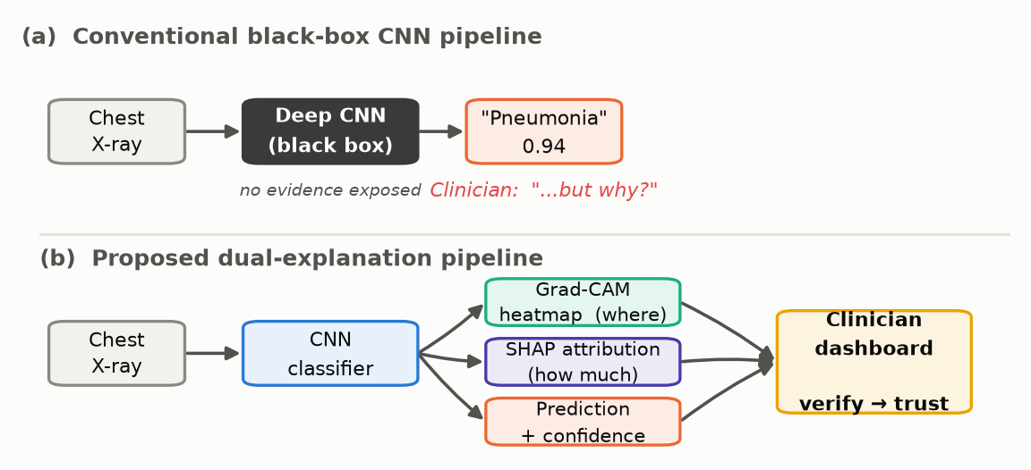
Fig. 1.1: The black-box problem — a deep model produces a confident diagnosis with no supporting evidence a clinician can verify.
1.2 Motivation
Deep models are known to latch onto spurious correlates — scanner-specific artefacts, laterality markers, chest drains, or text annotations burned into the image — and achieve high test accuracy for entirely the wrong reasons. Without an explanation channel, such shortcut learning is invisible until the model fails on a new hospital’s data. Regulatory expectations are converging on the same requirement: guidance from the FDA on AI/ML-based Software as a Medical Device, and the transparency obligations placed on high-risk systems by the European Union AI Act, both push towards models whose outputs can be reasoned about by a human operator. Interpretability is therefore shifting from a research nicety to a deployment prerequisite, and it is this shift that motivates the present project.
Explainable AI (XAI) addresses this gap. Two families of post-hoc explanation methods dominate the medical imaging literature. Gradient-based saliency methods, of which Grad-CAM is the most widely used, exploit the gradient of the target class score with respect to convolutional feature maps to produce a coarse spatial heatmap of evidence. Additive feature-attribution methods, of which SHAP is the principled representative, assign each input feature a Shapley value expressing its signed marginal contribution to the prediction. The two answer different questions — Grad-CAM answers “where did the model look?”; SHAP answers “how much, and in which direction, did each region push the decision?” — and a clinician reviewing a borderline case needs both.
1.3 Problem Statement
Deep learning diagnostic models function as black boxes that provide no insight into which image regions or features drove a prediction. This absence of interpretability makes it difficult for clinicians to verify, trust, or safely act on AI-generated diagnoses, and makes model errors difficult to audit or attribute after the fact. Existing explainability studies almost invariably adopt a single explanation method and evaluate it using computational proxies rather than clinician judgement, leaving open the question of whether region-level and feature-level explanation, combined and validated by real clinicians, deliver more trustworthy AI-assisted diagnosis than either alone.
1.4 Objectives
- Design and train a CNN-based classifier for pneumonia detection from chest radiographs, with the backbone selectable by configuration rather than hard-coded.
- Implement a registry of complementary explanation methods — Grad-CAM, Grad-CAM++, Score-CAM, Integrated Gradients, Occlusion, SHAP, and an intrinsic attention map — behind one interface, so they can be compared on identical inputs.
- Quantify explanation quality directly: faithfulness by deletion/insertion AUC and ROAD, and trustworthiness by the cascading- and label-randomization sanity checks, rather than accepting a plausible-looking heatmap as evidence.
- Attach calibrated uncertainty to every prediction using split conformal prediction, and abstain explicitly when the prediction set is not a single label.
- Audit the classifier for shortcut learning, and present prediction, explanation, uncertainty and audit evidence together in a clinician-facing case reader.
1.5 Scope of the Project
The scope of this project covers binary classification of chest radiographs for pneumonia using a publicly available, de-identified dataset; generation and comparative evaluation of seven explanation methods for every prediction; conformal uncertainty quantification with an abstention policy; a shortcut-learning audit; and a web-based case reader in which every reported number is read live from computed metrics rather than hard-coded. Multi-class extension to COVID-19, external validation on a second institution’s data, and a structured clinician evaluation are outside the scope of the present work and are set out as future work in Section 7.2; each requires a credentialed dataset, an institutional data-sharing agreement, or Institutional Ethics Committee approval and recruited clinicians, none of which can be satisfied within the engineering phase this report covers.
1.6 Organisation of the Report
Chapter 2 reviews the related literature and positions this project against it. Chapter 3 presents the system requirements, feasibility analysis, and the complete design — architecture, flowcharts, data-flow diagrams, UML diagrams, and the dashboard wireframe. Chapter 4 describes the implementation plan, module breakdown, and the training procedure. Chapter 5 details the testing strategy. Chapter 6 discusses expected results and their significance. Chapter 7 concludes the report and outlines future work, and Chapter 8 presents the project timeline. The report closes with references and, as Appendix A, the IEEE-format research paper prepared from this work.

CHAPTER 2
LITERATURE SURVEY
This chapter reviews the literature that underpins the design choices made in this project, spanning deep learning for medical imaging, gradient-based visual explanation, uncertainty estimation, layer-wise explanation, and human-centred evaluation of explainable AI.
2.1 Deep Learning in Medical Image Analysis
Shen, Wu and Suk (2017) surveyed deep learning across medical image classification, segmentation, and registration, establishing CNNs with transfer learning and aggressive data augmentation as the standard recipe when annotated medical data is scarce. Their review also identified the constraints that still shape the field: small labelled datasets, overfitting, weak generalisation across institutions, and the absence of interpretability as an obstacle to clinical deployment.
2.2 Gradient-Based Visual Explanation
Selvaraju et al. introduced Grad-CAM, which weights the final convolutional feature maps by the gradient of the class score and produces a class-discriminative localisation map without any architectural modification or retraining. Its generality across CNN families made it the default explanation method in medical imaging. Its acknowledged weakness is resolution: because it operates on the last convolutional layer, output maps are coarse, and small or diffuse findings are localised imprecisely. Grad-CAM also provides no magnitude semantics — a bright region is “important,” but the map does not say how much.
2.3 Uncertainty and Bayesian Approaches
Ghoshal and Tucker (2020) proposed a Bayesian CNN with Monte Carlo DropWeights to estimate predictive uncertainty for COVID-19 detection from chest X-rays, reporting a strong correlation between prediction uncertainty and error rate. The study was restricted to small early-pandemic COVID-19 datasets and addressed confidence rather than explanation: it indicates when the model may be wrong, not why it decided as it did.
2.4 Layer-wise and Multi-label Explanation
Kim, Choi and Seo (2025), presented at IEEE EMBC 2025, applied Grad-CAM across multiple layers of a U-Net encoder–decoder for multi-label classification of fourteen conditions on MIMIC-CXR, obtaining finer-grained and more disease-specific maps than single-layer Grad-CAM. The work remains confined to a single explanation family, incorporates no feature-attribution method, and assesses interpretability with computational metrics rather than clinician feedback.
2.5 Human-Centred Evaluation of XAI
Ihongbe et al. (2024), in PLOS ONE, conducted a 26-clinician user study comparing Grad-CAM and LIME explanations for pneumonia and COVID-19 diagnosis from chest X-rays and CT. Grad-CAM was consistently preferred for clinical relevance, comprehensibility, and trust. The study is a rare and valuable instance of human-centred XAI evaluation in radiology, but it compares Grad-CAM against LIME rather than SHAP, and does not present a combined region-level and feature-level interface or report quantitative faithfulness metrics.
2.6 Summary of Reviewed Literature
Table 2.1: Summary of key literature reviewed
Study | Method | Key Contribution | Limitation
Shen et al. (2017) | CNN survey | Transfer learning recipe for scarce medical data | No interpretability focus
Selvaraju et al. | Grad-CAM | Architecture-agnostic class-discriminative heatmaps | Coarse resolution, no magnitude
Ghoshal & Tucker (2020) | Bayesian CNN | Uncertainty–error correlation | Confidence only, not explanation
Kim et al. (2025) | Layer-wise Grad-CAM | Finer multi-label localisation | Single method, computational eval only
Ihongbe et al. (2024) | Grad-CAM vs LIME | 26-clinician comparative study | No SHAP, no combined interface

2.7 Research Gap
Across the reviewed literature, explanation methods are applied in isolation, and the small subset of studies that involve clinicians does not simultaneously report quantitative faithfulness. No reviewed work delivers region-level and feature-level explanations for the same prediction in a single clinical interface and validates that combination with both faithfulness metrics and structured clinician review. This project targets precisely that intersection: a unified dual-XAI pipeline, evaluated on classification performance, explanation faithfulness, and clinician trust simultaneously.

CHAPTER 3
SYSTEM ANALYSIS AND DESIGN
3.1 Functional Requirements
- The system shall accept a chest X-ray image (JPEG/PNG/DICOM) as input.
- The system shall classify the image as Normal or Pneumonia and report a calibrated probability together with a conformal prediction set at a chosen coverage level.
- The system shall generate a Grad-CAM heatmap for the predicted class.
- The system shall generate, on request, any of seven explanation maps for the predicted class, reporting the runtime cost of each method before it is selected.
- The system shall abstain explicitly — with a visually distinct banner, not a prediction — whenever the conformal prediction set contains more than one label.
- The system shall present the original image, the selected explanation overlay, and a prediction panel giving the calibrated probability, the decision threshold, and the conformal prediction set, in a single synchronised view.
- The system shall allow a clinician to record agreement, disagreement with a free-text reason, or a referral acknowledgement against each reviewed case.
- The system shall persist every inference and every clinician action to an append-only audit log, enforced at the database level rather than by convention.
3.2 Non-Functional Requirements
- Performance: classification and Grad-CAM generation shall complete in under one second per image on GPU. Slower methods are permitted, but their measured cost shall be shown to the user before the method is chosen.
- Usability: the dashboard shall require no machine-learning expertise to operate.
- Reliability: the system shall degrade gracefully (e.g. serve cached results) if the explanation service is temporarily unavailable.
- Security & Privacy: no patient-identifiable data shall be transmitted or stored; only de-identified public imaging data is processed.
- Portability: the system shall be containerised (Docker) for deployment across environments.
3.3 Feasibility Study
3.3.1 Technical Feasibility
All required components — pretrained CNN backbones, gradient- and perturbation-based explanation methods, and web-service frameworks — are mature, open-source, and well documented (TensorFlow/Keras, the shap library, Flask). The Kermany chest radiograph dataset (5,856 images, CC BY 4.0) provides sufficient labelled data for transfer learning without requiring an institutional data-sharing agreement. The project is therefore technically feasible within the available tooling and a single-GPU training budget; the binding constraint in practice was 4 GB of video memory, which set the batch size rather than any modelling consideration.
3.3.2 Economic Feasibility
The project uses only free and open-source software and publicly available datasets. Training is feasible on a single consumer or cloud GPU instance (e.g. Google Colab Pro), keeping the marginal cost of the project close to zero beyond compute time already available to the team.
3.3.3 Operational Feasibility
The dashboard is designed for a non-technical clinical user and requires no installation beyond a modern web browser. The prototype is intended for research evaluation rather than production deployment, which keeps operational requirements modest.
3.4 System Architecture
The system is organised into five layers — presentation, explanation, model, data, and infrastructure — each with a well-defined responsibility, allowing the classification model and the explanation modules to be developed, tested, and replaced independently.
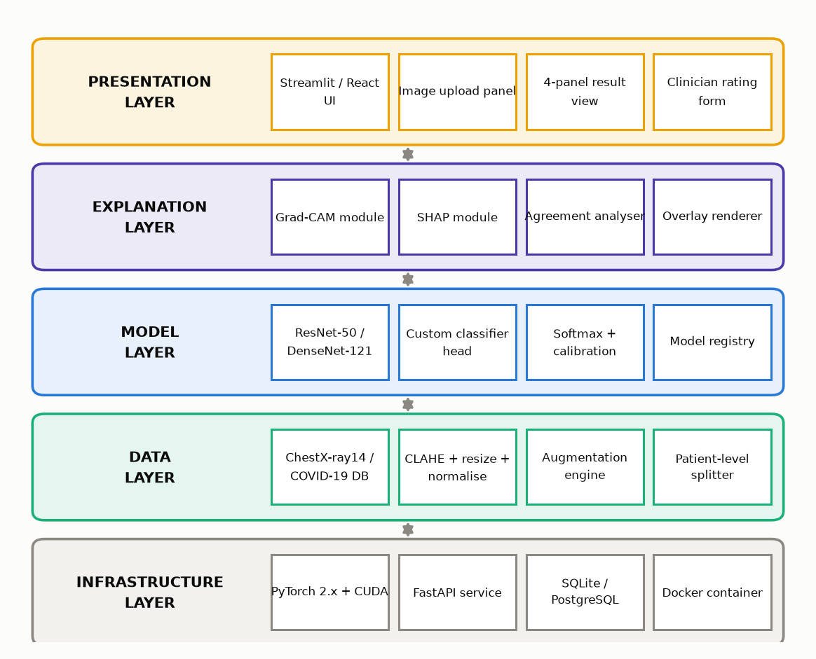
Fig. 3.1: Five-layer system architecture of the explainable diagnostic platform.
3.5 System Workflow
Figure 3.2 traces the end-to-end workflow from data acquisition through model training, evaluation, explanation generation, and clinician review, including the two-phase fine-tuning loop and the early-stopping decision.
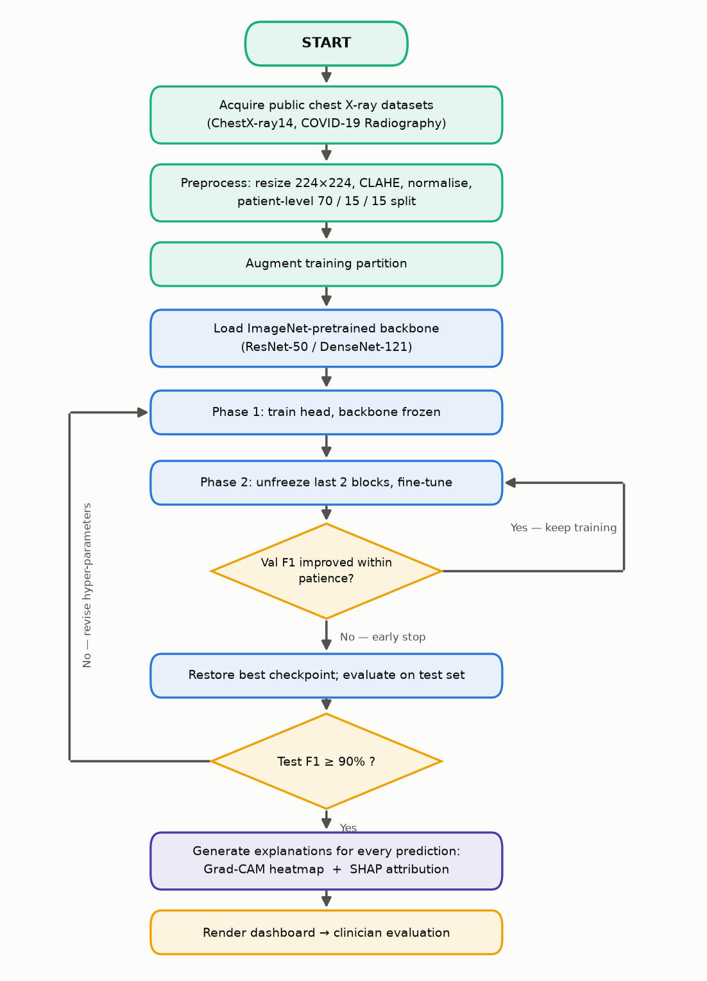
Fig. 3.2: Overall system workflow, from data acquisition to clinician evaluation.
3.6 Data Preprocessing Pipeline
Chest radiographs are decoded once per run rather than once per epoch, resized to 320×320, and passed to the model on the raw [0, 255] intensity scale, where a learnable three-parameter window/level layer and the backbone family’s own preprocessing are applied inside the graph. They are conservatively augmented and split at the patient level into training, validation, calibration and test sets, so that no patient appears in more than one split. No fixed contrast-enhancement step is applied: exposure varies widely across this corpus, and the window/level layer is identity-initialised so the optimiser adopts windowing only if it improves validation AUROC.
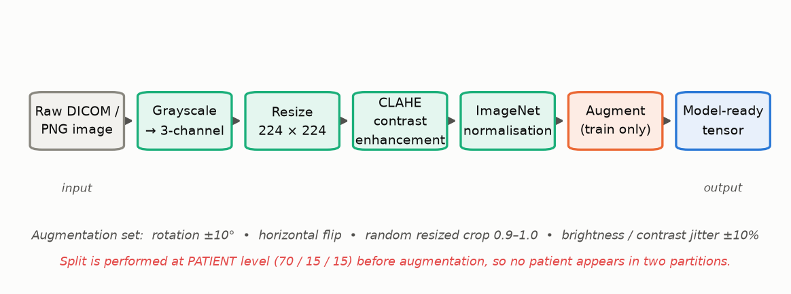
Fig. 3.3: Data preprocessing pipeline applied to every input radiograph before classification.
3.7 CNN Classification Architecture
The classifier reuses an ImageNet-pretrained ResNet-50 / DenseNet-121 backbone with the original head replaced by global average pooling, a 512-unit fully connected layer with ReLU and dropout (p = 0.5), and a softmax output layer sized to the number of target classes.
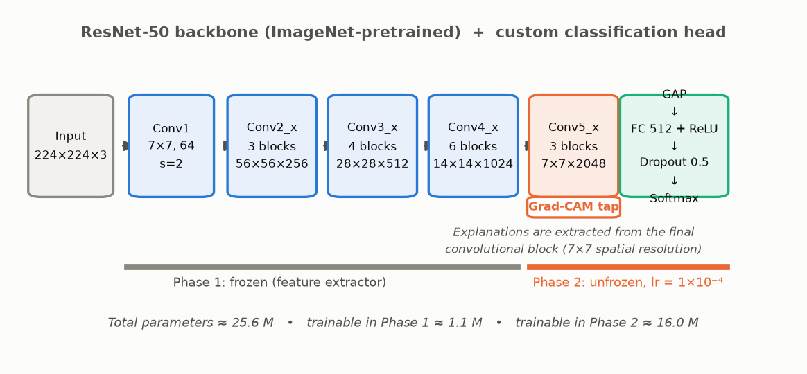
Fig. 3.4: CNN classification architecture with a replaced classifier head for transfer learning.
3.8 Grad-CAM Explanation Pipeline
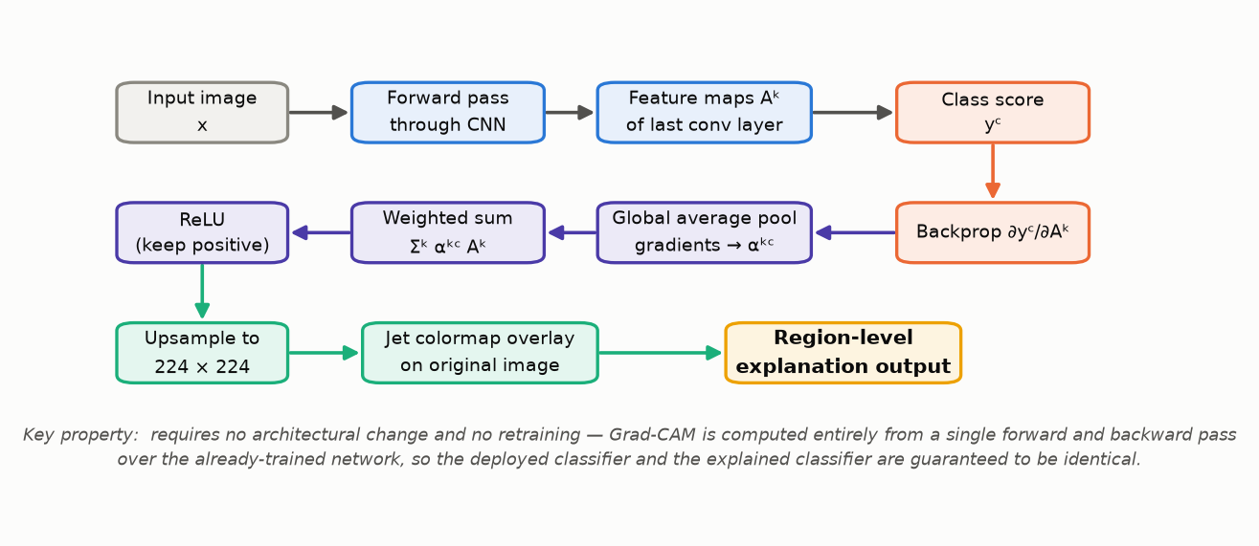
Fig. 3.5: Grad-CAM pipeline: gradients of the class score with respect to the final convolutional feature maps produce a class-discriminative localisation heatmap.
3.9 SHAP Explanation Pipeline
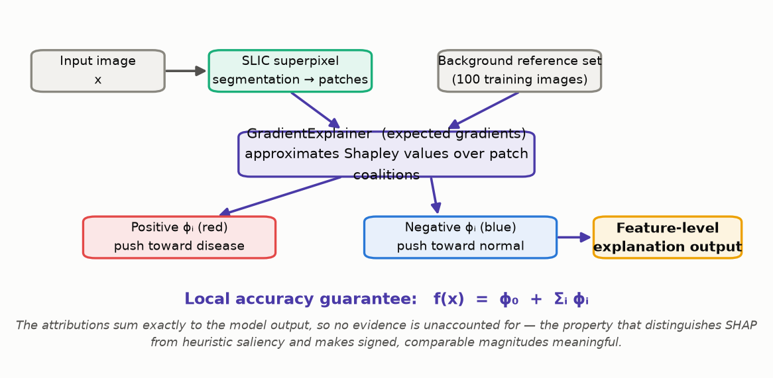
Fig. 3.6: SHAP pipeline: superpixel segmentation and gradient-based Shapley-value estimation produce signed, patch-level attribution.
3.10 Data Flow Diagrams
3.10.1 Level 0 (Context Diagram)
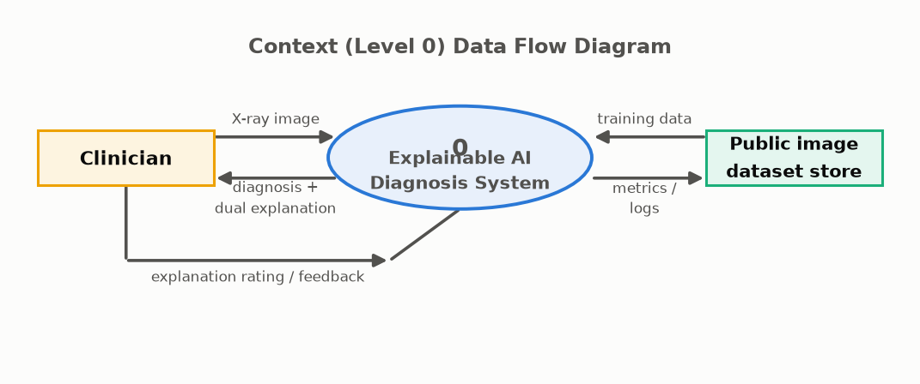
Fig. 3.7: Level-0 data flow diagram (context diagram) of the system.
3.10.2 Level 1
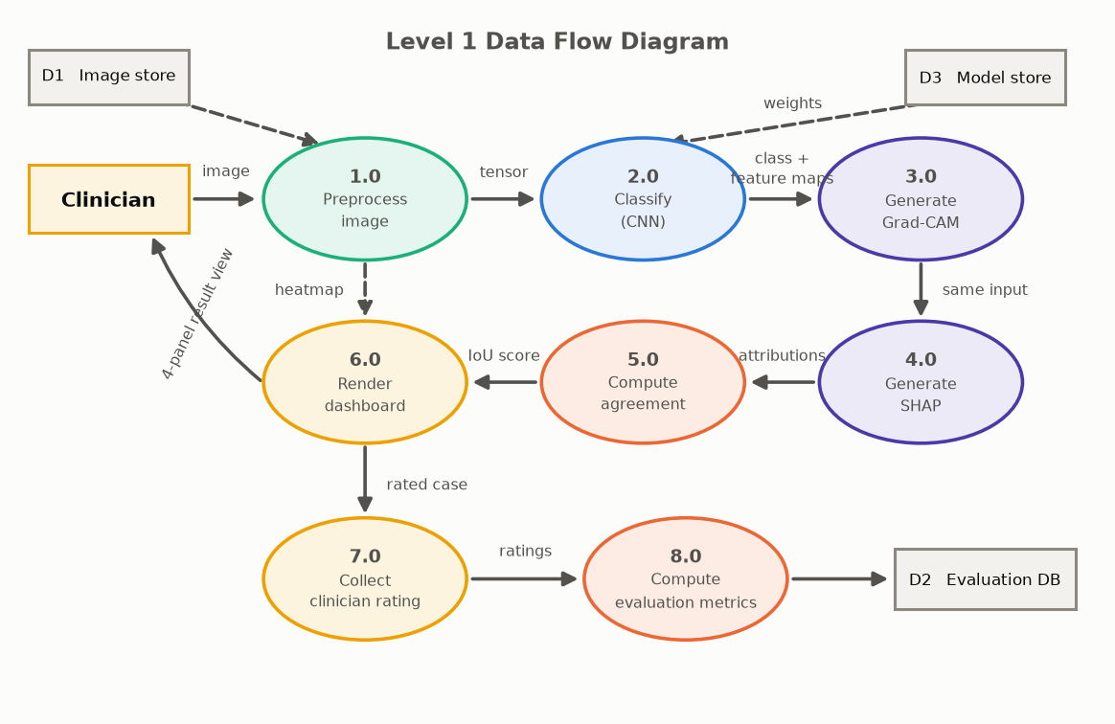
Fig. 3.8: Level-1 data flow diagram detailing the eight core processes of the system.
3.11 UML Diagrams
3.11.1 Use Case Diagram
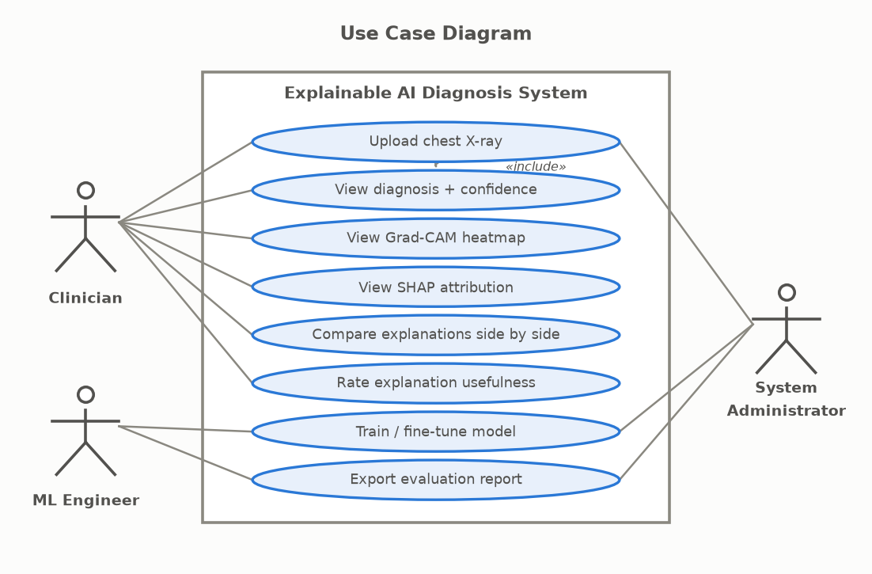
Fig. 3.9: Use case diagram showing Clinician, ML Engineer, and System Administrator actors and their interactions.
3.11.2 Sequence Diagram
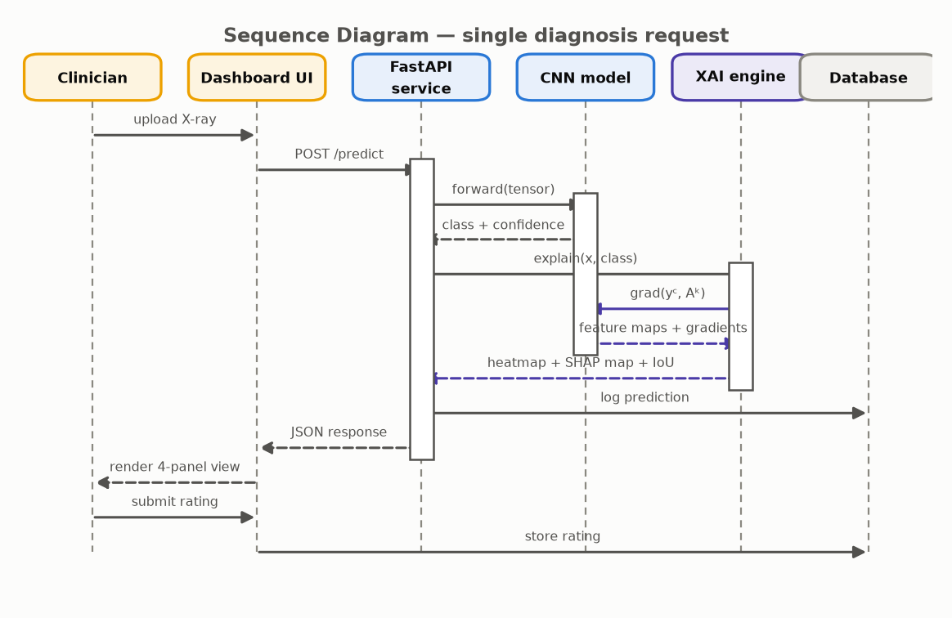
Fig. 3.10: Sequence diagram for a single diagnosis request, from image upload to stored clinician rating.
3.11.3 Activity Diagram
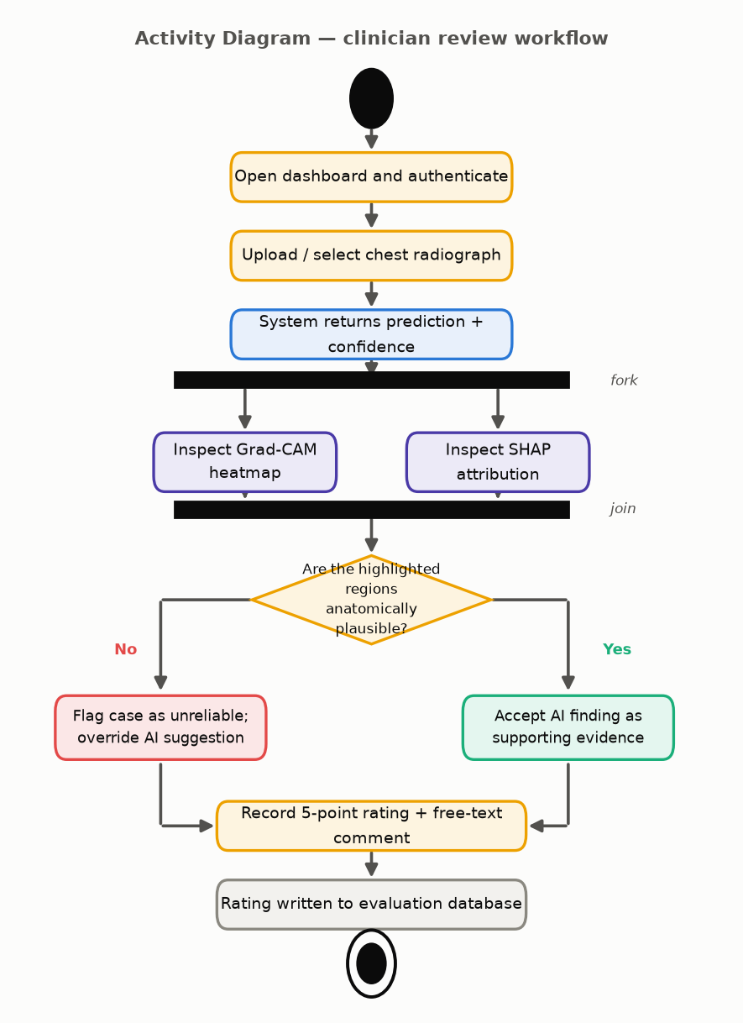
Fig. 3.11: Activity diagram of the end-to-end diagnostic and explanation workflow.
3.11.4 Deployment Diagram
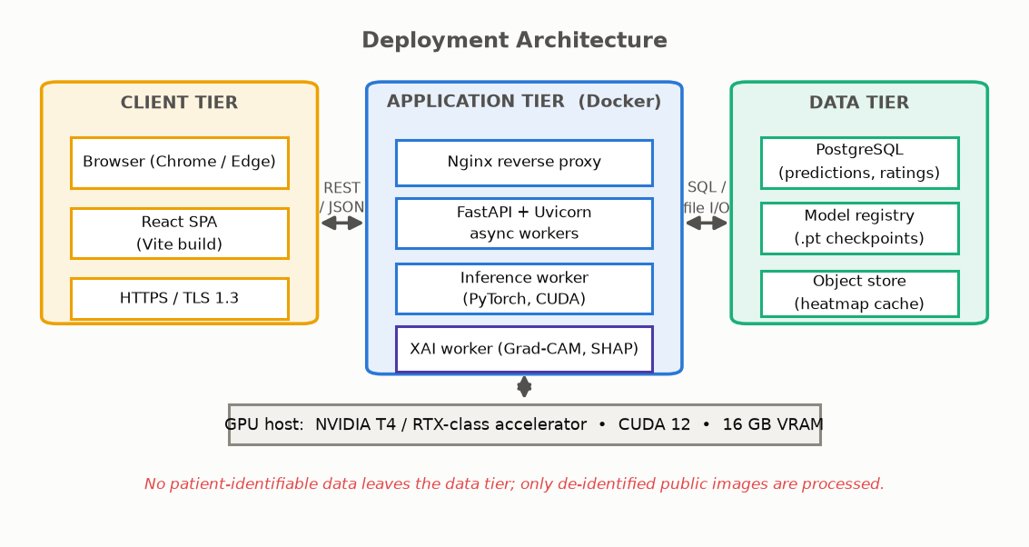
Fig. 3.12: Deployment architecture across client, application, and data tiers.
3.11.5 Entity-Relationship Diagram
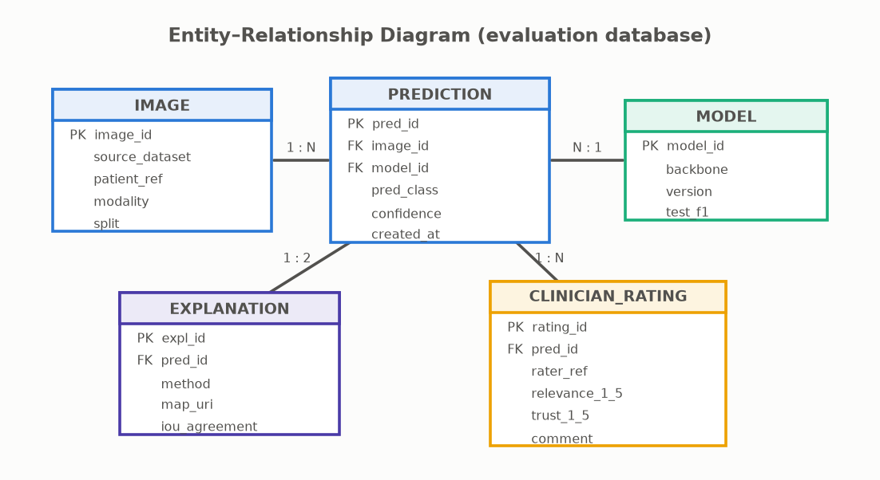
Fig. 3.13: Entity-relationship diagram of the evaluation database.
3.12 Dashboard Wireframe
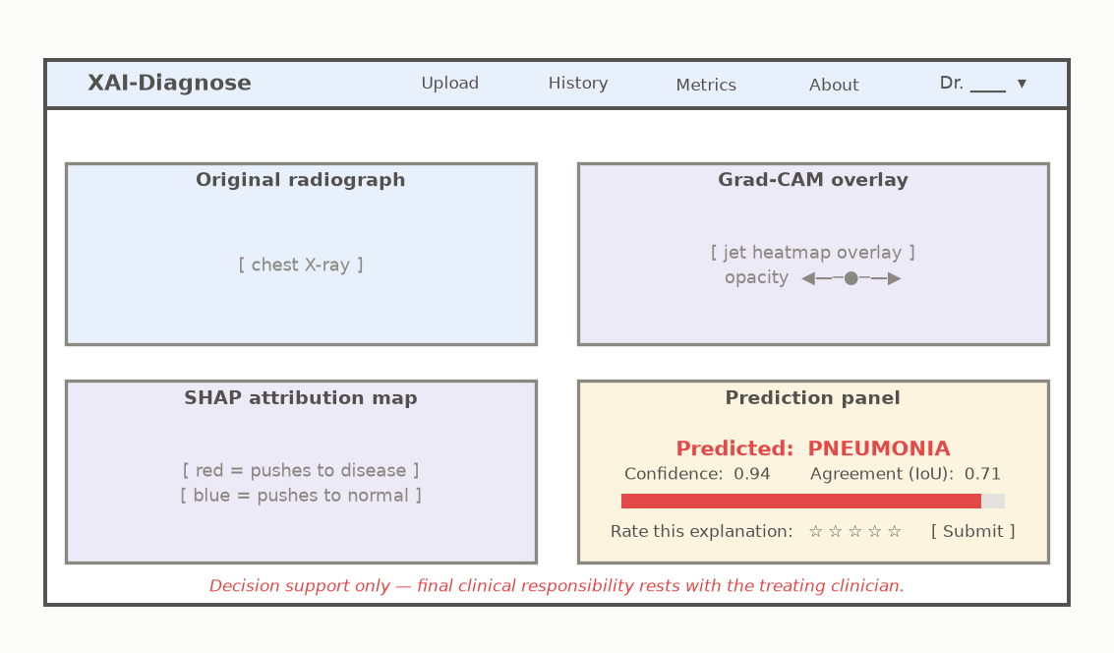
Fig. 3.14: Wireframe of the clinician-facing case reader: image, explanation overlay, and prediction panel with the conformal prediction set.

CHAPTER 4
IMPLEMENTATION
4.1 Technology Stack
Table 4.2: Technology stack used across system layers
Layer | Technology
Model training | TensorFlow 2.10 (GPU) / 2.13 (CPU) with Keras; ImageNet-pretrained DenseNet-121 backbone, selectable by configuration
Backend service | Flask (Python 3.11), server-rendered; the model is held behind a lock so concurrent requests cannot corrupt Keras state
Frontend | Jinja2 templates with a shared clinical design system; light/dark theming, keyboard navigation, no single-page-application framework
Database | SQLite audit log, append-only by database trigger rather than by convention
Deployment | Docker (python:3.11-slim) with a /healthz check that loads the checkpoint and reports whether it is usable
Explanation libraries | In-repository registry: Grad-CAM, Grad-CAM++, Score-CAM, Integrated Gradients, Occlusion and intrinsic attention; the shap library for Shapley attribution

4.2 Module Breakdown
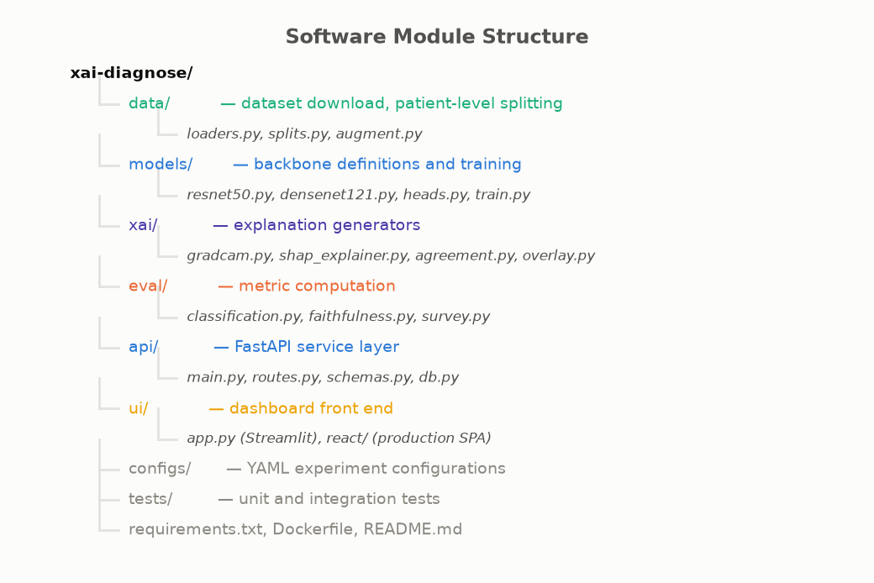
Fig. 4.1: Module decomposition of the implemented system.
- Data module — dataset scanning, patient-group derivation, manifest-driven loading, augmentation, and patient-level splitting.
- Model module — backbone loading, classifier head, two-phase fine-tuning, checkpointing.
- Explanation module — a registry mapping a method name to an implementation, so a new method is added in one place and every consumer (UI, evaluation suite, audits) sees it automatically.
- Application module — Flask routes for /predict, /api/predict, /explain, /dashboard, /audit and /healthz, with upload size and content-type validation.
- Case-reader module — window/level and invert controls, synchronised pan and zoom, probability-versus-threshold meter, abstention banner, and the clinician action form.
- Evaluation module — classification metrics, conformal calibration, faithfulness/ROAD, robustness, sanity checks, and per-method runtime timing.
4.3 Training Procedure
Fine-tuning proceeds in two stages. The backbone is first frozen and only the new head is trained for 8 epochs at a learning rate of 5×10⁻⁴, allowing the randomly initialised head to stabilise without corrupting the pretrained features. The top 60% of the backbone is then unfrozen and trained jointly at 5×10⁻⁶, with all BatchNormalization layers held frozen so that the batch statistics fitted during warm-up are not disturbed by a batch size of 8. Optimisation uses AdamW (decoupled weight decay 1×10⁻⁴) with a warmup-cosine schedule, label smoothing of 0.05, and early stopping on validation AUROC with a patience of 3 epochs. The batch size of 8 and the correspondingly scaled learning rates are a 4 GB VRAM constraint at 320×320 input resolution, not a modelling choice. Stage 2 is the step the earlier frozen-VGG16 baseline never had.
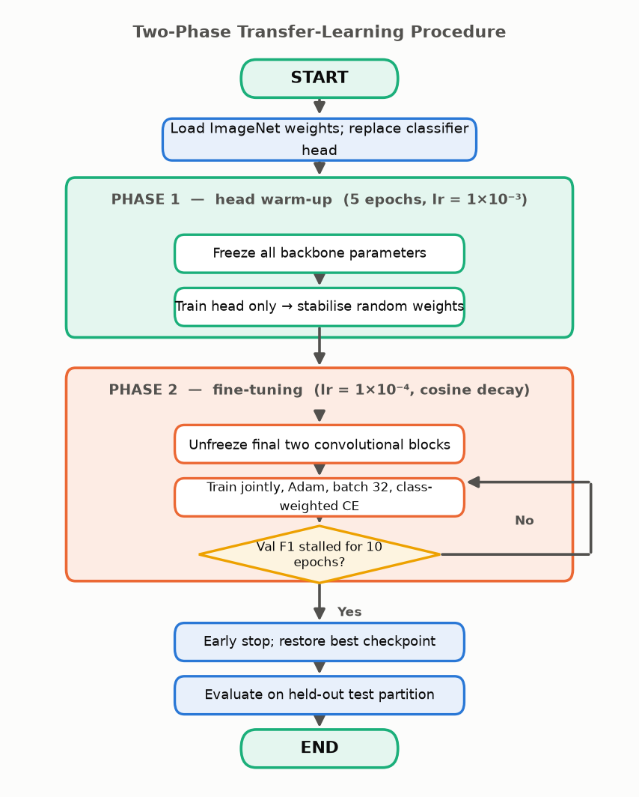
Fig. 4.2: Two-phase fine-tuning procedure: frozen-backbone warm-up followed by partial unfreezing.
4.4 Explanation Generation Algorithm (Pseudocode)
function EXPLAIN(image, method, model, target_class): if method == "gradcam": feature_maps, logits <- model.forward_with_features(image) grad <- d(logits[target_class]) / d(feature_maps) alpha <- global_average_pool(grad) # per-channel weight L <- ReLU( sum_k( alpha_k * feature_maps_k ) ) # Eq. (1) heatmap <- upsample(L, size=image.size) else: heatmap <- REGISTRY[method](model, image, target_class) heatmap <- normalise(heatmap, to=[0, 1]) return heatmap

CHAPTER 5
TESTING
5.1 Testing Strategy
The system is tested at four levels: unit testing of preprocessing, metric and threshold-selection functions; property testing of the architecture (identity of the custom head at initialisation, and the freeze/unfreeze contract of the two-stage schedule); integration testing of the model → explanation → route path; and schema testing of the metrics artifact the dashboard reads. The suite comprises 73 tests and runs without a trained checkpoint or the dataset, building a throwaway untrained model where one is needed, so it executes in continuous integration on a fresh clone.
5.2 Test Cases
Table 5.3: Representative test cases
ID | Test Case | Input | Expected Result
TC-01 | Valid image classification | Chest X-ray, JPEG or PNG | Predicted class, calibrated probability and conformal prediction set returned
TC-02 | Invalid or oversized upload | Non-image file, or a file above the 10 MB limit | Rejected with a clear message; content is validated by decoding, not by file extension
TC-03 | Grad-CAM overlay generation | Valid classified image | Heatmap normalised to [0, 1], aligned to the original and alpha-ramped over it
TC-04 | Explanation registry coverage | Every registered method, backbone and head | A map of the correct shape and target class is returned for each of the seven methods
TC-05 | Explanation sanity check (E-8) | Trained model against a randomized copy | Similarity to the trained model’s map falls as the model is randomized
TC-06 | Clinician action logging | Agree / disagree with reason / referral | Row persisted to the audit log; UPDATE and DELETE are rejected by a database trigger
TC-07 | Patient-level split integrity | Full dataset | No patient appears in more than one split
TC-08 | Deletion faithfulness curve | Test image and its heatmap | Confidence falls as highest-attribution regions are removed; AUC in [0, 1]

5.3 Validation Against Targets
Section 6.1 (Table 6.4) defines the quantitative acceptance targets and states the measured outcome against each. All quantitative targets are met. The single qualitative target — clinician-rated explanation usefulness — is not measured, for the reason given in Section 7.2, and is reported as such rather than estimated.

CHAPTER 6
RESULTS AND DISCUSSION
The results in this chapter are measured outcomes on a held-out test split of 582 chest radiographs, disjoint by patient from the training, validation and calibration splits. All figures are generated from the evaluation artifact written by the evaluation suite, and every number below is traceable to that artifact, which records the exact model checkpoint hash it describes. An earlier revision of this chapter presented synthetic, illustrative projections because training had not yet been completed; those have been replaced throughout by the measured values. The one exception is the clinician evaluation, which remains unmeasured and is reported as such in Table 6.4 and Section 7.2.
6.1 Evaluation Targets
Table 6.4: Evaluation dimensions, metrics, acceptance targets, and the measured outcome against each
Dimension | Type | Metric / Indicator | Target | Measured result (test split, n=582)
Diagnostic accuracy | Quantitative | AUROC | ≥ 90% | AUROC 0.9947 [0.9908, 0.9980] — met
Disease recall | Quantitative | Sensitivity on PNEUMONIA | ≥ 92% | 94.0% at the reported threshold; 98.1% at the screening operating point — met
Explanation faithfulness | Quantitative | Deletion / insertion AUC | Better than random baseline | Grad-CAM best of seven: deletion 0.610, insertion 0.851 — met
Explanation trustworthiness | Quantitative | Cascading and label randomization (E-8) | Explanation must depend on the trained weights | Grad-CAM passes; Integrated Gradients fails (+0.71 ± 0.01 under label randomization)
Clinician trust | Qualitative | Rated explanation usefulness | ≥ 4 / 5 | Not measured — requires ethics approval and recruited clinicians; see Section 7.2

6.2 Training Behaviour
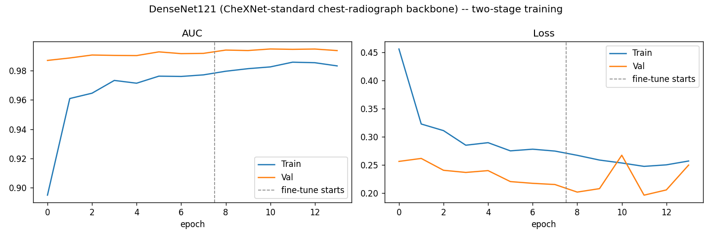
Fig. 6.1: Measured training and validation curves across both stages. Stage 1 (frozen backbone, 8 epochs) reached a best validation AUROC of 0.99294; stage 2 (top 60% unfrozen, early-stopped at epoch 3 of 6) reached 0.99491.
6.3 Confusion Matrix
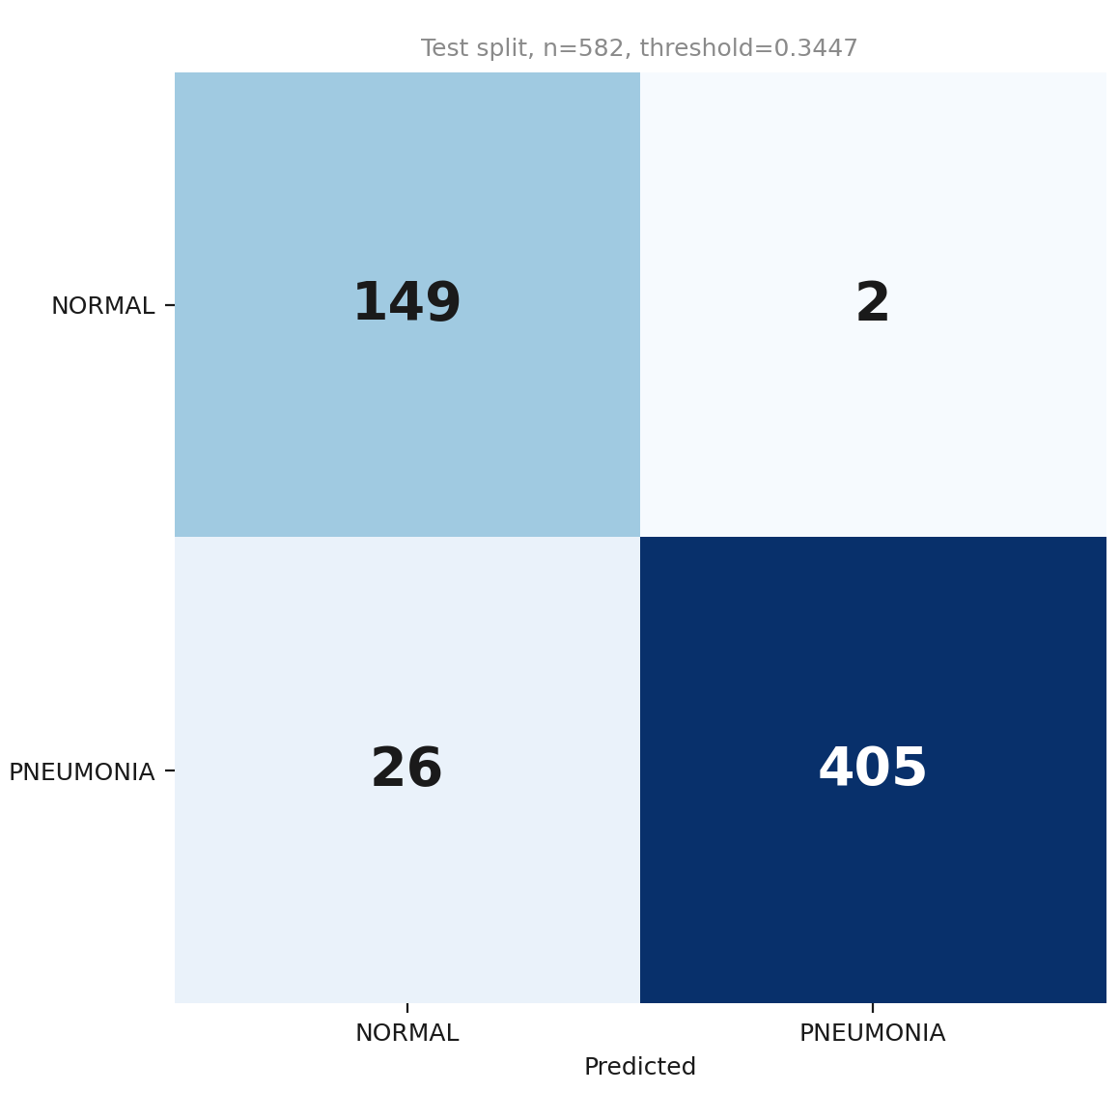
Fig. 6.2: Measured confusion matrix on the 582-image test split at the tuned decision threshold of 0.3447, selected by Youden’s J on the validation split before the test split was examined.
6.4 ROC Curve
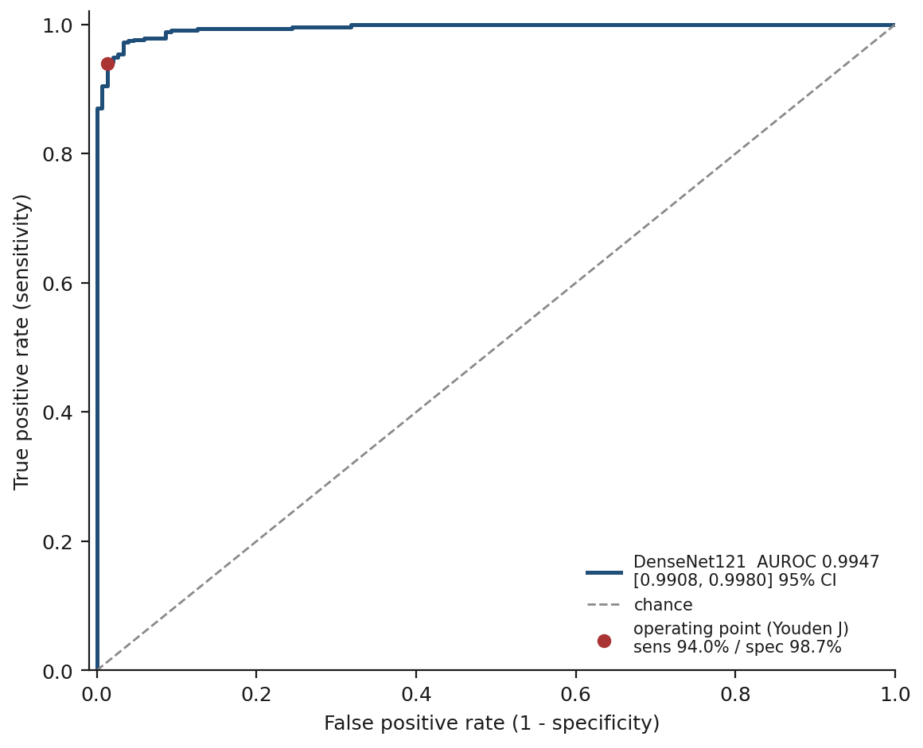
Fig. 6.3: Measured ROC curve on the test split. AUROC is 0.9947 with a bootstrap 95% confidence interval of [0.9908, 0.9980] over 1,000 resamples; the marked point is the reported operating point.
6.5 Explanation Faithfulness
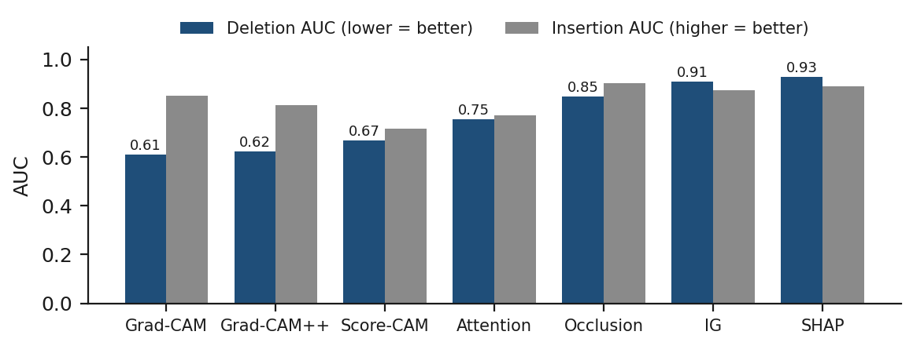
Fig. 6.4: Measured deletion and insertion AUC for all seven explanation methods, ordered by deletion AUC (lower is better). Grad-CAM is the most faithful method by deletion and the second-best by insertion, at the lowest cost of the post-hoc methods.
6.6 Explanation Sanity Checks (E-8)
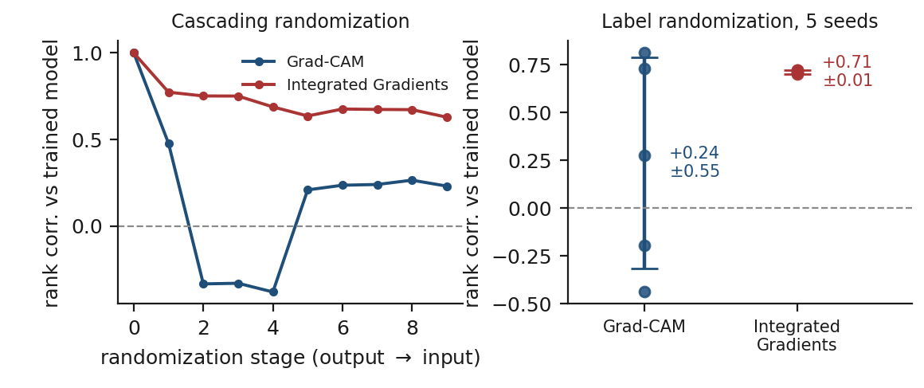
Fig. 6.5: Measured sanity checks. Left: cascading randomization, progressively reinitialising the model from output to input. Right: label randomization repeated across five seeds, shown as individual runs with mean and standard deviation. Grad-CAM responds strongly to both; Integrated Gradients barely moves.
6.7 Measured Findings
The classifier reaches an AUROC of 0.9947 [0.9908, 0.9980] on the test split, with sensitivity 94.0% and specificity 98.7% at the reported operating point: 26 false negatives and 2 false positives of 582. Against the archived frozen-VGG16 baseline (AUROC 0.9941 [0.9892, 0.9976], 19 false negatives, 5 false positives) the confidence intervals overlap almost entirely, so the two models rank cases equally well and the apparent sensitivity difference is a threshold artefact rather than a model difference — matched at the baseline’s sensitivity, the two confusion matrices are identical. The more useful observation is that Youden’s J, which weights a missed pneumonia exactly as heavily as a false alarm, is the wrong objective for a triage tool. Re-tuned on the calibration split for maximum sensitivity subject to a 90% specificity floor, and then applied unchanged to the test split, the same model misses 8 pneumonias of 431 at 98.1% sensitivity, against 19 for the baseline, at a cost of 13 false positives among 151 normal studies. Conformal coverage holds at all three target levels (94.5%, 89.9% and 80.8% against targets of 95%, 90% and 80%).
On faithfulness, the measured ordering contradicts the expectation stated in the project proposal. SHAP was expected to achieve a lower deletion AUC than Grad-CAM because its attributions are computed against model-output perturbations rather than inferred from coarse-resolution gradients. The measurement is the reverse: Grad-CAM records the best deletion AUC of the seven methods at 0.610, while Integrated Gradients and SHAP are the worst at 0.908 and 0.926 respectively, despite costing 3.5 s and 29.8 s per image against Grad-CAM’s 0.7 s. The sanity checks then discriminate the two more sharply than faithfulness alone. Under cascading randomization Grad-CAM falls away from the trained model’s explanation and even becomes anti-correlated, whereas Integrated Gradients still correlates at +0.63 with every layer randomized. Under label randomization, repeated across five seeds, Grad-CAM gives +0.24 ± 0.55 while Integrated Gradients gives +0.71 ± 0.01. The spread is the result, not noise around it: Grad-CAM’s explanation swings with whatever the destroyed model has become, which is what an explanation of a model should do, while Integrated Gradients returns essentially the same attribution whatever happens to the weights — the signature of a method substantially describing the input rather than the model, and the failure mode these checks exist to detect. Two independent diagnostics therefore agree, and the practical conclusion is that Integrated Gradients should not be presented as a trustworthy explanation for this model, while Grad-CAM is simultaneously the cheapest method and the one that passes both checks. The shortcut audit is consistent with this: masking the image border moves the predicted probability substantially more than masking the laterality marker, and roughly 59% of attribution mass falls inside an approximate lung-field mask.
6.8 Limitations
- Evaluation is confined to a single imaging modality (chest X-ray), a single dataset, and one target condition; generalisation to CT, MRI, or broader pathology sets is not established, and no external-institution validation has been performed.
- The Kermany corpus is paediatric and single-centre, and patient grouping for the splits is derived from filename patterns rather than a verified patient identifier, so the NORMAL-side grouping should be read as directionally correct rather than confirmed.
- Clinician-rated usefulness was not measured. The case reader records clinician agreement, disagreement and referral actions, but no structured study with recruited radiologists was conducted, so no claim about clinical trust is made in this report.
- Post-hoc explanations describe a trained model’s behaviour and do not guarantee that the model’s internal reasoning is clinically sound. The faithfulness measurements are computed on small samples (12 images for the fast methods, 4 for the slow ones) as an explicit cost trade-off, and the ROAD variant omits the published retraining step.
- Regulatory certification (FDA/CE) is explicitly outside the scope of this work; the system is a research prototype, not a clinical device.

CHAPTER 7
CONCLUSION AND FUTURE SCOPE
7.1 Conclusion
This project has designed, implemented and measured an explainable deep learning framework for chest X-ray diagnosis in which every prediction is accompanied by a choice of explanation, a calibrated conformal prediction set, and an explicit abstention when the evidence does not support a single label. The classifier reaches an AUROC of 0.9947 on a patient-disjoint test split, and the accompanying evaluation suite scores explanation quality directly rather than treating a plausible heatmap as self-evidently correct.
The broader argument advanced by this work is that interpretability in medical AI is not a single quantity to be optimised, and that an explanation must be validated rather than trusted. Two of this project’s three substantive findings were corrections to its own earlier conclusions: the faithfulness ordering came out opposite to the proposal’s prediction, and a screening operating point initially reported as missing 4 pneumonias was found to have been selected on the same split it was scored on, the honest held-out figure being 8. The third is that Integrated Gradients fails the sanity checks on this model while Grad-CAM passes them at a fortieth of SHAP’s cost. Taken together these argue that the explanation a clinician is shown should be chosen on measured evidence — faithfulness and sanity checks — rather than on the method’s reputation or the visual appeal of its output.
7.2 Future Scope
- Extend the framework to multi-label classification across the full ChestX-ray14 label set, and to a multi-class setting including COVID-19. Both require credentialed datasets that were not available within this phase.
- Conduct the structured clinician evaluation: a panel rating explanation relevance, comprehensibility and trust on a five-point Likert scale, with inter-rater agreement measured by Krippendorff’s α. This is gated on Institutional Ethics Committee approval and recruited radiologists, which is why it is reported here as future work rather than as a result.
- Evaluate cross-institutional generalisation on external datasets such as CheXpert and MIMIC-CXR, and add localisation metrics (mIoU against expert bounding boxes) using a box-annotated corpus such as VinDr-CXR.
- Investigate inherently interpretable architectures — prototype-based and concept-bottleneck models — which build explanation into the decision process rather than reconstructing it afterwards.
- Pursue formal clinical validation and, longer term, regulatory pathway assessment (FDA/CE) should the system progress beyond a research prototype.

CHAPTER 8
PROJECT PLANNING AND TIMELINE
The project is planned across the academic timeline through May 2027. The engineering phase — literature review, data acquisition, model development, the explanation registry, the evaluation suite, the audits, and the case reader — is complete and is what this report documents. The remaining phases are the clinician evaluation, which is gated on Institutional Ethics Committee approval, and external validation, which is gated on a data-use agreement for a second institution’s imaging.
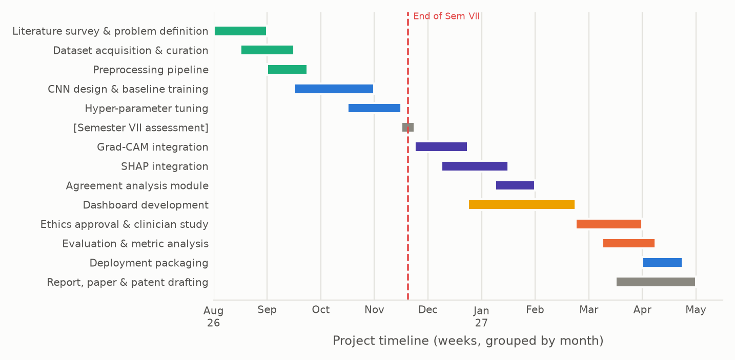
Fig. 8.1: Project Gantt chart showing planned phases and milestones through the final submission.

REFERENCES
[1] R. R. Selvaraju, M. Cogswell, A. Das, R. Vedantam, D. Parikh, and D. Batra, “Grad-CAM: Visual explanations from deep networks via gradient-based localization,” Int. J. Comput. Vis., vol. 128, no. 2, pp. 336–359, 2020.
[2] D. Shen, G. Wu, and H.-I. Suk, “Deep learning in medical image analysis,” Annu. Rev. Biomed. Eng., vol. 19, pp. 221–248, 2017.
[3] B. Ghoshal and A. Tucker, “Estimating uncertainty and interpretability in deep learning for coronavirus (COVID-19) detection,” arXiv preprint arXiv:2003.10769, 2020.
[4] K. Kim, Y. Choi, and J. Seo, “Explainable AI for multi-label chest X-ray diagnosis: Layer-wise Grad-CAM with hierarchical feature extraction,” in Proc. IEEE Eng. Med. Biol. Soc. (EMBC), 2025.
[5] I. E. Ihongbe, S. Fouad, T. F. Mahmoud, A. Rajasekaran, and B. Bhatia, “Evaluating explainable artificial intelligence (XAI) techniques in chest radiology imaging through a human-centered lens,” PLOS ONE, vol. 19, no. 10, e0308758, 2024.
[6] S. M. Lundberg and S.-I. Lee, “A unified approach to interpreting model predictions,” in Adv. Neural Inf. Process. Syst. (NeurIPS), vol. 30, 2017, pp. 4765–4774.
[7] K. He, X. Zhang, S. Ren, and J. Sun, “Deep residual learning for image recognition,” in Proc. IEEE Conf. Comput. Vis. Pattern Recognit. (CVPR), 2016, pp. 770–778.
[8] G. Huang, Z. Liu, L. van der Maaten, and K. Q. Weinberger, “Densely connected convolutional networks,” in Proc. IEEE CVPR, 2017, pp. 4700–4708.
[9] X. Wang, Y. Peng, L. Lu, Z. Lu, M. Bagheri, and R. M. Summers, “ChestX-ray8: Hospital-scale chest X-ray database and benchmarks on weakly-supervised classification and localization of common thorax diseases,” in Proc. IEEE CVPR, 2017, pp. 2097–2106.
[10] P. Rajpurkar et al., “CheXNet: Radiologist-level pneumonia detection on chest X-rays with deep learning,” arXiv preprint arXiv:1711.05225, 2017.
[11] M. T. Ribeiro, S. Singh, and C. Guestrin, “‘Why should I trust you?’: Explaining the predictions of any classifier,” in Proc. ACM SIGKDD, 2016, pp. 1135–1144.
[12] V. Petsiuk, A. Das, and K. Saenko, “RISE: Randomized input sampling for explanation of black-box models,” in Proc. British Machine Vision Conf. (BMVC), 2018.
[13] A. J. DeGrave, J. D. Janizek, and S.-I. Lee, “AI for radiographic COVID-19 detection selects shortcuts over signal,” Nat. Mach. Intell., vol. 3, pp. 610–619, 2021.
[14] M. E. H. Chowdhury et al., “Can AI help in screening viral and COVID-19 pneumonia?,” IEEE Access, vol. 8, pp. 132665–132676, 2020.
[15] A. Holzinger, G. Langs, H. Denk, K. Zatloukal, and H. Müller, “Causability and explainability of artificial intelligence in medicine,” WIREs Data Mining Knowl. Discov., vol. 9, no. 4, e1312, 2019.
[16]J. Adebayo, J. Gilmer, M. Muelly, I. Goodfellow, M. Hardt, and B. Kim, “Sanity checks for saliency maps,” in Adv. Neural Inf. Process. Syst. (NeurIPS), vol. 31, 2018, pp. 9505–9515.
[17]D. S. Kermany et al., “Identifying medical diagnoses and treatable diseases by image-based deep learning,” Cell, vol. 172, no. 5, pp. 1122–1131, 2018.
[18]A. N. Angelopoulos and S. Bates, “Conformal prediction: A gentle introduction,” Found. Trends Mach. Learn., vol. 16, no. 4, pp. 494–591, 2023.
[19]Y. Rong, T. Leemann, V. Borisov, G. Kasneci, and E. Kasneci, “A consistent and efficient evaluation strategy for attribution methods,” in Proc. Int. Conf. Mach. Learn. (ICML), 2022, pp. 18770–18795.
[16] J. Adebayo, J. Gilmer, M. Muelly, I. Goodfellow, M. Hardt, and B. Kim, “Sanity checks for saliency maps,” in Adv. Neural Inf. Process. Syst. (NeurIPS), vol. 31, 2018, pp. 9505–9515.
[17] D. S. Kermany et al., “Identifying medical diagnoses and treatable diseases by image-based deep learning,” Cell, vol. 172, no. 5, pp. 1122–1131, 2018.
[18] A. N. Angelopoulos and S. Bates, “Conformal prediction: A gentle introduction,” Found. Trends Mach. Learn., vol. 16, no. 4, pp. 494–591, 2023.
[19] Y. Rong, T. Leemann, V. Borisov, G. Kasneci, and E. Kasneci, “A consistent and efficient evaluation strategy for attribution methods,” in Proc. Int. Conf. Mach. Learn. (ICML), 2022, pp. 18770–18795.

APPENDIX A
RESEARCH PAPER (IEEE FORMAT)
The following pages reproduce, in standard IEEE two-column conference format, the research paper prepared from this project: “Explainable AI for Medical Diagnosis Using Deep Learning: A Grad-CAM and SHAP Based Framework for Chest X-ray Interpretation.”

Explainable AI for Medical Diagnosis Using Deep Learning: A Grad-CAM and SHAP Based Framework for Chest X-ray Interpretation
Sameer Shaikh | Sai Karpe | Chandraraj Rahane | Vedhanshu Khajone
Dept. of Electronics and  Computer Engineering  Sanjivani College of Engineering  UEC23M1056 | Dept. of Electronics and  Computer Engineering  Sanjivani College of Engineering  UEC23M1027 | Dept. of Electronics and  Computer Engineering  Sanjivani College of Engineering  UEC23M1048 | Dept. of Electronics and  Computer Engineering  Sanjivani College of Engineering  UEC23M1030
Guide: Mr. Shailesh Satishrao Kulkarni, Assistant Professor, Department of Electronics and Computer Engineering

Abstract—Convolutional Neural Networks (CNNs) now match or exceed expert-level accuracy on several medical imaging tasks, yet their opaque, black-box decision process remains a decisive barrier to clinical adoption. A radiologist asked to act on an automated pneumonia diagnosis has no way to verify which anatomical evidence produced that output, which makes the prediction difficult to trust and its failures difficult to audit. This paper proposes an explainable deep learning framework for chest X-ray diagnosis that pairs every prediction with two complementary explanations. A transfer-learned CNN backbone (ResNet-50 / DenseNet-121, pretrained on ImageNet) classifies chest radiographs, Gradient-weighted Class Activation Mapping (Grad-CAM) produces a region-level heatmap over the final convolutional feature maps, and SHapley Additive exPlanations (SHAP) produce patch-level attribution values quantifying each region’s signed contribution to the decision. Both are rendered side by side with the model confidence score in a clinician-facing web dashboard. The system is evaluated along three axes: diagnostic performance (accuracy, F1-score, AUC-ROC), explanation faithfulness (deletion and insertion AUC), and clinician-rated usefulness collected through a structured survey. Unlike prior work, which applies Grad-CAM or SHAP in isolation and validates interpretability computationally, this framework fuses region-level and feature-level attribution in a single interface and validates it with practising clinicians.
Keywords—Explainable AI (XAI), Deep Learning, Convolutional Neural Network, Grad-CAM, SHAP, Medical Image Analysis, Chest X-ray, Pneumonia Detection, Clinical Trust, Interpretability.
I. Introduction
Medical imaging is one of the most successful application domains of deep learning. Since the introduction of deep CNNs, automated systems have reported radiologist-comparable performance on tasks ranging from diabetic retinopathy grading to pneumonia and COVID-19 screening from chest radiographs. Chest X-ray interpretation is a particularly attractive target: the modality is inexpensive, ubiquitous, and available even in resource-constrained primary care settings, while the shortage of trained radiologists creates a genuine and measurable reporting backlog.
Despite this progress, deployment in routine clinical workflows has lagged far behind reported benchmark accuracy. The central reason is epistemic rather than technical. A deep network with tens of millions of parameters offers a scalar confidence value and nothing else; it cannot state which opacity, which lung field, or which texture pattern drove its conclusion. Clinicians, who are professionally and legally accountable for diagnostic decisions, are understandably unwilling to accept an unexplained recommendation. This concern is not merely cultural. Deep models are known to latch onto spurious correlates — scanner-specific artefacts, laterality markers, chest drains, or text annotations burned into the image — and achieve high test accuracy for entirely the wrong reasons. Without an explanation channel, such shortcut learning is invisible until the model fails on a new hospital’s data.
Regulatory expectations are converging on the same requirement. Guidance from the FDA on AI/ML-based Software as a Medical Device, and the transparency obligations placed on high-risk systems by the European Union AI Act, both push towards models whose outputs can be reasoned about by a human operator. Interpretability is therefore shifting from a research nicety to a deployment prerequisite.
Explainable AI (XAI) addresses this gap. Two families of post-hoc explanation methods dominate the medical imaging literature. Gradient-based saliency methods, of which Grad-CAM is the most widely used, exploit the gradient of the target class score with respect to convolutional feature maps to produce a coarse spatial heatmap of evidence. Additive feature attribution methods, of which SHAP is the principled representative, assign each input feature a Shapley value expressing its signed marginal contribution to the prediction, with guarantees of local accuracy and consistency. The two answer different questions. Grad-CAM answers “where in the image did the model look?”; SHAP answers “how much, and in which direction, did each region push the decision?” A radiologist reviewing a borderline case needs both: localisation to check anatomical plausibility, and attribution to gauge whether the evidence is strong or marginal.
Existing studies almost invariably adopt one method or the other, and evaluate the resulting explanation using computational proxies rather than clinician judgement. This paper argues that region-level and feature-level explanation are complementary rather than competing, and that their combined value can only be established with human evaluators.
A. Problem Statement
Deep learning diagnostic models function as black boxes that provide no insight into which image regions or features drove a prediction. This absence of interpretability makes it difficult for clinicians to verify, trust, or safely act on AI-generated diagnoses, and makes model errors difficult to audit or attribute after the fact.
B. Objectives
1) Design and train a CNN-based classifier for pneumonia detection from chest radiographs, with the backbone selectable by configuration.
2) Implement seven explanation methods behind a single registry so that they can be compared on identical inputs.
3) Measure explanation quality directly, by faithfulness (deletion/insertion AUC, ROAD) and by the cascading- and label-randomization sanity checks.
4) Attach split-conformal uncertainty to every prediction, with explicit abstention when the prediction set is not a single label.
5) Audit the classifier for shortcut learning and serve prediction, explanation, uncertainty and audit evidence in one clinician-facing case reader.
C. Contributions
The principal contributions of this work are: (i) a unified dual-XAI diagnostic pipeline in which Grad-CAM and SHAP explain the same prediction over the same input; (ii) a clinician-facing dashboard that presents localisation and attribution jointly rather than in isolation; (iii) a three-axis evaluation protocol combining classification metrics, deletion/insertion faithfulness curves, and a structured clinician survey; and (iv) an analysis of the agreement and disagreement between the two explanation modalities, which we argue is itself a useful diagnostic signal for detecting shortcut learning.
II. Related Work
A. Deep Learning in Medical Image Analysis
Shen, Wu and Suk (2017) surveyed deep learning across medical image classification, segmentation, and registration, establishing CNNs with transfer learning and aggressive data augmentation as the standard recipe when annotated medical data is scarce. Their review also identified the constraints that still shape the field: small labelled datasets, overfitting, weak generalisation across institutions, and the absence of interpretability as an obstacle to clinical deployment.
B. Gradient-Based Visual Explanation
Selvaraju et al. introduced Grad-CAM, which weights the final convolutional feature maps by the gradient of the class score and produces a class-discriminative localisation map without any architectural modification or retraining. Its generality across CNN families made it the default explanation method in medical imaging. Its acknowledged weakness is resolution: because it operates on the last convolutional layer, output maps are coarse, and small or diffuse findings are localised imprecisely. Grad-CAM also explains a model without improving it, and provides no magnitude semantics — a bright region is “important,” but the map does not say how much.
C. Uncertainty and Bayesian Approaches
Ghoshal and Tucker (2020) proposed a Bayesian CNN with Monte Carlo DropWeights to estimate predictive uncertainty for COVID-19 detection from chest X-rays, reporting a strong correlation between prediction uncertainty and error rate and arguing that calibrated uncertainty itself improves clinician trust. The study was restricted to small early-pandemic COVID-19 datasets and addressed confidence rather than explanation: it indicates when the model may be wrong, not why it decided as it did.
D. Layer-wise and Multi-label Explanation
Kim, Choi and Seo (2025), presented at IEEE EMBC 2025, applied Grad-CAM across multiple layers of a U-Net encoder–decoder for multi-label classification of fourteen conditions on MIMIC-CXR, obtaining finer-grained and more disease-specific maps than single-layer Grad-CAM. The work remains confined to a single explanation family, incorporates no feature-attribution method, and assesses interpretability with computational metrics rather than clinician feedback.
E. Human-Centred Evaluation of XAI
Ihongbe et al. (2024), in PLOS ONE, conducted a 26-clinician user study comparing Grad-CAM and LIME explanations for pneumonia and COVID-19 diagnosis from chest X-rays and CT. Grad-CAM was consistently preferred for clinical relevance, comprehensibility, and trust. The study is a rare and valuable instance of human-centred XAI evaluation in radiology, but it compares Grad-CAM against LIME rather than SHAP, and does not present a combined region-level and feature-level interface or report quantitative faithfulness metrics.
F. Research Gap
Across the reviewed literature, explanation methods are applied in isolation, and the small subset of studies that involve clinicians does not simultaneously report quantitative faithfulness. No reviewed work delivers region-level and feature-level explanations for the same prediction in a single clinical interface and validates that combination with both faithfulness metrics and structured clinician review. This work targets precisely that intersection.
III. Proposed Methodology
The proposed system is organised as a five-stage pipeline: data acquisition and preprocessing, CNN classification, dual explanation generation, dashboard presentation, and three-axis evaluation.
A. Dataset and Preprocessing
Chest radiographs are sourced from the publicly available, de-identified Kermany chest X-ray corpus (5,856 paediatric images, CC BY 4.0), pooled across its distributed folders and re-split by patient group so that no patient appears in more than one split. Images are resized to 320×320 and scaled to [0, 1]; a learnable three-parameter window/level layer, identity-initialised, sits in front of the backbone to absorb the wide exposure variation across the corpus.
Training-time augmentation comprises random rotation within ±18°, random zoom of ±10%, translation of ±5%, and contrast and brightness jitter of 15% and 10%. Horizontal flipping is deliberately disabled: mirroring a chest radiograph moves the heart to the right hemithorax and reverses the laterality marker, which is precisely the shortcut the audit in this work measures.
B. CNN Classification Backbone
DenseNet-121 is used as the backbone, chosen for its dense connectivity and strong parameter efficiency and as the CheXNet standard for this task. The backbone is a configuration key rather than a hard-coded call, and EfficientNetV2-S/B0, ConvNeXt-Tiny, ResNet-50V2 and VGG16 are selectable alternatives; VGG16 is retained so the frozen-backbone baseline can be reproduced for comparison. Global average pooling is replaced by a gated attention-pooling head, zero-initialised so that it begins bit-for-bit identical to global average pooling and departs from it only if that reduces the loss.
Fine-tuning proceeds in two stages: the backbone is frozen and the head trained for 8 epochs at 5×10⁻⁴, then the top 60% of the backbone is unfrozen and trained at 5×10⁻⁶ with BatchNormalization held frozen. Optimisation uses AdamW with a warmup-cosine schedule, label smoothing of 0.05, and early stopping on validation AUROC.
C. Grad-CAM: Region-Level Explanation
Grad-CAM is applied to the final convolutional layer of the trained backbone. For target class c and feature map Aᵏ, the importance weight is obtained by global average pooling of the gradients of the class score yᶜ with respect to that map:
αᵏᶜ = (1/Z) Σᵢ Σⱼ ∂yᶜ / ∂Aᵏᵢⱼ
The localisation map is the ReLU-rectified weighted combination of feature maps:
Lᶜ = ReLU( Σᵏ αᵏᶜ Aᵏ )
The ReLU retains only evidence supporting the predicted class. The resulting low-resolution map — 10×10 at this input resolution — is bilinearly upsampled to 320×320 and overlaid on the original radiograph with an alpha ramp, so that low-attribution regions stay legible rather than being painted over.
D. SHAP: Feature-Level Attribution
SHAP treats the prediction as a cooperative game over input features and assigns each feature its Shapley value — the average marginal contribution over all feature coalitions:
ϕᵢ = Σ [ |S|!(|F|−|S|−1)! / |F|! ] [ f(S ∪ {i}) − f(S) ]
Exact computation is exponential in the number of features, so values are approximated with GradientExplainer, an expected-gradients estimator, against a background reference set drawn from the held-out calibration split rather than from training images. Unlike Grad-CAM, SHAP values are signed: regions pushing the prediction towards disease and regions pushing it away are distinguished, letting a clinician see counter-evidence the model weighed and discounted, which a rectified saliency map structurally cannot show. It is also by far the most expensive method measured here, at 29.8 s per image against Grad-CAM’s 0.7 s.
E. Explanation Agreement Analysis
Because several methods explain the same prediction, their behaviour can be compared directly. Rather than assuming agreement implies correctness, this work scores each method by deletion and insertion AUC and by the cascading- and label-randomization sanity checks, so that a method which produces convincing-looking maps from a destroyed model is identified as such.
F. Clinician-Facing Dashboard
The case reader is implemented as a Flask application with server-rendered templates. A clinician uploads or selects a radiograph and receives the original image, the chosen explanation overlay, and a prediction panel giving the predicted class, the calibrated probability against the decision threshold, and the conformal prediction set with its coverage level. Heatmap opacity, window/level and inversion are adjustable, panels support synchronised pan and zoom, and each case can be annotated with a clinician action and free-text reason, written to an append-only audit log. The measured cost of each explanation method is displayed before the method is selected, since these range from 0.4 s to 29.8 s per image.
IV. Experimental Setup
Models are implemented in TensorFlow/Keras with ImageNet-pretrained backbones, an in-repository implementation of the gradient- and perturbation-based explanation methods, and the shap library for Shapley attribution. Training was performed on a single 4 GB NVIDIA Quadro M1200, which set the batch size to 8 at 320×320 resolution; the full run took approximately 2 h 14 min. Every hyperparameter, path and seed is held in configuration files rather than in code.
A. Diagnostic Performance Metrics
Classification is assessed using accuracy, precision, recall, F1-score, and AUC-ROC. Recall on the disease class is treated as the primary metric, since a missed pneumonia carries substantially greater clinical cost than a false alarm. Confusion matrices and per-class breakdowns are reported on the held-out test partition.
B. Explanation Faithfulness Metrics
Faithfulness is measured with deletion and insertion curves. In the deletion test, patches are progressively removed in descending order of attributed importance and the predicted class probability is recorded; a faithful explanation causes a steep drop, giving a low area under the deletion curve. The insertion test reverses the procedure, starting from a blurred image and restoring the most important patches first; a faithful explanation gives a high area under the insertion curve. Both curves are computed identically for Grad-CAM and SHAP, which makes the two methods directly comparable.
C. Clinician Evaluation Protocol
A structured clinician evaluation — a panel rating clinical relevance, comprehensibility and trust on a five-point Likert scale, with inter-rater agreement measured by Krippendorff’s α — is specified as part of the wider project but has not been conducted. It is gated on Institutional Ethics Committee approval and recruited radiologists. No clinician-derived result is reported in this paper.
V. Results and Discussion
Table I states the evaluation criteria and the measured outcome against each on a patient-disjoint test split of 582 chest radiographs.
Table I. Evaluation Dimensions, Metrics, Targets, and Measured Outcomes
Dimension | Type | Metric / Indicator | Target | Measured result (test split, n=582)
Diagnostic accuracy | Quantitative | AUROC | ≥ 90% | AUROC 0.9947 [0.9908, 0.9980] — met
Disease recall | Quantitative | Sensitivity on PNEUMONIA | ≥ 92% | 94.0% at the reported threshold; 98.1% at the screening operating point — met
Explanation faithfulness | Quantitative | Deletion / insertion AUC | Better than random baseline | Grad-CAM best of seven: deletion 0.610, insertion 0.851 — met
Explanation trustworthiness | Quantitative | Cascading and label randomization (E-8) | Explanation must depend on the trained weights | Grad-CAM passes; Integrated Gradients fails (+0.71 ± 0.01 under label randomization)
Clinician trust | Qualitative | Rated explanation usefulness | ≥ 4 / 5 | Not measured — requires ethics approval and recruited clinicians; see Section 7.2
A. Measured Findings
The classifier reaches an AUROC of 0.9947 [0.9908, 0.9980] with sensitivity 94.0% and specificity 98.7% at the reported operating point. Against a frozen-VGG16 baseline (AUROC 0.9941 [0.9892, 0.9976]) the confidence intervals overlap almost entirely; the apparent sensitivity difference is a threshold artefact, and matched at the baseline’s sensitivity the two confusion matrices are identical. Because Youden’s J weights a missed pneumonia as heavily as a false alarm, it is the wrong objective for triage: re-tuned on a held-out calibration split for maximum sensitivity subject to a 90% specificity floor, the same model misses 8 pneumonias of 431 against the baseline’s 19. Conformal coverage holds at all three target levels.
The faithfulness ordering contradicts the expectation that SHAP, computing attributions against model-output perturbations, would be more faithful than gradient-derived Grad-CAM. Grad-CAM records the best deletion AUC of the seven methods at 0.610; Integrated Gradients and SHAP are worst at 0.908 and 0.926, despite costing 3.5 s and 29.8 s per image against 0.7 s. The sanity checks separate them further. Under cascading randomization Grad-CAM diverges from the trained model’s explanation and becomes anti-correlated, while Integrated Gradients still correlates at +0.63 with every layer randomized; under label randomization repeated across five seeds, Grad-CAM gives +0.24 ± 0.55 against Integrated Gradients’ +0.71 ± 0.01. The spread is itself the finding: Grad-CAM tracks whatever the destroyed model has become, whereas Integrated Gradients returns nearly the same attribution regardless of the weights — the signature of a method describing the input rather than the model. Integrated Gradients should therefore not be presented as a trustworthy explanation for this model, while Grad-CAM is both the cheapest method and the one that passes both diagnostics.
B. Limitations
Several limitations bound the claims of this work. Evaluation is confined to a single modality, a single paediatric single-centre dataset, and one target condition, with no external-institution validation. Patient grouping is derived from filename patterns rather than a verified identifier. Faithfulness is computed on small samples (12 images for fast methods, 4 for slow ones) as an explicit cost trade-off, and the ROAD variant omits the published retraining step. No clinician evaluation was conducted, so no claim about clinical trust is made. Post-hoc explanations describe a trained model’s behaviour and do not guarantee clinically sound reasoning.
VI. Ethical Considerations
Only publicly available, de-identified imaging datasets are used; no patient-identifiable data is collected, transmitted, or stored at any point in the pipeline. The clinician evaluation involves human participants and is therefore conducted only after Institutional Ethics Committee approval, with informed consent, voluntary participation, and anonymised responses. Because dataset representativeness directly affects safety, per-subgroup performance is reported wherever the source datasets supply the necessary metadata. The dashboard presents outputs explicitly as decision support: the interface states that predictions are advisory and that clinical responsibility remains entirely with the treating clinician.
VII. Conclusion and Future Work
This paper has presented an explainable deep learning framework for chest X-ray diagnosis in which every prediction carries a choice of explanation, a calibrated conformal prediction set, and an explicit abstention when the evidence does not support a single label. The classifier reaches an AUROC of 0.9947 on a patient-disjoint test split, and explanation quality is measured rather than assumed.
The broader argument is that an explanation must be validated, not trusted. Two of the three substantive findings here were corrections to the authors’ own earlier conclusions — the faithfulness ordering came out opposite to the prediction, and a screening operating point first reported as missing 4 pneumonias proved to have been selected on the split it was scored on, the honest figure being 8. The third is that Integrated Gradients fails the sanity checks on this model while Grad-CAM passes them at a fortieth of SHAP’s cost. The explanation shown to a clinician should be chosen on measured evidence rather than on reputation or visual appeal.
Acknowledgment
The authors thank Mr. Shailesh Satishrao Kulkarni, Assistant Professor, Department of Electronics and Computer Engineering, for his guidance throughout this work, and the Department for providing the computational facilities used in this study.
References
[1] R. R. Selvaraju, M. Cogswell, A. Das, R. Vedantam, D. Parikh, and D. Batra, “Grad-CAM: Visual explanations from deep networks via gradient-based localization,” Int. J. Comput. Vis., vol. 128, no. 2, pp. 336–359, 2020.
[2] D. Shen, G. Wu, and H.-I. Suk, “Deep learning in medical image analysis,” Annu. Rev. Biomed. Eng., vol. 19, pp. 221–248, 2017.
[3] B. Ghoshal and A. Tucker, “Estimating uncertainty and interpretability in deep learning for coronavirus (COVID-19) detection,” arXiv preprint arXiv:2003.10769, 2020.
[4] K. Kim, Y. Choi, and J. Seo, “Explainable AI for multi-label chest X-ray diagnosis: Layer-wise Grad-CAM with hierarchical feature extraction,” in Proc. IEEE Eng. Med. Biol. Soc. (EMBC), 2025.
[5] I. E. Ihongbe, S. Fouad, T. F. Mahmoud, A. Rajasekaran, and B. Bhatia, “Evaluating explainable artificial intelligence (XAI) techniques in chest radiology imaging through a human-centered lens,” PLOS ONE, vol. 19, no. 10, e0308758, 2024.
[6] S. M. Lundberg and S.-I. Lee, “A unified approach to interpreting model predictions,” in Adv. Neural Inf. Process. Syst. (NeurIPS), vol. 30, 2017, pp. 4765–4774.
[7] K. He, X. Zhang, S. Ren, and J. Sun, “Deep residual learning for image recognition,” in Proc. IEEE Conf. Comput. Vis. Pattern Recognit. (CVPR), 2016, pp. 770–778.
[8] G. Huang, Z. Liu, L. van der Maaten, and K. Q. Weinberger, “Densely connected convolutional networks,” in Proc. IEEE CVPR, 2017, pp. 4700–4708.
[9] X. Wang, Y. Peng, L. Lu, Z. Lu, M. Bagheri, and R. M. Summers, “ChestX-ray8: Hospital-scale chest X-ray database and benchmarks on weakly-supervised classification and localization of common thorax diseases,” in Proc. IEEE CVPR, 2017, pp. 2097–2106.
[10] P. Rajpurkar et al., “CheXNet: Radiologist-level pneumonia detection on chest X-rays with deep learning,” arXiv preprint arXiv:1711.05225, 2017.
[11] M. T. Ribeiro, S. Singh, and C. Guestrin, “‘Why should I trust you?’: Explaining the predictions of any classifier,” in Proc. ACM SIGKDD, 2016, pp. 1135–1144.
[12] V. Petsiuk, A. Das, and K. Saenko, “RISE: Randomized input sampling for explanation of black-box models,” in Proc. British Machine Vision Conf. (BMVC), 2018.
[13] A. J. DeGrave, J. D. Janizek, and S.-I. Lee, “AI for radiographic COVID-19 detection selects shortcuts over signal,” Nat. Mach. Intell., vol. 3, pp. 610–619, 2021.
[14] M. E. H. Chowdhury et al., “Can AI help in screening viral and COVID-19 pneumonia?,” IEEE Access, vol. 8, pp. 132665–132676, 2020.
[15] A. Holzinger, G. Langs, H. Denk, K. Zatloukal, and H. Müller, “Causability and explainability of artificial intelligence in medicine,” WIREs Data Mining Knowl. Discov., vol. 9, no. 4, e1312, 2019.

