**Lab 3: Shell Scripting**

**Name: Tejaswini Wanare Roll No.: 48 PRN no.: 12111129**

1. **Check if Prime no. :**

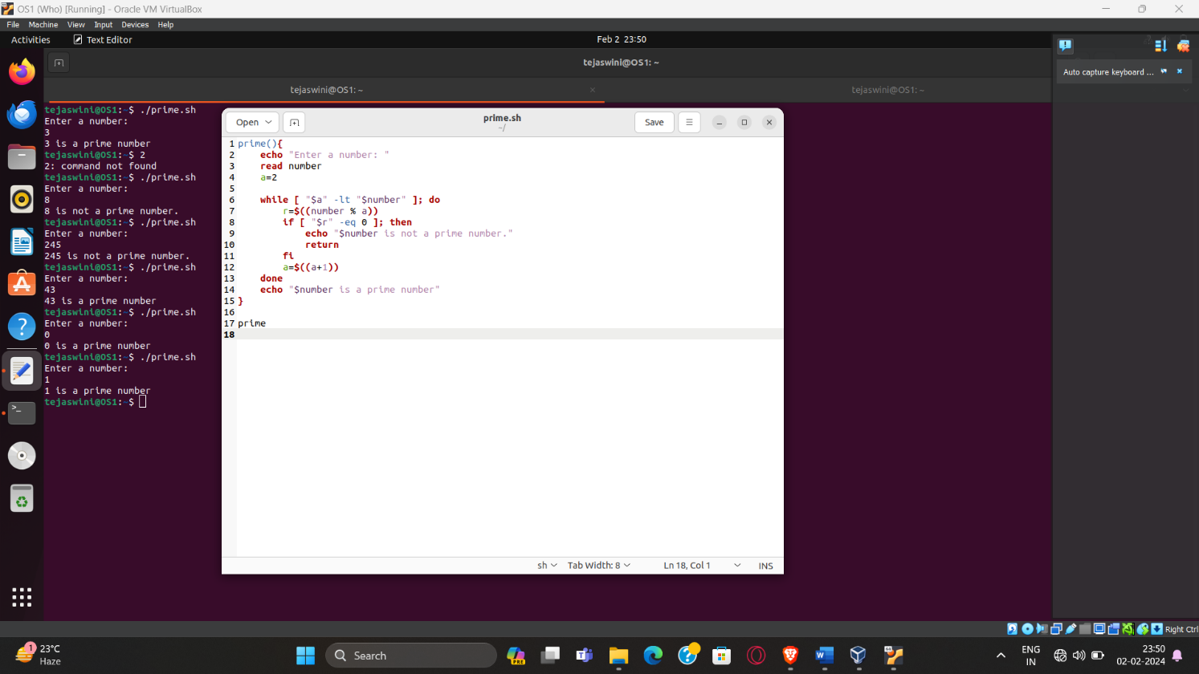

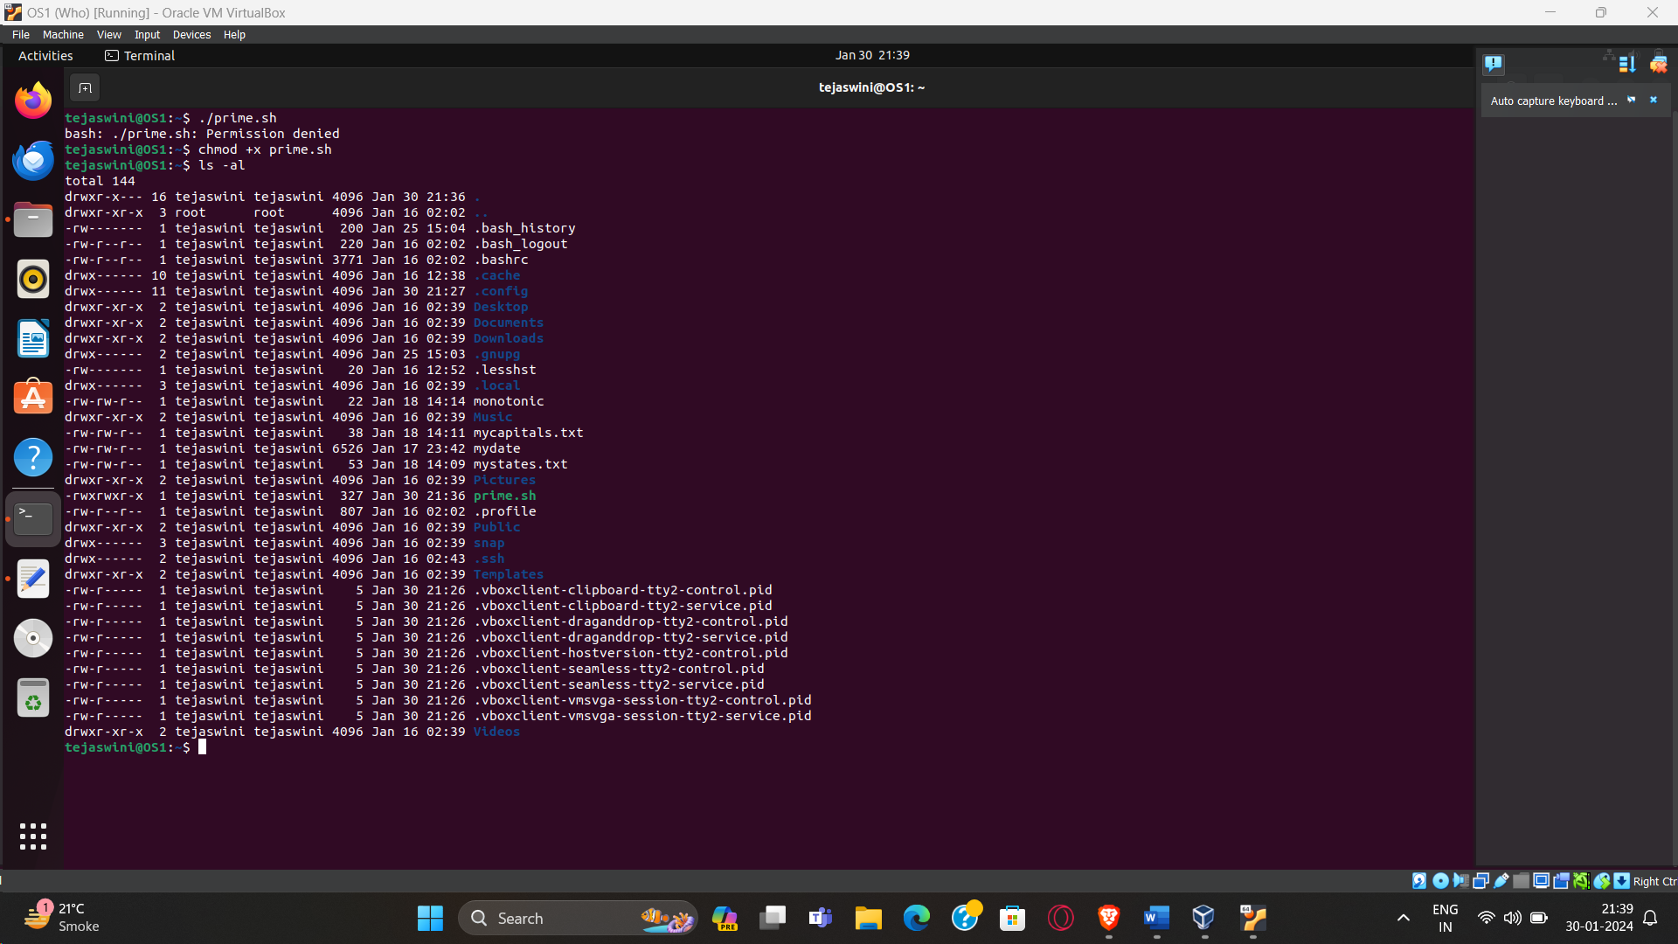

1. **Factorial**

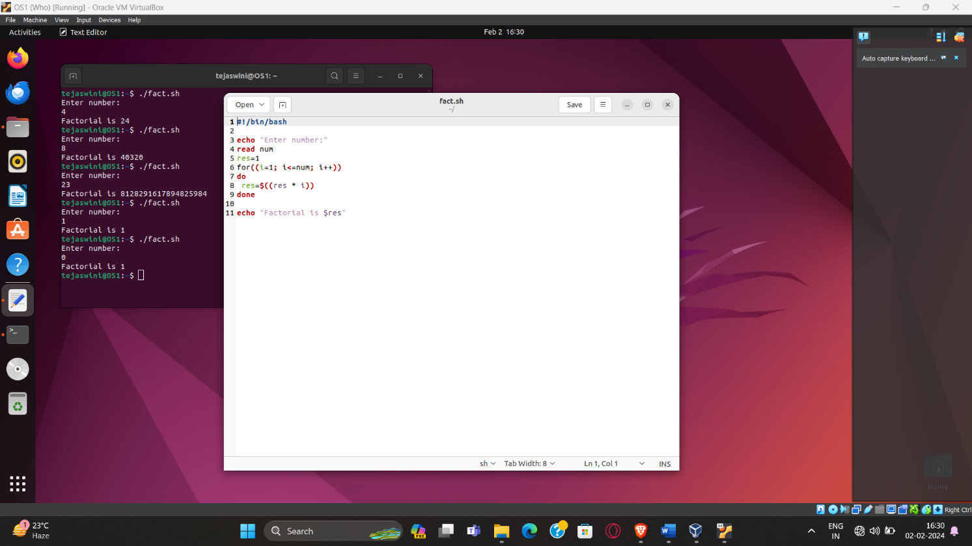

1. **Take str. Check palindrome**

