AWS Object Storage and CDN - S3, Glacier and CloudFront

S3 101
- Basic in all exams
- simple storage service
- object based storage
- files sizes from 0 to 5 TB
- there is unlimited storage
- files stored in Buckets
- names are unique
- upload the file get 200 OK response code for success
- read after write consistency
- consistency for overwrite PUTS and DELETES can take sometimes to sync
- on read it’s immediate.
- Simple key, value store
  - key-the name of object
  - value-the data, sequence of bytes
  - version id
  - Metadata
  - Subresources
    - Access control lists
      - access and permissions
    - Torrent
      - supports torrent protocol
  - design considerations
    - can add random config to the name to avoid performance issues
  - 99.99% availability, amazon guarantee
  - Amazon durability, 11*9’s, to not loose the file
  - Tiered storage available
  - lifecycle management
    - moving from state, bucket to another tracking
  - versioning
  - encryption
  - secure your data by access control lists and buckets policies
- stored, redundantly across multiple devices
- S3-IA Infrequently accessed
  - access immediatly the most visited data
- reduced redundancy storage, 99.99% durability
  - available for objects over a given year
- Glacier
  - data archiving
  - it takes 3-5 hours to restor from glacier
  - extermely low cost
- Charges
  - storage
  - requests
  - storage mangement pricing
    - tags
  - data transfer pricing
  - transfer acceleration
    - enables fast, easy and secure transfer files over long distances between end users locations and S3 buckets
    - from nearst edge location then routed to amazon S3.
    - Faster transfering files
- not suitable to install Dbs or Oss
- Read FAQ before taking the exam, it comes up a LOT in the exam.

S3 Bucket lab
- New buckets have the private access permission by default.

Versioning lab

Cross region replication lab
  - versioning must be enabled on both the source and destination buckets.
  - Regions must be unique
  - files in an existing bucket are not replicated automatically. All subsequent updated files will be replicated automatically.
  - You cannot replicate to multiple buckets or user daisy chaining(at this time)
  - delete markers are replicated
  - deleting individual versions or delete markers will not be replicated.
  - Understand what cross region replication is at high level.

Lab: S3 Life Cycle Management & Glacier
  - Life cycle management could be used in conjunction with versioning.
  - Can be applied to current versions and previous versions.
  - Supports the following actions.
    - Transition to the standard – infrequently access storage class for (>128KB and 30 days after the creation date).
    - Archive to the Glacier storage class (30 after the IA).
    - Permenentaly delete

CloudFront CDN Overview
- A content delivery network is a system of distributed servers (Network), that deliver web pages and other web content to a user based on the geo location of the user, the origion of the webpage and a content delivery system.
- Edge location
  - The location where the content will be cached, separate to AZ AWS region.
- Origin
  - Origin of all files that the CDN will distribute, can be S3 bucket, EC2 instance Elastic load balancer or Route53.
- Distribution
  - the name of a given CDN, which consists of a collection of Edge locations.
- CloudFront
  - Used to deliver your entire website (dynamic, static, streaming and interactive content using a global network of edge locations.
  - Requests are automatically routed to the nearst edge location, so content delivered faster.
  - Works with S3, EC2, AWS load balancer, AWS route 53 and can work seamlsy with non-AWS origin, which stores the original versions of the file.
- Exam tips
  - Edge locations comes a lot.
  - Origin.
  - Distribution, is a name gived to a CDN that have a group of Edge locations.
  - Edge location is not read-only, you can write on them.

Create a CloudFront CDN

Types of CDN
- Web
  - Static and dynamic content (.html, .css, .php, graphics files)
  - HTTP(s) media files
  - Add, update, or delete objects, and submit data from web forms.
  - Use live streaming to stream an event in real time.
- RTMP
  - Streaming media files using Adobe Flash Media Server's RTMP protocol.
    - To create an RTMP distribution, you must store the media files in an Amazon S3 bucket.
    - To use CloudFront live streaming, create a web distribution.
- Restrict bucket access
  - Prevent users from connecting directly to S3 bucket, force them to use the CDN url.
- Allowed HTTP Methods
  - If you want to upload files then use the third option (Get, Head, Options, Put, Post, …)
- TTL
  - TTL Is always done with seconds.
  - Always check how frequently your files are changing, to select the right time to live value.
- Restrict viewer access (Use signed URLs or Singed cookies)
  - If you have private contents that the user have to purchase first before seeing it, you can mark this location as restricted so only permitted users can reach it.
  - Exam question:
    - How you are going to secure CDN or S3, to only allow paid users to access your contents.
- CDN Restrictions:
  - Exam question: restrict some countries from accessing this location.
- Invalidations
  - Invalidating objects removes them from CloudFront edge caches. A faster and less expensive method is to use versioned object or directory names. For more information, see Invalidating Objects in the Amazon CloudFront Developer Guide.

S3 Security and Encryption
- By default all newly created buckets are private
- Buckets access control setup using
  - Bucket Policies
  - Access control list
- Configure S3 to log all requests made to the S3 bucket, can be done to another bucket or to the whole AWS account.
- Encryption
  - In Transit (from PC to bucket)
    - SSL/TLS
  - At Rest
    - Server side encryption
      - Server side Encryption
        - S3 managed keys – SSE-S3 (most common one)
        - AWS key management service, managed keys – SSE-KMS
        - Server side encryption with customer provided keys – SSE-C
    - Client side encryption
      - Encrypt on client side then upload it to S3

Storage Gateway
- Is a service that connects an on-premises software appliance with cloud-based storage to provide seamless and secure integration between an organization’s on premises IT environment and AWS’s storage infrastructure.
- Enables you to securely store data to the AWS cloud for scalabe and cost-effective storage.
- Replicates your data to AWS.
- VM image enables you to install on a host in your datacenter.
- Supports ESXi or Microsoft Hyper-V.
- Types of storage gateways
  - File Gateway (NFS)
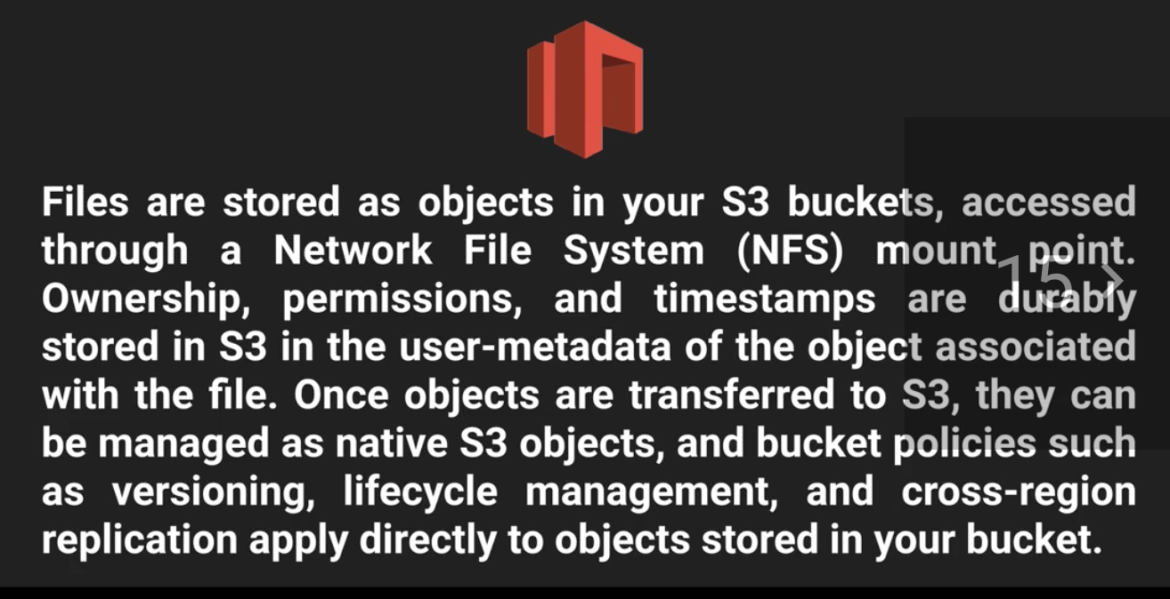
The Architecture
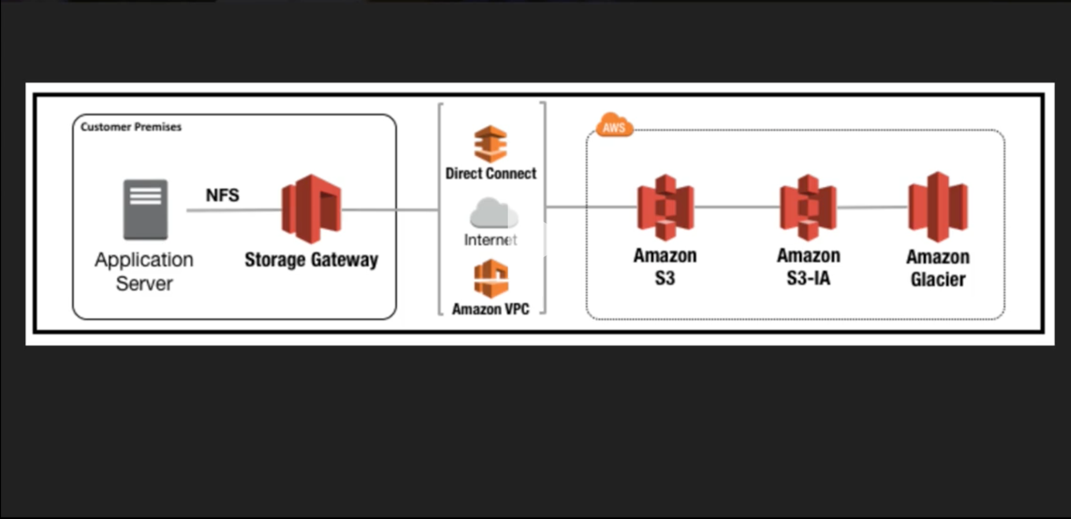
  - Volumes Gateway (iSCSI), blob base storage.(Virtual Hard disks)
    - Supports snapshots.
    - Snapshots are incremental to minimize cost.
    - Stored Volumes.
      - Store all your data on-site and Async back-up to AWS disk.
      - 1 GB – 16 TB in size for stored volumes.
      - Back-up to S3 as Amazon elastic block store (Amazon EBS).
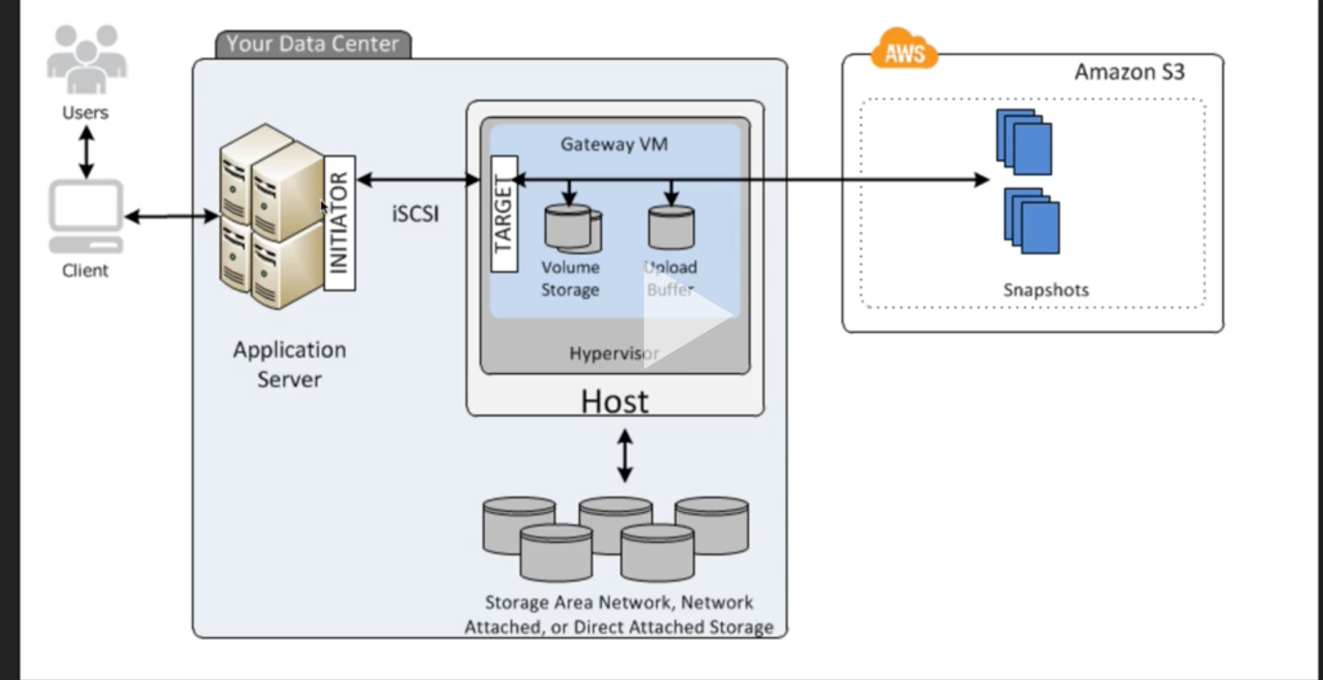
    - Cached Volumes.
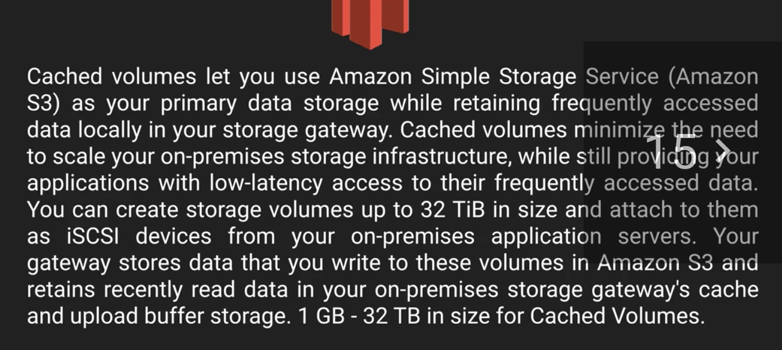
The Architecture
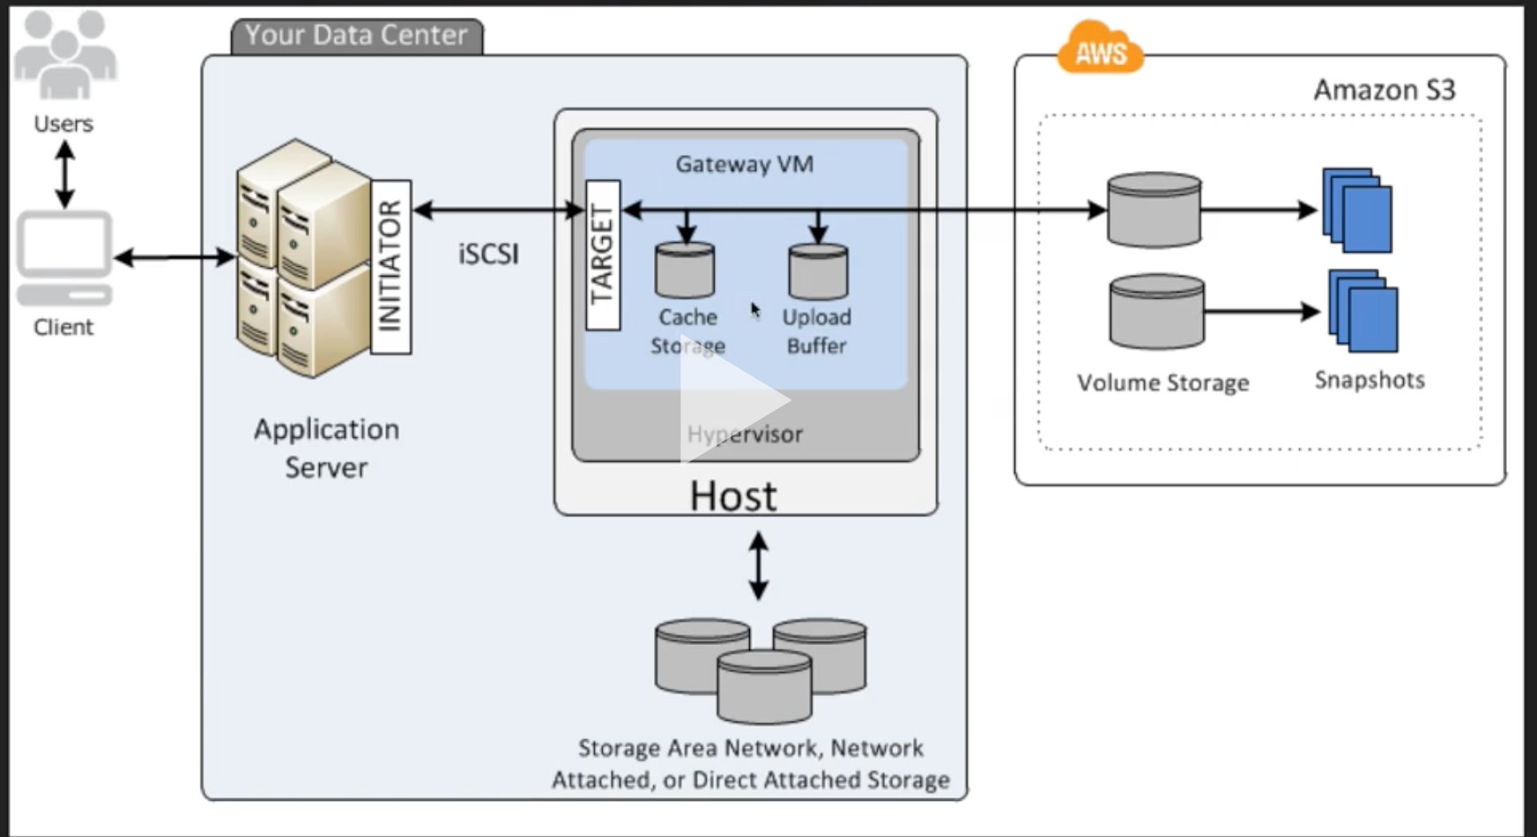
      - Use S3 as your primary data storage, while retaining frequently accessed data locally in your storage gateway.
      - Provide low latency access to their frequently accessed data.
      - Create volumes up to 32 TB.
      - Store data in S3 and retains recently read data in your on-premises storage gateway’s cache.
      - Back-up data on AWS.
  - Tape Gateway (VTL)
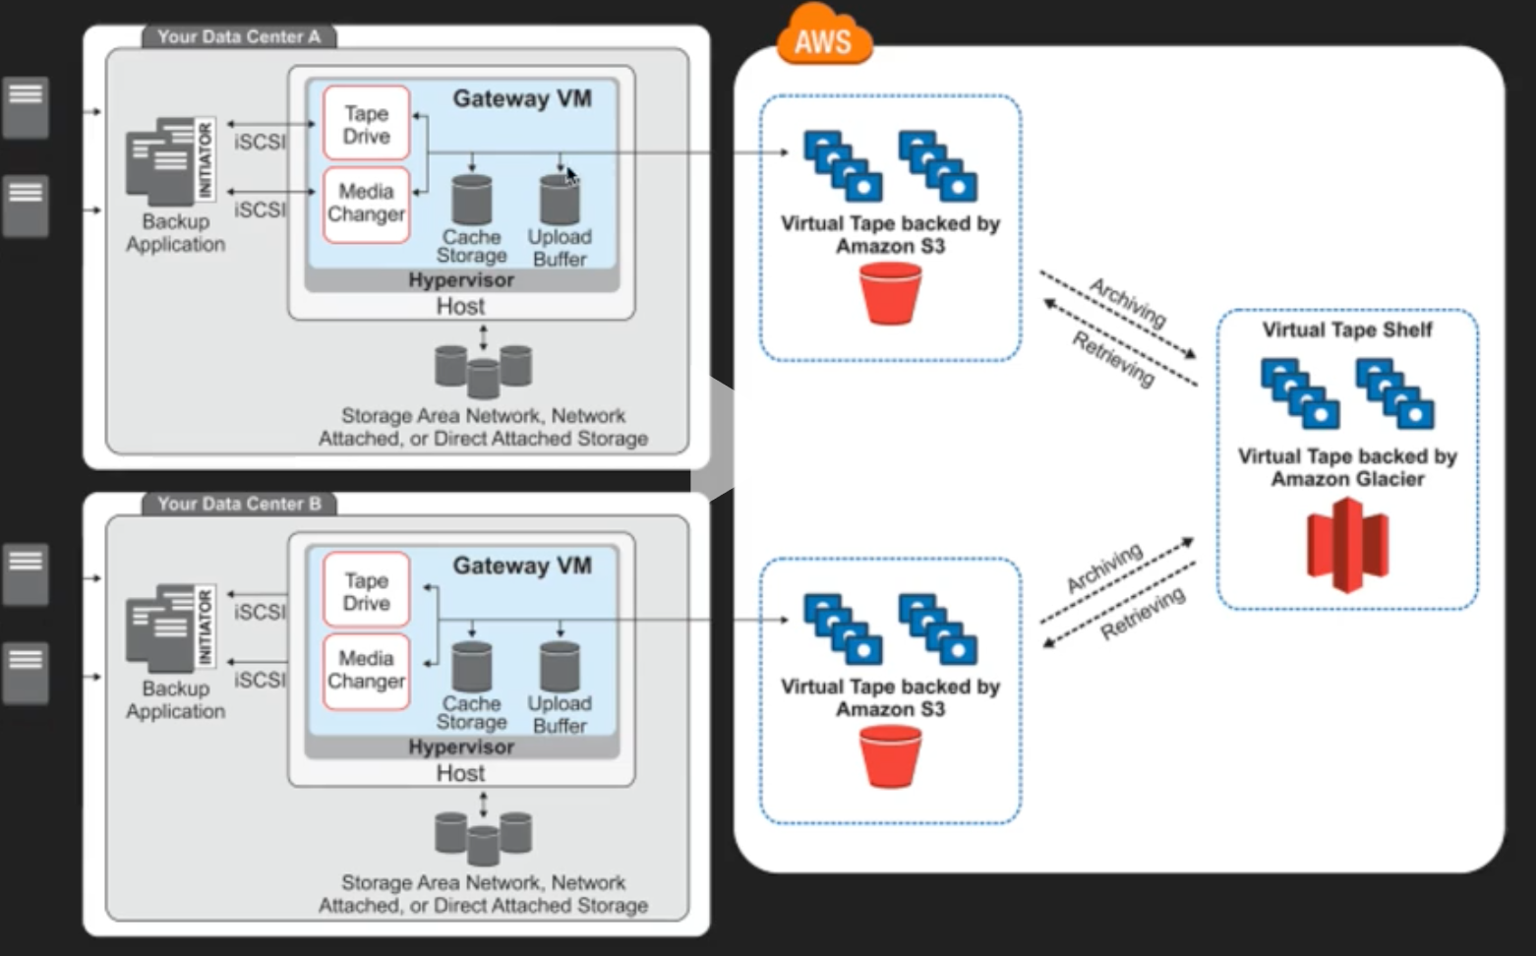
    - Back-up and Archiving solutions, creating virtual tapes on AWS with archiving lifecycle.

Snowball
- Import / Export disk accelerates moving large amount of data into and out of the AWS cloud using portable storage devices for transport.
- AWS import/export disk transfers your data directly onto and off of storage devices using Amazon’s high-speed internal network and bypassing the internet.
- Types of Snowballs
  - Snowball
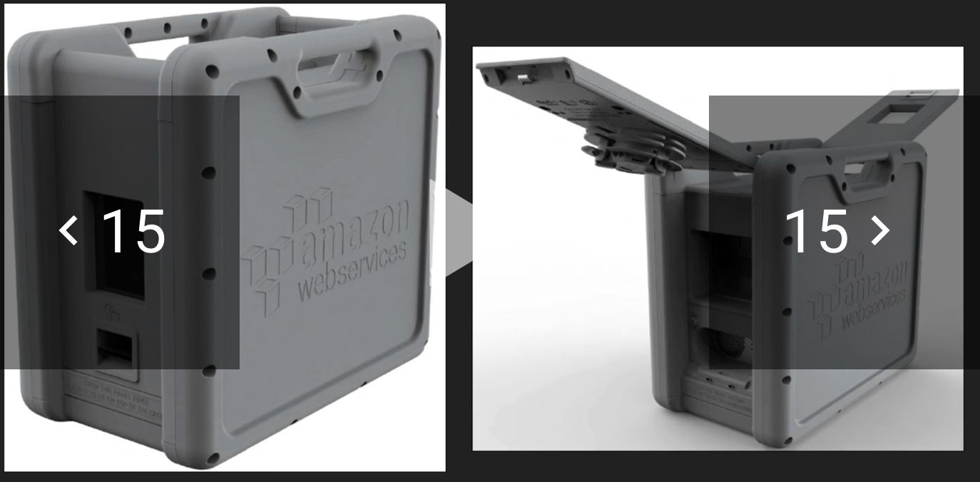
    - Is Petabyte scale data transport solution that uses secure appliances to transfer large amounts of data in/out AWS.
    - Protect your data from tamper-resistant, encryption, …..
  - Snowball Edge
    - 100TB data transfer device with on-board storage and compute capabilities.
    - Used to transfer large amounts of data in/out AWS.
    - Connects your existing applications and infrastructure using standard storage interfaces.
    - Can cluster together to form a local storage tier and process your data on-premises.
    - Ensure applications continue to run even when they are not able to access the cloud.
  - Snowmobile
    - Petabytes and Exabytes of data. Used to move extremely large amounts of data to AWS.
    - 45-foot long shipping container.
    - Move massive volumes of data to the cloud.
    - Can move complete data center migration to the cloud.
    - Secure, fast and cost effective.
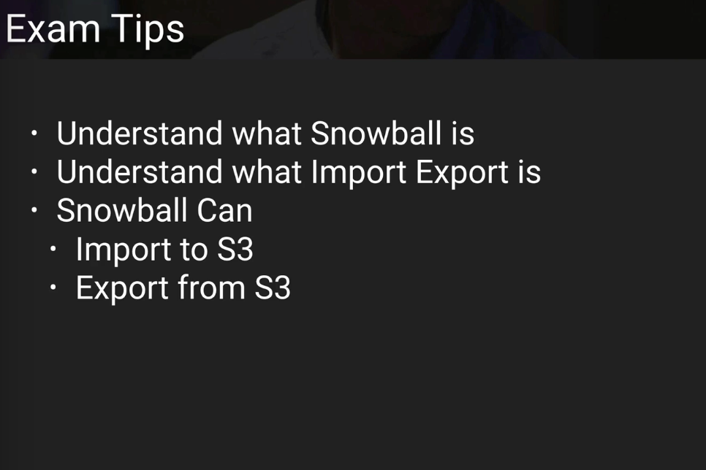

Snowball Lab
- Real job order, received the snowball, connected to it using network cable, transferred data to it using CLI tools.

S3 Transfer Acceleration
- Utilizes the cloudfront Edge Network to accelerate your uploads to S3.
- Instead uploading directly to S3 bucket, you can use distinct URL to upload directly to an edge location which will then transfer that file to S3. You will get distinct URL to upload to.
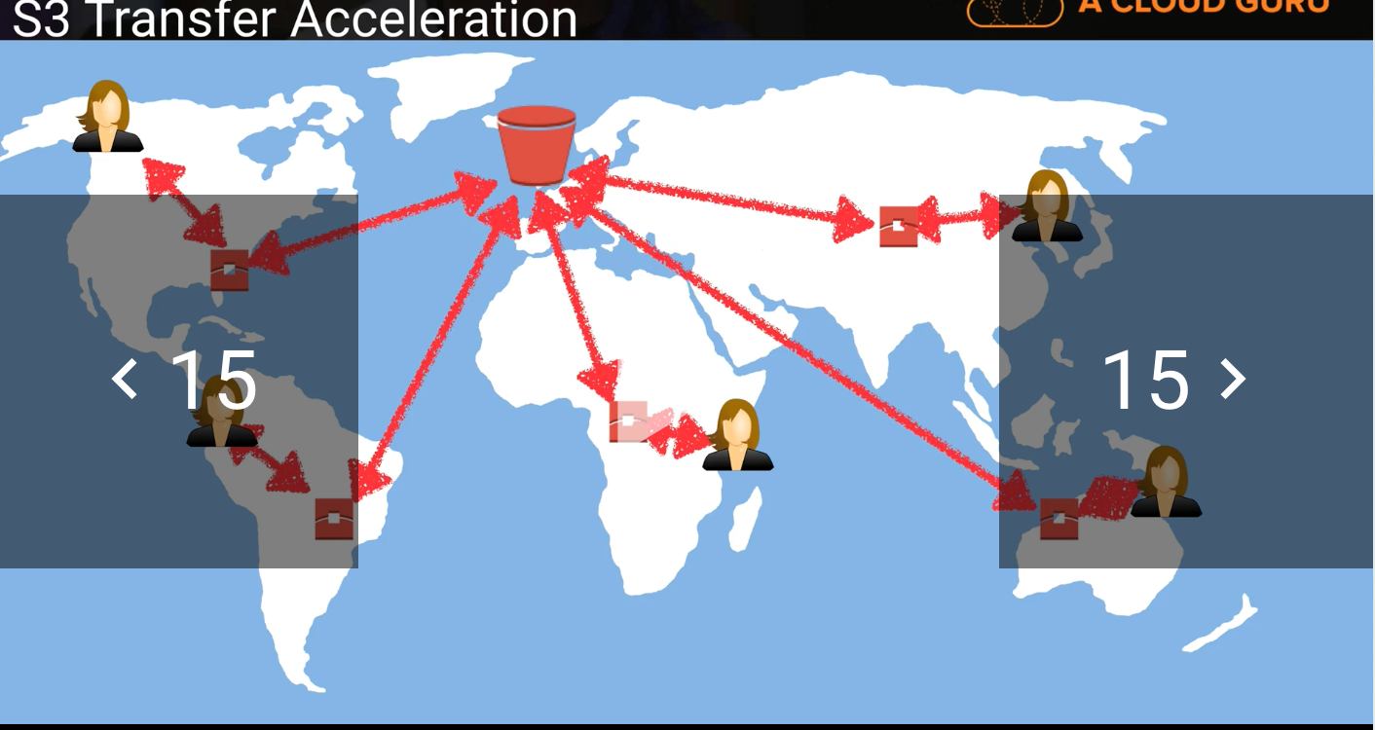

Create a Static Website Lab
- In Exam you have to know the URL naming convention, recognizing the URL pattern for static website.

Summary
- Files can be from 0-5 TB
- no unlimited storage
- S3 is a universal namespace, unique globally
- namespace is
  - https://s3-regionname-amazonaws.com/acloudguru
- Read after write consistency for PUTS of new objects
- On PUTs new S3 object you’ll be able to read it immediately, but if you want to DELETE or UPDATE an object, you may access an old version or undeleted version because it can take some time to propagate.
- S3 tiers
  - S3 (durable, immediately available, frequently accessed)
  - S3-IA(durable, immediately available, infrequently accessed)
  - S3-Reduced redundancy storage (data is easily reproducible, such as thumbnails etc), not very stable, should not be critical data.
  - Glacier-cheapest one, archived data, 3-5 latency on access these files
- Core fundamentals of S3
  - Key/Value store
  - Version ID
  - Metadata
- Object based storage only (for files), not OS or Dbs
- Versioning
  - Store all versions of an object including all writes and even you delete an object
  - Great backup tool
  - Once enabled, versioning cannot be disabled, only suspended
  - Integrates with Lifecycle rules
  - Versioning’s MFA delete capabilities, which uses multi-factor authentication, can be used to provide an additional layer of security
  - Cross region replication
- S3 Lifecycle management
  - Can be used in conjunction with versioning
  - Can be applied to current versions and previous versions
  - Following actions can now be done
    - Transition to the Standard – Infrequent access storage class(128 kb and 30 days after the creation date)
  - Archive to Glacier storage class (30 days after IA, if relevant)
  - Permanently delete
- CloudFront
  - Edge Location-This is the location where content will be cached, this is separate to an AWS region/AZ
  - Origin-this is the origin of all the files that the CDN will distribute, this can be either an S3 bucket, an EC2 instance, an Elastic Load balancer or Route53
  - Distribution-the name given the CDN which consists of a collection of Edge Locations.
    - Web distribution-typically used for websites
    - RTMP-used for media streaming
  - Edge locations are not just READ only, you can write to them
  - Object are cached for the life of the TTL(life to live), default value is 24 hours.
  - You can clear cached object, but you will be charged.
- Securing your buckets
  - By default, all newly created buckets are private
  - You can setup access control to buckets
    - bucket policies
    - access control lists
  - S3 buckets can be configured to create access logs which log all requests made to the S3 bucket, this can be done to another bucket.
- Encryption
  - In transit
    - SSL/TLS
  - At Rest
    - Server side encryption
      - S3 managed keys-SSE-S3
      - AWS key management service, managed keys – SSE-KMS
        - Same with more advantages
      - Server side encryption with customer provided keys himself – SSE-C
    - Client side encryption
- File Gateway-files stored directly on S3
- Volume Gateway
  - Stored volumes – Entire dataset is stored on site, and is async backup up to S3
  - Cached volumes- Entire dataset is stored on S3 and the most frequently accessed data is cached on site
- Gateway virtual Tape library (VTL)
  - Used for backup and uses popular backup applications like NetBackup, Backup Exec, Veam etc.
- Snowball
  - Snowball
    - pure storage
  - Snowball Edge- a box large
  - Snowmobile – hundreds of petabytes.
  - What import export is
  - Snowball can
    - Import to S3
    - Export from S3
  - S3 transfer acceleration
    - Speedup transfers to S3 using S3 transfer acceleration
      - This costs extra, and has the greatest impact on people who in far away locations.
  - S3 Static websites
    - host static websites
    - Serverless
    - Very cheap, scales automatically
    - STATIC only cannot host dynamic sites
  - Write to S3-HTTP 200 code
  - can load files to S3 much faster by enabling multipart upload
  - Read the S3 before taking the Exam.

