**Logistics Assignment 2**

**ISE 6984**

**Split Delivery Vs Transhipment Vehicle Routing Problem**

* **SAURABH MEHRA**

**Split Delivery Vehicle Routing Problem (SDVRP)**

In the Split Delivery Vehicle Routing Problem (SDVRP) a fleet of capacitated homogeneous vehicles is available to serve a set of customers. Each customer can be visited more than once, contrary to what is usually assumed in the classical Vehicle Routing Problem (VRP), and the demand of each customer may be greater than the vehicle capacity. Each vehicle has to start and end its tour at the same depot. The problem consists in finding a set of vehicle routes that serve all the customers such that the sum of the quantities delivered in each tour does not exceed the capacity of a vehicle and the total distance traveled is minimized.

Benefits of allowing split deliveries depends on certain on customer characteristics, e.g., customers’ locations and the customers’ demand patterns.

* when demands are large relative to the vehicle capacity, then there is little advantage to splitting deliveries
* when demands are small relative to the vehicle capacity, then there is little advantage to splitting deliveries
* when demands are a little over half the vehicle capacity, then there may be substantial advantages to splitting deliveries

**Vehicle Routing Problem with Transhipment Facilities (VRPTF)**

In several distribution networks shipment to a customer is performed directly, using vehicle routes emanating from a central depot, or through intermediate depots or transhipment facilities. In the latter case, the shipment is first delivered to a transhipment facility by a vehicle route; then it is delivered to the final customer. Transhipment facilities provide a way to consolidate shipments into large vehicle loads, thereby allowing for a reduction of total distribution cost, and providing the capability to transfer shipments between different vehicles or modes of transportation. More specifically, the problem consists of selecting transhipment facilities, allocating customers to these facilities, and designing vehicle routes to minimize the total distribution cost. In the VRPTF, each customer can be served directly by a vehicle route or through a facility selected from a set of potential facilities to which the customer can be assigned. The total load of a vehicle route, computed as the sum of the customer demands and the quantities delivered to the facilities, must be less than or equal to the vehicle capacity. The problem objective is to minimize the total sum of routing and assignment costs.

The between truck transfer problem can be considered a special case of VRPTF where the transshipment facilities are considered to be the nodes.

Introducing transhipment in vehicle routing enables transfers of goods among vehicles during the execution of customer transportation requests. In other words, the restriction that a single customer request for transportation is fulfilled by only one vehicle is relaxed.

Fig. 1 shows an example with two carriers and 6 pickup and delivery requests. The two depots of the carriers are depicted as the two squares noted with A and B. The solid lines represent the three requests (r1, r2, and r3) acquired by carrier A. The dashed lines represent the other three requests (r4, r5, and r6) of carrier B. Pickup locations are marked with plus signs and delivery locations with minus signs. The numbers given in the square brackets define the time window of the corresponding operation. The number on the right of the time window defines the service time.

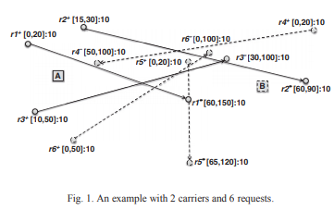

In the scenario of IP, i.e. without cooperation, each of the two carriers solves his own PDPTW and fulfils all his requests alone. The results of IP are given in Fig. 2. The total distances account to 138 distance units. The solid lines show the two vehicle routes of carrier A and the dashed lines depict those of carrier B.

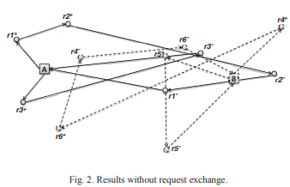

If the two carriers perform request exchange and make routing decisions together, they can solve the multi-depot PDPTW and obtain the results shown in Fig. 3 with the total distances of 131 units, i.e., a reduction of 7 distance units. In this case, request r6 of carrier B is transferred to carrier A. It is fulfilled by the same vehicle which also serves request r3.

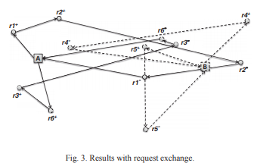

**Benefits of VRPTF over SDVRP:**

1. SDVRP is used to optimally use given number of vehicles and their capacity, can be used for reverse logistics also. VRPTF is used to optimally use the truck capacity and when minimize the number of trucks required for solving the VRP.
2. If entities are coming from different supplier and a customer need a mix of entities at a demand node cross docking VRP can be used to satisfy a mix of demand, whereas split delivery would be costlier as each truck has to visit each demand node to satisfy the demand.
3. VRPTF saves cost when in route restrictions are put up and all trucks cannot visit all demand nodes.
4. If no restrictions are put up on route then, both SDVRP and VRPTF problem gives the same optimal solution.

**References:**

1. Baldacci, Ngueveu, and Wolfler Calvo: VRP with Transhipment Facilities Transportation Science, Articles in Advance, pp. 1–15, © 2016 INFORMS
2. Vehicle routing under consideration of transhipment in horizontal coalitions of freight carriers. Benedikt Vornhusena , Xin Wanga , Herbert Kopfera. Robust Manufacturing Conference (RoMaC 2014)
3. To split or not to split: That is the question. Claudia Archetti, Martin W.P. Savelsbergh M. Grazia Speranza. Transportation Research Part E 44 (2008) 114–123